Home Page:
Hero section title: Libre Baskerville bold 40px
Quote below hero section title: Source Serif 4 regular 20px
Button: colour white, text colour- black -Source Serif 4 - 12 bold
The Result, Signature Programs, My 3 Growth Pillars - Libre Baskerville - 32px - regular
My 3 Growth Pillars Cards:
title : Libre Baskerville 24px bold
definition: Source Serif 4 20px light
Signature Programs cards:
Images:




Title Libre Baskerville 16px regular
Definition: Source Serif 4 12px light
Blog Section: Title : Libre Baskerville golden 32px bold
Blog Section cards:
Title : Libre Baskerville regular 20px
Definition : Source Serif 4 Light 16px
Blog Images:


The Result Section Circle definition: Source Serif 4 Light 16 px
Result Images:

Reviews Card:
Card Titile - Libre Baskerville Bold 24 px
Sub title - Libre Baskerville Regular 20 px
Review Paragraph: Source Serif 4 16px light

Program Page:
Same as home page
Image:

Program card:
Colour: Gradient: Linear Gradient white 29% opacity white 35% and white 37% opacity and 67%
Program card title: Libre Baskerville Bold 18px
Program card definition: Source Serif 4 regular 14px
Program card button: Source Serif 4 Bold 16px


Blog Page:
Same as home page
Hero section title: Libre Baskerville bold 40px
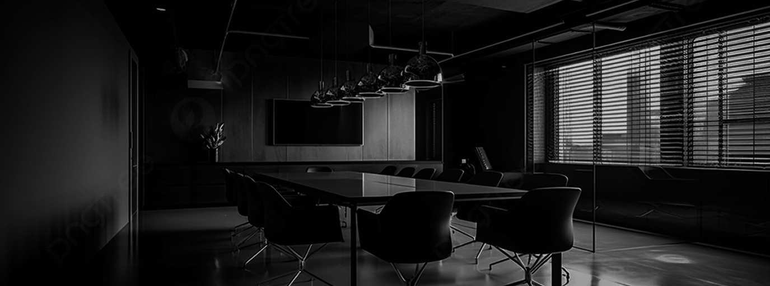
title: same as the home page
Blog card: words: Source Serif 4 Medium 16px

Contact Page:
Hero section title: Libre Baskerville bold 40px
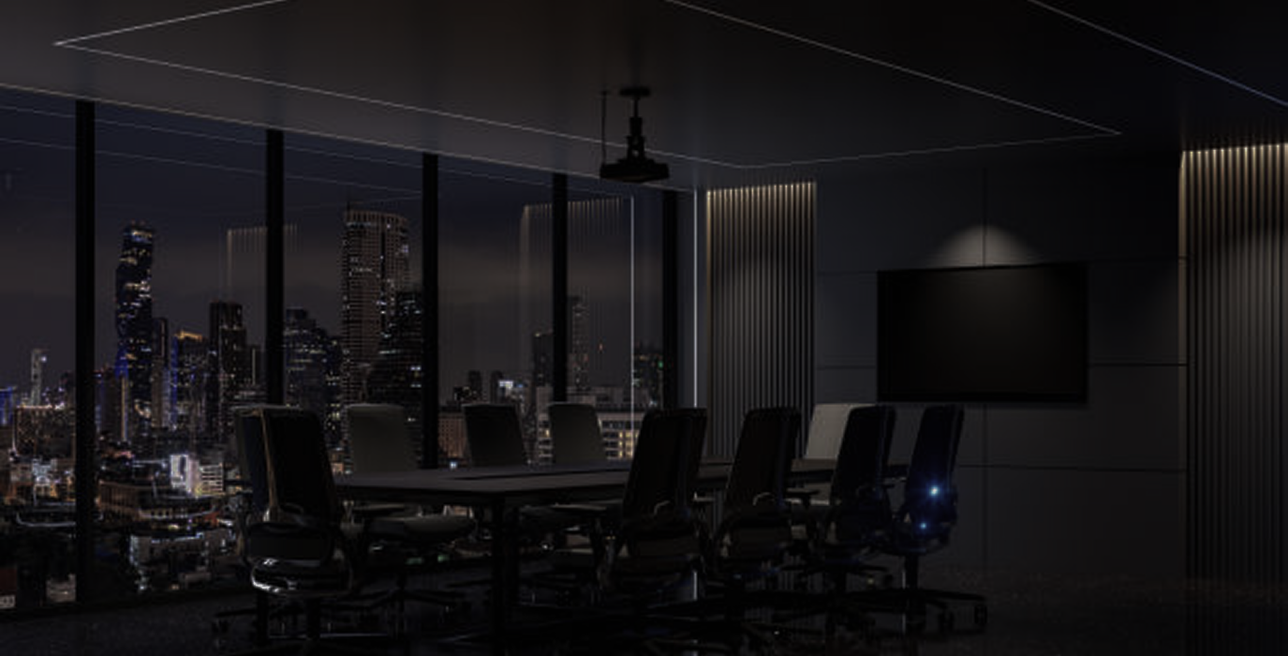
Sub title: Libre Baskerville Regular 20px
Below subtitle: Source Serif 4 Light 16
Workshop Page:
Hero section title: Libre Baskerville bold 40px

Previously Hosted Workshop: Libre Baskerville 32px bold
Below Title: Source Serif 4 Regular 20px
Card-1 Title: Libre Baskerville Bold 20px
Card-1 Time and sentence: Source Serif 4 regular 16px

Upcoming Workshops Title: Libre Baskerville 32px bold
Card-2 Title: Libre Baskerville Regular 24px

Card-2 definition: Source Serif 4 light 16px

About Page:
Hero section title: Libre Baskerville bold 40px

Sub title: Libre Baskerville Medium 24px
Who am I? Title: Libre Baskerville Bold 32px
Who am I? Section explanation: Source Serif 4 Regular 20px

Our Vision And Mission Title: : Libre Baskerville Bold 32px
Card-1-Our Vision And Mission: Source Serif 4 Light 20px
My Approach Title: Libre Baskerville Bold 32px
My approach card: Source Serif 4 16px regular
Why Work With Me Title: Libre Baskerville Bold 32px
Why Work With Me Points: Source Serif 4 Regular 24px

Ready to scale with clarity and confidence?: Source Serif 4 Regular 24px
Login Design:
Create an account: Libre Baskerville Bold 32px
Access your learning and growth tools.: Source Serif 4 regular 20px

Email And Password: Source Serif 4 Semibold 16px
Login Button: Source Serif 4 Bold 20px

NavBar: Source Serif 4 Medium 16px
Register: Source Serif 4 Bold 12px
Footer: Source Serif 4 Regular 14px

