UC1.

To check Employee Is Present Or Absent

#!/bin/bash -x

echo " Welcome to employee wage computution "

isPresent=1;

randomCheck=$((Random%2));

if [[ $isPresent -eq $randomCheck ]]

then

echo "Employee is Present"

else

echo "Employee is Absent"

fi

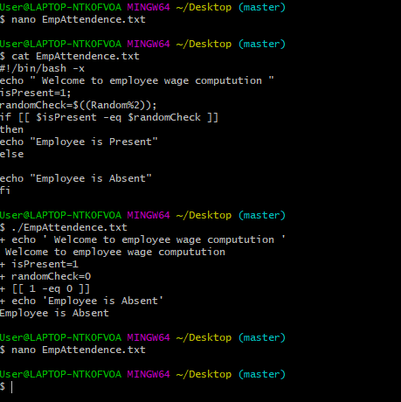

Uc2.

#!/bin/bash -x

echo " Welcome to employee wage computution "

isPresent=1;

randomCheck=$((Random%2));

if [[ $isPresent -eq $randomCheck ]]

then

echo "Employee is Present"

else

echo "Employee is Absent"

fi

To Calculate Daily Employee Wage

isPresent=1;

randomCheck =$((Random%2 ));

if[[ $isPresent -eq $RandomCheck ]]

then

empRatePerHr=20;

empHrs=8;

salary=$(( $empHrs*$empRatePerHr))

else

salary=0;

fi

UC3

randomCheck=$((Random%2));

if[[ $isPresent –eq $randomCheck]]

then

empRatePerHr=20;

empHrs=8;

salary=$(($empHrs*$empRatePerHr))

else

salary=0;

fi

isPartTime=1;

isFullTime=2;

empRateper=20;

randomcheck=$((RANDOM%3))

if[[ $isFullTime –eq $randomCheck]]

then

empHrs=8;

elif[[$isPartTime –eq $randomCheck]]

then

empHrs=4;

else

empHrs=0;

fi

salary=$(($empHrs *$empRateHr))

UC4

isPartTime=1;

isFullTime=2;

randomcheck=$((RANDOM%3))

empCheck=$((RANDOM%3))

case $empCheck in

$isFullTime)

empHrs=8

;;

$isPartTime)

empHrs=4

;;

)

empHrs=0

;;

Esac

salary=$(($empHrs*$empRateperHr));

UC5

isPartTime=1;

isFullTime=2;

empRateper=20;

randomcheck=$((RANDOM%3))

if [[ $isFullTime –eq $randomCheck ]]

then

empHrs=8;

elif [[ $isPartTime –eq $randomCheck ]]

then

empHrs=4;

else

empHrs=0;

;;

esac

salary=$(($empHrs *$empRateHr));

total salary=0;

numberWorkingDays=20;

for(( day=1;day<=$numberWorkingDays;day++ ))

do

empCheck=$((RANDOM%3));

case $empCheck in

$isFullTime)

empHrs=8

;;

$isPartTime)

empHrs=4

;;

)

empHrs=0

;;

esac

salary=$((empHrs *$empRatePerHr));

totalSalary=0;

numberWorkingDays=20;

for(( day=1;day<=$numberWorkingDays;day++ ))

do

empCheck=$((RANDOM%3));

case $empCheck in

$isFullTime)

empHrs=8

;;

$isPartTime)

empHrs=4

;;

)

empHrs=0

;;

esac

salary=$(($empHrs*$empRatePerHr));

totalSalary=(($totalSalary+$Salary));

done

UC_6

MAX_HRS_IN_MONTH=10;

EMP_RATE_PER_HR=20;

NUM_WORKING_DAYS=20;

totalEMPHrs=0;

totalWorkingDays=0;

while[[ $totalEmpHrs -1t $Max_HRS_IN_MONTH &&

&totalWorkingDays -1t $NUM_WORKING_DAYS ]]

Do

((totalWOrkingDays++))

empCheck=$((RANDOM%3));

case $empCheck in

$isFullTime)

empHrs=8

;;

$isPartTime)

empHrs=4;;

)

empHrs=0;;

esac

totalEmpHrs=$(TotalEmpHrs * empHrs))

done

totalSalary=$(($totalEmpHrs* $EMP_ATE_PER_HR))

UC7

getWorkHours()

{

Case $empCheck in

$isPartTime

workHours=4

$isFULLTIME

workHours=8;;

esac

echo $workHours;

}

getWorkHOurs

UC8

#calculate wage for each day

while [ $total_working_days -lt $MAX_WORKING_DAYS ]

do ((total_working_days++));

workDone=$( getEmployeeWage $((RANDOM%3)) ); tempWage=$((workDone*EMPLOYEE_RATE_PER_HOUR)); total_working_hours=$((total_working_hours+workDone));

totalWage=$((totalWage+tempWage));

done

echo "totalWage - " $totalWage

UC9

#!/bin/bash -x

#employee either part time or full, working for any organisation & will work till

# maximum working days allowed in month

# maximum working hours allowed in month;

# for that, we calculate wage.

# RANDOM%N ===> range > 0 to N-1

#Constant

EMPLOYEE_PART_TIME=1

EMPLOYEE_FULL_TIME=2

EMPLOYEE_RATE_PER_HOUR=100

MAX_WORKING_DAYS=5

MAX_WORKING_HOURS=200

#Variable

totalWage=0 #camel case

total_working_days=0 #underscore

total_working_hours=0

#get employee wage per day

getEmployeeWage() {

#switch - generate workDone per day

case $1 in

$EMPLOYEE_PART_TIME) workDone=4;;

$EMPLOYEE_FULL_TIME) workDone=8;;

*) workDone=0;;

esac

echo $workDone;

}

