集美大学工商管理学院信息专业实验报告

课 程 电子商务安全 实验名称 实验7 线性模型
系 别 工商管理学院电子商务系 日 期 2025年 4月 1日
专业班级 商务2212 学 号 202221213051 姓名__陈婉清
报告退发( 订正 、 重做 ) 教 师 审 阅 签 字

- 实验内容及主要过程或方案

1. insurance.csv数据集给出了某保险公司客户的数据，需要建立预测保险费用的模型。表1列出了数据集中各变量的名称及含义。
表1 insurance数据集说明
变量名称 | 变量说明
age | 年龄
sex | 性别，取值为“Female”（女）和“Male”（男）
bmi | 身体质量指数
children | 孩子数量
smoker | 是否是吸烟者，取值为“Yes”（是）和“No”（否）
region | 地区，取值为“northeast”（东北）、“northwest”（西北）、“southeast”（东南）和“southwest”（西南）
charges | 因变量，保险费用
（1）设置随机种子set.seed(12345)，读取insurance.csv中的数据（将sex、smoker和region按照字符型变量读入，其他变量按照数值型变量读入），声明各变量类型，并将数据储存为R数据框。查看各分类变量的频数表。对因变量charges进行对数转换。
（2）随机抽取70%的观测放入学习数据集，剩余30%放入测试数据集。将学习数据集和测试数据集存入insurance_learning.csv文件和insurance_test.csv文件。
（3）根据学习数据集建立线性模型。查看模型诊断图并点评。计算线性模型对测试数据集的保险费用预测的均方根误差。

- 实验分析
（一）设置随机种子，导入数据，设置变量类型，
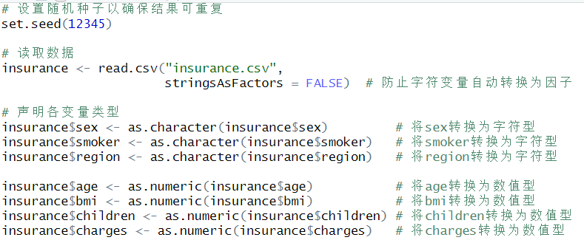
查看各分类变量的频数。
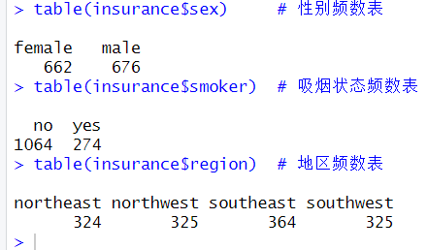
对因变量charges进行对数转换。
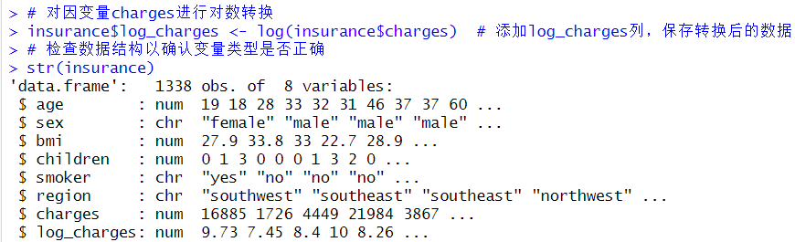
（二）随机抽取70%的观测放入学习数据集，剩余30%放入测试数据集。将学习数据集和测试数据集存入insurance_learning.csv文件和insurance_test.csv文件。
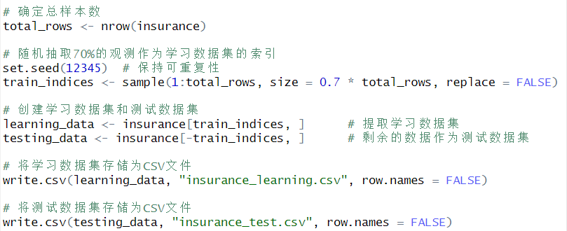
（三）根据学习数据集建立线性模型。查看模型诊断图并点评。计算线性模型对测试数据集的保险费用预测的均方根误差。
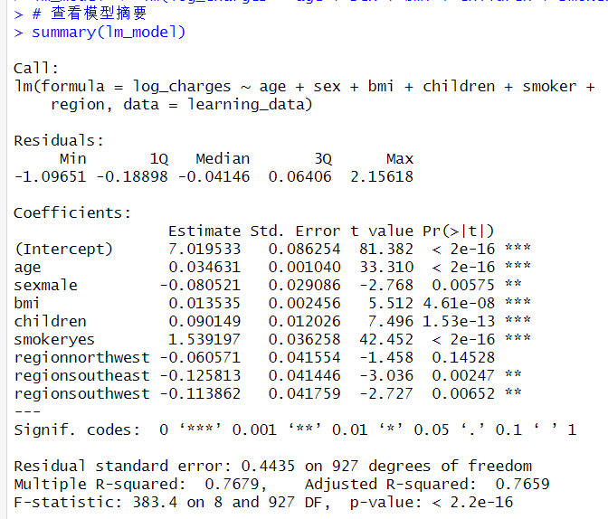
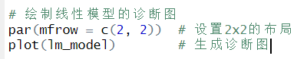
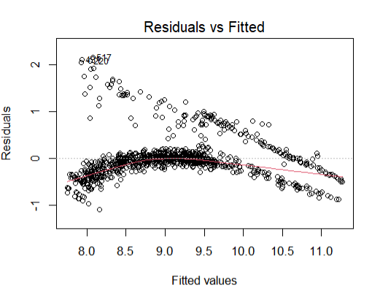
从图中可以看到低拟合值（低费用人群）残差大，高拟合值（高费用人群）残差小 → 费用分布右偏：
重度吸烟者（高 bmi、高 age）费用极高，模型 低估 他们的异常高费用。
年轻、非吸烟、低 bmi 人群费用集中，模型 高估 低消费群体。
异方差（费用越高，预测越不稳定）源于：
吸烟者费用 波动剧烈（癌症/急病突发 vs. 长期少量吸烟）。
bmi>35（重度肥胖）人群医疗支出 不可预测（并发症随机性强）。
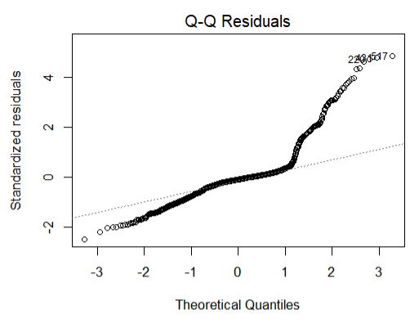
图中出现右尾极端值（费用>3σ）远超正态 → 重尾分布：
可能少数极高费用案例（癌症晚期、重大事故）拖尾。
可能漏掉关键交互：smoker*bmi、age^2 未建模，导致极端案例残差过大。
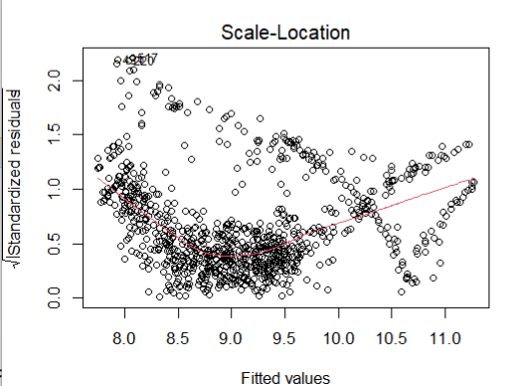
残差的变异程度仍然随着拟合值增加而增加，这说明仍然存在一定的 异方差性（即预测值较大的情况下，误差更大）。
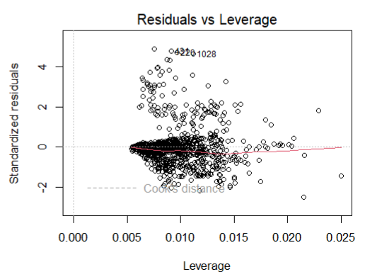
标注点（1028, 2357…）可能是：
极端吸烟老人（age>70, smoker="Yes", bmi>40）。
高 bmi 壮年吸烟者（并发症高风险）。
东北/西北地区（高医疗成本区域）的高费用患者。
这些点 单方面拉高回归线。

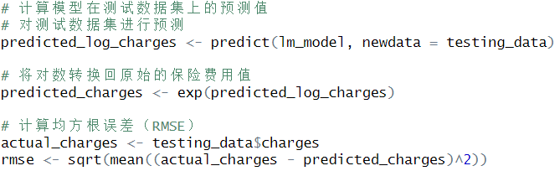

- 总结
本次实验利用 insurance.csv 数据集，建立了预测保险费用的线性回归模型。为了提高模型的拟合效果，我们对因变量 charges 进行了对数转换，并使用多个特征变量（年龄、性别、BMI、孩子数量、是否吸烟、地区）作为自变量。实验结果表明：
模型拟合情况
线性模型能够较好地解释保险费用的变化，但 残差图显示仍然存在一定的模式化残差和异方差问题，说明某些非线性关系未被完全捕捉。
Q-Q 正态性检验图显示，高保险费用个体的残差偏离正态分布，可能受到吸烟状态或特定人群的影响。
本次实验通过数据预处理，掌握了如何正确定义变量类型，避免数据类型错误影响建模。
了解了 对数变换在减少右偏分布和异方差性方面的作用，并学会利用 Q-Q 图、残差图等工具检查模型拟合情况。通过 RMSE 评估模型的预测效果，认识到线性回归在一定程度上能够解释保险费用的变化，但仍有进一步优化的空间，如使用非线性方法或改进方差建模。
General Rules

If a child is not born a vampire they must be changed or cast out of the household
Each Generation has three aspirations to complete before you can end the generation, they can be done in any order unless otherwise specified Once the three aspirations are done, they leave the household to retire as Vampires. Then allow their heir to lead the next generation. You must turn at least four sims per generation before any children are born (See creating a coven)
Every vampire in the coven must have a book written about them, a painting made of them or if you’re a modern vampire, you can take pictures of them but they must be large portraits. Every member of the coven must max Vampire Lore
Only the coven leaders may have the vampire creation power, but they must have it. The next coven leader can be any of your children. Coven members must be random townies turned by your coven leader and taught the skills they need to fulfill the roles needed by the coven. All roles must be filled before you’re able to have children. You cannot create them in advance, they must be turned and trained after you have the vampire creation perk. Coven members may also be spares from the legacy, however they cannot all be spares. Only four of the ten required may be spares and they must have a very good relationship with your leader at all times. Each Generation comes with a color, and you may work that into the generation or ignore it. I just thought it might be fun! The rules are adapted for all packs, but if you don’t have them feel free to adapt it to your owned packs! Creating a Coven The leaders of your coven (founder/heirs) are the grand masters of the coven. The title of leader goes to your heir and their spouse. Your leaders must max at least three skills, not including vampire knowledge Coven members can be spares or turned townies Any vampire you turn must join your household to fulfill a role in your coven before moving to a household in Forgotten Hollow. (See roles in the coven) If any vampires in your coven die you must keep the graves on one of the lots, home lot or otherwise.
All twelve main members of your coven (two leaders, four elite and six guardians) must live in Forgotten Hollow to start. Once it's full, you may begin to expand into the other worlds! I suggest all Forgotten Hollow homes have a gothic vibe the the other homes fit into their respective worlds… with creepy basements for your vampires! Elite and Guardian vampires can retire, but they must be replaced as soon as possible, with vampires of the correct skill levels. I suggest you retire them every other generation. Establish a castle somewhere outside of Forgotten Hollow for your Elderic Vampires to retire.

