集美大学工商管理学院电子商务专业实验报告

课 程 商业数据分析 实验名称 实验8 最小二乘法
系 别 电子商务 日 期 2025年 4月 3日
专业班级 商务2212 学 号 202221213051 姓名__陈婉清 ___
报告退发( 订正 、 重做 ) 教 师 审 阅 签 字

- 实验内容及主要过程或方案
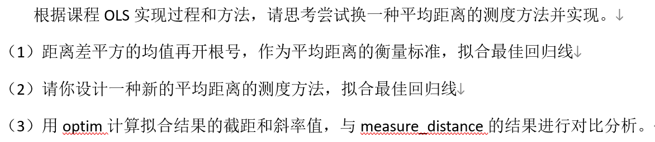
- 实验分析

（一）距离差平方的均值再开根号，作为平均距离的衡量标准，拟合最佳回归线
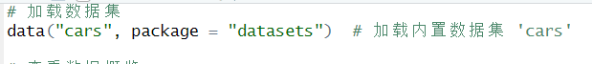
1. 定义目标函数：基于距离差平方的均值再开根号
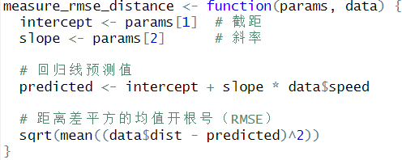
2. 使用优化算法寻找最佳拟合线
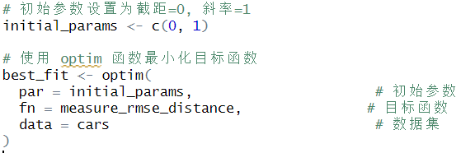
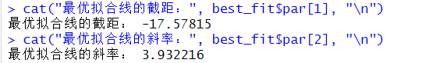
3.绘图展示拟合效果
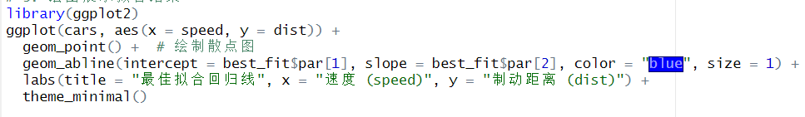
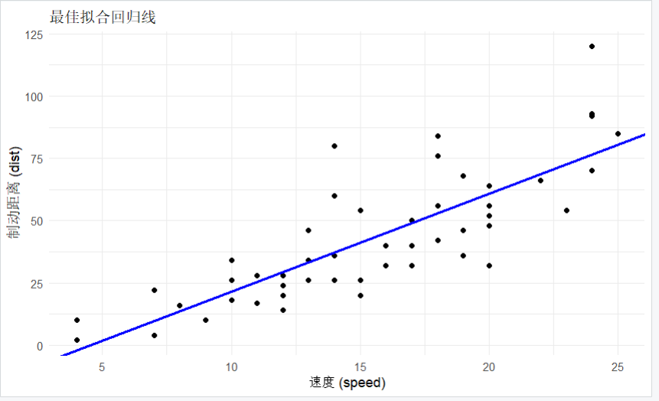
（二）设计一种新的平均距离的测度方法，拟合最佳回归线&用optim计算拟合结果的截距和斜率值，与measure_distance的结果进行对比分析
加载包和导入数据
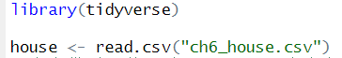
按照方法一再做一遍
定义计算平均距离的函数（RMSE）
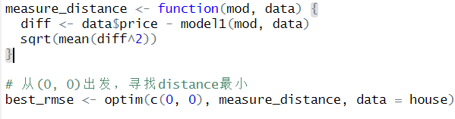
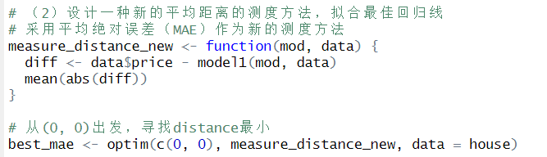
提前两种方法的截距和斜率
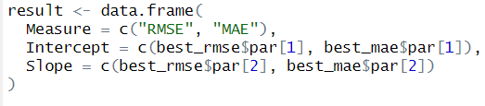
输出对比结果
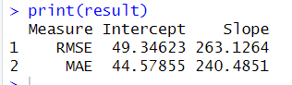
数据解释：
截距表示当自变量（房屋居住面积 sqft_living）为 0 时，因变量（房屋价格 price）的预测值。RMSE 方法得到的截距为 49.34623 ，MAE 方法得到的截距为 44.57855 。说明基于 RMSE 拟合的模型在理论上认为房屋面积为 0 时价格更高一些，而 MAE 拟合模型给出的对应价格更低。这反映出两种拟合方式在起始点的差异 。
斜率表示自变量每增加一个单位时，因变量的平均变化量。在这里即房屋居住面积每增加 1 平方英尺，房屋价格的平均变动情况。RMSE 方法的斜率为 263.1264 ，MAE 方法的斜率为 240.4851 。意味着 RMSE 拟合的模型认为房屋居住面积对房屋价格的影响更大，每增加 1 平方英尺，价格平均增加更多；而 MAE 拟合的模型认为这种影响相对较小 。

将两种方法放在同一张图里对比
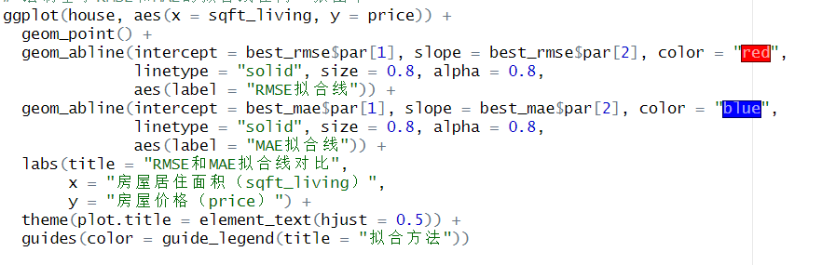
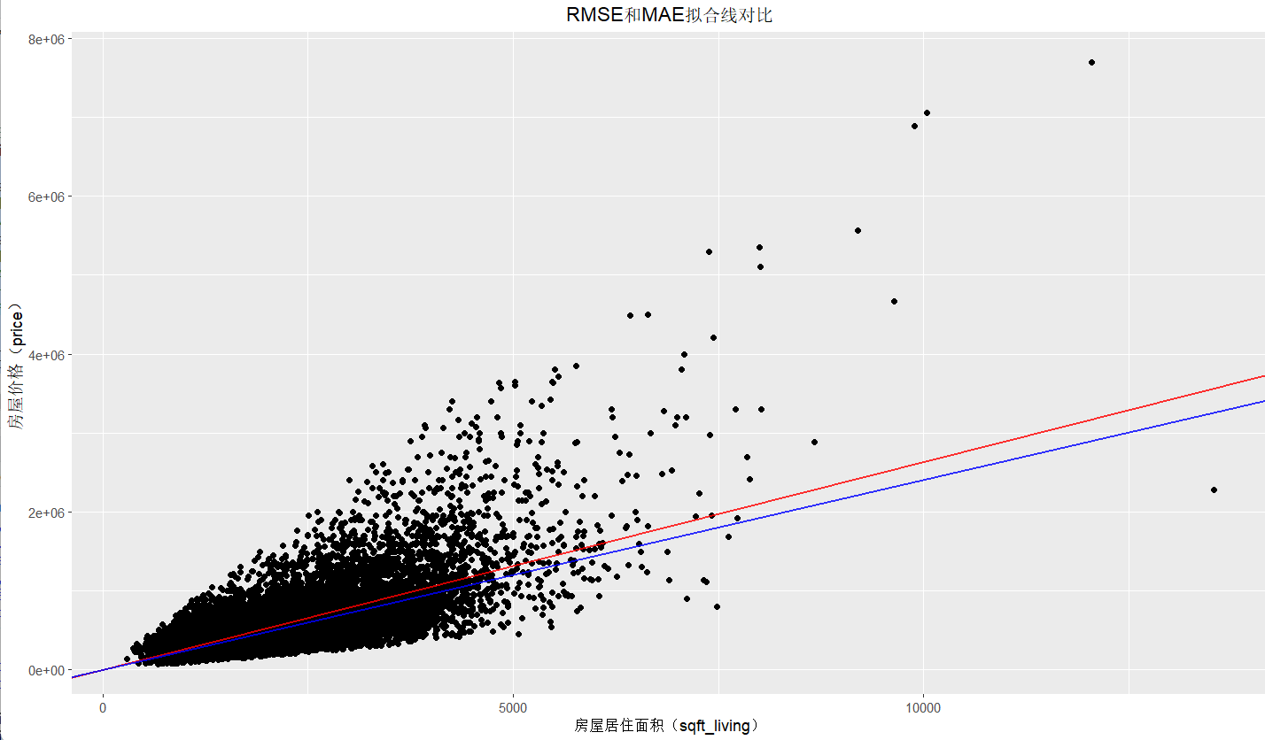
RMSE 侧重于最小化误差的平方和，对离群值较为敏感，它会为了使较大误差的平方和变小而调整参数，可能会让拟合线更倾向于平衡大误差的影响。MAE 侧重于最小化误差的绝对值之和，对离群值相对不那么敏感，拟合线更倾向于反映大部分数据点的趋势。从图中也能看到两条线倾斜程度不同，反映出对数据趋势捕捉的差异。

- 总结
在本次基于房屋数据集（house）构建线性回归模型的实验中，通过使用均方根误差（RMSE）和平均绝对误差（MAE）两种不同的平均距离测度方法拟合最佳回归线，得到了不同的截距和斜率值。这表明两种测度方法对数据的拟合方式存在差异，RMSE 由于对离群值更敏感，其拟合线在平衡大误差影响方面表现更突出，使得房屋居住面积对价格的影响权重相对较大；而 MAE 对离群值相对不敏感，拟合线更能反映大部分数据点的趋势，房屋居住面积对价格的影响权重相对较小。从可视化图形中也能直观地看到两条拟合线的倾斜程度和位置有所不同。
通过本次实验，更透彻地理解了 RMSE 和 MAE 两种误差测度方法的本质区别及其对线性回归模型的影响。RMSE 关注误差平方和，会放大离群值的影响；MAE 关注误差绝对值和，对离群值更具稳健性。这有助于在实际数据分析场景中，根据数据特点和研究目的合理选择误差测度方法来构建更合适的模型。
If a child is not born a vampire they must be changed or cast out of the household Each Generation has three aspirations to complete before you can end the generation, they can be done in any order unless otherwise specified Once the three aspirations are done, they leave the household to retire as Vampires. Then allow their heir to lead the next generation. You must turn at least four sims per generation before any children are born (See creating a coven) Every vampire in the coven must have a book written about them, a painting made of them or if you’re a modern vampire, you can take pictures of them but they must be large portraits. Every member of the coven must max Vampire Lore Only the coven leaders may have the vampire creation power, but they must have it. The next coven leader can be any of your children. Coven members must be random townies turned by your coven leader and taught the skills they need to fulfill the roles needed by the coven. All roles must be filled before you’re able to have children. You cannot create them in advance, they must be turned and trained after you have the vampire creation perk. Coven members may also be spares from the legacy, however they cannot all be spares. Only four of the ten required may be spares and they must have a very good relationship with your leader at all times. Each Generation comes with a color, and you may work that into the generation or ignore it. I just thought it might be fun! The rules are adapted for all packs, but if you don’t have them feel free to adapt it to your owned packs! Your parent messed up, big time. You remember the blowout when they were caught cheating, even if you were only little. Its stuck with you your whole immortal life. You decide you rather live for adventure and have some fun rather than settle down and get married. You even get to flirt with locals and you bring home a souvenir… a baby. Well, that's fine. You need to continue your legacy anyway! You may not be the best of parents, but you’re a hell of an explorer!
Your family has been rich for generations. Each of your ancestors have worked their ass off, and not relaxed. You got married pretty young because of your parent; not that you regret it. Your partner works their ass off, and you just get to shake yours. Partying, clubbing, and then a mistake that ends up losing you your spouse and ruining your relationship with your children. You don’t know how to recover from it all, but you try your best to make it up to your family, for the rest of your eternal life.

