**AI Assignment # 2 $α-β pruning$**

**max**

8

3

Z4

Z3

5

4

2

10

1

2

7

1

1

Z1

3

Z2

Y4

Y3

Y2

X2

X1

Y1

8

6

3

R

**Min**

**max**

6

W2

W1

0

4

**Min**

Before beginning, recall 2 important slides from the lecture:

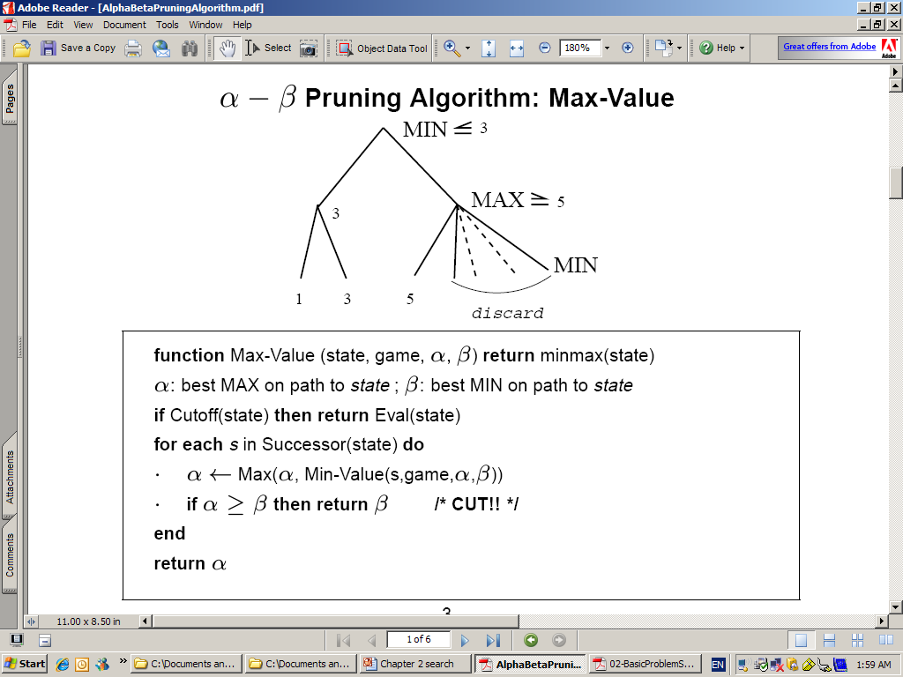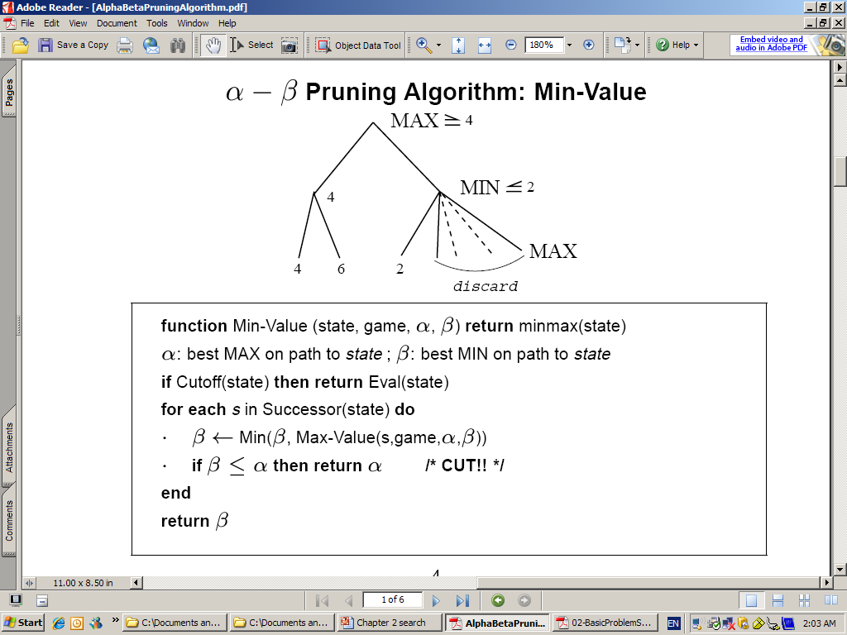

1. Implement $α-β pruning$ on the above game tree.
2. Show the optimal tree (Explain)
3. Show the pruned subtrees (Explain)

Due 19/8/2023