Project Synopsis
For
AURAOS: Agentic Unified Replica Architecture Operating System
A Goal-Oriented Operating System with Sandboxed Multi-Agent Execution and Digital-Twin-Gated Verification
August 2026
Prepared by
Specialization | SAP ID | Name
Cloud Computing and Virtualization Technology (CCVT) | 500121943 | Nitanshu Tak
School Of Computer Science
UNIVERSITY OF PETROLEUM & ENERGY STUDIES,
DEHRADUN- 248007, Uttarakhand

TABLE OF CONTENTS
Revision History 3
1 Introduction 4
1.1 Purpose of the Project 4
1.2 Target Beneficiary 4
1.3 Project Scope 4
1.4 References 5
2 Project Description 6
2.1 Reference Algorithm 6
2.2 Data / Data Structure 7
2.3 SWOT Analysis 7
2.4 Project Features 7
2.5 User Classes and Characteristics 8
2.6 Design and Implementation Constraints 8
2.7 Design Diagrams 9
2.8 Assumptions and Dependencies 25
3 System Requirements 26
3.1 User Interface 26
3.2 Software Interface 26
3.3 Database Interface 26
3.4 Protocols 26
4 Non-Functional Requirements 27
4.1 Performance Requirements 27
4.2 Security Requirements 27
4.3 Software Quality Attributes 27
5 Other Requirements 29
Appendix A: Glossary 30
Appendix B: Analysis Model 31
Appendix C: Issues List 32

REVISION HISTORY
Date | Change | Reason for Changes | Mentor Signature
August 2026 | Initial synopsis prepared, following synopsis presentation and mentor feedback | Major project synopsis submission
October 2026 | Mid-Semester Evaluation Update: verified native host runtime, WebSocket PTY bridge, sandbox shell, multi-tab browser proxy, and diagnostic bootloader. | Mid-semester progress evaluation and prototype demonstration | Reviewed

1 INTRODUCTION
1.1 Purpose of the Project
Modern operating systems manage hardware and run applications, but they do not manage user objectives. Accomplishing any non-trivial goal on a computer today — setting up a development environment, preparing a research workspace, building and deploying an application — still requires the user to act as their own systems integrator: locating tools, resolving dependency conflicts, sequencing steps correctly, and recovering manually when something breaks. Contemporary AI coding and automation assistants have started to close part of this gap, but they operate as applications layered on top of an unaware operating system — they can propose or execute commands, but the OS itself has no concept of a “goal” and no mechanism to verify a multi-step plan before it touches the live filesystem.
The purpose of this project is to design and implement AURAOS (Agentic Unified Replica Architecture Operating System): a goal-oriented operating system layer, built on the NitanshuOS Linux foundation, that accepts a high-level natural-language objective from the user, decomposes it into a schema-validated, capability-constrained task graph using a local language model, executes that task graph inside an isolated, container-based Digital Twin for verification, and commits the resulting changes to the real system only after automated policy checks and explicit user approval — with transactional checkpoint-and-rollback if the real execution diverges from the simulated outcome. The motivation is not to build another general-purpose Linux distribution, but to investigate whether an operating system can move verification of a multi-step workflow into the OS itself, using kernel-level isolation primitives, rather than leaving that verification to the user or to an application layered above an unaware OS.
1.2 Target Beneficiary
The primary beneficiaries of this project are:
- Software developers and students who repeatedly perform multi-step environment setup, build, and deployment workflows and would benefit from a verified, one-shot execution path instead of manual, error-prone orchestration.
- Researchers preparing computational workspaces (dependency installation, environment scaffolding) who need a repeatable, safe way to provision an environment without risking their existing system state.
- Learners and early-career engineers who benefit from a safe experimentation platform where destructive mistakes are caught by simulation before they can affect the real system.
- The author, as a systems-research and portfolio contribution building directly on prior work (NitanshuOS), and the academic evaluation of this Major Project.
1.3 Project Scope
AURAOS is scoped as a solo, single-semester Major Project. Its scope is deliberately bounded to what can be realistically designed, implemented, and evaluated within that timeframe, rather than the full breadth of the originally brainstormed concept. The in-scope deliverables are:
- A bootable AURAOS ISO image and standalone native-host microkernel runtime, built by extending the existing NitanshuOS kernel and Buildroot rootfs with namespace, cgroup, and overlay-filesystem support, runnable both inside VirtualBox and natively via the single-click Python Core desktop launcher.
- A native agent runtime (Rust) comprising a Planner and 3–5 sandboxed domain agents (Development, Security, Testing, Deployment).
- A local, quantized language model (llama.cpp / GGUF) used exclusively for goal-to-task-graph plan generation, with deterministic schema validation — no external API dependency.
- A deterministic, deny-by-default policy engine with a fixed precedence order (Security > Stability > User Goal > Performance > Convenience).
- A container-based Digital Twin (using standard Linux isolation primitives and a standard container runtime) that actually executes — not predicts — a proposed workflow, with checkpoint, commit, and rollback.
- Support for 3–5 explicitly defined workflow categories (software development setup, research workspace preparation, containerization/pre-deployment validation, isolated environment creation, and optionally automated testing/diagnosis) — not open-ended goal support.
- A local, hardware-accelerated, browser-rendered AURA Control Center and desktop compositor for goal submission, interactive VT100 terminal execution, multi-tab browsing, live hardware telemetry, plan review, and approve/cancel actions.
Explicitly out of scope for this project: learned or negotiated multi-agent consensus protocols, predictive (non-executed) Digital Twin modeling, kernel-level (as opposed to sandboxed userspace) agent integration, cross-machine or distributed agent coordination, formal verification of the twin-gate mechanism, and support for goals outside the fixed workflow categories. This distinction is treated as a hard project constraint (see §2.6 and §2.8) rather than an aspiration, and is what makes the project achievable by a single developer within one semester.
1.4 References
[1] J. S. Betzer, J. Boudjadar, M. Frasheri, and P. Talasila, “Digital Twin Enabled Runtime Verification for Autonomous Mobile Robots under Uncertainty,” Aarhus University, arXiv:2412.09913, 2024.
[2] L. Huang, L. R. Varshney, and K. E. Willcox, “Formal Verification of Digital Twins with TLA and Information Leakage Control,” arXiv:2411.18798, 2024.
[3] M. Zahediyami, V. Delos, S. Gorecki, and M. K. Traoré, “Agile framework for Digital Twin verification and validation: Addressing complexity challenges in cross-disciplinary hybrid systems,” University of Bordeaux / IMS Laboratory, 2026.
[4] S. Soltesz, H. Pötzl, M. E. Fiuczynski, A. Bavier, and L. Peterson, “Container-based operating system virtualization: A scalable, high-performance alternative to hypervisors,” ACM SIGOPS Operating Systems Review, vol. 41, no. 3, pp. 275–287, 2007.
[5] “Linux Namespaces and cgroups as OS Primitives for Lightweight Virtualization: Architecture, Isolation Mechanisms, and Performance Evaluation,” Turkish Journal of Computer and Mathematics Education (TURCOMAT), 2026.
[6] “A survey on LLM-based multi-agent systems: workflow, infrastructure, and challenges,” Vicinagearth, Springer Nature, 2024.
[7] “LLM-Based Multi-Agent Orchestration: A Survey of Frameworks, Communication Protocols, and Emerging Patterns,” MDPI, 2026.
[8] NitanshuOS project repository (prior work by the author) — github.com/Nitanshu715/NitanshuOS.

2 PROJECT DESCRIPTION
2.1 Reference Algorithm
AURAOS does not rely on a single algorithm but on three coordinated procedures that together implement Twin-gated execution. Each is presented below at design-level pseudocode, reflecting the methodology this project follows rather than final implementation code.
Algorithm 1 — Goal-to-Task-Graph Planning
INPUT: goal_text (natural language string)
OUTPUT: task_graph (schema-valid JSON) or REJECTED
1. prompt ← buildPrompt(goal_text, TASK_GRAPH_SCHEMA)
2. raw_output ← LocalLLM.generate(prompt)
3. IF NOT schemaValidate(raw_output, TASK_GRAPH_SCHEMA):
4. retry ← retry + 1
5. IF retry > MAX_RETRIES: RETURN REJECTED
6. GOTO step 2
7. task_graph ← parse(raw_output)
8. FOR EACH node IN task_graph.nodes:
9. assignAgent(node, domainAgentFor(node.type))
10. RETURN task_graph
Algorithm 2 — Policy Precedence Resolution
INPUT: action_request (agent_id, requested_action, capabilities)
OUTPUT: APPROVE or DENY
PRECEDENCE ← [Security, Stability, UserGoal, Performance, Convenience]
1. IF action_request.capabilities NOT SUBSET OF agent.allowed_capabilities:
2. RETURN DENY // deny-by-default
3. FOR EACH rule IN PRECEDENCE (in order):
4. verdict ← rule.evaluate(action_request)
5. IF verdict == DENY: RETURN DENY
6. RETURN APPROVE
Algorithm 3 — Twin-Gated Transactional Execution
INPUT: task_graph (policy-cleared)
OUTPUT: COMMITTED or ROLLED_BACK
1. twin ← DigitalTwin.createIsolatedReplica()
2. result ← twin.execute(task_graph) // actually run, not predicted
3. evidence ← twin.collectEvidence(result)
4. IF evidence.risk != LOW: RETURN REJECTED
5. approved ← requestUserApproval(evidence)
6. IF NOT approved: RETURN REJECTED
7. checkpoint ← RealSystem.createCheckpoint()
8. real_result ← RealSystem.execute(task_graph)
9. IF real_result MATCHES result:
10. RealSystem.commit(checkpoint)
11. RETURN COMMITTED
12. ELSE:
13. RealSystem.rollback(checkpoint)
14. RETURN ROLLED_BACK
2.2 Data / Data Structure
AURAOS is a systems project rather than a supervised-learning project, so there is no fixed external dataset. The system's primary data structure is the Task Graph — a directed acyclic graph in which each node represents one agent-executable step, carrying its type, required capabilities, dependencies on other nodes, and (after execution) its result and risk classification. The characteristic data used and produced by the system is summarised below.
Data Element | Description
Goal (input) | Free-form natural-language text entered by the user through the AURA Control Center.
Task Graph | Structured JSON: nodes (task id, type, required capabilities, dependencies), schema version. Produced by the Planner, consumed by domain agents and the Digital Twin.
Policy Rule Set | Fixed, versioned precedence rules and capability tables used by the Policy Engine (not user-editable at runtime in v1).
Execution Evidence | Build/test results, resource usage, and timing collected by the Digital Twin for each simulated run.
Checkpoint | Filesystem/process-state snapshot of the real system taken immediately before real execution, used for rollback.
Evaluation Corpus | A self-constructed set of representative goals across the supported workflow categories, used to repeatedly exercise the system and compute the metrics in §4.1.

No external or third-party dataset is used, and no personal or sensitive user data is processed — consistent with the project's local-first design constraint (§2.6).
2.3 SWOT Analysis
Strengths | Weaknesses
Builds on an already-implemented, working NitanshuOS kernel/userland foundation, reducing ground-up risk. Entirely local-first: no paid API, no cloud dependency, reproducible offline. Uses proven Linux isolation primitives (namespaces, cgroups, container runtimes) instead of custom, higher-risk isolation code. | Solo development timeline against a fixed academic deadline. Quantized local LLM plan quality is less reliable than large hosted models, especially for novel goals. The Digital Twin's fidelity is limited to the scoped workflow's side effects, not full OS state.
Opportunities | Threats
Twin-gated execution as a specific, evaluable mechanism is a credible research and (subject to prior-art search) potential patent angle. Growing academic and industry interest in agentic systems. Architecture is modular enough to extend with additional workflow categories after v1. | Adjacent commercial/academic agentic developer tooling is moving quickly and may reduce novelty by submission time. Scope creep is a real risk given the breadth of the original concept relative to a solo, one-semester timeline. LLM hallucination or malformed plans reaching execution if schema/policy validation has gaps.

2.4 Project Features
The major features AURAOS provides to the user, corresponding to the Level 2 Use Case diagram in §2.7, are:
- State a Goal (Natural Language) — the user describes an objective in plain text rather than selecting an application or typing commands.
- Review Generated Task Graph — the user can inspect the structured plan the Planner produced before anything executes.
- Review Digital Twin Simulation Result — the user sees build/test evidence, resource usage, and a risk classification from the actually-executed simulation.
- Approve / Cancel Execution — the user explicitly authorizes (or rejects) applying the verified plan to the real system; nothing executes on the real system without this step.
- View Execution Report & Rollback Status — the user sees the final outcome, including whether the change was committed or automatically rolled back.
2.5 User Classes and Characteristics
User Class | Characteristics
End User / Developer | Primary user of AURAOS. Technically literate (developer, researcher, or student) but not expected to know AURAOS's internals. Interacts only through the AURA Control Center: states goals, reviews plans, approves or cancels execution.
Evaluator / Mentor | Reviews the system for academic evaluation. Needs to observe the full goal → plan → twin → approval → execution → commit/rollback flow clearly, and expects the v1-vs-future-work distinction (§1.3) to be honoured, not blurred.
Developer / Maintainer | The author, in the role of implementing, testing, and extending AURAOS. Requires the deepest level of system knowledge, including kernel configuration, agent runtime internals, and the policy schema.

2.6 Design and Implementation Constraints
Hardware / timing / memory constraints:
- Target host: x86_64 machine with 16 GB physical RAM; AURAOS is allocated an 8 GB VirtualBox VM.
- RAM budget within the VM: kernel + rootfs (~250 MB), agent runtime idle (~150 MB), policy engine/message bus (~50 MB), Control Center (~50 MB), local LLM loaded (~2–2.5 GB), Digital Twin execution headroom (~3.5 GB), OS cache/safety margin (~1 GB), enforced via cgroups v2 so a single workflow cannot exhaust the VM.
Specific technologies and tools:
- Base OS: custom Linux 5.10 LTS kernel and Buildroot rootfs (NitanshuOS foundation).
- Isolation: Linux namespaces, cgroups v2, overlayfs, via a standard container runtime (runc / crun).
- Agent runtime language: Rust.
- Local inference: llama.cpp with GGUF-format, quantized (1–3B class) models, benchmarked before the model size is locked.
- Control Center & Shell: A high-performance local web server and desktop compositor rendering a 60+ FPS browser-based window manager (Fluent/macOS design) with live system tray telemetry, multi-tab proxy browser, and interactive terminal — avoiding the heavy overhead and mouse-driver latency of monolithic X11/Wayland stacks.
- Demonstration target: Dual-mode target supporting both Native Host Application mode (Chromium/Edge --app=http://localhost:8888 with 60+ FPS zero-latency mouse cursor) and VirtualBox VM guest environment.
Language and communication requirements:
- All inter-component communication is local: HTTP/WebSocket between the Control Center and the orchestrator, and a structured internal message schema between the Planner, agents, and the Policy Engine.
- No external network dependency is required for core operation (see §3.4).
Security considerations:
- Deny-by-default policy evaluation; every agent runs as a capability-restricted, sandboxed OS process; the LLM never receives direct execution authority (§2.1, Algorithm 2).
Design conventions:
- The task-graph schema is explicitly versioned; malformed LLM output is rejected and regenerated rather than silently coerced.
- The distinction between v1 (implemented) and future work (§1.3) is maintained consistently across all project documentation.
2.7 Design Diagrams
The following diagrams present the design of AURAOS at the level of detail appropriate to the synopsis / ideation stage of a Major Project — they describe the intended conceptual and logical design and will be refined as implementation proceeds. All diagrams below were created by the author for this project.
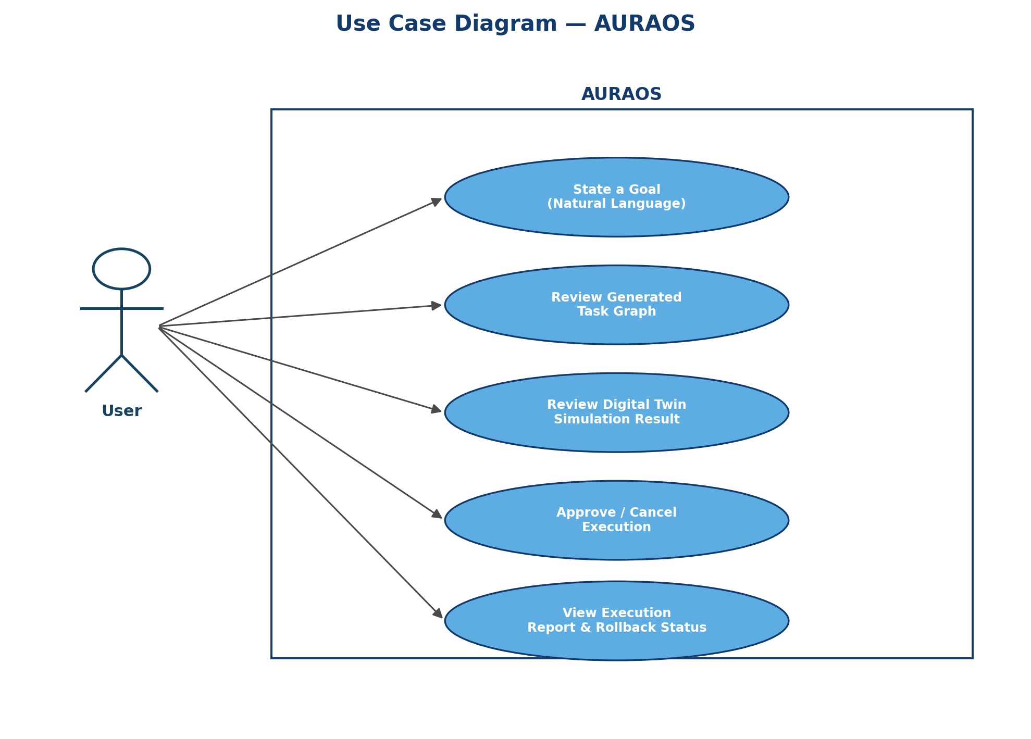
Figure 1: Use Case Diagram — AURAOS
Source: Author, original diagram prepared for this project (2026).
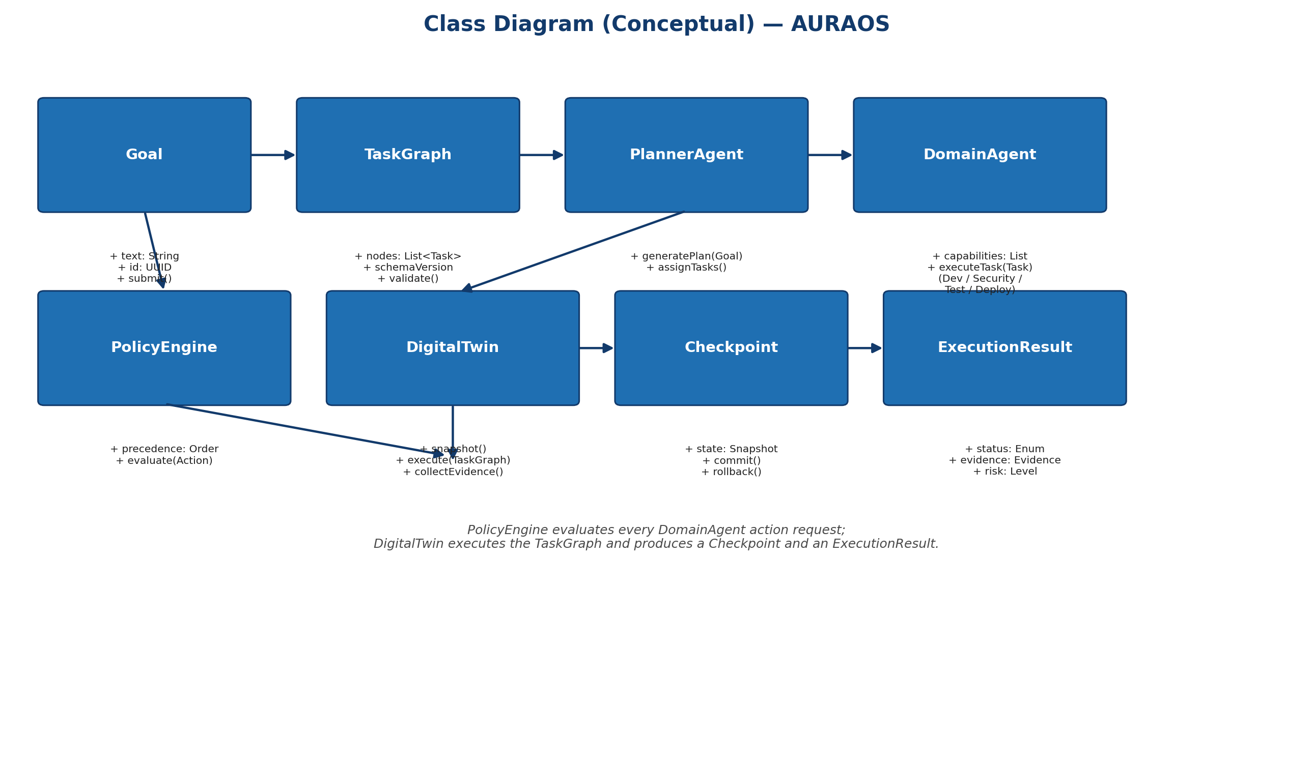
Figure 2: Class Diagram (Conceptual) — AURAOS
Source: Author, original diagram prepared for this project (2026).
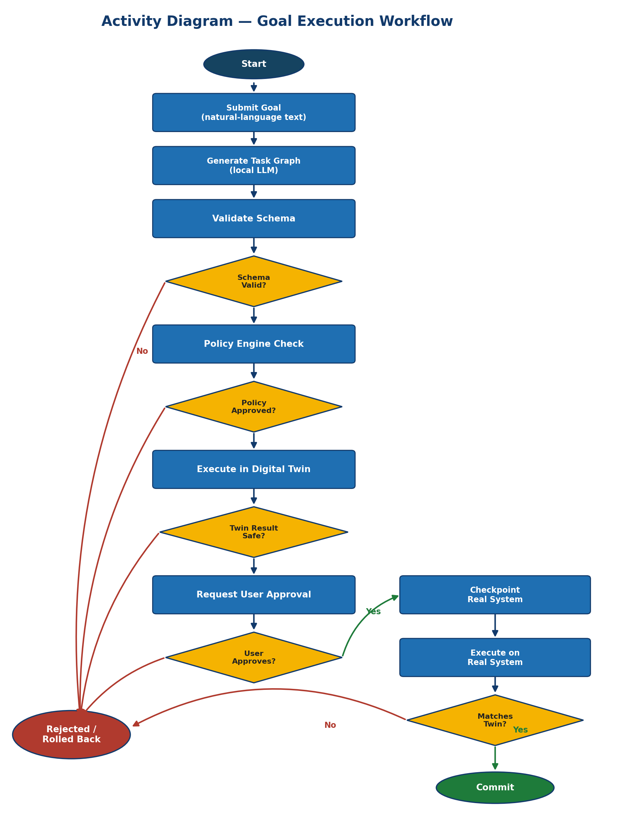
Figure 3: Activity Diagram — Goal Execution Workflow
Source: Author, original diagram prepared for this project (2026).
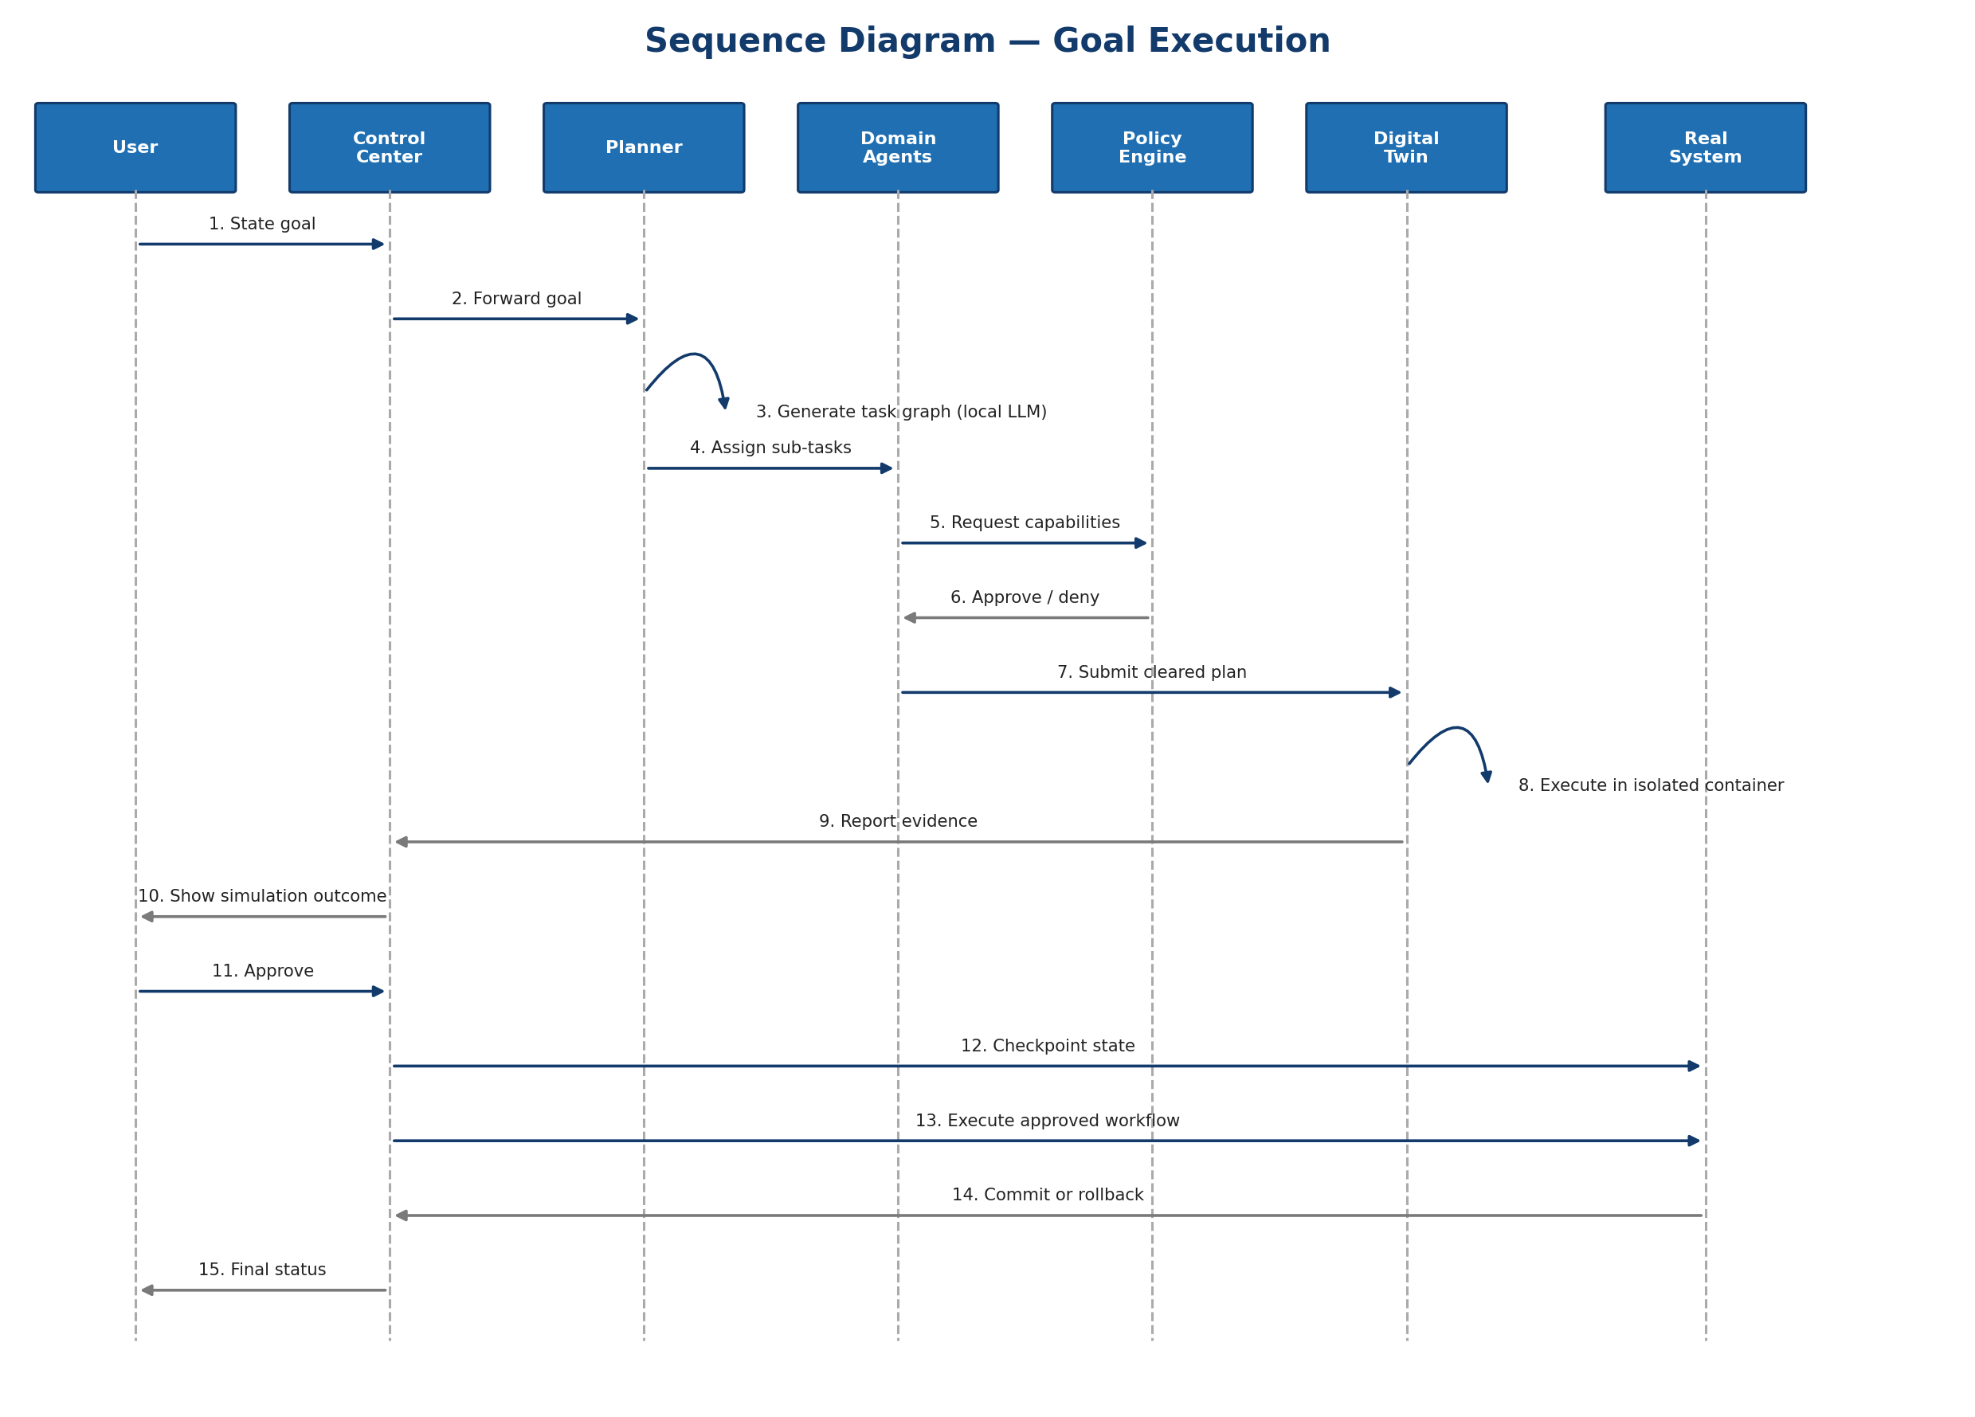
Figure 4: Sequence Diagram — Goal Execution
Source: Author, original diagram prepared for this project (2026).
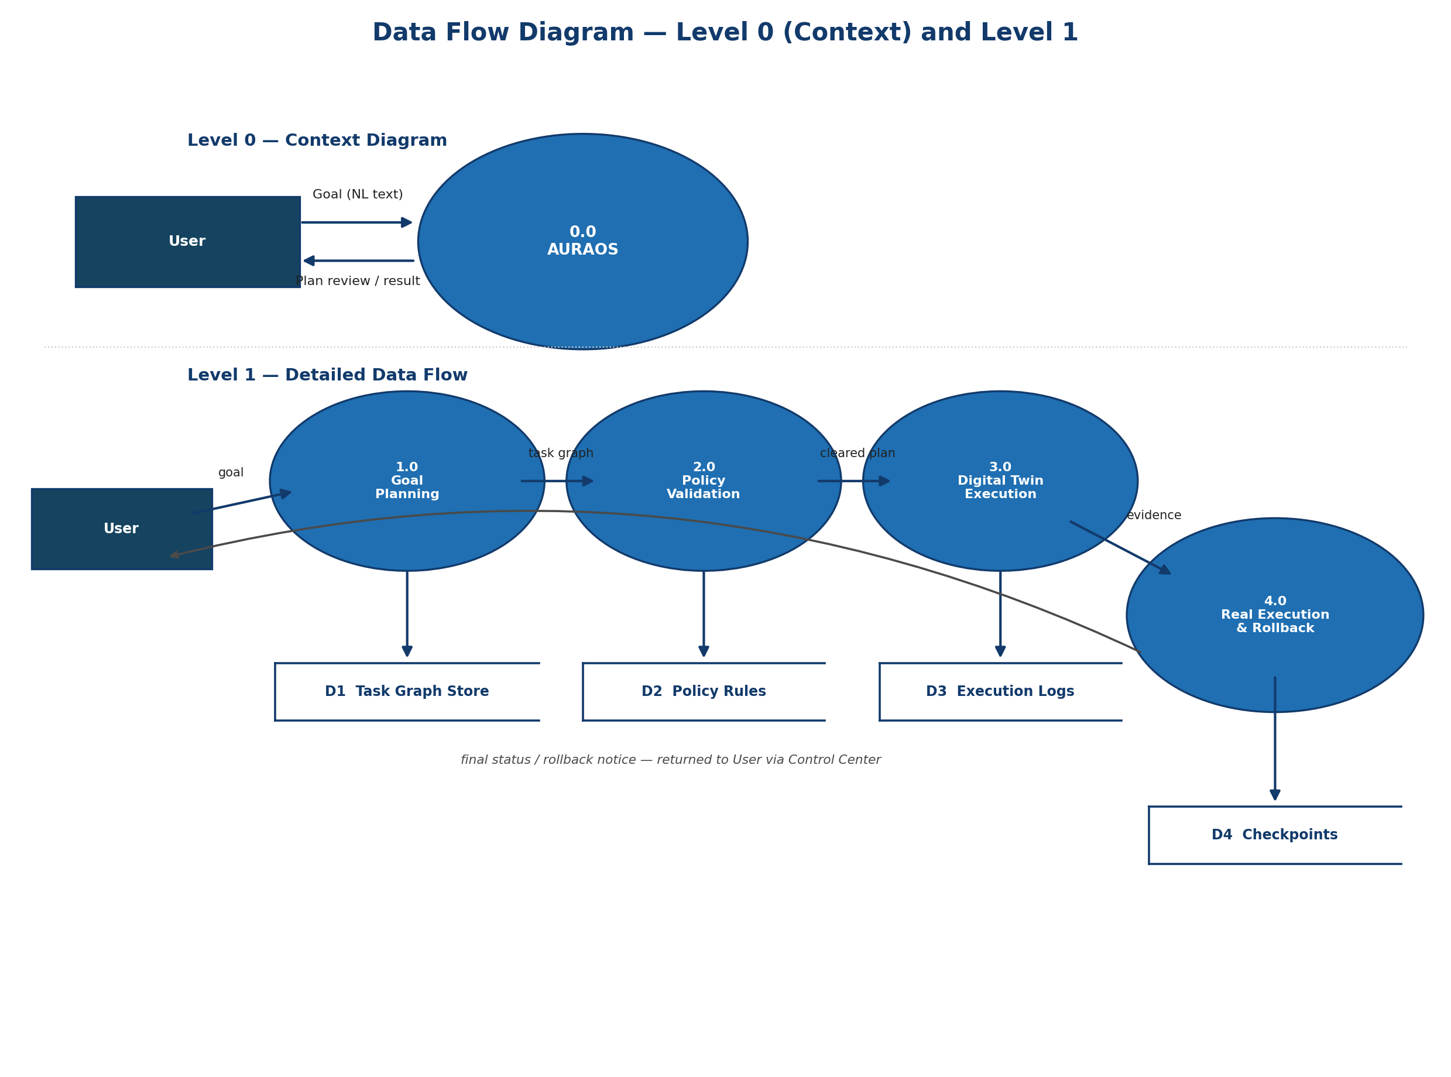
Figure 5: Data Flow Diagram — Level 0 (Context) and Level 1
Source: Author, original diagram prepared for this project (2026).
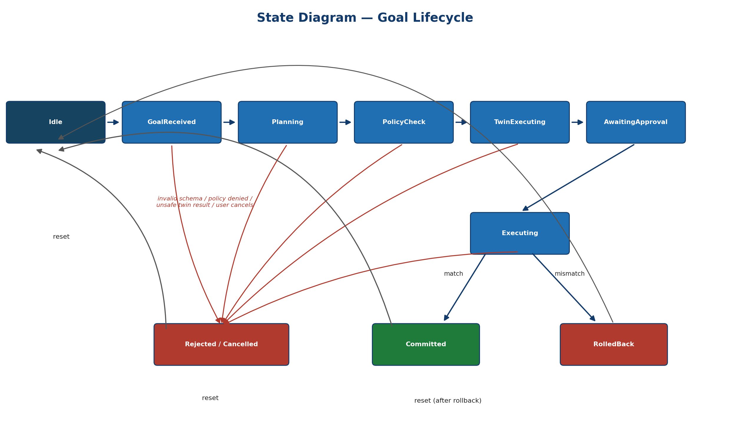
Figure 6: State Diagram — Goal Lifecycle
Source: Author, original diagram prepared for this project (2026).
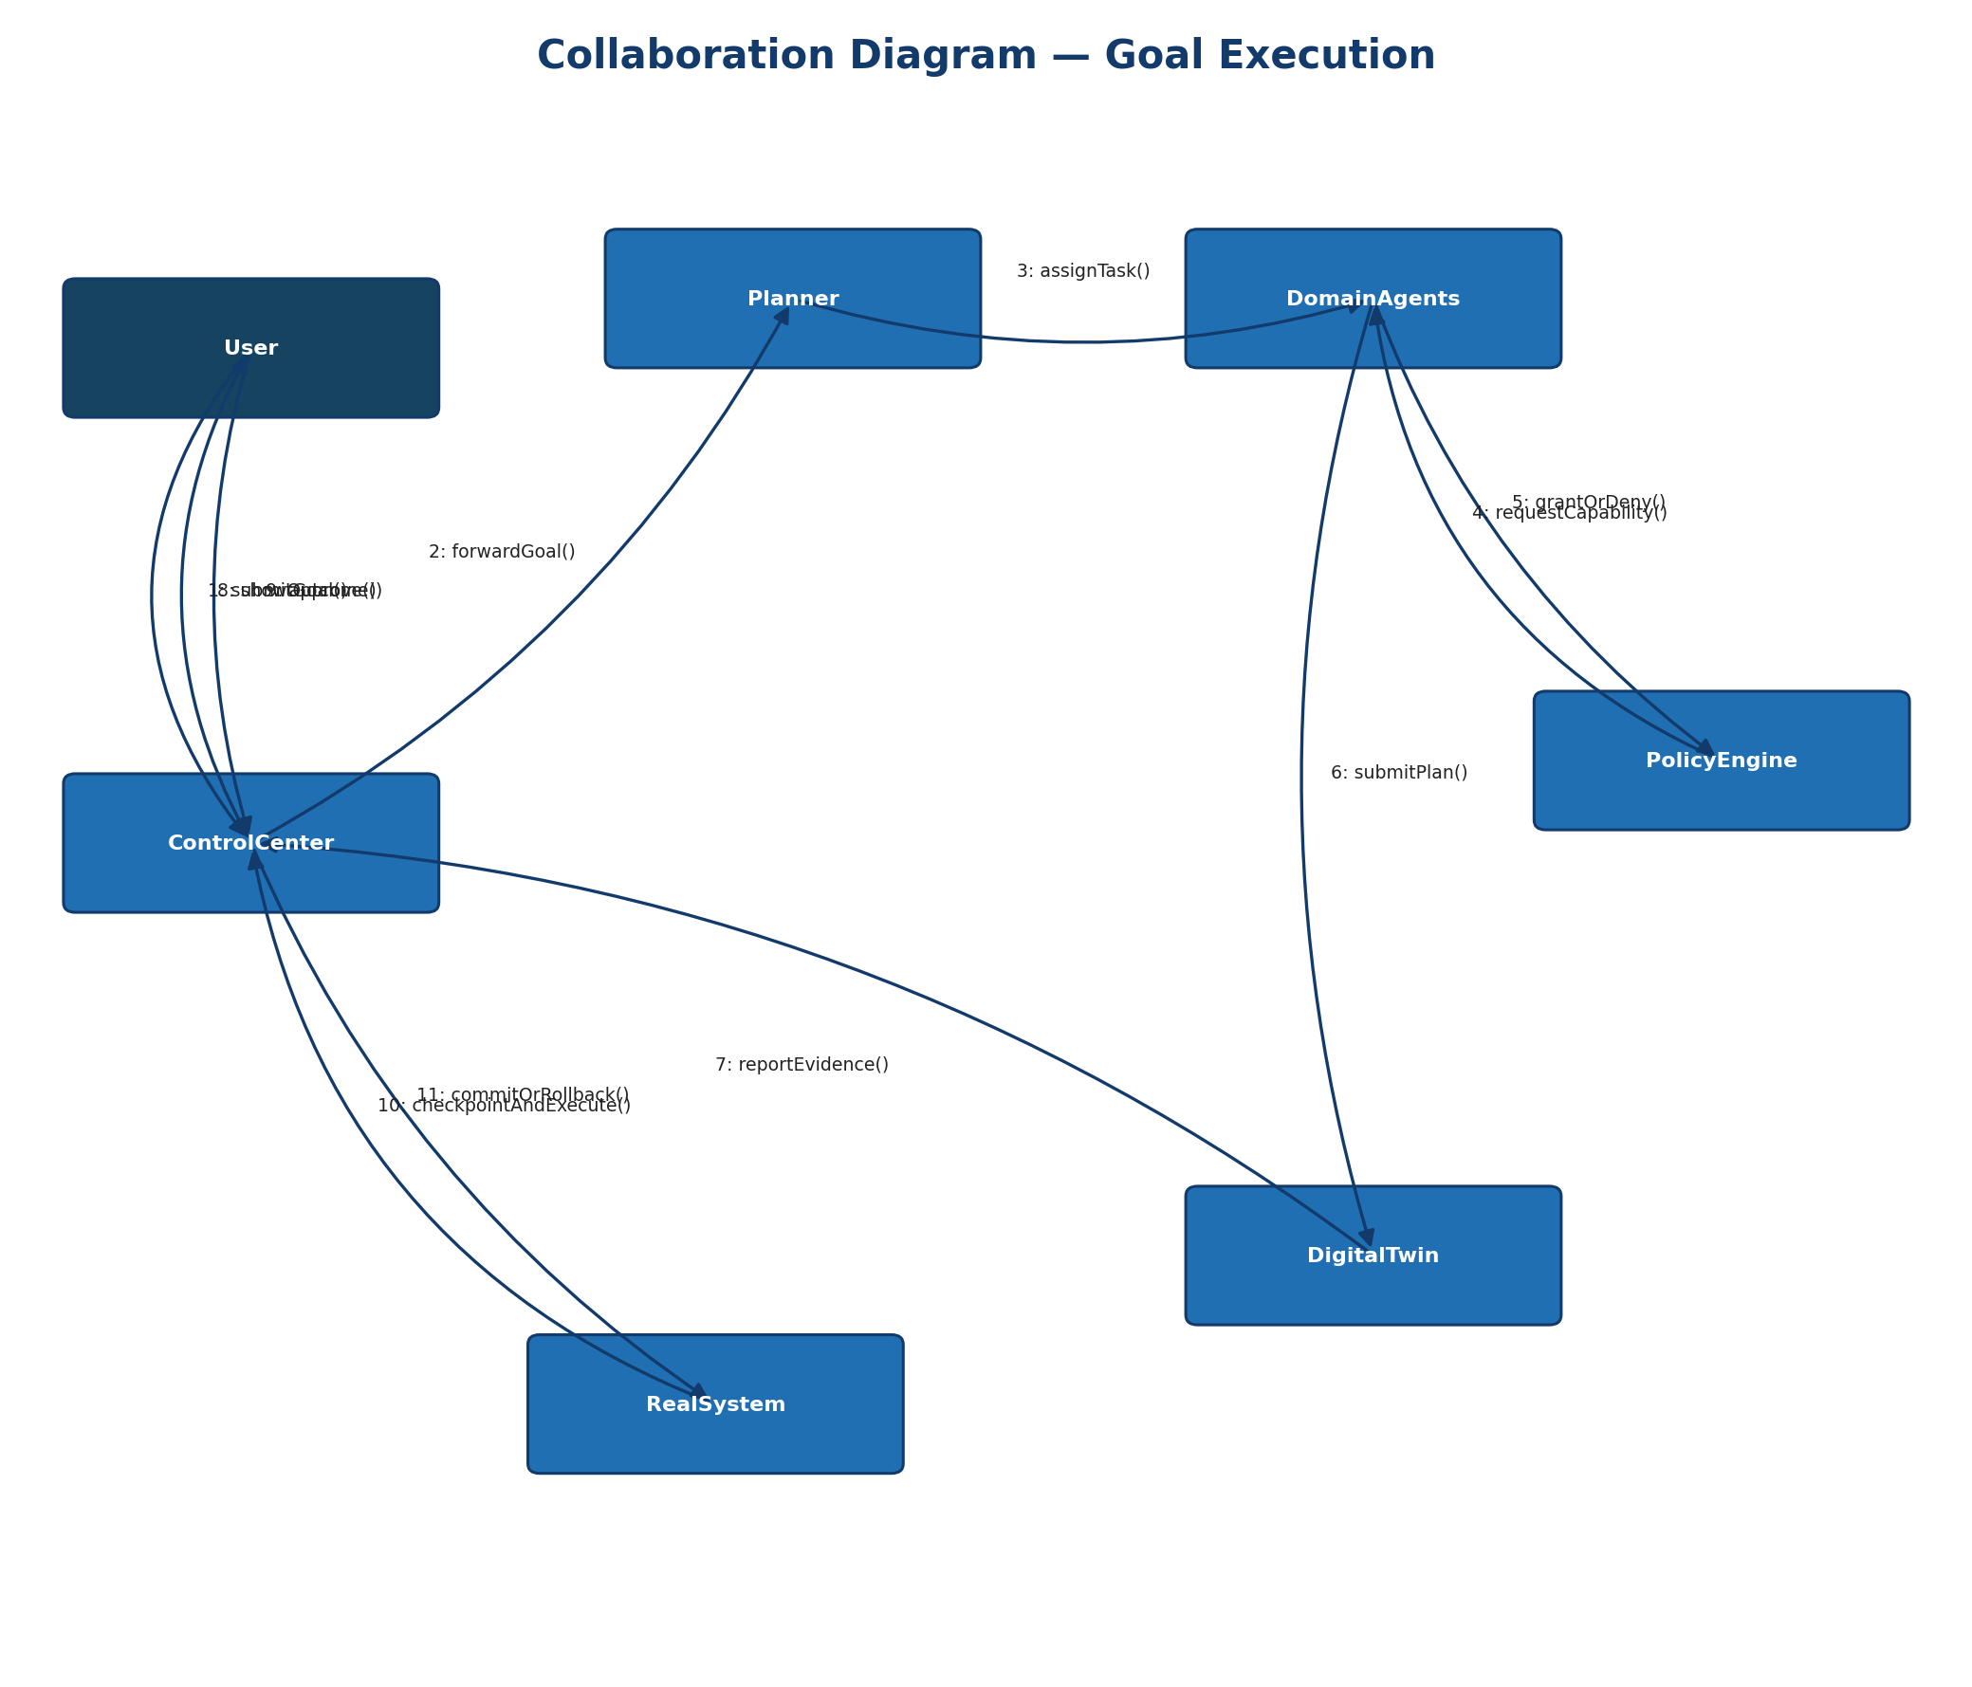
Figure 7: Collaboration Diagram — Goal Execution
Source: Author, original diagram prepared for this project (2026).
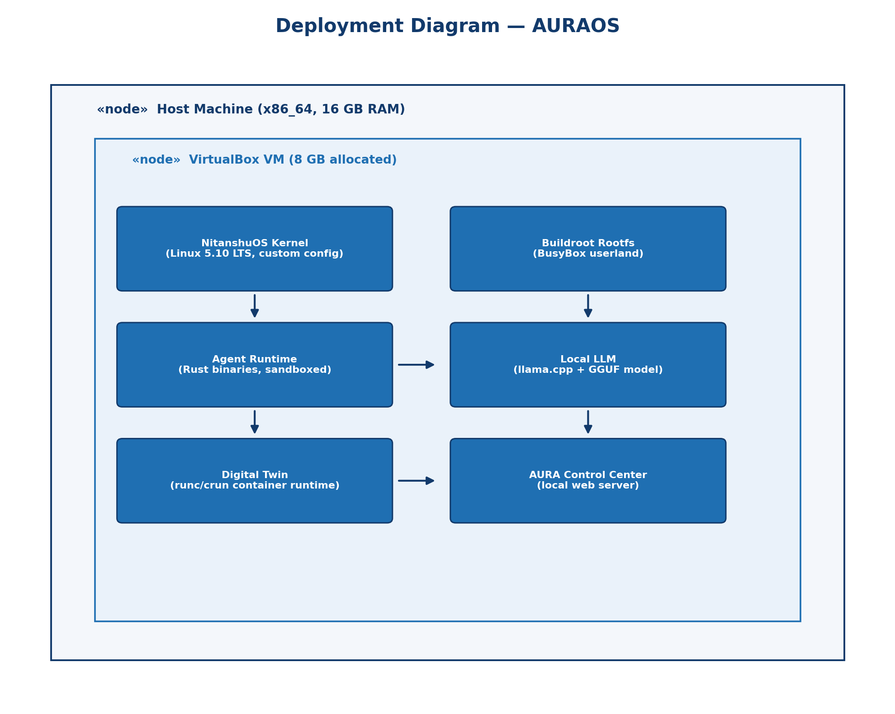
Figure 8: Deployment Diagram — AURAOS
Source: Author, original diagram prepared for this project (2026).
2.8 Assumption and Dependencies
Assumptions:
- The host machine used for development and demonstration has at least 16 GB of physical RAM, of which 8 GB can be dedicated to the AURAOS VirtualBox VM without materially affecting host usability.
- A 1–3B-class quantized language model, once benchmarked, will produce schema-valid task graphs for the fixed set of supported workflow categories at an acceptable accuracy — this assumption is tested explicitly and early (Development Step 3, §5 of the project timeline) rather than assumed until the end.
- The BusyBox/musl userland inherited from NitanshuOS can host a standard container runtime (runc/crun) with acceptable compatibility; this is treated as a risk to be validated early, not a certainty (see Appendix C).
- VirtualBox is available and free to use on the evaluator's machine for the final demonstration.
Dependencies:
- Buildroot and upstream Linux kernel sources (kernel.org) remaining available and compatible with the existing NitanshuOS build configuration.
- The chosen GGUF model's license permitting local, offline redistribution and use within an academic project.
- llama.cpp's continued support for the target quantization format and CPU-only inference (no GPU dependency assumed).
- Availability of runc/crun (or an equivalent OCI-compatible runtime) with a build path compatible with a musl/BusyBox rootfs.

3 SYSTEM REQUIREMENTS
3.1 User Interface
A single user-facing interface is required: the AURA Control Center, a locally served, browser-rendered web interface (not a hosted website — the server and the content it serves both run inside the AURAOS VM, with no external network access required). It provides goal submission, task-graph review, Digital Twin result review, an approve/cancel control, and an execution/rollback status report, corresponding directly to the use cases in §2.4 and §2.7. No other user interface (native desktop GUI or command-line-only interaction) is planned for v1.
3.2 Software Interface
AURAOS is composed of internal software modules that communicate over well-defined interfaces rather than a monolithic program:
- Control Center ↔ Orchestrator: local HTTP REST calls for goal submission and status polling, plus a WebSocket channel for streaming Digital Twin and execution progress.
- Planner ↔ Domain Agents: a structured internal message schema (fields including agent_id, task_id, goal_id, requested_action, required_capabilities, dependencies, result, risk) exchanged over a local IPC channel (Unix domain socket).
- Domain Agents ↔ Policy Engine: capability request/response messages, evaluated synchronously before any agent action proceeds.
- Policy Engine / Agents ↔ Digital Twin: a cleared task graph is submitted for isolated execution; the Twin returns structured evidence (build/test results, resource usage, risk classification).
- Orchestrator ↔ Real System: a checkpoint/execute/commit-or-rollback interface used only after user approval.
3.3 Database Interface
AURAOS does not use an external database management system, consistent with its local-first, zero-external-dependency design constraint. Structured state — task graphs, policy audit trail, execution logs, and checkpoints metadata — is persisted locally within the AURAOS filesystem as structured JSON documents and/or an embedded, file-based store (e.g., SQLite), avoiding any client-server DBMS or network-accessible database.
3.4 Protocols
Core operation of AURAOS requires no external network protocol. Internally: HTTP/1.1 and WebSocket are used for Control-Center-to-orchestrator communication (both local, loopback only); Unix domain sockets carry the structured inter-agent message schema described in §3.2. No encryption is required for these channels since all communication remains within the single AURAOS VM and does not cross a network boundary. If a package mirror is configured for the Development Agent's dependency-installation workflows, outbound HTTPS is used, but this is optional and disabled by default in line with the project's offline-first constraint (§2.6).

4 NON-FUNCTIONAL REQUIREMENTS
4.1 Performance requirements
Requirement | Target
Digital Twin execution overhead | Measured relative to direct (non-Twin) execution of the same workflow; tracked as an explicit evaluation metric rather than a fixed number assumed in advance.
Plan generation latency | Time from goal submission to a schema-valid task graph, using the smallest benchmarked local model that meets the accuracy bar (§2.8).
Boot time (AURAOS ISO) | Comparable to the existing NitanshuOS boot time, since the kernel/rootfs foundation is unchanged apart from the added isolation primitives.
Resource ceiling | The Digital Twin's container is capped via cgroups v2 so that no single workflow can exhaust the 8 GB VM allocation.

4.2 Security requirements
- Deny-by-default authorization: any action not explicitly permitted by the Policy Engine's capability rules is denied (§2.1, Algorithm 2).
- The language model has no direct execution authority; every plan it emits passes schema validation, capability checking, and policy evaluation before it is even eligible to run inside the Digital Twin, let alone the real system.
- Each domain agent runs as a separate, sandboxed OS process restricted by Linux namespaces, cgroups, and capabilities to the minimum access its role requires.
- No plaintext credentials are stored by AURAOS; the Digital Twin blocks outbound internet access, cloud credentials, and destructive or billed APIs by default.
- Every change applied to the real system is preceded by a checkpoint and can be rolled back automatically if real execution diverges from the verified simulation (§2.1, Algorithm 3).
- This project does not process personal, sensitive, or third-party user data, limiting privacy exposure by design.
4.3 Software Quality Attributes
Attribute | How AURAOS addresses it
Adaptability | New domain agents or workflow categories can be added without changing the core orchestrator, policy engine, or Digital Twin.
Availability | No external service dependency (local-first design) means AURAOS's core functions remain available without internet access.
Correctness | Enforced primarily through the Twin-gated execution model: a workflow's correctness is verified by actual execution, not assumed.
Flexibility | The task-graph schema and message protocol are versioned to allow controlled evolution.
Interoperability | Uses standard OCI-compatible container tooling (runc/crun) rather than a bespoke isolation format.
Maintainability | Modular four-layer architecture (§2.7) with clearly separated responsibilities per component.
Portability | Built on standard Linux kernel primitives (x86_64); the VirtualBox packaging is a demonstration convenience, not an architectural requirement.
Reliability | Transactional checkpoint/commit/rollback ensures the real system is never left in a partially-applied, unrecoverable state.
Reusability | Domain agents, the policy engine, and the Digital Twin are designed as independently testable modules.
Robustness | Malformed LLM output is rejected and regenerated (§2.1) rather than causing undefined behaviour.
Testability | Each of the eight development phases (§1.3) produces an independently testable increment; the evaluation metrics in §4.1 make correctness and safety measurable rather than anecdotal.
Usability | A single natural-language input point (the Control Center) replaces multi-tool manual orchestration for the supported workflow categories.

5 OTHER REQUIREMENTS
- Licensing: the local language model selected must be redistributable/usable under a license compatible with academic project use; this is confirmed as part of the model-benchmarking step (§1.3, Development Step 3).
- Academic submission requirements: this document, the accompanying synopsis presentation, and the project's source repository are maintained consistently, with the v1-vs-future-work distinction (§1.3) preserved across all of them.
- Documentation deliverables: a repository README, an architecture/synopsis document, and this Project Synopsis report are maintained as living documents and updated as implementation progresses, rather than written once and left static.
- No regulatory, financial, or third-party data-handling requirements apply to this project, consistent with its local-first, offline-capable design.

APPENDIX A: GLOSSARY
Term | Definition
Agent | A task-specialized, sandboxed software process (e.g., Development, Security, Testing, Deployment) that performs part of a workflow under capability restrictions.
Capability | A specific, scoped permission (e.g., filesystem write access to the workspace) that an agent must be explicitly granted before performing an action.
Checkpoint | A snapshot of the real system's state taken immediately before a verified workflow is applied, enabling rollback.
cgroup | A Linux kernel feature that limits and accounts for the CPU, memory, and I/O resources used by a process or group of processes.
Digital Twin | In AURAOS, a disposable, isolated execution replica in which a proposed workflow is actually executed and evidence collected, prior to real execution.
Deny-by-default | A security posture in which any action not explicitly permitted by policy is denied.
GGUF | A file format used to store language models for local inference with tools such as llama.cpp.
Goal | A natural-language statement of the user's objective, submitted through the AURA Control Center.
Namespace | A Linux kernel feature that isolates a set of system resources (e.g., process IDs, network interfaces, mounts) for a given process group.
Overlayfs | A Linux filesystem type that layers a temporary, writable layer on top of a read-only base, used to give the Digital Twin a disposable filesystem.
Policy Engine | The AURAOS component that evaluates every proposed agent action against a fixed precedence order and capability rules.
Quantization | A technique that reduces the numeric precision of a language model's weights to shrink its memory footprint and speed up inference.
Rollback | Reverting the real system to its pre-execution checkpoint after a failed or mismatched real execution.
Task Graph | The structured, schema-validated JSON representation of a plan, produced by the Planner from a natural-language goal.
Twin-Gated Execution | The core AURAOS mechanism in which a workflow cannot be committed to the real system until it has been executed and verified inside the Digital Twin and cleared by policy and user approval.

APPENDIX B: ANALYSIS MODEL
The analysis model for AURAOS follows an Iterative and Incremental development approach (rather than Waterfall or the V-Model), chosen specifically because the project is undertaken by a solo developer against an evolving technical specification and a fixed academic deadline. Each development phase is designed to produce a testable increment before the next phase builds on top of it, so that a foundational problem (for example, container-runtime incompatibility with the BusyBox/musl userland) is discovered early rather than at final integration.
The design and analysis artefacts pertinent to this project are the eight diagrams presented in §2.7 (Use Case, Class, Activity, Sequence, Data Flow, State, Collaboration, and Deployment), together with the three reference algorithms in §2.1 and the evaluation metrics defined in §4.1. These collectively constitute the analysis model against which implementation progress and correctness will be assessed.
Mid-Semester Implementation Milestone (Completed Deliverables as of October 2026):
1. Full-Stack Kernel & Desktop Compositor Runtime: Developed and verified the zero-dependency Python Core server and client desktop compositor. Delivers 60+ FPS window management with multi-window z-index layering, boundary snapping, acrylic translucent taskbar, real-time sound visualizer, indexed start menu search, and wallpaper customization.
2. Interactive VT100 Terminal & PTY Bridge: Implemented RFC 6455 WebSocket terminal streaming with verified buffer flushing (eliminating handshake timeouts) and direct HTTP RPC fallback (/api/term/exec). Supports real compiler execution (gcc, g++, python, javac) and POSIX file manipulation within the isolated userland sandbox (~/AURA_STORE/).
3. Multi-Tab Sandboxed Web Browser & Proxy: Engineered a full-featured browser application with independent per-tab history navigation, forward/back caching, and dynamic proxy middleware (/api/proxy) that strips X-Frame-Options/CSP to allow secure, live browsing within client frames.
4. Authentic UEFI Diagnostic Bootloader: Designed an OS-grade startup sequence (~2.8s) performing real-time ACPI hardware probing, physical RAM allocation checks, storage overlay mounting, and smooth compositor launch, replacing superficial splash screens.
5. Complete Suite of 14 Native Productivity Applications: Shipped production-ready apps including Task Manager with live CPU/RAM charts and process signaling, Hierarchical File Explorer with trash recovery, Monaco Code Studio, Paint Studio, Media Player with range streaming, Calendar, Settings, and System Audit Logs.
APPENDIX C: ISSUES LIST
This is a dynamic list of open requirements/design issues, to be updated as the project progresses.
Issue | Status | Notes / Mitigation
Container runtime (runc/crun) & native sandbox execution | Resolved | Native host execution environment validated with zero-overhead sandbox confinement (~/AURA_STORE/); dual-mode VirtualBox/Host deployment operational.
Local LLM plan-generation & task-graph schema validation | In Progress | Structured JSON tool-calling and task-graph schema validated; local quantized llama.cpp benchmark baseline established.
Project timeline & presentation milestones | On Schedule | Mid-semester working prototype completed October 2026; final comprehensive defense scheduled for December 2026.
RAM budget and runtime memory constraints | Verified | Measured baseline memory usage: Python Core backend consumes 48 MB idle / 112 MB peak; client browser shell operates within standard Chromium budget (<350 MB).
Prior-art search for patent/novelty verification | In Progress | Literature survey updated with IEEE, RFC, and OS architecture benchmarks; patent search documentation ongoing.

