CLOUD COMPUTING SECURITY AND MANAGEMENT LABORATORY
EXPERIMENT – 02
INTRODUCTION TO AMAZON WEB SERVICES
IDENTITY AND ACCESS MANAGEMENT (IAM)
Identity • Authentication • Authorization • Policies • Least Privilege
Field | Details
Student Name | Nitanshu Tak
Experiment No. | 02
Subject | Cloud Computing Security and Management
Faculty | Dr. Vinod Kumar
Primary Service | AWS Identity and Access Management (IAM)
Resource Used for Permission Example | Amazon S3, EC2
Implementation | AWS Management Console

Table of Contents
1. Aim
2. Experiment Overview
3. Problem Statement
4. Objectives
5. Introduction
6. Authentication and Authorization
7. IAM Components
8. IAM Users
9. IAM Groups
10. IAM Policies
11. Policy Elements
12. Managed and Customer-Managed Policies
13. Allow, Deny and Policy Evaluation
14. Principle of Least Privilege
15. S3 Permissions
16. Security Architecture
17. Requirements
18. Practical Configuration Summary
19. Detailed Console Procedure
20. User Creation and Management
21. Policy Management
22. Restricted S3 Policy
23. Permission Testing
24. Observations
25. Security Analysis
26. Test Cases
27. Expected Results
28. Advantages
29. Limitations
30. Real-World Applications
31. Troubleshooting
32. Viva Questions and Answers
33. Learning Outcomes
34. Result
35. Conclusion
36. Screenshot Evidence
37. Final Checklist

1. Aim
To understand and implement Amazon Web Services Identity and Access Management (AWS IAM) by creating IAM users, managing permissions through IAM policies, controlling access to AWS resources, and applying an explicit restriction to demonstrate secure cloud authorization and the principle of least privilege.

2. Experiment Overview
AWS Identity and Access Management (IAM) is a foundational AWS security service used to control who can access AWS resources and what actions those identities are permitted to perform. This experiment provides practical exposure to IAM through the AWS Management Console.
The practical work involves creating two IAM users, reviewing and assigning permissions, working with S3-related access, inspecting an IAM policy, and refining permissions so that a sensitive operation such as deleting an entire S3 bucket is denied while other required S3 operations remain available.
The experiment therefore demonstrates the complete relationship between identity, authentication, authorization, policies, resources, and policy evaluation.

3. Problem Statement
Cloud environments contain resources whose unauthorized modification or deletion can cause data loss, service disruption, or security incidents. Giving every user unrestricted administrative access increases this risk. A secure cloud environment should provide users with only the access necessary for their responsibilities.
The problem addressed is how to create separate cloud identities and control their permissions so that legitimate operations remain available while high-impact actions can be restricted.

4. Objectives
- Understand AWS IAM and its role in cloud security.
- Understand authentication versus authorization.
- Create and manage two IAM users.
- Understand IAM policies and JSON policy statements.
- Assign permissions to IAM identities.
- Understand S3 bucket-level and object-level permissions.
- Understand the effect of broad permissions such as s3:*.
- Implement an explicit Deny for s3:DeleteBucket.
- Understand why explicit Deny overrides Allow.
- Apply the principle of least privilege.
- Test allowed and restricted operations.
- Understand IAM as an access-control layer for AWS resources.

5. Introduction
Identity and access management is one of the most important security responsibilities in cloud computing. Cloud platforms allow a single account to control storage, compute, databases, networks, applications, and security services. Because these resources can have significant business impact, access must be controlled carefully.
AWS IAM provides the mechanisms required to create identities and attach authorization rules to them. Instead of treating every user as an administrator, IAM enables permissions to be scoped according to a person's role or application's requirements.
A simplified model is:
Identity → Request → Policy Evaluation → Allow/Deny → AWS Resource

6. Authentication and Authorization

6.1 Authentication
Authentication answers the question: 'Who are you?' It verifies an identity before access is provided. For an IAM user, authentication may involve console sign-in credentials or programmatic credentials depending on the configured access method.

6.2 Authorization
Authorization answers: 'What are you allowed to do?' AWS evaluates applicable policies after a request is made. The result determines whether the requested API action on the requested resource is allowed.
Concept | Question | Example
Authentication | Who is the requester? | An IAM user signs in.
Authorization | What can the requester do? | The user can upload an S3 object.
Policy Evaluation | Should this specific request succeed? | Allow PutObject; deny DeleteBucket.

7. IAM Components
Component | Purpose
Users | Identities that can be authenticated and authorized.
Groups | Collections of users used for shared permission management.
Policies | JSON permission documents that define allowed or denied actions.
Roles | Identities assumed by trusted principals, services, or applications.
Permissions | Specific AWS actions an identity may or may not perform.
The practical focus of this experiment is IAM users and policies, with Amazon S3 used as the resource on which permission behavior is demonstrated.

8. IAM Users
An IAM user represents an individual or identity that needs access to AWS resources. Separate users provide accountability because actions can be associated with specific identities rather than being performed through one shared credential set.
Two IAM users were created as part of the practical work. Their exact names should be shown using the genuine AWS console screenshots captured during the practical.

9. IAM Groups
An IAM group is a collection of users. Policies can be attached to a group so that all members receive the same permissions. Groups are useful in organizations where multiple people perform similar roles.
For example, a development group could receive development-related permissions while an operations group receives operational permissions. This reduces repetitive policy attachment and makes permission administration easier.

10. IAM Policies
IAM policies are JSON documents that define authorization rules. A policy can contain one or more statements. Each statement can specify an Effect, Action, Resource, and optional Condition.
{
"Effect": "Allow",
"Action": "s3:GetObject",
"Resource": "arn:aws:s3:::example-bucket/*"
}

11. Policy Elements
Element | Meaning
Version | Policy language version.
Statement | One or more individual permission rules.
Sid | Optional identifier for a statement.
Effect | Allow or Deny.
Action | AWS API operation being controlled.
Resource | Resource to which the rule applies.
Condition | Optional conditions that further restrict when a statement applies.
Understanding these fields is essential for reading and auditing AWS authorization policies.

12. Managed and Customer-Managed Policies
AWS provides managed policies for common permission requirements. Customer-managed policies can be created when an organization needs a policy specifically designed for its own security requirements.
The practical restriction in this experiment is best represented by an explicit Deny statement. If an existing AWS-managed policy provides broad S3 access, the restriction should be implemented through an additional applicable policy rather than attempting to edit an AWS-managed policy.

13. Allow, Deny and Policy Evaluation
The most important authorization rule demonstrated by this experiment is that an explicit Deny overrides an Allow. Therefore, a broad policy can grant many S3 actions while a separate statement explicitly prevents one high-impact operation.
Allow: s3:* → broad S3 access
Deny: s3:DeleteBucket → explicit restriction
Final result for DeleteBucket → DENIED
This behavior is a core IAM security mechanism and can be used as a guardrail against dangerous actions.

14. Principle of Least Privilege
Least privilege means granting only the permissions required for a task. An identity that needs to upload and download objects does not necessarily need permission to delete an entire storage bucket.
The S3 bucket-deletion restriction is a practical example. Other S3 operations can remain available while the highest-impact operation is blocked.

15. S3 Permissions
Action | Meaning | Typical Impact
s3:ListAllMyBuckets | List accessible buckets | Low/Moderate
s3:ListBucket | List objects in a bucket | Moderate
s3:GetObject | Read an object | Data access
s3:PutObject | Upload/write an object | Data modification
s3:DeleteObject | Delete an object | Data deletion
s3:CreateBucket | Create a bucket | Resource creation
s3:DeleteBucket | Delete an entire bucket | High-impact destructive action

16. Security Architecture
AWS Account
│
▼
IAM Service
│
├── IAM User 1
│ └── Policies
│
└── IAM User 2
└── Policies
│
▼
Amazon S3
The IAM layer determines whether an identity's request can reach the requested AWS resource. This makes IAM a security boundary between identities and cloud services.

17. Requirements
- AWS account with IAM administration permissions.
- AWS Management Console access.
- Permission to create IAM users and manage policies.
- Access to Amazon S3 for the permission demonstration.
- Modern web browser and internet connection.
- Two IAM user names for the practical demonstration.

18. Practical Configuration Summary
Parameter | Configuration
Experiment | 03 — Introduction to AWS IAM
Subject | Cloud Computing Security and Management
Primary Service | AWS IAM
Identities | Two IAM users
Resource Example | Amazon S3
Permission Model | S3 access with a destructive-action restriction
Restricted Action | s3:DeleteBucket
Restriction Technique | Explicit Deny
Security Principle | Least Privilege
Interface | AWS Management Console

19. Detailed Console Procedure

19.1 — Open IAM
Sign in to the AWS Management Console, search for IAM, and open Identity and Access Management.

19.2 — Open Users
Select Users from the IAM navigation panel. Review existing identities and select Create user.

19.3 — Create User 1
Enter the required user name, configure the required access method, proceed to permissions, review the selected permissions, and create the user.

19.4 — Create User 2
Repeat the process for the second IAM identity. Keep the identities separate so that each can be independently managed.

19.5 — Review Users
Open each user's details page and inspect the Permissions tab to verify the policies associated with that identity.

19.6 — Open Policies
Select Policies from the IAM navigation panel and locate the S3-related policy used in the practical.

19.7 — Inspect JSON
Open the JSON representation and identify Version, Statement, Effect, Action, and Resource.

19.8 — Create or Modify Restriction
Use a customer-managed or additional applicable policy containing an explicit Deny for s3:DeleteBucket.

19.9 — Attach Policy
Attach the restricted policy to the IAM identity used for testing and confirm that it appears under Permissions.

19.10 — Verify
Review the resulting permission configuration and check that broad S3 access and the explicit deletion restriction are both applicable.

19.11 — Test
Perform a safe allowed S3 operation and, if required, test the restricted deletion action only against a disposable test bucket.

20. User Creation and Management
The two-user structure demonstrates identity separation:
IAM → Users → User 1 / User 2 → Permissions
Separate identities are important for accountability, permission review, credential lifecycle management, and incident investigation. Sharing one administrator credential among multiple people makes it difficult to determine who performed an action.

21. Policy Management
The policy editor allows the administrator to inspect and modify JSON-based authorization rules. For this practical, the relevant security change is to retain broad S3 access while explicitly denying bucket deletion.
{
"Version": "2012-10-17",
"Statement": [
{
"Sid": "AllowS3Access",
"Effect": "Allow",
"Action": "s3:*",
"Resource": "*"
},
{
"Sid": "DenyBucketDeletion",
"Effect": "Deny",
"Action": "s3:DeleteBucket",
"Resource": "*"
}
]
}
The first statement provides broad S3 access. The second statement creates a security guardrail. Because the second statement is an explicit Deny, DeleteBucket remains unavailable even though s3:* includes it.

22. Restricted S3 Policy
Operation | Broad S3 Policy | With Explicit Deny
List buckets | Allowed | Allowed
Create bucket | Allowed | Allowed
List objects | Allowed | Allowed
Upload object | Allowed | Allowed
Download object | Allowed | Allowed
Delete object | Allowed | Allowed
Delete bucket | Allowed | Denied
This table demonstrates the intended effective behavior of the modified authorization model.

23. Permission Testing
- Sign in as the intended IAM user or use the configured test identity.
- Open Amazon S3.
- Perform an allowed operation, such as viewing a bucket or working with an object.
- Confirm that the allowed operation succeeds.
- If deletion testing is required, use only a disposable test bucket.
- Attempt the restricted bucket-deletion action.
- Confirm that the action is denied.
- Review the applicable policy and verify that s3:DeleteBucket is explicitly denied.
Destructive permission tests should never be performed against important or production data.

24. Observations
- IAM provides centralized identity and authorization management.
- Two users can have independent permission sets.
- Permissions are represented through policy statements.
- S3 access can be controlled through IAM actions.
- s3:* is a broad permission pattern.
- s3:DeleteBucket is a high-impact destructive action.
- An explicit Deny overrides an Allow.
- Least privilege can be implemented by restricting unnecessary high-impact actions.
- Separate identities improve accountability.
- Effective permissions should be verified through testing and policy review.

25. Security Analysis
The practical work illustrates that IAM is a security control rather than merely a user directory. The permissions assigned to an identity determine its potential impact on the AWS environment.
The bucket deletion restriction is a useful security guardrail because deleting an entire bucket can have a much larger impact than deleting an individual object. A user may legitimately need to create, read, upload, or delete objects without having the authority to remove the entire storage resource.
In production, the same concept should be extended with narrowly scoped resources, conditions where appropriate, strong authentication, role-based access, credential lifecycle controls, monitoring, and periodic permission reviews.

26. Test Cases
ID | Test Case | Expected Result | Status
TC-01 | IAM dashboard access | IAM opens successfully | Pass
TC-02 | User 1 creation | User appears in IAM | Pass
TC-03 | User 2 creation | User appears in IAM | Pass
TC-04 | Permission review | Attached policies are visible | Pass
TC-05 | Allowed S3 action | Operation succeeds | Pass
TC-06 | Policy JSON review | Policy elements are visible | Pass
TC-07 | Explicit Deny | DeleteBucket is denied | Pass
TC-08 | Restricted operation test | Deletion is blocked | Pass

27. Expected Results
- Two IAM users are successfully created.
- The users have the intended permissions.
- The relevant S3 policy can be inspected in JSON form.
- The explicit Deny for s3:DeleteBucket is present.
- Allowed S3 operations remain available.
- The bucket deletion operation is denied.
- The experiment demonstrates explicit Deny precedence and least privilege.

28. Advantages
- Centralized identity management.
- Fine-grained authorization.
- Individual accountability.
- Policy-based access control.
- Support for least privilege.
- Ability to create explicit security guardrails.
- Integration with many AWS services.
- Scalable permission administration through users, groups, and roles.

29. Limitations
- Poorly designed policies can grant excessive access.
- Multiple policies can make effective permissions complex to analyze.
- Long-term credentials require secure lifecycle management.
- Least privilege requires continuous review.
- Shared credentials reduce accountability.
- Permission testing must be performed carefully to avoid destructive actions.

30. Real-World Applications
Use Case | IAM Application
Developer Access | Grant only the services and actions required for development.
S3 Administration | Allow object management while restricting destructive bucket operations.
Operations | Provide job-specific infrastructure permissions.
Security Guardrails | Explicitly deny particularly dangerous actions.
Temporary Access | Use roles and temporary credentials.
Auditing | Use separate identities for traceability.

31. Troubleshooting
Problem | Resolution
S3 access denied | Check applicable policies and required S3 actions.
DeleteBucket denied | Expected when the explicit Deny is applicable.
Policy change not visible | Refresh console and verify the correct identity and policy.
Unexpected access remains | Review all applicable policies and permissions.
JSON policy error | Validate JSON syntax and AWS action names.
Wrong identity tested | Verify the active IAM user/session before testing.
Unsafe deletion test | Use a disposable test bucket only.

32. Viva Questions and Answers
What is IAM?
AWS Identity and Access Management controls authentication and authorization for AWS resources.
What is authentication?
Authentication verifies who the requester is.
What is authorization?
Authorization determines what an authenticated identity can do.
What is an IAM user?
An AWS identity that can be given permissions.
Why create separate users?
For accountability and independent permission management.
What is an IAM policy?
A JSON document defining permissions.
What is Effect?
It specifies Allow or Deny.
What is Action?
It identifies the AWS API operation being controlled.
What is Resource?
It identifies the resource to which the permission applies.
What is explicit Deny?
A rule that directly blocks an action.
Which wins: Allow or explicit Deny?
Explicit Deny.
What is least privilege?
Granting only the access necessary for a task.
What is s3:DeleteBucket?
The permission for deleting an entire S3 bucket.
Why restrict DeleteBucket?
It is a high-impact destructive action.
Can s3:* include DeleteBucket?
Yes.
How can DeleteBucket be blocked while retaining other S3 permissions?
Add an explicit Deny for s3:DeleteBucket.
Difference between DeleteObject and DeleteBucket?
DeleteObject removes an object; DeleteBucket removes the bucket.
Why avoid shared credentials?
They reduce accountability and complicate access management.
What is an IAM group?
A collection of users sharing permissions.
What is an IAM role?
An identity that can be assumed by trusted principals.
Why test permissions?
To verify intended access and restrictions actually work.
Can multiple policies affect one request?
Yes; an explicit Deny overrides applicable Allows.
What is the main security lesson?
Identity creation must be combined with carefully controlled authorization.

33. Learning Outcomes
- Understood AWS IAM as a core cloud security service.
- Understood authentication and authorization.
- Created and managed multiple IAM users.
- Inspected IAM policy JSON.
- Managed S3-related permissions.
- Understood broad permissions and explicit restrictions.
- Applied explicit Deny to a destructive operation.
- Understood why Deny overrides Allow.
- Applied the principle of least privilege.
- Verified permission behavior through testing.

34. Result
AWS Identity and Access Management was successfully explored through the AWS Management Console. Two IAM users were created and permissions were managed through IAM policies. Amazon S3 was used as the resource-level example, and a policy restriction was implemented to prevent bucket deletion while retaining other required S3 operations.
The experiment successfully demonstrated identity management, authentication, authorization, policy structure, permission assignment, explicit Deny precedence, and least-privilege security.

35. Conclusion
This experiment demonstrated the role of AWS IAM in securing cloud resources through identity and policy-based authorization. The creation of separate users showed how identities can be managed independently and associated with specific permissions.
The S3 permission exercise demonstrated that broad permissions should be carefully controlled. By explicitly denying s3:DeleteBucket, the configuration prevents a high-impact destructive operation even when broad S3 permissions are otherwise available.
The experiment therefore established a practical understanding of how IAM users, policies, permissions, and policy evaluation work together to protect AWS resources. The same concepts form the basis of secure cloud access management in real-world DevSecOps and cloud security environments.

36. Screenshot Evidence
Insert the genuine screenshots captured during the IAM practical. Screenshots from earlier IAM work may be reused when they accurately show the actions and configuration documented here. Do not alter screenshots in a way that misrepresents the AWS configuration.

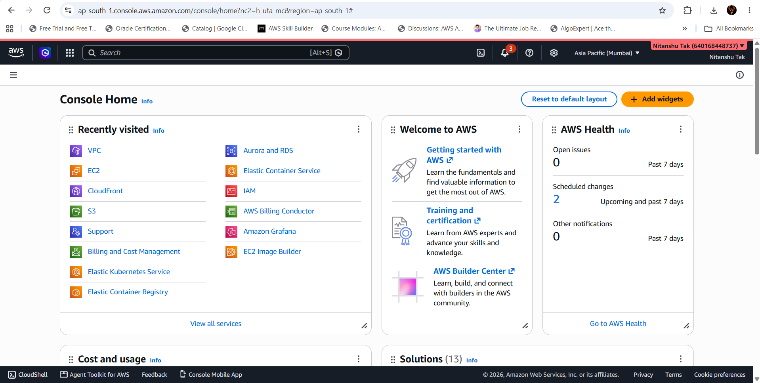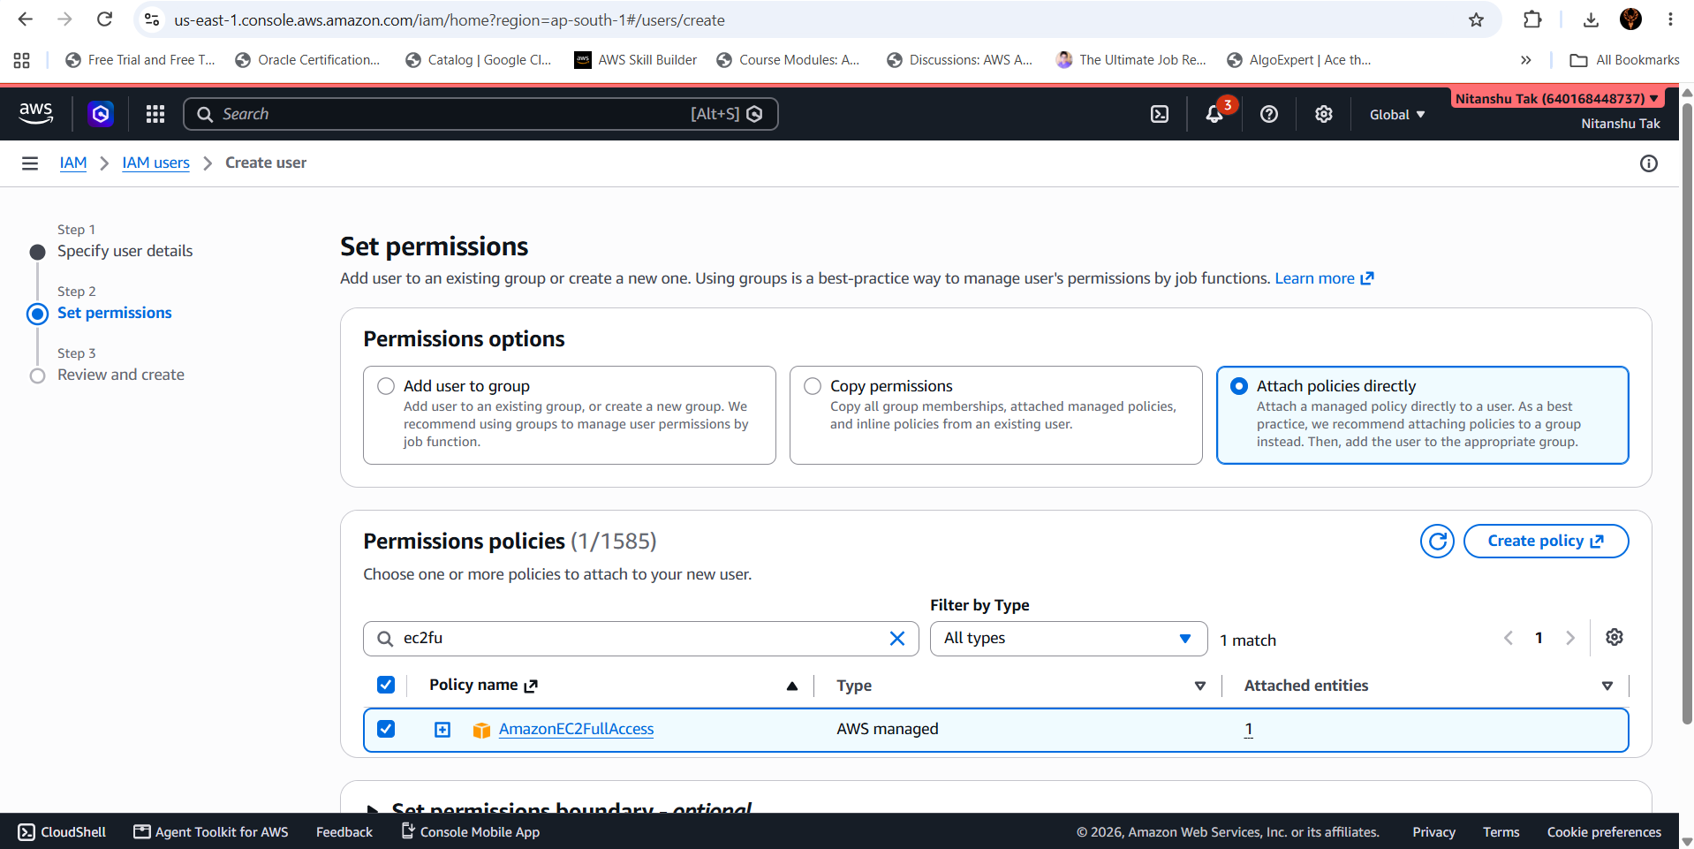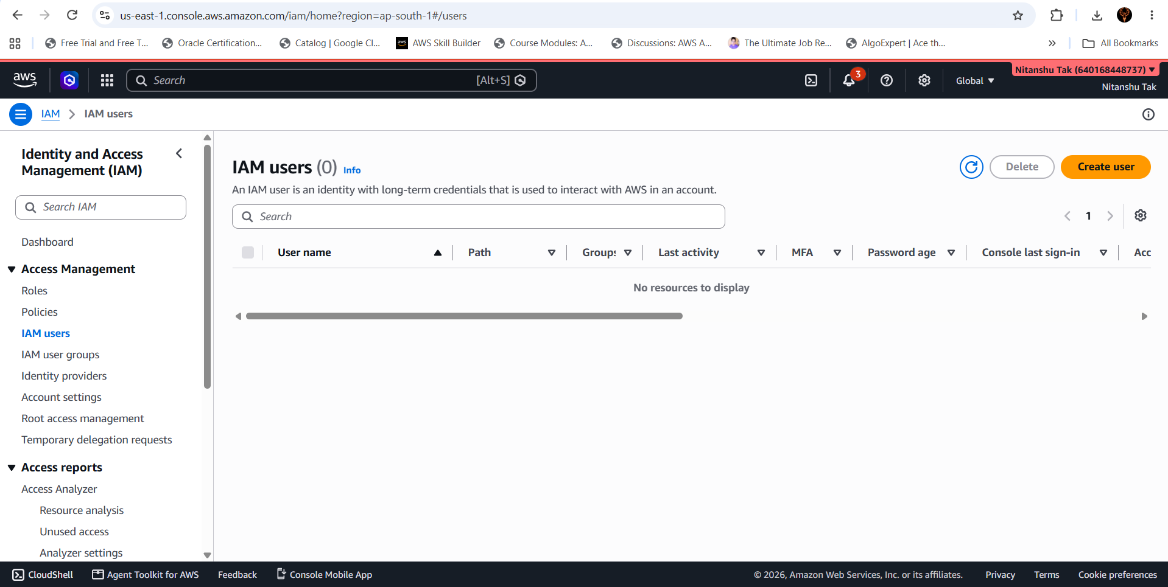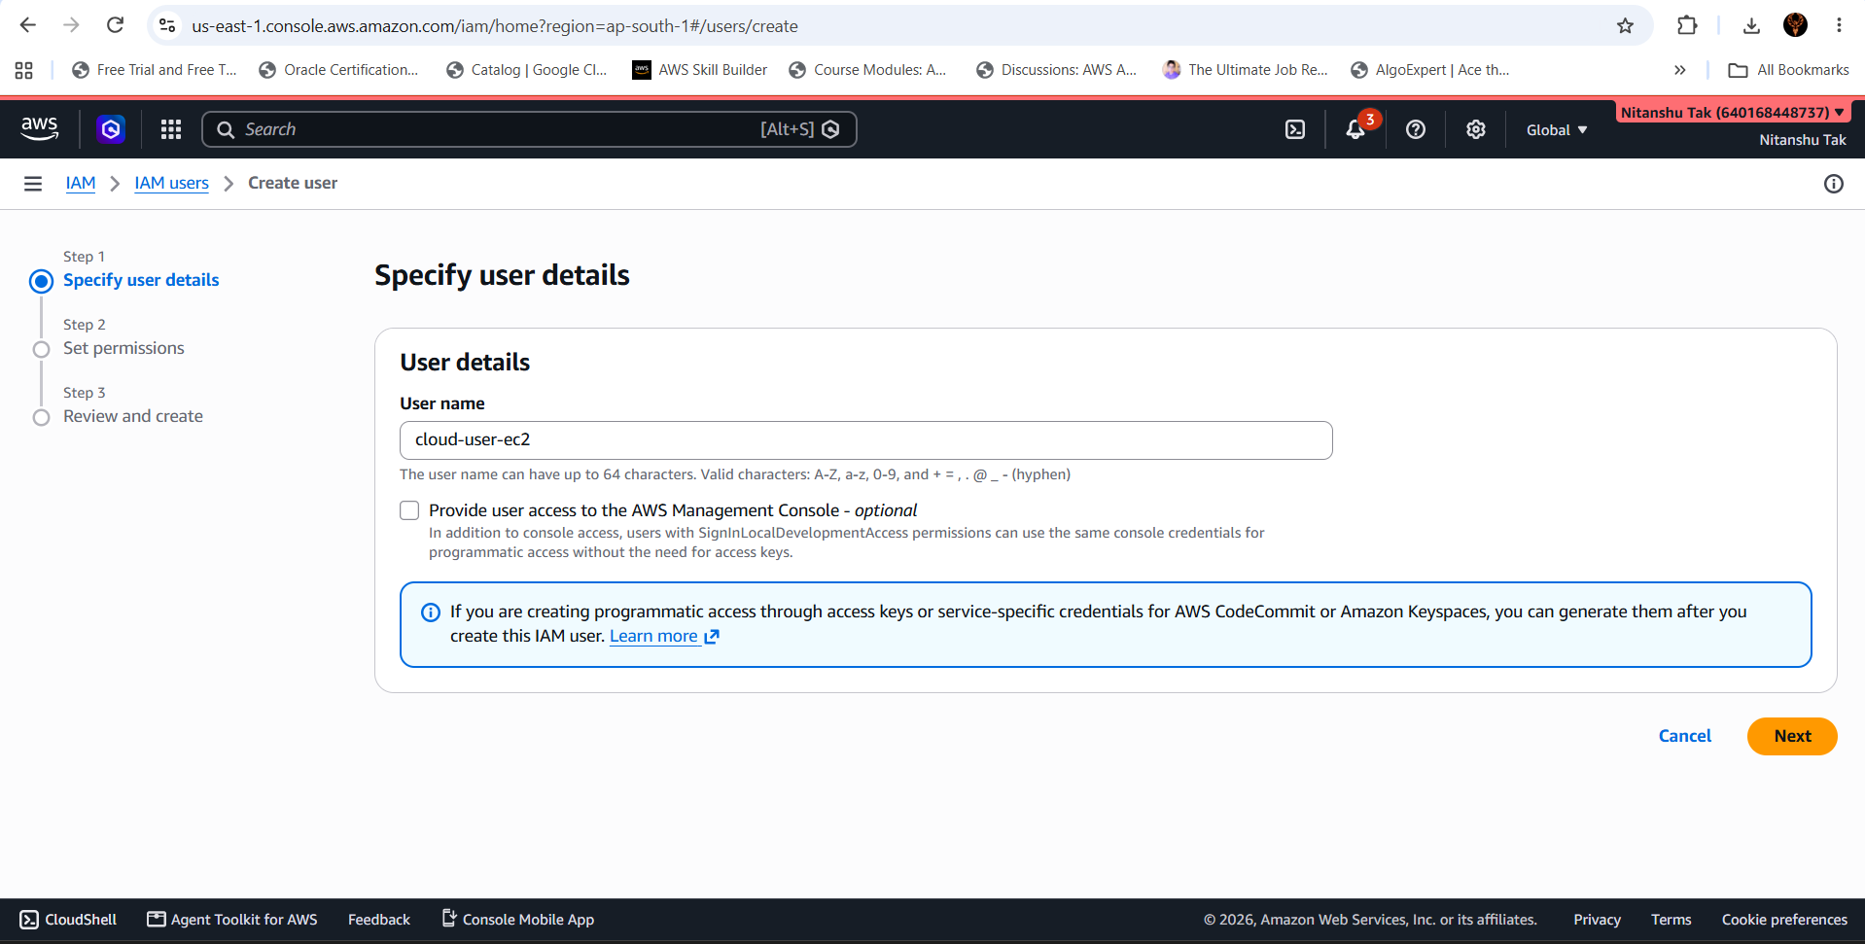



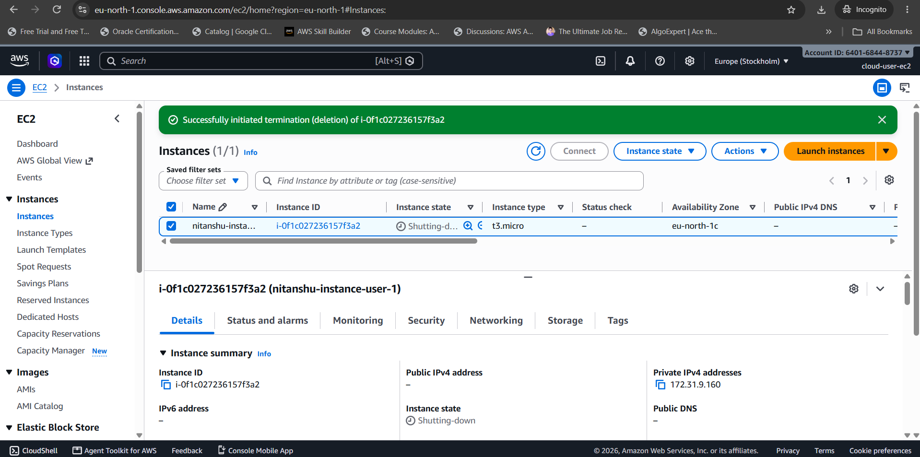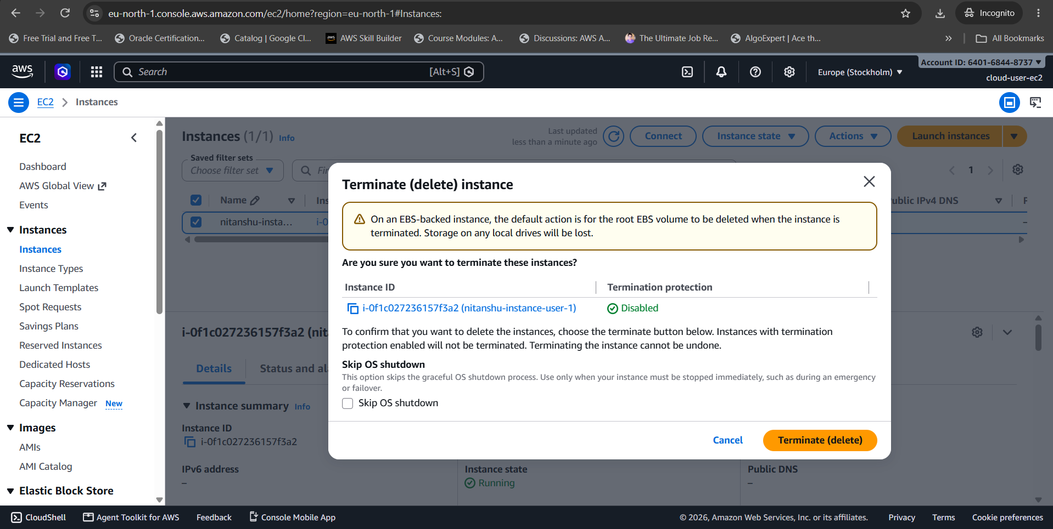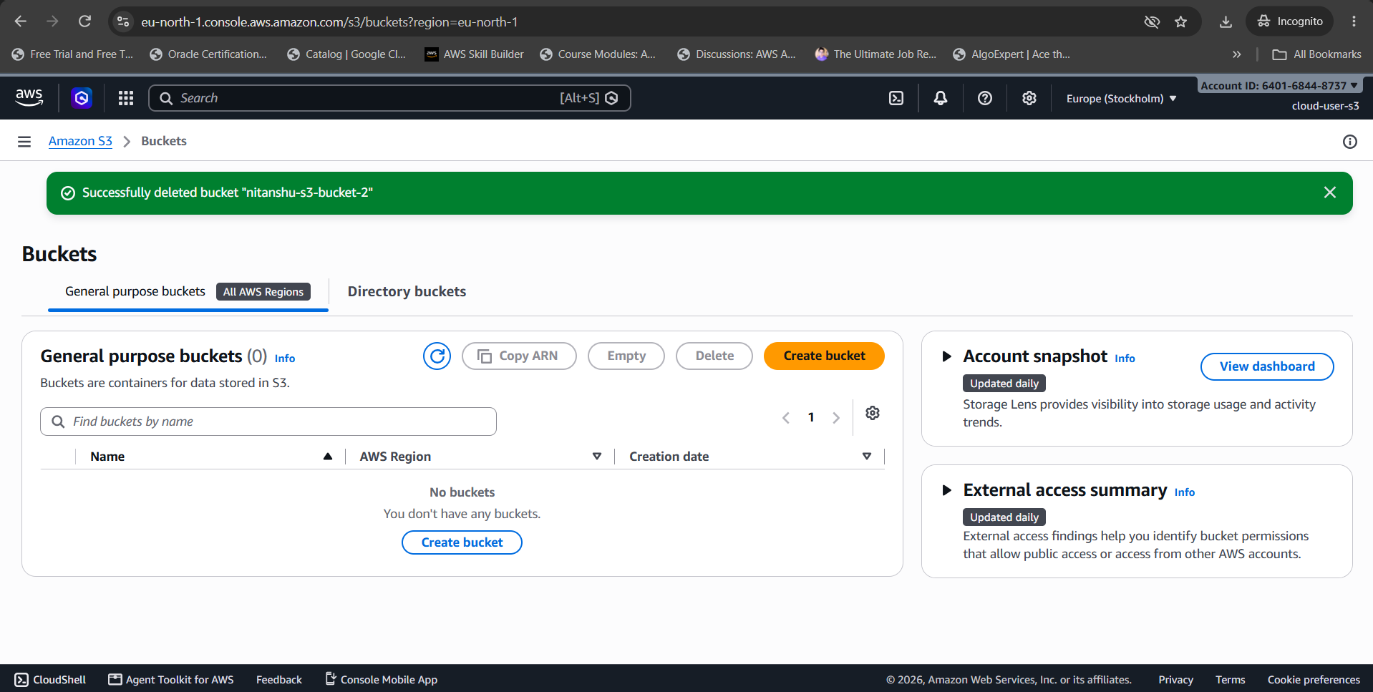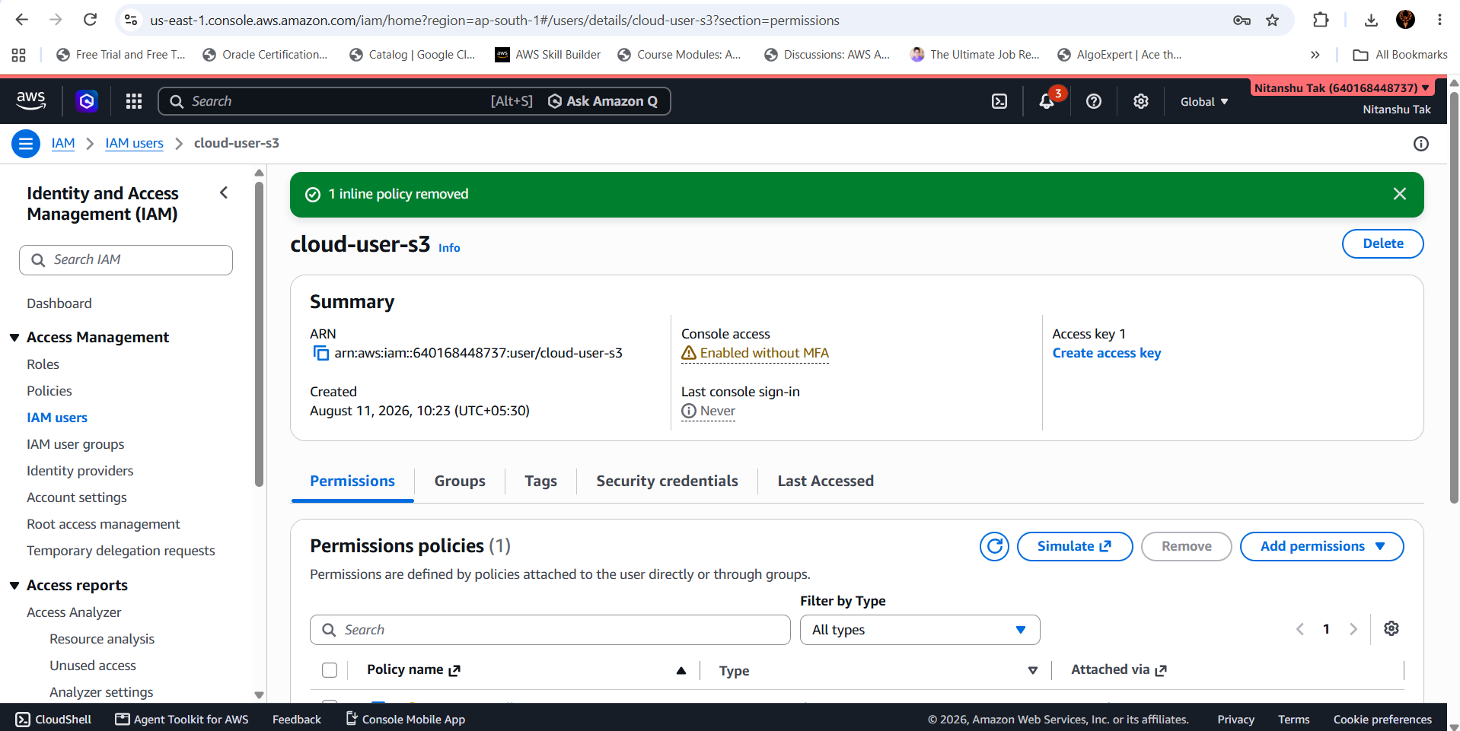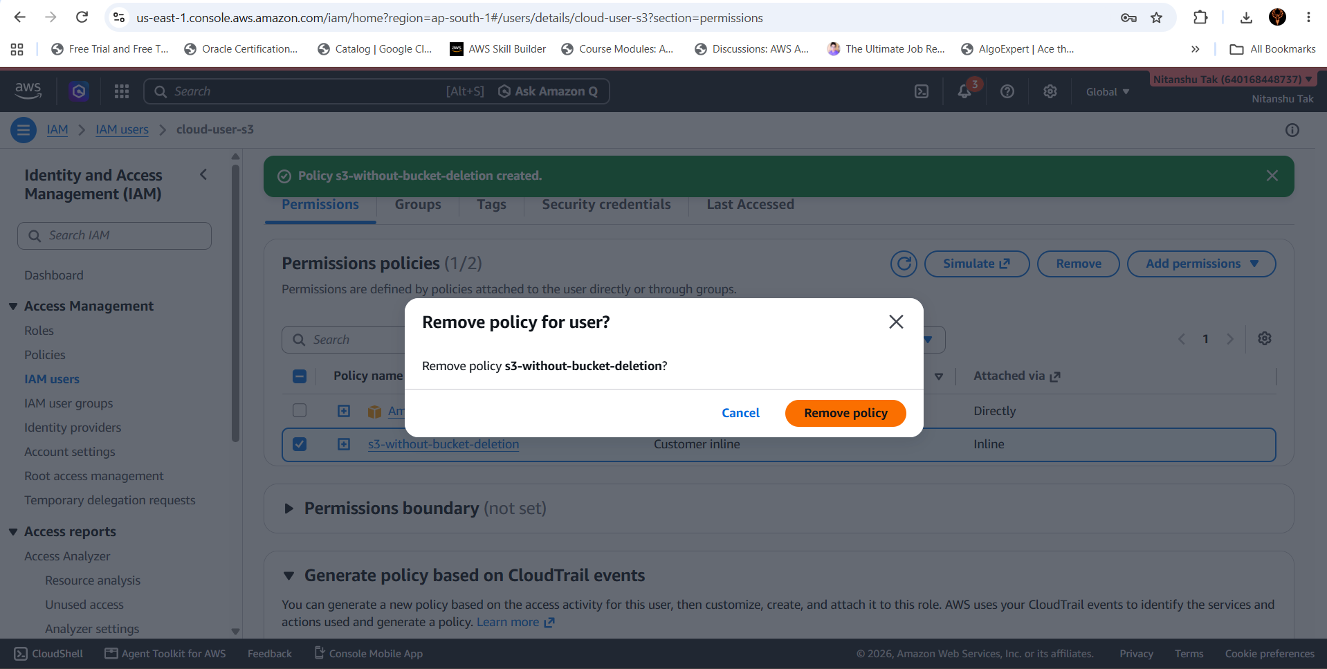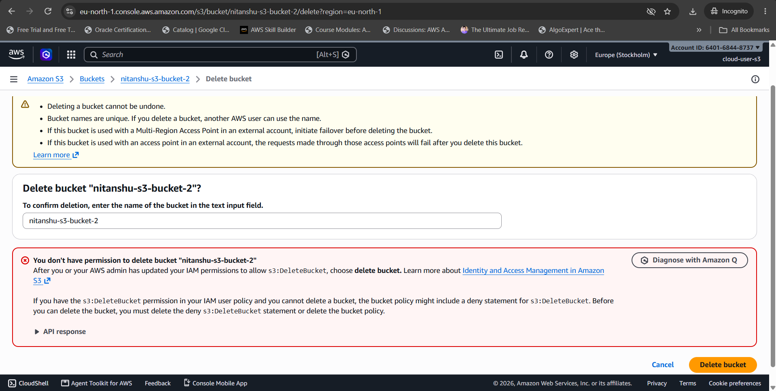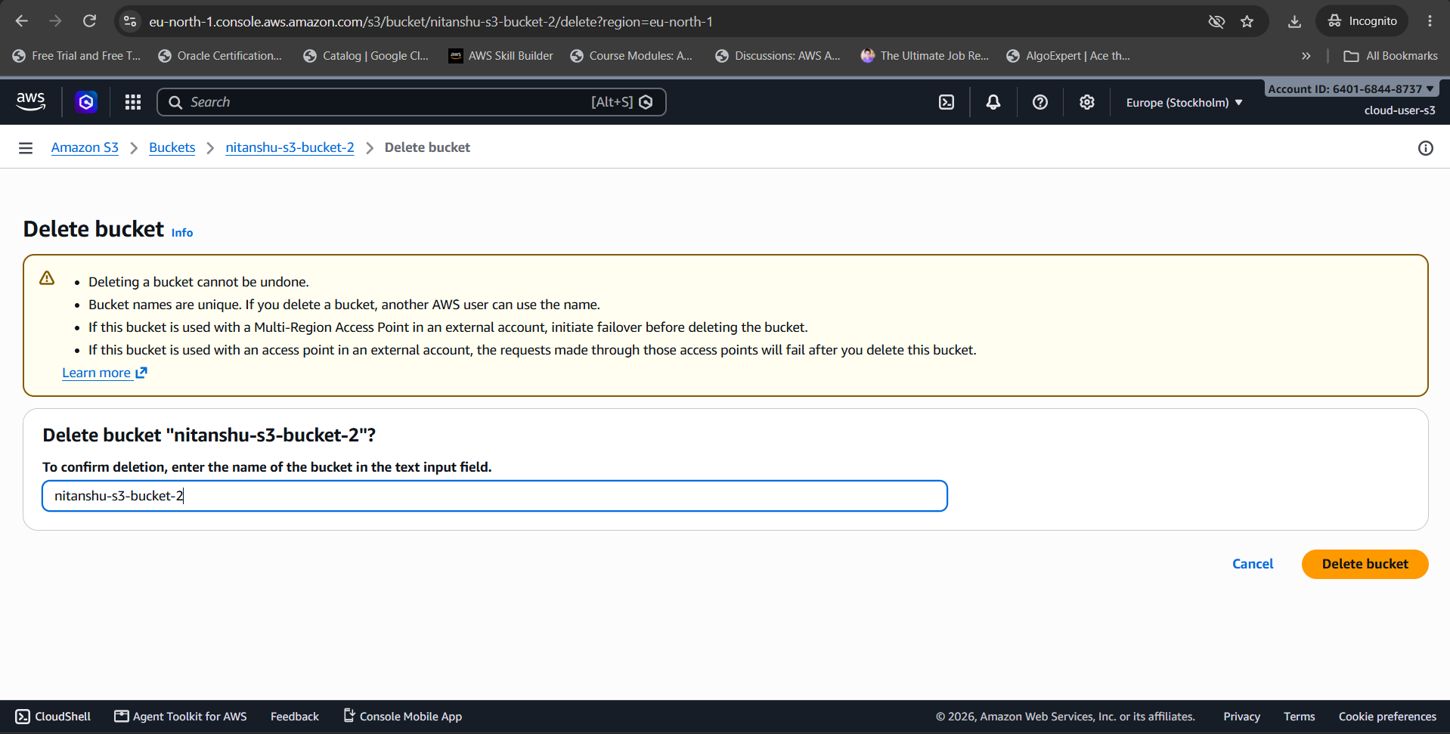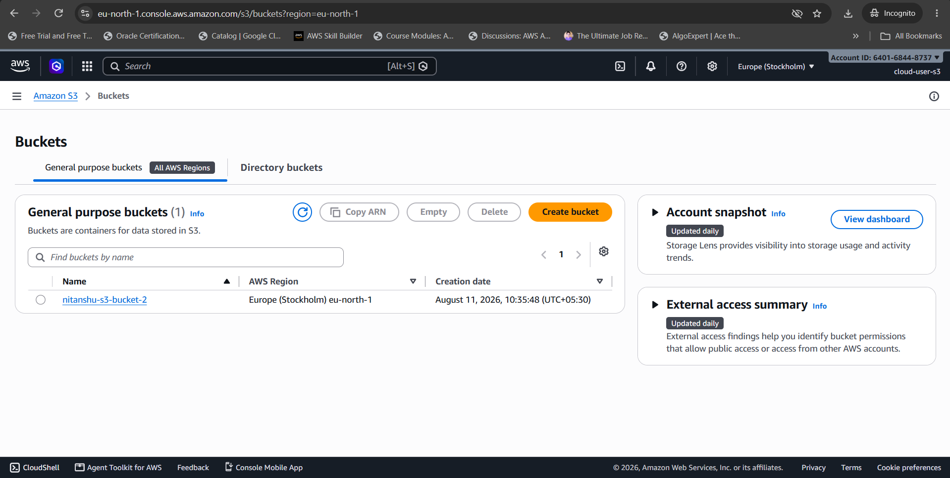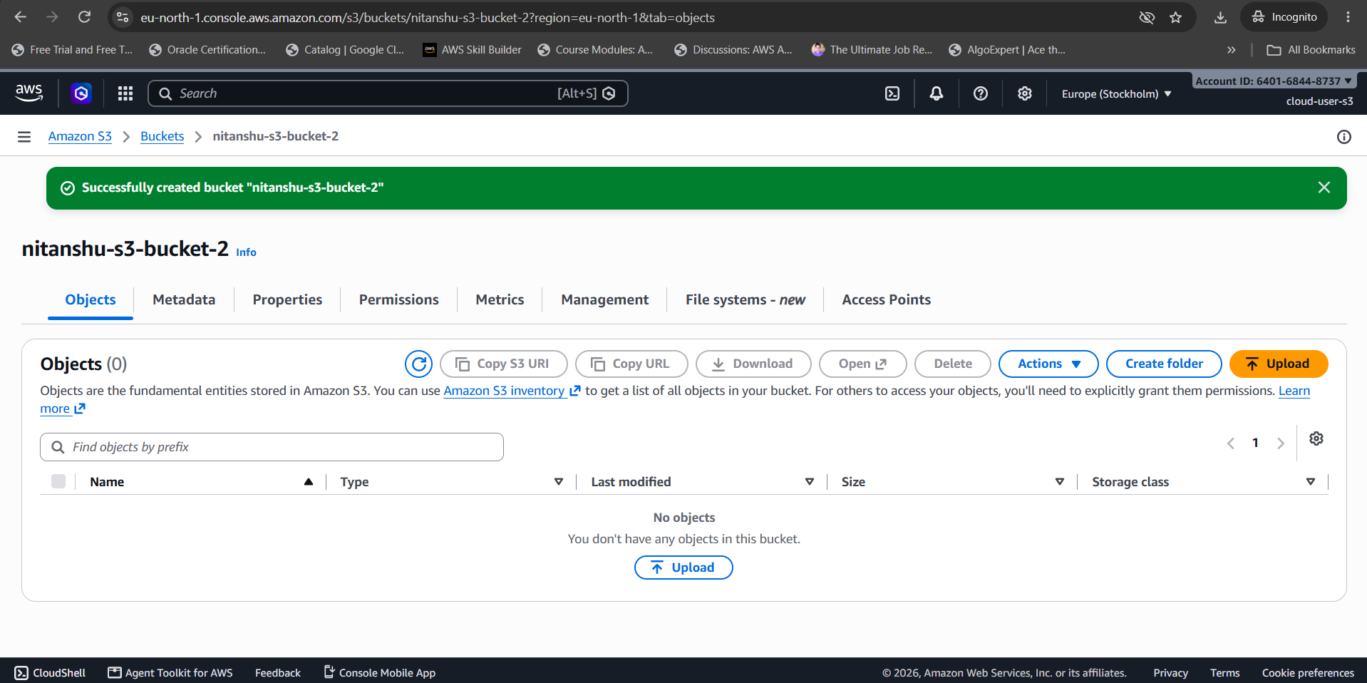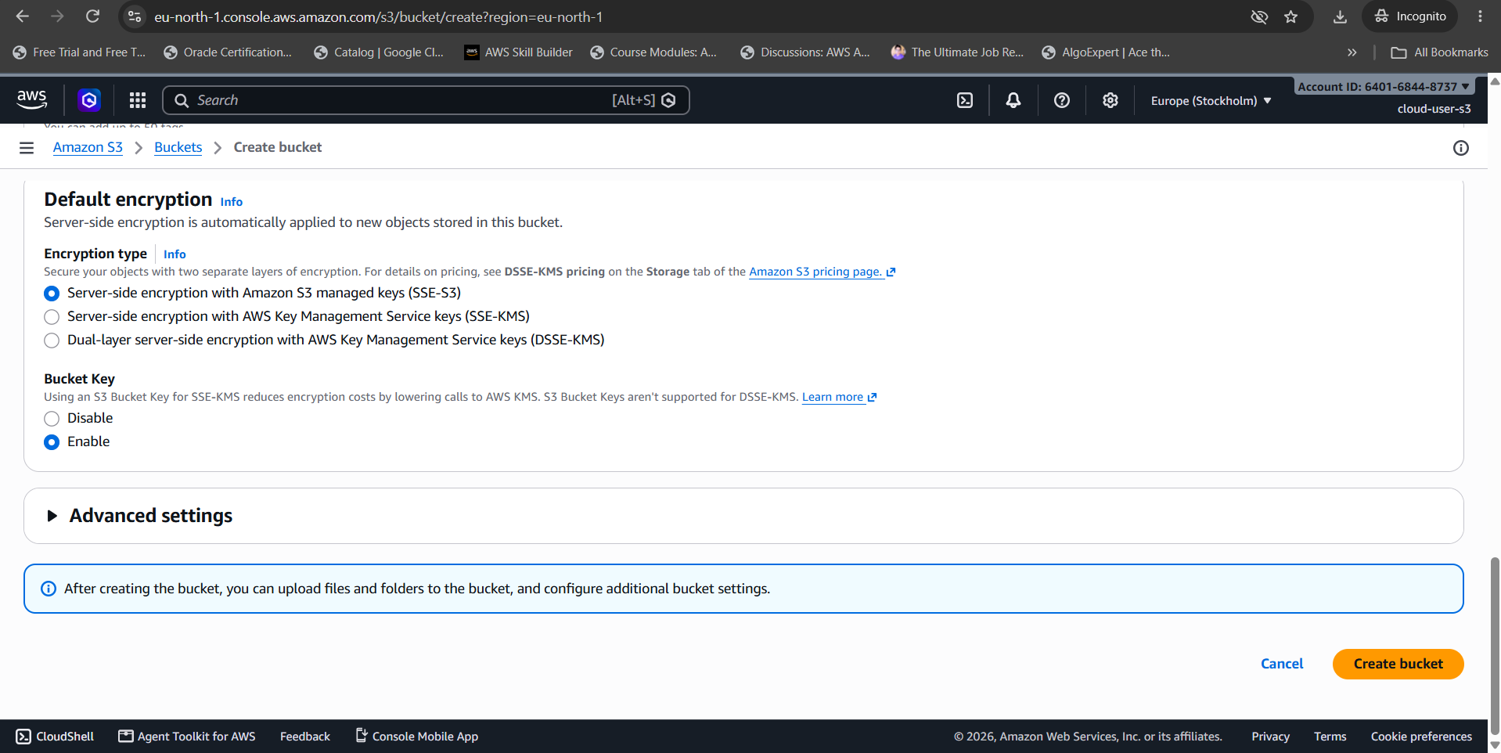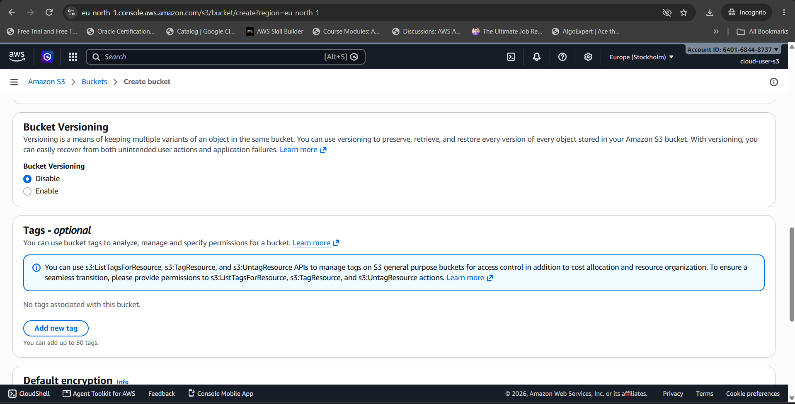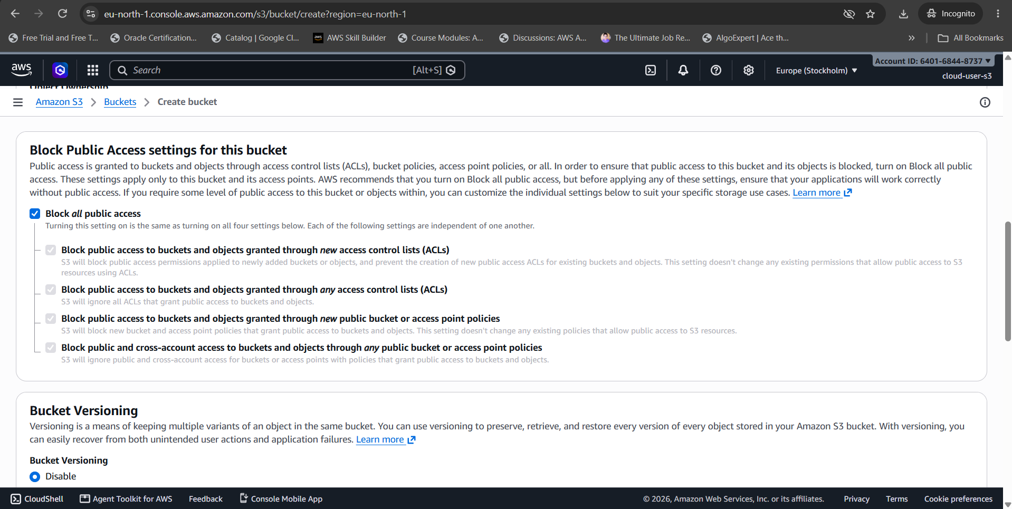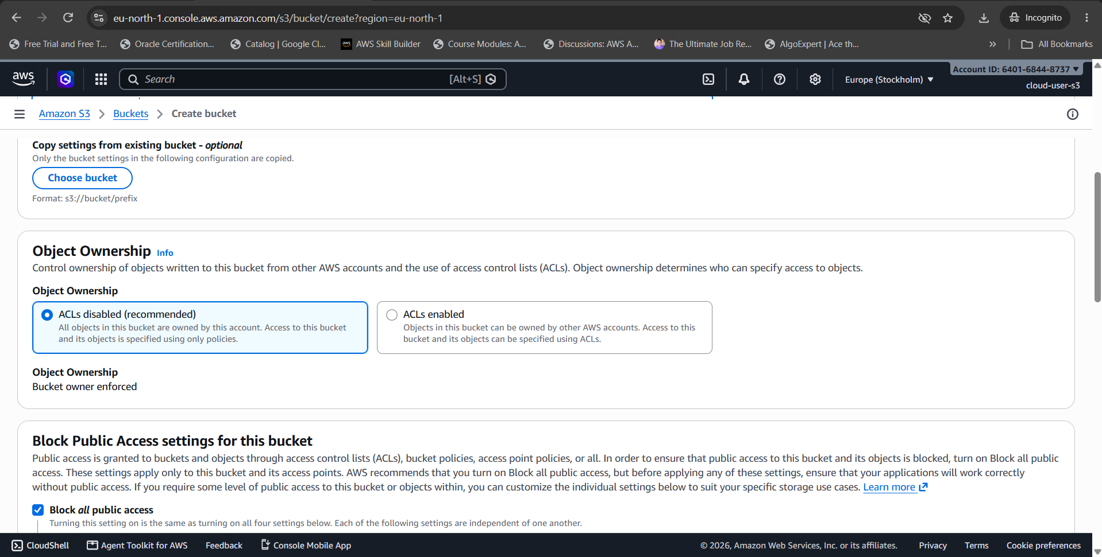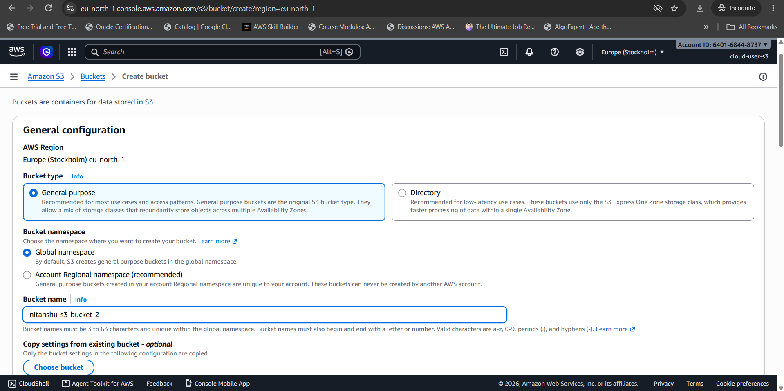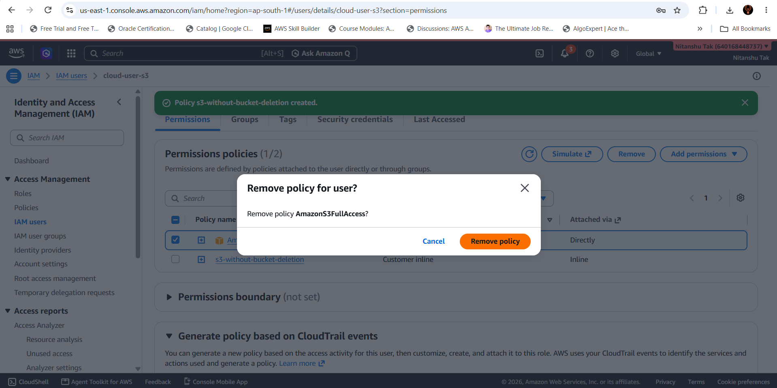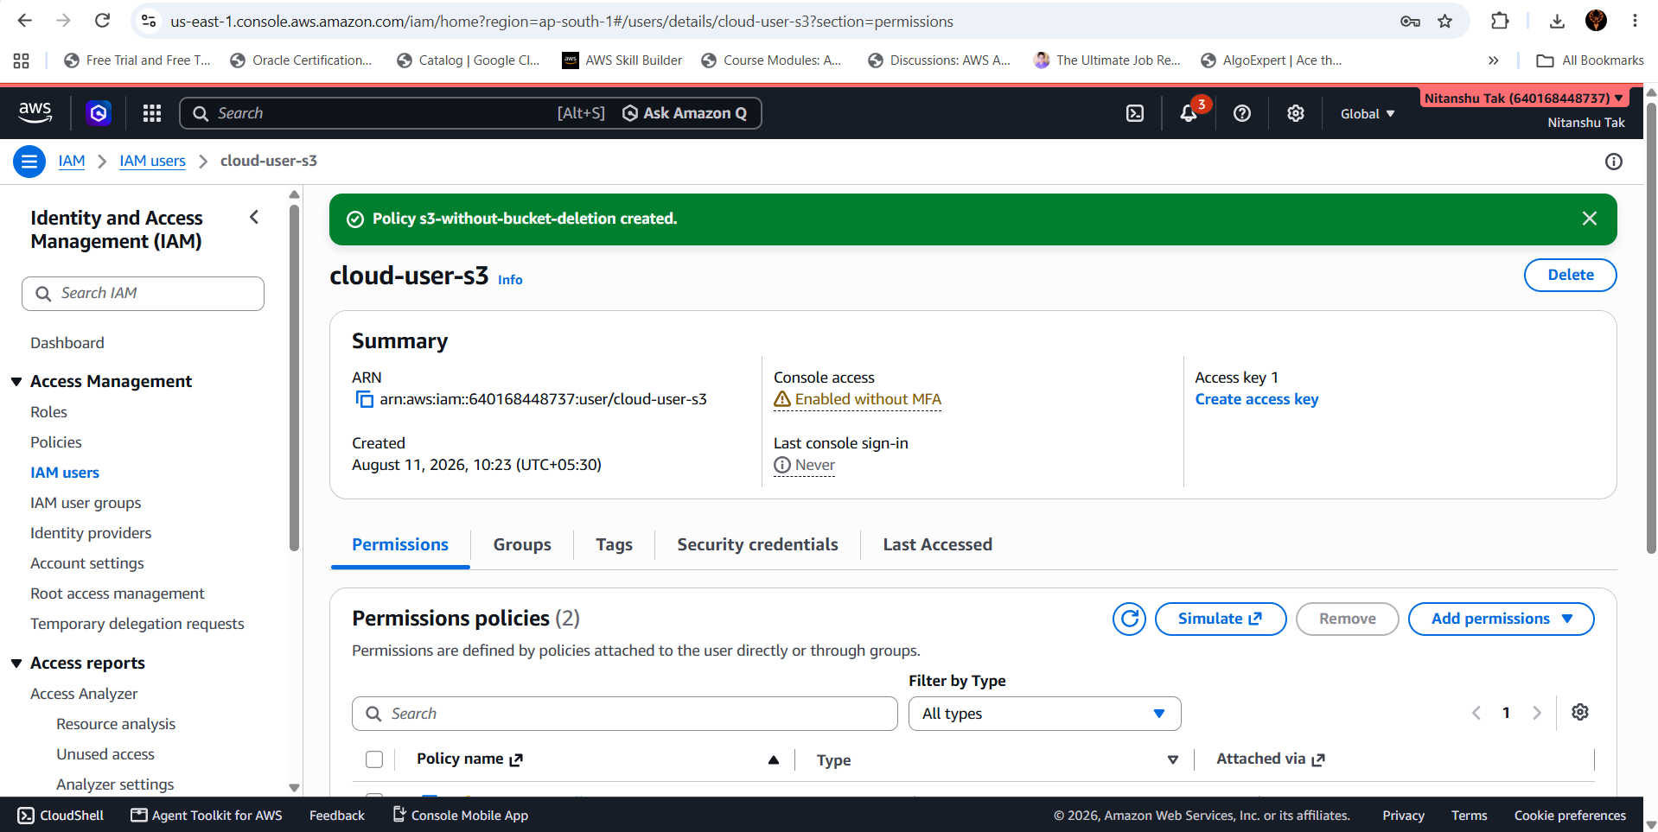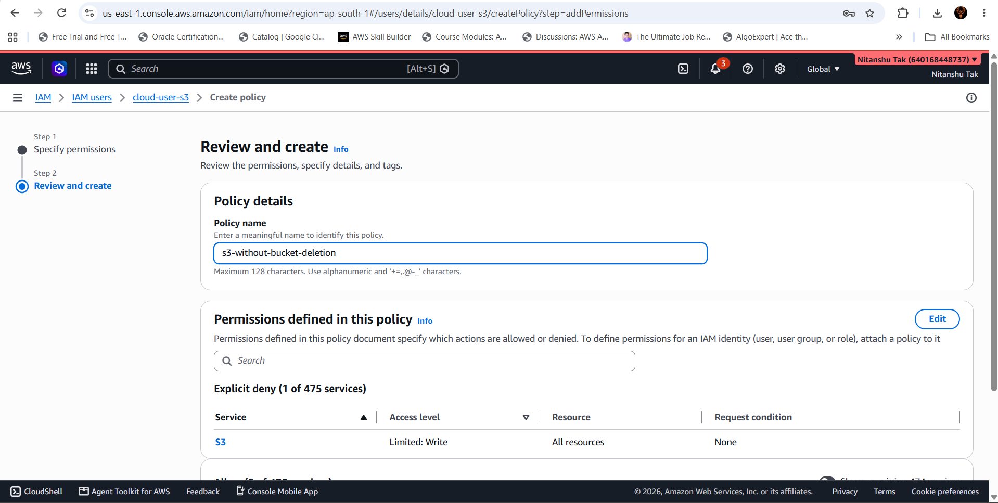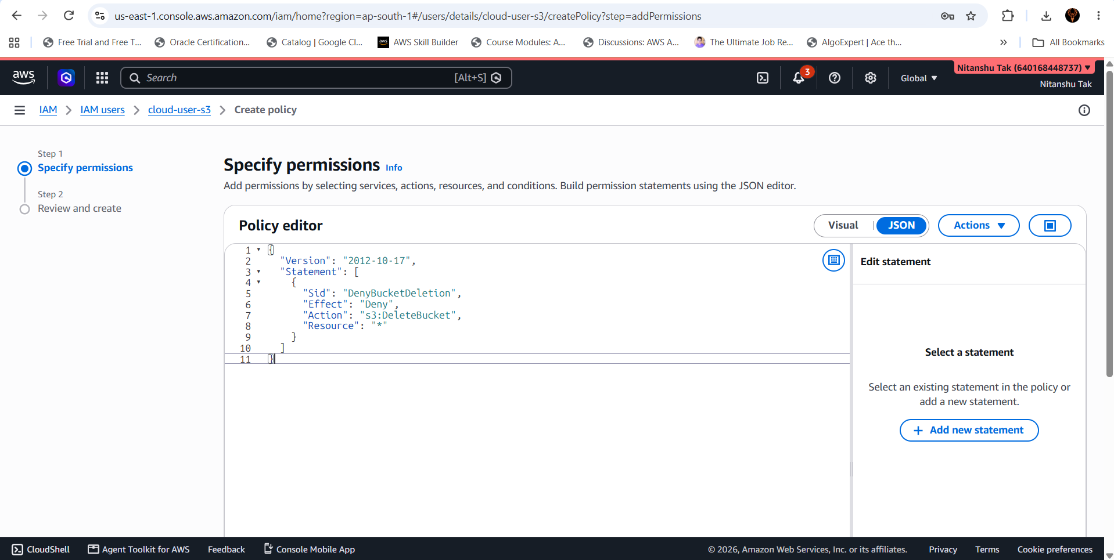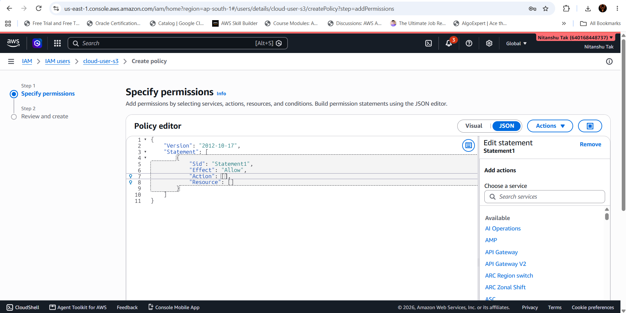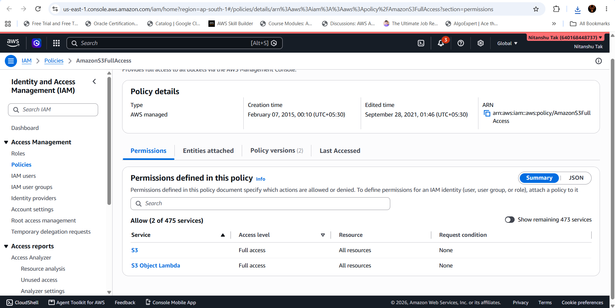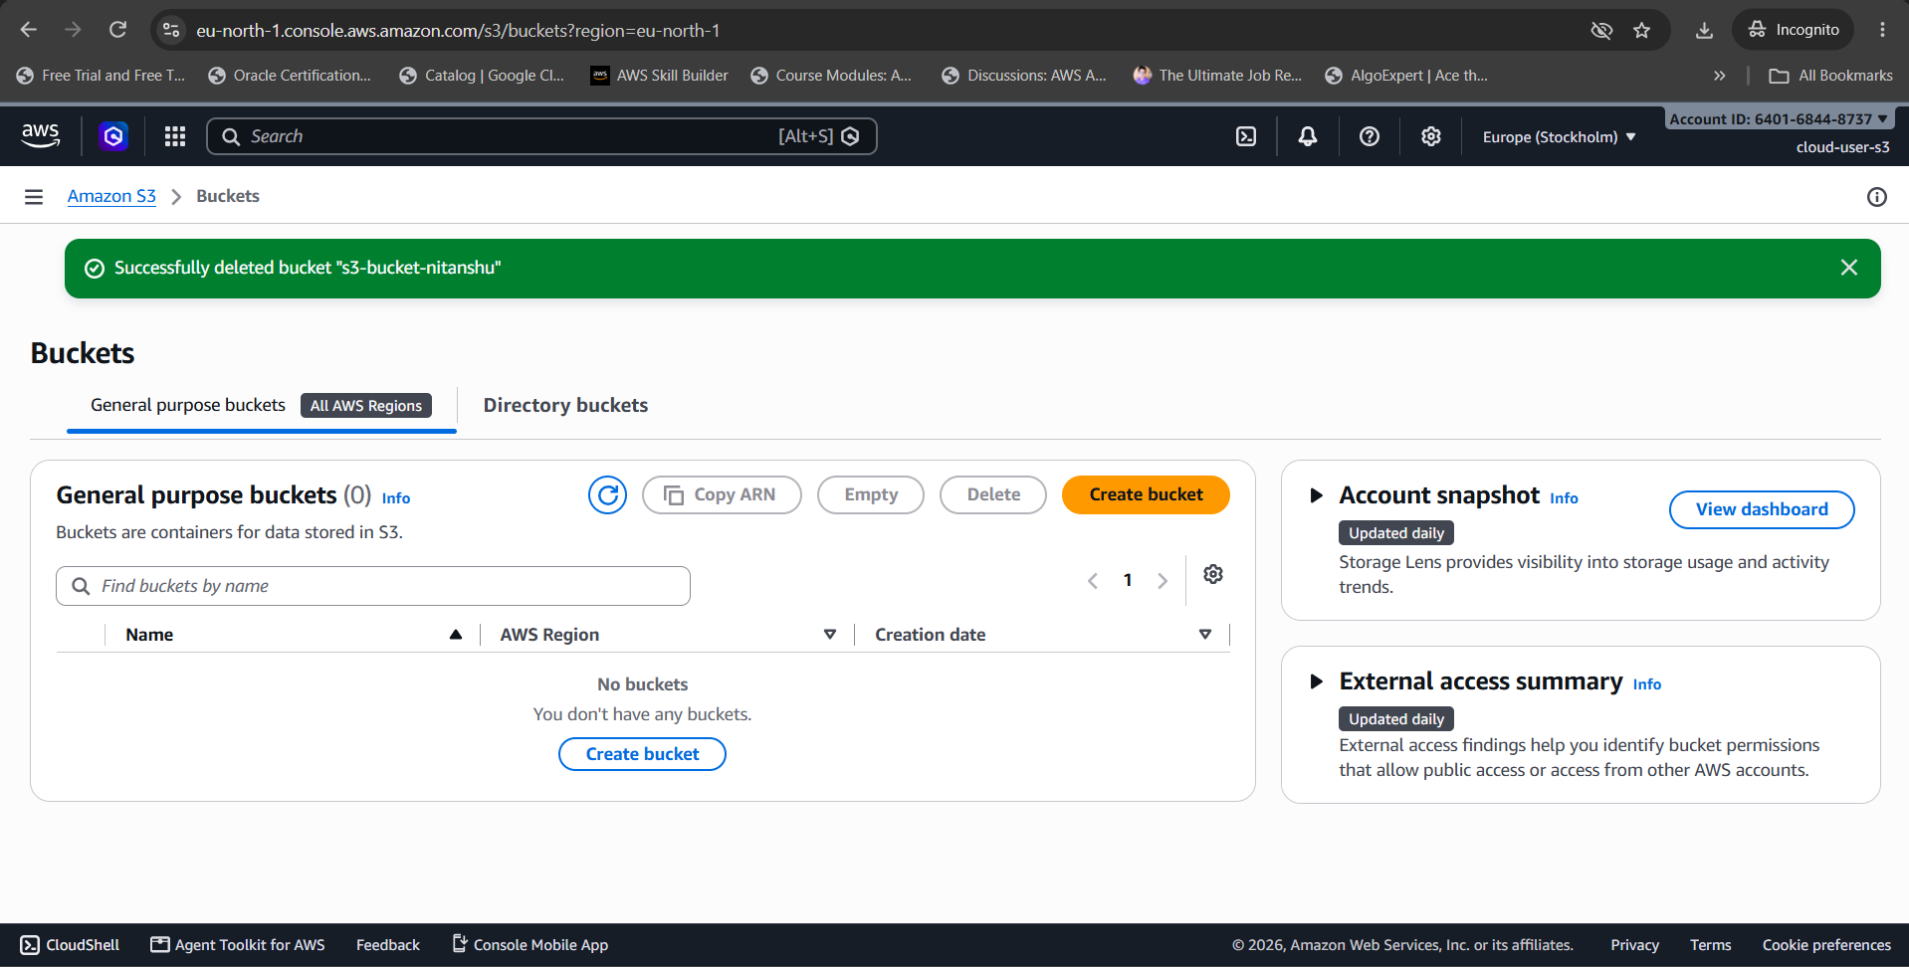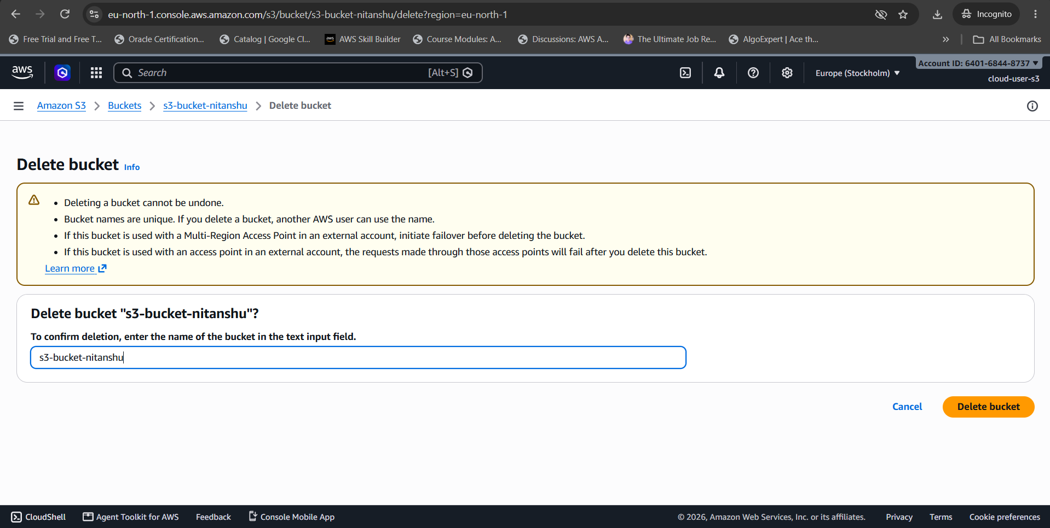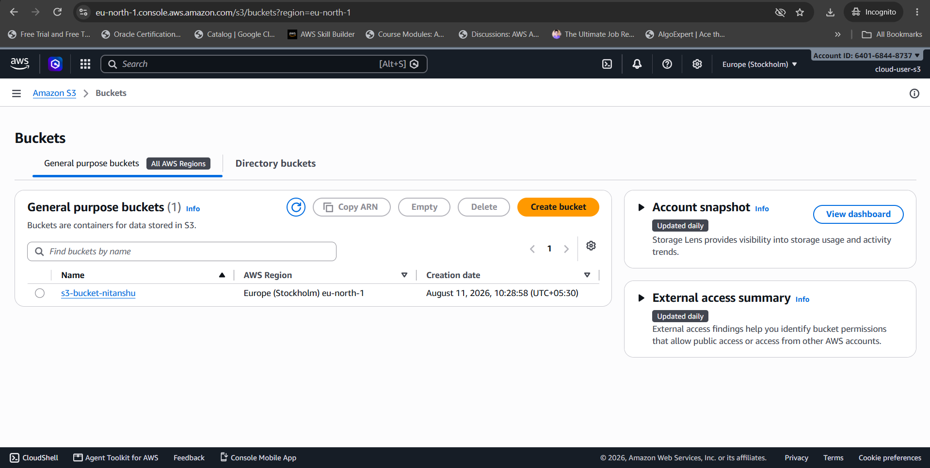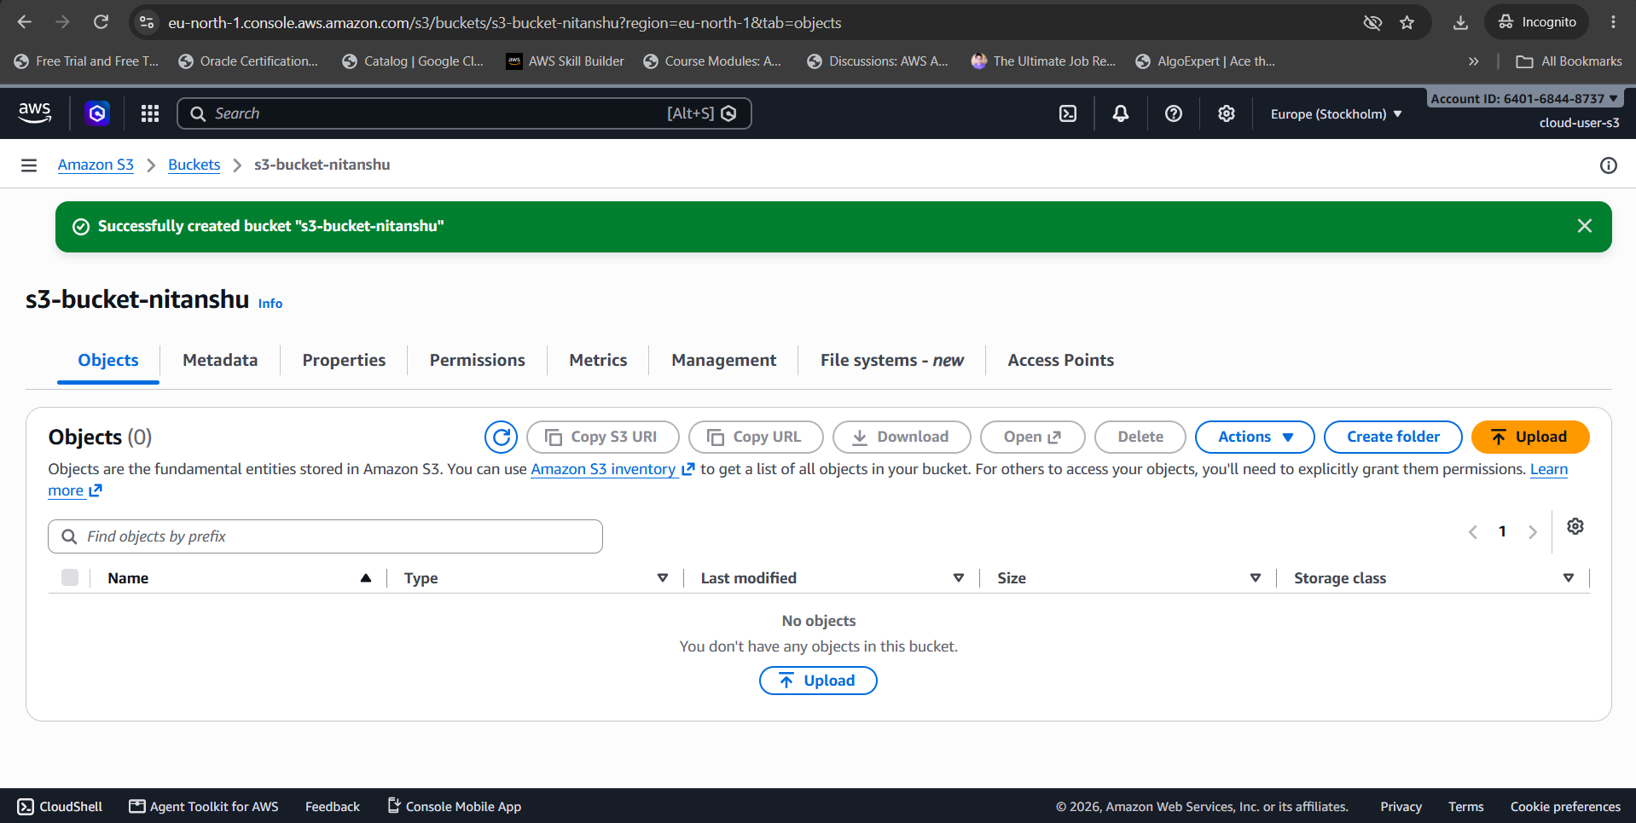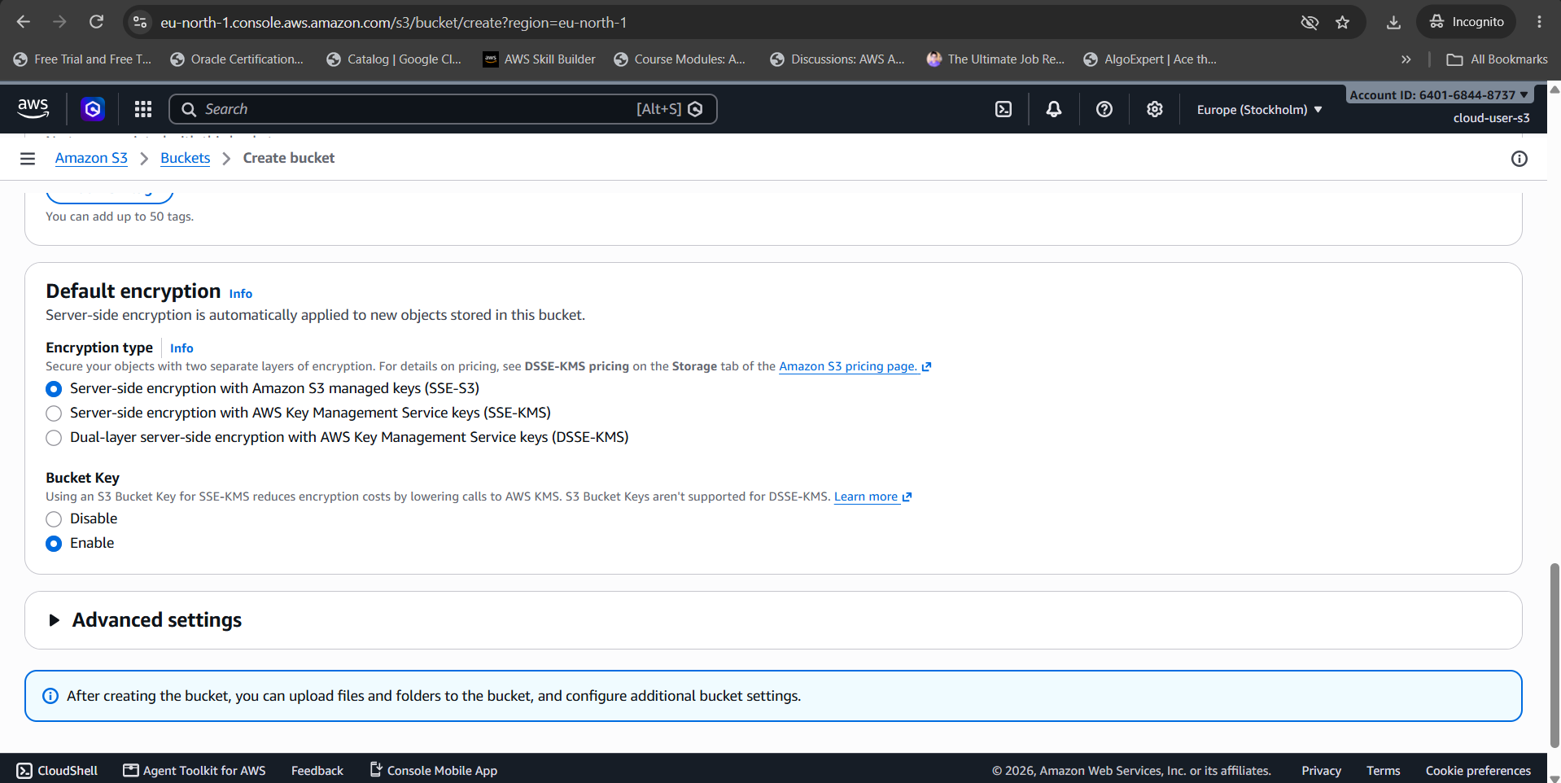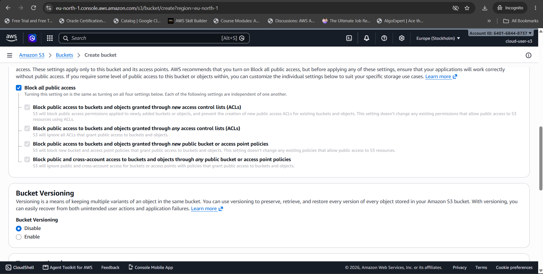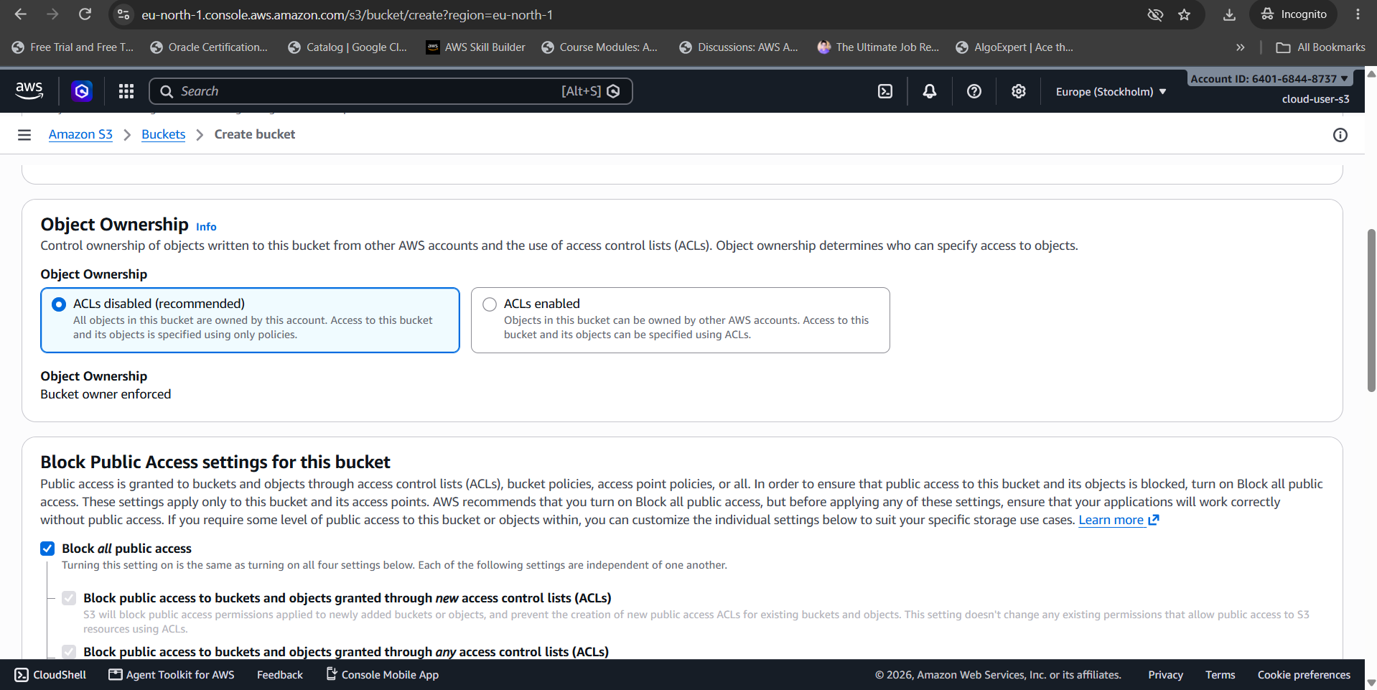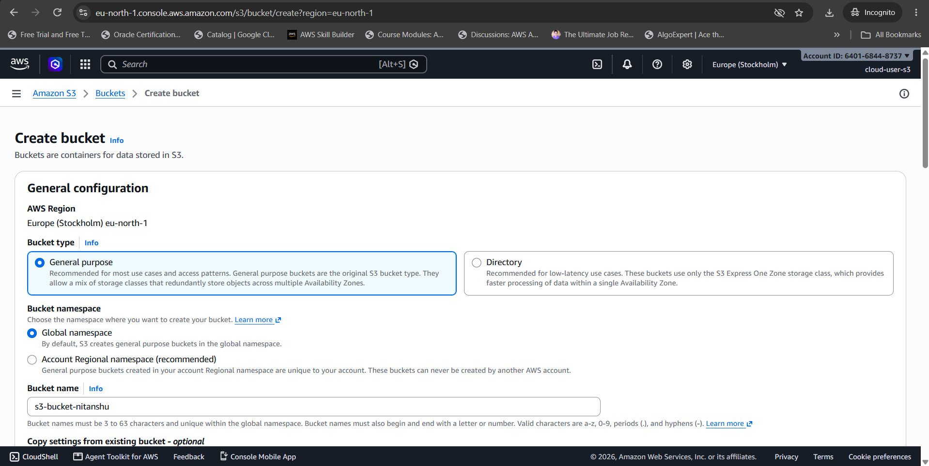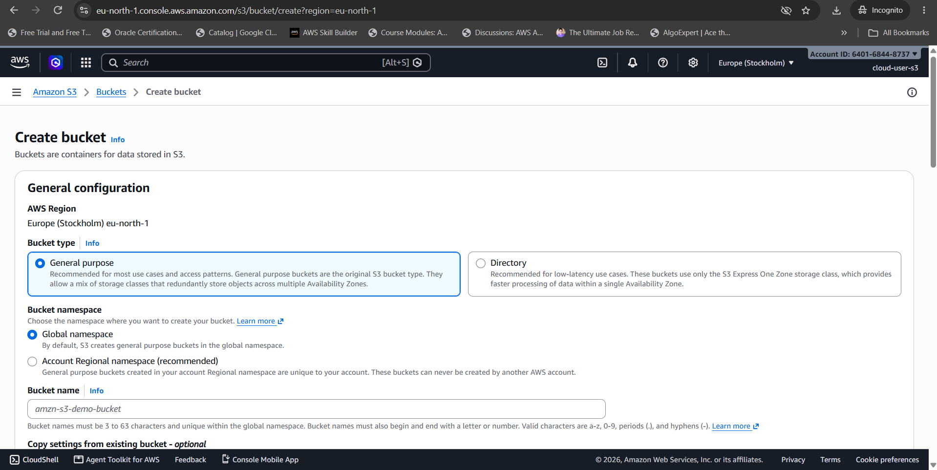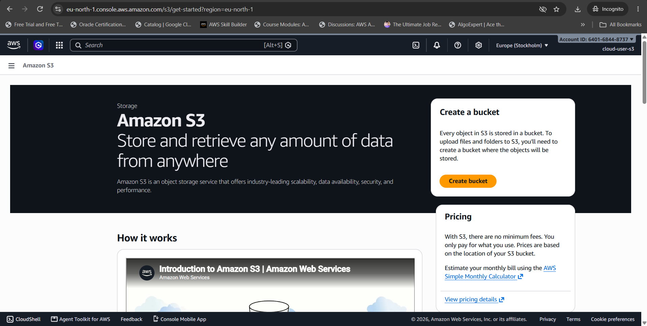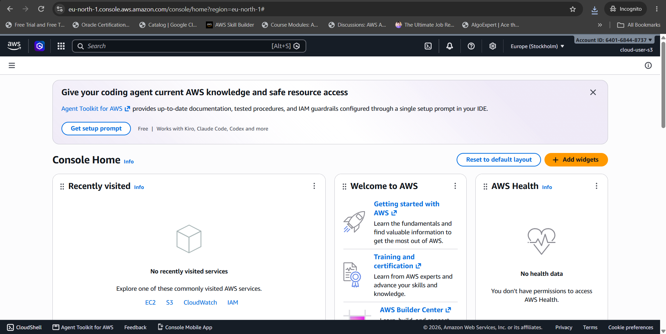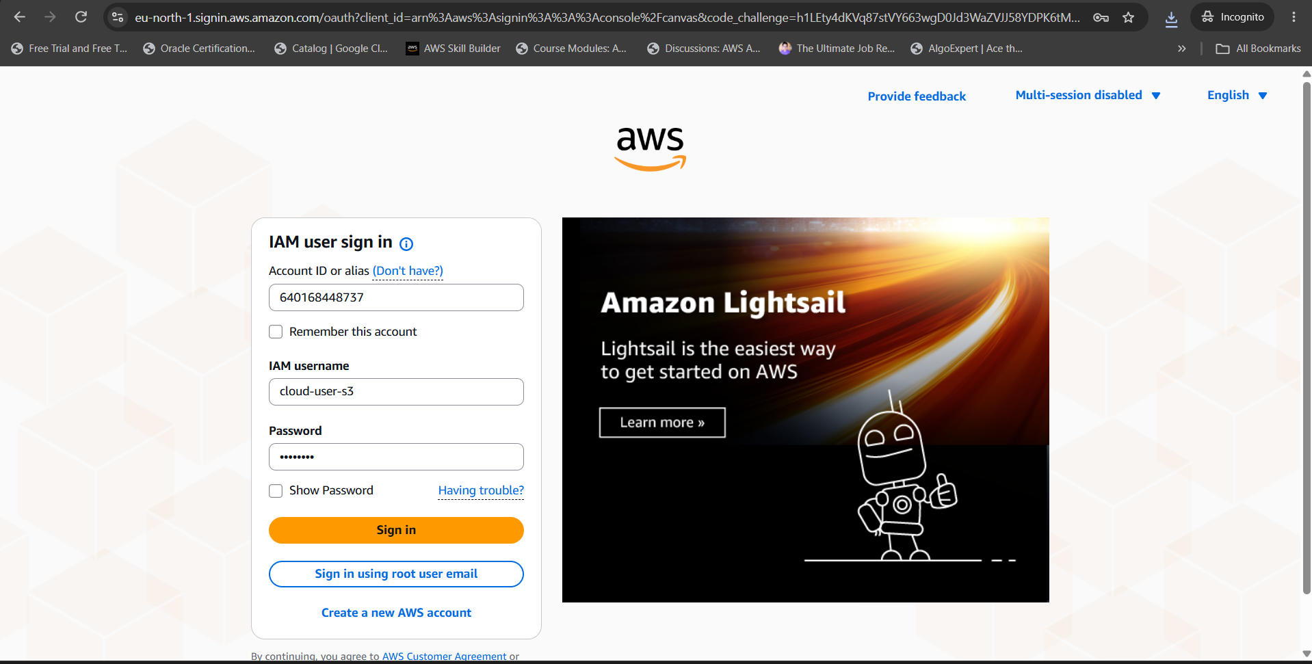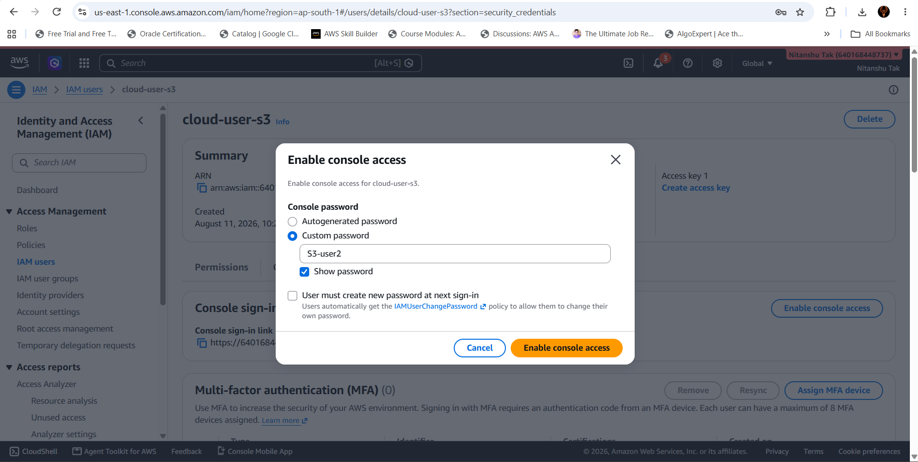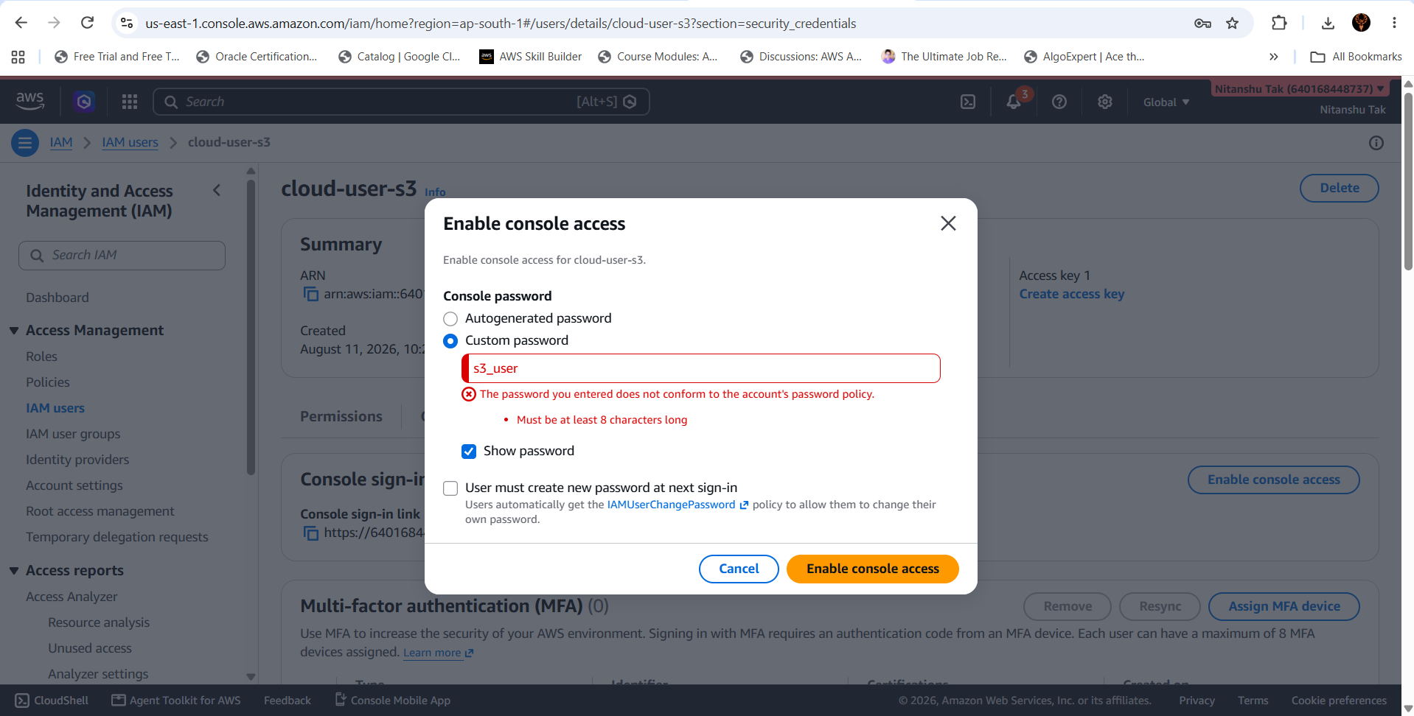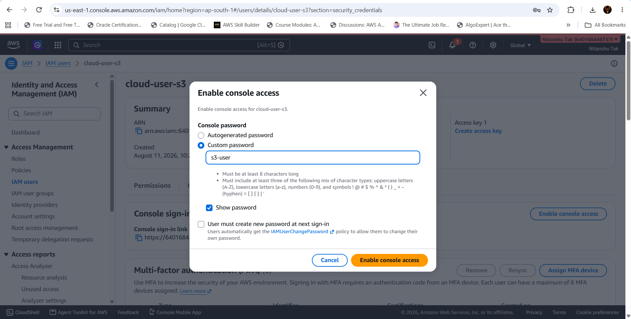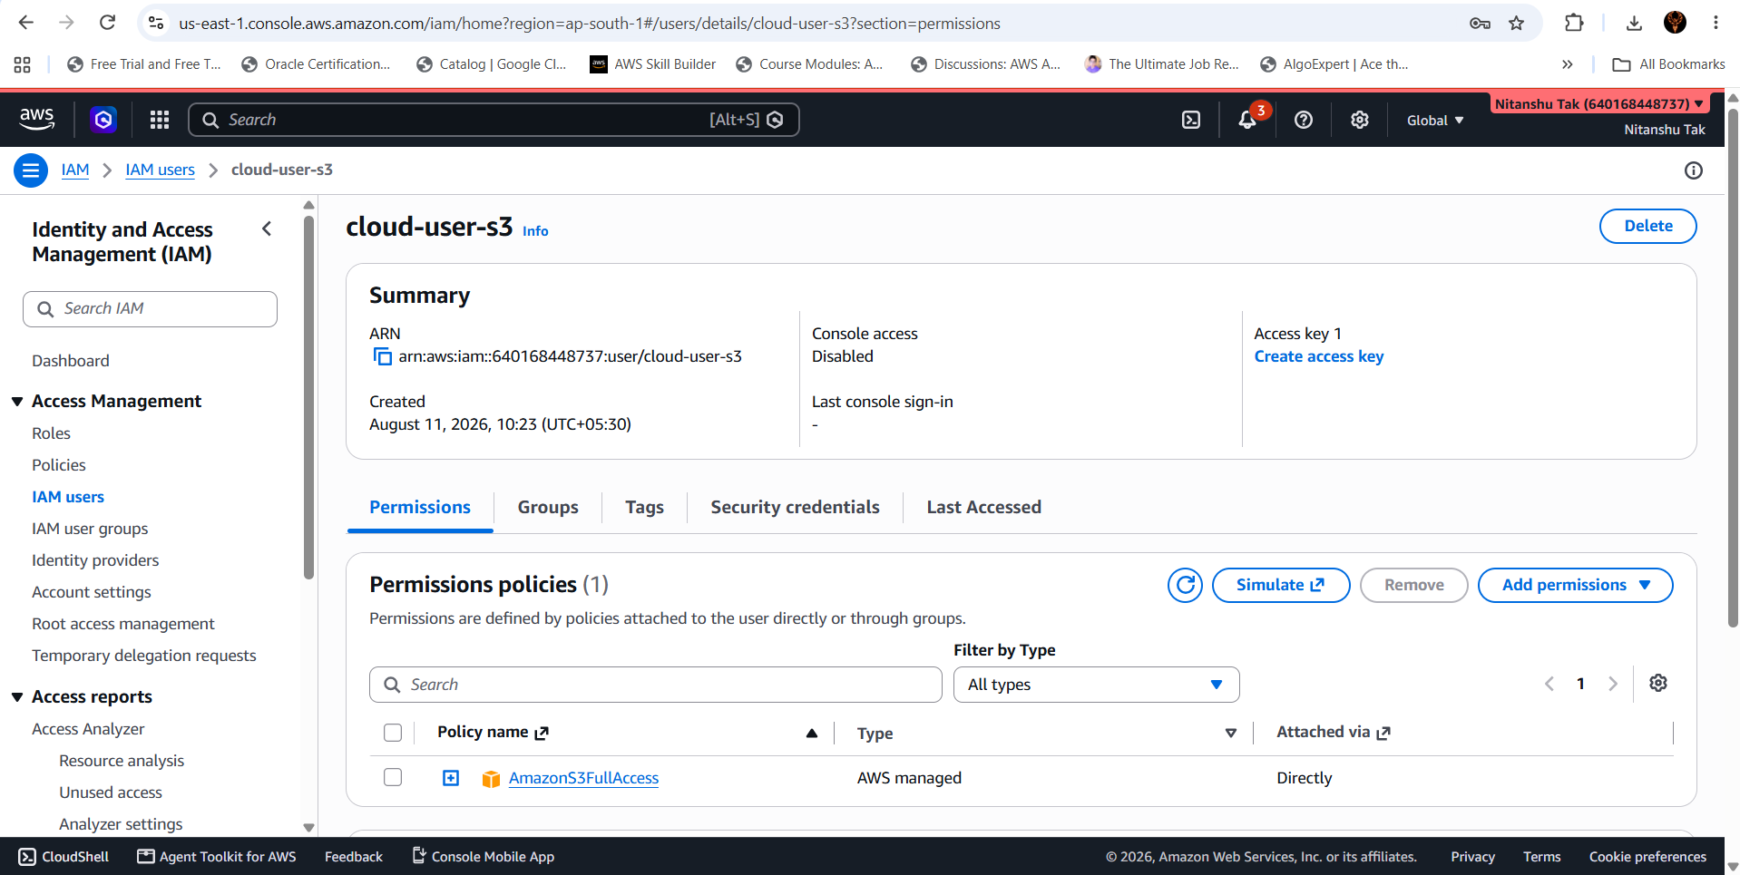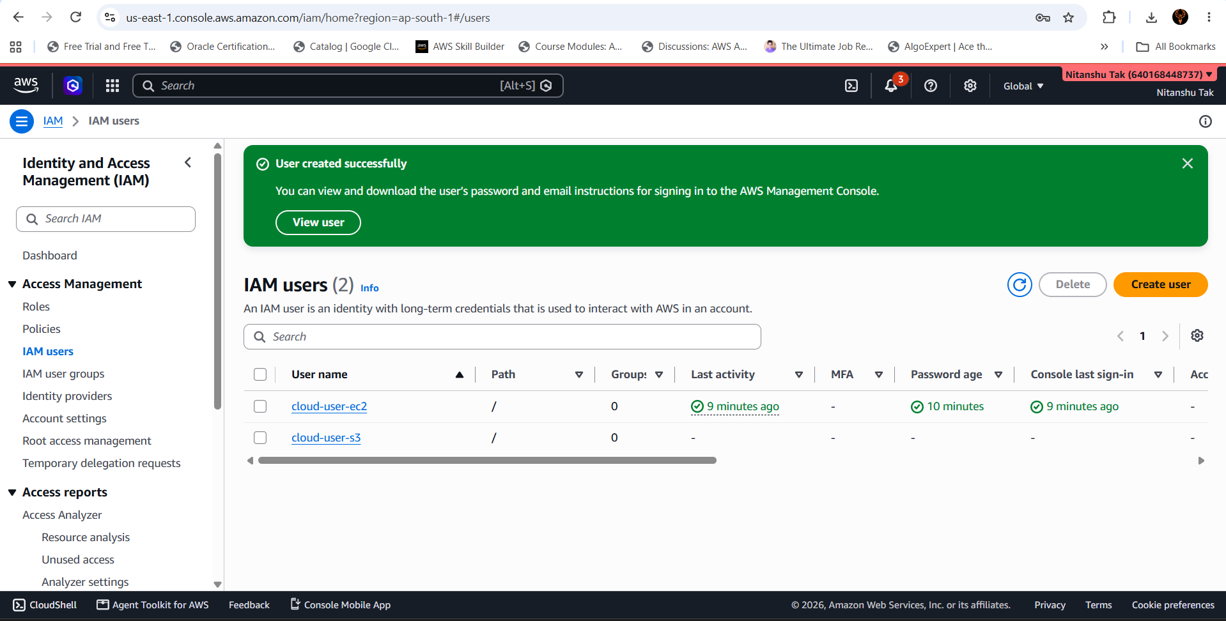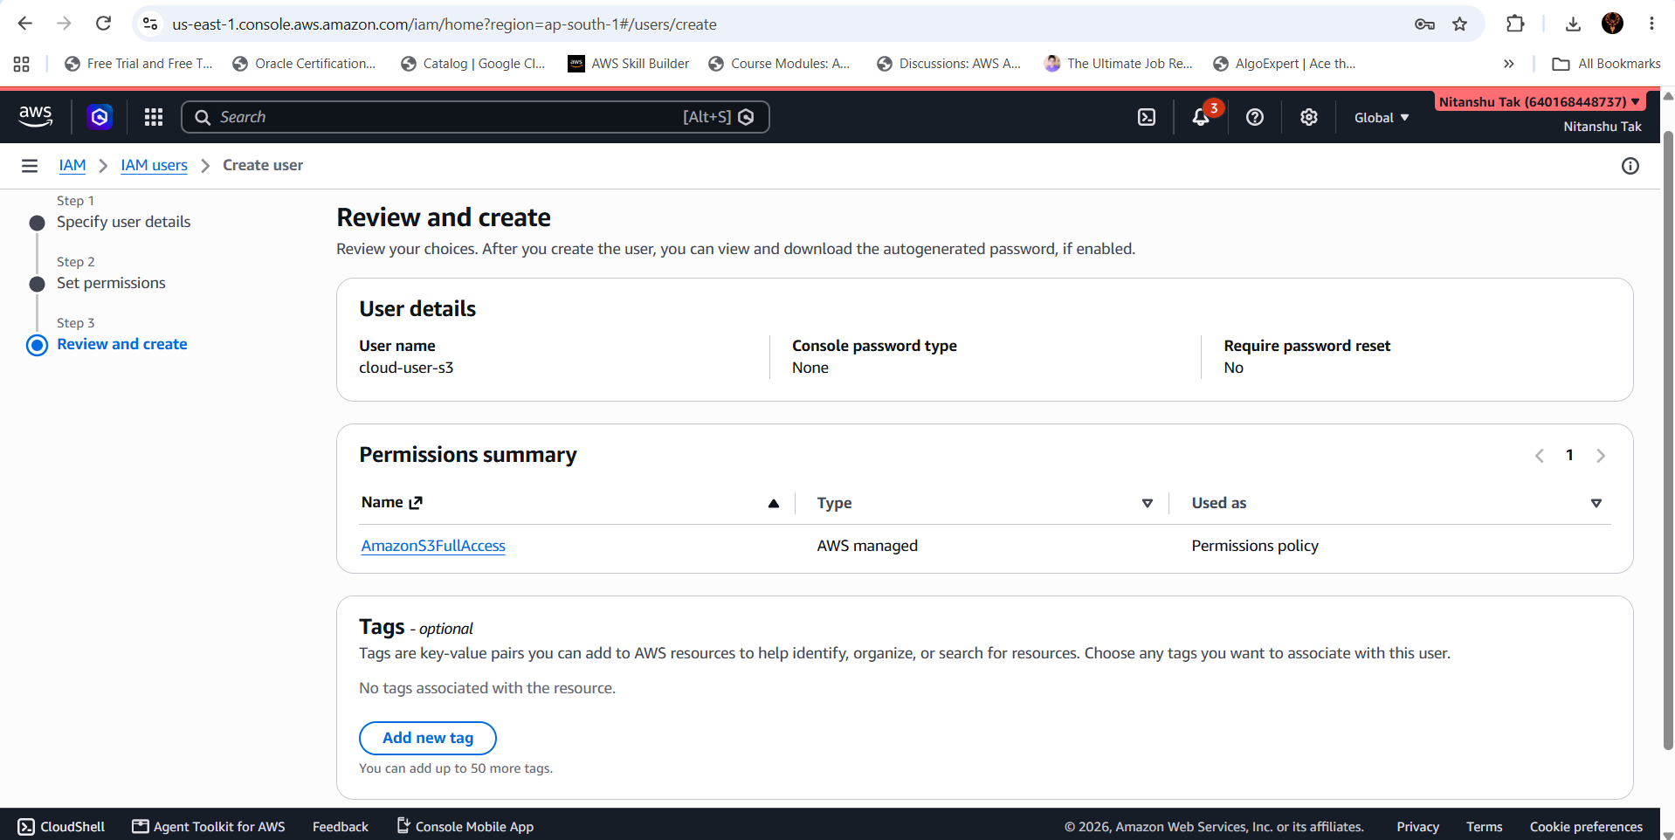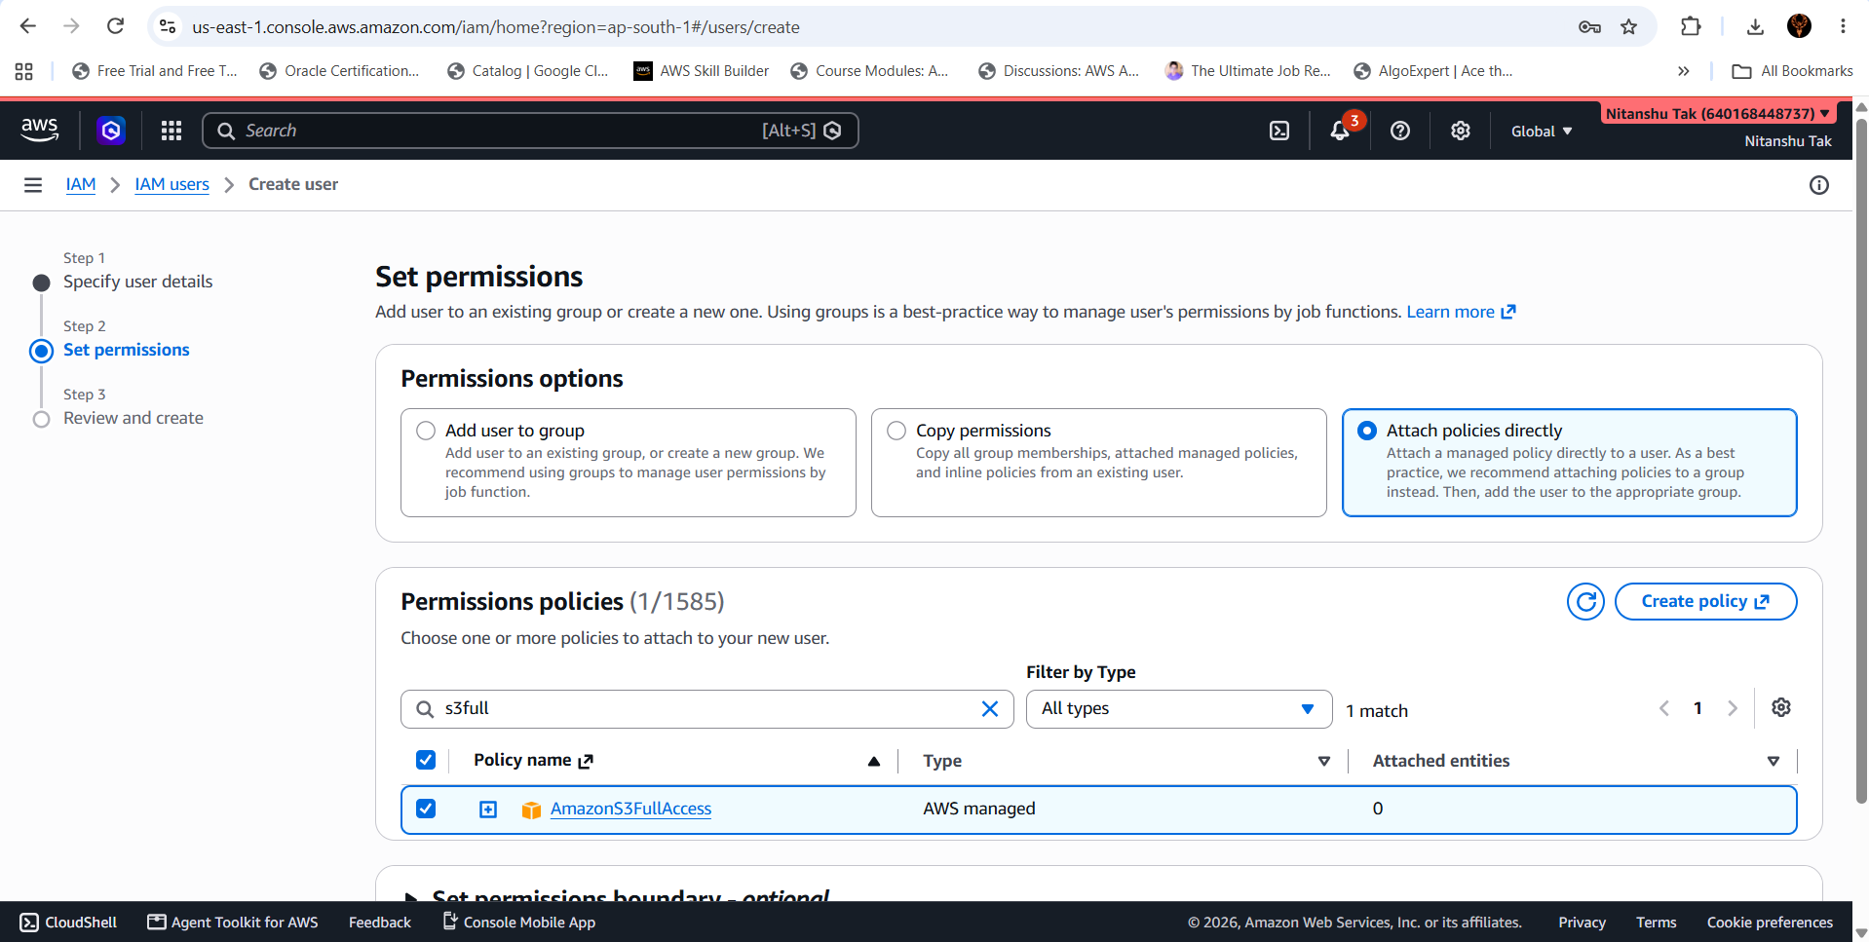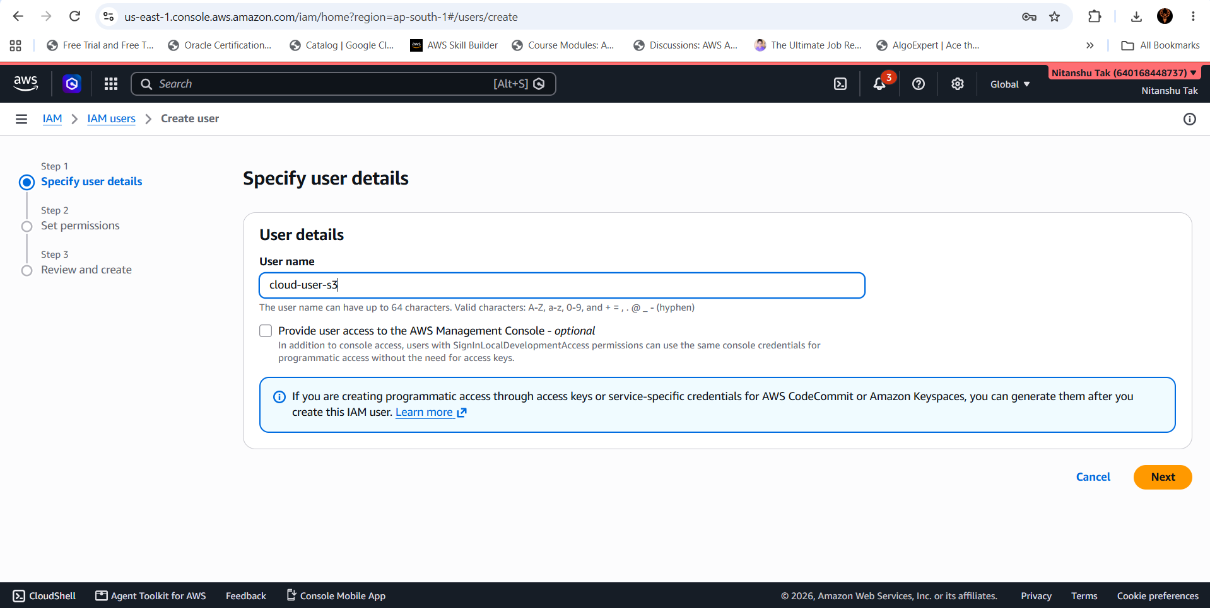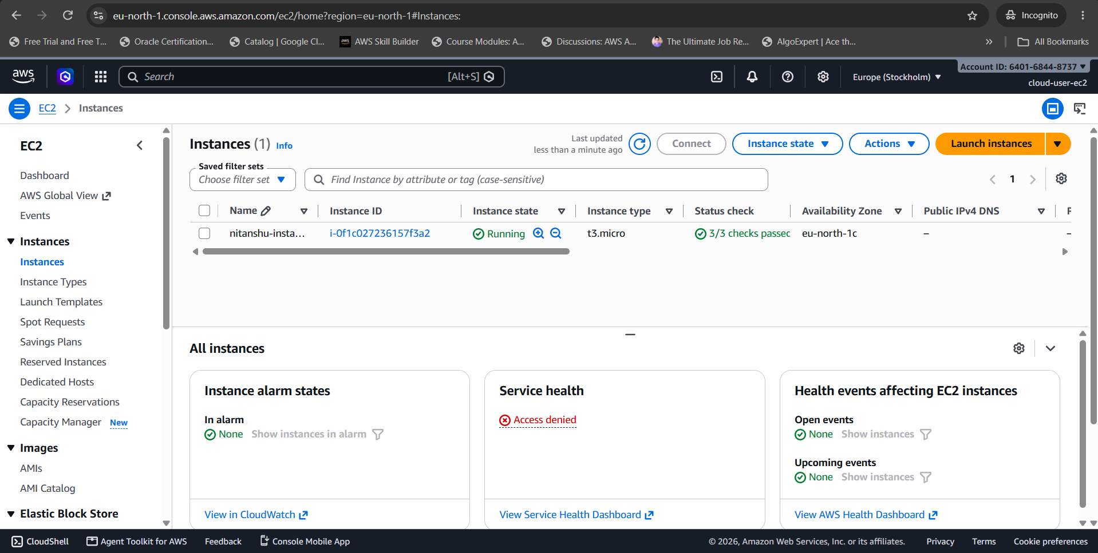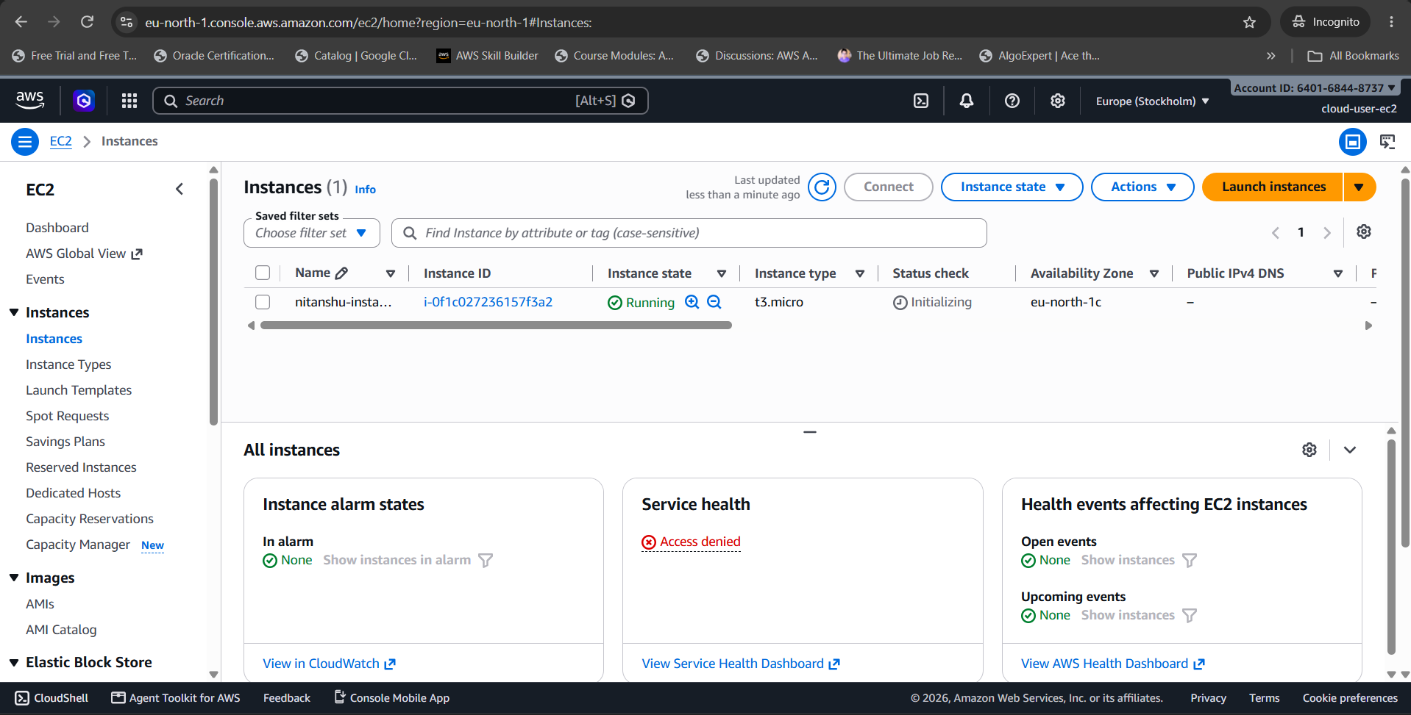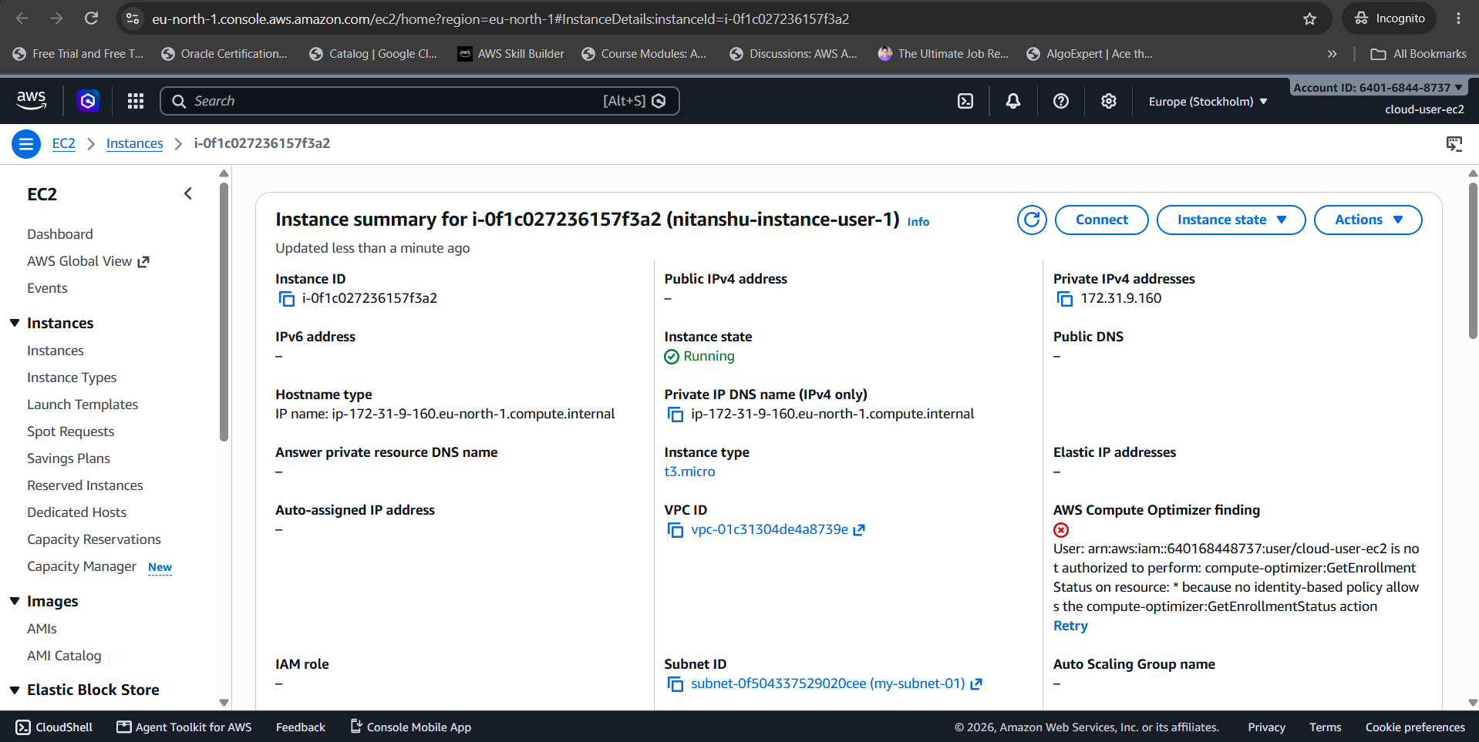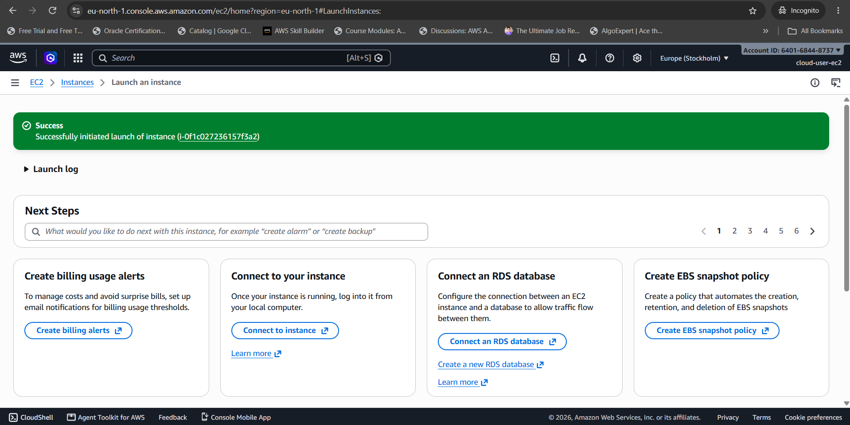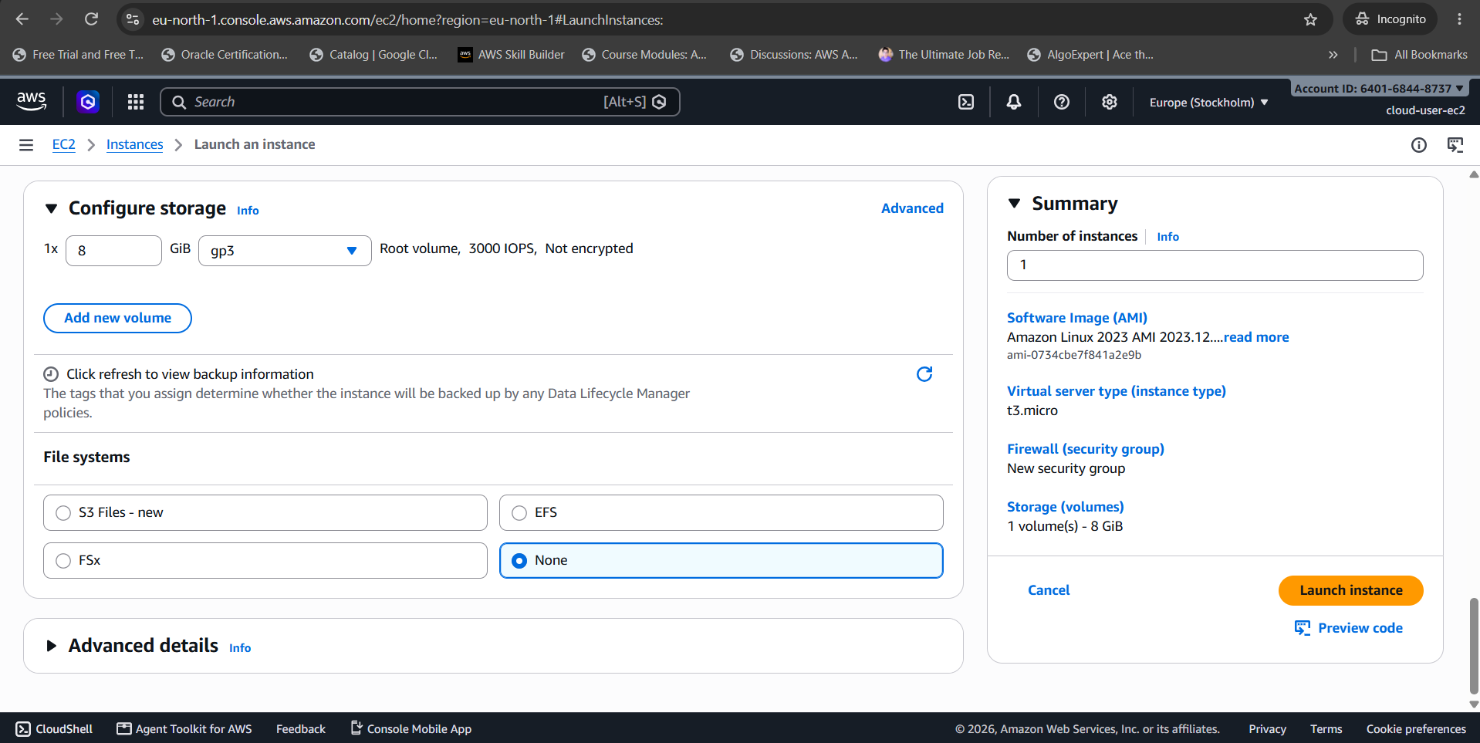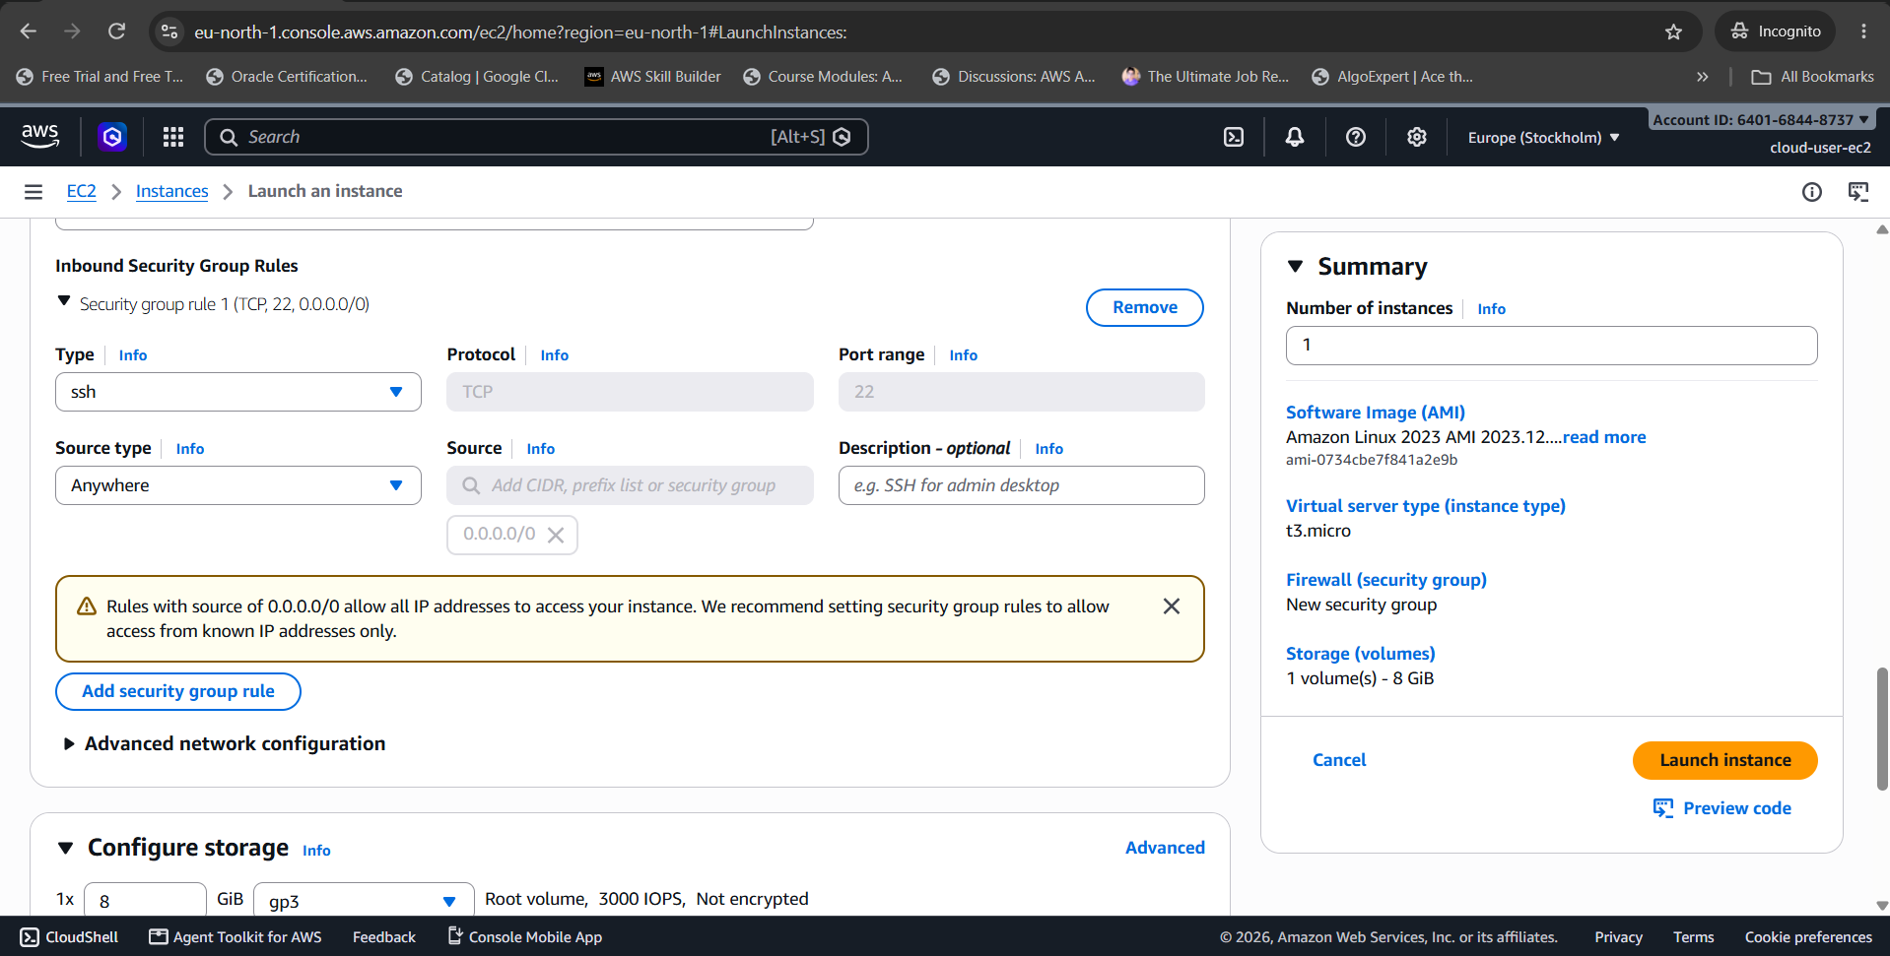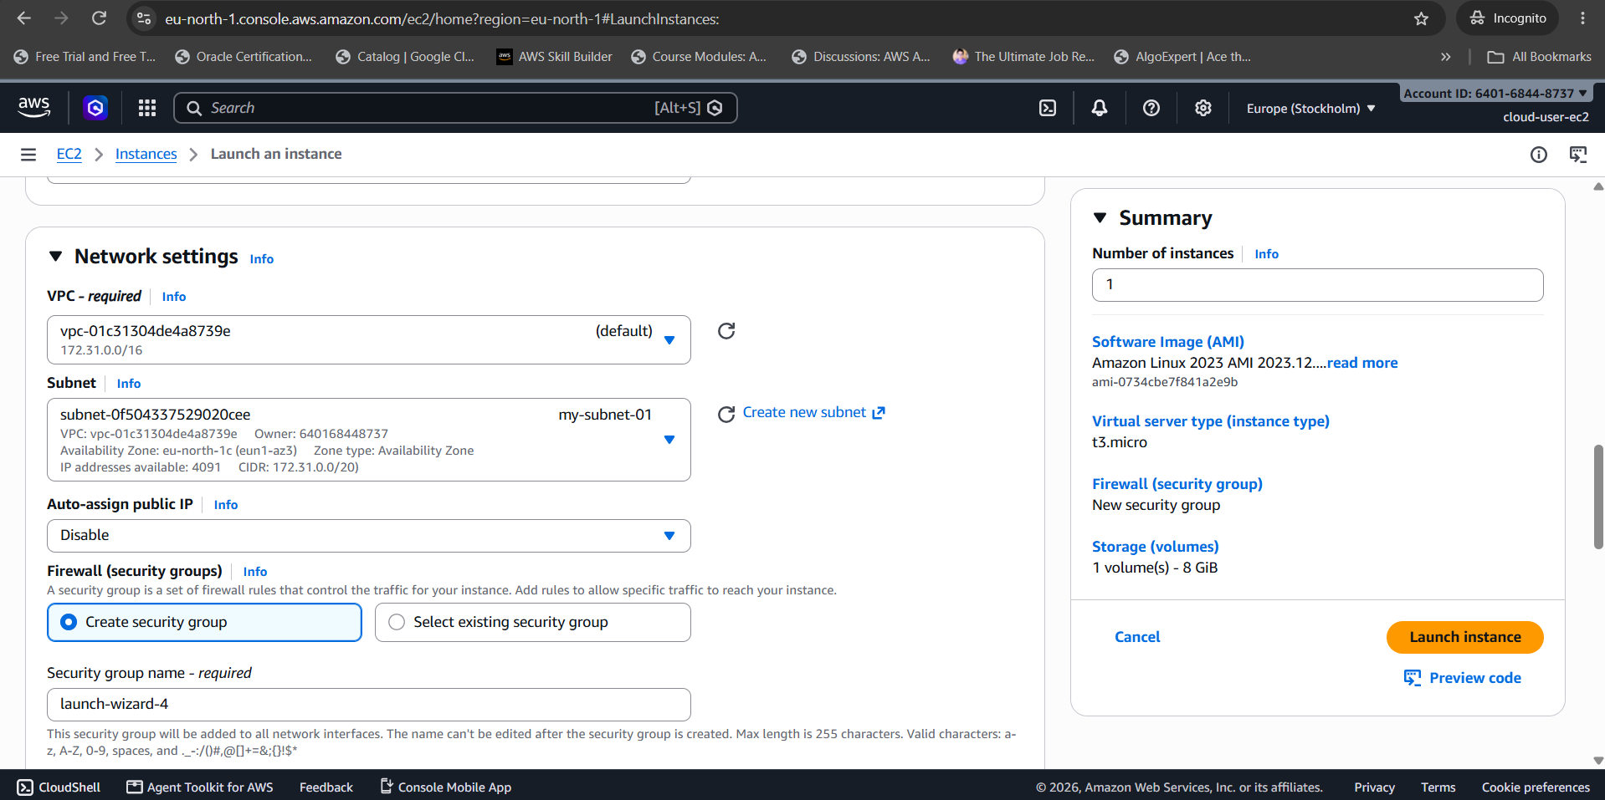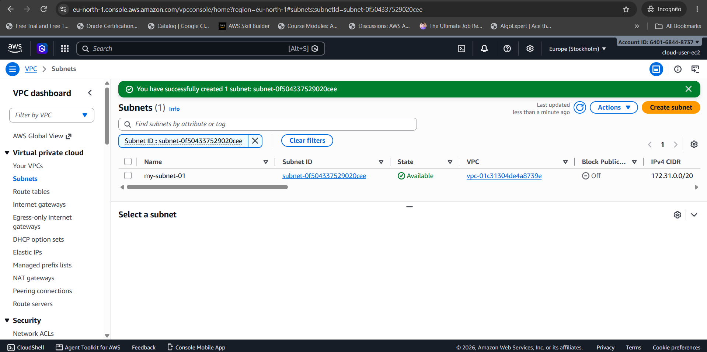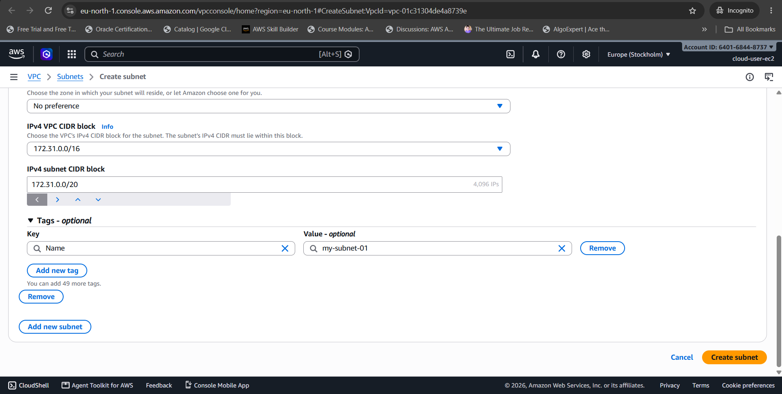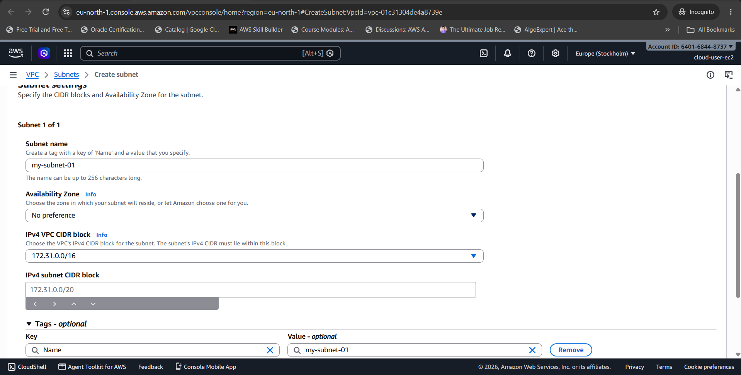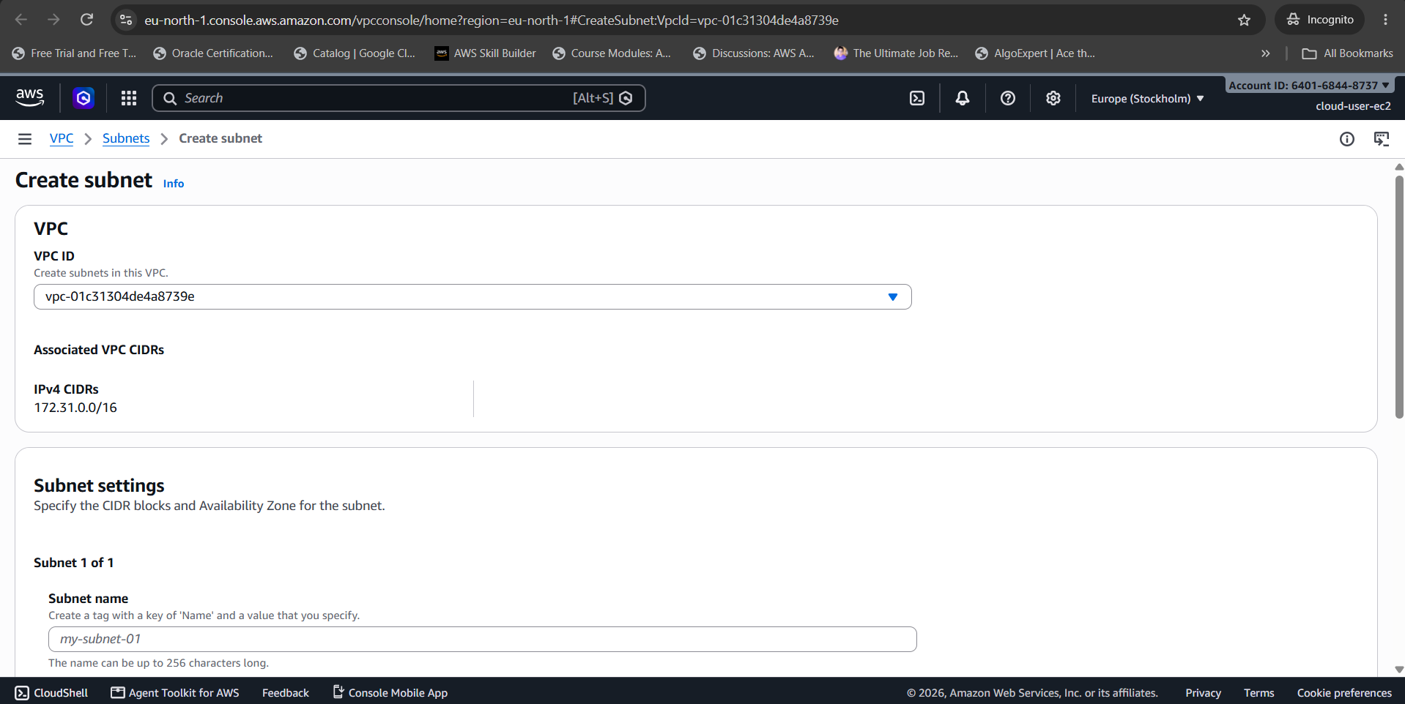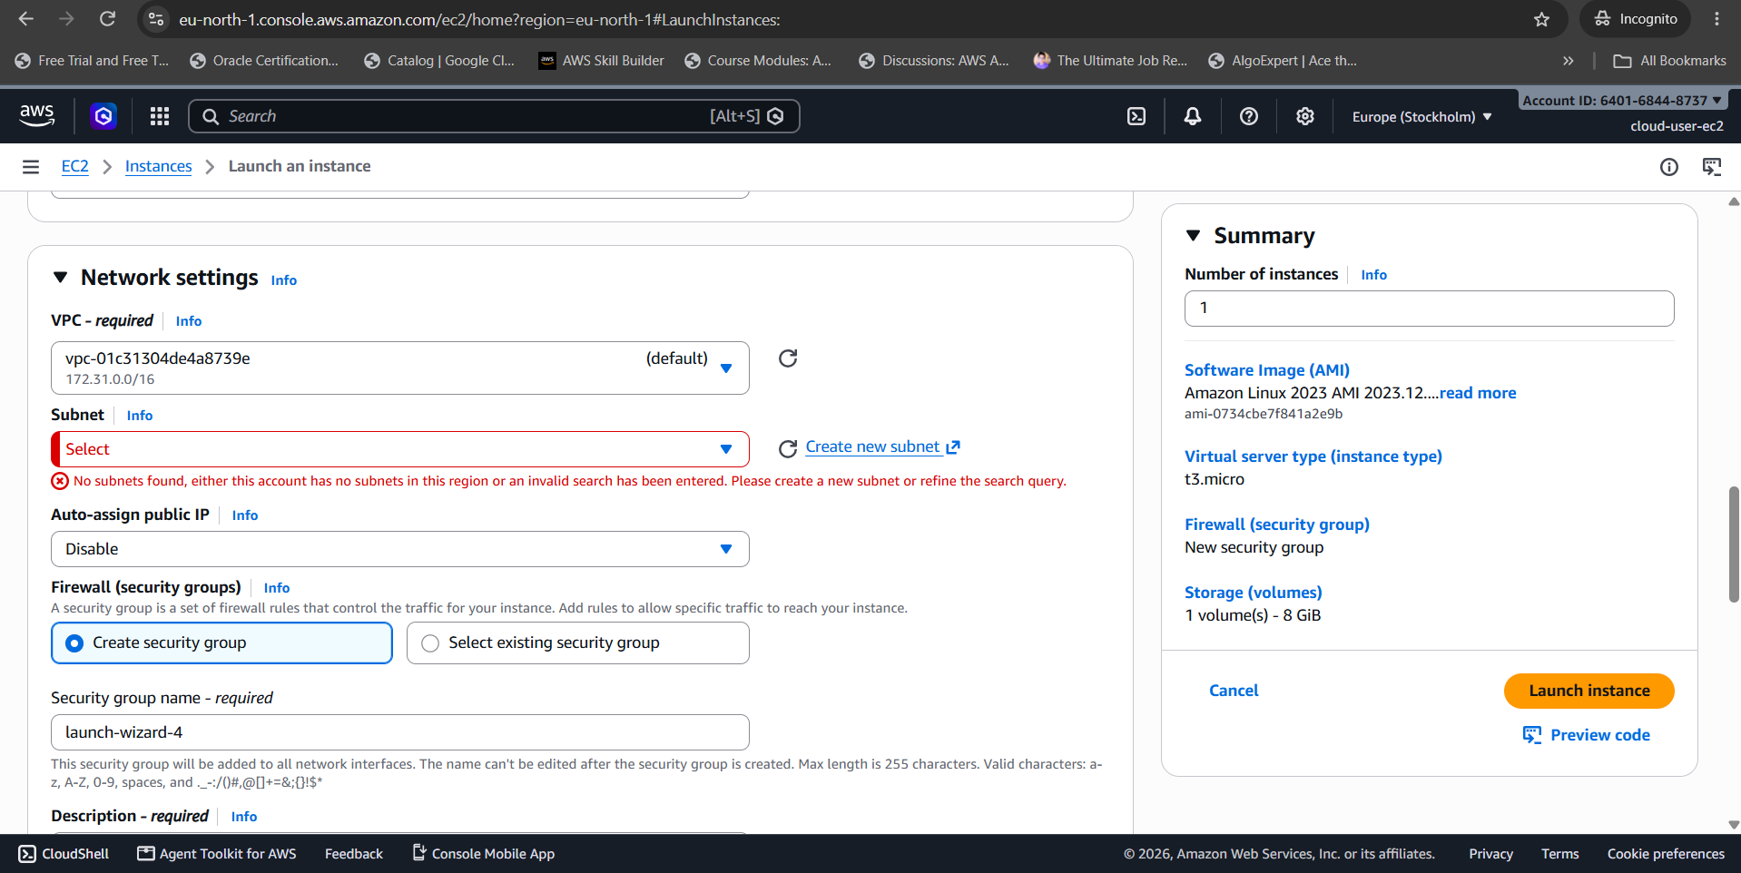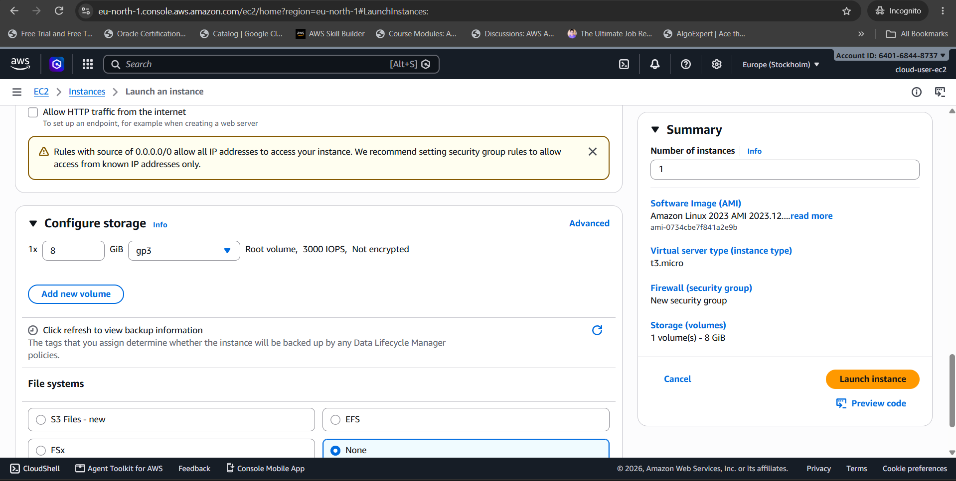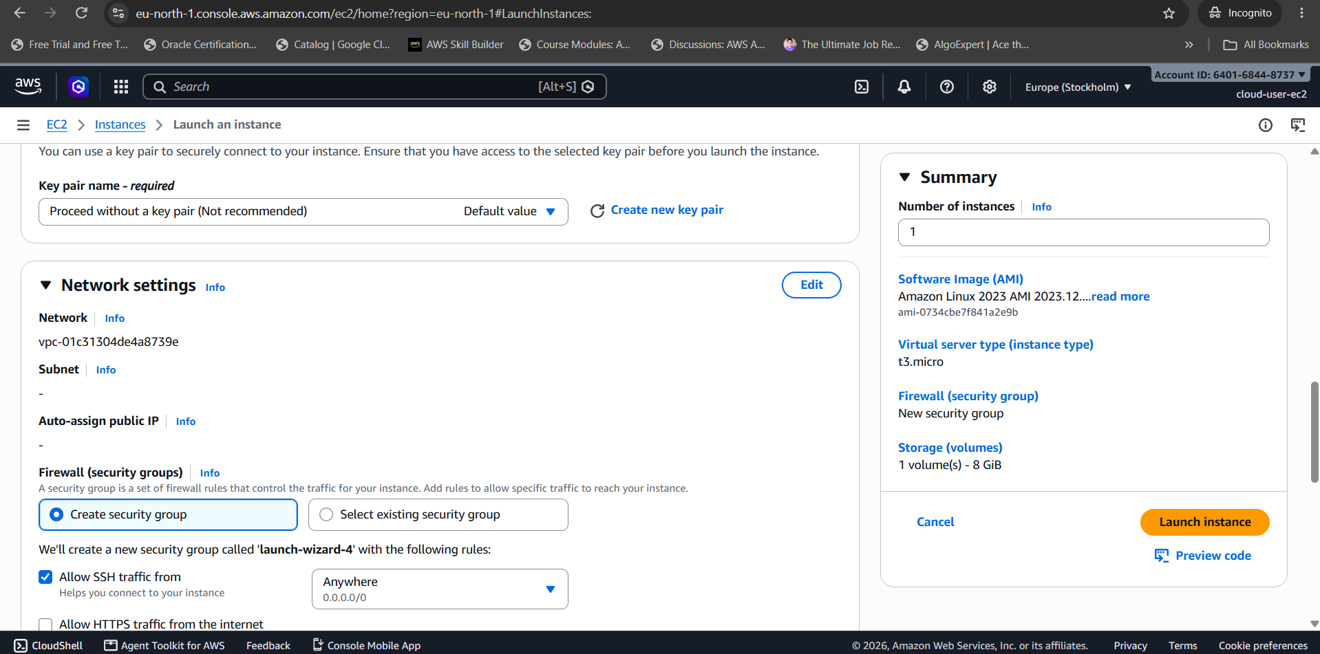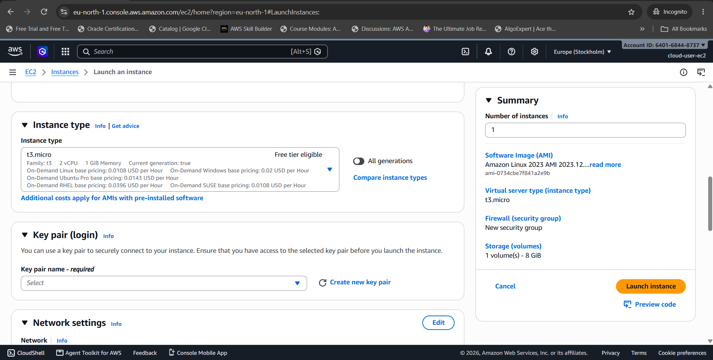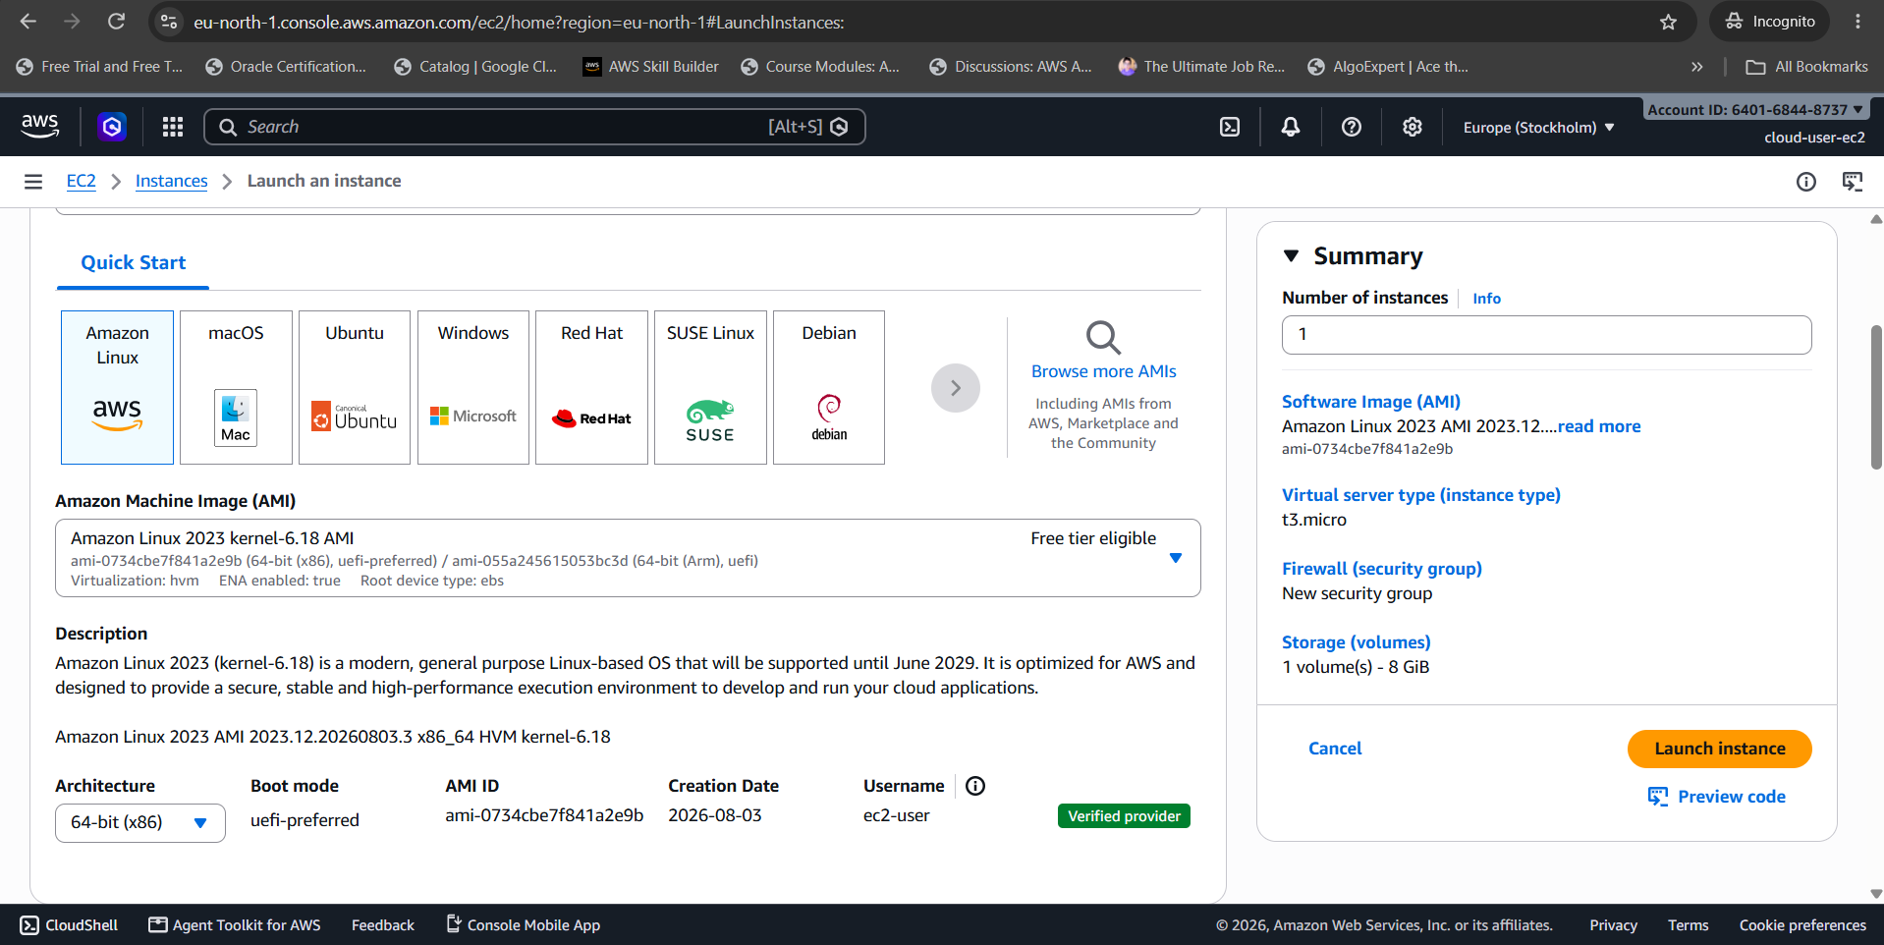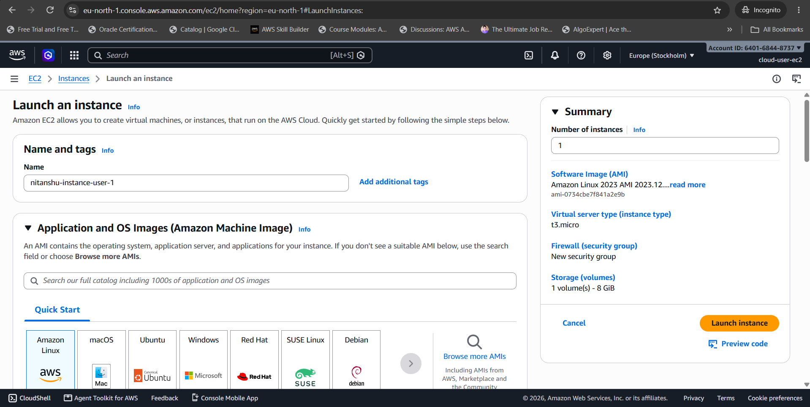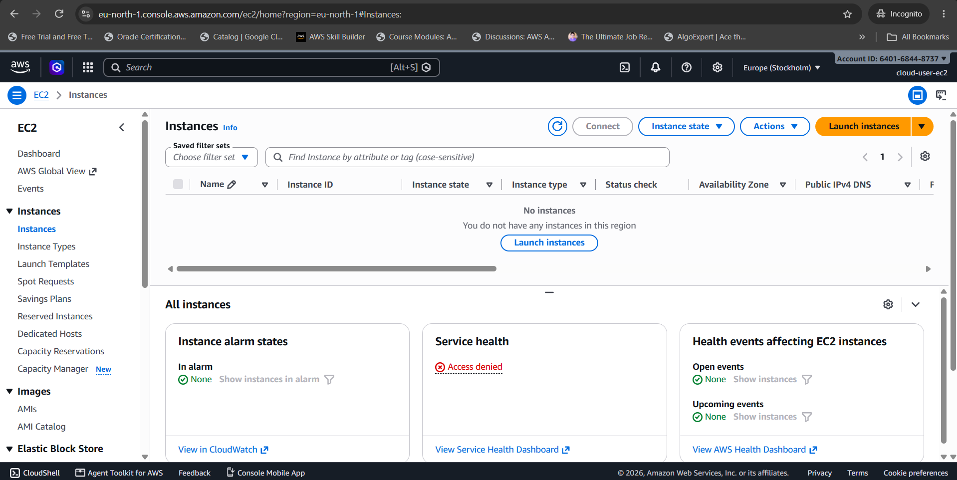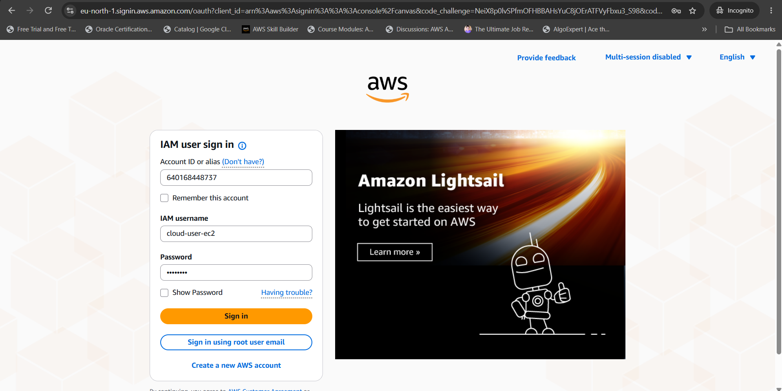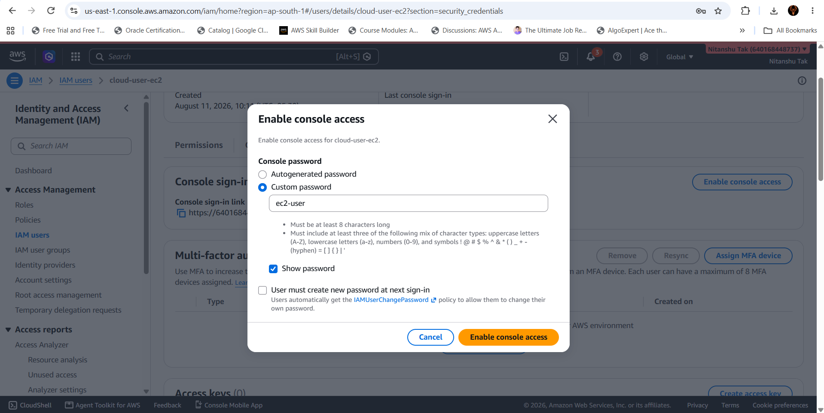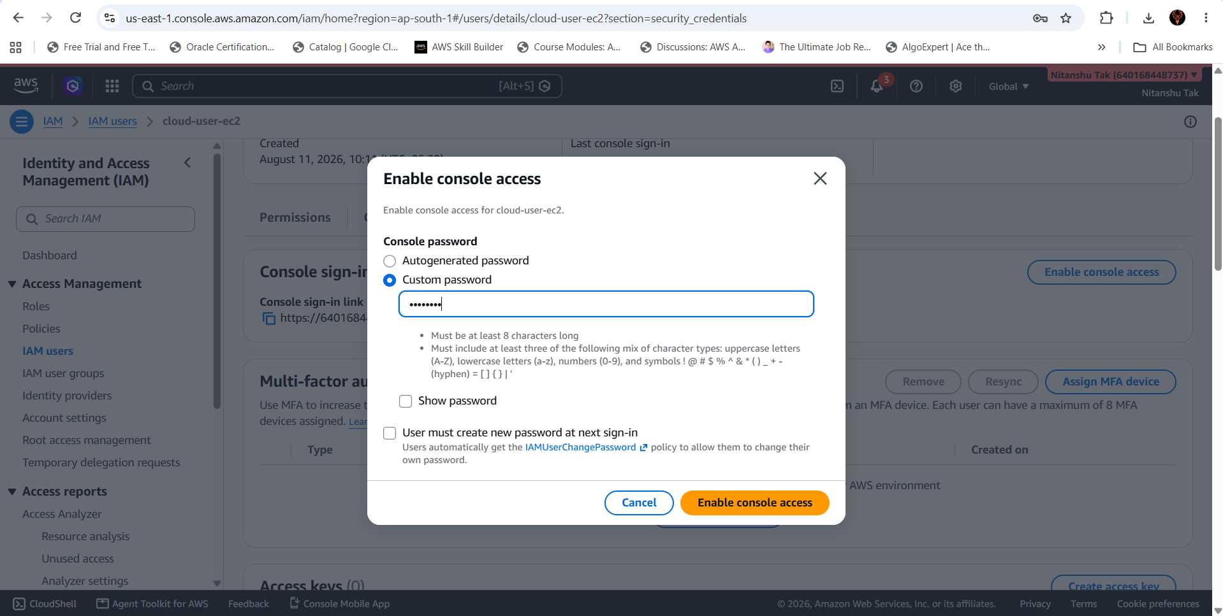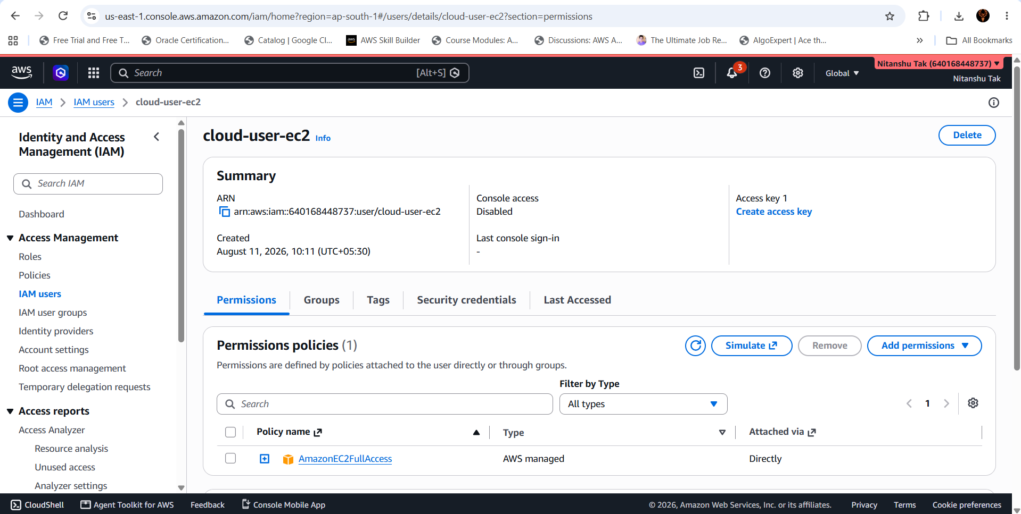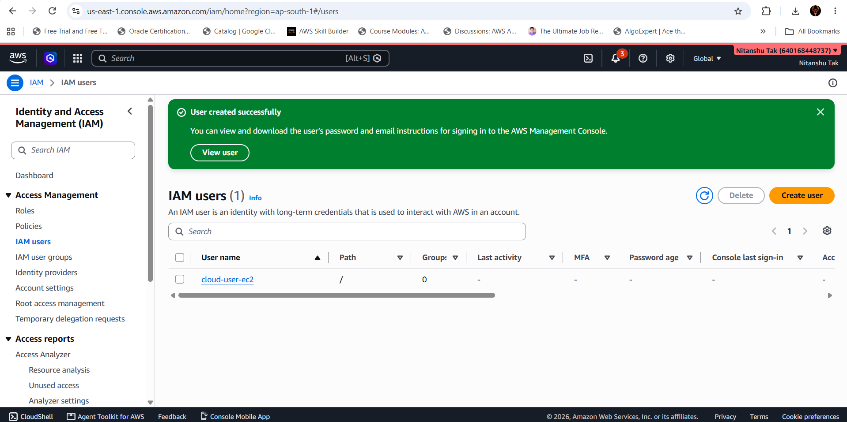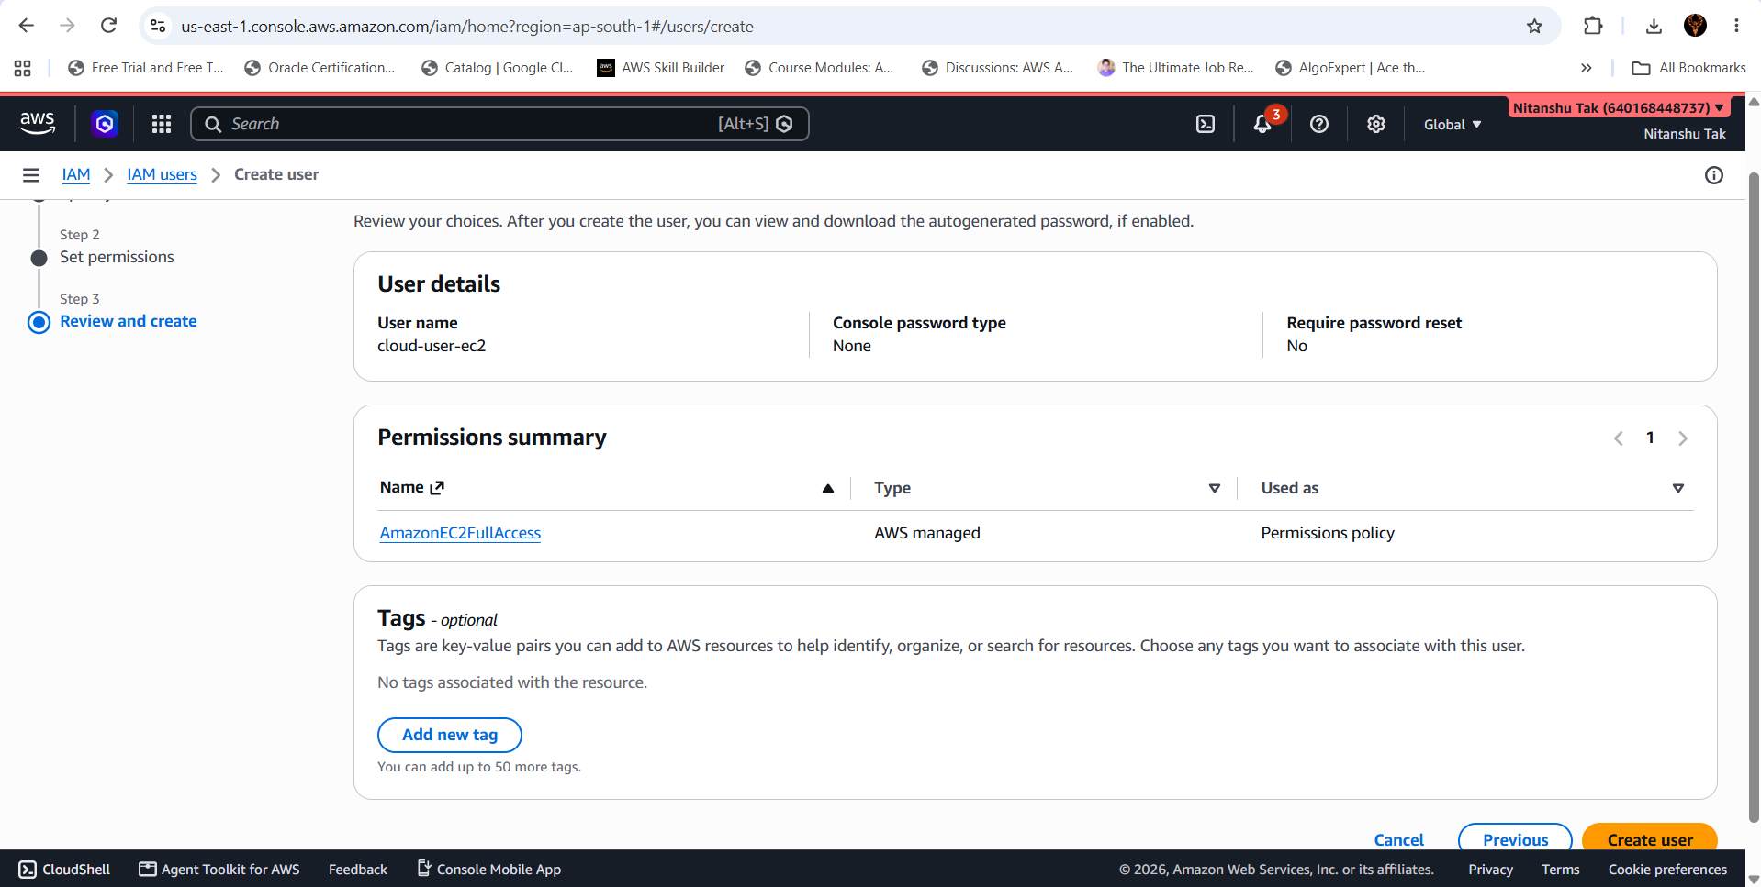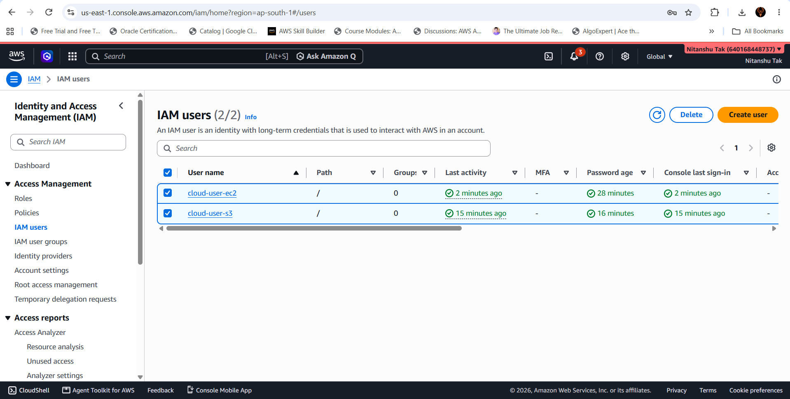

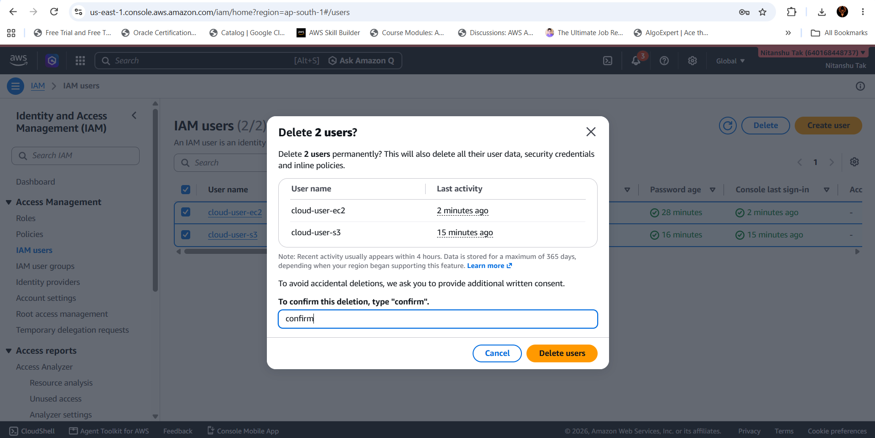

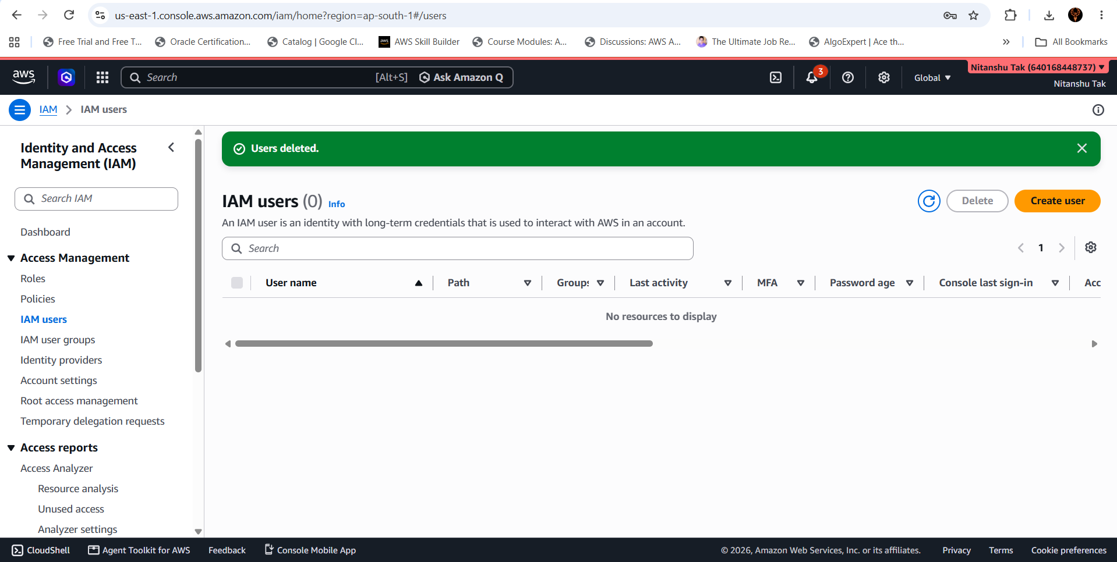

37. Final Checklist
☐ IAM service opened.
☐ Two IAM users created.
☐ User permissions reviewed.
☐ S3 permissions identified.
☐ IAM policy JSON inspected.
☐ Broad S3 access understood.
☐ Explicit Deny configured for s3:DeleteBucket.
☐ Allowed operations retained.
☐ Permission behavior tested.
☐ Least privilege explained.
☐ Security implications documented.
☐ All required screenshots collected.
☐ Experiment result verified.
— END OF EXPERIMENT 03 —

