CLOUD APPLICATION DEVELOPMENT LAB
EXPERIMENT – 3
Creating Buckets and Managing Objects in AWS

1. Experiment Information
Experiment | Experiment 3
Subject | Cloud Application Development
Experiment Title | Creating Buckets and Managing Objects in AWS
Cloud Platform | Amazon Web Services (AWS)
Primary Service | Amazon Simple Storage Service (Amazon S3)
Implementation | AWS Management Console
Main Concept | Cloud object storage and resource management
Key Operations | Create bucket, configure bucket, upload and manage objects
Faculty | Dr. Harvinder Malhotra

2. Aim
To understand Amazon Simple Storage Service (Amazon S3) and practically perform bucket and object management operations using the AWS Management Console. The experiment focuses on creating an S3 bucket, reviewing its basic configuration, uploading objects, inspecting stored objects, and performing basic object-management operations.

3. Objectives
- Understand the purpose and architecture of Amazon S3.
- Understand the difference between an S3 bucket and an S3 object.
- Create an S3 bucket using the AWS Management Console.
- Understand important bucket configuration options.
- Upload files as objects into an S3 bucket.
- View and manage objects stored in a bucket.
- Understand object keys, metadata, storage classes, and versioning at a conceptual level.
- Understand basic S3 security and access-control considerations.
- Verify the final state of the bucket and its objects.

4. Introduction to Amazon S3
Amazon Simple Storage Service (Amazon S3) is an AWS object storage service designed to store and retrieve data at scale. S3 stores data as objects inside containers called buckets. It is widely used for application assets, backups, media, documents, datasets, logs, software artifacts, static websites, and archival data.
Unlike a traditional filesystem, S3 uses an object-storage model. The basic structure is: AWS Account → S3 → Bucket → Object.

5. S3 Bucket
A bucket is a logical container for objects in Amazon S3. Every S3 object belongs to a bucket. Bucket names must follow AWS naming requirements and are globally unique within the S3 namespace. A bucket is created in a selected AWS Region and can have configuration such as versioning, lifecycle rules, access controls, and encryption settings.
- Provides the top-level container for objects.
- Can contain a very large number of objects.
- Has bucket-level configuration and access controls.
- Is associated with an AWS Region.
- Should be protected from unintended public access.

6. S3 Object
An object is the actual data stored in an S3 bucket. Examples include images, PDFs, text files, videos, datasets, source-code archives, and application assets. An object is identified by its key and can have metadata, tags, a storage class, and version information when versioning is enabled.
- Object data — the contents of the stored file.
- Object key — the name used to identify the object.
- Metadata — information associated with the object.
- Storage class — defines storage and access characteristics.
- Version ID — identifies a particular version when versioning is enabled.

7. Bucket vs Object
Aspect | Bucket | Object
Purpose | Container for objects | Actual stored data
Example | my-lab-bucket | report.pdf
Identification | Bucket name | Object key
Configuration | Policies, versioning, lifecycle | Metadata, tags, storage class
Level | Bucket-level resource | Object-level resource

8. Important S3 Concepts

8.1 Object Key
An object key is the name used to identify an object inside its bucket. A key such as documents/report.pdf can provide a folder-like organization in the S3 console through prefixes, although S3 itself uses a flat object namespace rather than a traditional filesystem.

8.2 Region
An S3 bucket is created in a selected AWS Region. Region selection can affect latency, regulatory requirements, data location, and service costs.

8.3 Storage Classes
S3 provides different storage classes for different access patterns. S3 Standard is intended for frequently accessed data, Intelligent-Tiering is useful when access patterns change, and S3 Glacier storage classes are designed for archival use cases.

8.4 Durability and Availability
Durability describes protection against data loss, while availability describes how accessible the service is when requested. S3 is designed for extremely high durability through redundant storage infrastructure.

8.5 Versioning
S3 Versioning can preserve multiple versions of objects and helps recover from accidental overwrites or deletions. Retained versions can increase storage usage and should therefore be managed appropriately.

8.6 Metadata and Tags
Metadata stores information associated with an object, while tags are key-value pairs useful for organization, automation, cost allocation, and management.

9. Basic S3 Security
S3 security should follow least privilege and secure-by-default principles. New buckets should not be made public unless public access is an intentional and understood requirement.
- Use IAM policies to control identity access.
- Use bucket policies when resource-based access control is needed.
- Keep S3 Block Public Access enabled when public access is unnecessary.
- Protect sensitive information and use encryption where appropriate.
- Use HTTPS/TLS for data in transit.
- Never commit AWS credentials to source-control repositories.
- Review and remove unnecessary permissions.

10. Practical Procedure
- Sign in to the AWS Management Console.
- Search for and open Amazon S3.
- Open the Buckets section.
- Choose Create bucket.
- Enter a valid, globally unique bucket name.
- Select the required AWS Region.
- Review Object Ownership settings.
- Review Block Public Access settings and keep public access blocked unless specifically required.
- Review the remaining configuration options and create the bucket.
- Open the newly created bucket.
- Open the Objects section.
- Choose Upload and select the required local file or files.
- Review the selected files and upload them.
- Verify that the uploaded files appear as S3 objects.
- Open an object to inspect its details and available management operations.
- Perform the required object-management operation(s).
- Verify the final bucket and object state.

11. Object Management Operations
Operation | Purpose | Example
Upload | Add data to a bucket | Upload a PDF/image
View | Inspect object details | Open object properties
Download | Retrieve an object locally | Download a document
Copy | Create another copy | Copy an object
Delete | Remove an object | Delete an unwanted file

12. Practical Workflow
AWS Management Console → S3 → Create Bucket → Configure Bucket → Create → Open Bucket → Upload Object → Verify Object → Manage Object → Final Verification

13. Verification
- The bucket appears in the S3 bucket list.
- The bucket name is correct.
- The bucket was created in the intended Region.
- The bucket opens successfully.
- Uploaded objects appear under the Objects section.
- Object names and sizes are displayed correctly.
- Object details can be inspected.
- The required object-management operation succeeds.
- No unintended public-access configuration was introduced.

14. Test Cases
ID | Test Case | Expected Result | Status
TC-01 | Open S3 | S3 console opens | Pass
TC-02 | Create bucket | Bucket appears in list | Pass
TC-03 | Open bucket | Bucket contents open | Pass
TC-04 | Upload object | Object appears in bucket | Pass
TC-05 | Inspect object | Object details are visible | Pass
TC-06 | Manage object | Required operation completes | Pass
TC-07 | Final verification | Expected final state is visible | Pass

15. Observations
- S3 uses an object-storage model based on buckets and objects.
- A bucket is a logical container for objects.
- Bucket names must satisfy global naming requirements.
- Objects are identified by object keys.
- The S3 console simplifies bucket and object management.
- S3 supports multiple storage classes and management features.
- Access should be restricted using appropriate AWS security controls.
- Public access should only be enabled intentionally.
- Cloud object storage removes the need to manage traditional storage hardware directly.

16. Applications of Amazon S3
- Static website assets and hosting.
- Backup and disaster recovery.
- Application file storage.
- Images, videos, and media.
- Data lakes and analytics datasets.
- Logs and audit data.
- Software packages and deployment artifacts.
- Documents and business files.
- Long-term archival storage.

17. Advantages of Amazon S3
- Highly durable object storage.
- Elastic storage capacity.
- Integration with many AWS services.
- Multiple storage classes.
- Fine-grained access control.
- Versioning and lifecycle management.
- Encryption capabilities.
- Console, CLI, SDK, and API access.
- Suitable for small applications and large-scale workloads.

18. Learning Outcomes
After completing this experiment, the following concepts were understood:
- Fundamentals of Amazon S3.
- Bucket and object architecture.
- Difference between buckets and objects.
- Creating and configuring an S3 bucket.
- Uploading and managing objects.
- Object keys and object properties.
- Basic S3 security and access control.
- Storage classes and versioning concepts.
- Verification of cloud-storage operations using the AWS Console.

19. Screenshot Documentation
Insert the screenshots captured during the practical execution in the spaces below. Keep them in chronological order so that the complete workflow can be followed.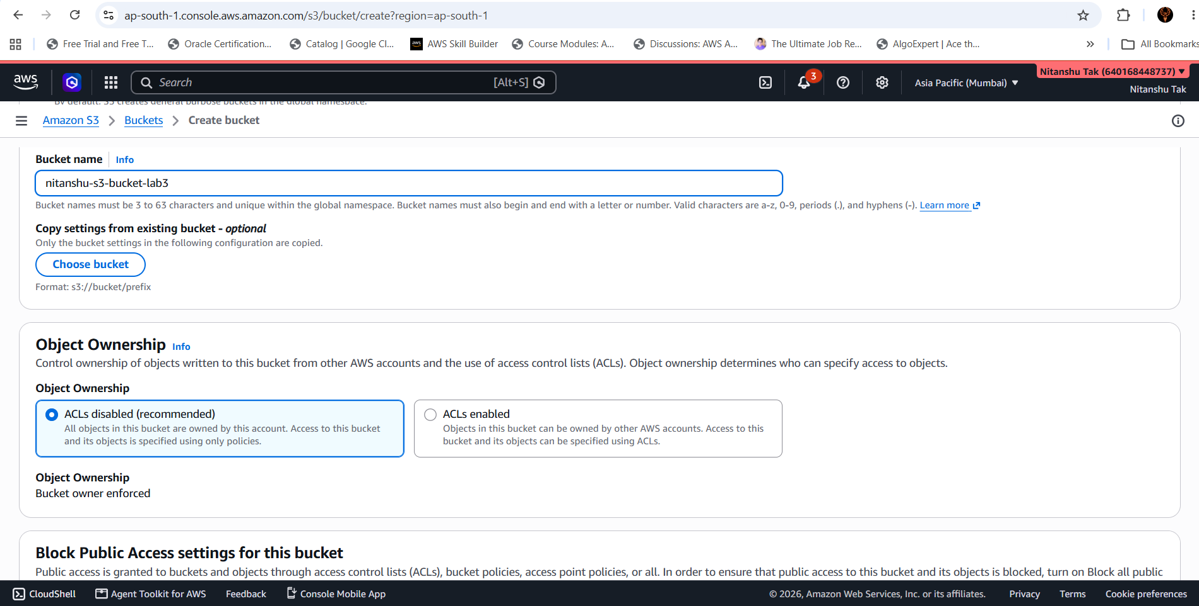

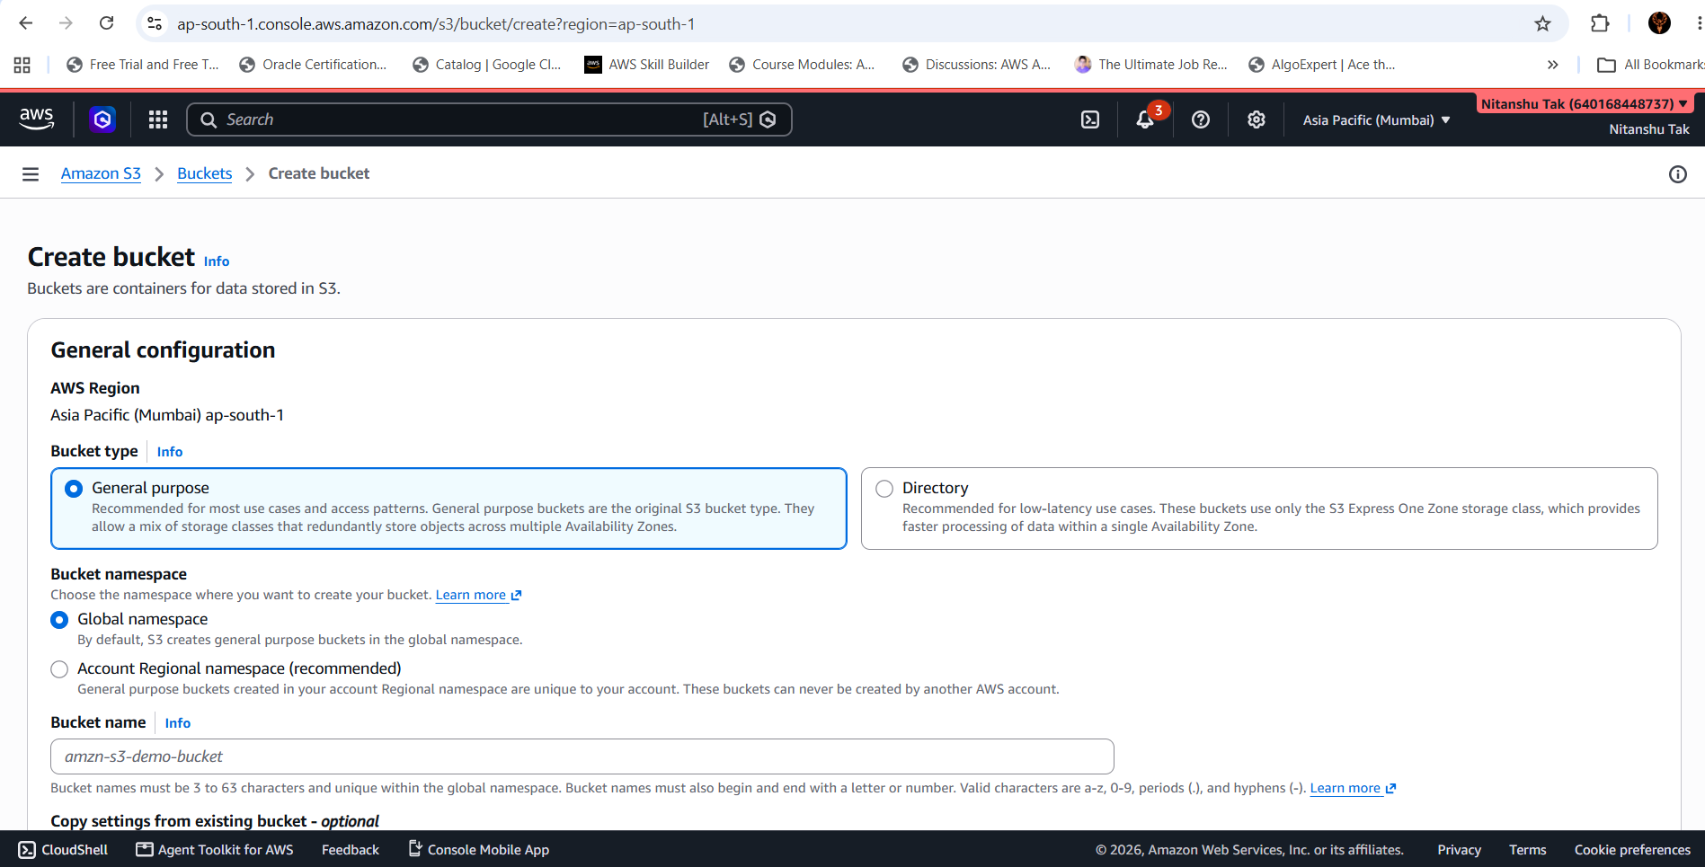

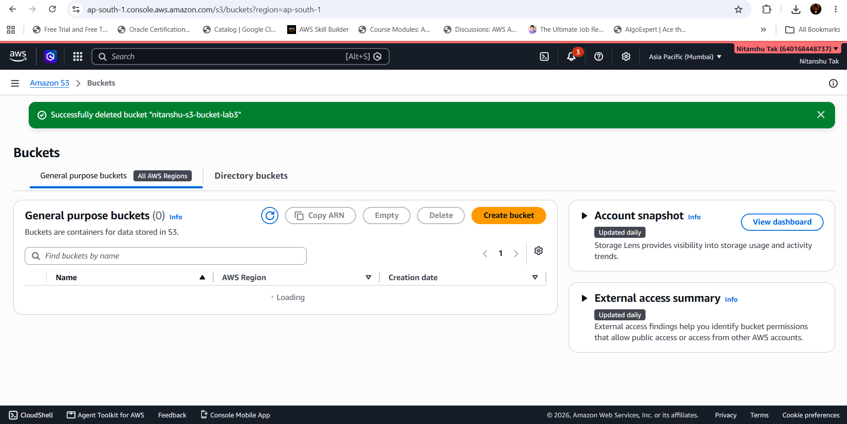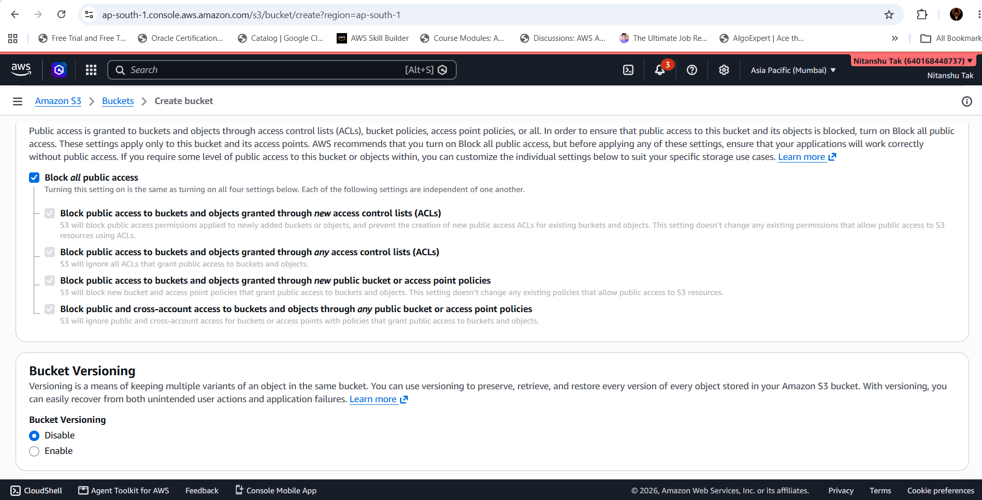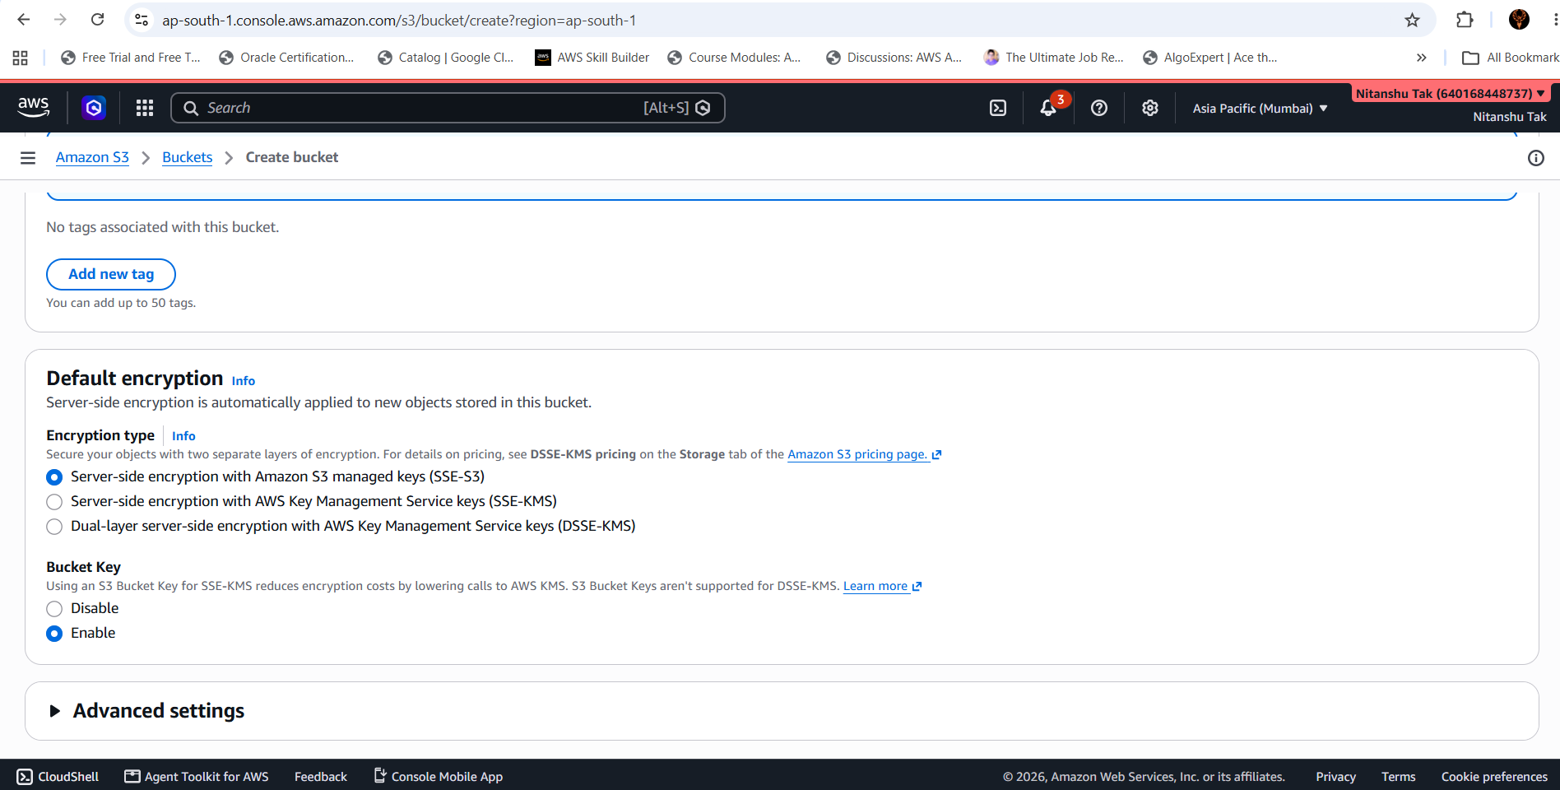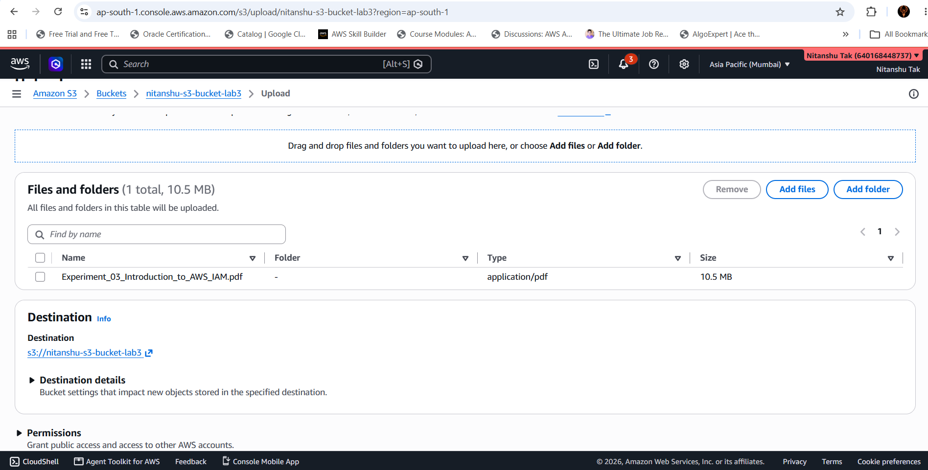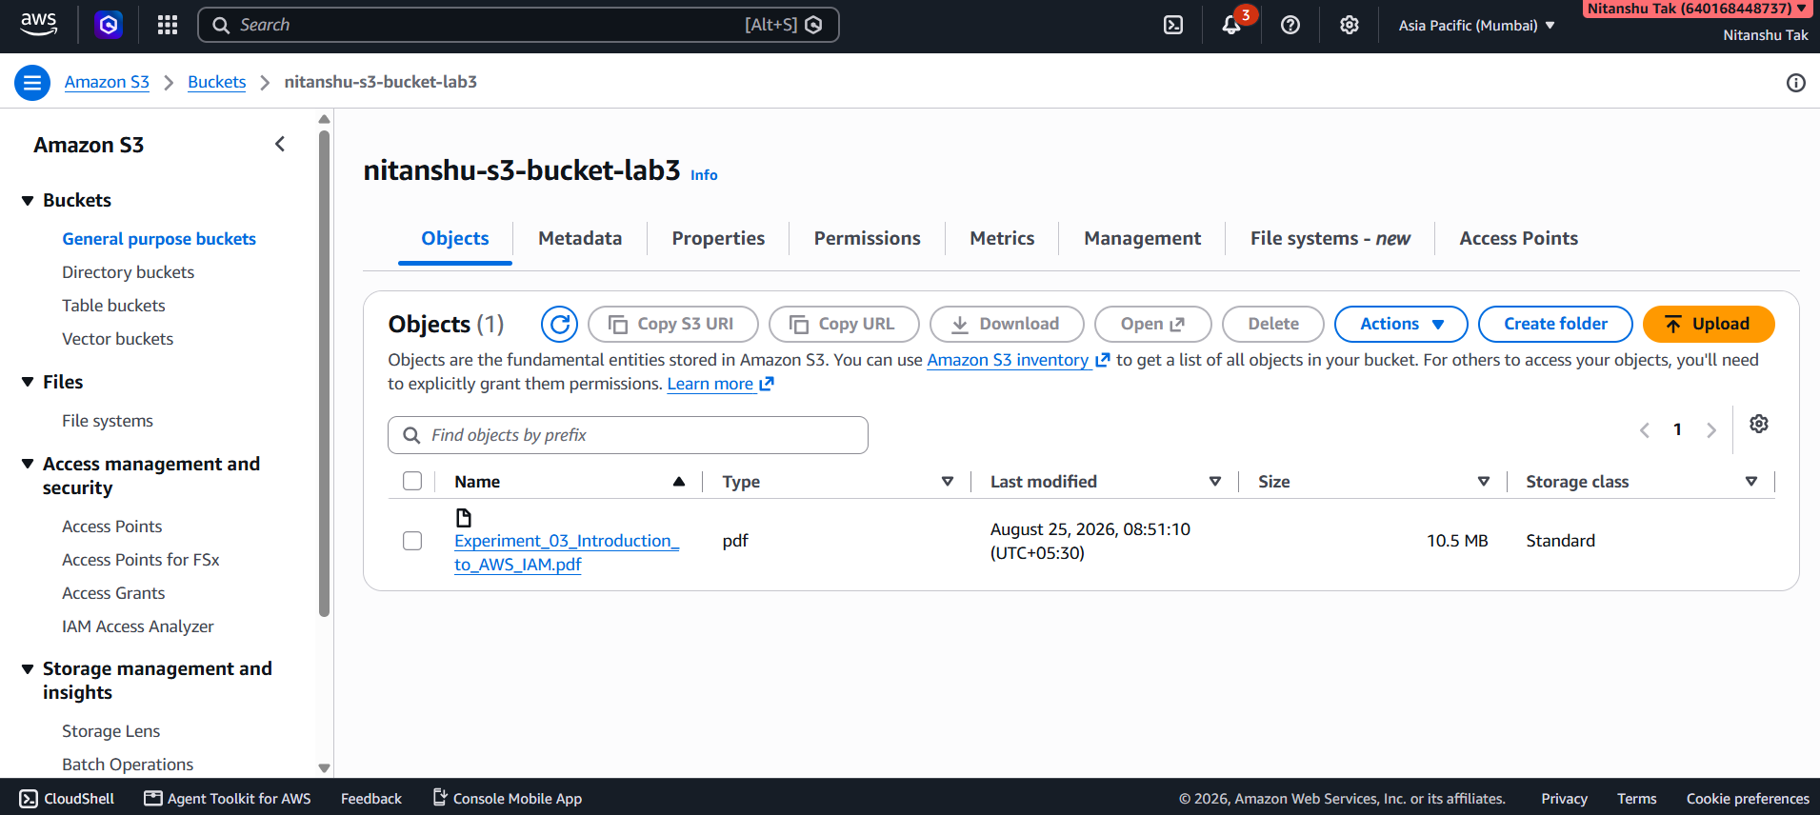

20. Result
The experiment was successfully completed. An Amazon S3 bucket was created using the AWS Management Console, objects were uploaded to the bucket, and the stored objects were inspected and managed. The practical demonstrated the basic workflow of creating and using AWS object storage.

21. Conclusion
This experiment provided practical exposure to Amazon S3 and its object-storage model. The complete basic lifecycle of an S3 resource was explored: creating a bucket, reviewing its configuration, uploading objects, inspecting object information, performing management operations, and verifying the final state.
The experiment also reinforced the importance of cloud-storage security. S3 resources should use least-privilege permissions, unnecessary public access should be avoided, and sensitive data should be protected through appropriate access-control and encryption mechanisms.

