EXPERIMENT 7 — PART 2
Error Handling, API Security, Monitoring, and Performance
Cloud Application Development | B.Tech CSE
Nitanshu Tak | 500121943 | CCVT Batch-2

1. Aim
To validate error handling in the deployed REST API, configure basic API-key access control and a usage plan, and use Amazon CloudWatch logs and metrics to understand API monitoring, troubleshooting, throttling, and scalability.

2. Learning Objectives
- Test API behavior when requests contain missing fields or invalid JSON.
- Configure API-key requirements for REST API methods.
- Create a usage plan and associate it with an API stage and API key.
- Test requests with and without the required API key.
- Enable and inspect API Gateway execution logs and CloudWatch metrics.
- Understand throttling, request management, and serverless scalability.

3. Prerequisites
- Part 1 is complete and the REST API is deployed.
- Existing API: CAD-Experiment-7-REST-API.
- Existing Lambda function: cad-exp7-student-api.
- Resource endpoint: /students.
- Deployment stage: dev.
- The actual invoke URL from the AWS Console.
- Permission to configure API Gateway, IAM, and CloudWatch in the lab account.

4. Architecture and Working Principle
Part 2 reuses the REST API and Lambda function from Part 1. API Gateway checks the API-key requirement, routes accepted requests to Lambda, and returns the response. A usage plan associates the API key with the deployed stage and defines request-usage targets. CloudWatch can collect execution logs and API metrics for monitoring and troubleshooting.
Request flow: Client → API Gateway API-key check → /students GET or POST → AWS Lambda → JSON response.
Component | Purpose
API key | Identifies a calling client for usage management; it is not strong user authentication.
Usage plan | Associates an API key with an API stage and defines throttling/quota targets.
CloudWatch Logs | Stores available API execution log events for troubleshooting.
CloudWatch Metrics | Shows request counts, errors, and latency where metrics are available.

5. Procedure

Step 1: Test Error Handling — Missing Student Name
Open Windows PowerShell. Replace the example endpoint below with the actual /dev/students URL from Part 1. This initial test assumes API-key enforcement has not yet been enabled.
$uri = "https://YOUR-API-ID.execute-api.ap-south-1.amazonaws.com/dev/students"
$body = @{
id = 104
} | ConvertTo-Json
try {
Invoke-WebRequest -Uri $uri -Method Post `
-ContentType "application/json" -Body $body
} catch {
Write-Output "HTTP status: $([int]$_.Exception.Response.StatusCode)"
Write-Output "The invalid request was rejected."
}
Expected result: HTTP 400 Bad Request because the required student name is missing. Record the actual response.

Step 2: Test Invalid JSON
try {
Invoke-WebRequest -Uri $uri -Method Post `
-ContentType "application/json" -Body '{ invalid json'
} catch {
Write-Output "HTTP status: $([int]$_.Exception.Response.StatusCode)"
Write-Output "The invalid JSON request was rejected."
}
Expected result: HTTP 400 Bad Request. Capture the command and observed result. If PowerShell displays an error differently, record the actual status and message.

Step 3: Understand Unsupported Methods
The API currently defines GET and POST only. A PUT request to /students is not configured and is normally rejected by API Gateway. The exact status and message depend on API configuration; do not assume that the Lambda function's 405 response will be returned for an unconfigured API Gateway method.

Step 4: Require an API Key for GET
- Open the Amazon API Gateway Console and select CAD-Experiment-7-REST-API.
- Open Resources and select /students, then select GET.
- Open Method request.
- Under Method request settings, click Edit if required.
- Enable API key required and save the method settings.

Step 5: Require an API Key for POST
- Select /students and open POST.
- Open Method request and click Edit if required.
- Enable API key required and save.
- Leave authorization set to NONE for this API-key demonstration; API keys are not a substitute for user authentication.

Step 6: Redeploy the REST API
- Click Deploy API.
- Select the existing dev stage.
- Click Deploy and confirm if prompted.
- Keep the existing invoke URL for the following tests.
REST API method-setting changes must be deployed to the stage before they take effect.

Step 7: Create an API Key
- In the API Gateway navigation pane, open API keys.
- Click Create API key.
- Set Name to CAD-Experiment-7-Key.
- Set Description to API key for Student REST API lab.
- Choose Auto generate and ensure the key is enabled if that option appears.
- Save the key, open its details, and copy the API key value.
Keep the API key private. Do not place its actual value in screenshots, the lab report, or public repositories.

Step 8: Create a Usage Plan
- Open Usage plans in API Gateway.
- Click Create usage plan.
- Set Name to CAD-Experiment-7-Usage-Plan.
- Set the description to Usage plan for the Student REST API lab.
- If the throttling settings are available, use a demonstration rate limit of 5 requests per second and a burst limit of 10.
- If a quota is available, optionally set a demonstration quota of 100 requests per day.
- Create the usage plan.
These are lab demonstration values. Usage-plan throttling and quotas are best-effort targets and are not guaranteed hard limits.

Step 9: Associate the API Stage and Key
- Open the usage plan and locate Associated API stages.
- Add CAD-Experiment-7-REST-API and select the dev stage, then save.
- Open Associated API keys.
- Add CAD-Experiment-7-Key and confirm the association.
- Wait a few minutes for the association to propagate before testing.

Step 10: Test Without an API Key
Open the /dev/students URL in a browser or send a request without the x-api-key header. The request should be rejected with an API-key-related error, commonly HTTP 403. Record the actual response.

Step 11: Test GET with the API Key
Run the following PowerShell commands. Replace the URL with the actual endpoint. Enter the key when prompted so it is not embedded directly in the script.
$uri = "https://YOUR-API-ID.execute-api.ap-south-1.amazonaws.com/dev/students"
$apiKey = Read-Host "Enter your API key"
$headers = @{
"x-api-key" = $apiKey
}
Invoke-RestMethod -Uri $uri -Method Get -Headers $headers
Expected result: the student JSON response is returned if the key, usage plan, stage association, and deployment are configured correctly.

Step 12: Test POST with the API Key
$body = @{
id = 105
name = "Nitanshu"
} | ConvertTo-Json
Invoke-RestMethod -Uri $uri -Method Post `
-Headers $headers `
-ContentType "application/json" `
-Body $body
Expected result: the response contains Student received successfully. Do not expose the key in screenshots.

Step 13: Configure CloudWatch Logging Role
Skip this step if the API Gateway CloudWatch role is already configured for the selected Region.
- Open IAM → Roles → Create role.
- Choose AWS service as the trusted entity and select API Gateway as the service/use case if offered by the console.
- Attach the AWS-managed policy AmazonAPIGatewayPushToCloudWatchLogs.
- Name the role APIGatewayCloudWatchLogsRole and create it.
- Open the role and copy its ARN.
- Return to API Gateway Settings in the same Region.
- Find CloudWatch log role ARN, paste the role ARN, and save.
If your lab account does not allow role creation or the console presents a different setup, stop and follow your institution's account procedure. Do not modify unrelated IAM roles.

Step 14: Enable Stage Logging
- Open CAD-Experiment-7-REST-API → Stages → dev.
- Find Logs and tracing and click Edit.
- Set CloudWatch execution logging to Errors and info logs or the equivalent INFO level.
- Leave data tracing disabled because request and response data can contain sensitive information.
- Enable detailed metrics if available and appropriate for the lab.
- Save the stage settings.

Step 15: Inspect CloudWatch Logs
- Send a successful GET request using the API key to generate activity.
- Open the CloudWatch Console in the same Region.
- Navigate to Logs → Log groups.
- Look for a log group similar to API-Gateway-Execution-Logs_<API-ID>/dev.
- Open the latest log stream and inspect the events for the request and any integration errors.
- Capture a screenshot of relevant log events, avoiding sensitive information.
If the log group does not appear, verify the Region, the API Gateway CloudWatch role ARN, and the stage logging settings. Allow time for log delivery.

Step 16: Inspect CloudWatch Metrics
- In CloudWatch, open Metrics → All metrics.
- Find the API Gateway namespace, commonly shown as ApiGateway.
- Select the dimensions for your API and stage where available.
- Inspect Count, 4XXError, 5XXError, Latency, and IntegrationLatency when available.
- Choose a time range that includes your test requests and refresh after a short delay.
- Capture a screenshot of the metrics available in your account.
Metrics can take time to appear and may depend on the selected dimensions and detailed-metrics settings.

Step 17: Document Throttling and Scalability
- Open the CAD-Experiment-7-Usage-Plan usage plan.
- Review and capture its rate limit, burst limit, and quota settings if configured.
- Explain that API Gateway can throttle requests and may return HTTP 429 when applicable limits are exceeded.
- Explain that usage-plan limits are best-effort and that Lambda scales within AWS service limits.
- Do not run a high-volume stress test merely to force a throttling response.

6. Expected Results
Test / Configuration | Expected outcome | Purpose
POST without name | HTTP 400 | Validates required input.
POST with invalid JSON | HTTP 400 | Validates malformed input handling.
Request without required API key | Usually HTTP 403 | Demonstrates API-key enforcement.
GET with valid key | HTTP 200 and student JSON | Confirms authorized-key request succeeds.
POST with valid key | HTTP 201 and submitted data | Confirms POST works with the key.
CloudWatch logs | Execution events, where logging is configured | Supports troubleshooting.
CloudWatch metrics | Available request, error, and latency metrics | Supports monitoring.

7. Troubleshooting Notes
- 403 with a valid key: verify both methods require a key, the dev stage is associated with the usage plan, the key is associated with the plan, and changes have been deployed.
- 403 without a key: this is the expected access-control behavior after API-key enforcement.
- 500 or 502: test Lambda independently and inspect API Gateway execution logs and the Lambda integration response.
- No CloudWatch logs: verify the Region, role ARN, stage logging level, and time allowed for delivery.
- No metrics visible: select the correct API/stage dimensions and time range; detailed metrics may need to be enabled.
- Do not share the API key or include its actual value in public documentation.

8. Observations
The deployed REST API was tested with valid and invalid POST requests to observe input validation. API-key requirements were enabled for GET and POST, an API key and usage plan were created, and requests were tested with and without the key. CloudWatch execution logs and available metrics were inspected. The usage plan's throttling and quota settings were reviewed to understand request management. Record the actual results observed during the practical session.

9. Result
Basic API-key enforcement and usage-plan configuration were implemented for the REST API. Error-handling behavior was tested, and CloudWatch monitoring was configured and examined, subject to the results obtained during the practical session. The exercise demonstrates request validation, basic API access control, monitoring, troubleshooting, and the role of throttling in serverless architectures.

10. Security Note
API keys identify clients and support usage management; they should not be treated as strong user authentication. Production APIs should use an appropriate authorization mechanism, such as IAM, a Lambda authorizer, or Amazon Cognito, based on application requirements. Avoid enabling data tracing or publishing API keys in screenshots or source repositories.

11. Screenshot Evidence to Attach
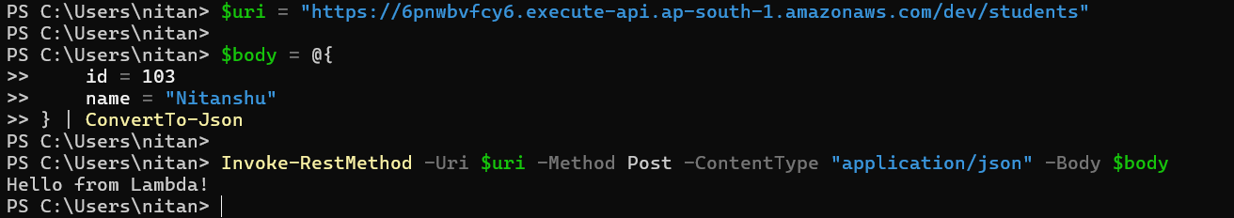

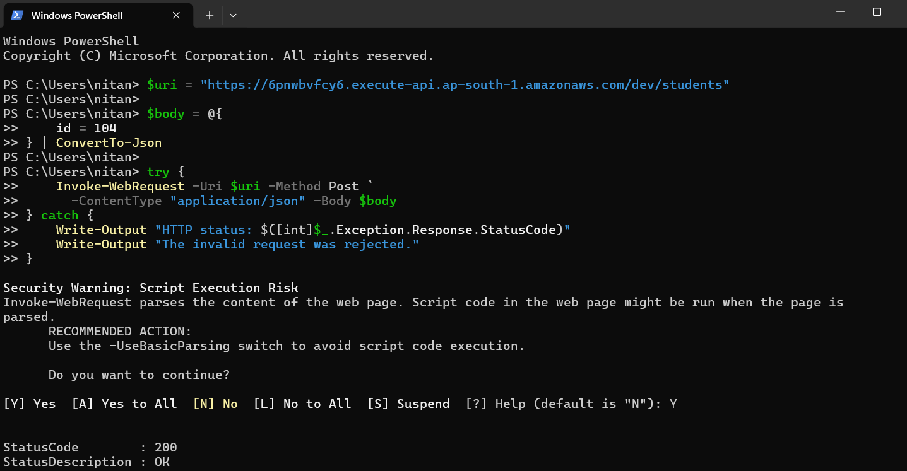
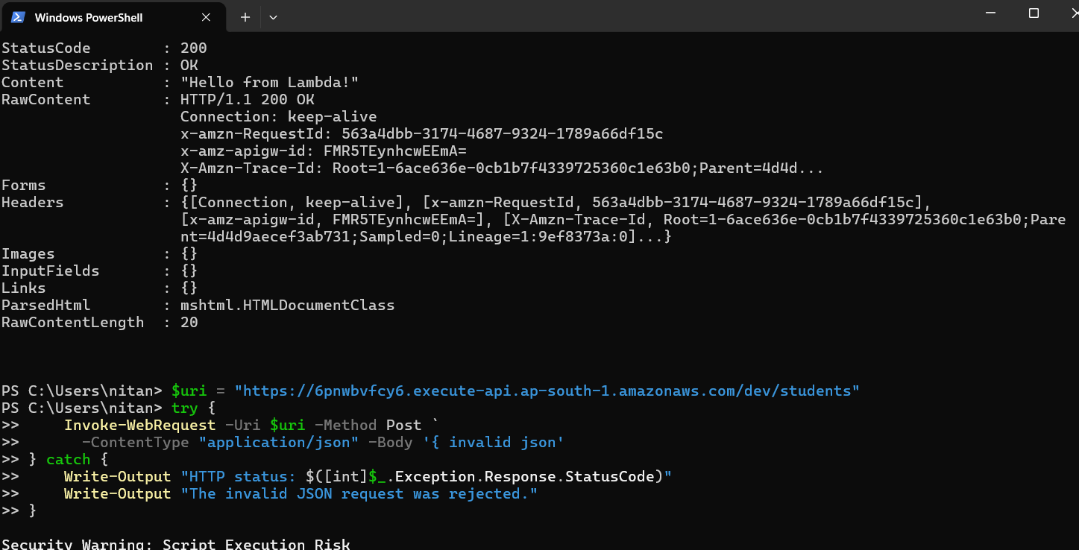
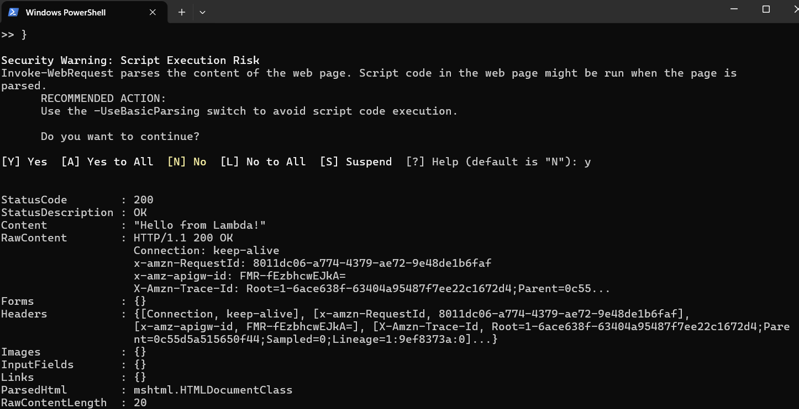
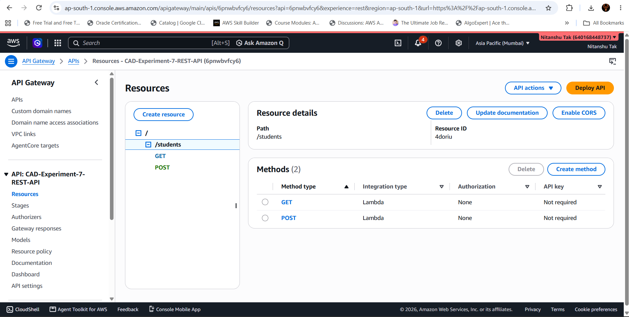
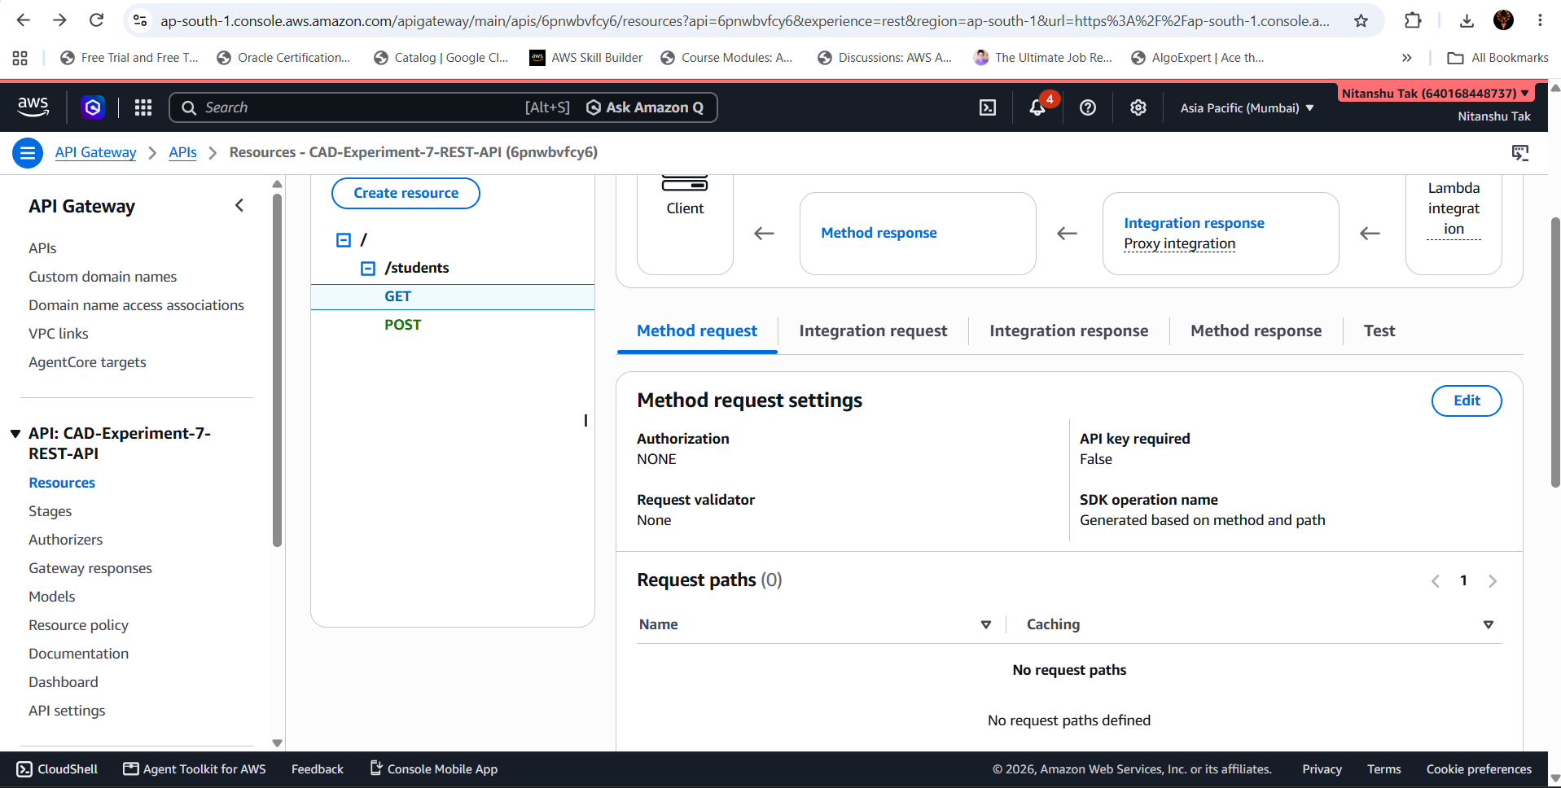
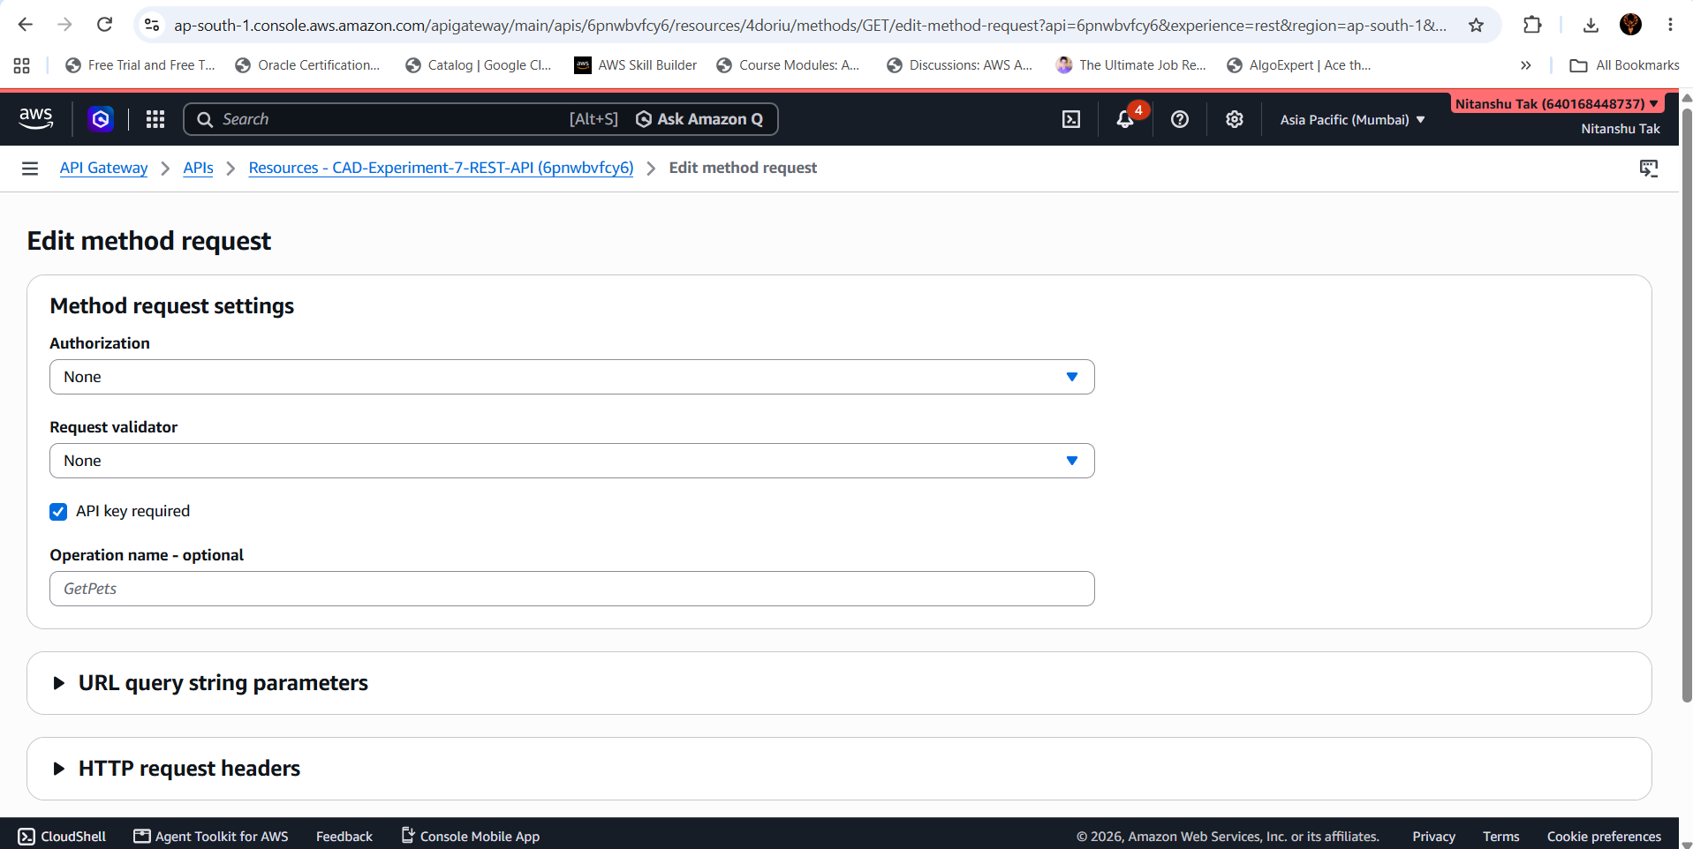
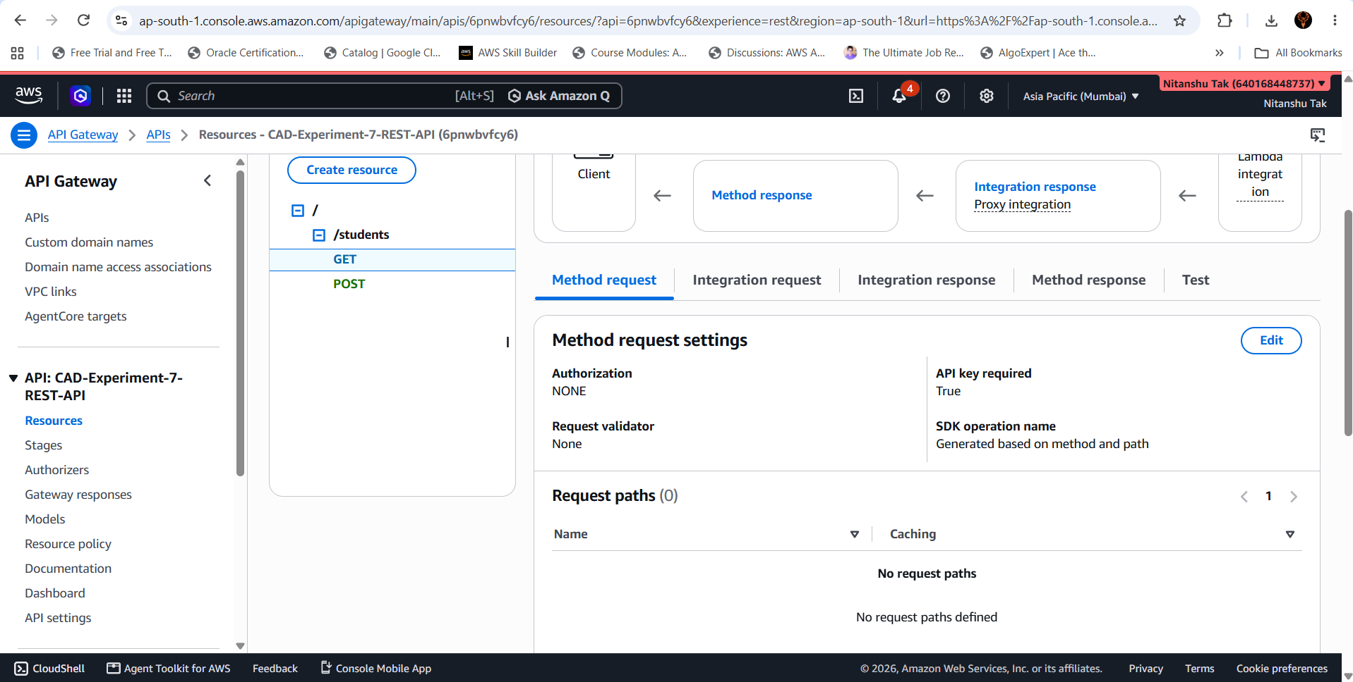
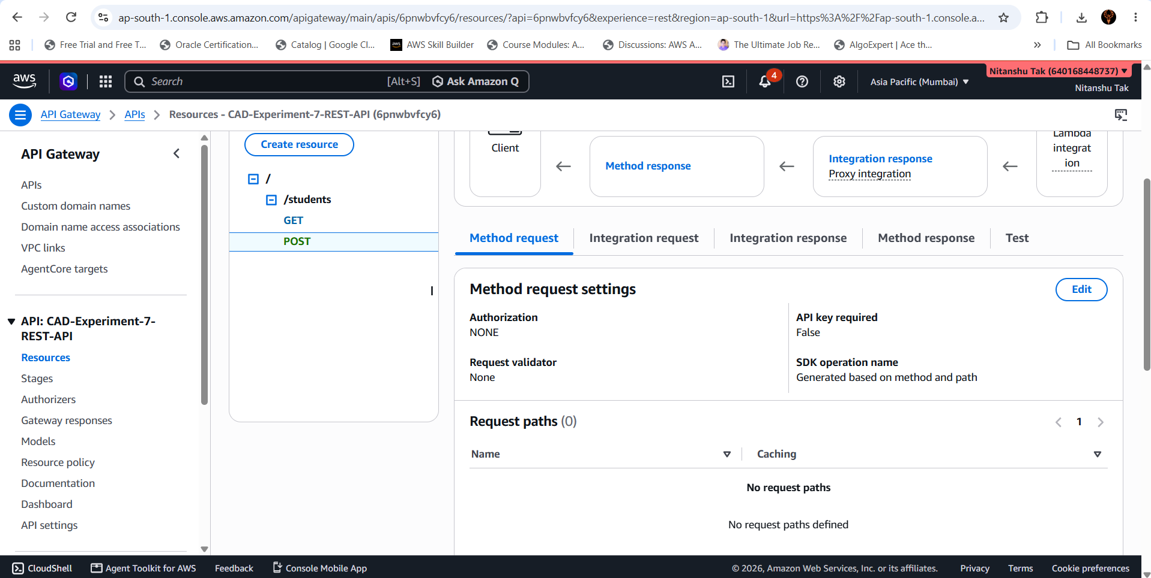
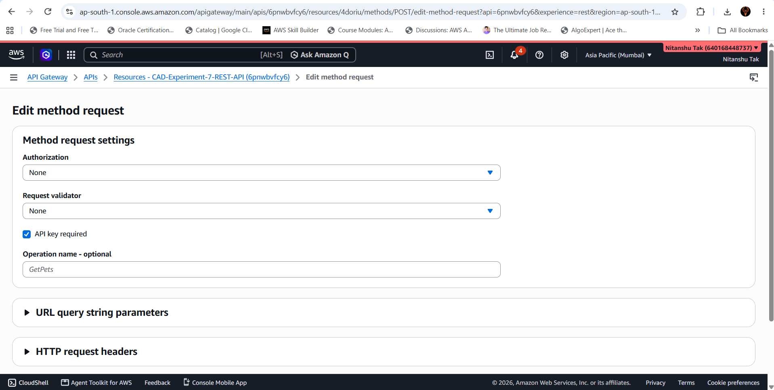
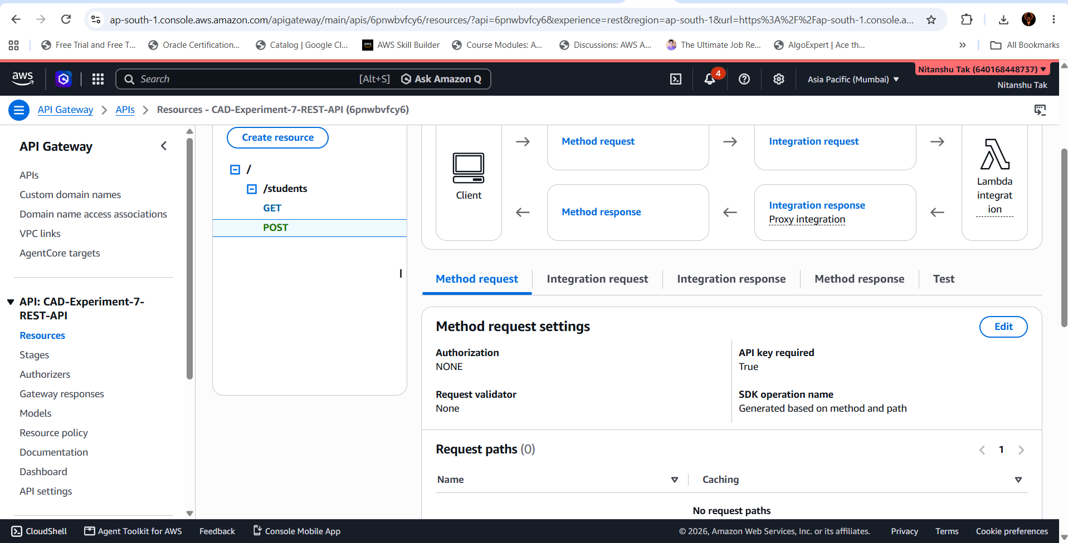
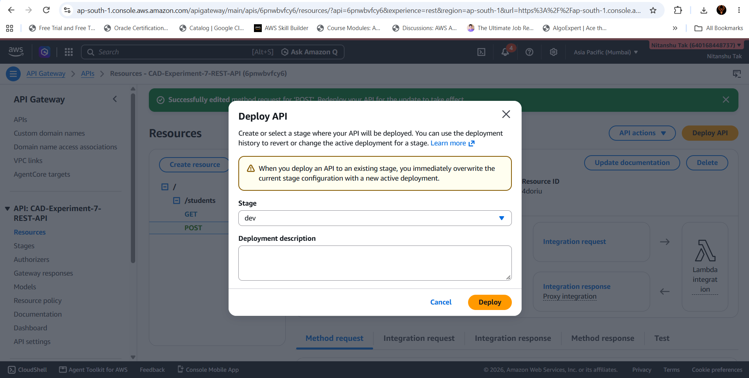
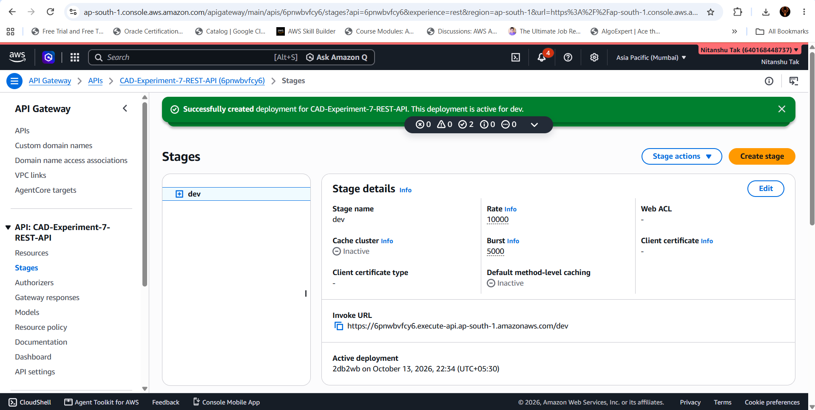
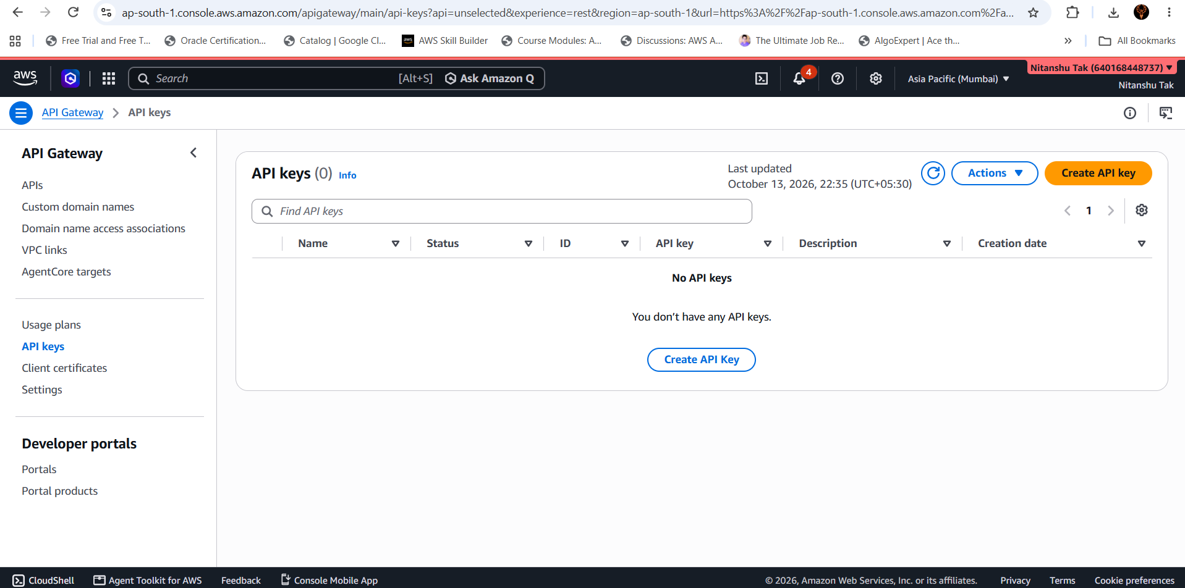
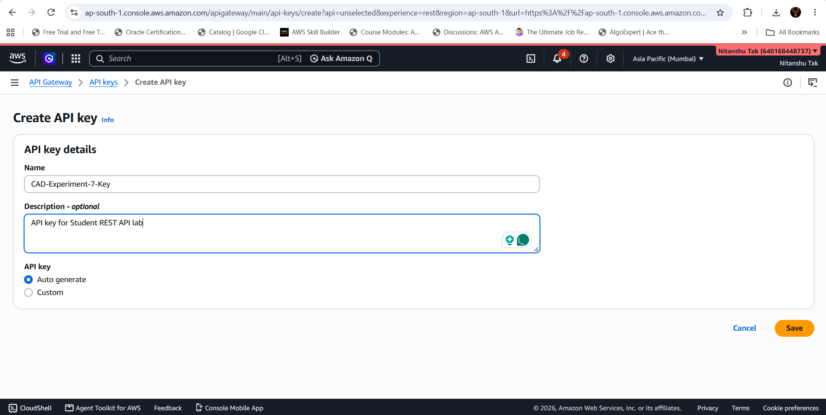
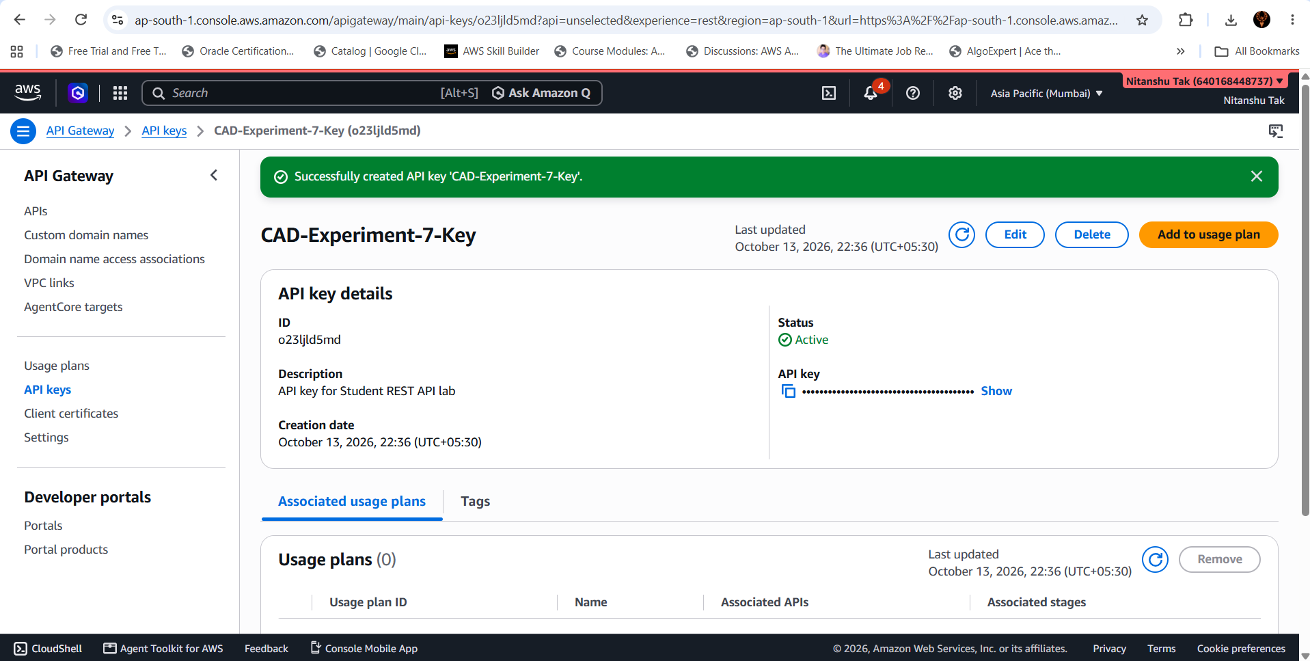
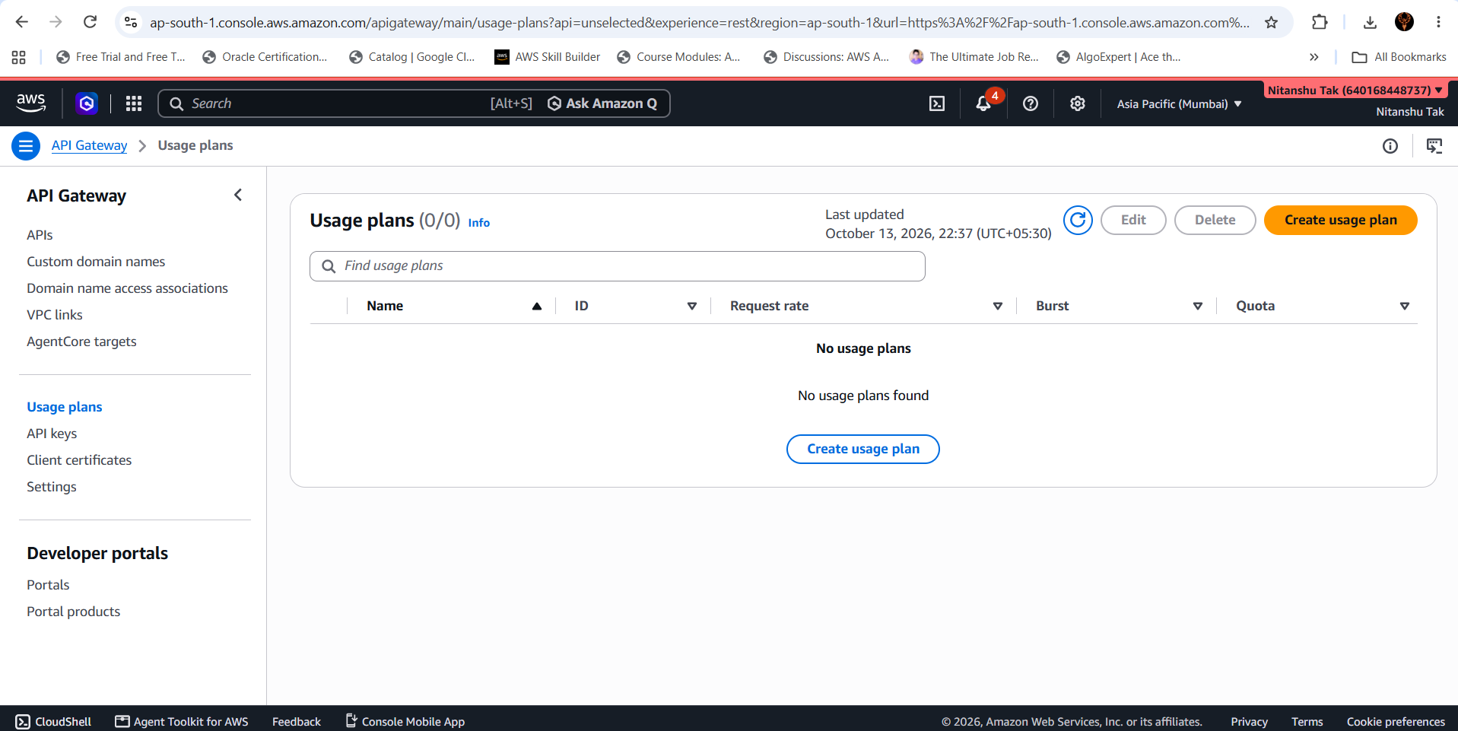
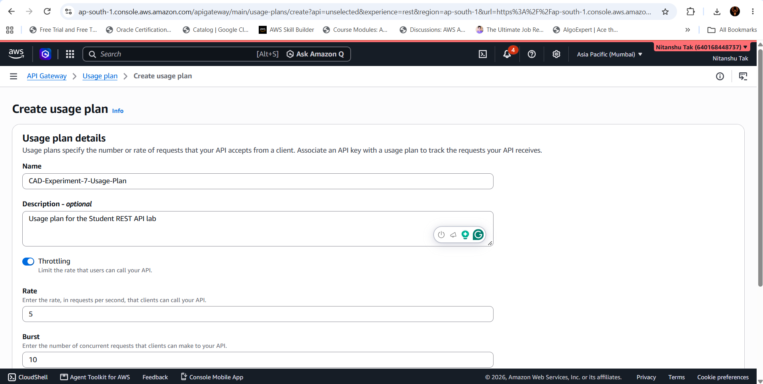
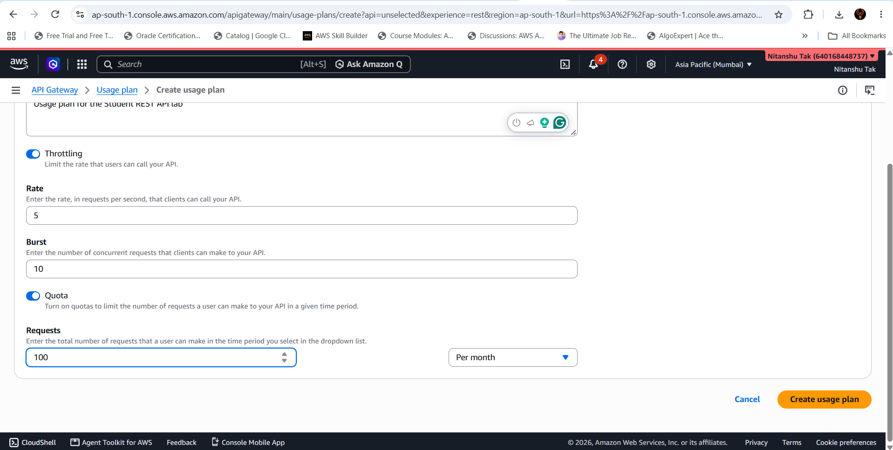
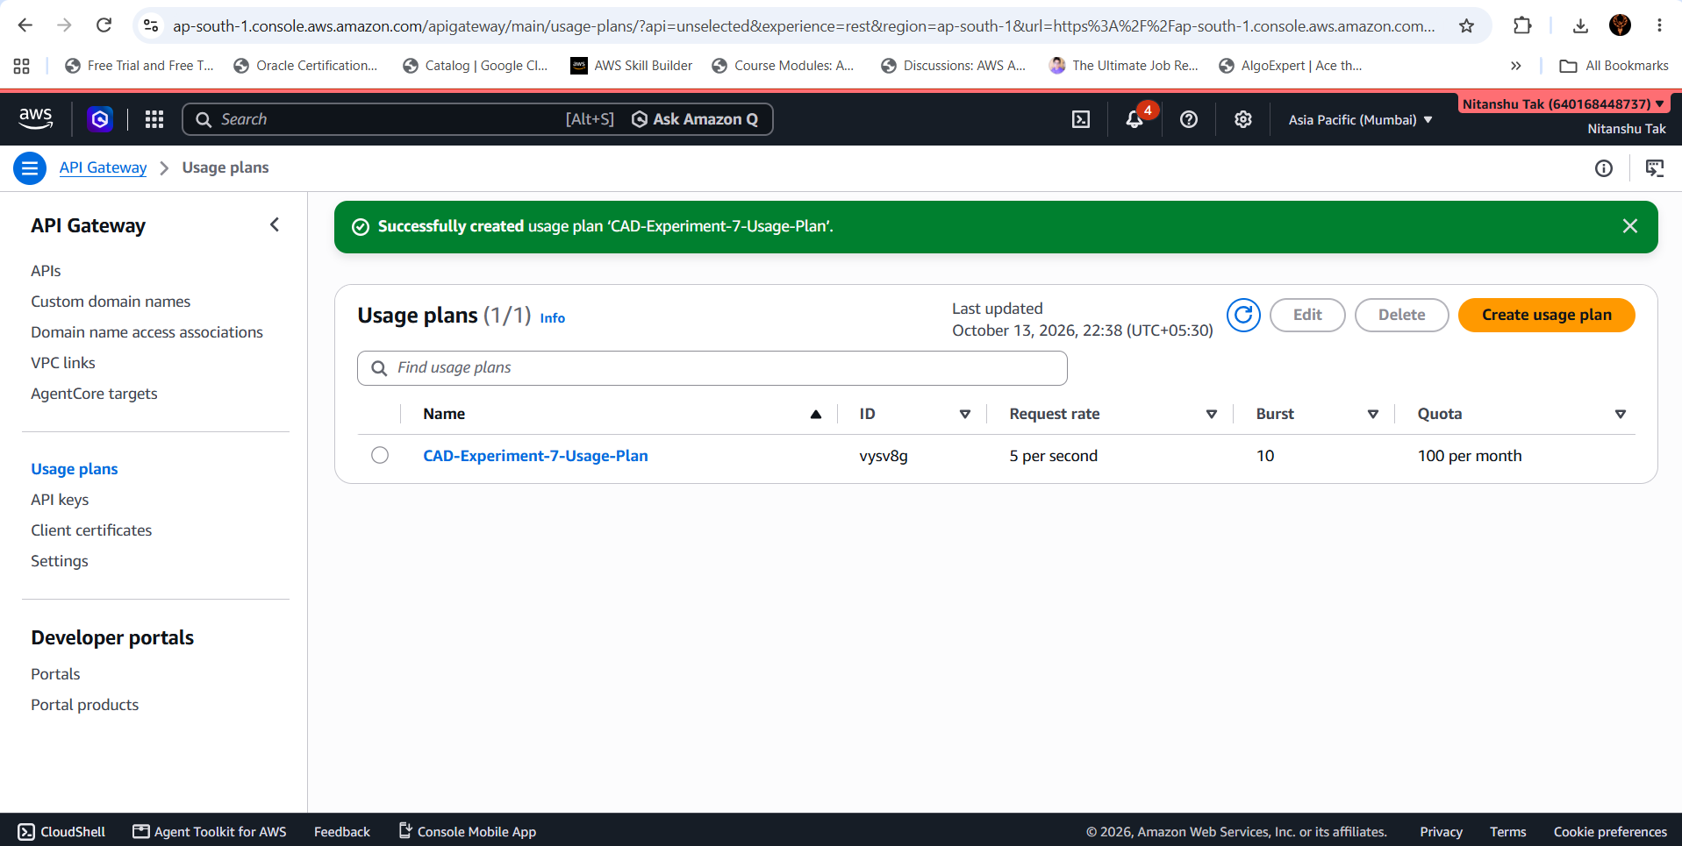
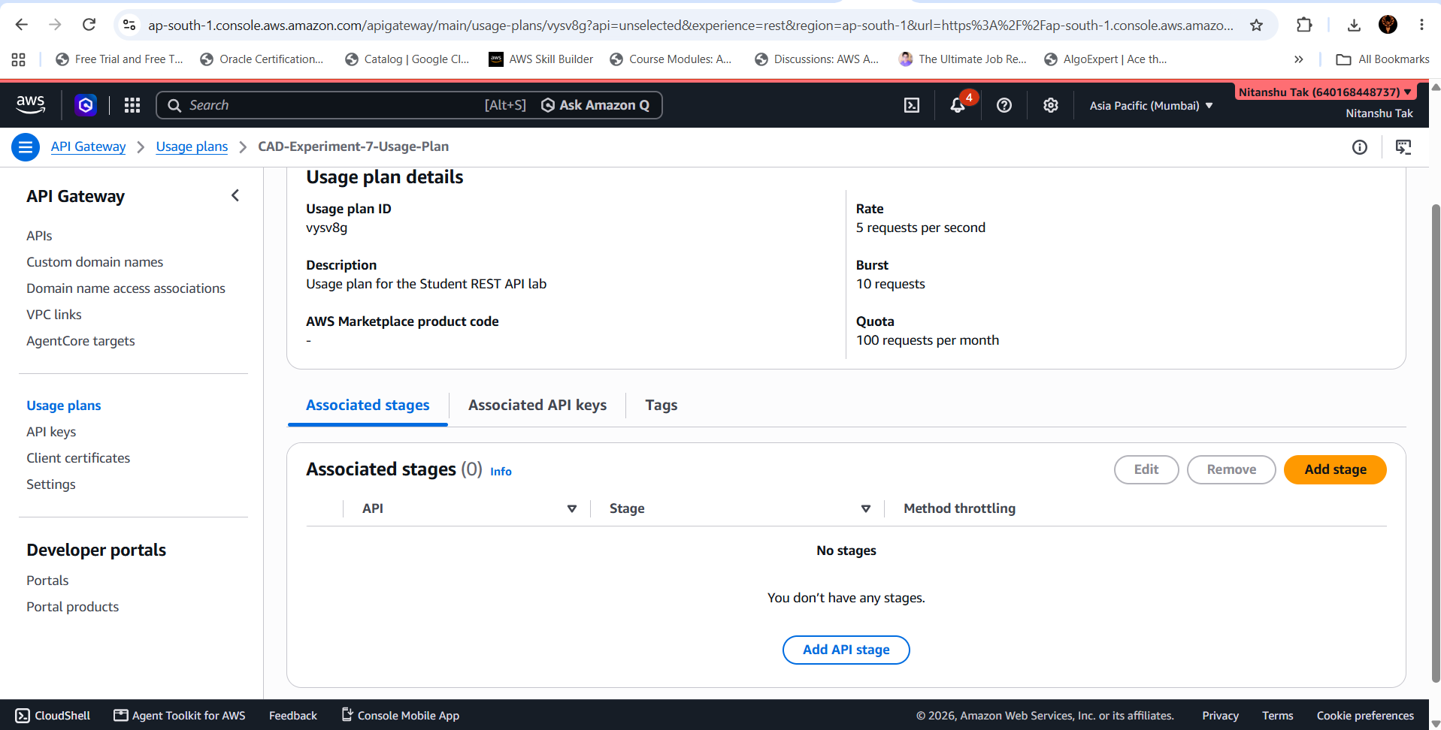
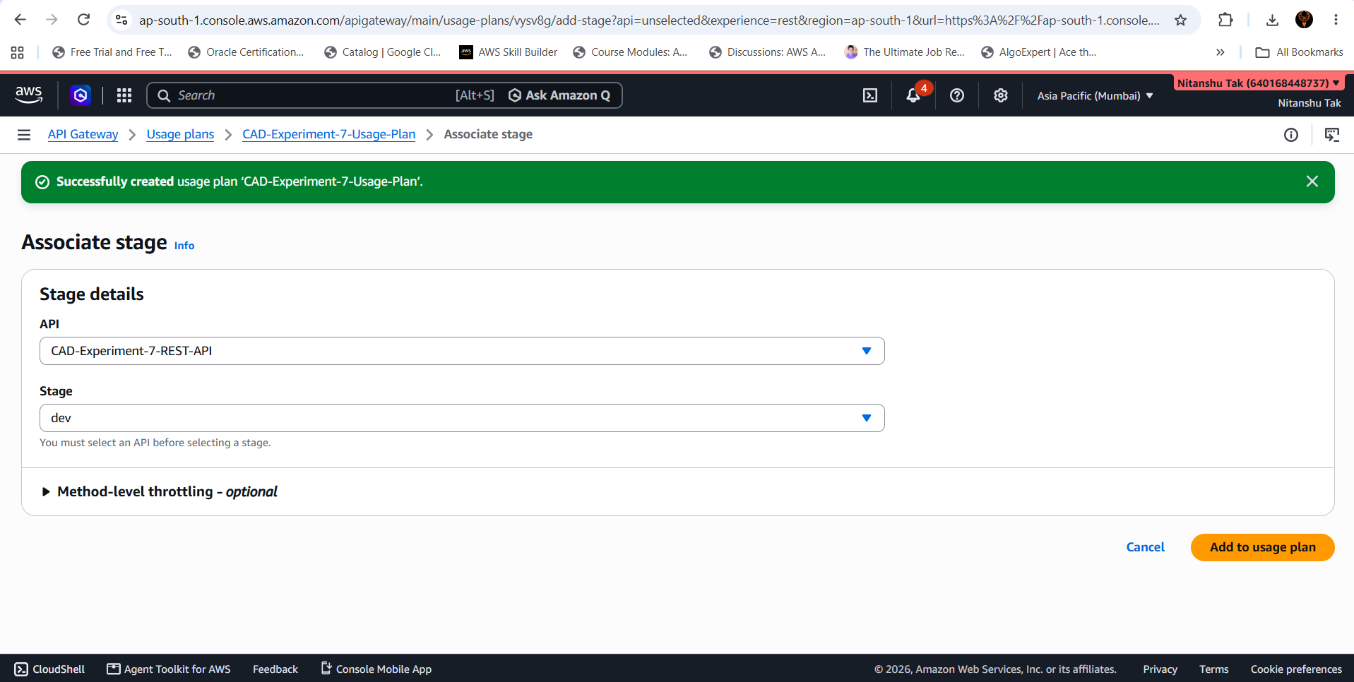
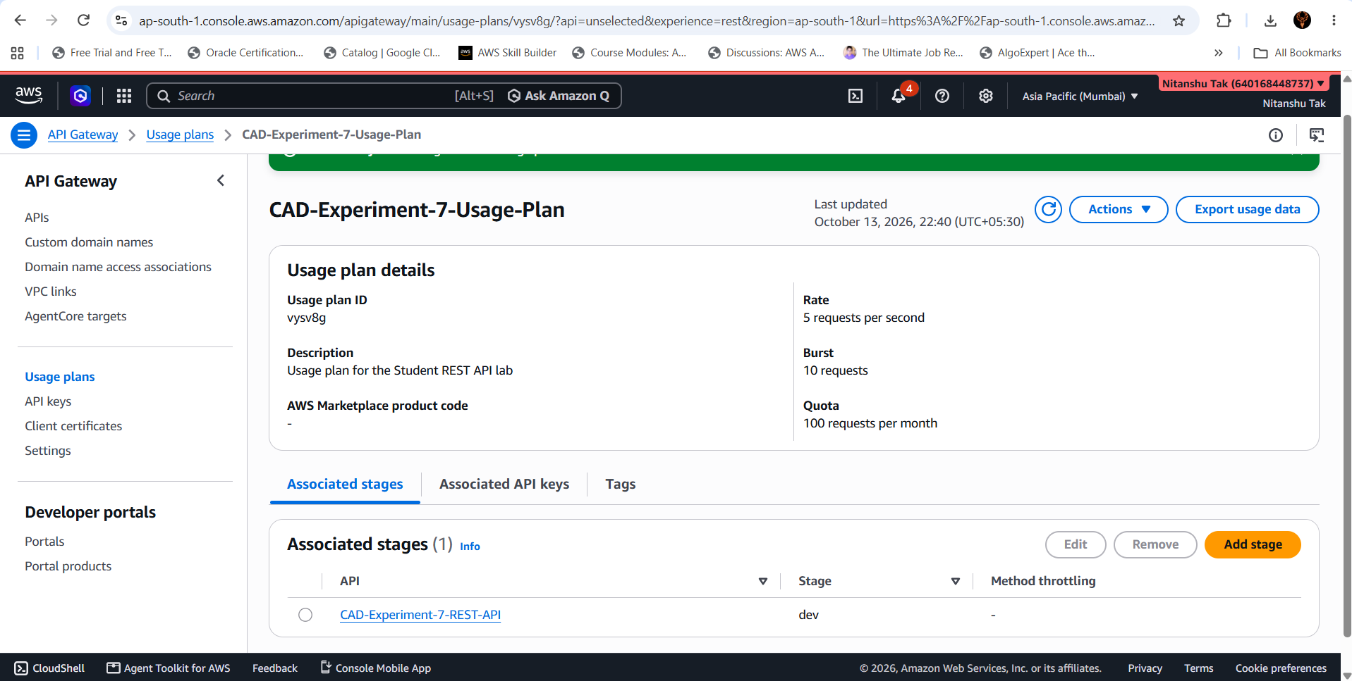
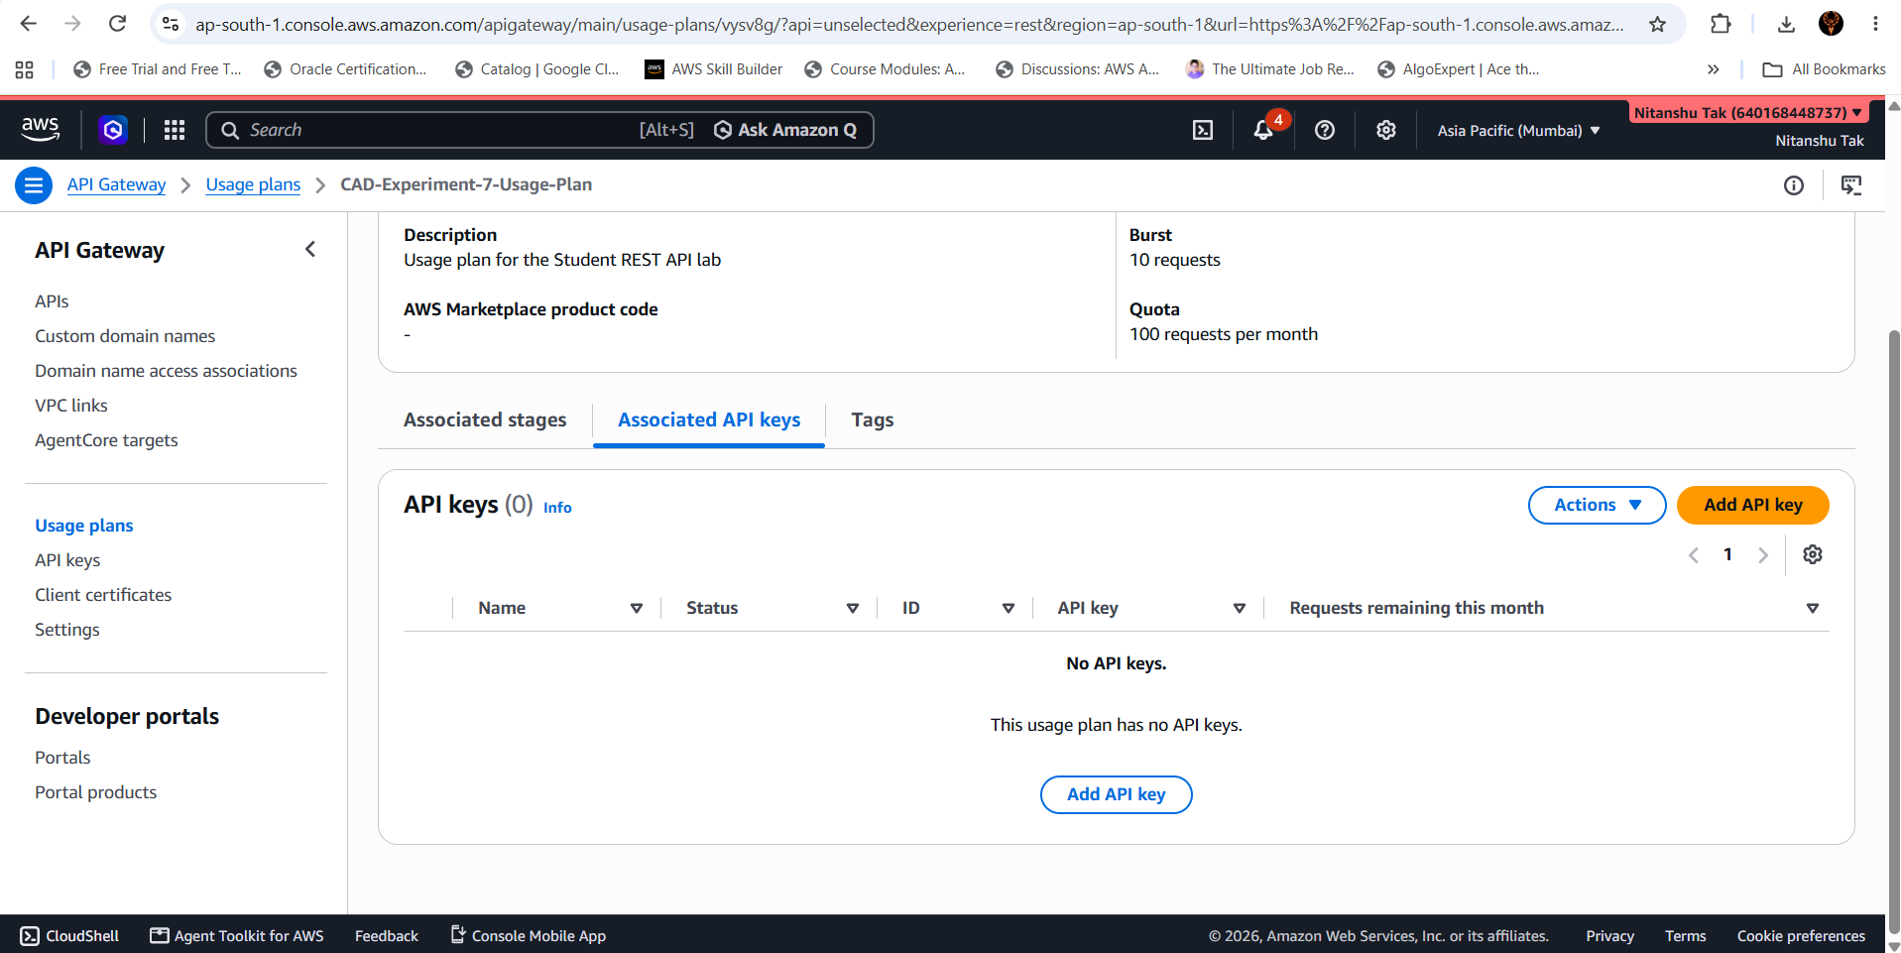
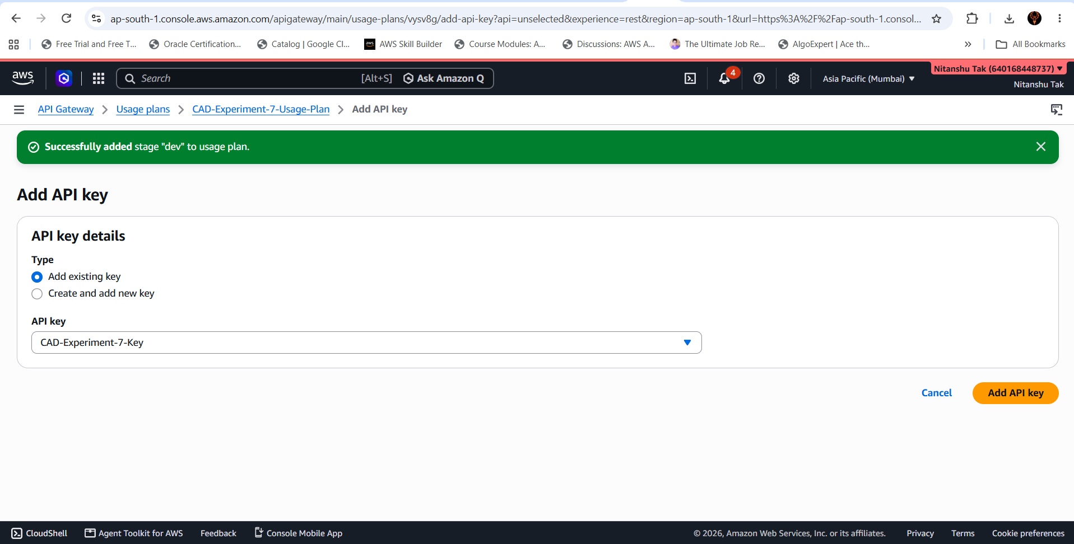
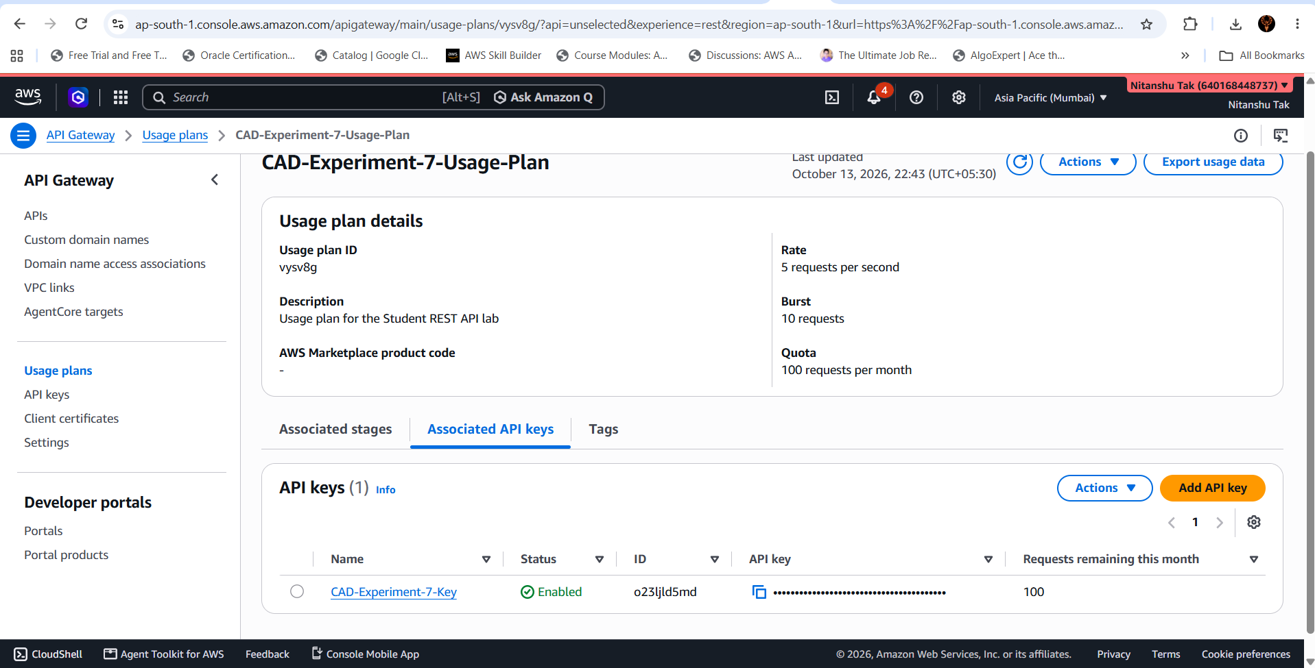
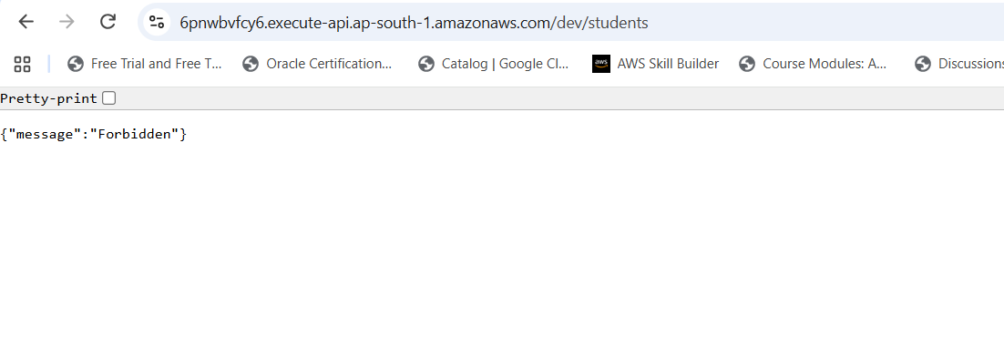
HERE COMES THE API
