Name- Nitanshu Tak

Batch-2

SapID-500121943

**EXPERIMENT-1**

**TITLE: Introduction to Java Environment**

**1. Explore and Understand the Role of JDK, JRE, and JVM (Detailed Explanation)**

1. **JDK (Java Development Kit):**
   * **Purpose:** The JDK is a toolkit provided by Oracle (or OpenJDK contributors) for developing Java programs.
   * **Components:** It includes the Java Compiler (javac), Java Debugger (jdb), and tools for packaging and deploying Java programs.
   * **Relationship with JRE:** JDK contains JRE, so developers can both run and develop Java applications.
   * **Usage:**
     + Developers use JDK to write and compile Java code into bytecode (.class files).
     + Example: When you compile a .java file with javac, the output is bytecode, which is then run on the JVM.
2. **JRE (Java Runtime Environment):**
   * **Purpose:** The JRE is the runtime environment that allows the execution of Java applications. It is what you need to **run** (not develop) Java programs.
   * **Components:** It includes the Java Virtual Machine (JVM) and libraries like rt.jar that provide Java's runtime functions.
   * **Usage:**
     + JRE is often used on user machines to execute Java programs, especially for software like Minecraft, IntelliJ, or other Java-based applications.
3. **JVM (Java Virtual Machine):**
   * **Purpose:** The JVM is the virtual platform where Java bytecode is executed.
   * **Core Responsibilities:**
     + Converts bytecode into machine-specific instructions using Just-In-Time (JIT) compilation.
     + Provides a **garbage collection mechanism** to manage memory automatically.
     + Ensures Java’s platform independence by abstracting the operating system.

**2. Install Latest JDK on Windows and Verify the Java Environment**

**Since you’ve installed the JDK using the installer version**, follow these steps to verify the setup.

1. **Confirm Installation:**
   * After installing the JDK, ensure the installer successfully added the JDK to your system.
2. **Verify Installation in Command Prompt:**
   * Open the **Command Prompt** (press Windows + R, type cmd, and hit Enter).
   * Check the installed Java version by typing:
   * java -version
     + Output:

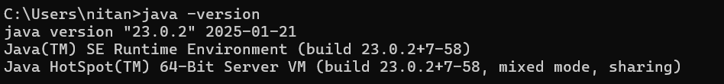

1. **Verify the Java Compiler (JDK):**
   * Type the following command to confirm the Java Compiler (javac) is working:
   * javac -version
     + Output:

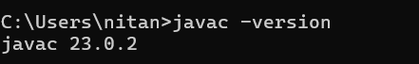

**3. Create a Sample Hello World Program**

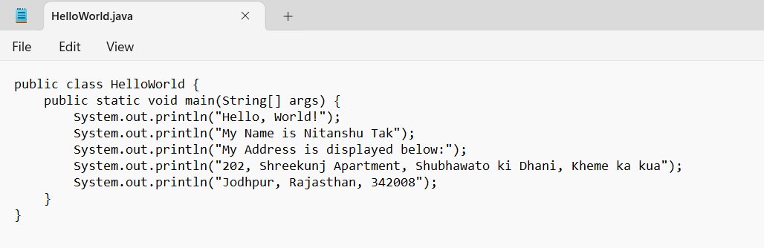

**Compile and Execute the Program**

**Output:**

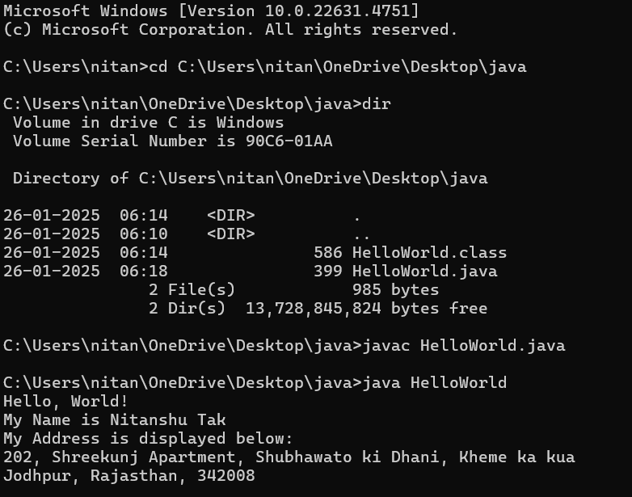

**4. Display Your Name and Complete Address in Different Lines**

Modify the program in step 3 to include personalized information in the System.out.println() statements.

