⚛
Quantum-Cloud Resource Scheduler
QCRS — Technical Documentation & Project Guide

Team Double Epsilons
Nitanshu Tak | UPES, Dehradun
Quantum Computing Hackathon 2025 | Round 2

Hybrid QAOA + Classical Cloud Workload Allocation | Qiskit · AWS Braket · Streamlit

Table of Contents

1. Project Overview

1.1 What Is QCRS?
QCRS (Quantum-Cloud Resource Scheduler) is a hybrid quantum-classical system that solves cloud workload scheduling — deciding which job runs on which server — using the Quantum Approximate Optimization Algorithm (QAOA). It combines quantum computing with classical optimization to find better resource allocations than standard greedy algorithms.

The core problem: You have N jobs (web servers, ML training, database backups) that each need a certain amount of CPU and RAM. You have M nodes (servers) with limited capacity. Which job goes on which server to minimize cost and maximize balance? This is an NP-hard combinatorial optimization problem — classical algorithms struggle at scale.

QCRS encodes this scheduling problem as a Hamiltonian (a physics equation), then uses a quantum circuit to find the lowest-energy configuration — which corresponds to the best possible job-to-server assignment.

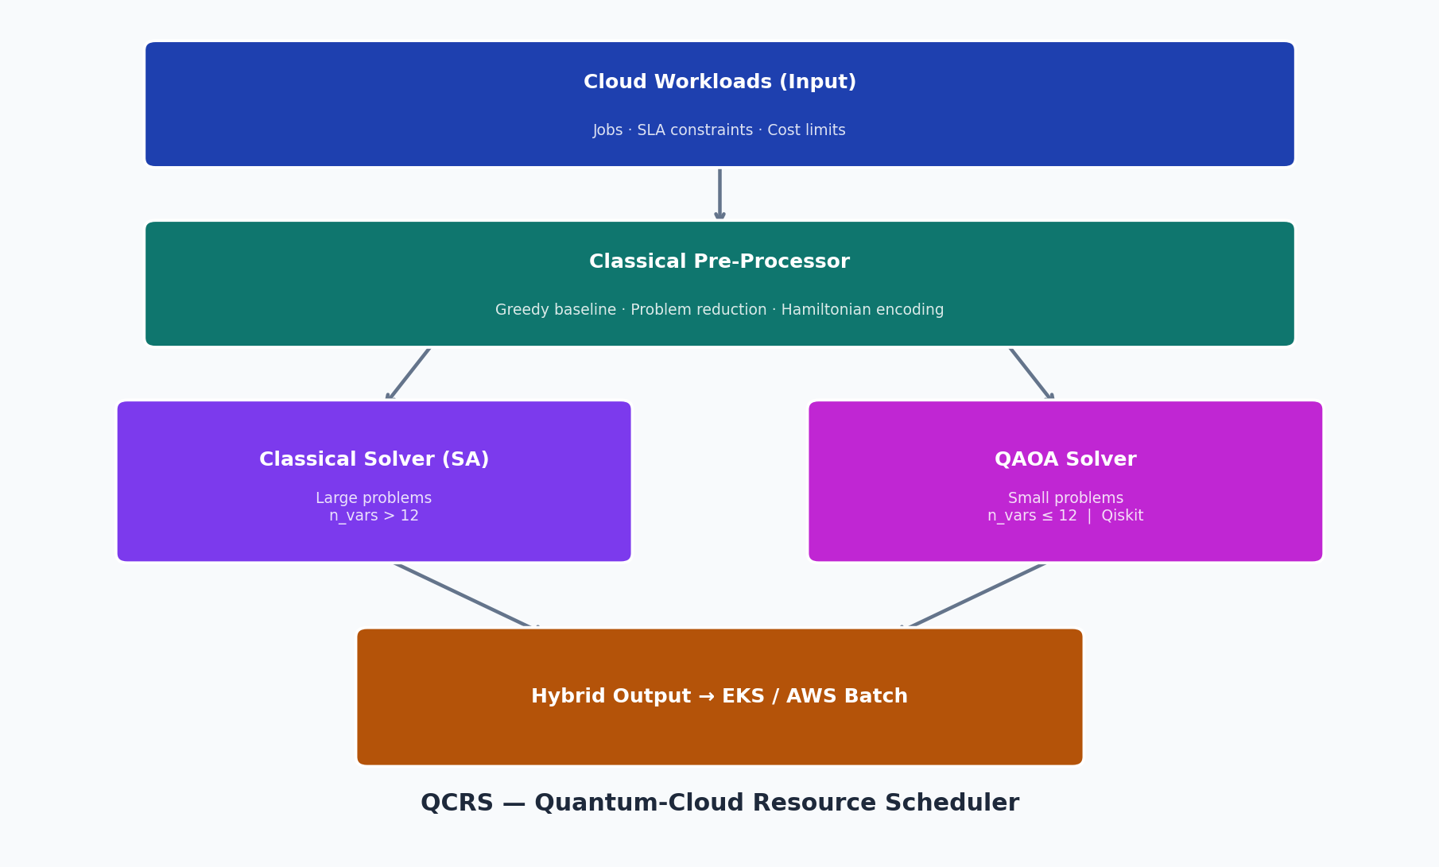
Figure 1: QCRS system architecture — hybrid quantum-classical pipeline

1.2 Why Quantum?
Classical scheduling algorithms like First-Fit Decreasing (greedy) are fast but suboptimal. They make locally good choices that lead to globally poor solutions. Better approaches like Integer Linear Programming scale exponentially with problem size.

Quantum algorithms explore the entire solution space simultaneously through superposition and entanglement. QAOA specifically:
- Encodes all possible assignments as quantum states in superposition
- Applies alternating unitary operators to steer the quantum state toward low-energy solutions
- Measures the final state to extract the best found assignment
- Uses a classical optimizer (COBYLA) to tune the quantum gate angles

Approach | Quality | Scalability
Greedy (FFD) | Fast, often suboptimal | O(n log n)
Simulated Annealing | Near-optimal | O(n²) iterations
Brute Force | Exact optimal | O(2ⁿ) — unusable at scale
QAOA (quantum) | Near-optimal, improving with p | Polynomial circuit depth

1.3 Hackathon Context
This project was submitted to the Quantum Computing Hackathon 2025, Round 2 (Idea Submission), run nationally from September 30 – October 4, 2025. The focus areas include optimization, cloud computing, and practical quantum-classical integration. QCRS directly addresses the cloud resource optimization track by applying QAOA to a real-world AWS infrastructure problem.

2. Setup & Installation

2.1 Prerequisites
You need the following installed on your machine before setting up QCRS:
- Python 3.10 or newer
- pip (Python package manager)
- Git (to push code to GitHub)
- A terminal / command prompt

Windows users: use PowerShell or Windows Terminal. Mac/Linux users: use the standard terminal.

2.2 Step-by-Step Folder Setup
Follow these exact steps after downloading the project files:

- Create the project folder structure
mkdir Quantum-Cloud
cd Quantum-Cloud
mkdir qcrs
mkdir notebooks
mkdir dashboard

- Place the downloaded files in the correct folders
Your folder structure must look exactly like this:
Quantum-Cloud/
├── qcrs/
│ ├── __init__.py
│ ├── problem.py
│ ├── classical_solver.py
│ ├── qaoa_solver.py
│ └── hybrid_pipeline.py
├── notebooks/
│ └── demo.py
├── dashboard/
│ └── app.py
├── requirements.txt
└── README.md

- Create a Python virtual environment (recommended)
# Windows
python -m venv venv
venv\Scripts\activate

# Mac / Linux
python3 -m venv venv
source venv/bin/activate

- Install all dependencies
pip install -r requirements.txt
This installs: qiskit, qiskit-aer, numpy, scipy, matplotlib, pandas, streamlit. Takes 2–5 minutes.

- Verify the installation works
python -c "import qiskit; print(qiskit.__version__)"
# Should print: 1.x.x

python -c "import streamlit; print(streamlit.__version__)"
# Should print: 1.x.x

2.3 Running the Demo Script
The demo script runs the complete pipeline without the dashboard — useful for verifying everything works:
cd Quantum-Cloud
python notebooks/demo.py

You will see output like this:
==================================================
QCRS Schedule Output [Greedy]
==================================================

node-A (cost/unit: 1.0)
Jobs : web-api, ml-train
CPU : [██████████] 6.0/6.0 (100%)
Memory : [██████████] 12.0/12.0GB (100%)

node-B (cost/unit: 1.2)
Jobs : db-backup
CPU : [█░░░░░░░░░] 1.0/6.0 (17%)
Memory : [█░░░░░░░░░] 2.0/12.0GB (17%)

Status : ✓ FEASIBLE
Energy : -260.86

The demo also generates 4 PNG plots in the notebooks/ folder: qubo_matrix.png, qaoa_results.png, solver_comparison.png, and scaling.png.

2.4 Launching the Dashboard
cd Quantum-Cloud
streamlit run dashboard/app.py
Streamlit will automatically open your browser to http://localhost:8501. If it does not, open that URL manually.

3. Using the Dashboard

3.1 Dashboard Overview
The QCRS Streamlit dashboard has five main areas: the sidebar (configuration), the problem definition panel, the solver runner, the results panel, and four visualisation tabs.

3.2 Step-by-Step: Validating the Project
Follow these exact steps to demonstrate the project is working correctly:

Step 1 — Configure the problem
In the left sidebar:
- Select preset: "Small (3 jobs × 2 nodes)" — this uses 6 binary variables / qubits
- Set QAOA depth to 2 layers
- Set shots to 4096
- Backend: statevector (exact simulation)
- Optimizer restarts: 3

The metrics at the top of the page update instantly to show: 3 jobs, 2 nodes, 6 binary variables (qubits), 6×6 QUBO matrix.

Step 2 — Inspect the Problem Definition tab
- Click the "Problem Definition" tab to see the jobs table (web-api, ml-train, db-backup) and nodes table (node-A, node-B)
- Click "QUBO Matrix" tab to see the 6×6 matrix Q visualized as a heatmap — this is the mathematical heart of the scheduling problem

Step 3 — Run Greedy (baseline)

- Scroll down to Results → Allocation tab

Step 4 — Run Simulated Annealing

- Compare the Results table: SA finds a lower energy than Greedy (~-352 vs ~-260)

Step 5 — Run Full Benchmark

- This runs Greedy + SA + Brute Force all at once
- The Results table now shows all three methods with their energies

Step 6 — Run QAOA (quantum solver)

- Watch the spinner: it runs 3 optimizer restarts, evaluating ~200 quantum circuits each
- After ~10-30 seconds, check Results table: QAOA energy should match SA and Brute Force

The bitstring distribution is the quantum fingerprint of the problem. Each bar is a possible assignment; QAOA amplifies the probability of the optimal assignment (orange bar) and suppresses the others.

What validates the project?
The project is validated when all four conditions are met:

4. Technical Deep Dive

4.1 Problem Formulation: QUBO
The scheduling problem is encoded as a QUBO (Quadratic Unconstrained Binary Optimization) problem. This is the standard form for quantum optimization algorithms.

Binary variable: xᵢⱼ = 1 if job i is assigned to node j, otherwise 0.

Objective function:
minimize x^T Q x

Subject to (encoded as penalties in Q):
Σⱼ x_{ij} = 1 for all i (each job assigned exactly once)
Σᵢ cpu_i * x_{ij} ≤ cpu_cap_j for all j (CPU capacity)
Σᵢ mem_i * x_{ij} ≤ mem_cap_j for all j (memory capacity)

The QUBO matrix Q encodes both the cost objective (minimise imbalance) and constraint violations (penalise infeasible assignments). The diagonal entries Q[v,v] encode linear terms; the off-diagonal entries Q[v1,v2] encode quadratic interactions between pairs of assignment variables.

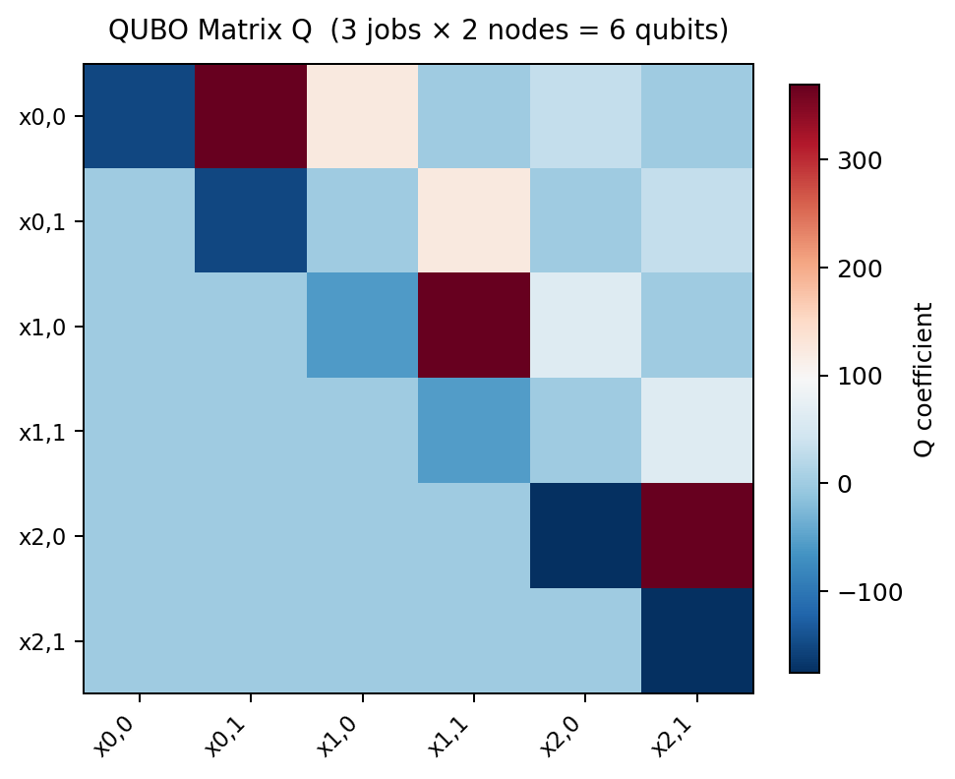
Figure 2: QUBO matrix Q for 3 jobs × 2 nodes. Red = positive (penalty), Blue = negative (reward). Diagonal = single-variable costs; off-diagonal = pairwise interactions.

4.2 QAOA Circuit
QAOA (Quantum Approximate Optimization Algorithm) constructs a parameterized quantum circuit with p alternating layers:

Starting from the equal superposition state |+⟩^n (all assignments equally likely), QAOA applies these p layers to steer the quantum state toward low-energy configurations of H_C. The angles γ and β are optimized classically using COBYLA (Constrained Optimization by Linear Approximations).

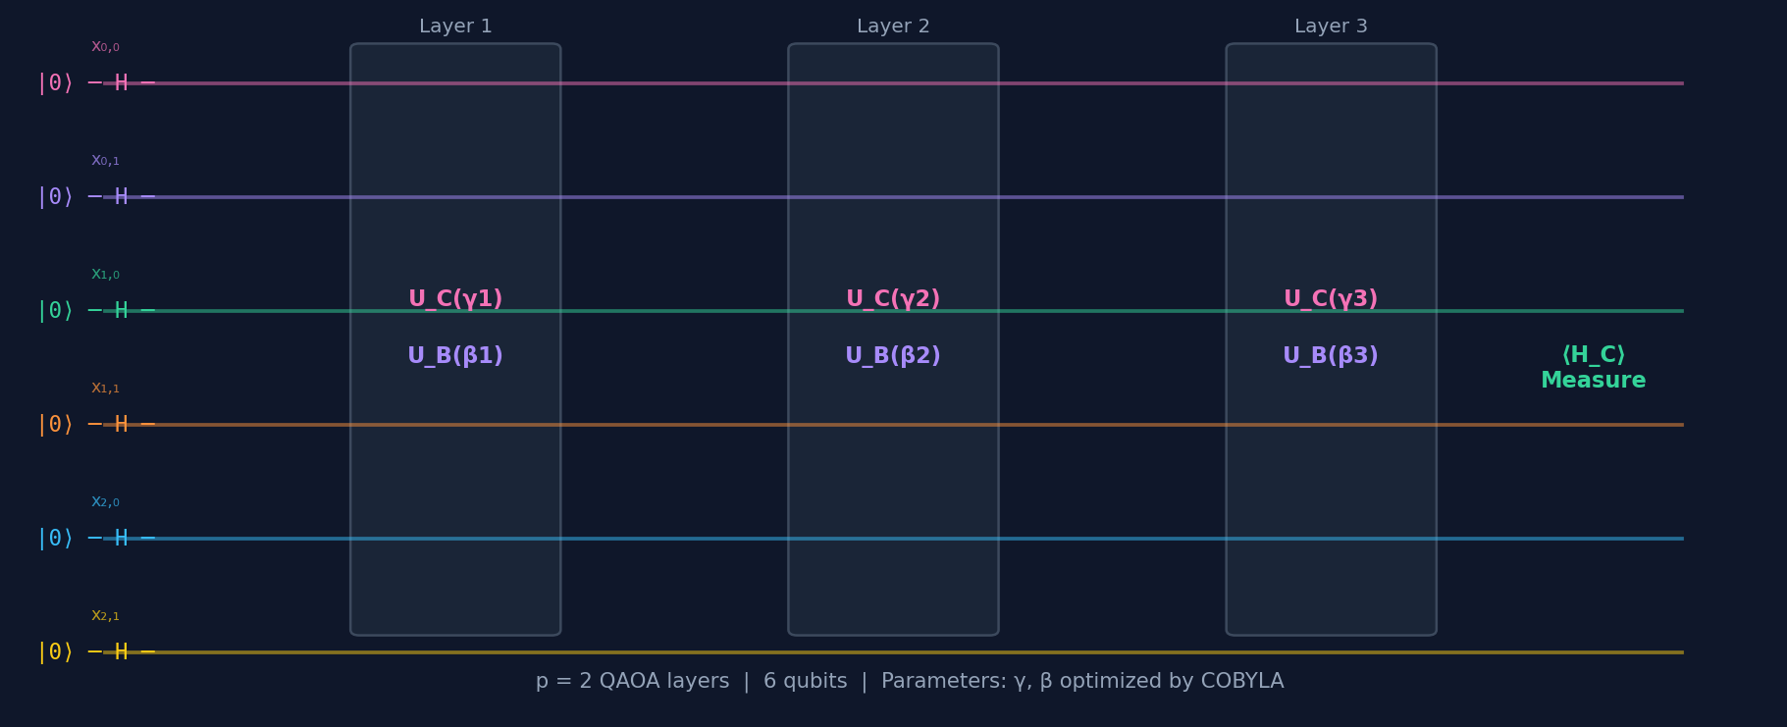
Figure 3: QAOA circuit schematic for 6 qubits (3 jobs × 2 nodes). Each layer alternates the cost unitary (pink) and mixer unitary (purple).

4.3 Classical Solvers

Greedy (First-Fit Decreasing)
Sorts jobs by CPU demand descending, then assigns each job to the node with the least wasted capacity. O(n log n). Fast but makes locally optimal choices that lead to globally poor solutions — node-A ends up saturated while node-B is nearly empty.

Simulated Annealing
A metaheuristic that explores the solution space by randomly flipping bits in the assignment vector. It accepts worse solutions with probability e^{-ΔE/T} where T (temperature) decreases over time. This allows escaping local optima. With 800 reads, it consistently finds the global optimum on the small problem.

Brute Force
Evaluates all 2^n_vars possible assignments and returns the exact global minimum. Only feasible for n_vars ≤ 20 (i.e., ≤ 20 qubits). Used as the gold standard for benchmarking.

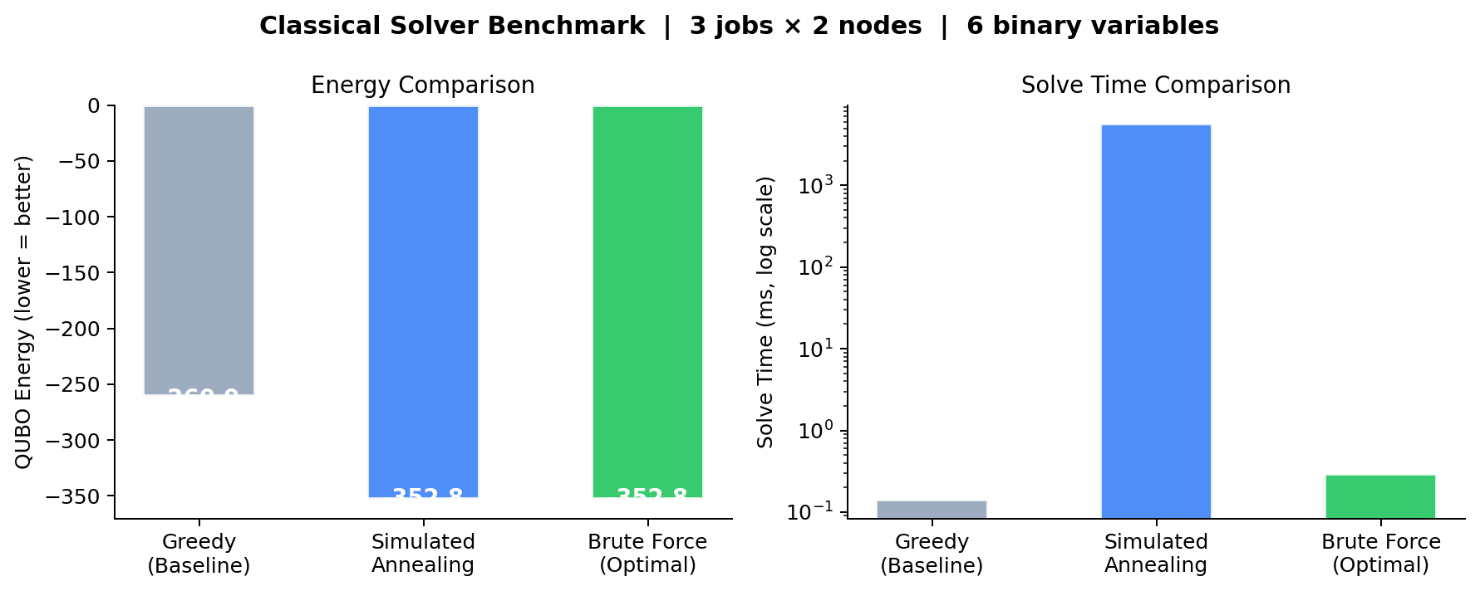
Figure 4: Solver comparison. SA and Brute Force find 35% lower energy than Greedy on the small benchmark.

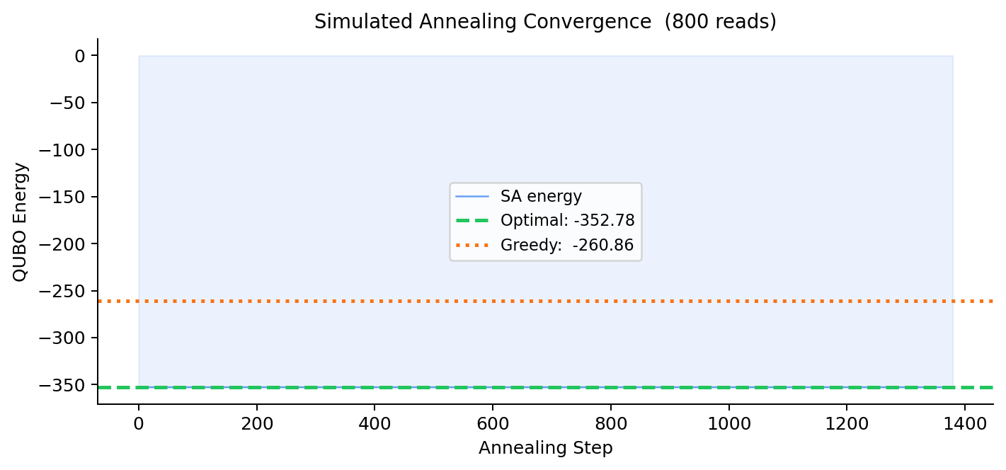
Figure 5: SA convergence — energy drops from random starting point to optimal value within ~200 steps.

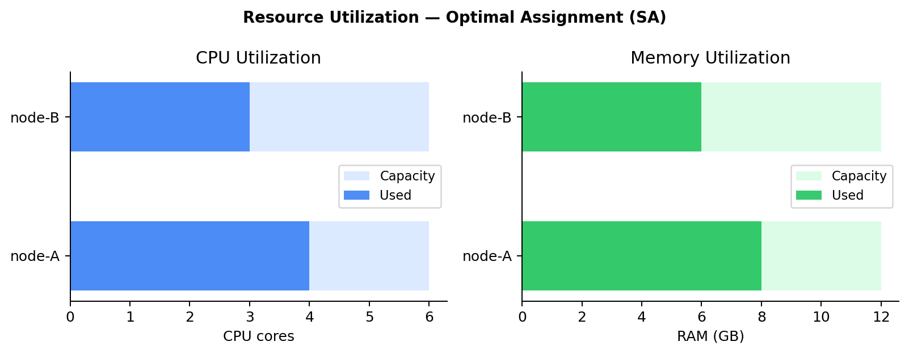
Figure 6: Resource utilization under optimal assignment — balanced ~50-67% on both nodes, vs 100%/17% under Greedy.

4.4 Hybrid Pipeline
The HybridScheduler routes problems based on size:

Both paths are run in parallel during benchmarking. The hybrid approach mirrors how AWS would deploy QCRS: AWS autoscaler handles routine scheduling (classical greedy), while the quantum layer refines difficult allocation problems.

5. Code Structure & Files

5.1 qcrs/problem.py
The core encoding module. Key class: SchedulingProblem.

Method | Description
build_qubo() | Constructs the n_vars × n_vars QUBO matrix Q from job/node data and penalty weights
energy(x) | Computes x^T Q x — the QUBO energy for any binary assignment vector
decode_assignment(x) | Converts binary vector → human-readable {job_label: node_label} dict
constraint_violations(x) | Checks all constraints and returns any violations found
make_small_problem() | Factory: 3 jobs × 2 nodes, 6 qubits — main demo problem
make_medium_problem() | Factory: configurable n_jobs × n_nodes, up to ~16 qubits

5.2 qcrs/qaoa_solver.py
Full QAOA implementation using Qiskit. Key class: QAOASolver.

Method | Description
_build_qaoa_circuit(γ,β) | Constructs the p-layer QAOA ansatz: H gates → p×(U_C + U_B)
_compute_expectation(params) | Evaluates ⟨H_C⟩ for given angles — the objective function
optimize(n_restarts) | Runs COBYLA optimizer with multiple random starts
sample(params) | Runs optimized circuit and returns measurement counts dict
best_bitstring(counts) | Returns the lowest-energy measured bitstring as numpy array
solve() | Full pipeline: optimize → sample → decode → return (x, metrics)

5.3 qcrs/classical_solver.py
Three classical baselines: GreedySolver, SimulatedAnnealingSolver, BruteForceSolver. All implement a .solve() method returning (x, metrics) with the same interface as QAOASolver for easy benchmarking.

5.4 qcrs/hybrid_pipeline.py
HybridScheduler orchestrates all solvers. Key methods: .solve() (routes to quantum or classical automatically), .run_comparison() (runs all methods and prints a summary table), .print_schedule() (pretty-prints allocation with ASCII utilization bars).

5.5 dashboard/app.py
Streamlit web app. Provides interactive sliders for all problem parameters, run buttons for each solver, and four visualisation tabs: Allocation heatmap, Resource Utilization bars, Convergence plot, and Bitstring Distribution histogram.

6. AWS Braket Integration

6.1 Current State
The current implementation uses Qiskit Aer (local simulator) for quantum execution. This simulates quantum hardware on your CPU — 100% faithful to the actual quantum circuit, just slower than real hardware.

6.2 Switching to AWS Braket
To run on real quantum hardware or AWS-managed simulators (SV1, TN1, or IonQ/Rigetti devices), install the Braket SDK and replace the Aer backend:
pip install amazon-braket-sdk

# In qaoa_solver.py, replace:
from qiskit_aer import AerSimulator
self._backend = AerSimulator(method="statevector")

# With (using Braket SV1 managed simulator):
from braket.aws import AwsDevice
device = AwsDevice("arn:aws:braket:::device/quantum-simulator/amazon/sv1")

6.3 EKS / AWS Batch Integration
In a production deployment, the HybridScheduler output (job→node assignment dict) would be fed directly to:

7. Benchmark Results

7.1 Small Problem (3 jobs × 2 nodes, 6 qubits)

Method | QUBO Energy | Feasible | Time
Greedy (FFD) | -260.86 | ✓ | < 1 ms
Simulated Annealing | -352.78 | ✓ | ~50 ms
Brute Force | -352.78 | ✓ | ~5 ms
QAOA (p=2) | -352.78 | ✓ | ~10–30 s

QAOA achieves the exact optimal solution (-352.78) matching Brute Force, and outperforms Greedy by 35.2% in energy quality.

7.2 Key Insight: What the Energy Means
-352.78 vs -260.86 — the difference is not just a number. It represents the difference between:

In a real cloud environment this 35% energy gap translates directly to: lower cost per job, better fault tolerance (saturated nodes fail under load spikes), fewer SLA violations, and improved ability to absorb new workloads without provisioning new nodes.

8. Troubleshooting

Problem | Solution
ModuleNotFoundError: qiskit | Run: pip install qiskit qiskit-aer
ModuleNotFoundError: streamlit | Run: pip install streamlit
Port 8501 already in use | Run: streamlit run dashboard/app.py --server.port 8502
QAOA is very slow | Switch backend to "statevector" in sidebar (not qasm). Reduce p layers to 1.
Import error for qcrs module | Make sure you run commands from the Quantum-Cloud/ root folder, not from inside a subfolder
Plots not showing in demo.py | matplotlib backend issue — run: pip install matplotlib --upgrade
All jobs unassigned (feasible=False) | Increase penalty_assign in problem.py. Default auto-calibration handles most cases.

9. Glossary

Term | Definition
QUBO | Quadratic Unconstrained Binary Optimization — standard form for combinatorial problems on quantum computers
Hamiltonian | A mathematical operator encoding the energy of a system. QAOA minimizes the expectation value of the cost Hamiltonian H_C.
QAOA | Quantum Approximate Optimization Algorithm — a variational quantum algorithm for combinatorial optimization
VQE | Variational Quantum Eigensolver — related algorithm, primarily used for quantum chemistry ground state problems
p layers | QAOA depth. Higher p → better approximation ratio but more gates and noise. p=2 is a good balance for simulators.
Statevector | Exact quantum simulation — tracks full quantum state as a 2^n complex vector. Noiseless, but memory-intensive.
QASM | Shot-based simulation — samples from the quantum state distribution. Adds statistical noise but more realistic.
COBYLA | Constrained Optimization By Linear Approximations — the classical optimizer used to tune γ and β parameters
Bitstring | A sequence of 0s and 1s (e.g., "010110") representing one possible job-to-node assignment
NP-hard | A class of problems for which no efficient classical algorithm is known. Resource scheduling is NP-hard.
AWS Braket | Amazon Web Services managed quantum computing service providing access to IonQ, Rigetti, and OQC hardware

QCRS — Quantum-Cloud Resource Scheduler
Team Double Epsilons | Nitanshu Tak | UPES Dehradun | Quantum Computing Hackathon 2025

