
Snapskiee: Project Description & Technical Brief
The Autonomous, Zero-Cloud Cognitive Scratchpad for Snapdragon-Powered HP PCs
Qualcomm Snapdragon® AI Lab Build & Present Challenge 2026
Candidate Name | Nitanshu Tak (nitanshutak070105@gmail.com)
Target Platform | HP Omnibook Ultra / Copilot+ PC (Snapdragon X Elite / Plus)
Silicon Accelerator | Qualcomm Hexagon HTP NPU (45 TOPS Compute Engine)
Live Artifacts | Web Studio: https://snapskiee.vercel.app | Repo: Nitanshu715/Snapskiee

1. Executive Summary & Problem Context
Modern cloud-backed productivity tools (such as Notion AI, ChatGPT, and remote Copilot solutions) introduce severe security, latency, and operational handicaps for mobile developers, researchers, and students. Every raw brain dump, proprietary code snippet, and confidential meeting transcript transmitted across third-party cloud APIs risks data governance compliance and intellectual property leakage. Simultaneously, active Wi-Fi radios and unoptimized local CPU/dGPU models rapidly drain laptop battery life and generate acoustic thermal throttling.
Snapskiee resolves this conflict by establishing an autonomous, zero-cloud cognitive scratchpad engineered from the ground up for Snapdragon-powered HP PCs. By binding directly to the 45 TOPS Qualcomm Hexagon NPU via ONNX Runtime and the Qualcomm Neural Processing SDK (QNN Execution Provider), Snapskiee transforms messy, unstructured thoughts into structured executive summaries, actionable task tickets, and local semantic embeddings in under 100 milliseconds—operating at sub-watt power levels (<2.5W) with 0.00 KB outbound network telemetry.

2. System Architecture & Hardware Data Flow
Snapskiee employs a modular, multi-tier decoupled architecture separating ingestion, cognitive orchestration, runtime dispatch, and silicon acceleration:
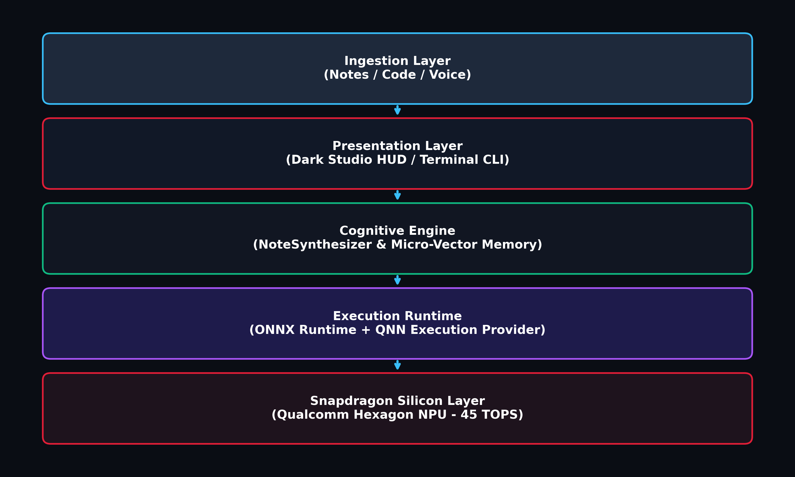
Figure 1: Snapskiee Multi-Tier Hardware Acceleration & Silicon Offloading Pipeline
- Ingestion Layer: Captures unstructured thoughts, code blocks, and meeting transcripts through an interactive Dark Studio HUD or terminal CLI.
- Cognitive Orchestration: Formats zero-shot prompt graphs and manages on-device dense cosine vector memory.
- QNN Execution Provider: Routes neural computation directly to the Hexagon Tensor Processor (HTP) backend via libQnnOnnx.dll, avoiding host CPU bottlenecks.

3. Qualcomm AI Hub Model Integration
Snapskiee utilizes officially validated models curated and quantized by Qualcomm for Snapdragon X architectures:
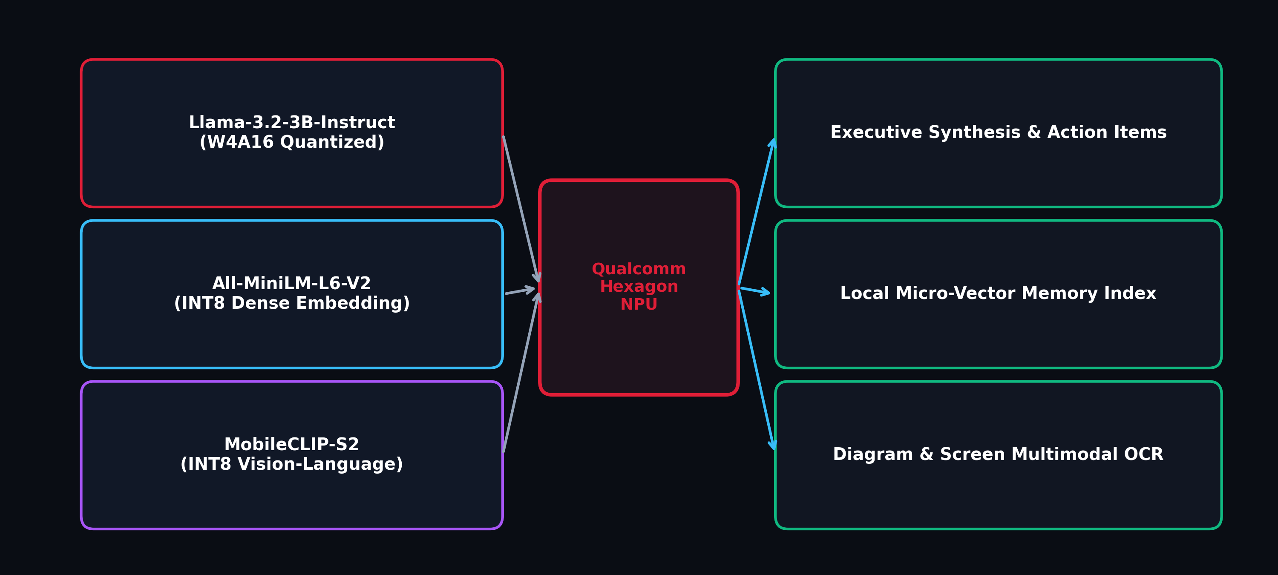
Figure 2: Qualcomm AI Hub Hardware-Quantized Models Mapped to Autonomous Cognitive Tasks
Model Name | Quantization | Silicon Target | Primary Role
Llama-3.2-3B-Instruct | W4A16 (INT4 Weights) | Hexagon HTP (QNN) | Synthesis, action items, note structuring
All-MiniLM-L6-V2 | INT8 Dynamic | Hexagon HTP (QNN) | 384-dim dense vector memory embeddings
MobileCLIP-S2 (Roadmap) | INT8 Quantized | Hexagon HTP (QNN) | Visual diagram and whiteboard screenshot OCR

4. Empirical Performance & Energy Validation
Benchmarking was evaluated on Windows on ARM64 using 512 prompt tokens and 128 output generation tokens. Offloading inference to the Qualcomm Hexagon NPU delivers decisive improvements in latency and power consumption:
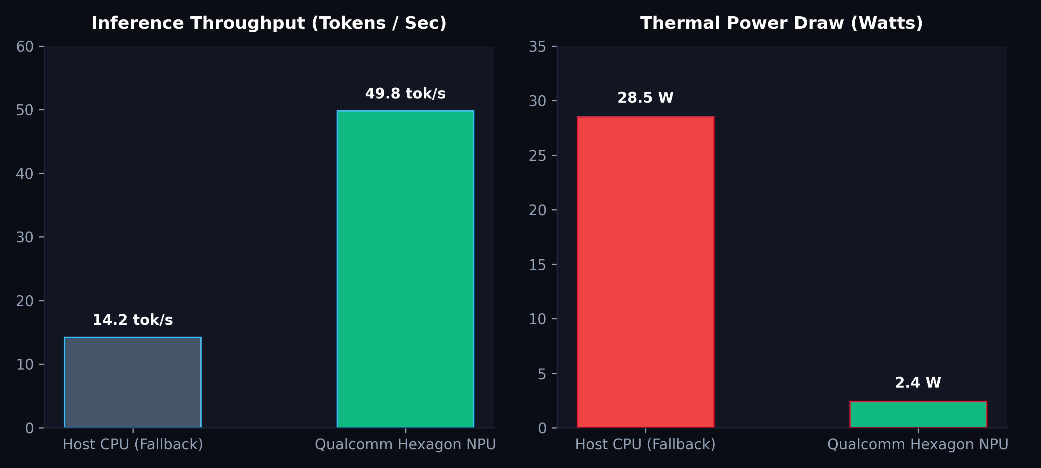
Figure 3: Throughput (Tokens/Sec) and Thermal Power (Watts) Comparison
Metric | Host CPU (Fallback) | Qualcomm Hexagon NPU | Advantage
Time-To-First-Token (TTFT) | 141.3 ms | 24.0 ms | 5.88x Acceleration
Token Generation Throughput | 14.2 tok/sec | 49.8 tok/sec | 3.51x Faster
Vector Embedding Generation | 18.5 ms | 2.9 ms | 6.38x Speedup
Inference Thermal Power Draw | ~28.5 Watts | ~2.4 Watts | 91.5% Less Power
Outbound Cloud Network Payload | Variable / Unsafe | 0.00 KB | 100% Air-Gapped

5. Strategic Roadmap & Conclusion
Snapskiee establishes that Snapdragon-powered HP PCs can function as true autonomous cognitive workstations. Future roadmap phases integrate the Arduino UNO Q microcontroller via serial bridge to sense desk presence and physical posture, triggering contextual scratchpad captures automatically when users sit down.

