Principles of Database Management

Department of Computer Science and Engineering

International University – Vietnam National University

**Forum Management Database System**

Nguyen Tien Cuong - ITITIU18172

Nguyen Le Nguyen - ITITIU18094

Nguyen Van Tri - ITITUN18051



12-05-2020

|  |  |  |
| --- | --- | --- |
| **Student name** | **Student ID** | **Contributions** |
| Nguyen Tien Cuong | ITITIU18172 | Be in charge of ER diagram, writing report, peer review |
| Nguyen Le Nguyen | ITITIU18094 | Create database file, review the ER diagram, create query GUI application |
| Nguyen Van Tri | ITITUN18051 | Create relational schema, support in creating the GUI, make presentation slide |

Contents

INTRODUCTION 4

HOW WE CARRY OUT THE PROJECT 4

PROJECT DEMO 4

CONCLUSIONS 4

# INTRODUCTION

With the explosion of the modern Internet, there are more and more types of social networks is being developed. Social networks are essentially an online website that people can access and connect to many other people including friends, family members, business partner, and so on. One type of social network that is very popular is forums. Forums are the place where people can discuss ideas and views on a particular topic such as machine learning forums, information technology forums, hacking forums, mathematics community forums, etc. Forums have now become an indispensable part for people nowadays as it gives access to knowledge and important information. Also, it connects many people with the same interest together.

In this project, we attempt to develop a small database system for managing such forum at a basic level. In this report, the process in which we analyze and develop the database system is presented in Section 2, a demo is given in Section 3, and the last section, i.e. Section 4, gives a brief conclusion for this report.

# HOW WE CARRY OUT THE PROJECT

In this project, we have done the following steps:

* First, we have created the ER diagram, after a period to normalize the database into 3NF, we have finally come up with the following ER diagram:

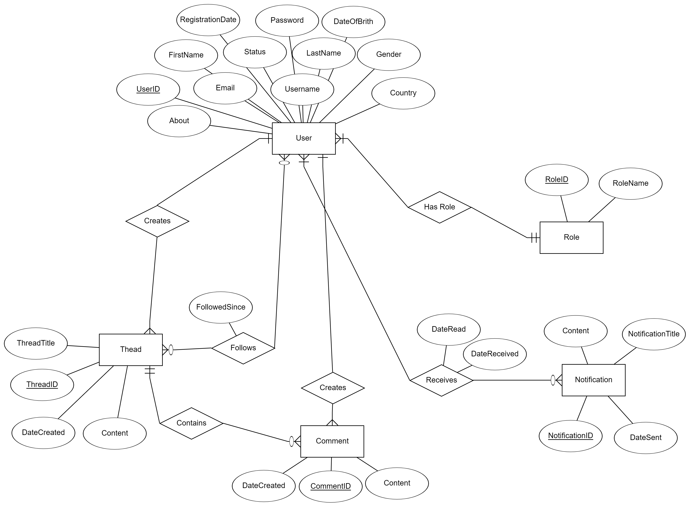

* Second, we construct the Relational Schema based on the ER diagram, the schema is given below:

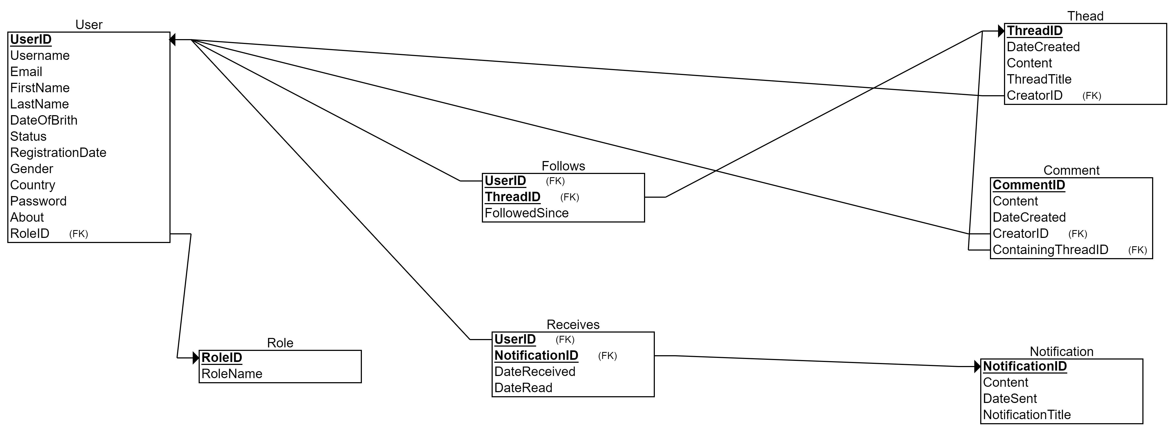

* + Our forum will include several basic functionalities such as creating threads, comments, user registration, and a notification system which will notify the user when the thread they subscribed to has a new comment or an update from the thread author.
  + The notification system will only maintain a basic function which is creating only system notifications sent to user.
  + User will have several roles which are admin, moderator, and normal user. There will be only one admin who is the creator of the forum.
  + Because of the many-to-many relationship of User and Thread, we created a Follows table to save the threads which a particular user follows.
  + The Receives table is also used to represent many-to-many relationship of User and Notification.
  + For one-to-many relationships between User and Comment, User and Thread, and, finally, User and Role, we save the primary key of the one end of the relationship in the many end of the relationship, i.e. the table in which one instance matched with many instances of the other table has the primary key as the foreign key in the other table.
* Finally, we create a GUI application which is used to perform some operations on the database such as querying the database, updating, inserting, and deleting the data.

# PROJECT DEMO

# CONCLUSIONS

The explosion of the net has led to the development of a variety of social networks. One of the most common type of social network is a forum. There are many types of forums which serves different purposes on the Internet. In this project, we have attempted to construct a basic database to serve some basic functionalities of a real forum. Because of the simplicity of the database, the database needs to be improved to be able to run in a large forum. However, the database shown in this report is so far a complete version of the database in a really basic forum.