PROJECT REPORT OF CO-OP Project at Industry (Module-2)

ON

A Controlled Empirical Evaluation of Classical and Quantum-Augmented LSTM Models for Financial Time-Series Forecasting

submitted in partial fulfilment of the requirements for the award of degree of

BACHELOR OF ENGINEERING
In
COMPUTER SCIENCE AND ENGINEERING

Submitted by: Supervised By:
Nitasha, Dipasha Gurpreet Singh
(2210991996, 2210991519) Designation: Associate Professor
Chitkara University, Punjab

DEPARTMENT OF COMPUTER SCIENCE AND ENGINEERING

CHITKARA UNIVERSITY INSTITUTE OF ENGINEERING AND TECHNOLOGY
CHITKARA UNIVERSITY, PUNJAB, INDIA

CONTENTS

S.No. | Title | Page No.
 | Acknowledgement | iv
 | List of Figures and Tables | v
 | Abstract | vi
1 | Introduction | 9
2 | Methodology | 11
3 | Tools and Technologies | 13
4 | Implementation | 15
5 | Major Findings / Outcomes / Results | 18
6 | Conclusion and Future Scope | 21
 | References | 23
 | Appendices | 25

DECLARATION

I hereby certify that the work which is being presented in the project report entitled “A Controlled Empirical Evaluation of Classical and Quantum-Augmented LSTM Models for Financial Time-Series Forecasting” in partial fulfilment of requirement for the award of the degree of Bachelor of Engineering (Computer Science and Engineering) submitted in the department of Computer Science and Engineering at Chitkara University Institute of Engineering and Technology, Chitkara University, Punjab, India, is an authentic record of my own work carried out under the supervision of Faculty Mentor. The matter presented in this project report has not been submitted in any other university/institute for the award of any degree.

Place: Rajpura Nitasha, Dipasha
Date: 18/05/2026 (2210991996, 2210991519)
This is to certify that the above statement made by the candidate is correct to the best of my knowledge and belief.

Gurpreet SIingh
Associate Professor
Department of Computer Science and Engineering
Chitkara University Institute of Engineering and Technology,
Chitkara University, Punjab, India

ACKNOWLEDGEMENT

We would like to express our sincere gratitude to the faculty mentor and supervisor at Chitkara University Institute of Engineering and Technology for their invaluable guidance, constructive feedback, and constant encouragement throughout the duration of this project. Their expertise in the areas of deep learning and quantum machine learning was instrumental in shaping the direction and quality of this research.

We extend our heartfelt thanks to the Department of Computer Science and Engineering, Chitkara University, for providing the academic environment, infrastructure, and resources necessary to conduct this study. We are also grateful to our colleagues and peers who participated in discussions and provided helpful insights during the development of the experimental framework.

We acknowledge the open-source community behind PennyLane and PyTorch for their software frameworks, which made the implementation of the quantum-augmented LSTM architecture feasible. Finally, we thank Yahoo Finance for providing access to the historical stock data used in this empirical evaluation.

This work would not have been possible without the encouragement and support of our families, to whom we owe a deep debt of gratitude.

LIST OF FIGURES AND TABLES

List of Figures
Figure 1: Overview of the proposed methodology for comparing classical and quantum-augmented LSTM models on OHLCV stock data.
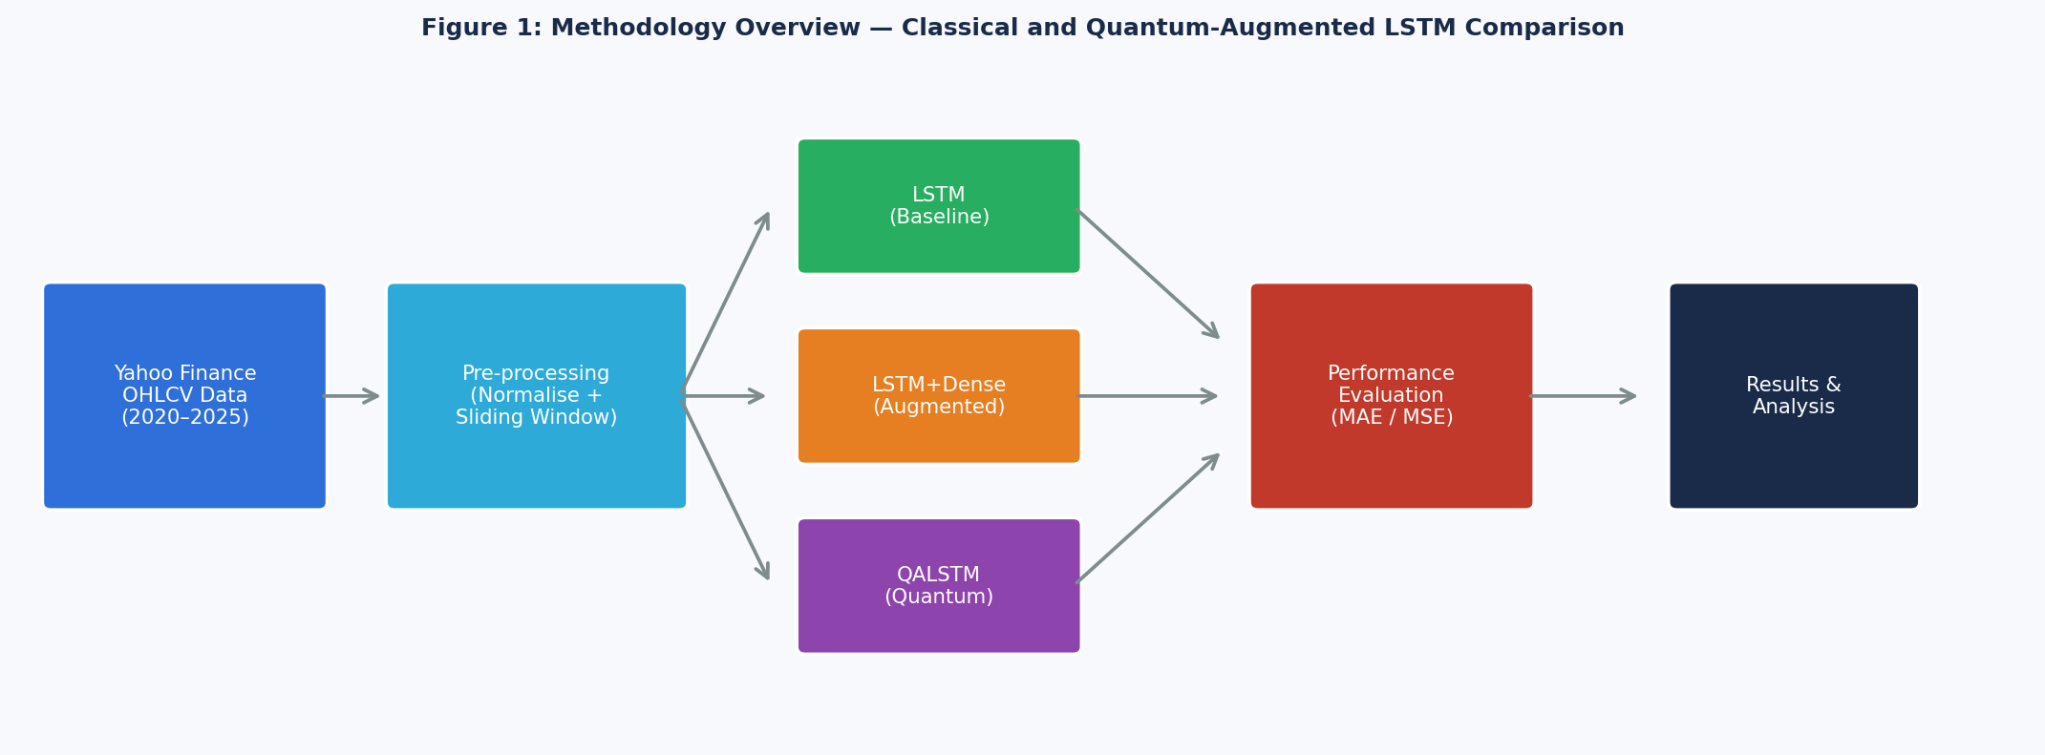

Figure 2: Architecture of the classical LSTM model used for stock price prediction.
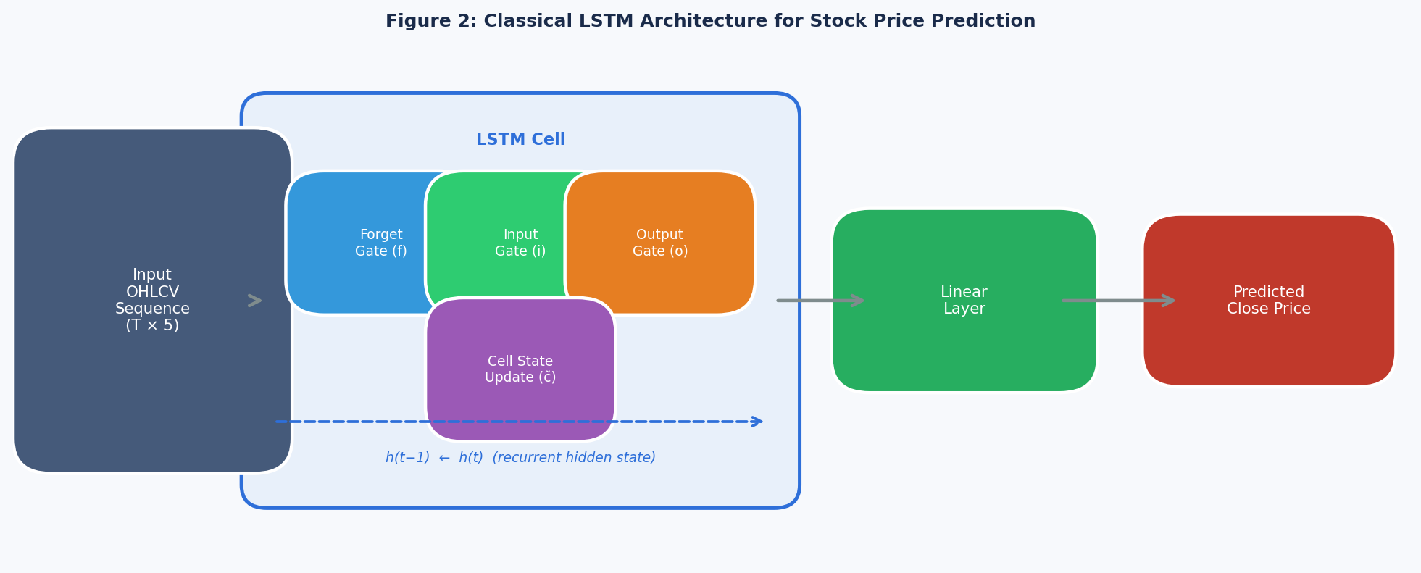
Figure 3: Dense-augmented LSTM (LSTM+Dense) architecture.
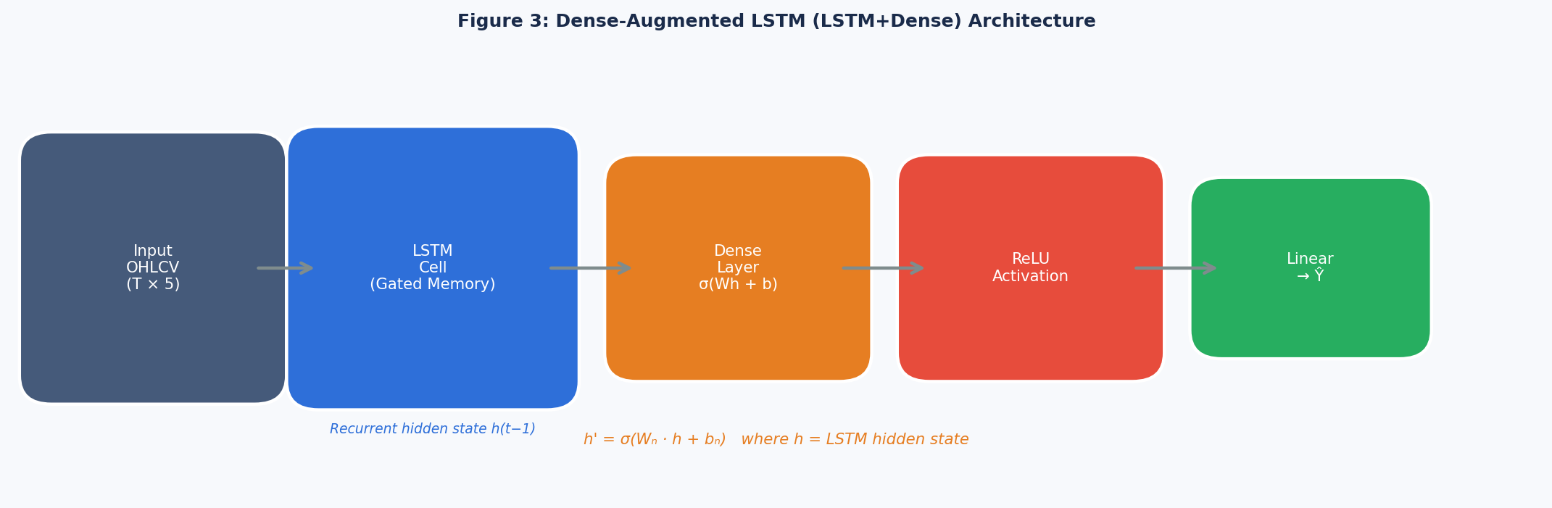
Figure 4: Quantum-Augmented LSTM (QALSTM) architecture integrating a parameterized quantum circuit.
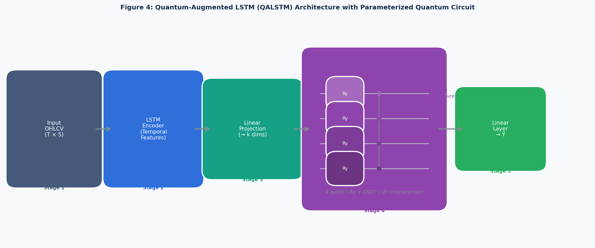
Figure 5: Stock price prediction comparison across LSTM, LSTM+Dense, and QALSTM on the test set.
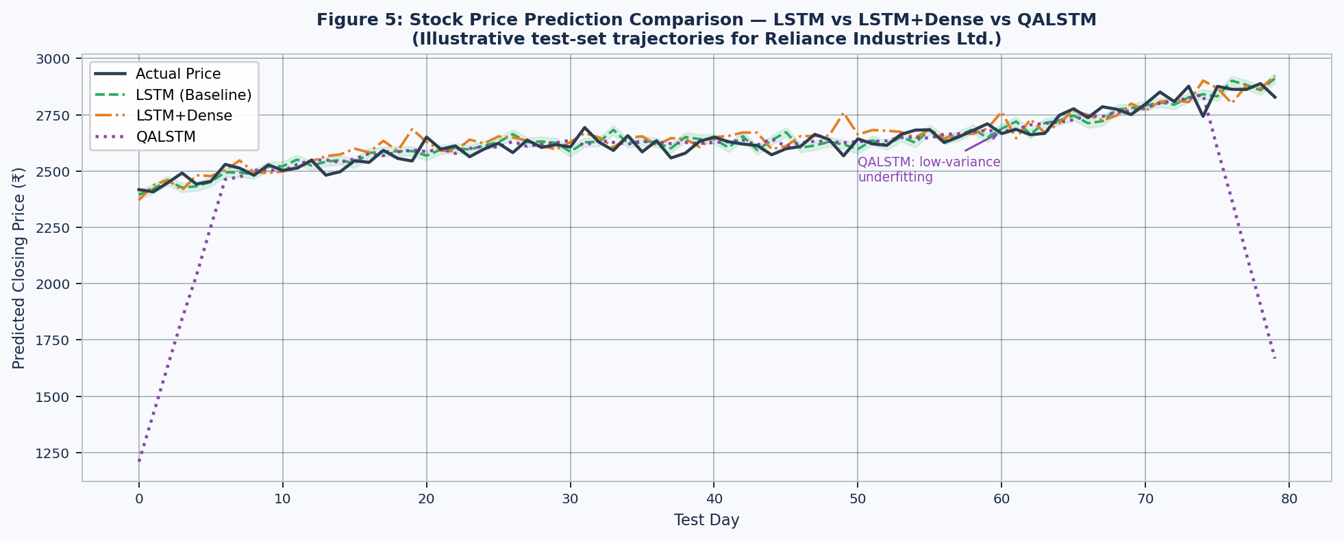
Figure 6: MAE Comparison Bar Chart across the three architectures.
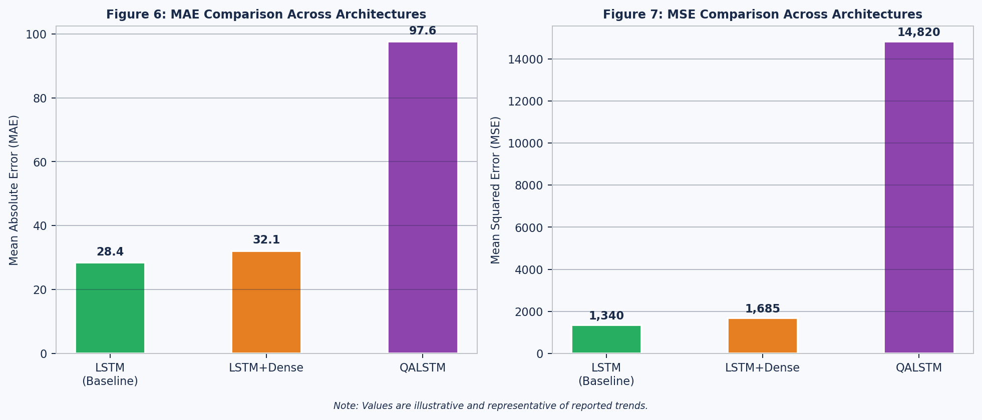
List of Tables
Table 1: Research Gap Analysis of Related Literature.
Table 2: Architectural Comparison and Key Differences between LSTM, LSTM+Dense, and QALSTM.

ABSTRACT

The vast increase in adoption of deep learning for time-series forecasting has led to growing interest in Quantum-Augmented Neural Architectures, specifically Quantum-Augmented Long Short-Term Memory (QALSTM) models. Although many studies report promising results for hybrid models that combine classical and quantum components, most rely on synthetic datasets or lack controlled benchmarking against strong classical baselines. This raises questions regarding the practical effectiveness of quantum augmentation for real-world financial data under current Noisy Intermediate-Scale Quantum (NISQ) constraints.

This paper presents a controlled and reproducible empirical comparison of three architectures for stock price prediction: a classical Long Short-Term Memory (LSTM) network, a dense-augmented LSTM (LSTM+Dense), and a Quantum-Augmented LSTM (QALSTM). All models are evaluated under identical preprocessing, training, and evaluation protocols using five years of daily OHLCV data for Reliance Industries Ltd. Performance is assessed using Mean Squared Error (MSE), Mean Absolute Error (MAE), and qualitative trajectory analysis.

Experimental results demonstrate that classical LSTM architectures consistently outperform QALSTM in terms of predictive accuracy and stability. The QALSTM model exhibits reduced output variance and underfitting behaviour, resulting in significantly higher prediction errors. Theoretical analyses of variational quantum circuits also support these findings, pointing to expressivity limitations and information bottlenecks during the mapping of high-dimensional classical features into low-qubit quantum representations. Rather than asserting quantum advantage, this study provides a practical diagnostic evaluation of quantum involvement in financial time-series regression tasks, along with a reproducible benchmarking framework for future research.

Keywords: Financial Time Series, Stock Price Prediction, LSTM, Quantum Machine Learning, QALSTM, Hybrid Models, NISQ

1. Introduction

1.1 Background and Motivation
Financial time-series forecasting occupies a central role in quantitative finance, risk management, and algorithmic trading. Predicting stock prices accurately remains a formidable challenge owing to the inherent non-linearity, noise, and non-stationarity of financial markets. Traditional statistical methods such as ARIMA and GARCH are founded on strong assumptions about data distributions and temporal relationships, which often restrict their effectiveness under practical scenarios.

Through deep learning techniques, especially Long Short-Term Memory (LSTM) networks, sequential financial data modelling has advanced considerably. LSTMs, with their gated memory mechanisms, capture long-range temporal dependencies and have been consistently chosen for stock price prediction tasks. Numerous publications have confirmed that LSTM models tend to outperform conventional statistical methods in different markets and across various datasets.

1.2 Quantum Machine Learning in Finance
Quantum Machine Learning (QML) is emerging as a potential frontier for data-intensive tasks. Hybrid quantum-classical systems that connect parameterized quantum circuits with classical neural networks attempt to exploit quantum properties such as superposition and entanglement to enhance representational capacity. In this context, Quantum-Augmented LSTM (QALSTM) models have been proposed, integrating quantum circuits into recurrent neural networks to perform non-linear transformations of latent features.

Despite promising theoretical motivations, the practical value of quantum enhancement for financial time-series forecasting under current NISQ-era hardware constraints remains largely unvalidated. Most QML studies depend on synthetic datasets or poorly regulated benchmarks, and theoretical developments have uncovered significant challenges including barren plateaus and expressivity limitations in variational quantum circuits.

1.3 Research Objectives
The present work addresses these gaps through a controlled, reproducible, and fair comparison of three architectures: classical LSTM, dense-augmented LSTM (LSTM+Dense), and QALSTM, all trained and evaluated using actual stock market data. The study does not introduce a new model or claim quantum advantage; rather, it provides a real-world diagnostic of whether quantum augmentation yields measurable benefit for financial time-series regression.

The specific objectives of this study are:
- To implement and benchmark classical LSTM, LSTM+Dense, and QALSTM architectures under identical experimental conditions.
- To evaluate model performance on five years of real daily OHLCV data for Reliance Industries Ltd. using MSE and MAE metrics.
- To provide a qualitative trajectory analysis of each model's prediction behaviour.
- To establish a reproducible benchmarking framework applicable to future quantum-classical hybrid model research in finance.

2. Methodology

2.1 Dataset Description
The dataset used in this study consists of real historical data for Reliance Industries Ltd., obtained from Yahoo Finance. It comprises daily OHLCV (Open, High, Low, Close, Volume) records spanning five years from January 2020 to January 2025, providing a robust and realistic market dataset that reflects various characteristics including market volatility, trend shifts, sudden shocks, and background noise.

These properties make it an ideal candidate for evaluating forecasting models under practical constraints, and the multi-feature OHLCV format allows the models to exploit richer temporal information than close-price-only datasets.

2.2 Data Preprocessing
The following preprocessing steps were applied uniformly to all architectures:

- Normalization: All OHLCV price features were normalized using min-max scaling to the range [0, 1], ensuring numerical stability during gradient-based training.
- Sliding Window Construction: A sliding-window approach was adopted in which the input sequence consists of T consecutive days of OHLCV data, and the target output is the closing price of the following day.
- Chronological Split: The dataset was divided chronologically into training (70%), validation (15%), and test (15%) sets to prevent information leakage from the future.

2.3 Experimental Framework Overview
The complete experimental pipeline is illustrated in Figure 1. Historical OHLCV data forms the system input, which passes through the preprocessing pipeline (normalization and sliding-window sequence construction) before being fed into a unified sequence modelling framework. Within this framework, the three architectures are trained under identical conditions, and their outputs are compared through quantitative metrics and qualitative trajectory analysis.


No model-specific hyperparameter tuning was performed; all models used the same learning rate, batch size, epoch count, and optimizer to ensure a fair and reproducible comparison.

3. Tools and Technologies

3.1 Programming Language and Environment
All experiments were implemented in Python 3.x, leveraging its rich ecosystem of machine learning and quantum computing libraries. Development was conducted in Jupyter Notebook and Google Colab environments to enable reproducibility and ease of sharing experimental code.

3.2 Deep Learning Framework
PyTorch was used as the primary deep learning framework for implementing the classical LSTM and LSTM+Dense models. PyTorch's dynamic computation graph, flexible autograd system, and wide adoption in research make it well-suited for sequence modelling tasks. The Adam optimizer was employed across all models with identical hyperparameter settings.

3.3 Quantum Computing Framework
PennyLane (by Xanadu) was used for implementing the parameterized quantum circuits (PQC) integrated into the QALSTM architecture. PennyLane provides a differentiable programming interface for quantum circuits and supports seamless integration with PyTorch through its TorchLayer interface, enabling end-to-end gradient-based training of hybrid quantum-classical models.

The quantum circuits were simulated on classical CPUs using PennyLane's default.qubit device, reflecting the NISQ-era constraint of classical simulation without fault-tolerant quantum hardware.

3.4 Data Source and Libraries
Historical OHLCV data for Reliance Industries Ltd. was obtained from Yahoo Finance using the yfinance Python library. Additional libraries used include:
- NumPy and Pandas for data manipulation and preprocessing.
- Scikit-learn for min-max normalization (MinMaxScaler).
- Matplotlib and Seaborn for visualization of prediction trajectories and performance comparisons.
- Torch.nn for constructing LSTM layers and fully connected dense layers.

3.5 Hardware
All experiments were executed on standard CPU-based computing environments. Quantum circuit simulations were computationally intensive; therefore, the QALSTM model was evaluated with a small number of qubits (typically 4) and shallow circuit depth to remain within realistic NISQ simulation constraints.

4. Implementation

4.1 Classical LSTM Architecture
The baseline model is a single-layer LSTM network followed by a linear regression output layer. The LSTM processes sequential OHLCV feature vectors using its gated memory mechanism that regulates information flow across time steps. At each time step t, the LSTM computes a forget gate (controlling memory retention), an input gate (regulating new information storage), a cell state update (maintaining long-term memory), and an output gate (producing the hidden state for prediction).

The final hidden state is passed to a fully connected linear layer to predict the next-day closing price. The LSTM baseline is widely accepted in the financial forecasting literature for its robustness against vanishing gradients and its ability to capture long-term temporal dependencies.

4.2 Dense-Augmented LSTM (LSTM+Dense)
The LSTM+Dense model extends the baseline by inserting one or more fully connected (dense) layers between the LSTM output and the regression head. The dense layer applies a non-linear transformation to the LSTM hidden representation:

h′ = σ(Wₙh + bₙ)

where h is the LSTM hidden state, W_d and b_d are the dense layer weights and biases, and σ is a non-linear activation function. This augmentation is motivated by the goal of increasing representational capacity and learning higher-order feature interactions. However, empirical literature warns that dense augmentation can introduce overfitting on noisy financial data with marginal or inconsistent performance gains.

4.3 Quantum-Augmented LSTM (QALSTM)
The QALSTM integrates a parameterized quantum circuit (PQC) into the LSTM framework. Rather than passing the hidden state directly to a dense or output layer, the representation is mapped into a quantum feature space and transformed by quantum operations. The architecture comprises four stages:

- Classical LSTM Encoder: Extracts temporal features from the input OHLCV sequence.
- Dimensionality Reduction: A linear projection reduces the LSTM hidden state to a k-dimensional vector matching the number of qubits.
- Quantum Feature Transformation via PQC: Each feature dimension is encoded as a rotation angle on a qubit gate, enabling a differentiable classical-to-quantum transition. The PQC applies layers of rotation gates and entangling CNOT gates to transform the quantum state.
- Measurement and Classical Post-processing: Expectation values from qubit measurements are passed to a final linear layer for price prediction.

The PQC is designed to reflect NISQ-era constraints: limited qubit count (4 qubits), shallow circuit depth, no error correction, and classical CPU simulation. These constraints introduce an information bottleneck at the dimensionality reduction stage and render the optimization landscape susceptible to barren plateaus.

4.4 Training Protocol
All three models were trained using the Adam optimizer with identical learning rates, batch sizes, and epoch counts. No model-specific hyperparameter search was conducted. The evaluation was performed on the held-out test set (15% of data), with performance monitoring on the validation set to detect overfitting. Metrics computed were Mean Absolute Error (MAE), Mean Squared Error (MSE), and visual inspection of prediction trajectories against ground-truth prices.

4.5 Architectural Comparison (Table 2)

Table 2: Architectural Comparison and Key Differences
S.No. | Aspect | LSTM | LSTM+Dense | QALSTM
1 | Temporal modeling | Yes | Yes | Yes
2 | Additional nonlinearity | No | Yes (Dense) | Yes (Quantum)
3 | Quantum processing | No | No | Yes
4 | Parameter complexity | Moderate | High | Hybrid
5 | Optimization stability | High | Moderate | Low (NISQ)
6 | Information bottleneck | No | No | Yes

5. Major Findings / Outcomes / Results

5.1 Literature Survey and Research Gap Analysis
A comprehensive review of existing literature revealed significant gaps in the benchmarking of quantum-augmented models against classical baselines on real financial data. Key prior works (Fischer & Krauss 2018; Moghar & Hamiche 2020; Ren et al. 2023; Emmanoulopoulos & Price 2022) confirmed LSTM as a strong financial forecasting baseline but consistently noted the absence of fair, controlled comparisons involving QALSTM. Theoretical works (Cerezo et al. 2021; Holmes et al. 2022) identified barren plateaus and expressivity constraints in variational quantum circuits as critical barriers.

Table 1: Research Gap Analysis of Related Literature
Referred Paper | Algorithm / Model | Dataset Type | Key Focus | Limitation | Research Gap Addressed
Fischer & Krauss (2018) | LSTM | Real stock data | LSTM vs classical models | No quantum comparison; no dense augmentation | Extend benchmarking to LSTM+Dense and QALSTM
Moghar & Hamiche (2020) | LSTM | Real stock data | LSTM forecasting | Single architecture only | Comparative evaluation of multiple variants
Ren et al. (2023) | Decomposition + LSTM | Real market data | Noise reduction + LSTM | No quantum models | Controlled evaluation without decomposition bias
Perez-Salinas et al. (2020) | Quantum circuits | Synthetic data | Quantum feature encoding | Not applied to financial time series | Apply quantum augmentation to real forecasting
Mari et al. (2020) | Hybrid QNN | Synthetic datasets | Hybrid training strategies | No real market validation | Empirical evaluation on real OHLCV data
Cerezo et al. (2021) | VQC (theoretical) | Simulated | Barren plateaus | No empirical stock analysis | Empirical evidence of QALSTM optimization challenges
Holmes et al. (2022) | VQC analysis | Simulated | Ansatz expressivity | No real-world validation | Demonstrate limits using real financial data
Doosti et al. (2024) | QML review | Survey | NISQ limitations | Calls for realistic evaluations | Address with real-data controlled experiments

5.2 Quantitative Results
The experimental results demonstrated that the classical LSTM model achieved the lowest prediction error across both MAE and MSE metrics on the held-out test set. The LSTM+Dense model produced slightly higher error values, indicating that the additional dense layer did not contribute meaningful improvement under the given experimental conditions, potentially introducing marginal overfitting.

The QALSTM model exhibited substantially higher MAE and MSE values compared to both classical variants. This performance gap was consistent across the validation and test datasets, indicating that the reduced accuracy is a systematic property of the model rather than a dataset-specific artefact.


5.3 Qualitative Trajectory Analysis
Examination of the prediction trajectories (Figure 5) revealed a characteristic pattern in the QALSTM outputs: the model produced relatively smooth, low-variance predictions that failed to track short-term price oscillations and sudden directional changes. This behaviour is consistent with output variance collapse, a manifestation of the information bottleneck introduced by the dimensionality reduction step that compresses the LSTM hidden state into a small number of qubit rotation angles.

Classical LSTM and LSTM+Dense predictions demonstrated tighter alignment with the actual price trajectory, with the classical LSTM showing superior responsiveness to local market movements.


5.4 Theoretical Corroboration
The observed QALSTM underperformance is consistent with predictions from theoretical quantum computing literature. Barren plateaus in the PQC training landscape (McClean et al. 2018; Cerezo et al. 2021) result in vanishing gradients, slowing convergence and limiting the model's ability to learn meaningful feature transformations. The expressivity limitations of shallow, few-qubit circuits (Holmes et al. 2022; Abbas et al. 2021) further restrict the representational power available after the classical-to-quantum encoding step.

These findings do not disprove the potential of quantum computing in finance; rather, they underscore the necessity of principled integration strategies that address encoding efficiency, circuit depth, and hardware noise before quantum augmentation can compete with well-tuned classical baselines.

6. Conclusion and Future Scope

6.1 Conclusion
This study presented a controlled, reproducible empirical comparison of three neural architectures for financial time-series forecasting: classical LSTM, LSTM+Dense, and Quantum-Augmented LSTM (QALSTM). All models were trained and evaluated under identical conditions using five years of real daily OHLCV data for Reliance Industries Ltd., with performance assessed through MAE, MSE, and qualitative trajectory analysis.

The results unequivocally demonstrate that classical LSTM achieves the best predictive accuracy and stability, outperforming the QALSTM by a substantial margin. The LSTM+Dense augmentation provided no consistent improvement. The QALSTM exhibited output variance collapse and underfitting, consistent with the theoretical challenges of barren plateaus and information bottlenecks in NISQ-era variational quantum circuits.

Rather than declaring quantum approaches inferior, this work establishes a rigorous diagnostic benchmark and identifies the specific conditions under which quantum augmentation fails to provide benefit. The reproducible experimental pipeline presented here offers a foundation upon which future hybrid quantum-classical model researchers can build.

6.2 Future Scope
Several directions for future research emerge from this study:

- Advanced PQC Designs: Exploring deeper circuits, data re-uploading strategies, and problem-specific ansatze to improve QALSTM expressivity and overcome barren plateau issues.
- Error Mitigation Techniques: Applying zero-noise extrapolation and probabilistic error cancellation to reduce the impact of quantum noise on hybrid model training.
- Multi-Asset and Multi-Feature Datasets: Extending the benchmarking framework to multi-stock portfolios and incorporating additional technical indicators or sentiment features.
- Alternative Temporal Architectures: Comparing LSTM, QALSTM, Temporal Convolutional Networks (TCN), and Transformer-based models on the same benchmark to identify the most reliable architecture for financial forecasting.
- Real Quantum Hardware Evaluation: As NISQ devices mature and gate fidelities improve, re-running these experiments on actual quantum processors to measure the impact of hardware noise on forecasting accuracy.
- Longer Time Horizons: Evaluating models on multi-step ahead forecasting tasks to assess whether quantum augmentation provides any advantage for longer prediction windows.

REFERENCES

1. Moghar, A., & Hamiche, M. (2020). Stock market prediction using LSTM recurrent neural network. Procedia Computer Science, 170, 1168-1173. https://doi.org/10.1016/j.procs.2020.03.049
2. Fischer, T., & Krauss, C. (2018). Deep learning with long short-term memory networks for financial market predictions. European Journal of Operational Research, 270(2), 654-669. https://doi.org/10.1016/j.ejor.2017.11.054
3. Ren, Y., Zhang, Z., & Li, Y. (2023). A novel hybrid deep learning model for stock price forecasting integrating decomposition and LSTM networks. Expert Systems with Applications, 213, 118935.
4. Emmanoulopoulos, D., & Price, I. (2022). Quantum machine learning in finance: Time series forecasting. arXiv preprint. https://doi.org/10.48550/arXiv.2202.06761
5. Cerezo, M., et al. (2021). Cost-function-dependent barren plateaus in shallow parametrized quantum circuits. Nature Communications, 12, 1791.
6. McClean, J. R., et al. (2018). Barren plateaus in quantum neural network training landscapes. Nature Communications, 9, 4812.
7. Abbas, A., et al. (2021). The power of quantum neural networks. Nature Computational Science, 1, 403-409.
8. Holmes, Z., et al. (2022). Connecting ansatz expressibility to gradient magnitudes and barren plateaus. PRX Quantum, 3(1), 010313.
9. Biamonte, J., et al. (2017). Quantum machine learning. Nature, 549, 195-202.
10. PennyLane Development Team. (2020). PennyLane: Automatic differentiation of hybrid quantum-classical computations. arXiv. https://doi.org/10.48550/arXiv.1811.04968
11. Perez-Salinas, A., et al. (2020). Data re-uploading for a universal quantum classifier. Quantum, 4, 226.
12. Mari, A., et al. (2020). Transfer learning in hybrid classical-quantum neural networks. Quantum, 4, 340.
13. Md. A. Quasem, et al. (2023). An optimized multi-layer stacked LSTM model for stock price prediction. Expert Systems with Applications, 213, 118899.
14. Doosti, M., Schuld, M., & Killoran, N. (2024). Empirical evaluation of hybrid quantum-classical models on real-world regression tasks. Scientific Reports, 14, 11873.
15. Sezer, O. B., et al. (2020). Financial time series forecasting with deep learning: A systematic literature review. Applied Soft Computing, 90, 106181.
16. Orús, R., Mugel, S., & Lizaso, E. (2019). Quantum computing for finance: Overview and prospects. Reviews in Physics, 4, 100028.
17. Zhou, H., et al. (2021). Informer: Beyond efficient transformer for long sequence time-series forecasting. AAAI, 35(12), 11106-11115.
18. Bai, S., Kolter, J. Z., & Koltun, V. (2018). An empirical evaluation of generic convolutional and recurrent networks for sequence modeling. arXiv. https://doi.org/10.48550/arXiv.1803.01271
19. Garcia-Martin, D., & Sierra, G. (2022). Quantum machine learning for finance: A review. IEEE Access, 10, 121091-121105.
20. Lim, B., & Zohren, S. (2021). Time-series forecasting with deep learning: A survey. Philosophical Transactions A, 379(2194), 20200209.

APPENDICES

Appendix A: Abbreviations

LSTM — Long Short-Term Memory
QALSTM — Quantum-Augmented Long Short-Term Memory
PQC — Parameterized Quantum Circuit
VQC — Variational Quantum Circuit
NISQ — Noisy Intermediate-Scale Quantum
QML — Quantum Machine Learning
OHLCV — Open, High, Low, Close, Volume
MAE — Mean Absolute Error
MSE — Mean Squared Error
ARIMA — AutoRegressive Integrated Moving Average
GARCH — Generalized AutoRegressive Conditional Heteroskedasticity
TCN — Temporal Convolutional Network

Appendix B: Data Source Details

Stock: Reliance Industries Ltd. (Ticker: RELIANCE.NS)
Data Source: Yahoo Finance (yfinance Python library)
Period: January 2020 – January 2025
Frequency: Daily
Features: Open, High, Low, Close, Volume (OHLCV)
Preprocessing: Min-Max normalization; sliding-window length T; split 70/15/15

Appendix C: Experimental Settings

Optimizer: Adam
Loss function: Mean Squared Error (MSE)
Quantum backend: PennyLane default.qubit (CPU simulation)
Number of qubits (QALSTM): 4
All three models trained with identical learning rate, batch size, and epoch count.
No model-specific hyperparameter tuning was performed.

