**Exercise 2 (23 points) – individual work**

* The answers can be typed or handwritten (handwriting must be clear and readable), in this exercise sheet or your own sheet (put your name & ID at the top of the sheet). All answers must be saved to only 1 PDF file.
* Some questions also require the submission of processes/workflows (file.rmp or file.ipynb).
* In case of re-submission (after first grading) or submission after solution is given, your points will be weighted by 0.5.

**-------------------------------------------------------------------------------------------------------------------------------------------------------**

1. (Total 10 points)

1.1 (4 points) From the table, calculate GINI

when splitting data by each attribute (answer in 4

decimal places). And based on GINI, which attribute

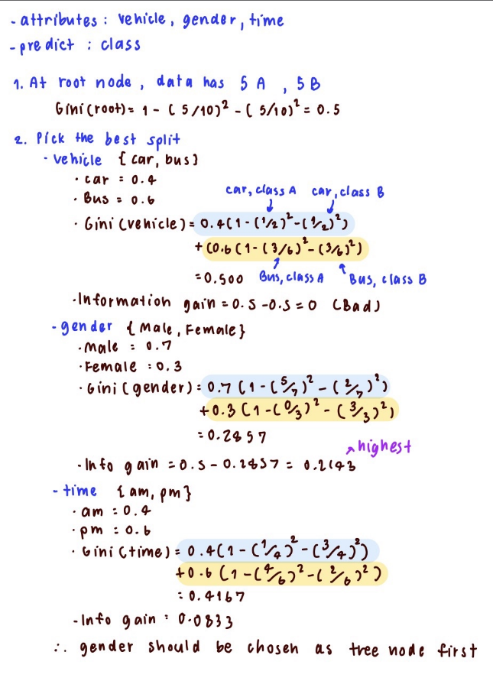should be chosen as a tree node first?

|  |  |  |  |  |
| --- | --- | --- | --- | --- |
| Record | Vehicle | Gender | Time | Class |
| 1 | Car | Male | pm | A |
| 2 | Car | Female | am | B |
| 3 | Bus | Male | pm | A |
| 4 | Bus | Female | pm | B |
| 5 | Bus | Male | pm | A |
| 6 | Car | Female | pm | B |
| 7 | Bus | Male | am | B |
| 8 | Bus | Male | am | A |
| 9 | Car | Male | pm | A |
| 10 | Bus | Male | am | B |

|  |  |
| --- | --- |
| Split by Vehicle | GINI = 0.5000 |
| Split by Gender | GINI = 0.2857 |
| Split by Time | GINI = 0.4167 |
| Which one to choose first? | Gender |

1.2 (4 points) Consider another dataset that has 12 records (6 in class yes, 6 in class no), and a nominal attribute "brand" with **3 categories {iPhone, Samsung, Oppo}.** When splitting the data by brand, using **both binary split and multi-way split**, entropies after split are as shown in the table. Calculate **gain ratio** for each split option.

Note 1: Find entropy before split from the full data set

Note 2: Use bin sizes to calculate split penalty for each option

|  |  |  |  |  |
| --- | --- | --- | --- | --- |
| Option | Split Method | Bin size | Total entropy  after split | Gain Ratio |
| 1 | Bin1: brand = iPhone, Samsung  Bin2: brand = Oppo | 4 yes, 4 no  2 yes, 2 no | 1 | 0/0.918 = **0** |
| 2 | Bin1: brand = iPhone, Oppo  Bin2: brand = Samsung | 5 yes, 4 no  1 yes, 2 no | 0.9729 | (1-0.9729)/0.811 = **0.0334** |
| 3 | Bin1: brand = iPhone  Bin2: brand = Samsung, Oppo | 3 yes, 2 no  3 yes, 4 no | 0.9793 | (1-0.9793)/0.979869 = **0.0211** |
| 4 | Bin1: brand = iPhone  Bin2: brand = Samsung  Bin3: brand = Oppo | 3 yes, 2 no  1 yes, 2 no  2 yes, 2 no | 0.9675 | (1-0.9675)/1.55459 = **0.0209** |

**Entropy before split** = -6/12 log (6/12) – 6/12 log (6/12) = **1**

**Calculate Split Penalty for each option**

* Option 1 : - 8/12 log (8/12) – 4/12 log (4/12) = 0.918
* Option 2 : - 9/12 log (9/12) – 3/12 log (3/12) = 0.811
* Option 3 : - 5/12 log (5/12) – 7/12 log (7/12) = 0.979869
* Option 4 : - 5/12 log (5/12) – 3/12 log (3/12) – 4/12 log (4/12) = 1.55459

1.3 (2 points) From question 1.2, which split option should be chosen if we use gain ratio as the criterion? And which option should be chosen if we use information gain as the criterion instead?

* Gain Ratio = Choose Option 2
* Information gain = Choose Option 4

2. (Total 5 points) Consider the following rule set generated from training data in question 1.1

Rule 1 if gender = female then class = B

Rule 2 if gender = male && vehicle = bus then class = A

Rule 3 if vehicle = car && time = pm then class = A

Rule 4 if vehicle = bus && time = am then class = B

There are 8 combinations of attribute values e.g. (car, male, am), (car, male, pm), (car, female, am), (car, female, pm), … **To check exhaustive and mutual exclusive properties**, you need to check whether every combination can be predicted by only 1 rule.

2.1 (1 point) Find combination (there is 1) that indicate the **lack of exhaustive** property.

- (car, male, am) lacks of exhaustive property

2.2 (2 points) Find combinations (there are 2) that indicate the **lack of mutual exclusive** property, and rules that are triggered by each combination.

- (car, female, pm) : Triggered by Rules 3, 1

- (bus, male, am) : Triggered by Rules 2, 4

2.3 (2 point) If we solve the conflicts in question 2.2 by following rules with **the highest accuracy**, what would be the prediction for each combination in 2.2.

- R1 accuracy = 1

- R2 accuracy = 3/5 = 0.6

- R3 accuracy = 2/3 = 0.6667

- R4 accuracy = 2/3 = 0.6667

* The prediction for (car, female, pm) = Rule 1, class B
* The prediction for (bus, male, am) = Rule 4, class B

3. (Total 8 points) Retrieve **Past Campaign Data**.

3.1 (2 points) Build a work flow for classification task.

* Step 1. Split data into 2 partitions: 70% of the data for training and 30% for testing.
* Step 2. Use either decision tree or rule induction to classify response. Adjust parameters to get high accuracy (>= 85% on test data). If the accuracy is already high, you may adjust parameters to get better or clearer patterns (e.g. bigger tree nodes with higher coverage or smaller nodes with more conditions).
* Step 3. Submit your workflow. Make sure that it outputs at least performance table and decision tree or rule set. Name the workflow **question3.rmp.**

3.2 (3 points) Capture (a portion of) tree or rule set and highlight node/rule that predict yes. The node/rule that you choose should have high coverage, high accuracy, and contain interesting conditions. In case of rule set, don't pick default rule without any precondition.

|  |  |
| --- | --- |
| Questions/Instructions | Answers |
| (a) Show the captured tree/rule & describe pattern that predicts yes in words (read all conditions in the rule, or all conditions that lead to the leaf node). |  |
| (b) Report coverage of this pattern, i.e. number or percentage of records it covers. |  |
| (c) Report accuracy of this pattern |  |

3.3 (3 points) Capture (a portion of) tree or rule set and highlight node/rule that predict no. Follow the same guidelines as in question 3.2.

|  |  |
| --- | --- |
| Questions/Instructions | Answers |
| (a) Show the captured tree/rule & describe pattern that predicts no in words. |  |
| (b) Report coverage of this pattern. |  |
| (c) Report accuracy of this pattern |  |