Exercise 5 (14 points) – individual work
- The answers can be typed or handwritten (handwriting must be clear and readable), in this exercise sheet or your own sheet (put your name & ID at the top of the sheet). All answers must be saved to only 1 PDF file.
- Some questions also require the submission of processes/workflows (file.rmp or file.ipynb).
- In case of re-submission (after first grading) or submission after solution is given, your points will be weighted by 0.5.
-------------------------------------------------------------------------------------------------------------------------------------------------------
1. (Total 6 points)
Retrieve cpu data, which contains the following attributes. All of them are numeric.
Attribute | Description
MYCT | Machine cycle time (nanoseconds)
MMIN | Minimum main memory (kilobytes)
MMAX | Maximum main memory (kilobytes)
CACH | Cache memory (kilobytes)
CHMIN | Minimum channels (units)
CHMAX | Maximum channels (units)
PERF (target) | Performance score

  - (3 points) Predict PERF by linear regression method.
Instructions/Questions | Answers
Step 1. Run linear regression to predict PERF in split validation with split ratio = 0.7. When setting linear regression parameters, don't use feature selection & colinear feature elimination. | RMSE = 67.354  RRSE = 0.742  r = 0.757  r² = 0.573
Step 2. Run linear regression as in step 1. This time, use feature selection (pick 1 method that gives best result) & colinear feature elimination. | RMSE = 66.419  RRSE = 0.732  r = 0.762  r² = 0.581
Step 3. Compare results from steps 1 and 2. Identify attribute(s) that can be considered redundant or can be excluded from the regression model. | Redundant attributes = CHMIN  Result from Step 2 is better because we removed features with less weights and features that have collinearity property
Also submit your workflow that performs both steps. The output in each step must include linear regression table and performance vector (RMSE, RRSE, r, and r²). Name the workflow question1_1.rmp.

1.2 (3 points) Use 1 machine learning method (decision tree, SVR, neural network) to predict PERF instead. Try to get better performance than linear regression. If any data preprocessing is needed, do it.
Instructions/Questions | Answers
Submit your workflow. Name the workflow question1_2.rmp. Make sure that it output the same performance vector as in 1.1. | Your method = Neural Net  RMSE = 55.489  RRSE = 0.611  r = 0.799  r² = 0.638
Briefly explain which data preprocessing is applied to which attribute (if there is any). | Explain preprocessing  I use Weight by Correlation to achieve higher performance because it only keeps features with strong linear relationship with the target PERF. I also used normalization parameter in neural net operator to scale all the attributes
Briefly explain how the method's parameters are set differently from classification task. | Explain setting (diff from classification)  For this kind of task, it doesn’t require any type conversion since all attributes are already numerical. So each input node represents each numerical attribute directly. Also, in regression task, neural net uses a numerical label so the output node is set to a single linear output instead of multiple class neurons like in classification task. Everything else remains the same.

2. (Total 8 points) Use training data in the following table to answer questions
2.1 (3 points) Consider AdaBoost model trained by the following training data.
Training Data
Record | A | B | C | Buy (class)
1 | T | T | positive | yes
2 | F | T | negative | no
3 | F | F | neutral | yes
4 | T | F | negative | no
5 | F | T | positive | no
6 | T | T | positive | yes
7 | F | T | negative | no
8 | T | F | positive | yes
9 | F | F | negative | no
10 | T | T | neutral | yes

AdaBoost model
Base classifier 1, weight = 2.197
if C = negative then buy = no
if C = neutral then buy = yes
if C = positive then buy = yes
Base classifier 2, weight = 2.079
if A = F && B = F then buy = yes
if A = F && B = T then buy = no
if A = T && B = F then buy = no
if A = T && B = T then buy = yes
Base classifier 3, weight = 2.708
if A = F then buy = no
if A = T then buy = yes

(a) During 3 rounds of training base classifiers, which training records are easiest to predict?

Round 1
Record 1 = yes, correct
Record 2 = no, correct
Record 3 = yes, correct
Record 4 = no, correct
Record 5 = yes, incorrect
Record 6 = yes, correct
Record 7 = no, correct
Record 8 = yes, correct
Record 9 = no, correct
Record 10 = yes, correct

Round 2
Record 1 = yes, correct
Record 2 = no, correct
Record 3 = yes, correct
Record 4 = no, correct
Record 5 = no, correct
Record 6 = yes, correct
Record 7 = no, correct
Record 8 = no, incorrect
Record 9 = yes, incorrect
Record 10 = yes, correct

Round 3
Record 1 = yes, correct
Record 2 = no, correct
Record 3 = no, incorrect
Record 4 = yes, incorrect
Record 5 = no, correct
Record 6 = yes, correct
Record 7 = no, correct
Record 8 = yes, correct
Record 9 = no, correct
Record 10 = yes, correct

Records that are easiest to predict : Record 1,2,6,7,10

(b) Find ensemble predictions for record 3 and for record 5.

Y1, w1 = 2.197 | y | n | y | n | y | y | n | y | n | y
Y2, w2 = 2.079 | y | n | y | n | n | y | n | n | y | y
Y3, w3 = 2.708 | y | n | n | y | n | y | n | y | n | y
Actual y | y | n | y | n | n | y | n | y | n | y

Ensemble prediction for record 3 = 2.197+2.079-2.708 = 1.568. -> predicts y
Ensemble prediction for record 5 = 2.197-2.079-2.708 = -2.59 -> predicts n

2.2 (2 points) After training 5 weak classifiers, their predictions on training data are as follows.
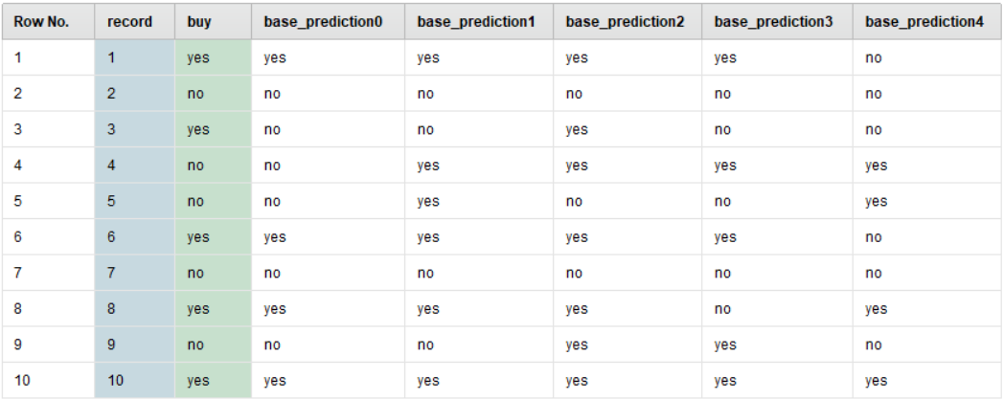

(a) Using voting ensemble by majority vote, find ensemble prediction for record 3.
Answer : No
(b) Find the training accuracy of this voting model (when it predicts all training records).
Record 1 = yes, correct
Record 2 = no, correct
Record 3 = no, incorrect
Record 4 = yes, incorrect
Record 5 = no, correct
Record 6 = yes, correct
Record 7 = no, correct
Record 8 = yes, correct
Record 9 = no, correct
Record 10 = yes, correct
Accuracy = 8/10 = 80%

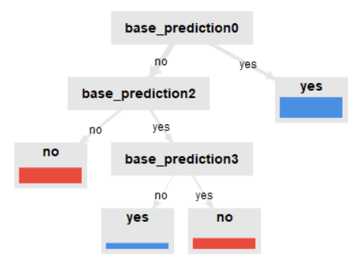
2.3 (3 points) Suppose that we train meta decision
tree classifier to learn the prediction patterns of 5 weak
classifiers in 2.2 (i.e. the table in 2.2 is training partition
for meta training). The meta model is as follows.

(a) Find ensemble prediction for record 3.
Answer : yes
(b) From the meta model, list all base classifiers that contribute to the final prediction.
Answer : base_prediction0, base_prediction2, base_prediction3

(c) From the meta model, list all base classifiers that don't contribute to the final prediction
Answer : base_prediction1, base_prediction4

