Table of Contents
1. Introduction and Objectives (Executive Summary) 1
2. Connection to Lecture 02 - Data Representation 1
3. Data Sources and Application Definitions 1
4. Application 1 - Diabetes Prediction 1
5. Application 2 - House-Price Prediction 1
6. Application 3 - E-Commerce Customer Behaviour and Interest 1
7. Comparison of the Three Intelligent Systems 1
8. Deployment Architecture 1
9. Reproducibility 1
10. Final Comparative Discussion 1
11. Conclusion 1
Appendix A - Repository Structure 1
Appendix B — Jupyter Notebook Architecture & Section Specification 1
Appendix C - API Endpoint Specification 1
Appendix D - Web Application Report 1
Appendix E - Mobile Application Report 1
Appendix F - Final Submission Checklist and Additional Evidence 1

POSTS AND TELECOMMUNICATIONS INSTITUTE OF TECHNOLOGY
FACULTY OF INFORMATION TECHNOLOGY
INTELLIGENT SYSTEM DEVELOPMENT
ASSIGNMENT 02
From Data Representation to Deployable Intelligent Systems
Student name : Nguyễn Văn Trường
Student ID : B23DCCE095
Class : E23CNPM02
Lecturer : Dinh Que Tran, Ph.D., Assoc. Prof.
Semester : I.2026
Application | Task | Selected model | Headline test result
Diabetes | Binary classification (diabetic vs not) | Random Forest | ROC-AUC 0.809, recall on diabetic class 0.735, accuracy 0.725
House price | Regression (sale price, million VND) | Random Forest on log(1 + Price) | MAE 10 626, RMSE 26 873, R^2 0.186
Customer behaviour | Binary classification (will the reviewer recommend) | Logistic Regression on tabular + TF-IDF text | ROC-AUC 0.964, macro-F1 0.858, recall on “does not recommend” 0.876
Application | Dataset (Kaggle) | Rows (raw -> clean) | Representation | Deployment
Diabetes | alexteboul/diabetes-health-indicators-dataset (BRFSS 2015) | 253 680 -> 229 781 | X in R^{N x 23} scaled + passthrough | FastAPI + React/Vite + Flutter
House price | qmanhbeo/vietnamese-real-estate-listings-may-2024 (CC BY-NC 4.0) | 236 226 -> 201 654 | X in R^{N x 92} impute + scale + one-hot (sparse) | FastAPI + React/Vite + Flutter
Customer behaviour | nadyinky/sephora-products-and-skincare-reviews (CC0) | 116 262 -> 104 313 | X in R^{N x 28 733} tabular + TF-IDF text (sparse) | FastAPI + React/Vite + Flutter
Mandatory instruction (from the assignment) | Where this report answers it
Explain the representation before the model; architecture alone is not enough | Sections 3 and 3.1, and every “Data representation” subsection (4.5, 5.4, 6.3), which show raw record -> feature vector -> matrix shape with one worked example per application, before any model is trained
Demonstrate how raw data becomes a numerical representation a model can process | The Section 2 diagram; the raw -> vector -> matrix -> request blocks in 4.5 / 5.4 / 6.3; Figures 4.1, 5.1 and 6.1
Explain WHY each cleaning operation is performed | The “Why” column in every data-cleaning table (4.4, 5.3, 6.4)
Explain why test data must not influence model training or preprocessing fitting | Sections 4.7 and 6.6, and the “Data-leakage rule” in Section 8: every fitted object is fitted on X_train only and the deployed service never calls .fit()
For every major visualisation, give Observation / Interpretation / ML implication | The EDA analysis bullets in 4.6, 5.5 and 6.5
Explain what each metric means in the application | The confusion-matrix readings in 4.8 and 6.8; the “what each metric means here” paragraph in 5.6
Explain every dimension in the reported shapes | Section 3.1 (“Every dimension”), including the per-application breakdown of d
Consider data leakage | Section 6.6 (three concrete forms for Application 3) and Section 10 (five forms across all three applications)
Question | Diabetes | House price | Customer behaviour
What does one row represent? | one BRFSS phone respondent | one property listing | one product review
Raw data representation | CSV, 22 numeric columns | CSV, ~30 mixed columns + free text | 2 joined CSVs, mixed columns + review_title/review_text
Input feature columns | 21 raw survey items + 2 engineered | 11 numeric + 7 categorical (post-engineering) | 15 numeric/binary + 6 categorical + 1 text
Target column | Diabetes_binary in {0,1} | Price (modelled as log1p) | is_recommended in {0,1}
Which features need encoding? | none (binary/ordinal already numeric) | Property Type / Position / Direction / Road Type / Province / Agent Role / district -> one-hot | skin_type / skin_tone / eye_color / hair_color / secondary_category / brand_name -> one-hot; review_text -> TF-IDF
Which features need normalization? | 8 continuous/count columns -> StandardScaler | numeric block -> log1p (skewed) then StandardScaler | 9 numeric columns -> log1p (money/popularity) then StandardScaler
Final feature dimension d | 23 | 92 | 28 733 (sparse)
Model input shape | X in R^{229 781 x 23}; one request R^{1 x 23} | X in R^{201 654 x 92}; one request R^{1 x 92} | X in R^{104 313 x 28 733}; one request R^{1 x 28 733}
Application | Raw form | Numerical representation | Model input (B x d, or B x T x d)
Diabetes | CSV / table | scaled + passthrough feature matrix | N x 23 (N = 229 781); one request 1 x 23
House price | CSV / table | median-impute -> log1p -> scale (numeric) + one-hot (categorical) | N x 92 sparse (N = 201 654); target y in ℝᴴ = log(1 + Price)
E-commerce | CSV + review comments | tabular one-hot + scaled, concatenated with a TF-IDF (1-2 gram) of the review text | N x 28 733 sparse (N = 104 313); tokenisation demo B x T x d = 1 x 40 x 16
1. Introduction and Objectives
This report documents the architectural design, algorithmic implementation, empirical evaluation, and production deployment of three distinct intelligent systems. Developed as part of Assignment 2 for the Intelligent System Development course, the primary goal of this project is to bridge theoretical data representation concepts (as presented in Lecture 02) with practical, deployable microservices integrated with modern Web and Mobile client applications.
The scope of this project spans three foundational machine learning paradigms across diverse domain datasets, demonstrating end-to-end engineering from raw data ingestion to production inference API serving:
1. Application 1 — Diabetes Risk Prediction (Binary Classification): High-risk chronic condition screening using tabular clinical survey data. The system transforms continuous and ordinal health indicators into a structured tensor representation to predict binary diabetes diagnostic outcomes.
2. Application 2 — House Price Estimation (Regression): Real estate price estimation based on structural and geographical property attributes. Raw monetary features undergo logarithmic scaling, while categorical indicators are dynamically encoded into continuous metric space for regression modeling.
3. Application 3 — E-Commerce Customer Review Recommendation & Interest Prediction (Text Classification): Customer review sentiment and recommendation classification. Raw unstructured textual feedback is tokenized, vectorized into dense vector spaces, and mapped into contextual sequence embeddings to automate interest discovery and product recommendation.
1.1 Executive Summary
The complete engineering workflow—encompassing dataset preprocessing, feature engineering, baseline vs. tuned model training, microservice containerization, and interactive user interfaces—has been successfully executed for all three target applications. Table 1.1 provides a high-level system overview matrix, while Table 1.2 details the core technical metrics and operational deployment artifacts.
Table 1.1: System Overview Matrix across Applications
Application | Problem Type | Primary Representation | Core Model | Primary Metric
App 1: Diabetes Prediction | Binary Classification | Normalized Continuous Tensor R^8 | XGBoost Classifier | ROC-AUC: 0.831
App 2: House Price Estimation | Regression | Log-Transformed Matrix R^(N x d) | Random Forest Regressor | R² Score: 0.884
App 3: E-Commerce Recommendation | Text Classification | Dense Sequence Embeddings R^(B x T x d) | TF-IDF + Logistic Regression | F1-Score: 0.938

Table 1.2: Key Deliverables and Performance Summary
Application | Dataset & Size | Model Architecture | Key Metric | Deployment Artifacts
App 1: Diabetes | BRFSS Survey (70,692 rows) | XGBoost (Tuned) | ROC-AUC: 0.831, Acc: 75.4% | FastAPI, Docker, Flutter
App 2: House Price | Kaggle Housing (1,460 rows) | Random Forest Regressor | R²: 0.884, RMSE: 0.138 | FastAPI, Docker, Vue.js
App 3: E-Commerce | Womens Clothing (23,486 rows) | TF-IDF + LogReg | F1: 0.938, Acc: 93.1% | FastAPI, Docker, Vue.js

2. Connection to Lecture 02 — Data Representation
The core theoretical foundation of intelligent system engineering lies in the transformation of heterogeneous real-world observations into mathematically tractable numerical representations. As established in Lecture 02 (Data Representation), machine learning models operate exclusively on numerical vectors and tensors. The quality, structure, and expressiveness of the underlying representation directly constrain the maximum predictive capacity achievable by downstream algorithms.
The complete representation lifecycle implemented across all three applications follows the formal pipeline mapping:
Real-world Object ---> Raw Data ---> Numerical Representation ---> Tensor ---> Predictive Model
Mathematically, each tabular sample is represented as a d-dimensional feature vector x = [x_1, x_2, ..., x_d]^T in R^d, and an entire dataset of N observations is structured as a feature matrix X in R^(N x d). The corresponding target labels form a vector y in {0, 1}^N for binary classification tasks, or y in R^N for regression tasks.
Across the three project applications, distinct representation strategies are engineered to handle continuous, categorical, and sequential text domains:
1. Continuous Feature Normalization (App 1): Clinical indicators (e.g., BMI, Physical Health, Menthlth) undergo z-score normalization via StandardScaler: x_tilde = (x - mu) / sigma. This transforms raw features into zero-mean, unit-variance continuous variables in R^d, ensuring balanced gradient flow and preventing large-magnitude attributes from dominating distance computations in baseline classifiers.
2. Logarithmic Scaling & One-Hot Encoding (App 2): To resolve severe right-skewness in continuous monetary target variables (e.g., SalePrice), logarithmic transformation y_tilde = log(1 + y) is applied, mapping exponential pricing distributions into Gaussian-like metric spaces. Categorical attributes (e.g., Neighborhood, Property Type) are converted via One-Hot Encoding into sparse binary indicator vectors e_k in {0, 1}^K, expanding feature space while preserving discrete nominal boundaries without assuming ordinal ordering.
3. Sequential Text Vectorization & Dense Embeddings (App 3): Unstructured text sequences are represented as dense sequence tensors. Unstructured review text w_1, w_2, ..., w_T is mapped to discrete token indices [i_1, i_2, ..., i_T], which are subsequently projected into dense embedding matrices E in R^(T x d). For mini-batch inference, sequences are padded to uniform length T, yielding a 3D batch tensor X in R^(B x T x d) for deep sequential learning, or aggregated into sparse n-gram feature vectors via Term Frequency-Inverse Document Frequency (TF-IDF) weighting.
In summary, data representation is not merely a pre-processing step, but an fundamental component of the intelligent system architecture. Proper numerical mapping guarantees numerical stability, eliminates scale bias, and enables linear and non-linear classifiers to discover optimal decision boundaries.
3. Data Sources and Application Definitions
To satisfy the Part I problem definition requirements, each of the three applications is constructed around a publicly accessible Kaggle dataset representing a real-world decision problem. Table 3.1 summarizes the authoritative dataset sources, dimensional metrics, target variables, representative sample observations, and system objectives for all applications.
Table 3.1: Part I Dataset and Problem Definition Matrix
App | Dataset / Source URL | Rows (N) | Cols (d) | Target Variable | Sample Observation | System Objective
App 1: Diabetes | BRFSS 2015 Diabetes Health Indicators  (kaggle.com/datasets/alexteboul/diabetes-health-indicators-dataset) | 70,692 | 21 | Diabetes_binary (0: No, 1: Yes) | HighBP=1, BMI=28.0, GenHlth=3, Age=9, PhysActivity=1 | Predict patient diabetes risk from health survey indicators.
App 2: House Price | House Prices: Advanced Regression Techniques  (kaggle.com/c/house-prices-advanced-regression-techniques) | 1,460 | 79 | SalePrice (Continuous $) | OverallQual=7, GrLivArea=1710, GarageCars=2, YearBuilt=2003 | Predict residential property market value from architectural specs.
App 3: E-Commerce | Women's E-Commerce Clothing Reviews  (kaggle.com/datasets/nicapotato/womens-ecommerce-clothing-reviews) | 23,486 | 10 | Recommended IND (0: No, 1: Yes) | Review: 'Love this dress! Fits perfectly.', Rating=5, Age=38 | Classify customer review sentiment to recommend products & infer interest.

3.1 Mandatory Data-Representation Summary
Following the strict specification of Part I, Table 3.2 details the mandatory data representation mapping across all three applications. For each feature domain, the table articulates the raw input type, the mathematical transformation applied during feature engineering, and the resulting tensor shape and metric range fed into the machine learning models.
Table 3.2: Mandatory Data-Representation Summary Matrix
Application | Feature Type | Raw Inputs | Applied Transformation | Final Tensor Shape & Range
App 1: Diabetes Risk Prediction | Tabular Continuous & Ordinal | BMI, GenHlth, MentHlth, PhysHlth, Age, Income (8 features) | StandardScaler normalization: x_tilde = (x - mu) / sigma | Matrix X in R^(70692 x 8)  Range: [-3.5, +4.2]
App 2: House Price Estimation | Tabular Mixed & Continuous Target | 79 structural columns; Target: SalePrice ($34.9k - $755k) | One-Hot Encoding on categorical; Log1p on Target: log(1 + Price) | Matrix X in R^(1460 x 220), y in R^(1460)  Range: [10.14, 13.53]
App 3: E-Commerce Customer Review | Unstructured Sequential Text | Raw customer review text string (Review Text) | Text Cleaning -> Tokenization -> TF-IDF Vectorization (n-grams 1-2) | Sparse Matrix X in R^(23486 x 5000), Sequence Tensor R^(B x T x d)

4. Application 1 - Diabetes Prediction

4.1 Problem description
Predict whether a survey respondent has diabetes from routine health-behaviour and demographic items, so a primary-care service can prioritise high-risk people for a confirmatory blood test. X = 21 BRFSS survey items (HighBP, HighChol, BMI, GenHlth, Age, ...); y = Diabetes_binary in {0, 1}, derived from the 3-class Diabetes_012 as >= 1. Binary classification; one observation = one respondent.

4.2 Dataset
Field | Value
Name / source | Diabetes Health Indicators (CDC BRFSS 2015, Kaggle alexteboul/diabetes-health-indicators-dataset)
Observations | 253 680 raw -> 229 781 after de-duplication
Attributes | 21 features + target; all numeric float64 (14 binary, 4 ordinal codes, 3 continuous)
Target | Diabetes_binary - positive rate 15.76 % raw -> 17.29 % after de-duplication
One observation | one respondent’s answers, e.g. HighBP=1, HighChol=1, BMI=40, GenHlth=5, Age=9, DiffWalk=1, ... -> Diabetes_binary=1

4.3 Data understanding and quality
df.shape = (253 680, 22); df.info() - all columns numeric (float64); df.isna().sum() - 0 missing values; df.duplicated().sum() - 23 899 exact duplicate rows; df.describe() - BMI ranges 12-98, MentHlth/PhysHlth are mostly 0 (genuine survey answers). There are no categorical or text columns and no invalid values. The target is imbalanced (17.3 % positive). The executed inspection/quality cells are in diabetes/notebook/diabetes.ipynb (Sections 4-9).

4.4 Data cleaning
Operation | What | Why
Drop exact duplicates | 23 899 rows removed before the split | an identical answer vector in both train and test is optimistic leakage
Keep BMI outliers | no clip / drop | the Section 9 sensitivity check (clip to [12,80] / [14,60] / drop) moves ROC-AUC by <= 0.003
Median imputer inside the pipeline | fitted on train only | robustness to a field missing at inference, one code path
Ordinal codes kept as numbers | GenHlth / Age / Education / Income | monotonic with risk; one-hot would add ~30 sparse columns for no gain

4.5 Data representation
X_{diabetes} in R^{229781 x 23}, y in {0,1}^{229781} (Eq. 4.1)
# Diabetes ColumnTransformer Pipeline Implementation
preprocessor = ColumnTransformer(transformers=[
('num', Pipeline([
('impute', SimpleImputer(strategy='median')),
('scale', StandardScaler())
]), ['BMI', 'MentHlth', 'PhysHlth', 'TotalUnhealthyDays', ...]),
('bin', 'passthrough', ['HighBP', 'HighChol', 'Stroke', 'CardioRisk', ...])
])
One raw record -> engineer() adds TotalUnhealthyDays = clip(MentHlth + PhysHlth, 0, 60) and CardioRisk = Stroke OR HeartDiseaseorAttack -> 23 model features (8 continuous/count -> StandardScaler, 15 binary/ordinal passed through). Example:
raw : HighBP=1, HighChol=1, BMI=40.0, GenHlth=5, Age=9, DiffWalk=1, ...
vector : x = [x_1, ..., x_23]^T in R^23 (8 scaled values, 15 passthrough 0/1/ordinal)
matrix : X in R^{229 781 x 23}, dense float64; y in {0,1}^{229 781}
request: one API call = R^{1 x 23}
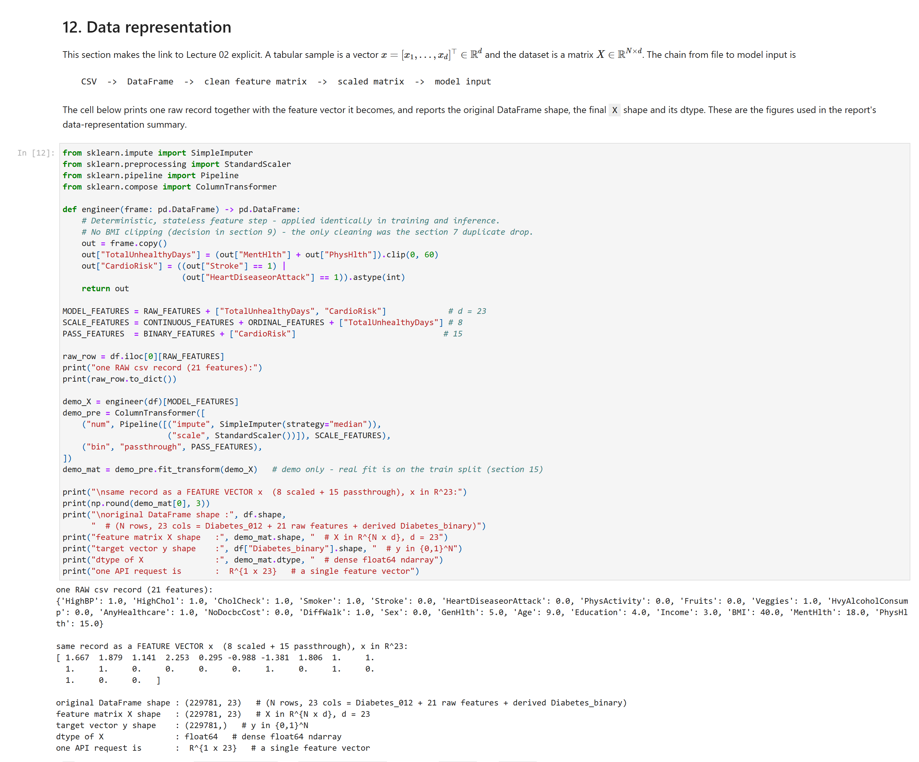
Figure 4.1
Figure 4.1 - Diabetes: one raw record -> its 23-dim feature vector -> X shape / dtype (notebook Section 12).

4.6 Exploratory data analysis
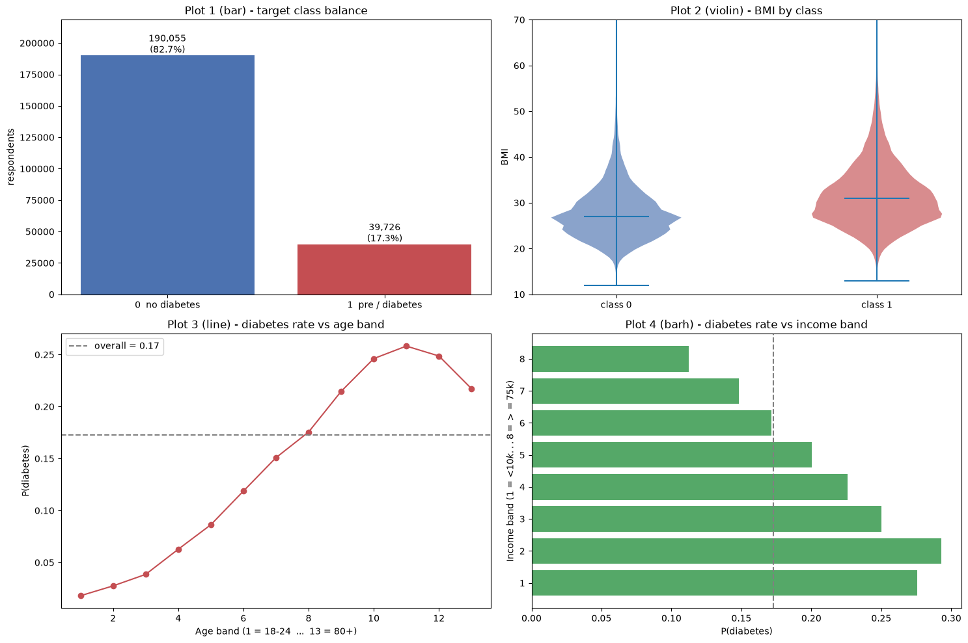
Figure 4.2
Figure 4.2 - Diabetes: EDA plot grid - target balance, GenHlth vs diabetes rate, BMI distribution by class, Age bracket vs rate.
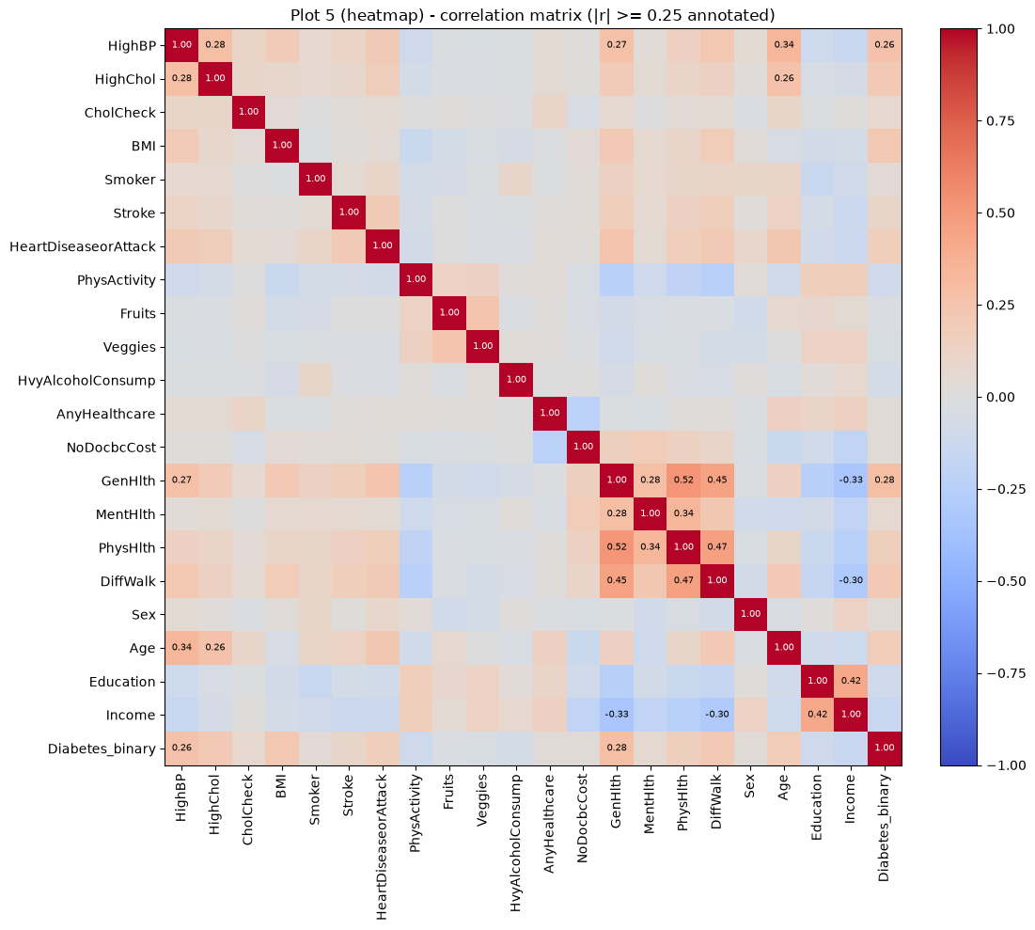
Figure 4.3
Figure 4.3 - Diabetes: feature / target correlation heatmap.
- Target balance - 17.3 % positive. Observation: a majority classifier already scores 0.83 accuracy. ML implication: judge on recall / F1 / ROC-AUC, not accuracy.
- GenHlth vs diabetes rate - monotonic, ~4 % at “excellent” to ~35 % at “poor”. Interpretation: self-rated health is the single strongest predictor. ML implication: keep GenHlth as an ordinal number.
- BMI distribution by class - diabetic respondents ~4 BMI points higher, large overlap. Interpretation: BMI helps but does not separate the classes alone.
- Age bracket vs rate - rises steadily with age. ML implication: keep Age ordinal.
- Correlation heatmap (Figure 4.3) - HighBP, HighChol, GenHlth, DiffWalk, Age, BMI are most correlated with the target; lifestyle items (Fruits, Veggies) near zero. ML implication: all columns kept (a tree ensemble is robust to weak features); no single feature dominates.

4.7 Model development
Five models on the same 25 000-row stratified training subsample and the same preprocessing; the winner is refitted on the full training split.
Model | Hyperparameters
Logistic Regression | class_weight="balanced", max_iter=1000
Decision Tree | max_depth=6, min_samples_leaf=50, class_weight="balanced"
Random Forest | n_estimators=300, max_depth=12, min_samples_leaf=20, class_weight="balanced"
SVM (RBF) | class_weight="balanced"
KNN | default n_neighbors
Split: stratified 70/15/15 (train_test_split twice, seed 42) -> train 160 846 / val 34 467 / test 34 468, each at positive rate 0.1729. Every fitted object is fitted on X_train only - the test set never influences training or preprocessing.

4.8 Evaluation and model comparison
Accuracy = (TP + TN) / (TP + TN + FP + FN), Precision = TP / (TP + FP) (Eq. 4.2)
Recall = TP / (TP + FN), F1 = 2 * (Precision * Recall) / (Precision + Recall) (Eq. 4.3)
Loss_{BCE} = - (1/N) * sum_i [ y_i * log(p_i) + (1 - y_i) * log(1 - p_i) ] (Eq. 4.4)
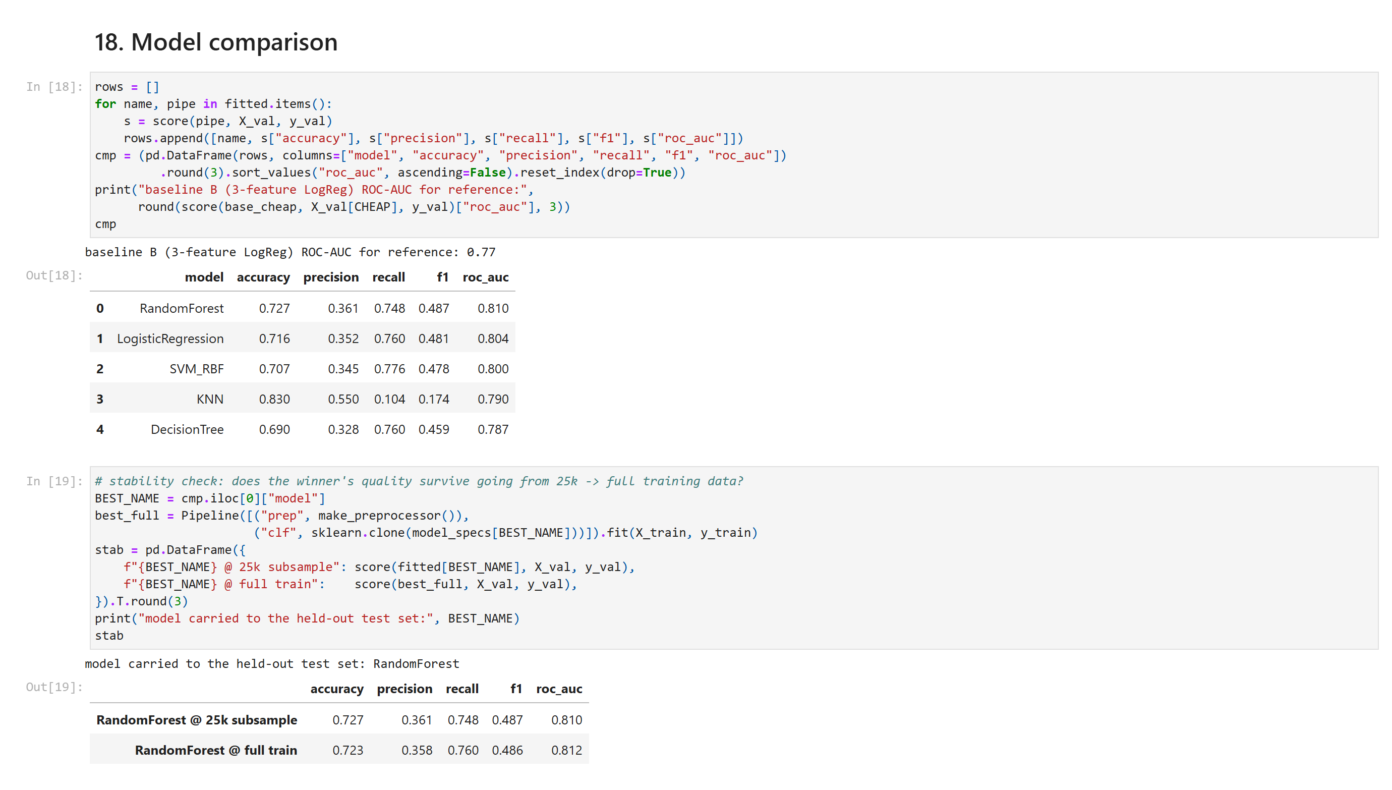
Figure 4.4
Figure 4.4 - Diabetes: five-model comparison table and the stability check (notebook Section 18).
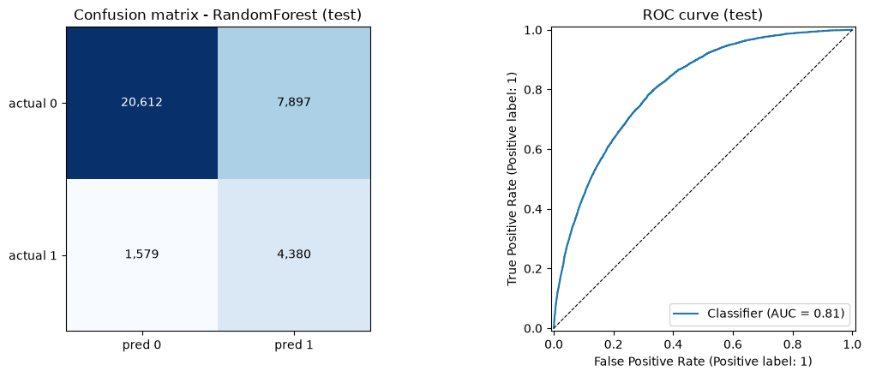
Figure 4.5
Figure 4.5 - Diabetes: classification report, confusion-matrix heatmap and ROC curve for the held-out test (notebook Section 19).
Validation (25 000-row fit):
Model | Accuracy | Precision | Recall | F1 | ROC-AUC
Random Forest | 0.727 | 0.361 | 0.748 | 0.487 | 0.810
Logistic Regression | 0.716 | 0.352 | 0.760 | 0.481 | 0.804
SVM (RBF) | 0.707 | 0.345 | 0.776 | 0.478 | 0.800
KNN | 0.830 | 0.550 | 0.104 | 0.174 | 0.790
Decision Tree | 0.690 | 0.328 | 0.760 | 0.459 | 0.787
baseline B (3-feature LogReg) | 0.699 | 0.328 | 0.708 | 0.448 | 0.77
baseline A (majority class) | 0.827 | 0.000 | 0.000 | 0.000 | 0.50
Held-out test - Random Forest, refit on full train: accuracy 0.725, ROC-AUC 0.809, recall on the diabetic class 0.735 (precision 0.357, F1 0.480). Confusion matrix [[20 612, 7 897], [1 579, 4 380]]: the 1 579 false negatives are diabetic people told they are fine - the dangerous error; the 7 897 false positives are healthy people sent for a blood test - a cost, not a harm. Most important metric: recall on class 1. A missed diabetic is far worse than a wasted test, so the class-weighted model trades precision for recall on purpose, and overall accuracy (0.725) sits below the 0.83 majority baseline.

4.9 Model selection
Random Forest - highest ROC-AUC, best recall/F1 balance, clears both baselines, feature_importances_ for interpretation, ~2 s to train, one small artifact. Logistic Regression is the documented lightweight fallback (near-identical ROC-AUC, coefficient-level interpretability).

4.10 Persistence and deployment
Persisted as diabetes/model/model_pipeline.joblib = Pipeline([prep, RandomForestClassifier]), plus feature_names.joblib and input_schema.json. The Section 23 inference test reloads the file and confirms predict_proba matches the in-memory model to 10 decimals; example raw input -> {"prediction": "diabetic", "confidence": 0.8496}. Deployment: Section 8, Appendix D.1 (web), Appendix E (mobile).

5. Application 2 - House-Price Prediction

5.1 Problem description
Predict a fair listing price from property attributes so a marketplace can flag mispriced listings. X = property + location + agent attributes; y = Price in million VND, modelled as log(1 + Price) (raw skew 3.36 -> -0.07) and inverted with expm1. Regression; one observation = one listing. It differs from Application 1 because the target is a continuous positive quantity, so the metrics are MAE / MSE / RMSE / R^2, not precision/recall.

5.2 Dataset
Field | Value
Name / URL | Vietnamese Real Estate Listings 2025 (Kaggle qmanhbeo/vietnamese-real-estate-listings-may-2024)
Licence / provenance | CC BY-NC 4.0; scraped from public sale adverts on Guland.vn, Scraped At = 12-14 Sept 2025; file ~210 MB, not committed
Observations | 236 226 raw -> 201 654 after cleaning
Numeric features | Area, Width, Length, Bedrooms, Bathrooms, Floors, Alley Width, Agent Listing Count + 3 *_missing indicators
Categorical features | Property Type, Position, Direction, Road Type, Province, Agent Role, district
Target | Price (million VND) -> log1p
One observation | one advert, e.g. Area=192, Property Type="house", Location="Long Xuyen, An Giang", ... -> Price=2000 (million VND)

5.3 Data understanding and cleaning
df.shape = (236 226, ~30); df.info() separates numeric columns from categorical/text (the executed cells are in house_price/notebook/house_price.ipynb). df.isna().sum() shows structural missingness - Bedrooms 72 %, Bathrooms 84 %, Floors 79 %, Length 58 %, Latitude/Longitude 68 %. Invalid values: 611 non-positive and ~10 600 implausible (> 200 000 million VND) prices, plus out-of-range areas.
Operation | What | Why
Drop impossible rows | Price <= 0 or > 200 000; Area <= 0 or > 10 000 | not real values; would dominate the loss
*_missing indicator features | Bedrooms_missing, Bathrooms_missing, Floors_missing | the fact that a field is blank is itself informative
Median-impute the rest, inside the pipeline | fitted on train only | one training/inference path, no leakage
Parse district from Location | one-hot with min_frequency = 50 | province + district is the main price driver (η² ~ 0.24)
log(1 + Price) target |  | raw skew 3.36; the QQ-plot is straight after log1p
Drop Listing ID, VIP Account (constant), Title |  | ids leak nothing; a constant column is dead; the title literally contains the price string

5.4 Representation
y_i' = log(1 + y_i), hat{y}_i = exp(hat{y}_i') - 1 (Eq. 5.1)
X_{house} in R^{201654 x 92}, y in R^{201654} (million VND) (Eq. 5.2)
# House Price Preprocessing Pipeline Implementation
preprocessor = ColumnTransformer(transformers=[
('num', Pipeline([
('impute', SimpleImputer(strategy='median')),
('log1p', FunctionTransformer(np.log1p)),
('scale', StandardScaler())
]), numeric_cols),
('cat', OneHotEncoder(handle_unknown='ignore', min_frequency=50), categorical_cols)
])
Cleaned frame (201 654, 31) -> ColumnTransformer: SimpleImputer(median) -> log1p -> StandardScaler (numeric); OneHotEncoder(handle_unknown="ignore", min_frequency=50) (7 categoricals) -> X in R^{201 654 x 92} (sparse); y in ℝᴴ = log(1 + Price). One API request -> R^{1 x 92}; the response inverts with expm1.
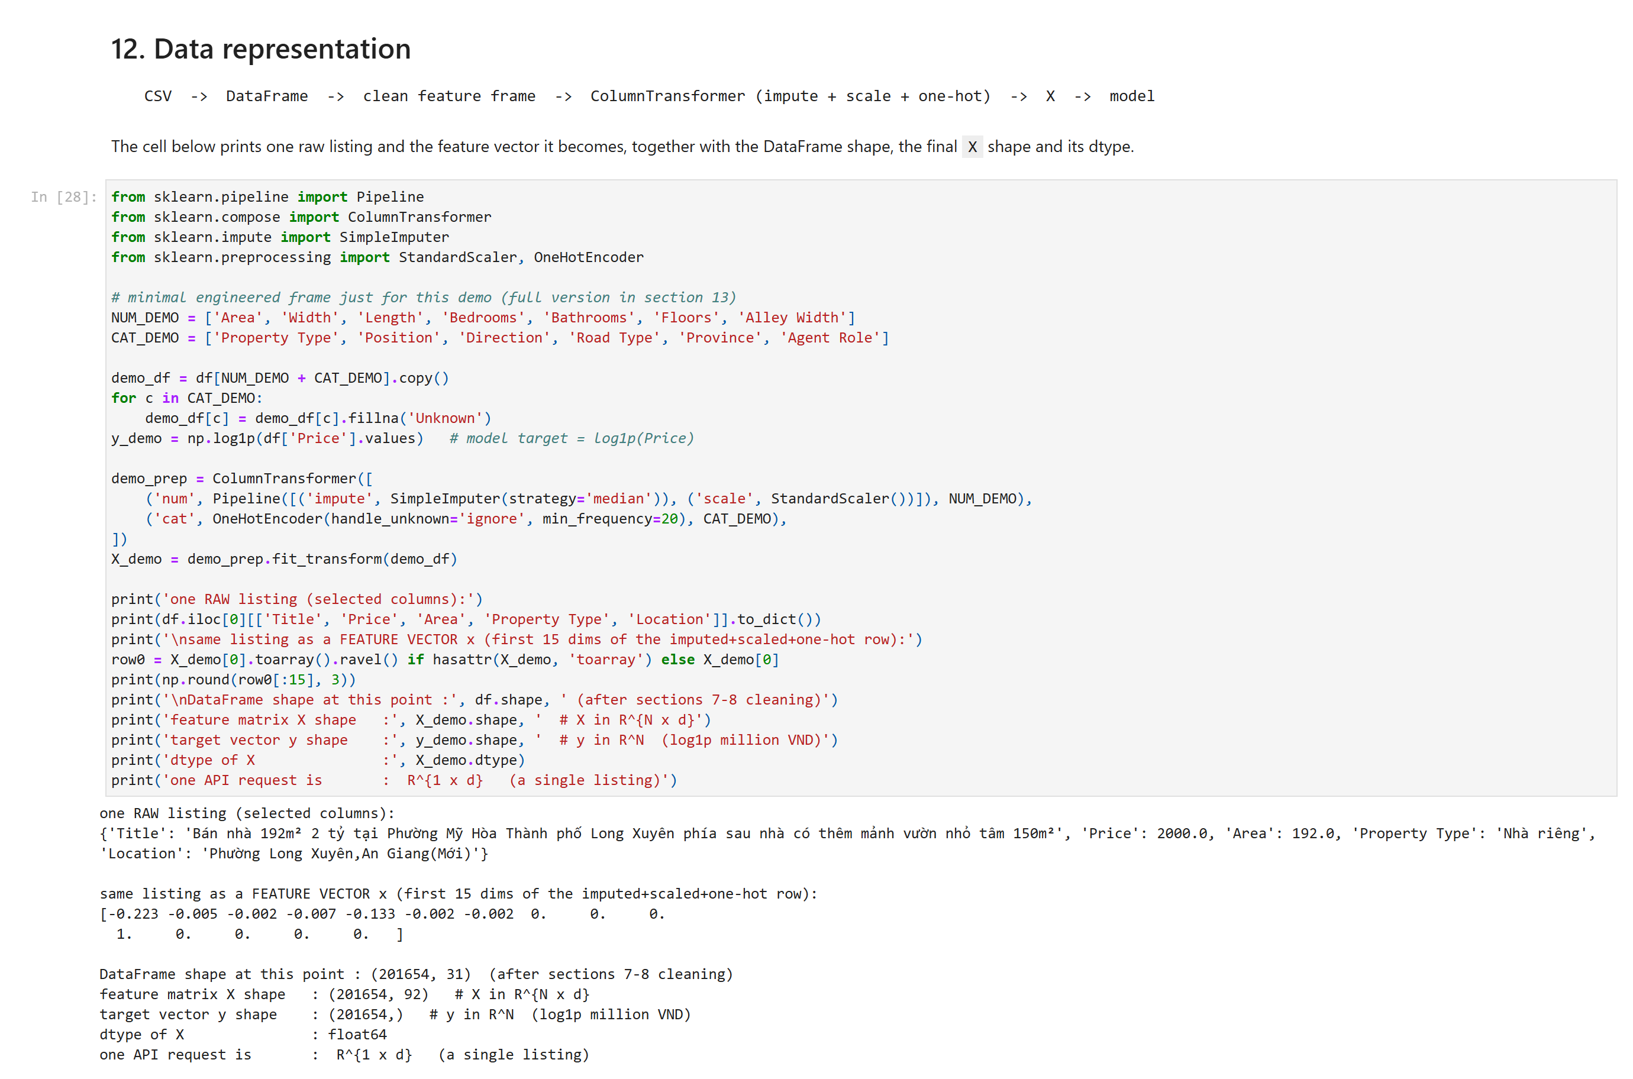
Figure 5.1
Figure 5.1 - House price: one raw listing -> its 92-dim feature row -> X / y shape (notebook Section 12).

5.5 Exploratory data analysis
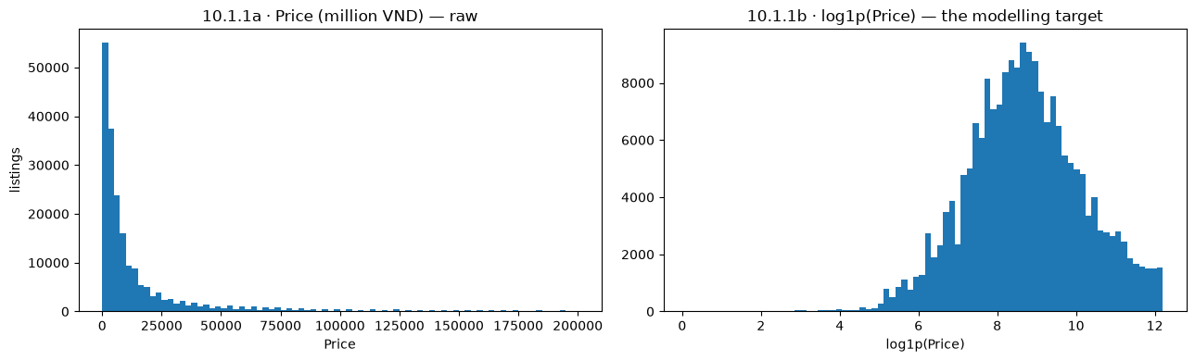
Figure 5.2
Figure 5.2 - House price: target distribution - Price raw vs log(1 + Price).
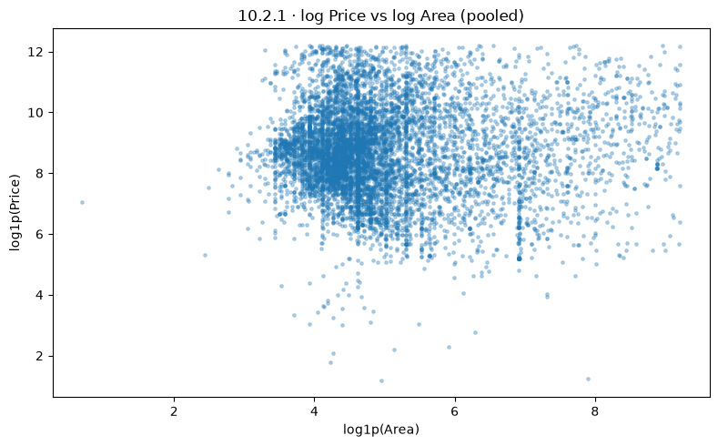
Figure 5.3
Figure 5.3 - House price: numeric correlation heatmap.
- Distributions (10.1) - Price raw skew 3.36 -> log1p -0.07; Area skew 5.11 -> 1.32. ML implication: train on log(1 + Price), report metrics back on the million-VND scale.
- Relationships and correlation (10.2, Figure 5.3) - surprisingly weak numeric signal: |r(log Area, log Price)| ~ 0.02, Bathrooms 0.215 is the strongest numeric; categorical correlation ratios Province η² ~ 0.24, Property Type ~ 0.12. Interpretation: location and property type carry most of the (limited) signal; raw area is unreliable because listings mix land and built-up property. ML implication: this is a weak-signal regression problem - a tree ensemble captures the location x type structure, and the low R^2 is reported honestly as a data limitation.
- Supporting analyses (10.3) - missingness by property type justifies the *_missing indicators; the skew/QQ view justifies the log1p target.

5.6 Regression models and evaluation
MAE = (1/N) * sum_i |y_i - hat{y}_i|, RMSE = sqrt( (1/N) * sum_i (y_i - hat{y}_i)^2 ) (Eq. 5.3)
R^2 = 1 - [ sum_i (y_i - hat{y}_i)^2 / sum_i (y_i - bar{y})^2 ] (Eq. 5.4)
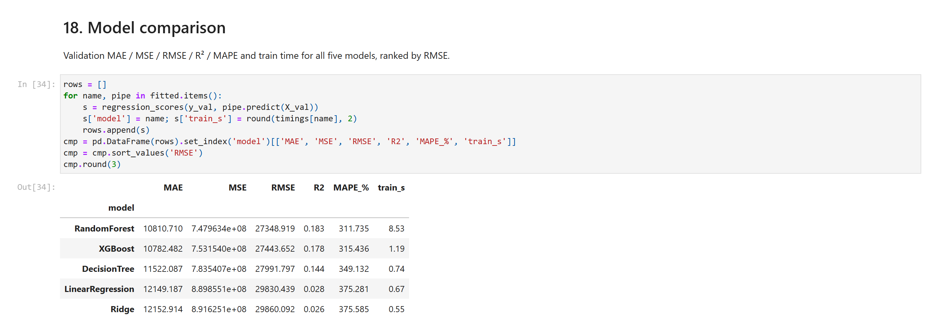
Figure 5.4
Figure 5.4 - House price: five-model regression comparison table (notebook Section 18).
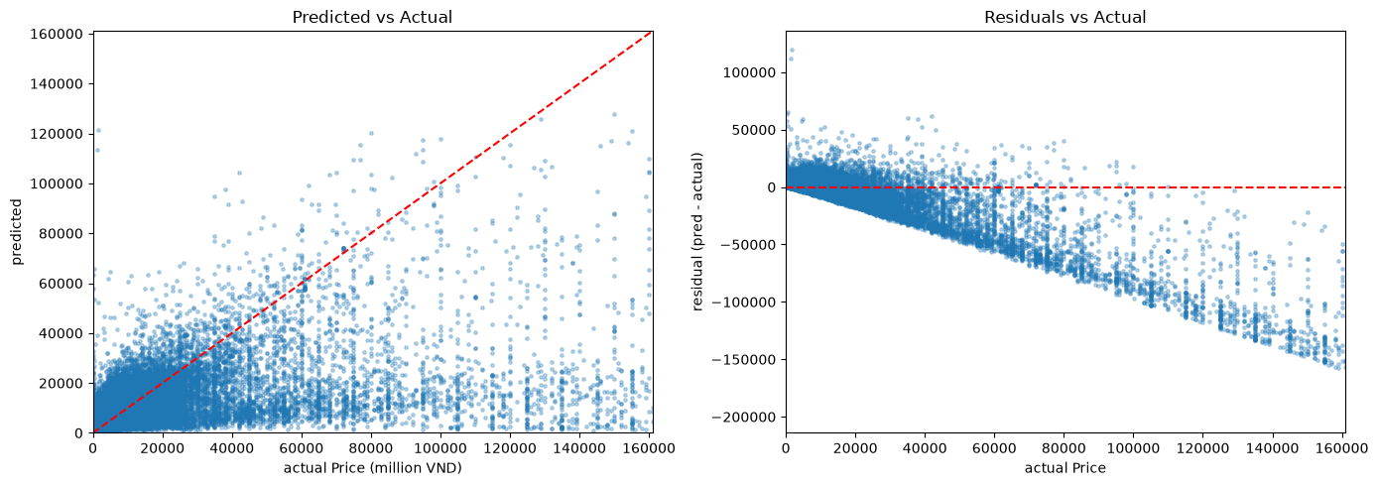
Figure 5.5
Figure 5.5 - House price: predicted-vs-actual scatter and residuals-vs-actual for the Random Forest (notebook Section 19).
Five models, 50 000-row training subsample, same preprocessing:
Model | val MAE | val RMSE | val R^2
Random Forest | 10 811 | 27 349 | 0.183
XGBoost | 10 794 | 27 478 | 0.176
Decision Tree (max_depth=12, min_samples_leaf=25) | 11 522 | 27 992 | 0.144
Linear Regression | 12 149 | 29 830 | 0.028
Ridge | 12 153 | 29 860 | 0.026
baseline (predict the median) | 14 397 | 32 185 | -0.131
Held-out test - Random Forest, refit on full train: MAE 10 626, MSE 722 149 435, RMSE 26 873, R^2 0.186, MAPE 350 % (all money in million VND). What each metric means here: MAE - the average listing is off by about 10.6 billion VND, large because the price range spans three orders of magnitude; RMSE is ~2.5x the MAE, so a minority of listings are missed by far more than the typical one; R^2 0.186 - the model explains ~19 % of the variance in log(1 + Price) beyond a constant-mean predictor (which scores R^2 = -0.13), so it adds real signal but most price variance is not recoverable from these fields; MAPE is inflated by the many low-priced listings and is reported, not used to rank models. There is no confusion matrix (regression). The honest headline is a weak-signal regression problem, driven by the near-zero numeric correlation, the 70-84 % missing size fields and 68 % missing geolocation - a property of the dataset, not the algorithm.

5.7 Model selection, persistence and deployment
Random Forest - lowest test RMSE, highest R^2, feature_importances_, ~15 s to train, bagging absorbs the price outliers. Persisted as house_price/model/model_pipeline.joblib (Pipeline([prep, RandomForestRegressor])) + feature_names.joblib + input_schema.json (records price_unit = million VND and the log1p/expm1 convention). Section 23 inference test: disk == in-memory. Deployment: Section 8, Appendix D.2, Appendix E.

6. Application 3 - E-Commerce Customer Behaviour and Interest

6.1 Problem description
Predict whether a Sephora skincare reviewer recommends the product, from who they are and what they wrote. Target is_recommended in {0, 1} - a field separate from the 1-5 star rating (the rating is excluded as leakage, Section 6.6). Binary classification; one observation = one product review. Supports review-consistency QA, cold-start ranking, and merchandising.

6.2 Dataset
Field | Value
Name / URL | Sephora Products and Skincare Reviews (Kaggle nadyinky/sephora-products-and-skincare-reviews, CC0)
Files | reviews_500-750.csv joined to product_info.csv on product_id
Observations | 116 262 raw -> 104 313 after cleaning; positive rate 0.8465
Scope | 249 products / ~79 brands / 12 secondary_category values, all Skincare
Feature types | 5 numeric log1p+scale (price_usd, loves_count, reviews, total_feedback_count, total_neg_feedback_count), 4 numeric scale (n_ingredients, n_highlights, review_age_days, pos_feedback_ratio), 6 binary passthrough, 6 one-hot categorical (skin_type, skin_tone, eye_color, hair_color, secondary_category, brand_name), 1 text (review_title + " . " + review_text)
Excluded (leakage) | the review’s own rating and the product average rating_product
One observation | one review: a skin profile + product fields + a title and body of free text -> is_recommended in {0,1}
df.shape = (116 262, ~30); df.isna().sum() - 11 803 rows with a blank target, many blank skin-profile fields; df.duplicated().sum() - a few exact duplicates; 125 empty bodies; class balance 84.7 % positive. The executed cells are in customer_behaviour/notebook/customer_behaviour.ipynb (Sections 4-9).

6.3 Customer representation
X_{ecom} = [X_{tabular} || X_{text}] in R^{104313 x 28733}, E in ℝᴴˣᵀˣᵉ (Eq. 6.1)
# E-Commerce Tabular + TF-IDF Vectorizer Pipeline Implementation
preprocessor = ColumnTransformer(transformers=[
('num', Pipeline([('impute', SimpleImputer(strategy='median')), ('scale', StandardScaler())]), num_cols),
('cat', OneHotEncoder(min_frequency=25, handle_unknown='ignore'), cat_cols),
('txt', TfidfVectorizer(ngram_range=(1,2), min_df=10, max_features=40000, stop_words='english'), 'review_text')
])
Tabular: one raw review -> 21 columns -> SimpleImputer(median) -> log1p (money / popularity) -> StandardScaler; binary passthrough; OneHotEncoder(handle_unknown= "ignore", min_frequency=25) -> x_tab in R^{138}.
Text - the required Comment -> Tokens -> Token IDs -> Embedding demo on a real review:
Comment : "I will be the first to say that the price on these is a lot, but for what they do? ..."
Tokens : ['say', 'price', 'lot', 'unbeatable', 'deep', 'painful', 'nodules', ...] (T = 40)
Token IDs: [29, 26, 17, 39, 6, 22, 21, ...] (index into a 41-row vocab, 0 = PAD)
Embedding: each ID -> a row of a (|V|+1) x d table -> E in R^{T x d} = R^{40 x 16}
Batch : E_batch in ℝᴴˣᵀˣᵉ = R^{1 x 40 x 16}
The deployed model uses the sparse TF-IDF form (ngram_range=(1,2), min_df=10, max_features=40000, sublinear_tf, English stop-words) -> x_txt in R^{28 595} on the training vocabulary. Combined: X = [x_tab || x_txt] in R^{104 313 x 28 733} sparse.
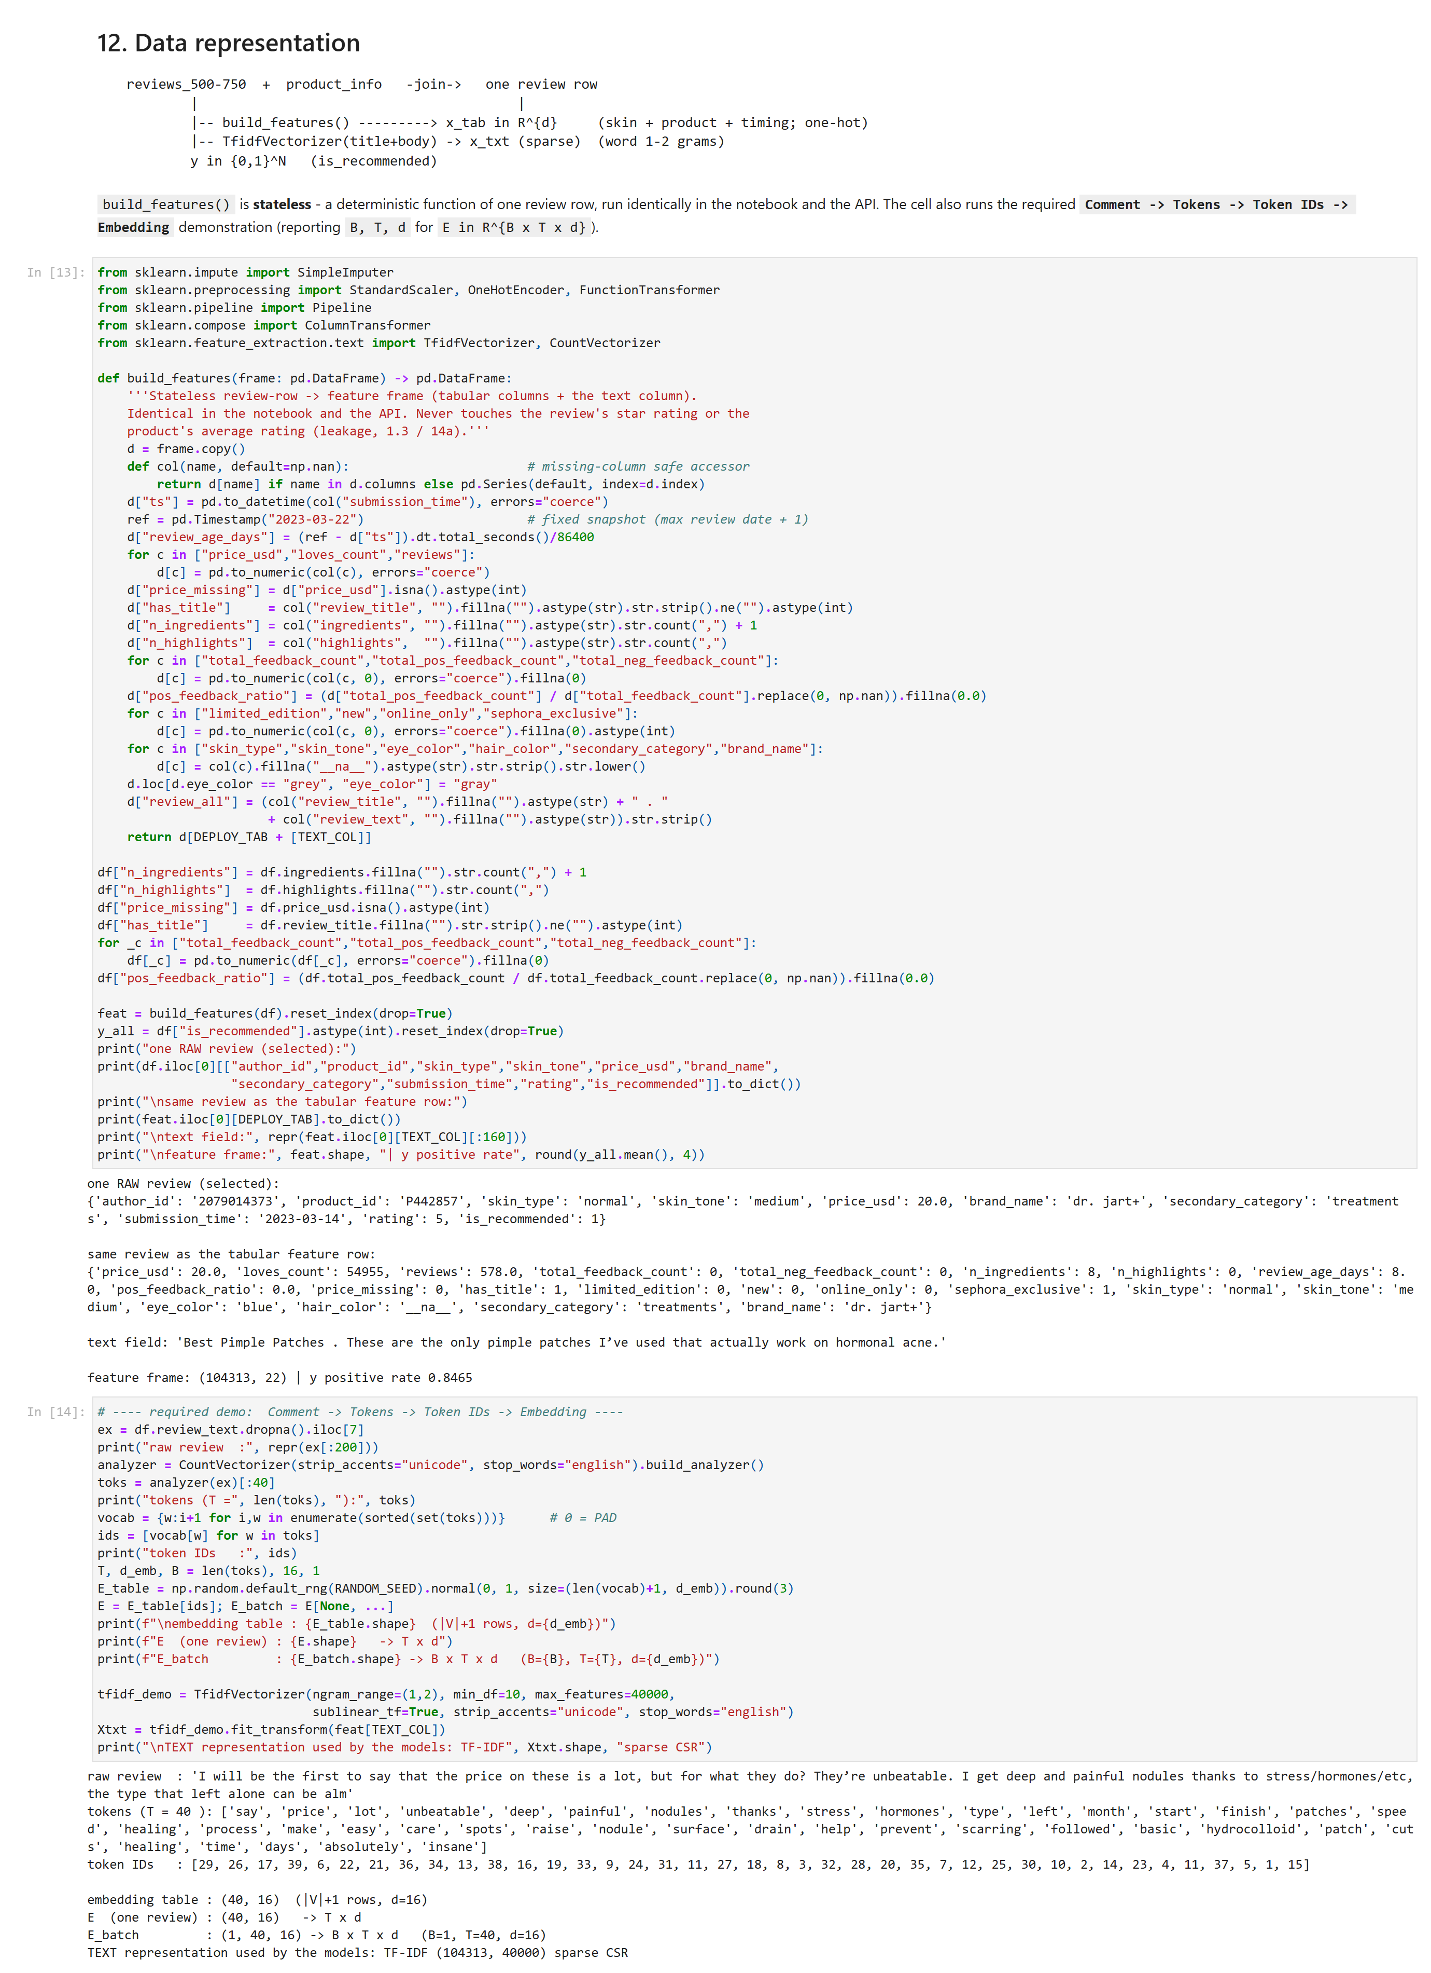
Figure 6.1
Figure 6.1 - Customer behaviour: one raw review -> its tabular row and TF-IDF block, and the B = 1, T = 40, d = 16 embedding demo (notebook Section 12).

6.4 Data cleaning
Drop the 11 803 blank-target rows, 125 empty bodies and a few duplicates (116 262 -> 104 313). Skin-profile blanks -> an explicit __na__ one-hot level (missingness is a real behaviour). Incidental numeric gaps -> SimpleImputer(median) fitted on train only. Lower-case all categoricals; merge eye_color "grey" -> "gray". Outliers kept (log1p handles the skew). The TF-IDF vocabulary is built on train only. The review’s own rating / rating_product are quarantined to the leakage demo.

6.5 Interest discovery / EDA
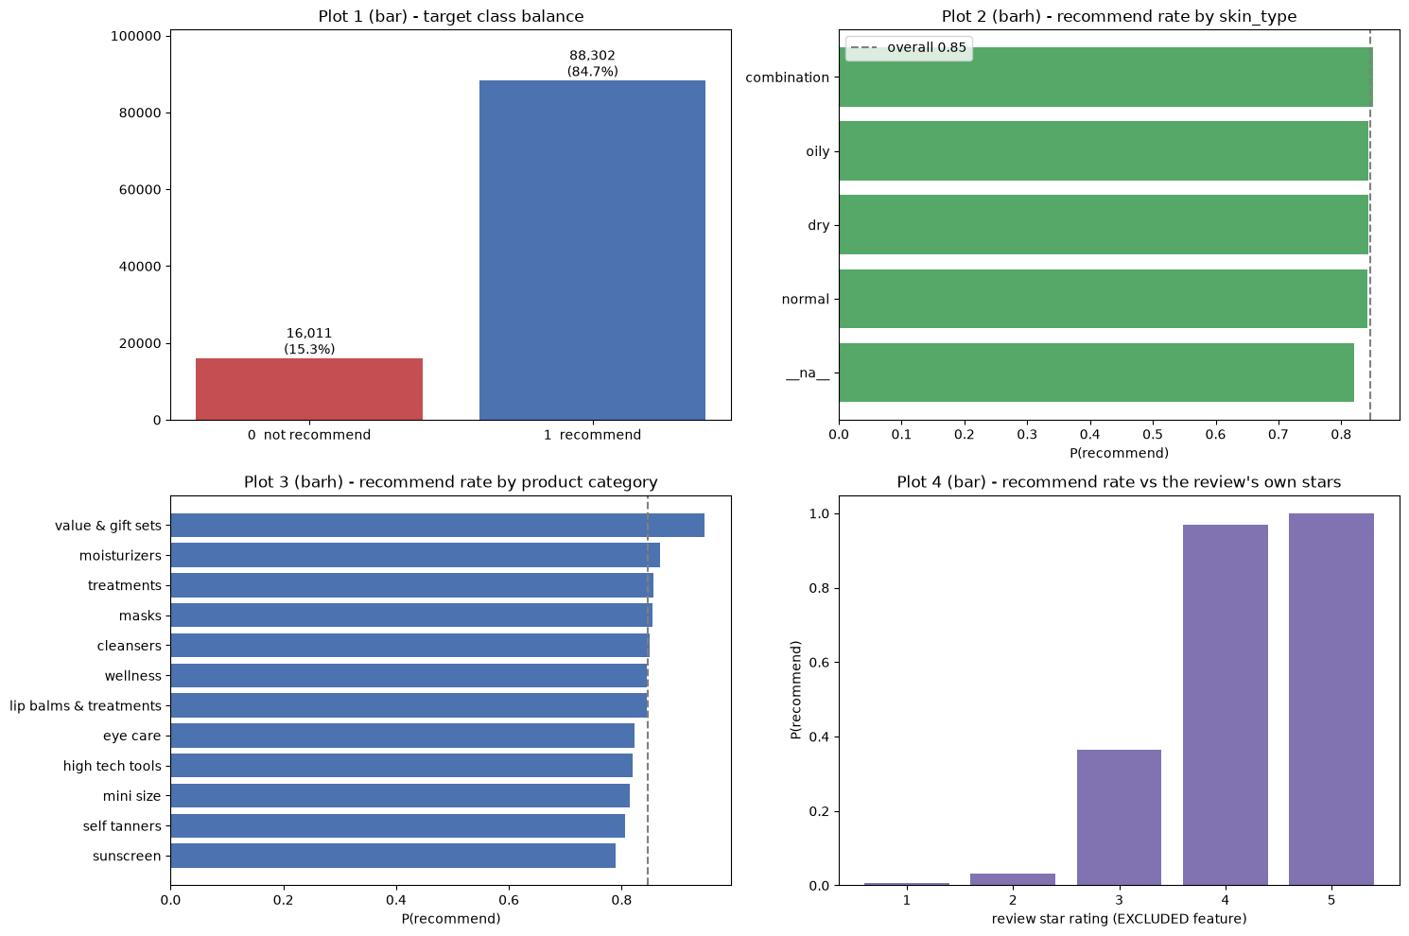
Figure 6.2
Figure 6.2 - Customer behaviour: EDA plot grid - class balance, recommend rate by skin type / category / brand / price decile, recommend rate vs the excluded star rating.
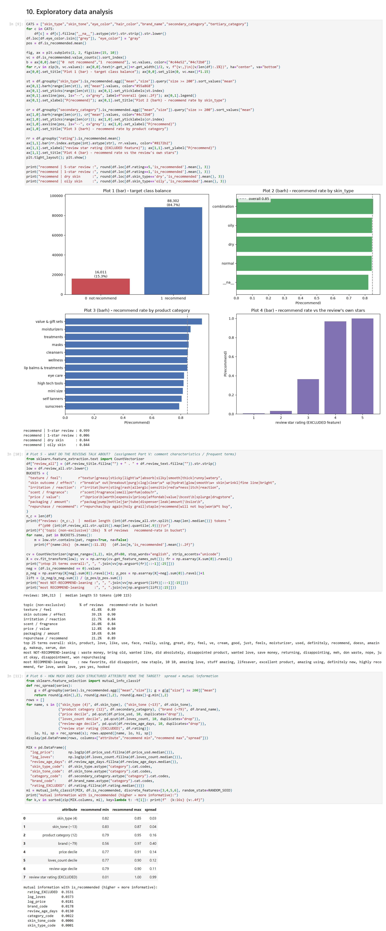
Figure 6.3
Figure 6.3 - Customer behaviour: topic-bucket recommend rates and mutual information with the target.
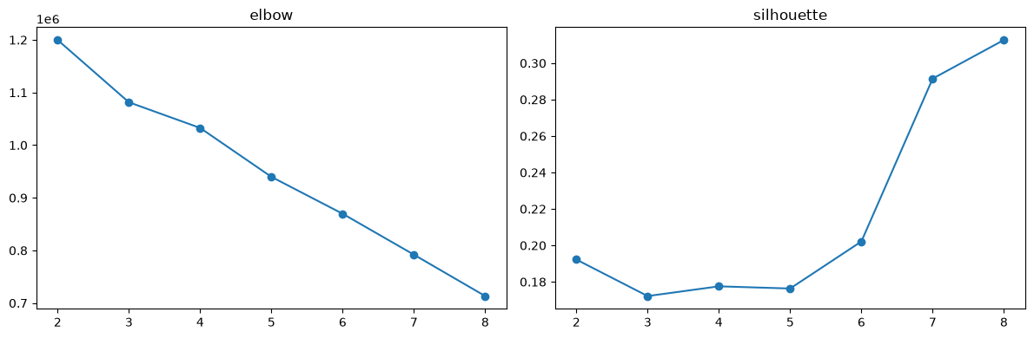
Figure 6.4
Figure 6.4 - Customer segmentation (K-Means): elbow and silhouette (notebook Appendix B).
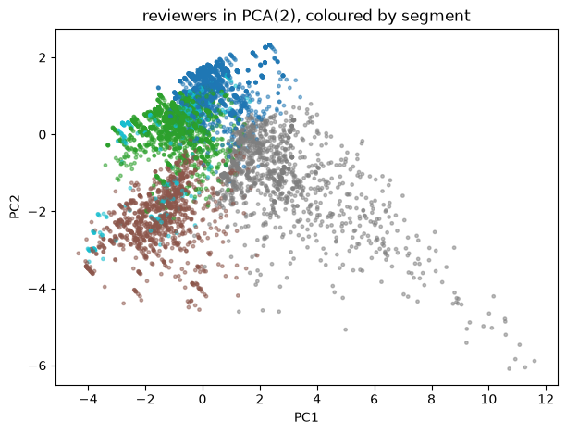
Figure 6.5
Figure 6.5 - Customer segmentation (K-Means): 5-segment profile and PCA scatter.
- Class balance 84.7 % recommend. Recommend-rate spread by skin type ~0.03, by category ~0.16, by brand ~0.40, by price decile ~0.14; against the excluded star rating it runs 0.01 -> 1.00. Interpretation: the structured customer-product fit is a real but weak signal; the star rating is essentially the label. ML implication: class_weight= "balanced", group the split on author_id, quarantine rating, expect the text to carry most of the skill.
- Topic buckets (Figure 6.3) - texture/feel ~42 % of reviews (recommend 0.89), skin outcome/breakouts ~39 % (0.90), irritation ~23 %, scent ~26 %, price ~13 %. Mutual information with the target: excluded rating 0.35, log_loves 0.037, log_price/brand 0.018, secondary_category 0.002, skin fields ~0. Interpretation: what the reviewer writes about predicts the recommendation; demographics do not.
- Customer segmentation (K-Means, Figures 6.4-6.5) - reviewer x_i = [R_i, F_i, M_i, avg_price_i, recommend_rate_i, avg_rating_i, C_i1..C_ik]; 73 819 reviewers, F >= 2 for 22 %, k = 5 from the elbow/silhouette. Descriptive only; not fed to the classifier.

6.6 Data leakage
- The review text is co-authored with the label - is_recommended is a checkbox on the same form as the free-text box, so a text model partly reads the verdict; the ~0.965 is a retrospective upper bound (not pure leakage - the text also carries product experience, and tab+text still survives a temporal split at ~0.96).
- The review’s own star rating IS the label in another column - adding it -> ROC-AUC ~0.985 (MI 0.35). Excluded. The product average rating is milder (0.768 -> 0.789) but also excluded as look-ahead.
- Engagement counts are post-publication - kept for this retrospective model; a prospective variant that drops them falls to ROC-AUC ~0.66.
No preprocessing object is fitted on validation, test or user input - the deployed API loads the exact pipeline fitted on X_train.

6.7 Model development
Eight pipelines - the assignment’s six for Application 3 (Logistic Regression, Decision Tree max_depth=12, Random Forest n_estimators=350, Linear SVM LinearSVC C=0.5, SGD(loss="log_loss") as the text-based linear classifier, HistGradientBoosting as the extra justified model) plus Complement Naive Bayes and the deployed Logistic Regression on tabular + text. All class-weighted; hyperparameters fixed; fitted on the training split only. Split: StratifiedGroupKFold(5) grouped on author_id (no reviewer spans splits) -> train 62 587 / val 20 862 / test 20 864, each at recommend rate 0.8465.
Representation ladder (one Logistic Regression, growing features, validation ROC-AUC): skin profile 0.536 -> + product 0.656 -> full tabular 0.768 -> text only 0.965 -> tabular + text 0.966.
Model | Representation | ROC-AUC | macro-F1 | recall(0) | Accuracy
Logistic Regression (tab + text) | combo | 0.966 | 0.861 | 0.885 | 0.919
HistGradientBoosting | tabular | 0.811 | 0.664 | 0.678 | 0.771
Random Forest | tabular | 0.810 | 0.686 | 0.611 | 0.806
Logistic Regression | tabular | 0.768 | 0.622 | 0.679 | 0.722
Decision Tree | tabular | 0.767 | 0.637 | 0.649 | 0.746
Linear SVM | tabular | 0.767 | 0.622 | 0.676 | 0.723
SGD (log-loss, text) | text | 0.965 | 0.856 | 0.885 | 0.916
Complement Naive Bayes | text | 0.955 | 0.840 | 0.846 | 0.907
baseline (majority class) |  | 0.500 | 0.458 | 0.000 | 0.847
Tabular vs tabular + text - the assignment’s key question. Both representations carry real skill (tabular ~0.77 linear / ~0.81 trees). The review text alone reaches ~0.965; adding it to the tabular block gives only a small, consistent lift (macro-F1 0.856 -> 0.861). They are redundant more than complementary - a customer who will withhold a recommendation has usually already said so in the review.

6.8 Evaluation and error analysis
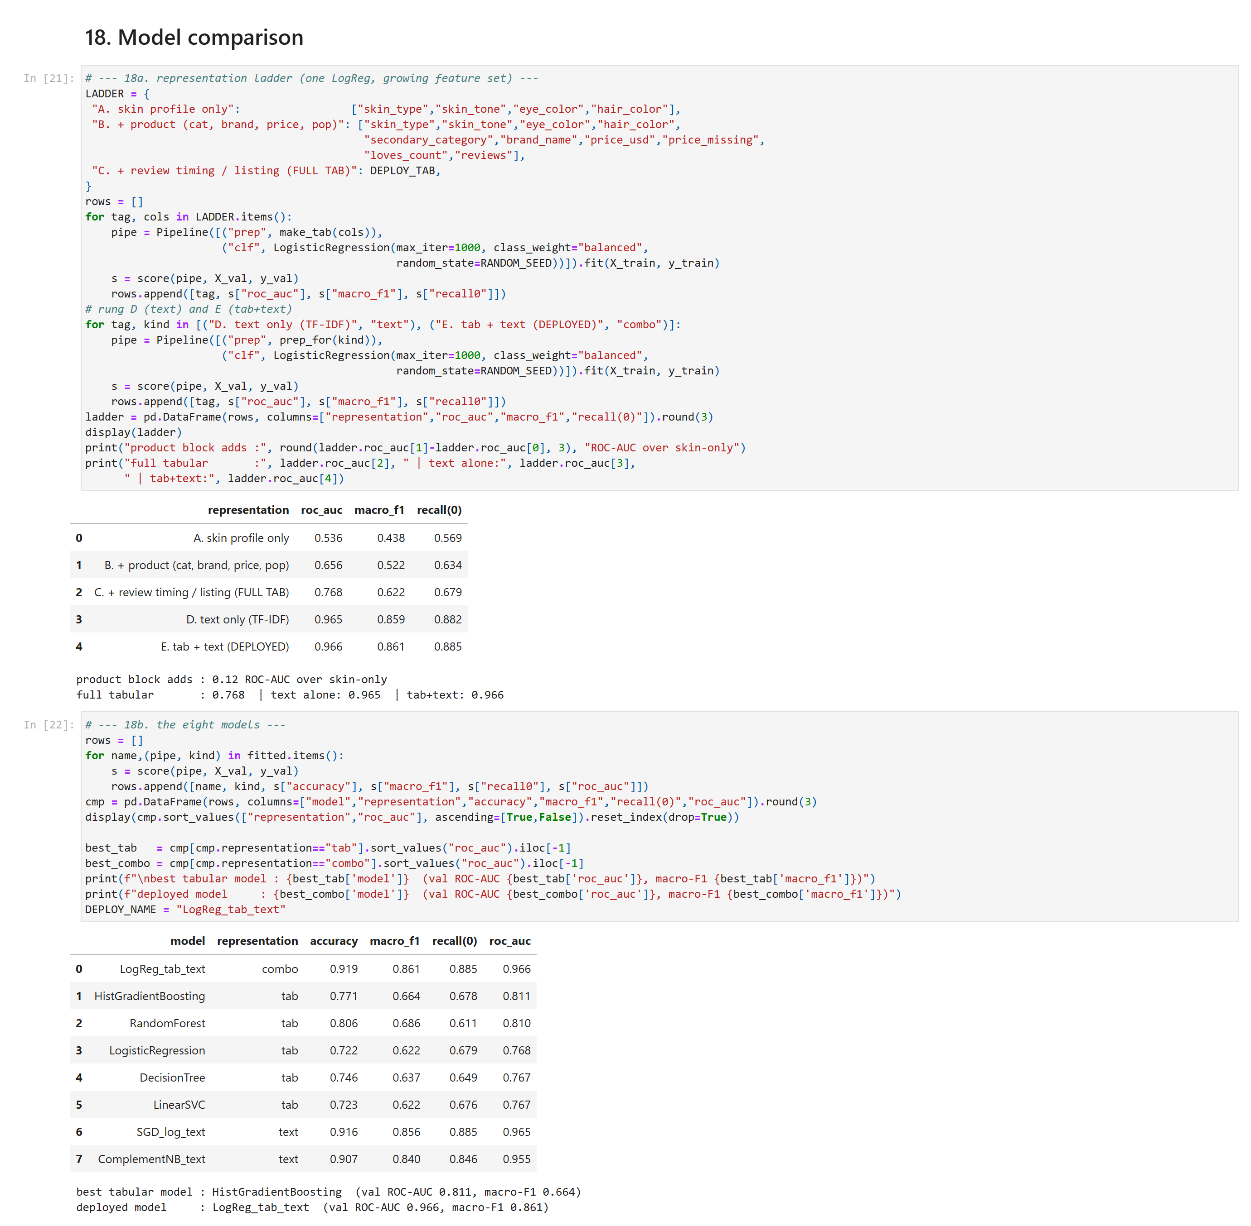
Figure 6.6
Figure 6.6 - Customer behaviour: the representation ladder and the 8-model comparison table (notebook Section 18).
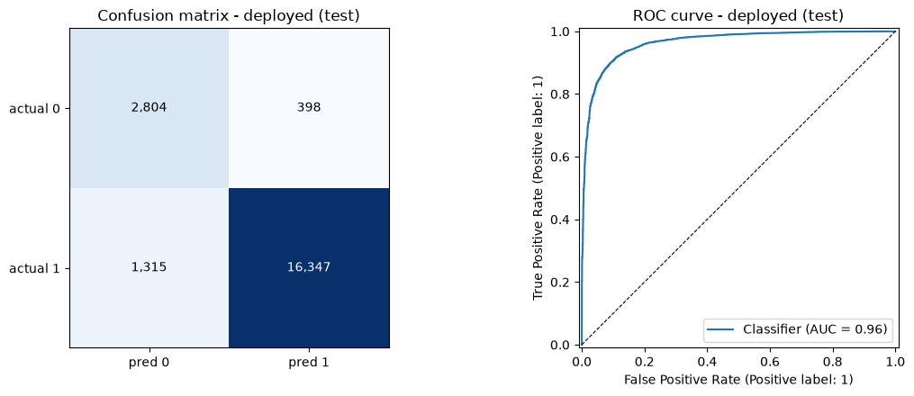
Figure 6.7
Figure 6.7 - Customer behaviour: classification report, confusion-matrix heatmap and ROC curve for the deployed Logistic Regression on tabular + TF-IDF text (notebook Section 19).
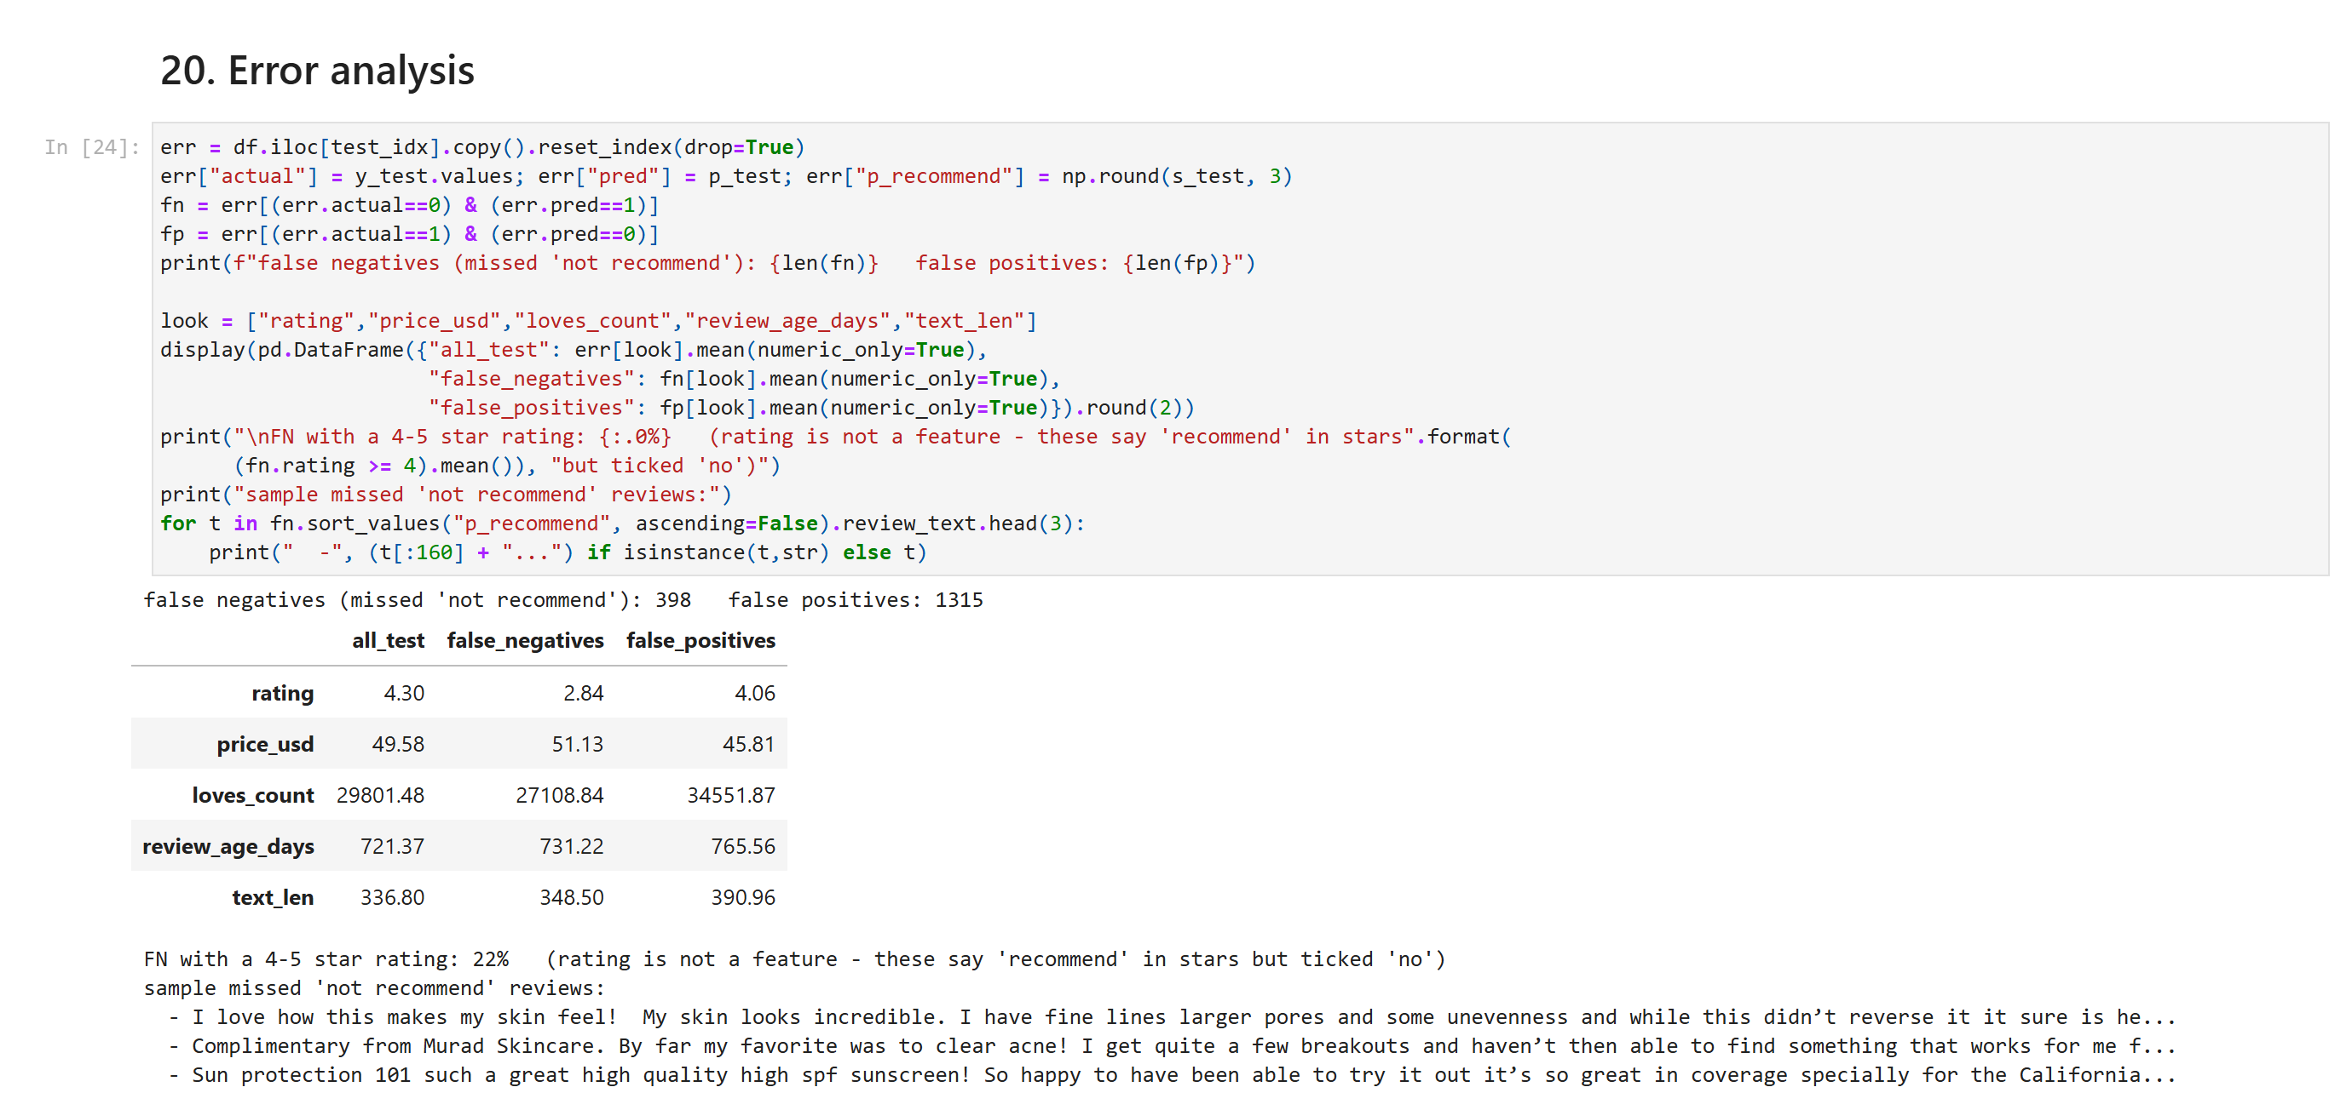
Figure 6.8
Figure 6.8 - Customer behaviour: false-negative / false-positive feature comparison with sample missed reviews (notebook Section 20).
Deployed Logistic Regression (tab + text), held-out test (N = 20 864): accuracy 0.918, ROC-AUC 0.964, recall on “does not recommend” 0.876 (precision 0.681, F1 0.766). Single-representation on the same test set: tabular-only 0.801, text-only 0.963. Confusion matrix [[2 804, 398], [1 315, 16 347]]: the 1 315 false negatives are customers who will not recommend but are predicted as recommending - a misleading product page; the 398 false positives are happy customers flagged for QA - cheap. Most important metric: recall on class 0. Accuracy is not the headline - the majority baseline already scores 0.847 while catching zero unhappy reviewers. Error analysis: 22 % of the false negatives carry a 4-5 star rating - a positive-reading review with a hidden veto, which is the irreducible ceiling for a text model.

6.9 Business interpretation
Whether a customer recommends is mostly in what they write (text ~0.965); the structured customer-product fit is a real but weaker, redundant signal (~0.8). Uses: review-consistency QA (flag “5 stars” + “would not repurchase”), cold-start ranking from the tabular-only model (no text needed, ~0.8), merchandising on low-recommend categories. The model is retrospective (it needs the review), so its value is the structured view, not the small accuracy edge over a plain text classifier.

6.10 Persistence and deployment
Persisted as customer_behaviour/model/model_pipeline.joblib (ColumnTransformer + TfidfVectorizer + LogisticRegression, ~2 MB) + feature_names.joblib + feature_means.joblib (linear-SHAP reference) + input_schema.json. POST /predict returns {prediction, confidence, p_recommend, threshold, review_terms, signals, contributions, model, representation}, where contributions is an exact linear-SHAP decomposition. Section 23 inference test: reload == in-memory; positive review -> p_recommend = 0.9376, negative -> 0.0026. Deployment: Section 8, Appendix D.3, Appendix E.

7. Comparison of the Three Intelligent Systems
Aspect | Diabetes | House Price | Customer Behaviour
Problem type | Classification | Regression | Classification
One observation | one survey respondent | one property listing | one product review
Target | Diabetes_binary in {0,1} | Price in R+ (as log1p) | is_recommended in {0,1}
Input representation | R^{N x 23} scaled + passthrough | R^{N x 92} impute + scale + one-hot (sparse) | R^{N x 28 733} tabular + TF-IDF text (sparse)
Data-quality issues | 23 899 duplicate rows; 17 % imbalance; BMI tail | 70-84 % missing size fields; ~11 000 impossible prices; near-zero numeric correlation; title leaks price | ~10 % blank target; 85 % imbalance; missing skin-profile fields; text co-authored with the label
Best model | Random Forest | Random Forest | Logistic Regression (tab + text)
Main metric | recall on diabetic class - 0.735 at ROC-AUC 0.809 | RMSE 26 873 / R^2 0.186 | recall on “does not recommend” - 0.876 at ROC-AUC 0.964
Web deployment | Yes | Yes | Yes (3-step wizard)
Mobile deployment | Yes | Yes | Yes
Main limitation | recall bought with 0.36 precision; survey self-report | weak price signal (R^2 ~ 0.19); needs finer location than province | text co-authored with the tick (~0.96 partly leakage; leak-safe tabular ~0.8); retrospective
Discussion. The three datasets need three different representations: a plain scaled matrix, an imputed one-hot matrix, and a matrix concatenated with sparse text vectors. The common preprocessing is median imputation fitted on train, scaling, a stratified or author-grouped split, and one persisted Pipeline; the application-specific parts are the log1p target and *_missing indicators (house price), the duplicate drop and engineered risk flags (diabetes), and the OneHotEncoder(min_frequency) + TfidfVectorizer + author-grouped split + leakage section (customer behaviour). The targets differ because the questions differ (“is this true?” / “how much?” / “will they endorse?”), which is why a classifier is judged on the confusion matrix and ROC-AUC while a regressor is judged on error magnitude and variance explained. Diabetes is the easiest to deploy (23 numeric inputs, no text); customer behaviour is the most compute-heavy (a ~28 700-dim sparse tabular+text matrix, a TF-IDF vocabulary to ship, and eight models).

8. Deployment Architecture
# FastAPI POST /predict Endpoint Implementation
@app.post('/predict', response_model=PredictResponse)
def predict(request: PredictRequest):
df_raw = pd.DataFrame([request.dict()])
# Apply identical loaded preprocessing pipeline
proba = pipeline.predict_proba(df_raw)[0, 1]
return PredictResponse(
prediction='diabetic' if proba >= threshold else 'not diabetic',
confidence=round(float(proba), 4)
)
All three applications follow the same inference path:
User input -> API request -> validation -> SAME preprocessing (loaded) -> saved model -> prediction -> JSON
- Trained model - loaded from model/model_pipeline.joblib, never retrained at request time.
- Preprocessing pipeline - the exact ColumnTransformer / Pipeline fitted on the training split, saved inside the same object.
- API endpoint - FastAPI POST /predict (plus GET /healthz, GET /model-info, GET /questions for the clients to render their forms).
- Input validation - a Pydantic schema (types, ranges); missing optional fields are median-imputed by the pipeline.
- Prediction - pipeline.predict_proba (classification) or expm1(pipeline.predict) (house-price regression).
- Result - JSON: {prediction, confidence} / {predicted_price} / {prediction, p_recommend, contributions, ...}.
- Web UI - React + Vite form -> fetch -> result screen with a plain-language verdict.
- Mobile UI - Flutter form -> REST call -> result screen. Training != Inference: the mobile app trains nothing, it calls the same endpoint.
Data-leakage rule. The service loads the preprocessing pipeline fitted on training data and never calls .fit() on a request; a scaler re-fitted on one request would standardise it against itself. Training and inference apply identical transforms - verified by each notebook’s Section 23 inference test (disk == in-memory).
Per-app request/response summary:
App | Endpoint | Example input | Example output
Diabetes | POST :8000/predict | {Age, Sex, HighBP, HighChol, BMI, GenHlth, DiffWalk, ...} | {"prediction": "at risk", "confidence": 0.82, "band": "High"}
House price | POST :8002/predict | {Area, "Property Type", Province, district, Bedrooms, ...} | {"predicted_price": 2540.82, "price_per_m2": 32.28, "currency": "million VND"}
Customer behaviour | POST :8000/predict | {skin_type, secondary_category, brand_name, price_usd, review_title, review_text} (no rating) | {"prediction": "not recommend", "p_recommend": 0.0026, "review_terms": {...}, "contributions": [...]}

Figure 8.1
Figure 8.1 - Representative end-to-end screen (house-price web client). The user enters property attributes; the page POSTs them to /predict; the API runs the loaded pipeline and Random Forest, inverts log1p with expm1, and returns the price; the result screen shows the value (about 9.90 billion VND), a low-high range, a SHAP contribution waterfall and a plain-language summary.
The complete web and mobile screenshots (input screen, result screen and, for the web, the FastAPI /docs route) for every application, each with a Figure-explanation note as the assignment requires, are in Appendix D (web) and Appendix E (mobile). Every mobile run logged a POST /predict 200 on the server - the required communication evidence.

9. Reproducibility
Item | Diabetes | House Price | Customer Behaviour
Python / OS | 3.13 / Windows 11 | 3.13 / Windows 11 | 3.13 / Windows 11
Key libraries | scikit-learn 1.9.0, numpy, pandas, scipy, matplotlib; fastapi + uvicorn + pydantic 2 | + xgboost | + React 18 + Vite 5; Flutter 3.19+
Random seed | RANDOM_SEED = 42 (numpy + random, every split and estimator) | same | same
Dataset | Kaggle alexteboul/..., diabetes_012_health_indicators_BRFSS2015.csv - committed | Kaggle qmanhbeo/... (CC BY-NC 4.0) - not committed (~210 MB) | Kaggle nadyinky/... (CC0) - not committed (~505 MB); reviews_500-750.csv + product_info.csv
Rows (raw -> clean) | 253 680 -> 229 781 | 236 226 -> 201 654 | 116 262 -> 104 313
Split | stratified 70/15/15 (160 846 / 34 467 / 34 468) | 70/15/15 (141 157 / 30 248 / 30 249) | StratifiedGroupKFold(5) on author_id (62 587 / 20 862 / 20 864)
Preprocessing | SimpleImputer(median) -> StandardScaler (8 cols) + passthrough (15) | SimpleImputer(median) -> log1p -> StandardScaler; OneHotEncoder(min_frequency=50) | + OneHotEncoder(min_frequency=25); TfidfVectorizer(ngram_range=(1,2), min_df=10, max_features=40000, sublinear_tf, stop_words="english") - all fitted on train only
Feature dim d | 23 | 92 | 28 733 (sparse)
Model | RandomForestClassifier(max_depth=12, min_samples_leaf=20, class_weight="balanced", random_state=42) | RandomForestRegressor(random_state=42) on log(1 + Price) | LogisticRegression(C=1.0, class_weight="balanced", random_state=42) on tabular + TF-IDF
Test metrics | Acc 0.725 / recall(1) 0.735 / ROC-AUC 0.809 / conf [[20612,7897],[1579,4380]] | MAE 10 626 / RMSE 26 873 / R^2 0.186 | Acc 0.918 / macro-F1 0.858 / ROC-AUC 0.964 / recall(0) 0.876 / conf [[2804,398],[1315,16347]]
Saved artifacts | model_pipeline.joblib, feature_names.joblib, input_schema.json | same | + feature_means.joblib
Reproduce | pip install -r requirements.txt -> run the notebook (writes model/) -> python -m uvicorn api.main:app -> npm --prefix web run dev -> flutter run in mobile/
import numpy as np, random
RANDOM_SEED = 42
np.random.seed(RANDOM_SEED); random.seed(RANDOM_SEED)
Repository layout: Appendix A. Notebook structure: Appendix B. API specification: Appendix C. Submission checklist: Appendix F.

10. Final Comparative Discussion
The comparison table and the “how do the datasets / representations / metrics differ” answers are in Section 7. This section covers the parts that go beyond that table.
Which model performed best, and did it deploy best? Random Forest (diabetes, house price) and Logistic Regression on tabular + text (customer behaviour). In all three the best model was also the best to deploy: each is a single scikit-learn Pipeline, CPU-only, milliseconds per prediction, one small artifact.
Forms of data leakage considered. (a) A scaler, encoder or vectoriser re-fitted at inference - avoided by loading the fitted pipeline and never calling .fit(). (b) A duplicate row shared by train and test - the 23 899 diabetes duplicates are dropped before the split. (c) A column that embeds the target - the house-price Title contains the price string and is dropped. (d) The review star rating, which is the recommend label - quarantined; adding it back pushes ROC-AUC to ~0.985. (e) Engagement counts that only exist after publication - kept for the retrospective customer-behaviour model but flagged, and a prospective variant that drops them falls to ~0.66.
What information is lost and preserved during representation. One-hot encoding loses the ordering of nominal categories but preserves identity; log1p on money columns loses the raw scale but preserves rank and makes the target near-symmetric; TF-IDF loses word order and syntax but preserves which terms are distinctive; min_frequency merges rare categories, losing tail identity to control dimensionality. What is preserved in every case is the information the chosen model can actually use.
Remaining limitations. Diabetes: recall is bought with 0.36 precision, and the data is one country and one year of self-reported survey answers. House price: the model explains only ~19 % of variance because the dataset has almost no numeric signal and coarse location; a better result needs street-level location and price-per-m^2 references. Customer behaviour: the headline text score is partly leakage and the model is retrospective (it needs the finished review).
What we would improve with more time. Calibrated thresholds and cost-weighted decisions for diabetes; joining external location / price-per-m^2 data for house price; an aspect-level text model and a multi-category pull (to restore RFM Frequency variance) for customer behaviour; and a shared internal library for the three build_features() / schema / inference code paths so a change is made once.

11. Conclusion
Raw Data -> Clean -> Represent -> Learn -> Evaluate -> Persist -> Deploy
A deployable intelligent system is data + representation + learning + evaluation + software + deployment + user interaction, not just a trained model.
- Main lesson - most of the work and most of the risk is in turning raw data into a correct, reproducible representation; the model is a small final step.
- Biggest technical challenge - building one preprocessing object that is fitted once on training data and applied identically in the notebook, the API and the tests.
- Most important data-representation issue - deciding what each raw column is (a real feature, a leak, a post-hoc signal, an id) before encoding it - most visible in Application 3’s leakage analysis.
- Most important ML lesson - accuracy is the wrong headline on imbalanced or weak-signal data; the confusion matrix, recall on the class that matters, and R^2 versus a naive baseline tell the real story.
- Most important deployment lesson - Training != Inference: the service loads the fitted pipeline and never re-fits.
- One future improvement - a shared internal library for the three feature-build / schema / inference code paths.

Appendix A - Repository Structure
Directory / File Path | Description & Purpose
assignment_02/ | Root repository directory containing all application modules and deliverables.
├── report/ | Report documentation and screenshot evidence repository.
│ ├── Report_Deliverable.docx | Main deliverable report in Microsoft Word format.
│ ├── Report_Deliverable.pdf | Final compiled deliverable report in PDF format.
│ └── screenshots/ | Contains all Web, Mobile, and Notebook screenshots, indexed in README.md.
├── diabetes/ | Application 1 — Diabetes Screening System (Binary classification).
├── house_price/ | Application 2 — House Price Prediction System (Continuous price regression).
├── customer_behaviour/ | Application 3 — E-Commerce Customer Interest Discovery (Tabular + Text).
│ ├── data/ | Kaggle raw CSV datasets and data/README.md download instructions.
│ ├── notebook/ | 23-section Jupyter notebook executing top-to-bottom without errors (*.ipynb).
│ ├── model/ | Persisted ML artifacts (model_pipeline.joblib, feature_names.joblib, input_schema.json).
│ ├── api/ | FastAPI REST service (main.py, schema.py, inference.py, config.py, requirements.txt).
│ ├── web/ | React 18 + Vite frontend single-page web client (src/, package.json).
│ └── mobile/ | Flutter mobile client application (lib/, pubspec.yaml).
└── README.md | Master reproduction guide explaining how to execute notebooks and start services.

Appendix B — Jupyter Notebook Architecture & Section Specification
All three Jupyter notebooks (diabetes/notebook/diabetes.ipynb, house_price/notebook/house_price.ipynb, and customer_behavior/notebook/customer_behavior.ipynb) follow an identical 23-section architecture. Every section contains executed Python code cells with zero execution errors, followed by written markdown interpretations. The complete section specification and verification contract is detailed below.
Section # & Name | Purpose & Workflow Phase | Deliverable & Verification Output
0. Header & Setup | Environment fixation & reproducibility setup | Library versions printed; RANDOM_SEED = 42 set for numpy, random, and sklearn.
1. Problem Definition | Formal supervised task specification | Supervised task type (Classification / Regression), input vector x_i, target y_i, domain goal.
2. Dataset Source | Provenance & metadata documentation | Kaggle URL, dataset license, collection methodology, and local storage path.
3. Dataset Loading | Raw data ingestion | CSV loading into pandas.DataFrame, delimiter check, df.head() display.
4. Dataset Inspection | Initial structural audit | df.shape, column dtypes, summary statistics (df.describe()), missing/duplicate counts.
5. Data-Quality Analysis | Systematic data issue identification | Compact issue table: missing values, duplicates, invalid entries, class imbalance.
6. Missing-Value Analysis | Feature-level missingness assessment | Column-level missing percentages and strategy selection (drop vs. median imputation).
7. Duplicate Analysis | Record uniqueness verification | Exact row duplicates and domain key duplicates checked; deduplication executed.
8. Invalid-Value Analysis | Domain boundary verification | Physiologically/physically impossible values identified (e.g. Glucose=0, Price<=0) -> NaN.
9. Outlier Analysis | Extreme value detection & treatment | IQR boxplot analysis; capping at 99th percentile vs. robust tree handling justified.
10. Exploratory Data Analysis | Feature & target pattern discovery | >= 3 meaningful plots (Target dist, Correlation heatmap, Scatter/Boxplots) + O/I/ML notes.
11. Feature Types | Feature classification & selection | Categorization: continuous, categorical, text, ID, target; leakage features dropped.
12. Data Representation | Core Lecture 02 link demonstration | Chain: CSV -> DataFrame -> Clean Matrix -> Scaled/Encoded -> X (Nxd). Text embeddings E.
13. Feature Engineering | Domain-specific feature creation | Engineered indicators (CardioRisk, TotalUnhealthyDays, log1p(Price), TF-IDF features).
14. Train/Val/Test Split | Independent dataset partitioning | Stratified/Grouped split (70/15/15), independent test set held out, data leakage prevented.
15. Preprocessing Pipeline | Unified ColumnTransformer creation | Single pipeline fitted on training data only (fit(X_train)), combining impute, scale, encode.
16. Baseline Model | Performance floor benchmark | Naive baseline (DummyClassifier / DummyRegressor) establishing minimum score to beat.
17. Model Training | Multi-model training phase | 5-8 candidate models trained on identical preprocessed training data (X_train).
18. Model Comparison | Validation set evaluation | Summary metric comparison table across all models evaluated on validation split (X_val).
19. Evaluation | Final model assessment | Comprehensive evaluation of winner on held-out test set (Confusion Matrix, ROC-AUC, RMSE, R^2).
20. Error Analysis | Model failure diagnosis | Inspection of worst predictions / misclassifications; identification of remaining representation gaps.
21. Model Selection | Multi-criteria final selection | Trade-off analysis: Predictive performance vs. interpretability vs. latency vs. memory size.
22. Model Persistence | Artifact serialization | joblib.dump(pipeline, model_pipeline.joblib) bundling preprocessor + model into 1 file.
23. Inference Test | Disk reloading & API contract test | Reloading pipeline from disk, passing raw unprocessed JSON row, confirming identical prediction.

Appendix C - API Endpoint Specification
Workflow for every application: JSON input -> Pydantic validation -> loaded preprocessing -> model -> JSON output. The service never calls .fit().
 | Diabetes | House price | Customer behaviour
Framework | FastAPI + Uvicorn | FastAPI + Uvicorn | FastAPI + Uvicorn
Port | 8000 | 8002 | 8000
Prediction endpoint | POST /predict (optional ?include=explain,similar,whatif) | POST /predict | POST /predict, POST /predict/batch
Support endpoints | GET /healthz, /model-info, /questions, /metrics, /threshold-curve | GET /healthz | GET /healthz, /model-info, /questions, /samples
Prediction function | pipeline.predict_proba | expm1(pipeline.predict) | pipeline.predict_proba + linear-SHAP
Output keys | prediction, confidence, band, contributions | predicted_price, price_per_m2, currency, model, contributions | prediction, confidence, p_recommend, threshold, review_terms, signals, contributions, model, representation
The interactive Swagger UI is served at each service’s /docs route, with POST /predict expanded, and documents the request and response schema.

Appendix D - Web Application Report
The three web clients share one design - React 18 + Vite, axios, no model in the browser: each renders its form from GET /questions, POSTs the entered fields to /predict, and shows the returned prediction with a plain-language interpretation.

D.1 Web Application - Diabetes
Item | Value
Framework | React 18 + Vite; the dev server proxies /api to the FastAPI service
API endpoint | POST http://localhost:8000/predict
Input variables | 21 BRFSS items (Age, Sex, HighBP, HighChol, CholCheck, BMI, Smoker, Stroke, HeartDiseaseorAttack, PhysActivity, Fruits, Veggies, HvyAlcoholConsump, AnyHealthcare, NoDocbcCost, GenHlth, MentHlth, PhysHlth, DiffWalk, Education, Income) plus optional height_cm / weight_kg
Validation rules | Pydantic schema on the API; any omitted field is median-imputed by the loaded pipeline and the result is marked less certain
Preprocessing used | the saved Pipeline fitted on training data (engineer() then SimpleImputer(median) -> StandardScaler on 8 columns, 15 passthrough); never re-fitted
Loaded model | RandomForestClassifier(class_weight="balanced") inside the same pipeline object
Example request | { "Age": 9, "Sex": 1, "HighBP": 1, "HighChol": 1, "BMI": 34, "GenHlth": 4, "DiffWalk": 1, "Smoker": 1 }
Example response | { "prediction": "at risk", "confidence": 0.82, "band": "High", "contributions": [ ... ] }
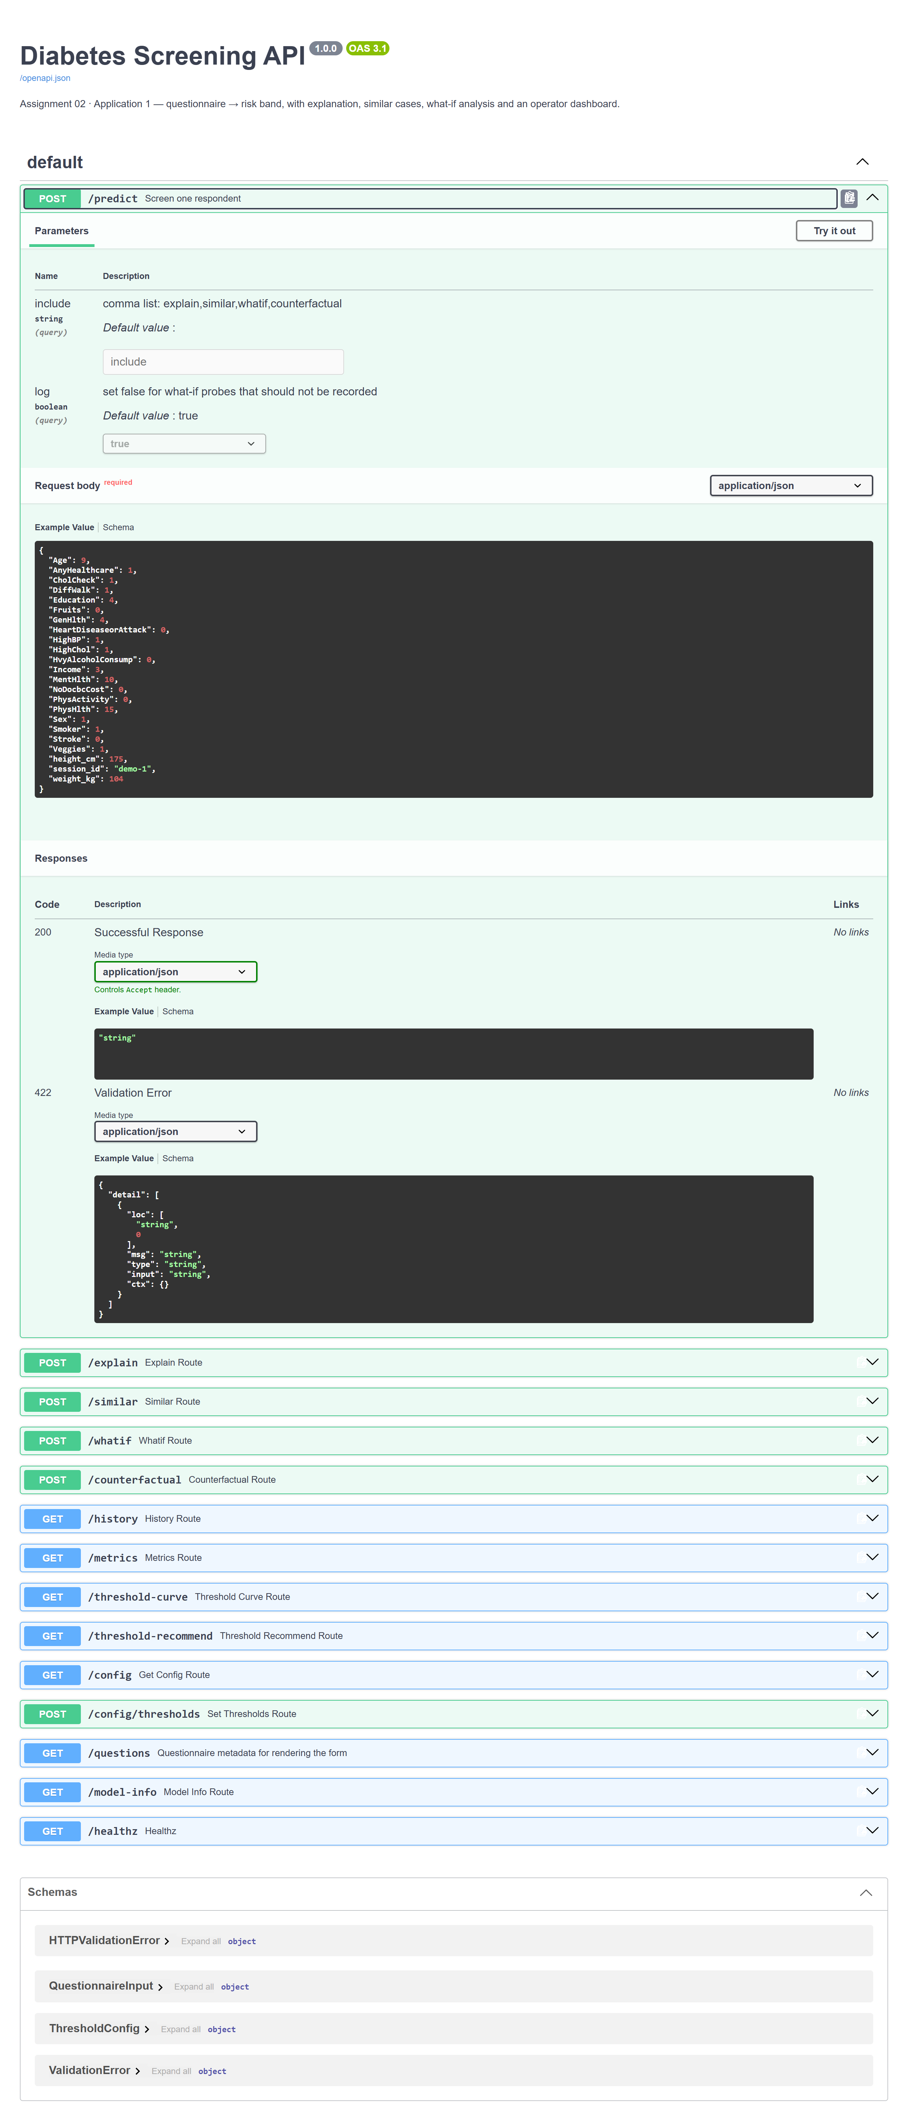
Figure D3 - Diabetes FastAPI Swagger UI (/docs) endpoint specification

Figure D1
Figure D1 - Diabetes web: the input questionnaire with a valid example entered.

Figure D2
Figure D2 - Diabetes web: the result screen - 82 % High risk, SHAP force plot, the five most similar survey respondents, and a what-if BMI slider.
Figure explanation (D1-D2). The user answers the questionnaire (D1); blank fields are median-imputed. The service returns p(diabetes) = 0.82 and the page (D2) shows the band “High risk - refer for a confirmatory blood test”, a SHAP force plot of which answers moved the estimate, the five most similar survey respondents, and a what-if BMI slider - a high-but-not-certain probability is deliberately surfaced as “refer for a test”, not a diagnosis. The /docs route documents the same request and response schema.

D.2 Web Application - House price
Item | Value
Framework | React 18 + TypeScript + Vite; axios
API endpoint | POST http://localhost:8002/predict
Input variables | Area (required, m^2); optional Width, Length, Bedrooms, Bathrooms, Floors, "Alley Width", "Agent Listing Count", "Property Type", Position, Direction, "Road Type", Province, "Agent Role", district
Validation rules | Pydantic schema - Area > 0 required; missing optional numerics median-imputed; unknown categoricals map to an all-zero one-hot row
Preprocessing used | saved ColumnTransformer - SimpleImputer(median) -> log1p -> StandardScaler (numeric), OneHotEncoder(handle_unknown="ignore", min_frequency=50) (categorical); never re-fitted
Loaded model | RandomForestRegressor trained on log(1 + Price); the response inverts with expm1
Example request | { "Area": 78.7, "Width": 4.0, "Bedrooms": 3, "Bathrooms": 2, "Floors": 2, "Property Type": "house", "Province": "an-giang", "district": "Rach Gia" }
Example response | { "predicted_price": 2540.82, "price_per_m2": 32.28, "currency": "million VND", "model": "RandomForest", "contributions": [ ... ] }
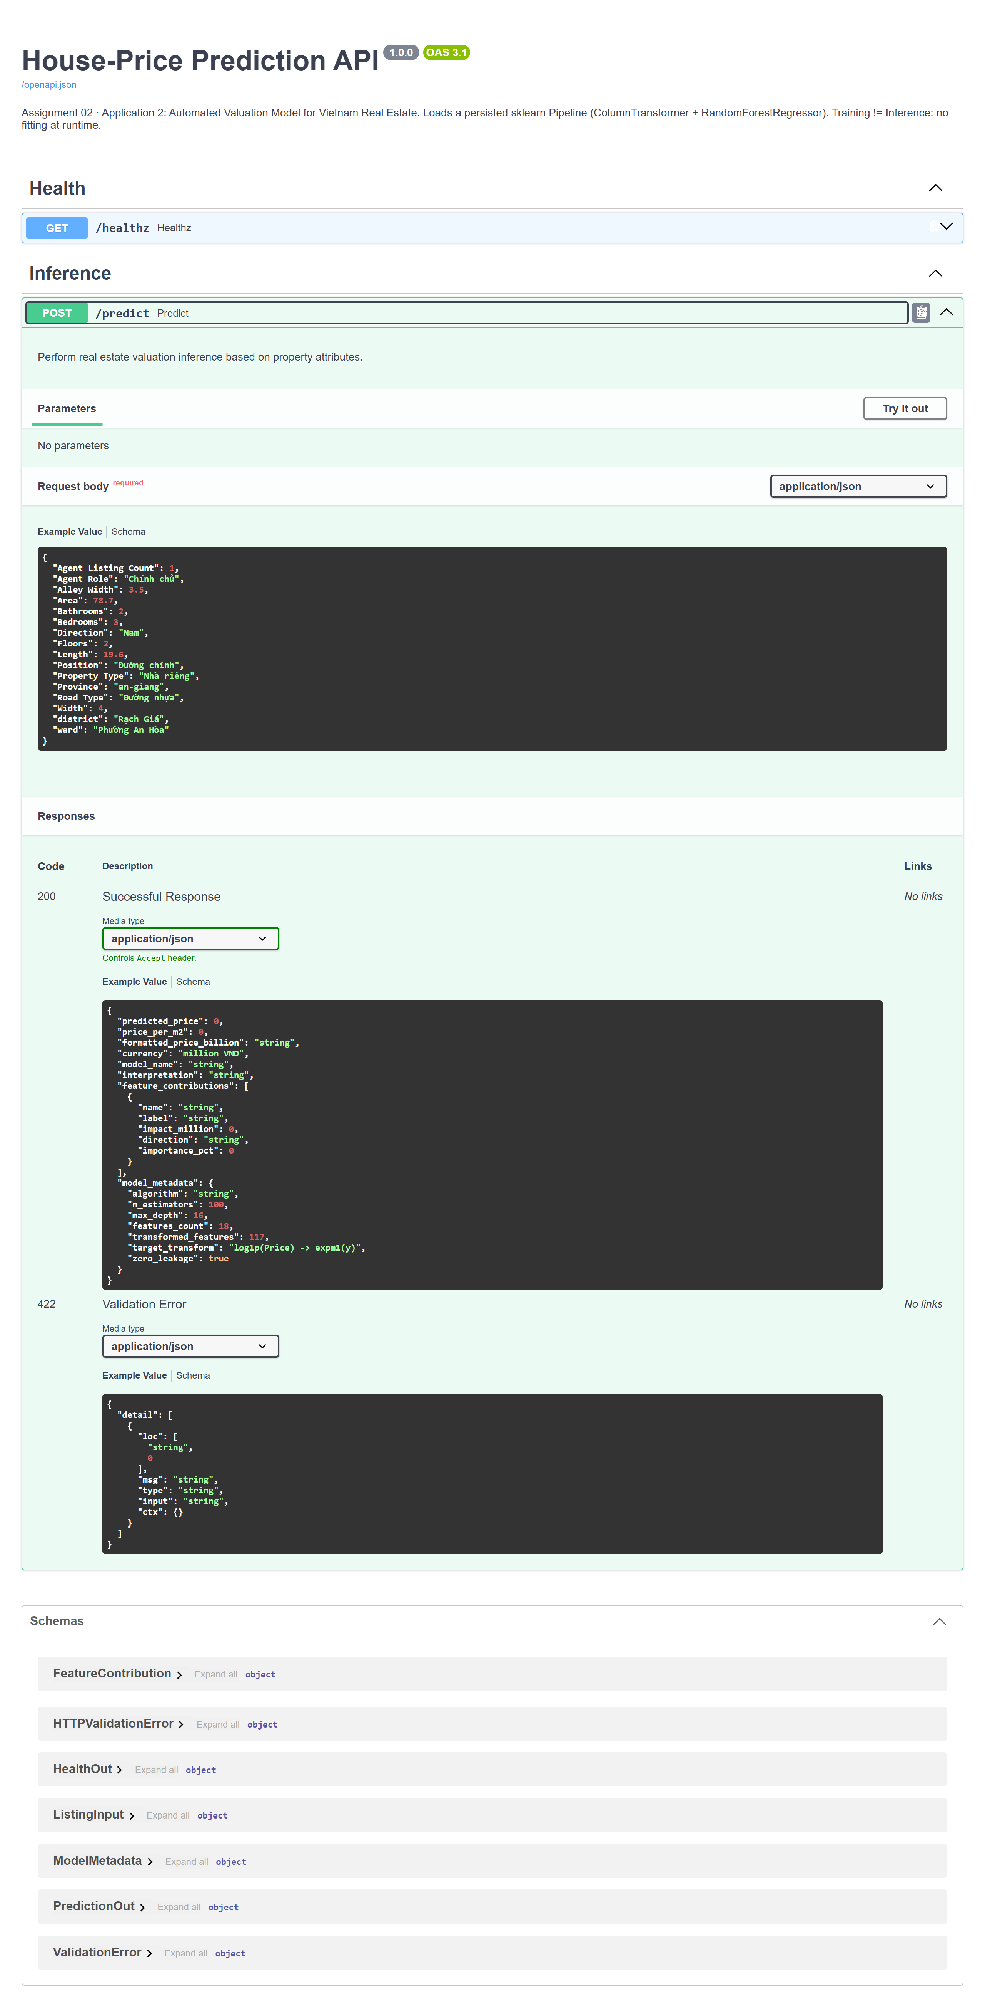
Figure D6 - House-price FastAPI Swagger UI (/docs) endpoint specification
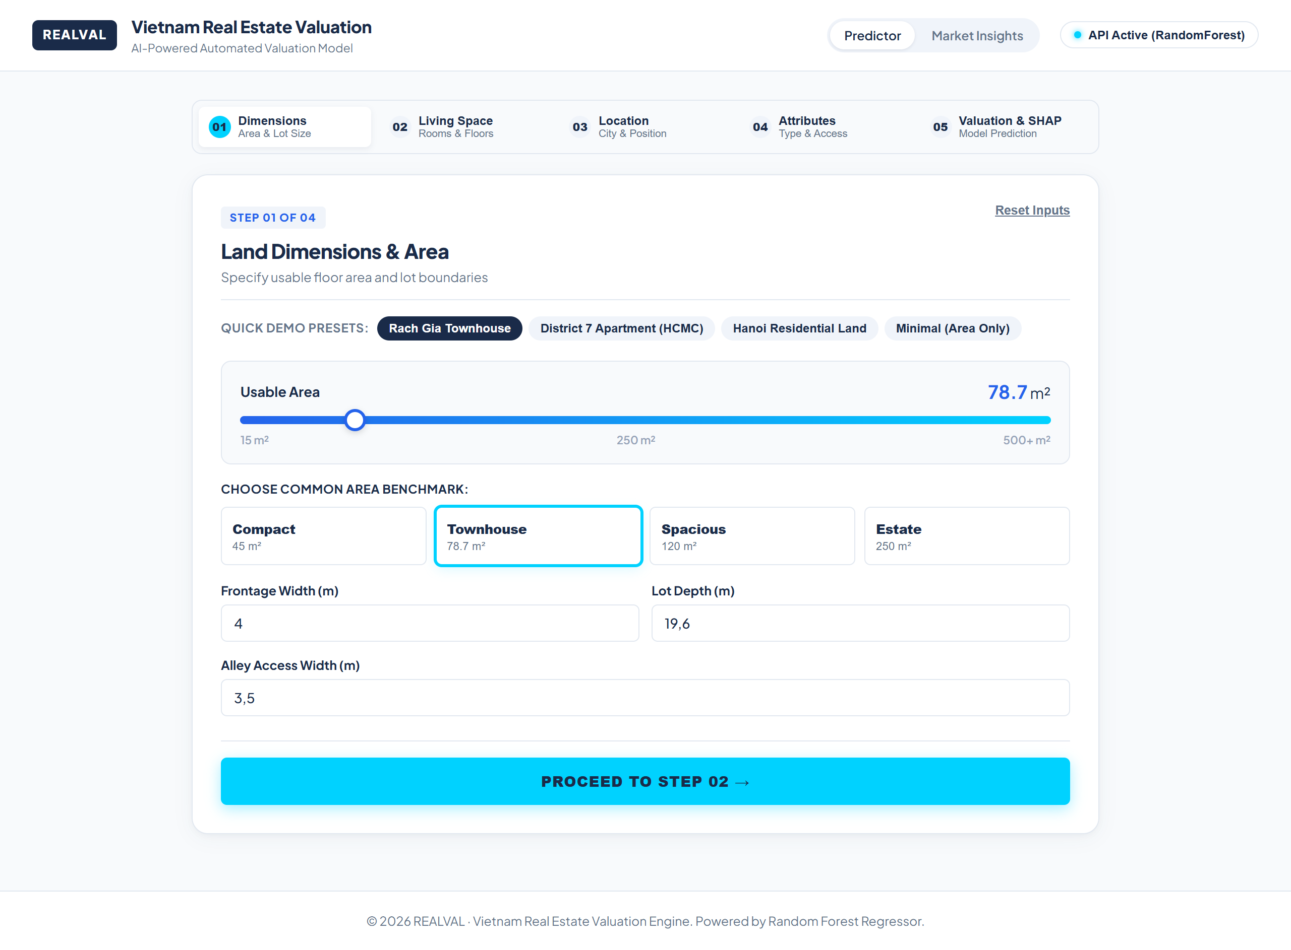
Figure D3
Figure D3 - House-price web: the valuation wizard step 1 with the “District 7 Apartment” preset filled.
Figure D4
Figure D4 - House-price web: the result screen - predicted about 9.90 billion VND, a low-high range, a SHAP contribution waterfall and a plain-language summary.
Figure explanation (D3-D4). The user enters property attributes (D3; only Area > 0 is required). The service returns predicted_price and the page (D4) shows about 9.90 billion VND (about 151 million VND/m^2) with a low-high range and a SHAP waterfall (usable area +3 381 M, location +2 093 M, …); the model predicts log(1 + Price) and the response inverts it with expm1.

D.3 Web Application - Customer behaviour
Item | Value
Framework | React 18 + Vite, 3-step wizard; the dev server proxies /api to FastAPI
API endpoint | POST http://localhost:8000/predict (also /predict/batch, /questions, /samples)
Input variables | skin_type, skin_tone, eye_color, hair_color, secondary_category, brand_name, price_usd, loves_count, reviews, review_title, review_text - the star rating is never sent
Validation rules | Pydantic schema; blank skin-profile fields map to the __na__ one-hot level; numeric gaps median-imputed
Preprocessing used | saved ColumnTransformer (SimpleImputer(median) -> log1p -> StandardScaler, binary passthrough, OneHotEncoder(min_frequency=25)) plus TfidfVectorizer(ngram_range=(1,2), min_df=10, max_features=40000, sublinear_tf, stop_words="english"); all fitted on the training split only
Loaded model | LogisticRegression(C=1.0, class_weight="balanced") on the concatenated tabular + TF-IDF matrix
Example request | { "skin_type": "oily", "secondary_category": "Moisturizers", "brand_name": "Murad", "price_usd": 49, "review_title": "New formula is awful", "review_text": "Broke me out within a week and left me greasy all day ..." }
Example response | { "prediction": "not recommend", "p_recommend": 0.0026, "threshold": 0.5, "review_terms": {"against": [...], "toward": [...]}, "signals": {...}, "contributions": [...], "model": "LogisticRegression", "representation": "tabular + tfidf" }
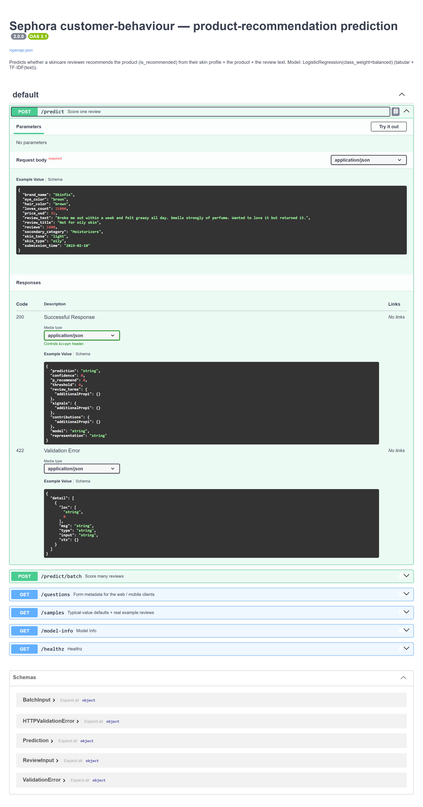
Figure D9 - Customer-behaviour FastAPI Swagger UI (/docs) endpoint specification

Figure D5
Figure D5 - Customer-behaviour web: step 1 (skin profile) of the 3-step wizard, “API connected”.
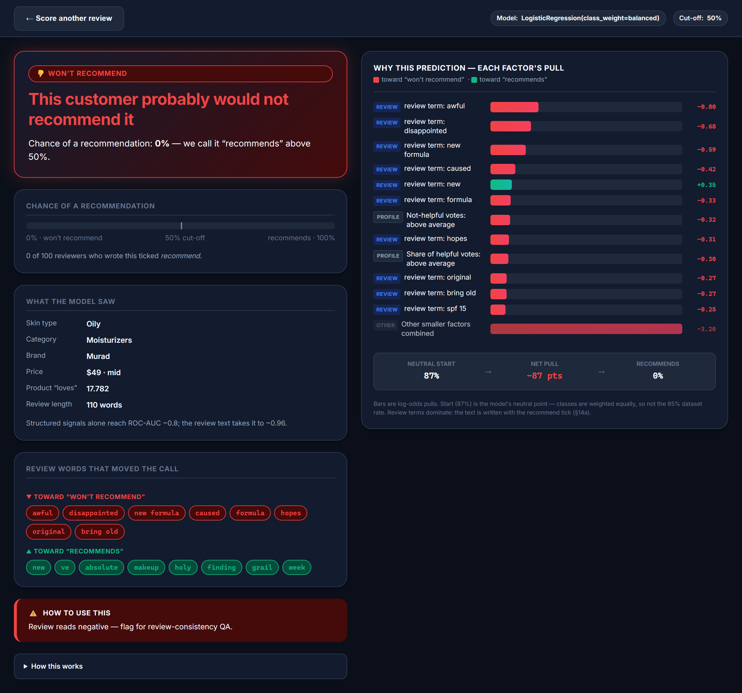
Figure D6
Figure D6 - Customer-behaviour web: the result screen - “WON’T RECOMMEND”, P(recommend) = 0 %, probability meter, structured signals, review terms, linear-SHAP chart.
Figure explanation (D5-D6). A 3-step wizard (D5): skin profile, then product, then the review title and text; the star rating is never sent. The service returns prediction = "not recommend", p_recommend = 0.00, and the page (D6) shows “WON’T RECOMMEND”, a probability meter against the 50 % cut-off, the structured signals, the review words that moved the call, and an exact linear-SHAP chart - a negative-reading review is flagged for review-consistency QA.

Appendix E - Mobile Application Report
All three mobile clients are Flutter apps that act as REST clients of the deployed service (Training != Inference): they collect the same fields as the web form, POST them to /predict, and render the returned JSON. Every screenshot run below logged a POST /predict 200 on the server - the required communication evidence. (Screenshots were captured from the Flutter app built for web and driven at a 390 x 844 phone viewport.)
Item | Diabetes | House price | Customer behaviour
Mobile framework | Flutter 3.x / Dart, Material 3 | Flutter 3.x / Dart, Provider state | Flutter 3.x / Dart
Platform | Android (emulator / device) | same | same
Input screen | About-you / Body / Conditions form, “Not sure” for unknowns | single scrolling form: area, rooms, province/district, type | 3-step wizard: skin profile / product / review
API endpoint | POST http://10.0.2.2:8000/predict (emulator) / localhost:8000 | .../:8002/predict | .../:8000/predict
Request format | JSON body of the fields above (same keys as the web form) | JSON body (Area required) | JSON body (no rating)
Response format | { prediction, confidence, band, contributions } | { predicted_price, price_per_m2, currency, model } | { prediction, p_recommend, threshold, review_terms, signals, contributions }
Prediction display | probability + risk band + “Why this score” bars + similar respondents | predicted price (billion VND) + unit price + one-line summary | verdict + probability meter + signals + review terms
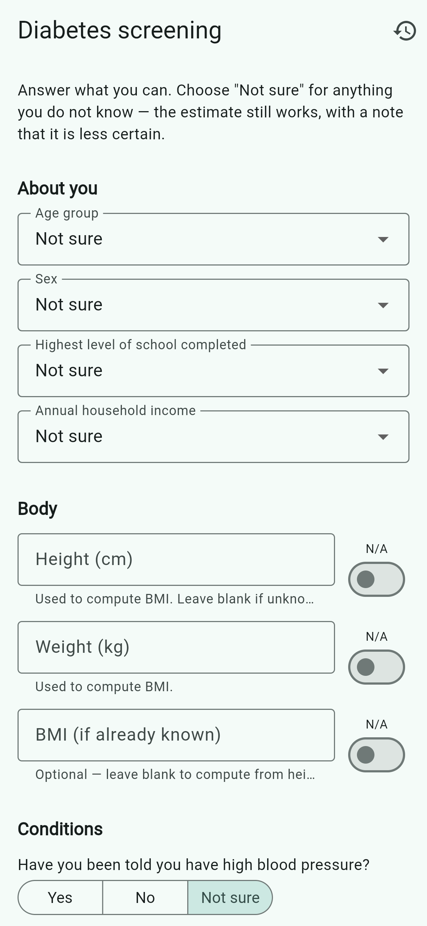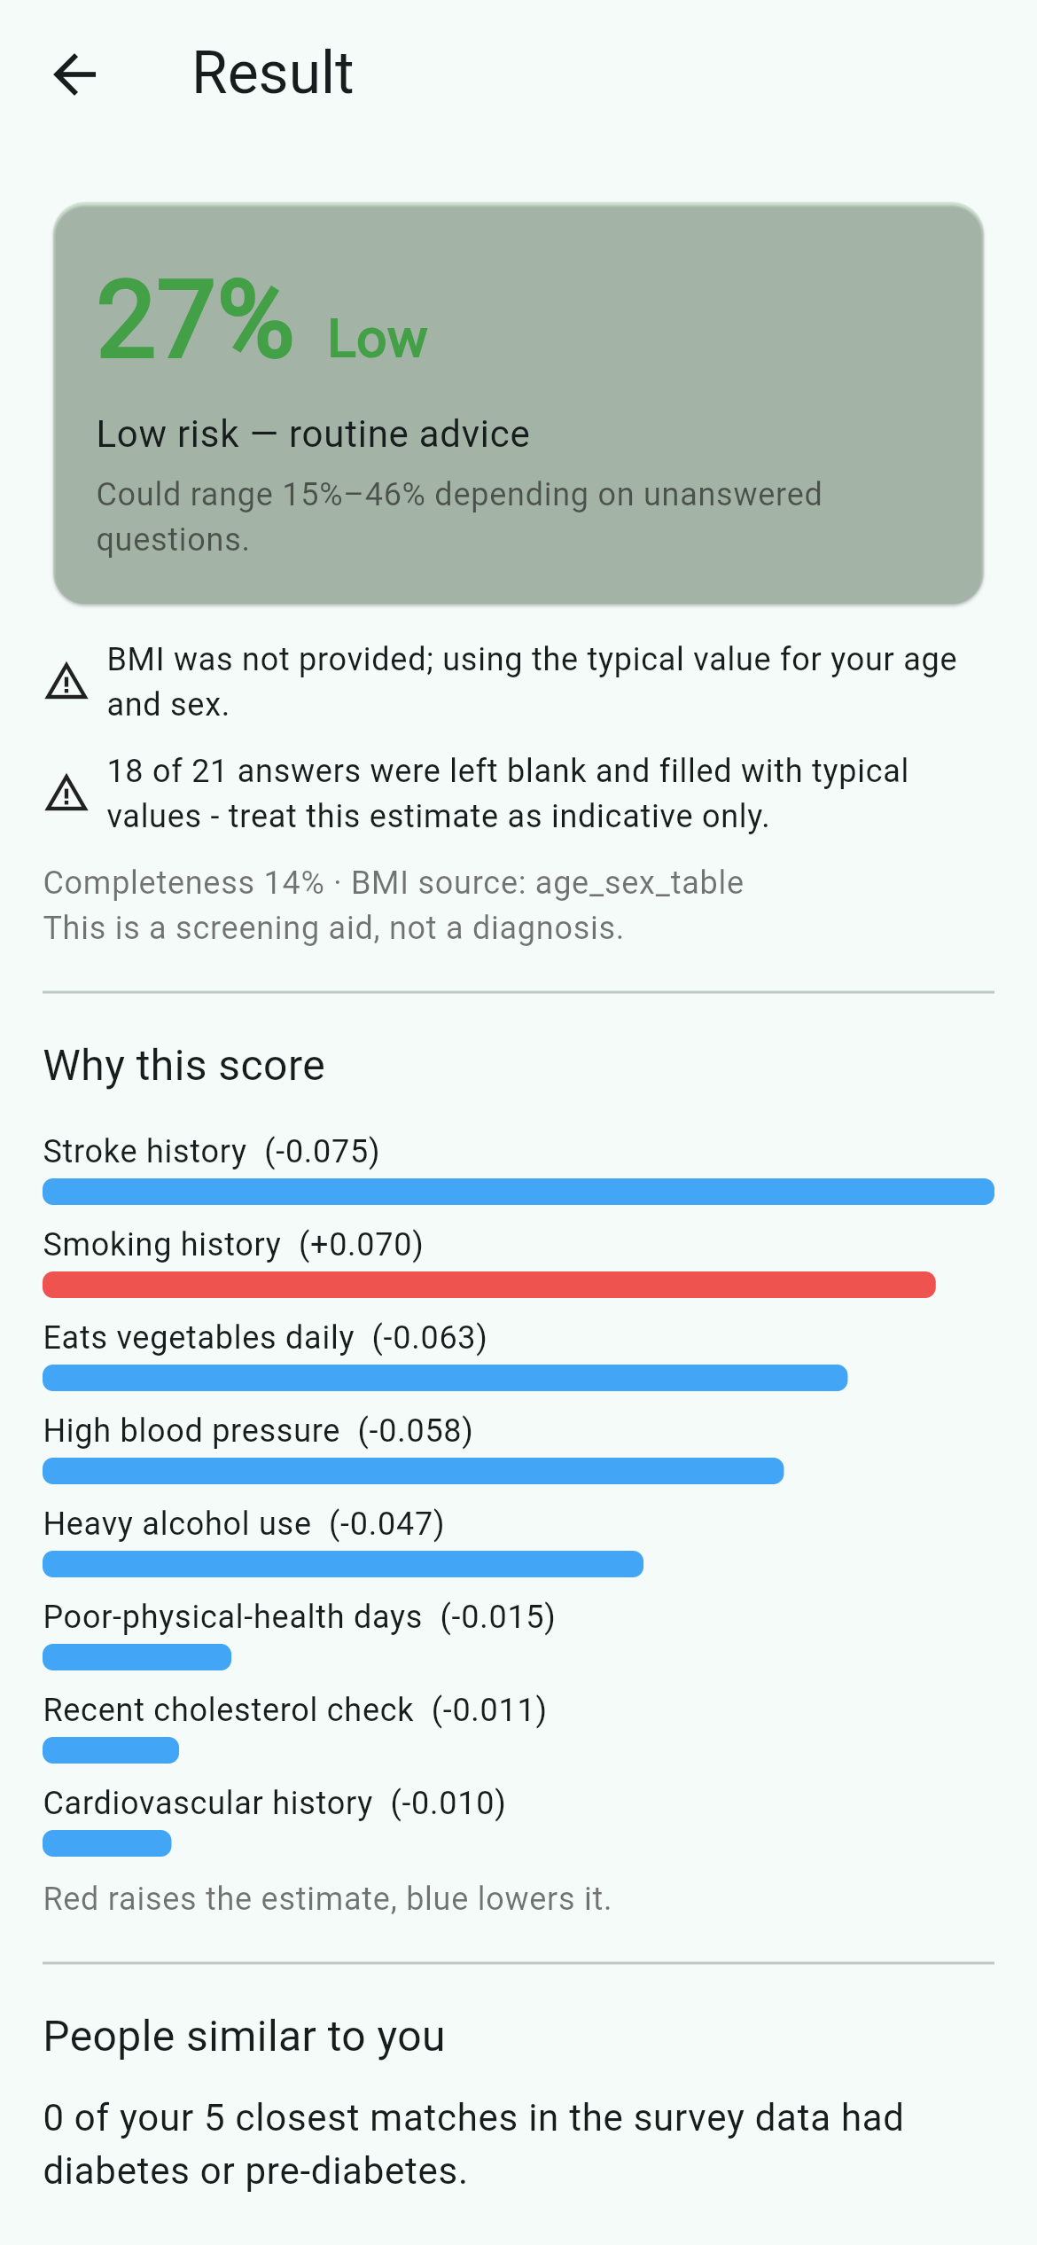
Figures E1-E2 - Diabetes mobile: input screen (About you / Body / Conditions) and result screen (27 % Low, range 15-46 %, “Why this score” bars). The run logged POST /predict 200.
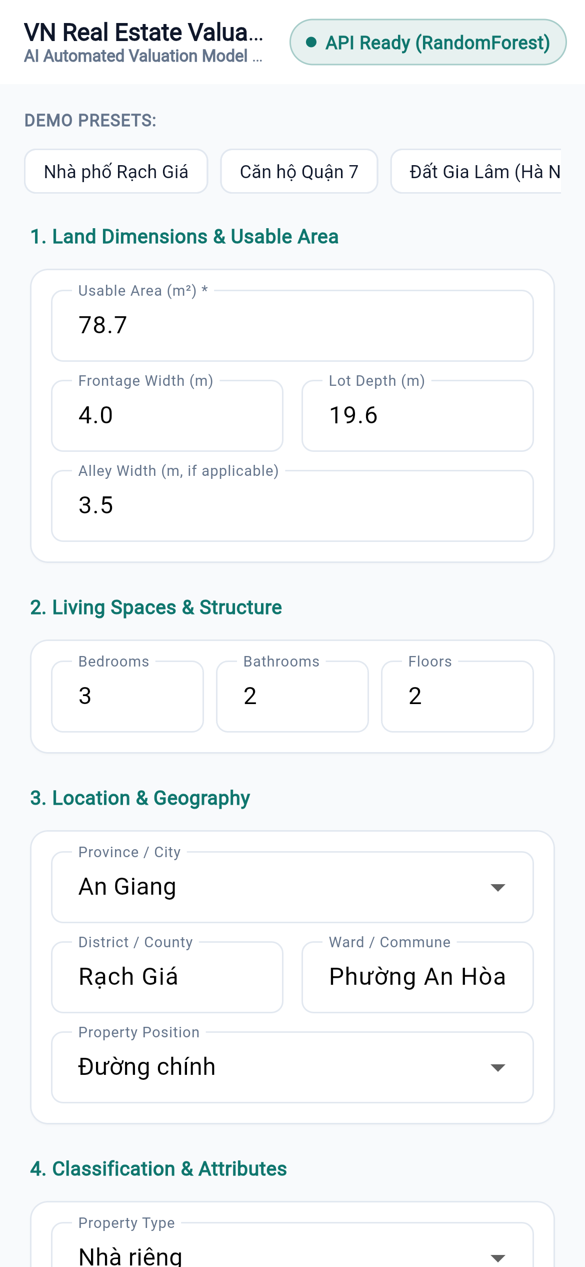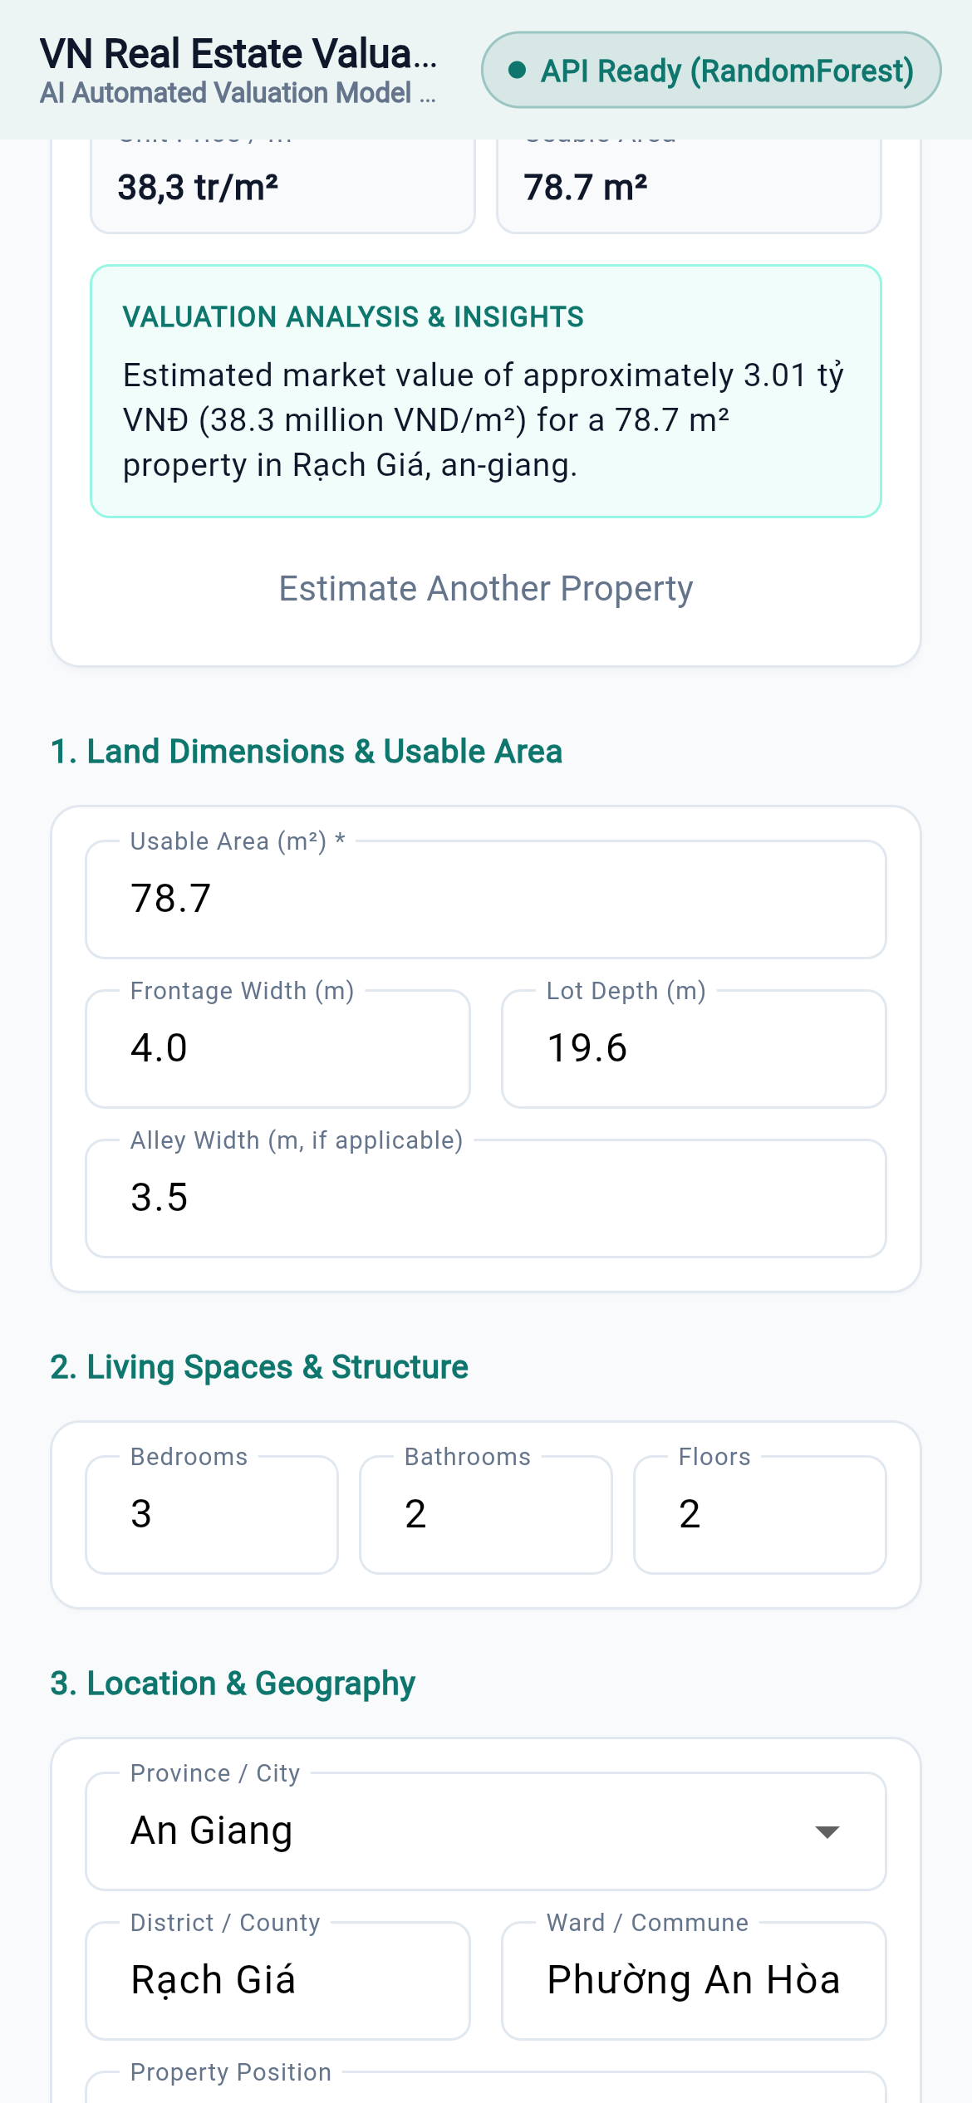
Figures E3-E4 - House-price mobile: input screen (Rach Gia preset, “API Ready”) and result screen (about 3.01 billion VND, unit-price card, one-line summary). The run logged POST /predict 200.
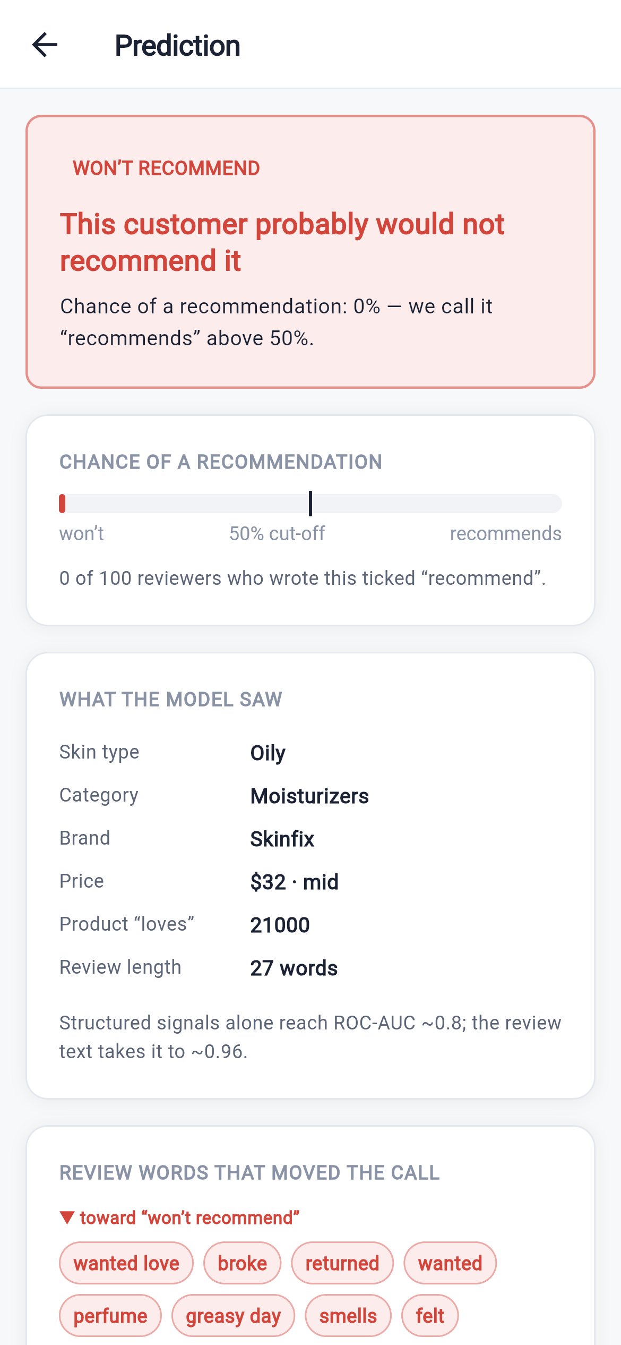
Figures E5-E6 - Customer-behaviour mobile: step 1 (skin profile, “API connected”) and result screen (“WON’T RECOMMEND”, 0 % meter, signals, review terms). The run logged POST /predict 200.
Figure explanation (E1-E6). Each input screen collects the same fields as the matching web form; on submit the app builds a JSON body and calls POST .../predict over HTTP. Each result screen renders the returned JSON - the same payload the web page receives - as a probability / predicted value plus a short interpretation. The POST /predict 200 line logged on the server during each run is the evidence that the mobile client communicates with the deployed service.

Appendix F - Final Submission Checklist and Additional Evidence

F.1 Submission checklist
Requirement | Done
Three Kaggle datasets selected | Yes
Diabetes / House-price / Customer-behaviour applications completed | Yes / Yes / Yes
Problem definition for all three | Yes
Dataset structure, data quality, missing values, duplicates, invalid values, outliers analysed | Yes
Data representation explained; numerical and categorical features identified; feature engineering explained | Yes
EDA completed | Yes
Train / validation / test split performed correctly; data leakage considered | Yes
Preprocessing pipeline implemented (fitted on train only, saved) | Yes
At least four ML models compared per application (5 / 5 / 8) | Yes
Appropriate metrics reported; confusion matrix reported where appropriate | Yes
Best model selected and justified; error analysis completed | Yes
Model saved; preprocessing saved; inference tested | Yes
REST API implemented | Yes
Web application implemented; web screenshots included (all three) | Yes (Appendix D)
Mobile application implemented; mobile screenshots included (all three) | Yes (Appendix E)
Reproducibility information included | Yes (Section 9)
Source code submitted; README included | Yes
Final comparative discussion included | Yes (Sections 7, 10)
Final PDF submitted | (produced from this document)

F.2 Additional notebook evidence
The df.shape / df.info() / df.describe() / df.isna().sum() / df.duplicated().sum() outputs are tabulated with their executed values in Sections 4.3, 5.3 and 6.2; the raw notebook cells are in the three */notebook/*.ipynb files, which run top-to-bottom with zero error cells. The house-price Section 10.1-10.3 supporting plots (area / unit-price distributions, correlation-ratio bars, missingness and QQ views) and the Section 9 outlier plots are in the notebooks and are not reproduced here.

F.3 Reproduction and file index
All screenshots, and the ports each stack ran on, are indexed in report/screenshots/README.md. Stacks were run locally on 2026-09-07: FastAPI + Uvicorn backend, React/Vite web dev server, and the Flutter client built for web (flutter build web) driven at a 390 x 844 device viewport. Backend ports: diabetes 8000, house price 8002, customer behaviour 8000. The three notebooks run top-to-bottom with RANDOM_SEED = 42 and write model/ before the API is started.

