HỌC VIỆN CÔNG NGHỆ BƯU CHÍNH VIỄN THÔNG
KHOA CÔNG NGHỆ THÔNG TIN
--------

ASSIGNMENT REPORT
Subject name: Introduction to Software Engineering
Class name: E23CN5
Project name: Spa Management
Project code: 06
Group code: Group 05
Member list: lưu anh dũng - B23DCDK036
nguyễn minh hùng - B23DCCE041
nguyễn văn trường - B23DCCE095
BÙI NGUYÊN HOÀNG VIỆT - B23DCDT285
Module name: Process Payment
Requirement: Analysis

Table of Contents
Concept exploration 1
Glossary list 1
Business model 7
1. Business model in natural language 7
Question 1: Objective and scope 7
Question 2: Who? What could they do? 8
Question 3: How does function work? 8
Question 4: What information needed? 10
Question 5: Relationship among information needed? 11
2. Business model in UML 12
General use case diagram 12
Use case: Process payment 13
Analysis 14
Scenario 14
Entity class 17
Entity class extraction using noun extraction method 17
Entity class diagram 18
Full class 18
Full class explain 18
Full class diagram 20
Dynamic analysis 21
Scenario v.2 21
Sequence diagram 22

Concept exploration

Glossary list

No | Concept (English) | Concept (Vietnamese) | Meaning
Concept related to humans
1 | Manager | Quản lý | The person who manages operations and can view statistics
2 | Customer | Khách hàng | The client who uses the services provided by the spa
3 | New customer | Khách hàng mới | Customer who hasn’t used services from the spa
4 | Reserved customer | Khách đã đặt trước | Customer who has made a reservation before coming to the spa
5 | Waiting customer | Khách đang chờ | Customer who is waiting in the queue
6 | In-service customer | Khách đang sử dụng dịch vụ | Customer who is using the service
7 | Paid customer | Khách đã thanh toán | Customer who has already paid for the service and had their invoice saved
8 | Receptionist | Lễ tân | The staff responsible for checking in customers, managing reservations and assigning service staff
9 | Service staff | Nhân viên phục vụ | The staff responsible for providing beauty services to customers
10 | Idle service staff | Nhân viên phục vụ đang rảnh | Service staff who are currently available
11 | Supplier | Nhà cung cấp | The establishment providing the materials used by the spa
12 | New supplier | Nhà cung cấp mới | The supplier that provides materials for the first time
13 | Employee | Nhân viên | The staff that is responsible for other activities
Concept related to the object
14 | Beauty service ID | Mã dịch vụ làm đẹp | The ID of the spa services
15 | Beauty service name | Tên dịch vụ làm đẹp | The name of the spa’s beauty treatments
16 | Beauty service category | Danh mục dịch vụ làm đẹp | The type of cosmetic treatments provided by the spa
17 | Material | Nguyên vật liệu | Consumable items used in a service
18 | Newly imported material | Nguyên vật liệu mới nhập hàng | Materials that are recently added from the current import
19 | New material | Nguyên vật liệu mới | Material that hasn’t appeared in the list of available materials
20 | Used material | Nguyên vật liệu đã sử dụng | Material that are consumed on service
21 | Imported invoice | Hóa đơn nhập hàng | The invoice describing the imported material entries
22 | Booking schedule | Lịch hẹn | The appointment schedule of customers
23 | Reserved schedule slot | Suất đã được đặt trước | Slot in the booking schedule that has been reserved by an appointment
24 | Service slot | Suất dịch vụ | A unit of service provided to one customer in a period of time by a service staff member
25 | Service queue | Hàng đợi dịch vụ | A waiting line for non-reserved customers when there’s no service slot or service staff available
26 | Reservation | Đơn đặt trước | An appointment for a service slot
27 | Assigned service slot | Suất dịch vụ đã được phân bổ | A slot assigned to the current customer for service
28 | Service cost | Chi phí dịch vụ | The commission fee for the provided service
29 | Material cost | Chi phí nguyên vật liệu | The cost of materials used on service
30 | Customer invoice | Hóa đơn khách hàng | The invoice containing customer information and a list of material/services used in the session
31 | Basic salary | Lương cơ bản | The base amount of salary for a service staff
32 | Service commission | Phí hoa hồng dịch vụ | A performance-based payment awarded to service staff, calculated from the services they have provided during a payment period.
33 | Monthly salary slip | Phiếu lương hàng tháng | A slip that details the basic salary and a list of services provided by the service staff during that month
34 | Staff list of served services | Danh sách các dịch vụ và nhân viên đã phục vụ | A record showing all services performed by a staff member during a specific payment period
35 | Payment period | Kỳ trả lương | A time interval used to calculate staff salary and service commission
36 | Statistical time | Thời gian thống kê | A range of time used to narrow the query result
37 | Detailed services | Thống kê dịch vụ chi tiết | Information for a service in a range of time (code, name, type, total number of services and revenue)
38 | Total amount | Tổng tiền | The final amount that the customer must pay, calculated from all invoice lines
39 | Invoice line | Dòng chi tiết hóa đơn | A single line item in the invoice representing one service or material, including quantity and price
40 | Statistics | Thống kê | The process of collecting and analyzing data for reporting purposes
41 | Statistical time | Thời gian thống kê | A time range used to filter and generate statistical results
42 | Revenue | Doanh thu | The total income generated from provided services and materials
43 | Service date | Ngày sử dụng dịch vụ | The date on which a service is provided to the customer
44 | Total amount collected | Tổng số tiền thu được | The total amount of money collected from customers during a specified period
45 | Total number of servings | Tổng số lượt phục vụ dịch vụ | The count of time a service has been provided within a selected time range
Concept related to activities
46 | Select the import menu | Chọn chức năng nhập hàng | Choose the import function to start the material importing process
47 | Display import page | Hiển thị trang nhập hàng | Display the interface for entering supplier and material import information
48 | Enter supplier name | Nhập tên nhà cung cấp | Input the supplier name to search and select the corresponding supplier
49 | Search supplier | Tìm kiếm nhà cung cấp | Find the supplier by name in the list of suppliers
50 | Display supplier list | Hiển thị danh sách nhà cung cấp | Display a list of suppliers that match the search query
51 | Add new supplier | Thêm mới nhà cung cấp | Add a new supplier if it doesn’t exist
52 | Select supplier | Chọn nhà cung cấp | Select the currently imported supplier in the supplier list
53 | Enter material name | Nhập tên nguyên liệu | Input the material name to search and select the corresponding material
54 | Search material | Tìm kiếm nguyên vật liệu | Search material by name in the list of materials
55 | Display material list | Hiển thị danh sách nguyên vật liệu | Display a list of materials that contains the entered name
56 | Select material | Chọn nguyên vật liệu | Select the material that need to be imported from the list
57 | Add new material | Thêm mới nguyên vật liệu | Add a new material into the list of materials
58 | Enter material quantity | Nhập số lượng nguyên liệu | Enter the quantity of the selected material to be imported
59 | Add invoice to the list of invoice entries | Thêm hóa đơn vào danh sách các dòng chi tiết hóa đơn. | Add the entered material information as a new line item in the import invoice
60 | Submit invoice | Nộp hóa đơn | Finalize and save the import invoice after all materials have been entered
61 | Print out imported invoice | In phiếu nhập nguyên liệu | Generate and print the import invoice after successful submission
62 | Select customers receiving function | Chọn chức năng tiếp nhận khách hàng | Choose the customer receiving function to start the customer check-in process
63 | Enter customer name | Nhập tên khách hàng | Entering the customer name to search for reservations or customer record
64 | Search customer name | Tìm tên khách hàng | Search for customers whose names contain the entered keyword
65 | Display appointments list containing keyword | Hiển thị danh sách cuộc hẹn có chứa tên được nhập | Display a list of appointments that match the entered customer name
66 | Add new customer to queue | Thêm khách mới vào hàng đợi | Add a new customer to the waiting list in case of unavailable slot or service staff at the moment
67 | Make a reservation | Đặt lịch hẹn | Create a new appointment for a customer in the system
68 | Display service/material input interface | Hiển thị giao diện nhập dịch vụ/nguyên liệu | Display the interface for entering selected services and materials for a customer
69 | Add selected services to list of chosen services | Thêm dịch vụ được chọn vào danh sách khách hàng chọn | Add selected services and materials to the customer service list
70 | Create customer list of chosen services | Tạo danh sách dịch vụ khách hàng chọn | Create a service list based on the customer selected services
71 | Search for service | Tìm dịch vụ | Entering a service name to search for available services
72 | Display a list of matched services | Hiển thị danh sách dịch vụ phù hợp | Displays detailed information for services matching the entered name
73 | Check available service’s staff | Kiểm tra nhân viên dịch vụ khả dụng | Check if a service staff is available for the selected services
74 | Select idle staff corresponding to selected service | Chọn nhân viên rảnh rỗi tương ứng với dịch vụ được chọn | Assign an idle staff member to the selected service
75 | Save customer list of chosen services | Lưu danh sách dịch vụ khách hàng chọn | Save the customer selected services and assigned staff
76 | Select payment method | Lựa chọn phương pháp thanh toán | Display payment method to customer
77 | Select payment function | Chọn chức năng thanh toán | Select the payment function to start the payment process
78 | Display slot selection interface | Hiển thị giao diện chọn suất | Display the interface for selecting the customer service slot
79 | Select customer slot | Chọn suất của khách hàng | Select the correct slot corresponding to the customer
80 | Print customer detailed invoice | In hóa đơn chi tiết của khách hàng | Generate and print the customer detailed invoice
81 | Inform payment total cost | Thông báo giá tiền thanh toán | Staff informs the customer of the total payment amount
82 | Confirm customer payment | Xác nhận thanh toán | Acknowledge the customer’s payment confirmation for the services
83 | Selects service statistics by revenue function | Chọn chức năng thống kê doanh thu dịch vụ | Select the service revenue statistics function
84 | Display select statistical time interface | Hiển thị giao diện chọn thời gian thống kê | Display the interface for selecting a statistical time range
85 | Select statistical time | Chọn thời gian thống kê | Select a time range for generating statistics
86 | Display statistics | Hiển thị kết quả thống kê | Display statistical results including services and revenue
87 | Select a line of services | Chọn một dòng dịch vụ | Select a service entry from the statistics list
88 | Display list of detailed service statistics | Hiển thị danh sách thống kê chi tiết dịch vụ | Display a list of detailed services: code, name, type, total number of servings, total revenue (sorted by revenue descending)
89 | Display list of detailed invoice statistics | Hiển thị danh sách thống kê chi tiết hóa đơn | Display a list of detailed invoice for each services: id, customer name if any, service date, unit price, total amount collected (arranged in chronological order of payment)
IV | POLICIES (RULES) | CHÍNH SÁCH (QUY TẮC) | Business logic and constraints
90 | Enqueue threshold | Ngưỡng cho vào hàng đợi | Enqueue a customer when the number of waiting customers exceed the number of slots or the number of available service staffs
91 | Queueing policy | Quy tắc chờ hàng đợi | All waiting customers must follow the queue except the ones who made a reservation
92 | Staff availability check | Kiểm tra nhân viên rảnh | Check if a staff is in service or not to assign to a new customer
93 | Material charge | Chi phí nguyên vật liệu | Take into account material fee in addition to service fee
94 | Material unit price adjustment | Chỉnh sửa đơn giá nguyên vật liệu | Adjust material unit price accordingly when needed
95 | Service commission salary | Lương hoa hồng dịch vụ | Acknowledge the service commission when calculating monthly pay slip
96 | Customer invoice modifiability | Thay đổi hóa đơn khách hàng | Customers can ask the receptionist to modify the invoice if there’s an error
97 | Detailed services sorting | Sắp xếp chi tiết các dịch vụ | Sorts the detailed services in revenue descending order
98 | Detailed invoice sorting | Sắp xếp chi tiết các hóa đơn | Sorts the detailed invoices in chronological order
99 | New material insertion | Thêm vào nguyên liệu mới | Ability to add new materials appearing in an import
100 | New suppliers insertion | Thêm vào nhà cung cấp mới | Add suppliers that first appeared in an import

Business model

Business model in natural language

Question 1: Objective and scope

Objective:
- The spa management system enables a spa to manage customers and their reservations, manage staffs and their salaries, and manage materials used in services

Scope:
- Application type: Desktop application
- Use: Only the following staff of the spa could use:
- Administrator
- Manager
- Inventory Staff
- Receptionist
- Service Staff
- Function:
- Import materials
- Booking and queue management
- Customer check-in
- Payment processing
- View statistics

Question 2: Who? What could they do?

Manager:
- View statistics: Select the function of service statistics by revenue, choose the start and end date, and view the details of services and invoices

Inventory staff:
- Manage supplier info: add, search supplier
- Manage materials info: add, search materials, edit imported unit price
- Manage import report: input invoice entries, report successful import, print import invoice

Receptionist:
- Check in customer: find the booking schedule or an empty slot for the customer, enter keywords to find specific customer appointments, search and select the exact service name, quantity, and provisional amount added to the list of selected services, view list of free service staff corresponding to the service and assign a staff member
- Process payment: select the correct slot for the customer to pay, add/reduce/change the services/materials used to match reality if there is a mistake, confirm the amount and print customer detailed invoices

Service staff:
- Serve corresponding service: each service staff can serve some services.

Question 3: How does function work?

Import materials:
- An inventory staff selects the function to import materials on the home page
- -> The screen displays the management interface, including search box and search button
- Staff enters supplier name in the search box and clicks search button
- -> Display the list of suppliers whose name contained the entered keyword, includes:
  - Supplier ID
  - Supplier name
  - Number of materials supplied
- If the supplier is not in the list => Add this supplier
- -> Enter name and click search button to show a list of material containing the name just entered, includes:
  - Material ID
  - Material name
  - Stock quantity
  - Material description
  - Material unit price
- -> The staff checks if the importing material is in the list, if the material is not in the list, choose to add the new one.
- -> Then enter to change the information for each material, including the quantity and the price for each unit if needed
- Once all of materials are added, the staff will use submit button to save
- -> The new report is then are created and print out the imported invoice, includes:
  - Import date
  - A table of imported materials, includes:
    - Material ID
    - Material name
    - Import quantity
    - Unit price
    - Total price

Customer check-in:
- A client at the front of the queue or has reserved slot checks in
- -> A receptionist selects the function of receiving clients.
- -> The interface to find the booking schedule displays, enter customer’s name -> a list of appointments whose names contain the keyword entered
  - If the customer is not in the list, find an available slot
    - If there is no available slot, add customer to the queue
    - Else choose an free slot for the customer
  - If the customer is in the list, selects the correct slot for the customer being received
- -> The service/ material input interface appears:
- -> The receptionist asks customer and enters service name and selects search -> a list of detailed services appears
- -> The receptionist selects a service exactly as the customer wants, including:
- service name
- quantity
- provisional amount
- -> Then add it to the list of selected services
- -> The staff uses these steps to select services/materials until all the services/materials required by the customer are entered
- ->The staff clicks to assign service staff and the interface then shows a list of corresponding free service staff corresponding to each service -> selects a service staff for each service and confirms
- -> The system saves and the receptionist informs the customer.

Payment processing:
- Customer ask receptionist to pay
- -> The receptionist selects payment function
- -> The slot selection interface appears with a list of slots or customers.
- If the receptionist finds the correct slot for the customer, then they select it, else search again
- After select the correct slot for the customer, the customer’s detailed invoice interface appears
- The customer’s detailed invoice interface contains
  - Customer information
  - A list of materials or services that the customer has used, each line contains
    - id
    - name
    - type
    - unit price
    - quantity
    - money
  - Total amount
- Customer can ask the staff to modify the services/materials used
- -> Receptionist click ‘Modify’ button
  - If customer want to add the services, click on ‘Add service’ and type service id, name, type, unit price, quantity and money
  - If customer want to remove the services, right click on the selected services and click ‘Remove service’
  - If customer want to change the services, right click on the requested services and click ‘Modify service’ and change according to the customer’s request
- After finishing, the receptionist informs the customer of the total amount
- -> The customer pay for the amount
- After payment, the customer clicks confirm
- -> The system saves the customer’s invoice and print it for the customer

View statistics:
- The manager selects the function of service statistics by revenue
- -> The interface to select the statistical time appears
- -> The manager selects the start and end date and click statistics
- -> The results appears
- Results include a list of detailed services containing:
  - code
  - name
  - type
  - total number of servings
  - total revenue
- This list is sorted by revenue descending
- The manager clicks on one row
- -> The system displays detailed invoices for that service, containing:
  - id
  - customer name (if any)
  - service date
  - unit price
  - total amount collected
- The list of detailed invoices is sorted by chronological order of payment

Question 4: What information needed?
- Suppliers: name, materials
- Material: name, stocked quantity, imported unit price, selling price
- Imported invoice: list of material name, quantity, unit price
- Booking schedule: start time, end time, is reserved
- Appointment: name, service, check-in time
- Service: code, name, type, slots, service staffs
- Queue: queue start, queue length
- Service staff: service, is idle, basic salary
- Assigned service slot: list of service name, quantity, provisional amount, service staff
- Customer invoice: customer information, list of material and services (id, name, type, unit price, quantity, money), total amount
- Salary slip: service staff, basic salary, list of services served
- Statistical time: start date, end date
- Detailed services result: list of detailed services (code, name, type, total number of servings, total revenue)
- Detailed invoice result: id, customer name (if any), service date, unit price, total amount

Question 5: Relationship among information needed?
- A spa can have many services
- Each services can have many service staffs
- Each service staff can serve many services
- Each service have some slots
- Each slot can only have one customer
- If the number of customers is more than the number of slots or the number of available service staffs, they have to wait in queue
- Each service has one queue, each queue serves one service
- The customer can make a reservation to be served on time
- Each customer can make one reservation at a time
- Customer can use many services
- Each service uses many materials
- Materials are imported from a supplier
- Each material has an imported unit price and quantity for each import
- Each supplier can import different materials
- Each import has an imported invoice
- Each customer can have one invoice at a time
- Each service staff has a basic salary and monthly salary slip
- Detailed service results are sorted by revenue descending
- The detailed invoice result is sorted by chronological order of payment

Business model in UML

General use case diagram
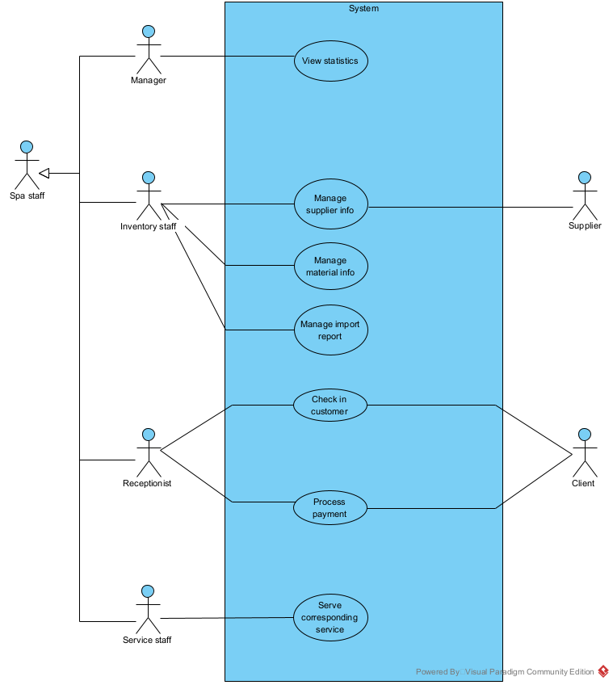

Use case description

Manager
- View statistics: The system enables the manager to view statistics like select the function of service statistics by revenue, choose the start and end date, and view the details of services and invoices

Inventory Staff
- Manage supplier information: The system enables the inventory staff to manage supplier information including add, edit, search supplier
- Manage material information: The system enables the inventory staff to manage material information such as add, edit, delete, search materials
- Manage import report: The system enables the inventory staff to manage import reports like input invoice entries, report successful report, print import invoice

Receptionist
- Check in customer: The system enables the receptionist to check in customers such as find the booking schedule or an empty slot for the customer, enter keywords to find specific customer appointments, search and select the exact service name, quantity, and provisional amount added to the list of selected services, view list of free service staff corresponding to the service and assign a staff member
- Process payment: The system enables the receptionist to process payments with the client including select the correct slot for the customer to pay, add/reduce/change the services/materials used to match reality if there is a mistake, confirm the amount and print customer detailed invoices

Service staff
- Serve corresponding service: The system enables the service staff to serve corresponding services with the condition that each service staff can serve some services.

Use case: Process payment
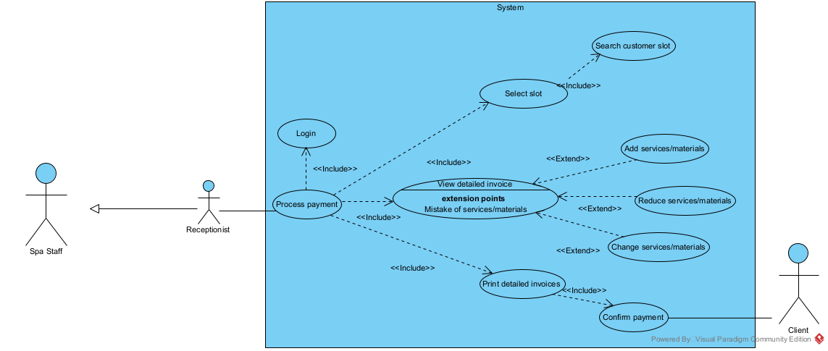

Use case description
- Select slot: The system enables the receptionist to select the correct slot for the customer including searching for the correct slot for the customer from a list of slots or Customer and selecting the correct slot
- View detailed invoice: The system enables the receptionist to view detailed invoice of the customer, including add, reduce, change services/materials used if there is a mistake
- Print detailed invoice: The system enables the receptionist to print detailed invoices with the client such as client clicking confirm payment and print customer detailed invoice

Analysis

Scenario

Scenario | Process payment
Actor(s) | The receptionist, client
Pre-condition | The receptionist has account of receptionist
Post-condition | Client received payment invoice
Main events | - Receptionist logins with username: a, password: abc123 in the login page in order to process client payment  - The system shows receptionist home page with the option to process payment  - The receptionist selects the function payment  - The system shows slot selection interface with a list of occupied slots and corresponding customers  Slot ID Customer name Customer phone number  1 Nguyen Van A 0932764827  2 Nguyen Van B 0382842834  3 John Smith 0932795836  4 Nguyen Van B 0328467521  - The receptionist asks the client about the client’s name and phone number  - The client responses:  - Name: Nguyen Van B  - Phone number: 0382842834  - The receptionist finds row with customer name = Nguyen Van B, customer phone number = 0382842834 (slot ID 2) and click the corresponding row  - The system shows the client’s detailed invoice interface  Name: Nguyen Van B  Phone number: 0382842834  ID Name Type Unit price Quantity Money  1 Shampoo Material 20000 1 20000 Edit Delete  2 Hair conditioner Material 20000 1 20000 Edit Delete  3 Hair wash Service 20000 1 20000 Edit Delete  4 Haircut Service 50000 1 50000 Edit Delete  5 Hair dye (red) Material 30000 1 30000 Edit Delete  6 Hair dying Service 50000 1 50000 Edit Delete  - Add new materials/services  Total: 190000 VND  Confirm Cancel  - The receptionist informs the customer of the amount  - The client pays for the total amount and confirm payment  - The receptionist clicks Confirm button  - The system saves and prints detailed invoice for the client  - The client receives detailed invoice
Exception | 2. The system shows error message: Incorrect username or password  2.1. Receptionist clicks OK of message  2.2. The system returns to the login page with username: a, password: abc123  2.3. The receptionist changes password to abc@123 then click Enter  2.4. The system shows receptionist home page  8. The receptionist selects the wrong customer detailed invoice  8.1. The receptionist clicks Cancel  8.2 The system returns to the slot selection interface  8.3 The receptionist selects the right customer information row  9. The client notices there’s a mistake in the materials/services list  9.1. The client wants to edit materials/services  9.1.1. The receptionist asks the client for the materials/services name and what to change  9.1.2. The client responses  - Materials/services name: Hair conditioner  - Quantity: 2  9.1.3. The receptionist finds the row with name: Hair conditioner and clicks Edit  9.1.4. The system shows materials/services edit interface  ID 2  Name Hair conditioner  Type Material  Unit price 20000  Quantity 1  Total 20000  9.1.5. The receptionist edits quantity = 2 and clicks Save  9.1.6. The system shows the client’s detailed invoice with updated materials/services  9.2. The client wants to add new materials/services  9.2.1. The receptionist clicks Add new materials/services  9.2.2. The system shows the materials/services addition function, with input of materials/services name and search button  9.2.3. The receptionist type materials/services name = Hair and click search  9.2.4. The system shows the list of materials/services whose name contains ‘Hair’  ID Name Type Unit price  2 Hair conditioner Material 20000  4 Hair wash Service 20000  7 Hair perm product Material 25000  9 Hair perm Service 30000  …  9.2.5. The receptionist asks the customer what materials/services are missing  9.2.6. The client responses  - Materials/services name: Hair perm product  - Quantity: 2  9.2.7. The receptionist selects Hair perm product  9.2.8. The system shows the materials/services edit interface for the chosen material/services  9.2.9. The receptionist edits quantity = 2 and clicks Save  9.2.10. The system shows the client detailed invoice with new materials/services  9.3. The client wants to delete materials/services  9.3.1. The receptionist asks the client for the materials/services name  9.3.2. The client responses  - Materials/services name: Hair dye (red)  9.3.3. The receptionist finds the row with name Hair dye (red) and clicks Delete  9.3.4. The system displays a warning box: Are you sure you want to remove Hair dye (red)?  9.3.5. The receptionist clicks OK  9.3.6. The system returns to the client’s detailed invoice with Hair dye (red) row disappeared

Entity class

Entity class extraction using noun extraction method
S1: The module supports to process customer payment and print detailed invoices. The system enables the receptionist to select correct customer slot in a list of slots or Customer, view detailed invoice of the customer including customer information, a list of materials/services used, receptionist can add, reduce, change services/materials if there is a mistake, print detailed invoices for the client after confirm.
S2 + S3:
- Customer payment: too general
- Detailed invoices (1)
- Receptionist -> user (2)
- Customer slot (3)
- Slots: too general
- Customer (4)
- Customer information: attributes only
- Materials/services -> ServiceItem (5)
-> 4 classes: Detailed invoices, User, Customer slot, Customer, ServiceItem
S4:
- A Customer can occupy different Customer slots at different times, a Customer slot can be occupied by only one Customer
-> Customer slot - Customer is 1-n
- A Customer slot can only have one Detailed invoice, a Detailed invoice is only made for one Customer slot
-> Detailed invoices - Customer slot is 1-1
- A User can make many Detailed invoices at different times, a Detailed invoice can only be made by one User
-> Detailed invoices - User is 1-n
- A Detailed invoice can have many ServiceItems, a ServiceItem can appear in many Detailed invoices
-> Detailed invoices - ServiceItem is n-n
-> We make ServiceItemInvoice
S5:
- Generalization: Material and Service -> ServiceItem
- Compound:
  - Customer slot is a part of Customer -> Aggregation
  - Detailed invoice is a part of Customer slot -> Aggregation
  - Detailed invoice is a part of User -> Aggregation
- Association: Detailed invoice and ServiceItem -> ServiceItemInvoice

Entity class diagram
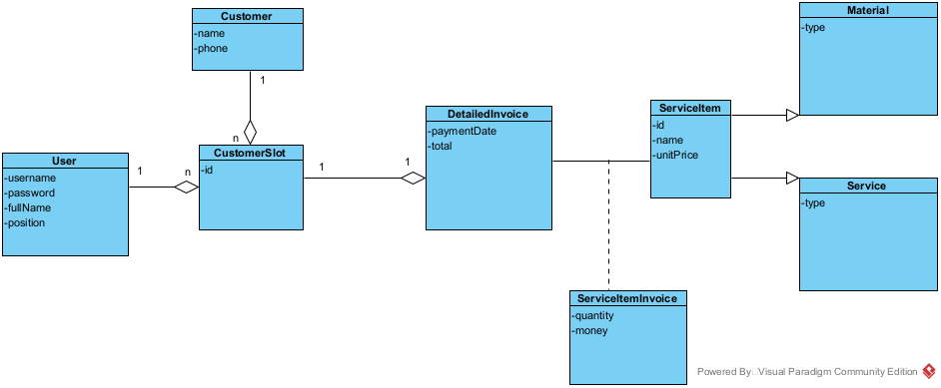

Full class

Full class explain
S1:
- Enter the system -> The login interface appears -> LoginView
  - Input for username -> inUsername
  - Input for password -> inPassword
  - Submit to login -> subLogin
- After login -> Receptionist homepage appears -> ReceptionistHomeView
  - Control to select option for process payment -> subProcessPayment
- After selecting the function payment -> Slot selection interface appears -> SlotSelectionView
  - Table with customer slot information and select button -> outsubListSlot
- After selecting the correct customer slot -> Detailed invoice interface appears -> DetailedInvoiceView
  - Output for customer name: read only -> outCustomerName
  - Output for customer phone number: read only -> outCustomerPhone
  - Output for list of materials/services and edit, delete button -> outsubListServiceItem
  - Button to add new materials/services -> subAddServiceItem
  - Output for total amount: read only -> outTotalAmount
  - Button to confirm -> subConfirm
  - Button to cancel -> subCancel
- If edit button is clicked or after choosing new materials/services -> edit materials/services interface appears -> EditServiceItemInvoiceView
  - ID of materials/services: read only -> outServiceitemID
  - Name of materials/services: read only -> outServiceItemName
  - Type of materials/services: read only -> outServiceItemType
  - Unit price of materials/services: read only -> outServiceItemUnitPrice
  - Quantity of materials/services: read and editable -> inoutServiceItemQuantity
  - Total of materials/services: read only -> outServiceItemTotal
  - Button to save -> subSave
- If delete button is clicked -> delete materials/services confirm interface appears -> ConfirmDeleteServiceItemInvoiceView
  - Delete confirmation message: read only -> outMessage
  - Button to confirm -> subConfirm
- If add button is clicked -> add materials/services interface appears -> AddServiceItemInvoiceView
  - Input name to search -> inKey
  - Button to search -> subSearch
  - A list of materials/services contain the query: clickable -> outsubListServiceItem
- After clicking Confirm, the system saves the invoice, prints the detailed invoice then returns to the ReceptionistHomeView
S2:
- LoginView:
  - To verify login information:
    - name: checkLogin()
    - input: username, password (User)
    - output: boolean
    - owner: User
- SlotSelectionView:
  - To get customer slots:
    - name: getCustomerSlots()
    - input: none
    - output: a list of CustomerSlot
    - owner: CustomerSlot
- DetailedInvoiceView:
  - To get customer invoice:
    - name: getCustomerDetailedInvoice()
    - input: id (CustomerSlot)
    - output: DetailedInvoice
    - owner: CustomerSlot
  - To save customer invoice:
    - name: saveCustomerDetailedInvoice()
    - input: an object of DetailedInvoice
    - output: none or boolean
    - owner: DetailedInvoice
  - To print customer invoice:
    - name: printCustomerDetailedInvoice()
    - input: an object of DetailedInvoice
    - output: none
    - owner: DetailedInvoice
- EditServiceItemInvoiceView:
  - To save the materials/services into the DB:
    - name: saveServiceItemInvoice()
    - input: an object of ServiceItemInvoice
    - output: none or boolean
    - owner: ServiceItemInvoice
- ConfirmDeleteServiceItemInvoiceView
  - To delete the materials/services from the detailed invoice:
    - name: deleteServiceItemInvoice()
    - input: id (ServiceItemInvoice)
    - output: boolean
    - owner: ServiceItemInvoice
- AddServiceItemInvoiceView:
  - To search for materials/services whose name contains the entered keyword:
    - name: searchServiceItem()
    - input: a keyword
    - output: a list of ServiceItem
    - owner: ServiceItem

Full class diagram
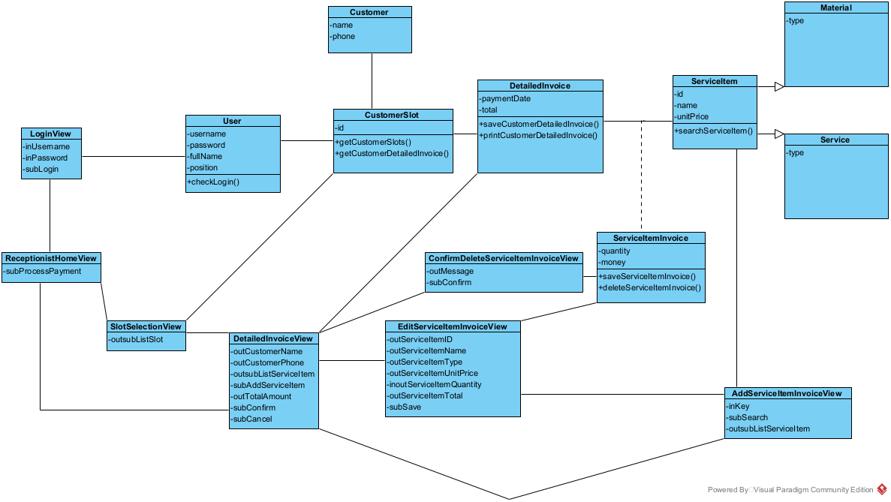

Dynamic analysis

Scenario v.2
- The client asks the receptionist to pay
- The receptionist logins in the LoginView
- The class LoginView calls the class User to process
- The class User calls method checkLogin(). The login is successful
- The class User returns the results to the class LoginView
- The class LoginView calls the class ReceptionistHomeView
- The class ReceptionistHomeView displays itself to the receptionist
- The receptionist chooses the option of process payment
- The class ReceptionistHomeView calls the class SlotSelectionView
- The class SlotSelectionView calls the class CustomerSlot to process
- The class CustomerSlot calls method getCustomerSlots()
- The class CustomerSlot returns the results to the class SlotSelectionView
- The class SlotSelectionView displays itself to the receptionist
- The receptionist asks the client name and phone number
- The client responds their name and phone number
- The receptionist chooses the correct customer slot
- The class SlotSelectionView calls the class DetailedInvoiceView
- The class DetailedInvoiceView calls the class CustomerSlot to process
- The class CustomerSlot calls method getCustomerDetailedInvoice()
- The class CustomerSlot returns the results to the class DetailedInvoiceView
- The class DetailedInvoiceView displays itself to the receptionist
- The receptionist informs the customer of the amount
- The client pays for the total amount and confirm payment
- The receptionist clicks confirm button
- The class DetailedInvoiceView calls the class DetailedInvoice to process
- The class DetailedInvoice calls method saveCustomerDetailedInvoice()
- The class DetailedInvoice returns the results to the class DetailedInvoiceView
- The class DetailedInvoiceView calls the class DetailedInvoice to process
- The class DetailedInvoice calls method printCustomerDetailedInvoice()
- The class DetailedInvoice returns the results to the class DetailedInvoiceView
- The class DetailedInvoiceView calls the class ReceptionistHomeView
- The class ReceptionistHomeView displays itself to the receptionist
- The receptionist gives the invoice to the client

Sequence diagram
