Coursera Capstone Project

IBM Applied-Data-Science-Capstone

***Analyzing the places near office spaces to open new restaurants in Bangalore.***

By Niteeka Prashant

April 2020

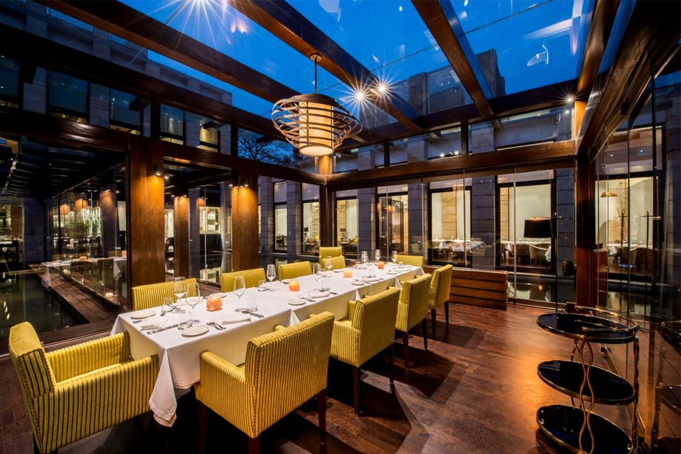

1. **Introduction**
   1. **Background**
   2. **Business Understanding/Problem Description**
   3. **Target Audience**
2. **Data**
3. **Introduction**
   1. **Background**

This Coursera Capstone Project is for IBM Data Science Final Assignment. In this project we have taken a scenario where a person wants to open a new restaurant in the nearby space of an IT office in Bangalore. As opening the new restaurant in these areas is costly affair, it becomes important to analyze the places and existing restaurants around the offices to get a clear idea of the competition there. With the help of Machine Learning, we can not only determine the probable areas but the cuisines can also be analyzed. This project involves gathering location information of the IT offices spaces and using Foursquare APIs to get the location based details. Using the nearby venues we can divide the places in clusters to determine the best options.

**1.2 Business Understanding/Problem Description**

You need a spot that draws crowds, is easily accessible, and has the potential for growth. It makes sense to take your time, as you’re looking for the right space. You might also want to do some research to find out spaces for restaurants that describe the market conditions which exist in the location. Whether you decide to rent space or build from scratch, selecting a location is one of the biggest decisions you’ll make as an owner.

* 1. **Target Audience**

The aim of doing a target audience analysis is to know which portion of the population is most likely to come to your restaurant. As we have taken the place to be near and IT office our population we can explore the related options and cuisines. The target audience is the new business willing to open new restaurant.

1. **Data**

In this assignment first we have to clean the data obtained from Web page for the Bangalore city and using web scraping method. Then convert addresses into their equivalent latitude and longitude values. Use Foursquare API to explore neighborhoods in Bangalore City. Get the most common venue categories in each neighborhood, and then use this feature to group the neighborhoods into clusters. Use the k-means clustering algorithm to complete this task. Finally, use the Folium library to visualize the neighborhoods in Bangalore City and their emerging clusters. This project involves gathering location information of the IT offices spaces and using Foursquare APIs to get the location based details. Using the nearby venues we can divide the places in clusters to determine the best options.

Based on definition of our problem, factors that will influence our decision are:

* number of existing restaurants in the neighborhood (any type of restaurant)
* number of offices present in a particular neighborhood
* Preferable nearest places (Most Valued)

Following data sources will be needed to extract/generate the required information:

* The data is pulled from the site - here, which contains 300 IT company name along with their address. The data also contain PIN code for all the offices.
* Foursquare API are used to understand the data graphically and get the details of the nearby places

Figure: Dataframe created from the Web page

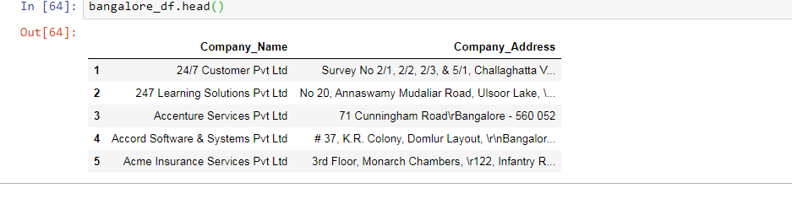

Figure2: Foursquare API is used get the details of the nearby places respectively.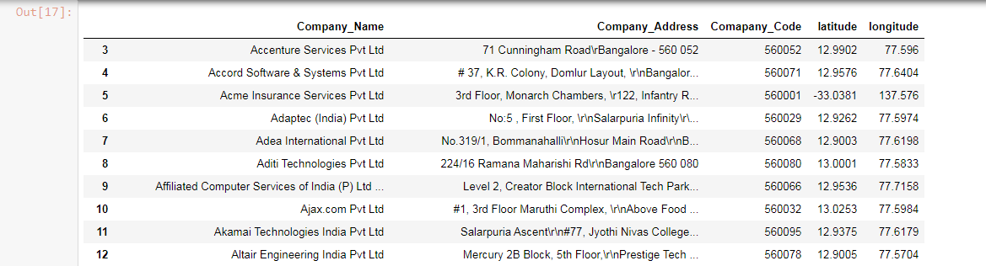

Figure3 Folium is used to understand the data graphically.

