IAM (Identity & Access Management)
I am starting from Fundamentals and will list steps by one on one by simple explanations.

🎯 What We need to know
- IAM = Service that controls who can do what in AWS.
- Key elements:
  - User → Single person/app with credentials.
  - Group → Collection of users with policies.
  - Role → Temporary permissions assigned to users/services (EC2, Lambda..etc).
  - Policy → JSON document that defines Allow/Deny actions.
- Best Practices for our role:
  - Use MFA for console users.
  - Never use root user for daily/Any tasks.
  - Follow least privilege principle.
  - Use roles instead of access keys whenever possible.

Now, let’s start from creating the user as it’s the very basic step to follow up for.
Go to IAM Console → Users → Create user
- Name: Devops-user
- Select AWS Management Console access
- Set password
- Permissions → Attach policy → AdministratorAccess (for learning only).
- ✅ User created.

  - Upon opening console search for IAM as mentioned below in image and click on the service to get started.
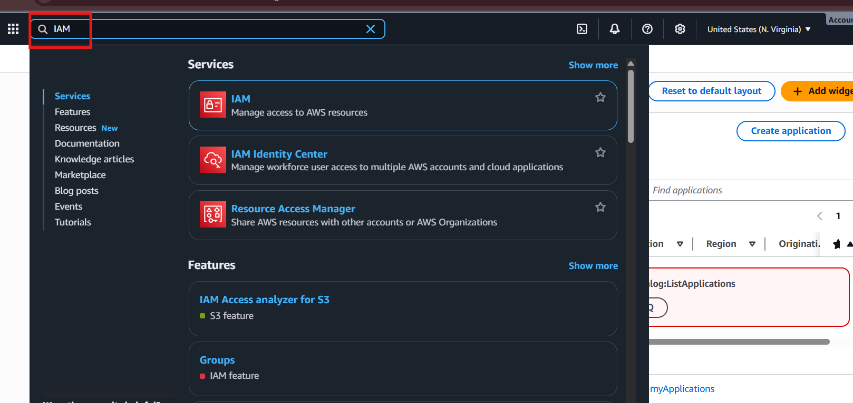

- Click on users and the select create user.
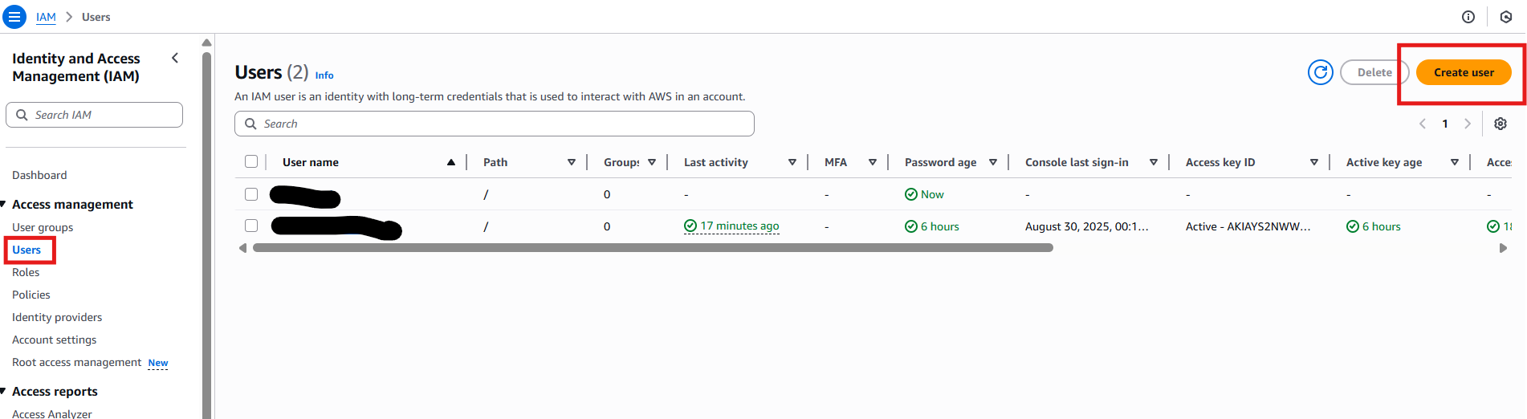
- Enter the user details like username and make it as auto generated password or custom one and enable the option “users must create password at next sign in” so on there first sign in there can create their desired password.
- Here I used username as iamuser-1.

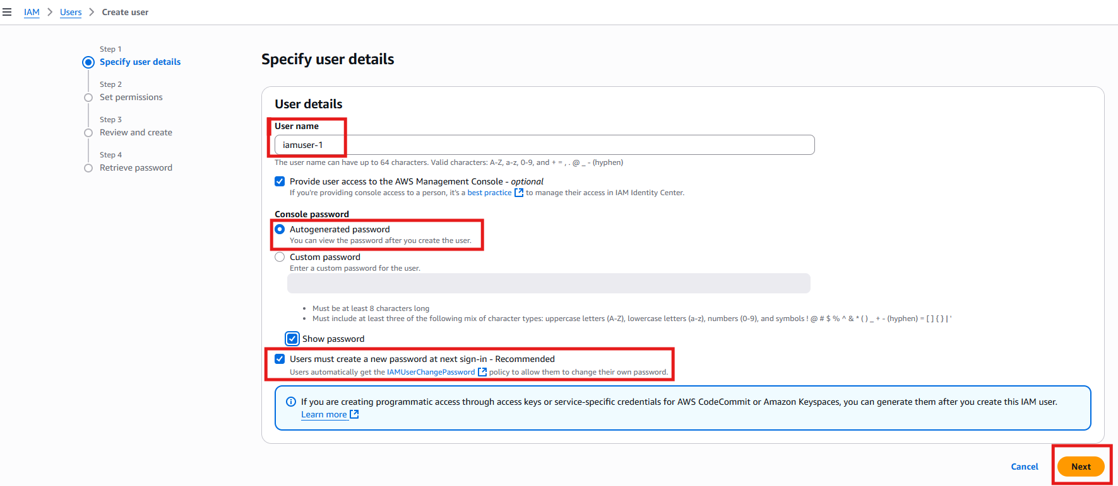
- Upon getting into second set to attach permissions, as mentioned in below image you can click on attach policies directly and then select administrator access policy to make the user have full access.

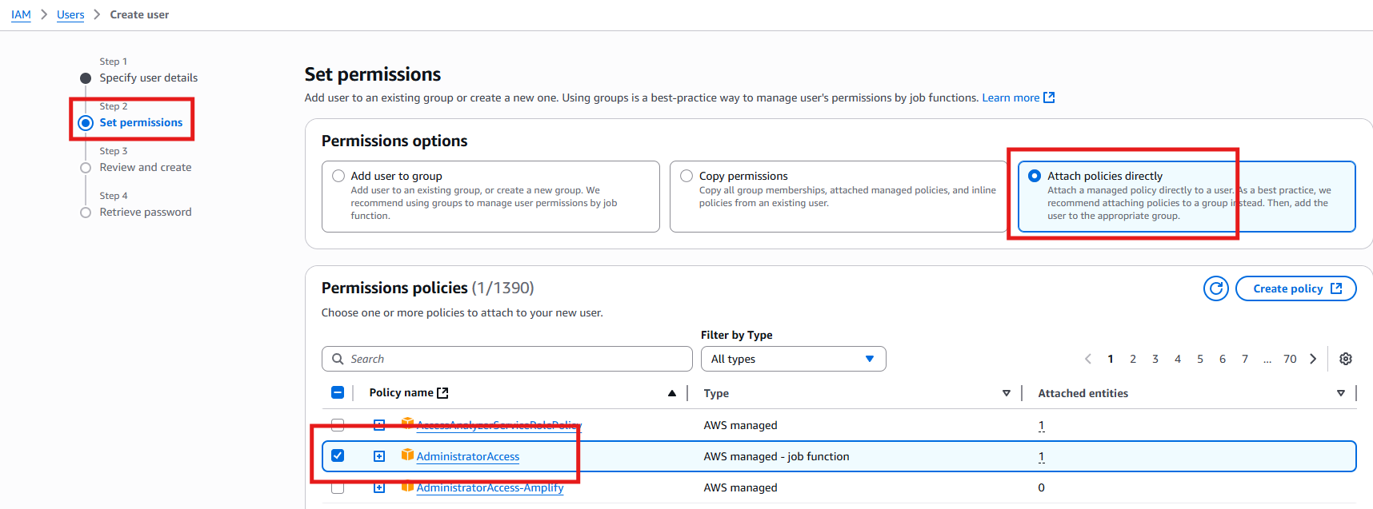

- By getting into next step, we will go for review and create, just verify details once and click on create user. This is just for demo, we should never assign a full admin access to any user and as a best practise never attach policies directly to user, just attach the policies to group and then add the users to group.
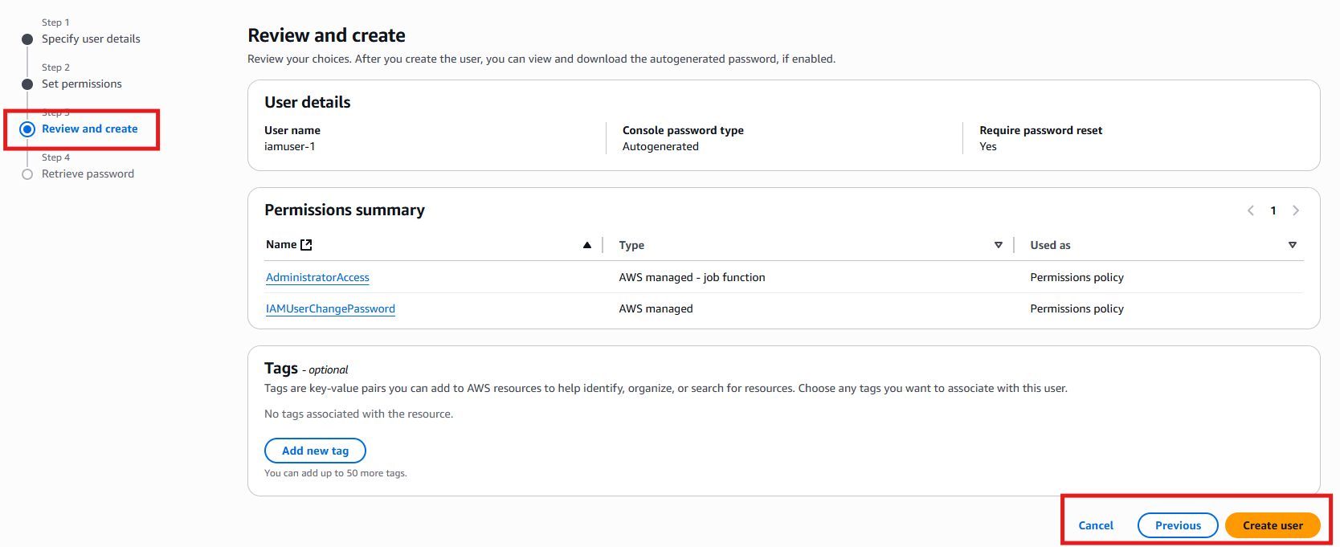

- User has been created now.
- Let’s see how to create to create “User groups” and adding of policies to it and later user to the group.
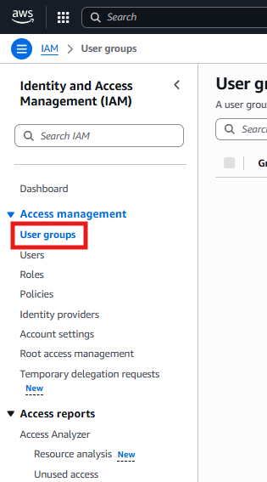
- As mentioned in above screenshot click on the User groups to create the groups further.

- On the very right-hand side of you, there will be an option called “create group” click on it like mentioned below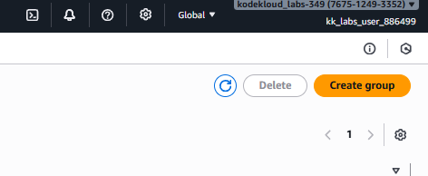

- Specify the group name needed as I mentioned it as demogroup and then select the user that you need to be part of this group, in organisation we have different each group like database team, application team, system admin team. Etc based on that we must attach user specifically.
- Now select the required policies, keep it in mind to give as least as permissions as it can cause risk. Here I have selected ec2 full access. (Over permissions=security risk)
- “We use groups because managing user-by-user permissions does not scale in large teams. Group-based permissions ensure consistent, auditable, and easily maintainable access.”
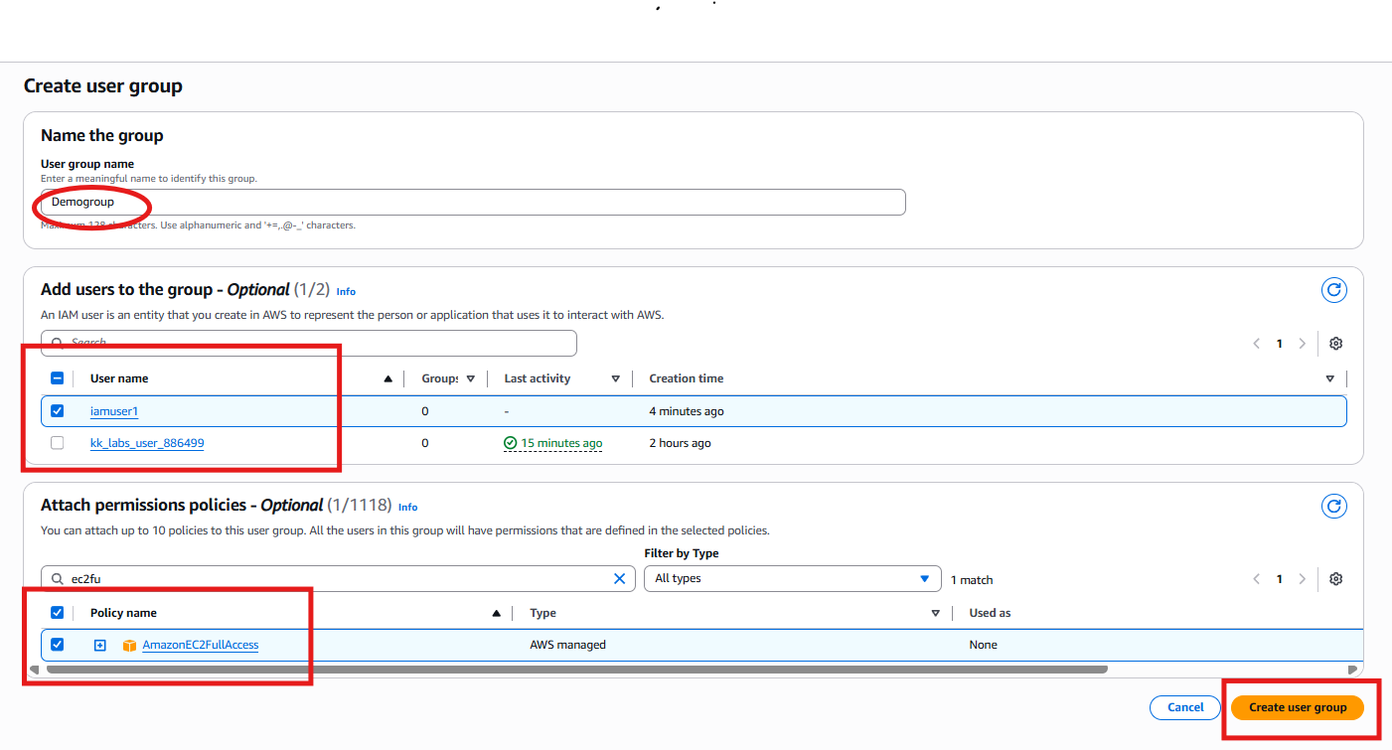
- Here is our result we added user to group and whatever the policies that were there for group will reflect to user Aswell now.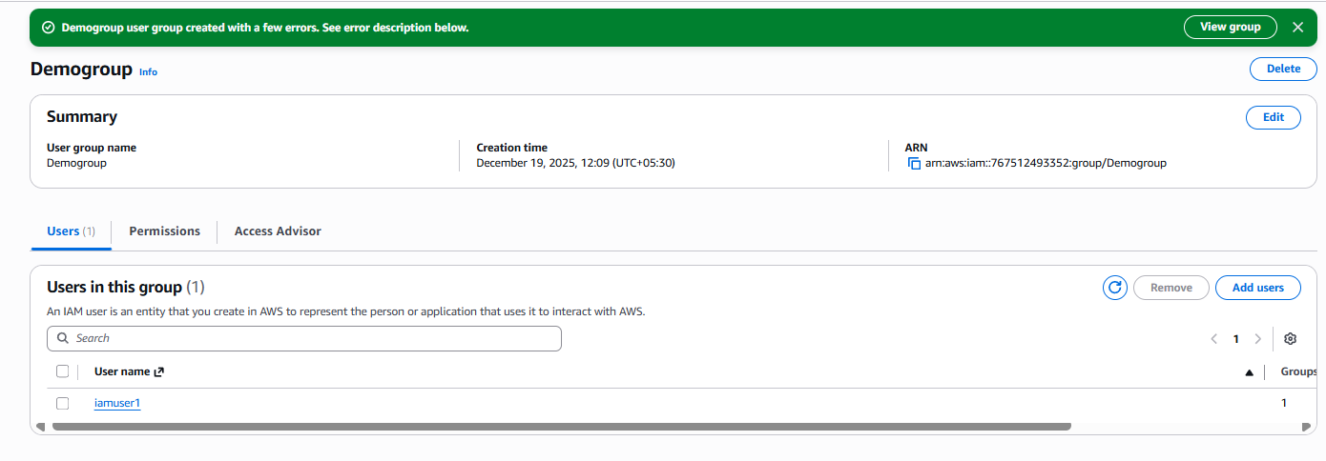
- Now let’s jump into “Roles” topic in IAM

- Click on Roles and then create Role.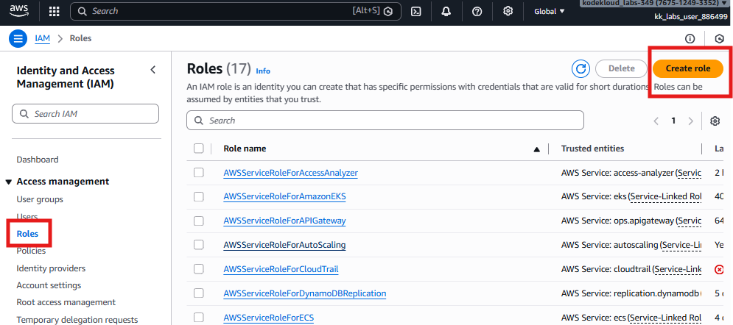
- Unlike IAM user, roles are for temporary use cases like upon user requirements on any task we will assign a role to user or to a service to make the job done.
- It won’t have permanent access; it will be a temporary one and will be lost at defined time
- Trust Relationship: A "trust policy" defines which external identities (users, other AWS accounts, services) are allowed to assume the role.
- Permissions Policies: These define what the assumed identity can do (e.g., read from S3, start EC2 instances).
- Now let’s see how to create them in real time 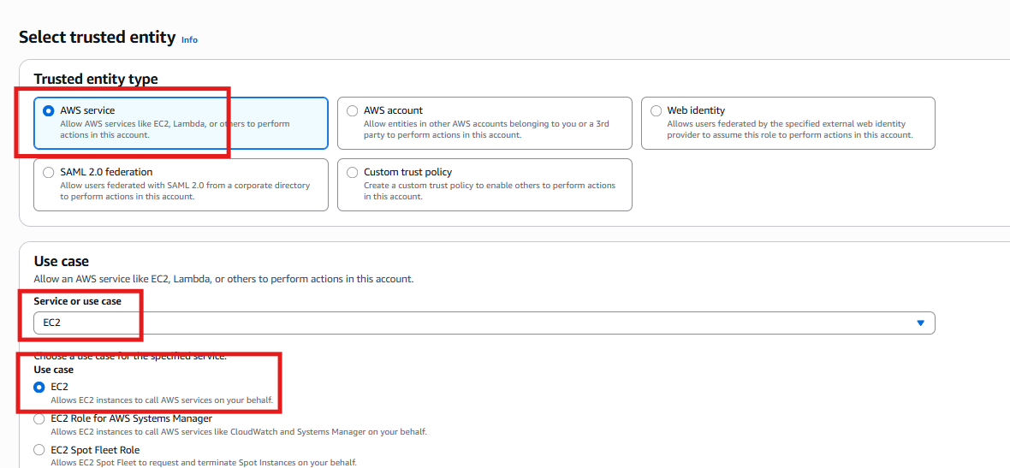
- I have allowed only S3readonly access that to from EC2 not from any user, so now a ec2 can use the S3 but not a user directly.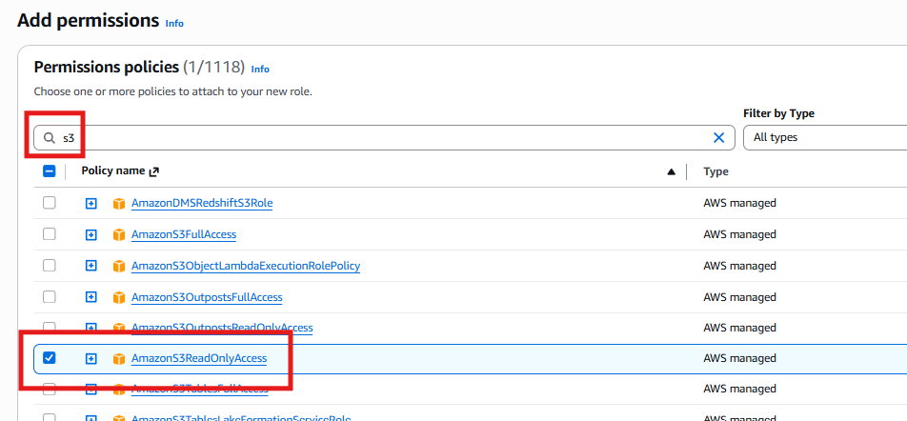
- Just give the name and don’t worry about the script, it is a template based we no need to write it. 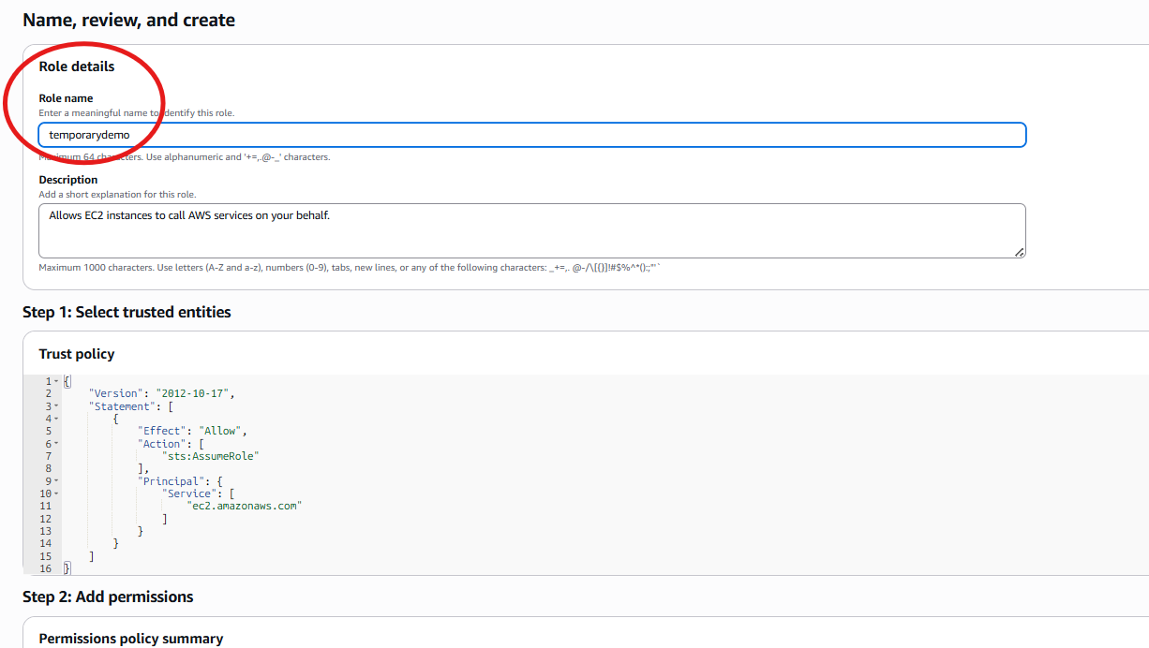
- Here if we can observe in the below picture like whatever we create the role it is having only a one hour of time. The STS session credentials generated when EC2 assumes the role expire in 1 hour, but EC2 refreshes them automatically. The role itself does not expire.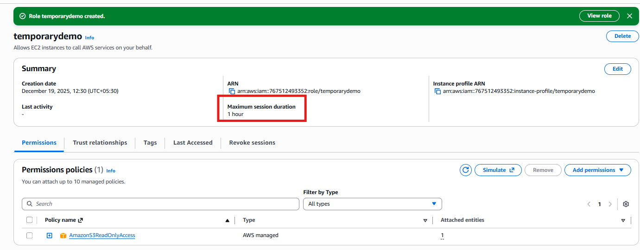and you can verify it by calling it from any EC2.To verify SSH into EC2 and give command aws s3 ls ->if it prints then you were successfully create role for ec2 with s3 permissions policy attached.
The LAST topic is setting up MFA and it’s for experimental, let’s see how we goanna do it.

Thanks.

