SHARDA UNIVERSITY

**DEPARTMENT OF COMPUTER SCIENCE AND ENGINEERING**

SCHOOL OF ENGINEERING AND TECHNOLOGY

GREATER NOIDA



Project Report

On

**“Design Mobile Responsive Website on Online Tutorials”**

***Submitted in partial fulfillment for the***

***Award of degree of***

Bachelor of Technology

Batch 2013-2017

In

Computer science & Engineering

**Submitted to:- Submitted by:-**

Dr. Ishan Ranjan Niteesh Singh

Head of Dept. (CSE) Kundan Singh Jodha

Kazim Raza

**Project Guide:-**

Dr. Ruchi Agarwal

**Certificate**

This is to certify that the report entitled

“Design Mobile Responsive Website on Online Tutorials” By Niteesh Singh, Kundan Singh Jodha and Kazim Raza (Roll nos. 130101114, 130101091, 130101086 respectively) to Sharda University, towards the fulfillment of requirements of the degree of Bachelor of Technology is record of bonafide final year Project work carried out by him/her in the Department of Computer Science Engineering, School of Engineering, Sharda University. The results/findings contained in this Project have not been submitted in part or full to any other University/Institute for award of any other Degree/Diploma.

Signature of Supervisor

Name:

Designation:

Signature of Head of Department

Name:

(Office seal)

Place:

Date:

# Signature of External Examiner

# Date:

**Abstract**

We will create a mobile responsive website on online tutorials so that anyone can learn from the website. When a website is *responsive*, the layout and/or content responds or adapts based on the size of screen they are presented on.

A responsive website automatically changes to fit the device you’re reading it on.

Typically there have been four general screen sizes that responsive design has been aimed at: the widescreen desktop monitor, the smaller desktop (or laptop), the tablet and the mobile phone.

**ACKNOWLEDGEMENT**

I would like to express my special thanks of gratitude to my teacher Dr. Ruchi Agarwal as well as our HOD Dr. Ishan who gave me the golden opportunity to do this wonderful project on the topic “Design Mobile Responsive Website on Online Tutorials”, which also helped me in doing a lot of Research and I came to know about so many new things for which I am really thankful to them.Secondly I would also like to thank my friends who helped me a lot in finalizing this project within the limited time frame.

**CONTENTS**

1. Introduction
   1. Motivation
   2. Overview
   3. Validity of Project Title
   4. Brief Introduction to Area
   5. Project Objectives
   6. Implementable Objectives
   7. Scope of Proposed System
   8. Gantt Chant
2. Methodology
   1. Defined Methodology
   2. Clearly Defined Design
   3. Practical Aspects of Methodology Stated
   4. Feasibility of Methodology
   5. Theoretical/Practical Issues Related to Implementation
   6. Evaluation Criteria Stated
   7. Input and Output Defined on Implementation Aspect
   8. Result Analysis Methodology Stated
3. Conclusion
4. References

**Introduction**

Responsive web design makes your web page look good on all devices. Responsive web design uses only HTML and CSS. Responsive web design is not a program or a JavaScript.Responsive web design (RWD) is an approach to [web design](https://en.wikipedia.org/wiki/Web_design) aimed at allowing desktop webpages to be viewed in response to the size of the device one is viewing with. We will add some tutorials on the website so that students can study from there.

1.1 Motivation

In responsive web design contents moves freely across all screen resolutions and all devices. Both the grids and the images are fluid. Just as a liquid spreads out or draws in to allow its content to fill an allotted space and retain its appearance, responsive web design’s fluidity achieves the same result with website content on a device screen. While, content is king and discover ability of content are foremost success metrics, it is the user experience that enables visitors to consume content on any website through the device of their choice and preference, anytime. Thus, responsive web design is about providing the optimal user experience irrespective of whether they use a desktop computer, a smartphone, a tablet or a smart-TV. Responsive web design accommodates the busy professional during the day and the wide-awake college student needing access to your site anytime. No scrolling or resizing is needed for any visitor to access your website from their favorite device.

The advantages of having a single site that conforms to the need of all devices are significant when compared to having two separate websites. One website costs less than two, and the savings can be substantial.

1.2 Overview

The objective of this project is to make a good responsive website and make it available for everyone so that anybody go through the site and learn from there. Responsive web design (RWD) is a setup where the server always sends the same HTML code to all devices and CSS is used to alter the rendering of the page on the device.

We recommend using responsive web design because it:

* Makes it easier for users to share and link to your content with a single URL.
* Helps Google’s algorithms accurately assign indexing properties to the page rather than needing to signal the existence of corresponding desktop/mobile pages.
* Requires less engineering time to maintain multiple pages for the same content.
* Reduces the possibility of the [common mistakes](https://developers.google.com/webmasters/mobile-sites/mobile-seo/common-mistakes/) that affect mobile sites.

1.3 Validity of Project Title

**You are losing users and probably money** if responsive web design is your entire goal and your only solution for mobile. Responsive web design is great, but it’s not a silver bullet. If it’s your only weapon for mobile, then a performance problem might be hindering your conversion rate. Around 11% of the websites are responsive, and the number is growing every month, so now is the time to talk about this.

1.4 Brief Introduction to Area

Area of mobile responsive website is very big. Many people don’t want to carry laptop every time with them that’s why responsive website are made so that they can easily access to the site with their mobile phones or tablets.

1.5 Project Objectives

Objective of this project is to make such a website which is accessible with laptop as well as with mobile phones and tablets. We will add some tutorials on the site which will help people to learn.

1.6 Implementable Objective

Three key technical features are the heart of responsive Web design:

* Media queries and media query listeners.
* A flexible grid-based layout that uses relative sizing.
* Flexible images and media, through dynamic resizing or CSS.

1.7 Scope of Proposed System

Responsive web design is an intelligent way to design a website. It essentially detects the size of a device or browser and resizes images and adjusts the layout in a way that the site can be easily viewed at the particular dimensions.

Therefore, whether users are viewing a site from a smart phone, tablet, laptop, or desktop computer, your website will look its best and be easy to navigate.

Sept

1.8 Gantt Chant

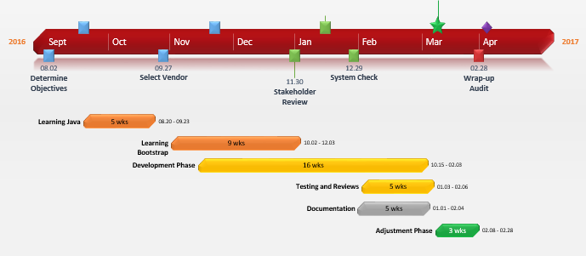

**Methodology**

Almost every new client these days wants a mobile version of their website. It’s practically essential after all: one design for the BlackBerry, another for the iPhone, the iPad, netbook, Kindle — and all screen resolutions must be compatible, too.

**Responsive Web design** is the approach that suggests that design and development should respond to the user’s behavior and environment based on screen size, platform and orientation. The practice consists of a mix of flexible grids and layouts, images and an intelligent use of CSS media queries. As the user switches from their laptop to iPad, the website should automatically switch to accommodate for resolution, image size and scripting abilities. In other words, the website should have the technology to automatically respond to the user’s preferences. This would eliminate the need for a different design and development phase for each new gadget on the market.

2.1 Defined Methodology

### Adjusting Screen Resolution:

Link With more devices come varying screen resolutions, definitions and orientations. New devices with new screen sizes are being developed every day, and each of these devices may be able to handle variations in size, functionality and even color. Some are in landscape, others in portrait, still others even completely square. As we know from the rising popularity of the iPhone, iPad and advanced smartphones, many new devices are able to switch from portrait to landscape at the user’s whim. How is one to design for these situations?

2.2 Clearly Defined Design

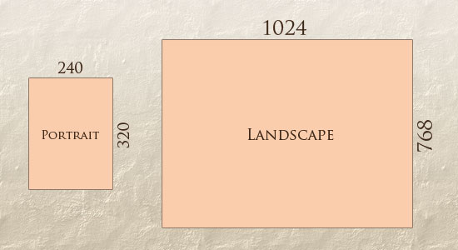

In addition to designing for both landscape and portrait (and enabling those orientations to possibly switch in an instant upon page load), we must consider the hundreds of different screen sizes. Yes, it is possible to group them into major categories, design for each of them, and make each design as flexible as necessary. But that can be overwhelming, and who knows what the usage figures will be in five years? Besides, [many users do not maximize their browsers](http://www.456bereastreet.com/archive/200704/poll_results_504_of_respondents_maximise_windows/), which itself leaves far too much room for variety among screen sizes.

Morten Hjerde and a few of his colleagues identified statistics on about 400 devices sold between 2005 and 2008. Below are some of the most common:

[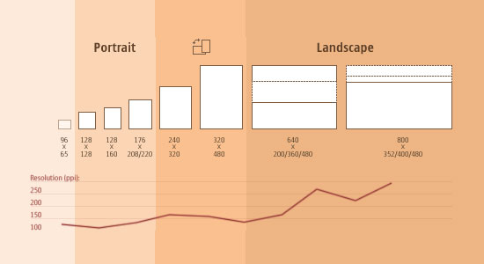](http://sender11.typepad.com/sender11/2008/04/mobile-screen-s.html)

2.3 Practical Aspects of Methodology Stated

There is a wide variety of information on responsive web design available all over the Internet, and much of that information is abstract, philosophical, and anecdotal. If you’re looking for a clean, concrete understanding of the foundation of responsive web design, it comes down to three techniques that all work in conjunction:

### 2.3.1 Fluid Images and Grids

From a technical standpoint, creating flexibility for your imagery is one of the most important problems to solve when you are creating a responsive design. There are several techniques to resize images proportionately; some of them very simple to apply. The most popular, cited in the article by Ethan Marcotte on fluid images is to set two simple CSS rules: max-width, and height:auto.

### 2.3.2 Media Queries

Media Queries are probably the most important tool that a web designer has to make their sites responsive. This set of rules enables developers to create fluid designs that adapt without distortion or loss of quality to the viewer’s device. It’s good to point out that this set of guidelines (or rules) should be stored in a separate CSS style sheet from the one in which there are those for the general style (which is usually named style.css).

2.4 Feasibility of Methodology

When thinking of responsive design, the designer should always ask a few simple questions:

1. What platform/devices has the client requested or what should this site be optimized for?
2. What content is absolutely necessary for the user?
3. What content is feasible to deliver to these devices?

These questions will help determine how responsive your site needs to be, or if in fact you need a responsive design at all. Alternatively, you may require a different mobile site altogether.  Understanding that each project is different and being able to acknowledge this is the first and most crucial step to becoming a responsive designer.

During the initial project discussions, the client outlines the platform/device requirements. It is the designer/developer’s responsibility to not only know, but also inform the client on how much work is required to include the multiple platforms. You must make sure the client understands responsive design is not as simple as shrinking an application to fit a smaller screen. What content is absolutely necessary for the user, in my opinion, is the most difficult to answer.  This is why a good content inventory strategy and in-depth discussions with your client is crucial. Determining which content is needed to give the consumer the best possible experience will be the greatest factor in determining just how your responsive design will work.

2.5 Theoretical/Practical issues related to implementation

### 2.5.1 Image Resizing

This is a major issue considering that every good designer must rely on images to illustrate its concepts. In responsive web design this is the most problematic matter because resizing a desktop image to fit a mobile device’s screen implies downloading an image that’s been suited for a desktop environment. To view full images on a mobile device you need to download an unnecessary large file and resizing it to fit the screen

2.5.2. Resizing images forces CPU and memory

Viewing a responsive website on a mobile device forces the CPU and memory of it while resizing images because you are downloading a large image, uncompressing it in your phone’s memory and then resizing it to fit a small screen. This process takes about 3 bytes per pixel of memory, so a 1024×768 image will take about 2.36 MB of memory. Most clients only request 4 images in average at the time, but 9.44 MB is still a lot for a page load. A recommended file size for images in a mobile context could be 100×100, but this is kind of utopic since a suitable image for desktop websites exceeds that resolution.

### 2.5.3 Mobile devices download non-viewable data

One good example for this can be viewed within the old dconstruct 2010 website. It displays, as the site grows bigger, bigger images of the speakers, which were not viewed on mobile devices thanks to CSS media queries placed on the div where the images are. Instead, labels are shown with the names of the speakers when the width is lesser than 450px, fitting perfectly some of the most popular mobile devices. Although this is kind of cool**, images were still being downloaded on the device.** This can be identified by making a copy of the website into a local server, loading it on a device and watching the web server logs to see what was downloaded. Other way is by setting up a computer as a proxy server and set the device with it to see if every request to the site was logged. Both cases showed the same result: the device downloaded 172K in photos that were not seen.

### 2.5.4 Mobile speed vs. Desktop speed

There are several factors that affect mobile speed. With 3G connectivity, being the greatest feature the type of coverage. For this there are as well several types like GPRS, or 2.5G, which has a download rate of 64 Kbps and a 20 Kbps upload rate. UMTS (Universal Mobile Telecommunications System) or 3G, which has a download rate of 14Mbps and is the most popular nowadays with several releases and updates. HSDPA (High Speed Downlink Packet Access) is the 5th revision and optimization of UMTS, also known as 3.5G, 3G+ or turbo 3G. It has a 14Mbps download rate. There is also HSUPA (High-Speed Uplink Packet Access), which is the 6th release of UMTS and the evolution of HSDPA, also known as 3.75 (3.75G) o 3.5G +; this technology offers improved rates of voice and data.

### 2.5.5 Hiding background images is a bad idea

Using CSS media queries isn’t very bad to handle images and one might think hiding background images is a better idea than using labels. Well, the display: none won’t stop a background image to be downloaded on a mobile device.

2.6 Evaluation Criteria Stated

* Test your responsive designs by **emulating different screen sizes and resolutions**, including Retina displays.
* Evaluate your site’s performance using the **network emulator**, without affecting traffic to other tabs.
* Visualize and **inspect CSS media queries**.
* Accurately **simulate device input** for touch events, geolocation, and device orientation.
* Enhance your current debugging workflow by combining device mode with the existing Dev Tools.

2.7 Input and Output defined on implementation aspect

A transformation is simply a system that transforms its input into an output according to a set of predefined rules.



The key thing about transformations isn’t the action they perform but the capability they enable. Transformations create an **abstraction that decouples content and functionality from presentation.** This separation is a design goal of many frameworks, but transformations facilitate it in powerful and unique ways.

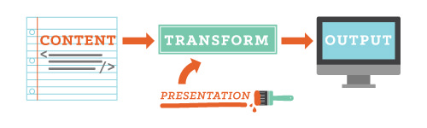

A transformation and templating system written in Clojure. Most templating engines use a customized markup language to mix HTML with programming constructs such as loops and variables.

2.8 Result Analysis Methodology Stated

* Realkk.com is one of the websites which we examined using Google Mobile-friendly Test and several other tools. During this process, every element of the website was analyzed and eventually discovered that it’s not Mobile Responsive as seen on the “before” section illustrated below.
* Later on, with the data about the issues discovered, we coded and designed solutions to completely refine the website in par with the latest design trends, given primary concern to Google guidelines.
* We then implied regression testing with tools to check the quality of the website after consecutive enhancements, thus making sure that the website of Mobile-friendly as seen on the “after” section of the illustration below.
* We as well did a post analysis process to ensure if the website is complete in all perspective such as the Page Speed and User Experience of the website.
* After deploying the project online, we listened to the client closely enough to know if he was happy about the outcome. Until we were certain about it, we were all ears and helped make all his requirements into 100% fruition.
* For utmost satisfaction, we gave an insightful report that which explains all the processes involved and the reflection of the efforts applied on his website to make it Mobile Responsive.

3 Conclusion

A responsive designs means a website synchronizes with a mobile device, and adjusts according to the screen size of the device. This is an important asset to have as a business as a mobile responsive website allows a better viewing experience for the browser. The mobile industry is growing rapidly, as well as the amount of time and money people are spending on mobile devices. Even with this knowledge, many companies have yet to adapt their desktop website into a mobile responsive website. Taking this step into the digital world is essential, because mobile usage currently amounts to 10% of the global Internet traffic, and within a year it is expected to exceed the PC Internet traffic according to a report done by Gartner.

4 Reference

* 1. <https://en.wikipedia.org/wiki/Responsive_web_design>
  2. <http://www.w3schools.com/html/html_responsive.asp>
  3. <http://www.copyblogger.com/mobile-responsive-design-101/>
  4. <http://www.rapidvaluesolutions.com/whitepapers/responsive-web-design.html>
  5. <http://www.studiopress.com/beginners-guide-responsive-design/>