**AI-Driven Exploration and Prediction of Company Registration Trends with (RoC)**

**-M Raja Malla Reddy**

**Project:** **AI-Driven Exploration and Prediction of Company Registration Trends with (RoC)**

**Phase-3: Development Part 1**

**Topic: In this part you will begin building your project by loading and preprocessing the dataset.**

The development phase of your AI-driven exploration and prediction project for company registration trends with the Registrar of Companies (RoC) is where you transition from data preparation to building and evaluating predictive models. During this phase, you will leverage the preprocessed dataset to create machine learning models that can provide insights and predictions regarding company registration trends.

This phase is a crucial step in harnessing the power of artificial intelligence to make informed decisions and forecasts in the business and regulatory domains. Central to the development phase is the utilization of your preprocessed dataset as a cornerstone for constructing machine learning models. These models are designed to decipher patterns, uncover trends, and make predictions regarding company registration trends. The choice of models depends on the nature of your prediction task. If you aim to predict numerical outcomes, such as the quantity of new company registrations, regression models will be the avenue of choice. In contrast, if your objective is to forecast categorical outcomes, like whether registrations will increase or decrease, classification models become the instrument of preference.

The ultimate goal of this phase is two-fold: to derive valuable insights and to furnish predictions. These insights often unveil concealed patterns, dependencies, and influential factors that may not be readily apparent through traditional data analysis. They serve as illuminating signposts for businesses and regulatory authorities, offering a profound understanding of the forces driving company registration trends. On the other hand, predictions empower decision-makers with a forward-looking perspective. Businesses can harness these predictions to inform resource allocation, marketing strategies, and long-term planning. Regulatory authorities can leverage them for policy formulation, resource allocation, and monitoring compliance within the corporate landscape. The power of AI is harnessed to enable data-driven, evidence-based decision-making in these spheres, potentially leading to more effective and efficient operations.

In summary, the development phase is a pivotal juncture where you advance from data preparation to constructing machine learning models that provide profound insights and predictive capabilities. These insights and predictions have the potential to profoundly impact decision-making in business and regulatory domains. The iterative nature of model maintenance and adaptation to fresh data underpins the project's long-term success and relevancy. It is in this phase that the promise of AI-driven analytics materializes, offering a data-informed lens through which to view and understand company registration trends.

**Given Dataset:**

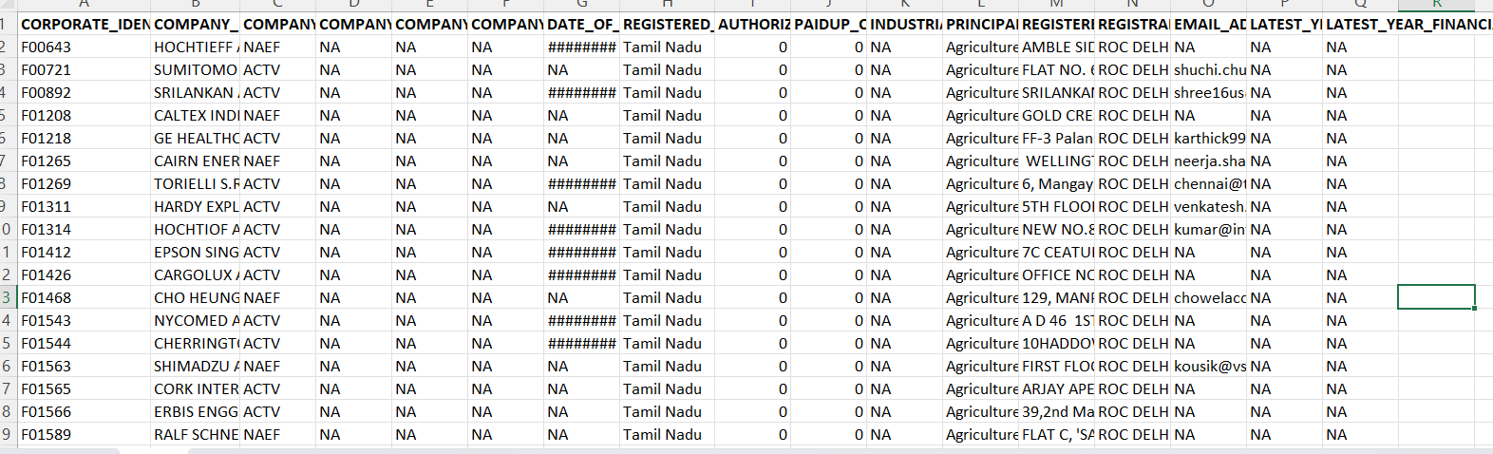

**Importance of Loading and preprocessing datasets**

Loading and preprocessing datasets is a fundamental and critical step in data analysis, machine learning, and data-driven decision-making. Here are several key reasons for the importance of these tasks:

**Data Quality Assurance:** Loading and preprocessing data allow you to inspect and ensure the quality of the dataset. You can identify and address issues like missing values, outliers, and inconsistencies, which are essential for reliable and accurate analysis.

**Data Understanding:** Loading the data provides an initial understanding of its structure, size, and format. It helps you become familiar with the dataset, which is necessary for planning your analysis, choosing the right techniques, and making informed decisions.

**Data Cleaning:** Preprocessing involves data cleaning, which includes handling missing data, removing duplicates, and addressing outliers. Clean data is vital for obtaining meaningful and reliable insights, as well as for building robust machine learning models.

**Feature Engineering:** Preprocessing often involves feature engineering, where you create, transform, or select features to enhance the predictive power of your models or to gain better insights in data analysis.

**Normalization and Scaling:** Preprocessing ensures that data is on a consistent scale, which is particularly important for many machine learning algorithms. Normalization and scaling help prevent features with larger values from dominating the learning process and ensure the algorithms work effectively.

**Categorical Data Handling:** Many datasets include categorical variables that need to be transformed into numerical format for machine learning models to process. Preprocessing helps in encoding or transforming these variables, making them suitable for analysis.

**Efficiency:** Proper preprocessing can lead to more efficient analysis and modeling. By removing unnecessary or redundant information and optimizing data structures, you can speed up computations and reduce resource requirements.

**Data Privacy and Security:** Preprocessing can also play a role in data privacy and security. Steps like anonymization and data masking can be part of the preprocessing process to protect sensitive information.

**Loading and exploring of the data**

**Python Program:**

import matplotlib.pyplot as plt

import numpy as np

import os

import pandas as pd

import seaborn as sns

dataset=pd.read_csv(“Data_Gov_Tamil_Nadu.csv”)

dataset.head()

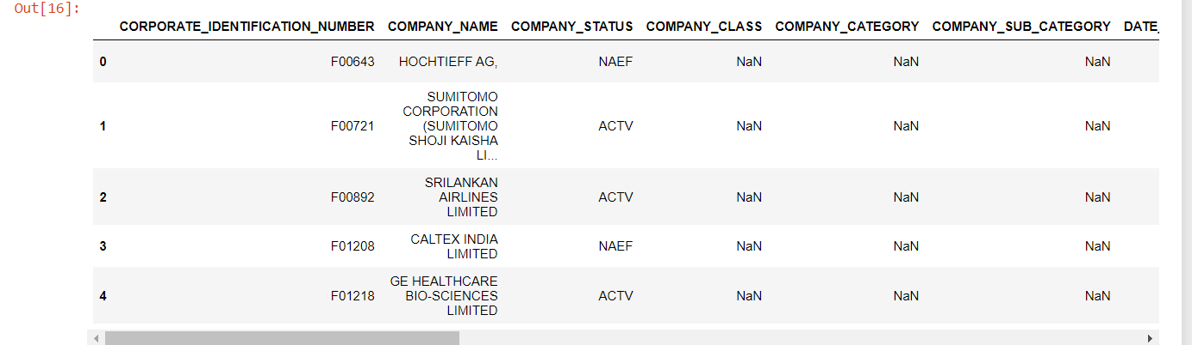

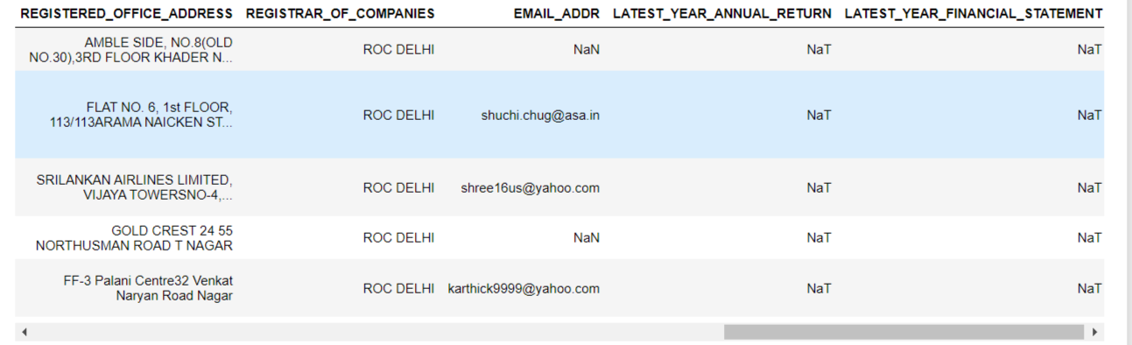

dataset.describe().T

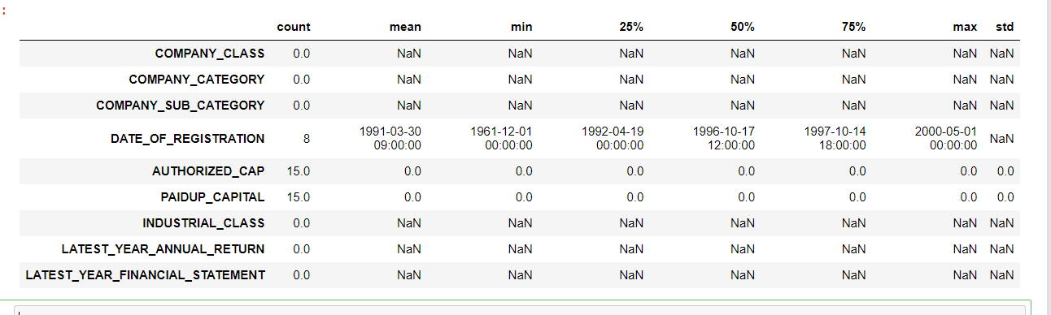

**Data preprocessing**

**Handling Missing Values**: Identify columns with missing data and decide whether to impute, drop, or fill these missing values.

**Data Type Conversion**: Convert the 'DATE_OF_REGISTRATION' column to a datetime data type if it's not already in the correct format.

**Cleaning and Formatting**: Some columns may require cleaning or formatting for consistency. For example, remove leading/trailing white spaces.

**Handling Categorical Data**: If there are categorical variables like 'COMPANY_STATUS,' 'COMPANY_CLASS,' or 'REGISTERED_STATE,' you might need to encode them, possibly using one-hot encoding.

dataset = dataset.dropna()

dataset['DATE_OF_REGISTRATION'] = pd.to_datetime(dataset['DATE_OF_REGISTRATION'], format='%d-%m-%Y')

dataset = dataset.apply(lambda x: x.str.strip() if x.dtype == "object" else x)

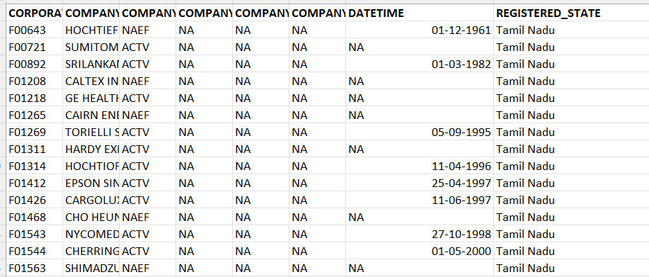

**Splitting the Data:**

If you're planning to build a predictive model, split the data into training and testing sets. The testing set will be used to evaluate the model's performance.

from sklearn.model_selection import train_test_split

X = data.drop('COMPANY_STATUS', axis=1) # Excluding the target column

y = data['COMPANY_STATUS']

# Split the data into training and testing sets (e.g., 80% for training, 20% for testing)

X_train, X_test, y_train, y_test = train_test_split(X, y, test_size=0.2, random_state=42)

# Print the shapes of the resulting sets

print("X_train shape:", X_train.shape)

print("X_test shape:", X_test.shape)

print("y_train shape:", y_train.shape)

print("y_test shape:", y_test.shape)

## Data Visualization:

Data visualization is a powerful tool for understanding your dataset and identifying patterns. You can use libraries like Matplotlib or Seaborn to create various plots and visualizations, such as histograms, scatter plots, and bar charts. This can help you gain insights into your data.

plt.figure(figsize=(8, 6))

sns.histplot(data['AUTHORIZED_CAP'], bins=20)

plt.xlabel('Authorized Capital')

plt.ylabel('Frequency')

plt.title('Distribution of Authorized Capital')

plt.show()

