First when you run the program i.e, when you run the Main class,the no of customers in the database are counted and their details are stored in arrays,these details from the arrays are used to create the bank accounts.Now several bank accounts with respective Account Number,Pin and Balance are created(only these account numbers and pins are valid) customers are linked to their specific bank accounts along with their respective names by creating objects of the Customer class.An object of cash dispenser is created giving the input of the total cash put in it.An object of ATM class is created by passing cash dispenser object created to it. Then the customers are added to the Arraylist of customers in the ATM object created. Now the ATM is set to function.

A Login GUI window appears asking the customer to enter their Account number and pin.

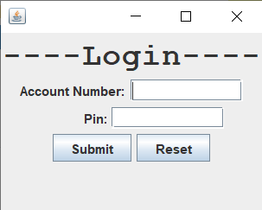

Please enter only digits here as in an ATM we have only digits in the keypad provided.After entering the details press submit.Press reset if you want to change the details entered. The login details are validated once you press the submit button, these details are validated by checking if these details match with the Bank accounts that are linked to the ATM in the beginning and if the details entered match with any one of the customers it shows Login Succesful.

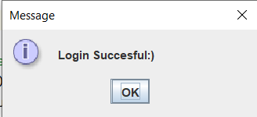

Press OK in the login succesful window and please close the login window once the login is successful.

Please close the Login window once the Login is successful.

If the details do not match an error message is shown,press OK and you can re-enter your details in the login window again

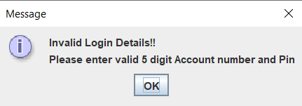

If you enter a number between 1-100, It will display a welcome message with the customers name,press ok

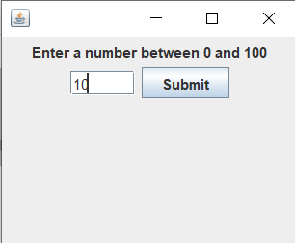

It will show some buttons with options

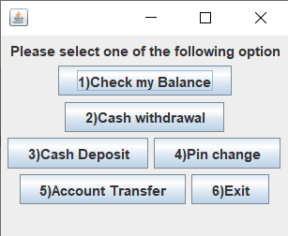

Account balance is shown if you press the button 1)Check my Balance,these details are fetched from the customers respective account using the methods in bank account class

Withdrawal amount is asked if you press button 2)Cash Withdrawal, and the cash dispenser is checked if there is sufficient amount present in the cash dispenser in order to complete the transaction,it shows cash is not available in the ATM please choose a lower amount if there is no sufficient amount in the dispenser.If the cash available in the dispenser is sufficient, the account balance of the customer is checked and if there is enough balance the transaction will be successful and the customer can collect the cash and the respective amount withdrawn will be reduced from the balance of the customer's account. (please enter withdrawal amount in multiples of 100)

If you press button 3)Cash Deposit, Deposit amount in multiples of 100 is asked and the respective amount is added to the balance of the customers account.

If you press button 4)Pin Change,you should enter previous pin and a new pin,you should confirm the new pin.if the previous is correct and if both new pin and confirm pin matches then the pin will change successfully or else error dialog boxes are shown,you can try again.

If you press button 5)Account Transfer,you should enter the destination account number and its ifsc code and the amount to transfer.if you have sufficient funds to transfer and if the account details are correct then the money will be transferred successfully or else error message dialog boxes are shown and you can try again

If you press button 6)Exit,the transaction will end.

The current transaction will end after completing the process done for a particular option chosen.

And all the details will be updated in the database,so all the changes made during the running of the program are updated in the database

The program goes to the login and Login GUI appears again.

**In the 2)Cash Withdrawal, 3)Cash Deposit, 4)Pin change, 5)Account Transfer GUIs please enter something in the text fields while pressing Exit button,if you simply press the Exit button without entering anything in all the text fields nothing is happening and probem occurs**

If you press the Off button on the Login GUI window,the program terminates

Sample Test Cases

Test Case 1:

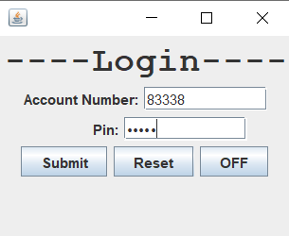





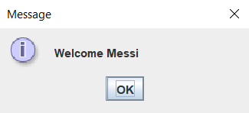



1)Check my Balance option is chosen

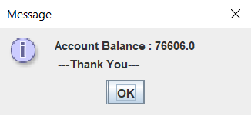

Test Case 2:

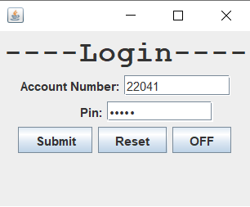



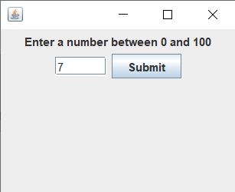

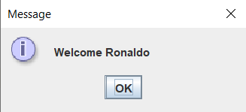



2)Cash Withdrawal is chosen

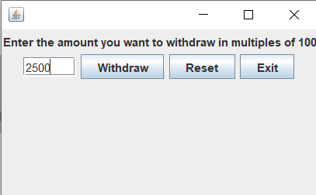

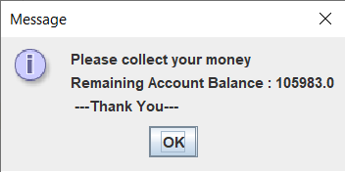

Test Case 3

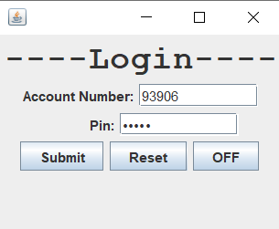





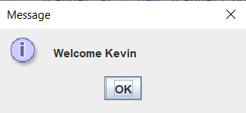



4)Pin change is chosen

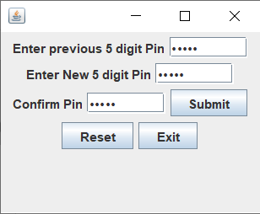

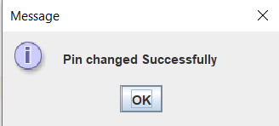

Test Case 4:

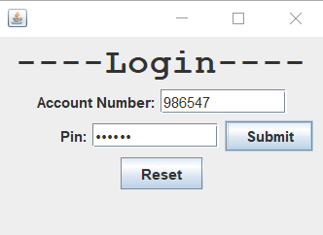



Test Case 5:

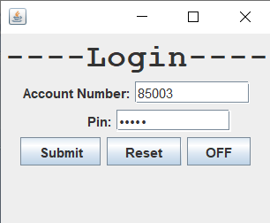





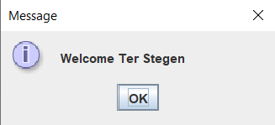



5)Account Transfer is chosen

