Care Transition Efficiency & Placement Outcome Analytics
Research Paper: EDA, Insights, and Recommendations
Dataset coverage: 2023-01-12 to 2025-12-21 | 720 valid reporting rows

Abstract
This project reframes the UAC care data as a process pipeline rather than a simple capacity report. The analysis measures how children move from CBP custody into HHS care and then to discharge or sponsor placement. Across the cleaned reporting window, the data records 67,337 apprehensions, 92,641 transfers out of CBP custody, and 124,853 HHS discharges. The average transfer efficiency ratio is 69.1%, while the average discharge effectiveness index is 2.4%. The main analytical finding is that backlog risk is episodic: system-level exits exceeded entries overall, but short windows showed substantial accumulation risk, with the strongest 14-day HHS backlog period ending 2024-05-02 at 1,100 net cases.

1. Background and Context
The care transition process is a multi-stage operational pipeline: apprehension and CBP custody, transfer to HHS/ORR care, medical screening and case management, and discharge or reunification with a vetted sponsor. In this context, custody counts alone are incomplete because they reveal inventory but not flow, delay, or placement reliability.
The analysis therefore prioritizes speed, continuity, and reliability. These dimensions matter because a functioning care system must not only have available capacity; it must also move children through stages in a timely and stable manner.

2. Problem Statement
Aggregate counts of children in custody are monitored, but process-efficiency metrics are often absent from basic reporting. The project answers four operational questions: how efficiently children are transferred from CBP to HHS, whether discharges keep pace with inflows, where backlogs accumulate, and whether placement outcomes are improving or deteriorating over time.

3. Dataset and Data Preparation
The uploaded CSV contained six columns: reporting date, apprehensions placed in CBP custody, active CBP custody, transfers out of CBP custody, active HHS care, and HHS discharges. Blank rows were removed, dates were parsed, numeric fields were standardized, and the file was sorted chronologically.
Field | Analytical Role
Date | Reporting grain
CBP apprehended | Stage entry volume
CBP custody | Stage inventory
Transferred out of CBP | CBP to HHS transition flow
HHS care | HHS stage inventory
HHS discharged | Successful exit / sponsor placement proxy

4. Methodology
Care pipeline modeling defines the stages as CBP custody -> HHS care -> sponsor placement. The analysis calculates daily movement and rolling indicators to surface short-term bottlenecks that aggregate totals can hide.
Kpi | Formula | Interpretation
Transfer Efficiency Ratio | Transfers out of CBP / CBP custody | Higher means faster CBP-to-HHS transition
Discharge Effectiveness Index | HHS discharges / HHS care | Higher means stronger placement output relative to active HHS load
Pipeline Throughput | HHS discharges / CBP apprehensions | Higher means exits are keeping pace with entries
Backlog Accumulation Rate | Transfers to HHS - HHS discharges | Positive values indicate accumulation pressure
Outcome Stability Score | 100 / (1 + rolling 30-day coefficient of variation) | Higher means more consistent placement performance

5. Exploratory Data Analysis
Cleaned reporting coverage spans 720 rows. Average active CBP custody was 171.5 children, while average active HHS care was 6061.3 children, showing that the HHS stage held far more inventory than the CBP stage. This is expected in a pipeline where HHS case management and sponsor vetting are more complex and longer-duration than initial custody transfer.
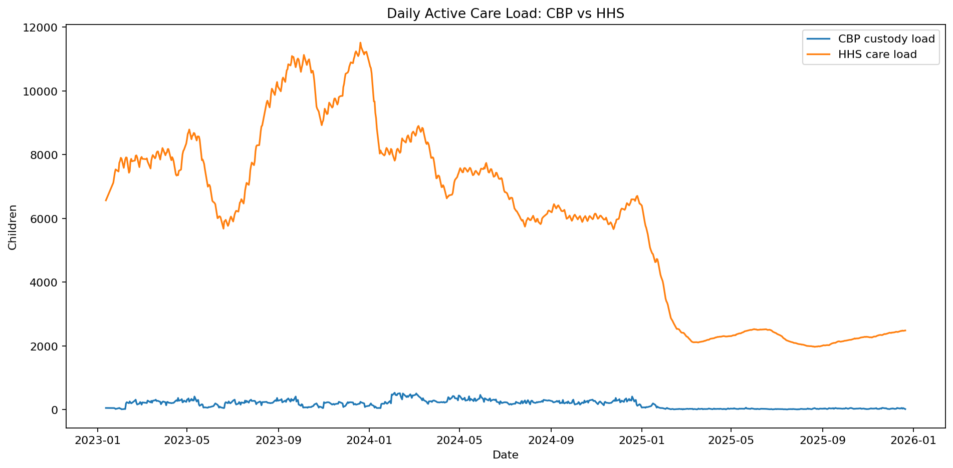
The active care-load chart shows that HHS care is the dominant inventory stage. Therefore, discharge effectiveness is the most important downstream indicator for long-duration pressure.
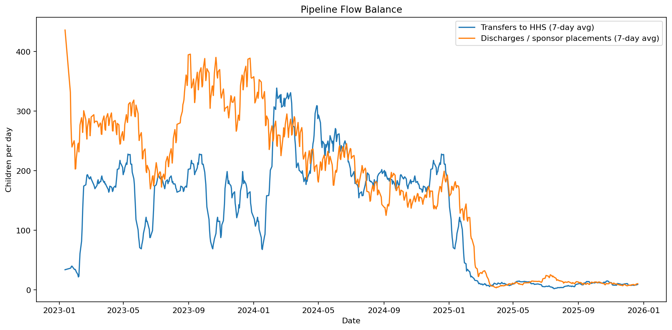
The rolling flow chart compares transfers into HHS with discharges from HHS. Where the discharge line falls below the transfer line for sustained periods, backlog pressure accumulates.
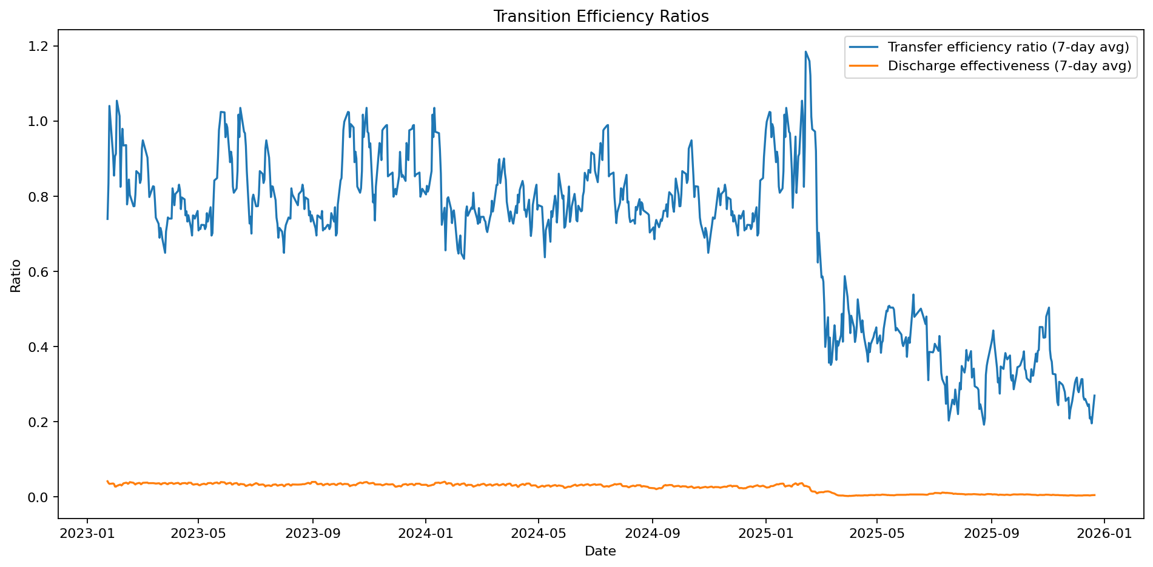
Ratio indicators normalize the operational flows by the current stage inventory. This makes low-volume periods comparable with high-volume periods and supports threshold-based alerts in the dashboard.

6. Bottleneck Findings
The overall net HHS backlog was -32,212, meaning cumulative HHS discharges exceeded transfers during the full cleaned period. However, the maximum rolling 14-day backlog was 1,100, ending on 2024-05-02. This shows why rolling bottleneck detection is more useful than a single cumulative total.
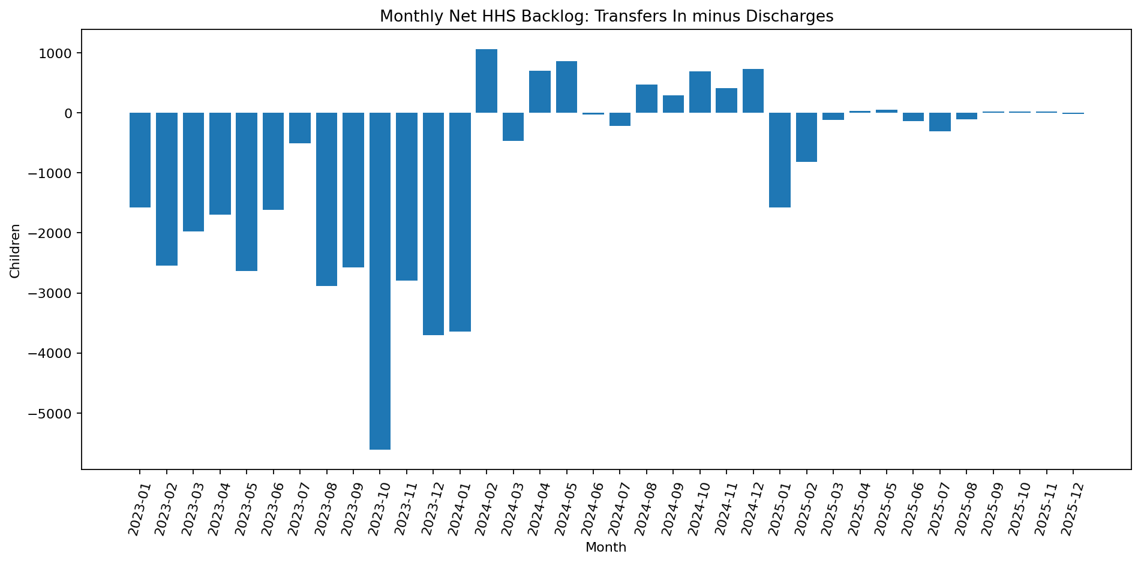
Date | Cbp Apprehended | Cbp Transferred | Hhs Discharged | Hhs Care | Net Hhs Backlog | Rolling 14D Backlog
2024-05-02 | 206.00 | 293.00 | 194.00 | 7577 | 99.00 | 1,100.00
2024-02-25 | 244.00 | 366.00 | 329.00 | 8404 | 37.00 | 1,032.00
2024-05-08 | 167.00 | 205.00 | 202.00 | 7583 | 3.00 | 1,016.00
2024-05-07 | 176.00 | 246.00 | 163.00 | 7566 | 83.00 | 1,011.00
2024-05-05 | 150.00 | 228.00 | 332.00 | 7447 | -104.00 | 1,011.00
2024-05-06 | 173.00 | 211.00 | 205.00 | 7449 | 6.00 | 975.00
2024-05-01 | 197.00 | 295.00 | 190.00 | 7508 | 105.00 | 954.00
2024-05-09 | 138.00 | 268.00 | 244.00 | 7570 | 24.00 | 937.00
2024-02-26 | 199.00 | 326.00 | 329.00 | 8404 | -3.00 | 926.00
2024-05-12 | 138.00 | 263.00 | 245.00 | 7464 | 18.00 | 918.00

7. Temporal Pattern Analysis
Weekday analysis evaluates whether transfer and discharge speed differs across the reporting week. This is useful for identifying staffing, paperwork, sponsor-contact, court, transportation, or administrative-cycle effects.
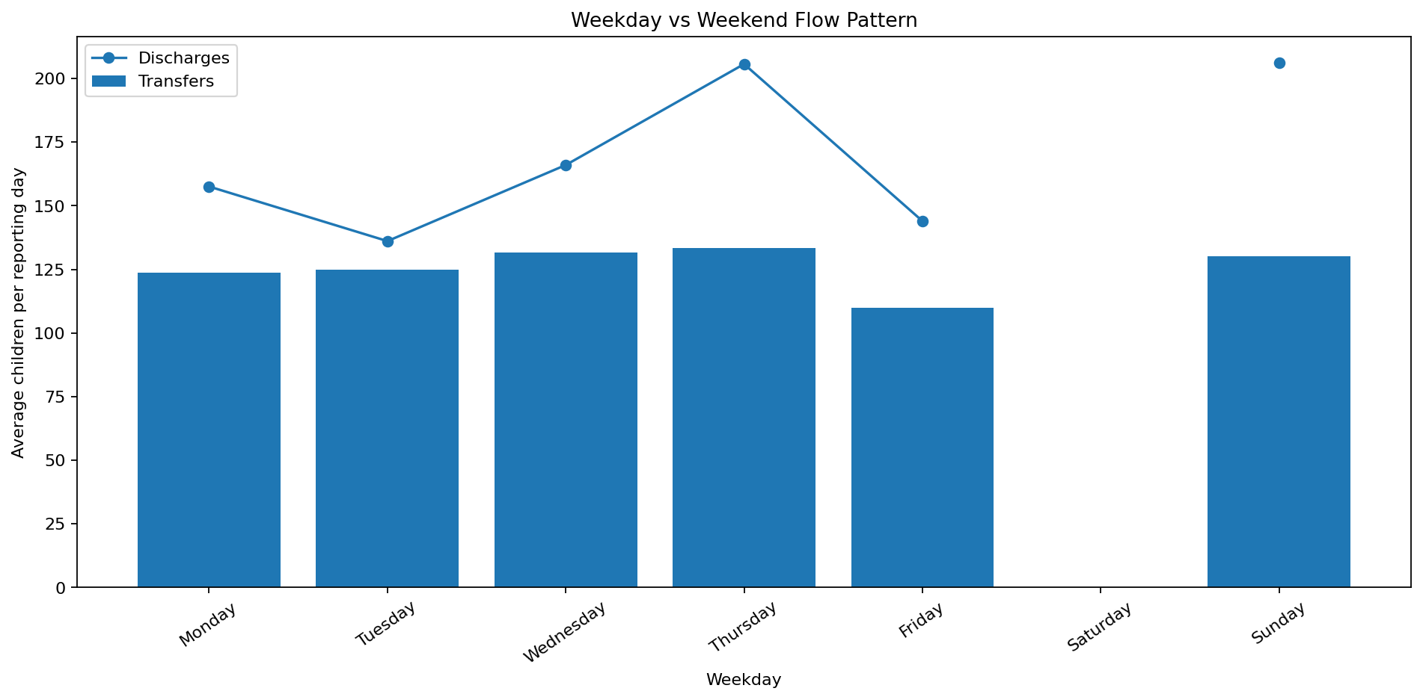
Weekday | Avg Transfers | Avg Discharges | Avg Transfer Eff | Avg Discharge Eff
Monday | 123.73 | 157.56 | 0.66 | 0.02
Tuesday | 124.86 | 136.11 | 0.67 | 0.02
Wednesday | 131.67 | 166.01 | 0.69 | 0.02
Thursday | 133.41 | 205.69 | 0.73 | 0.03
Friday | 110.00 | 144.00 | 0.71 | 0.02
Saturday | nan | nan | nan | nan
Sunday | 130.06 | 206.14 | 0.70 | 0.03

8. Outcome Stability Analysis
Outcome stability is measured as the inverse variability of the discharge effectiveness index. A lower score reflects more volatile placement performance and signals the need for management attention even when average output appears acceptable.
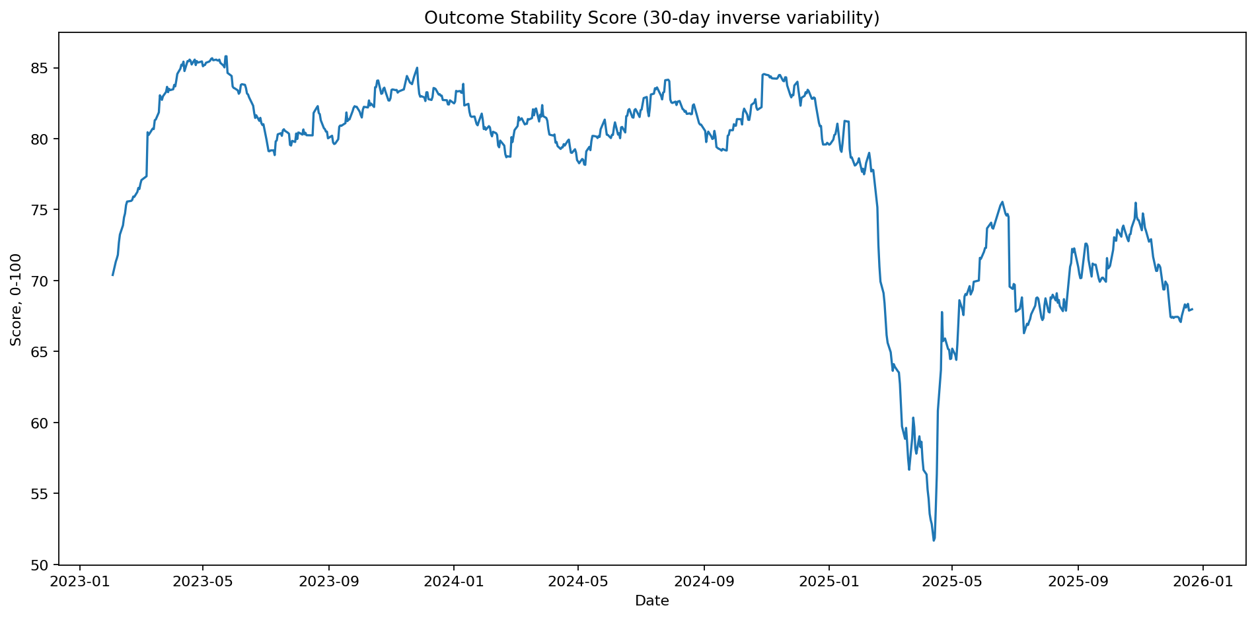

9. Recommendations
- Adopt rolling 7-day and 14-day flow dashboards as standard operational views instead of relying only on daily inventory counts.
- Use threshold alerts for low transfer efficiency, low discharge effectiveness, and positive rolling backlog accumulation.
- Separate upstream bottlenecks from downstream bottlenecks: CBP transfer delays require different interventions than HHS discharge slowdowns.
- Review days and months with positive net HHS backlog to identify staffing, sponsor-vetting, transportation, legal, or documentation constraints.
- Track outcome stability to distinguish a consistently functioning placement system from one that alternates between high-output and stagnation periods.

10. Conclusion
The project demonstrates that UAC operational reporting can be transformed into a transition-efficiency and placement-outcome monitoring system. The key contribution is not merely calculating totals, but detecting when the pipeline slows, where inventory accumulates, and whether sponsor placements remain stable over time. The provided Streamlit dashboard turns these findings into a repeatable monitoring workflow for policy and operational stakeholders.

References
U.S. Department of Health and Human Services, Office of Refugee Resettlement, Unaccompanied Children Program public data and information pages.
HealthData.gov, HHS Unaccompanied Alien Children Program dataset.

