MongoDB -Aggregation Exercises
Import the zips.json file into your MongoDB. Database name is "population" and collection name is "zipcodes".
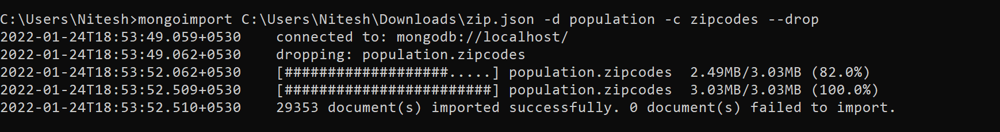
Atlanta Population
- use db.zipcodes.find() to filter results to only the results where city is ATLANTA and state is GA.
Ans: - 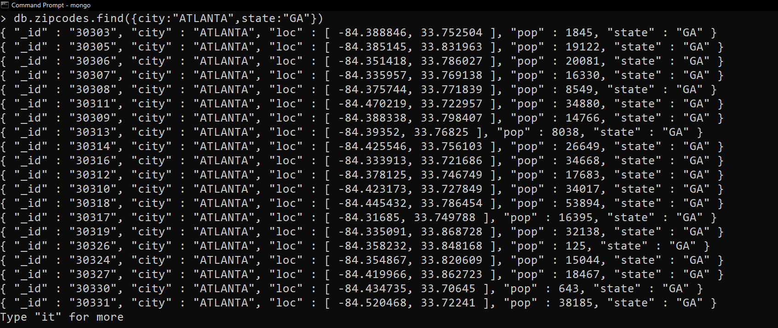

- use db.zipcodes.aggregate with $match to do the same as above.
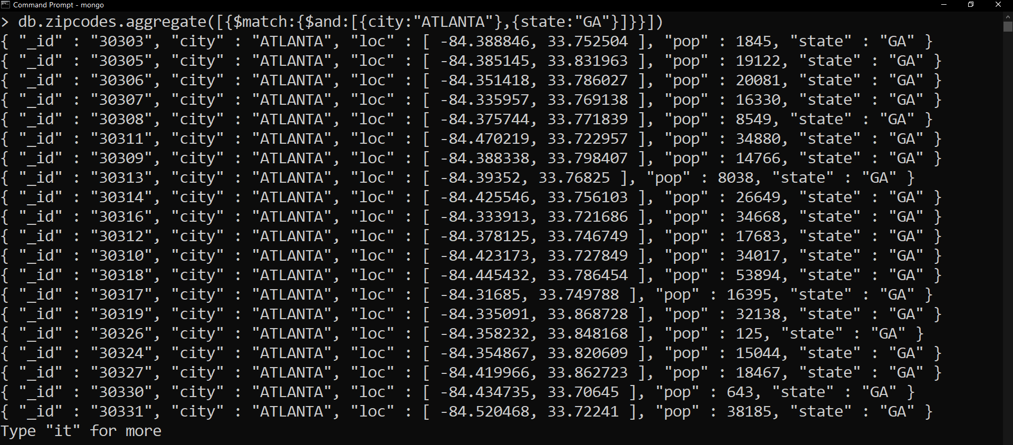
Ans: -

- use $group to count the number of zip codes in Atlanta.
Ans: -
4. use $group to find the total population in Atlanta.
Ans:-

Populations By State

- use aggregate to calculate the total population for each state
Ans: - 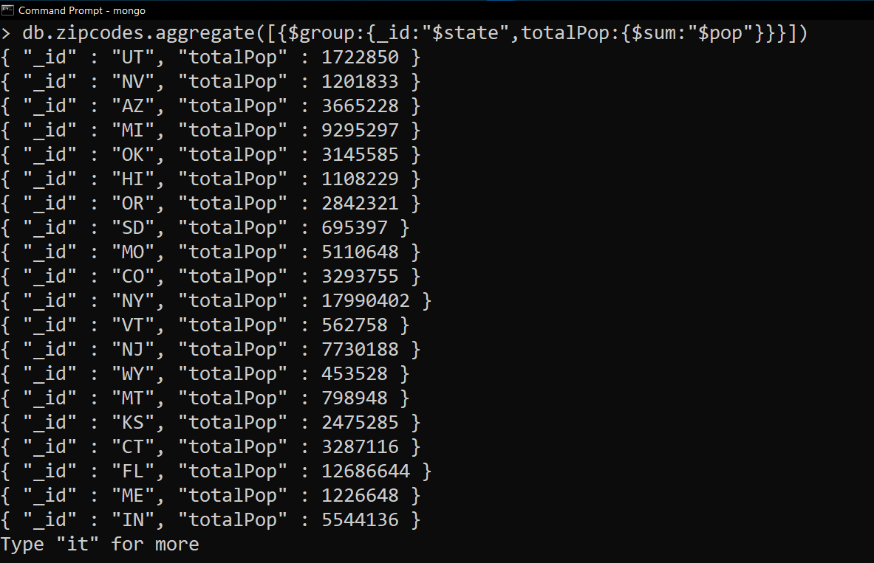

- sort the results by population, highest first
Ans: - 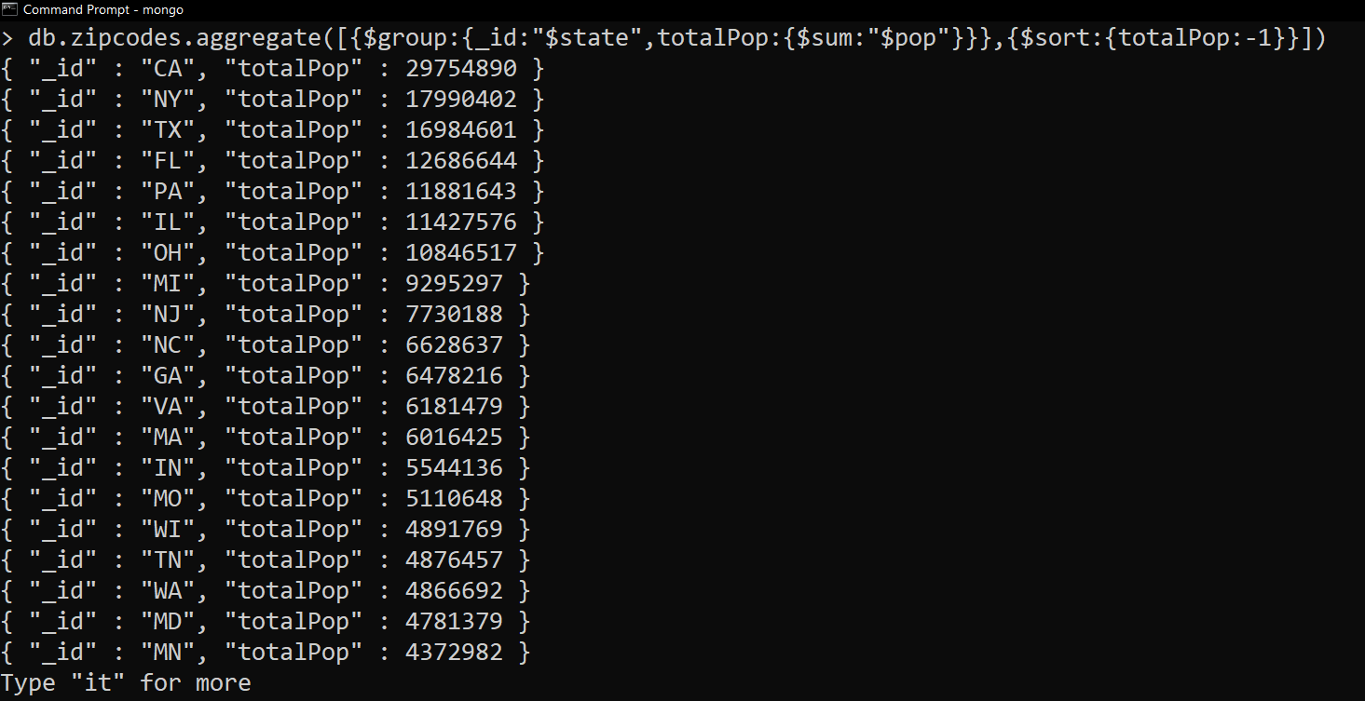

- limit the results to just the first 3 results. What are the top 3 states in population?
Ans: - 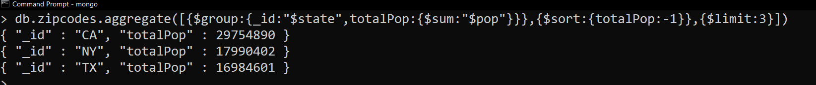

Populations by City
- use aggregate to calculate the total population for each city (you have to use city/state combination). You can use a combination for the _id of the $group: { city: '$city', state: '$state' }
Ans: - 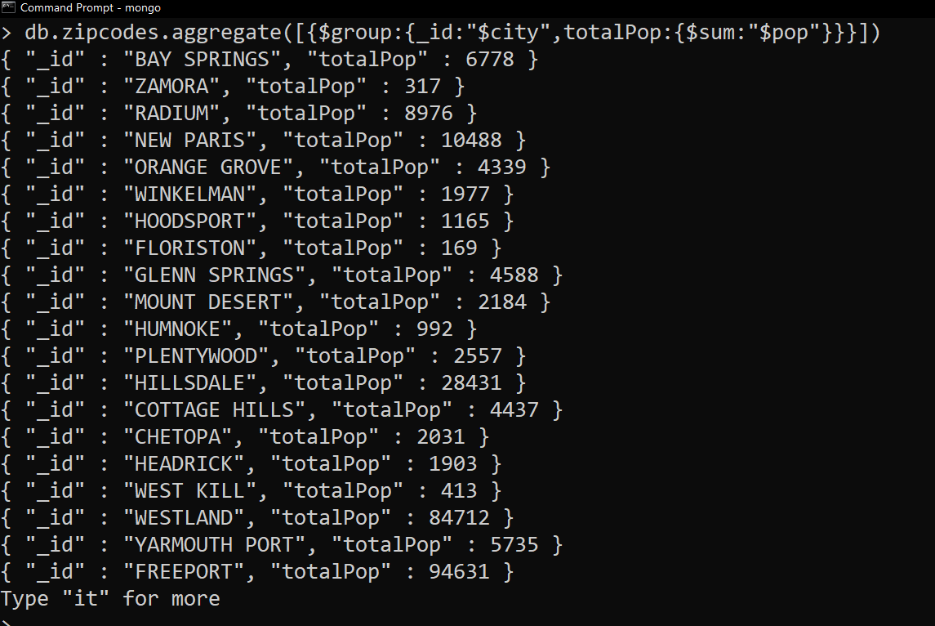
- sort the results by population, highest first
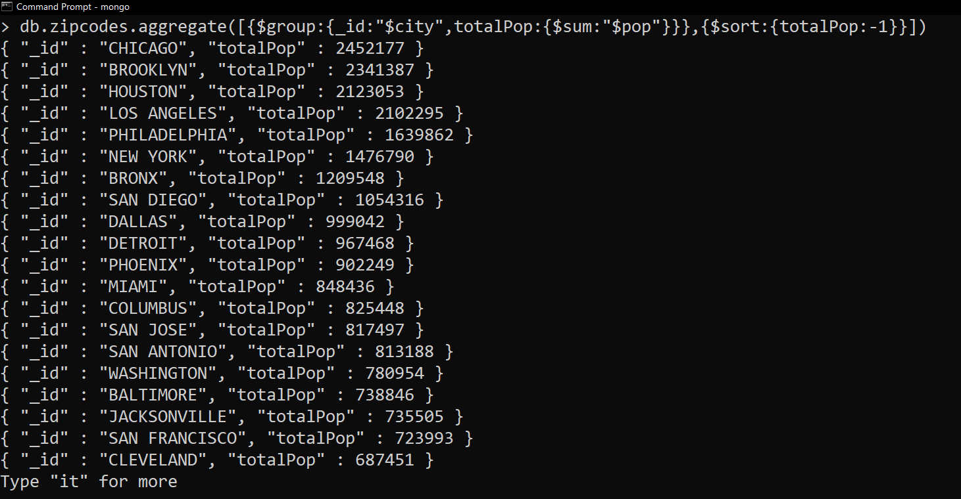
Ans: -

- limit the results to just the first 3 results. What are the top 3 cities in population?
Ans: -
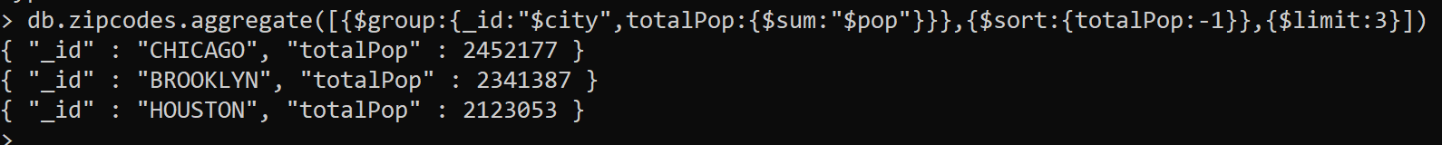

- What are the top 3 cities in population in Texas?
Ans: - 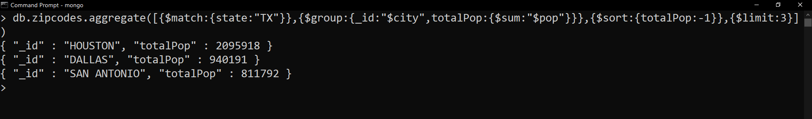

Bonus

- Write a query to get the average city population for each state.
Ans: -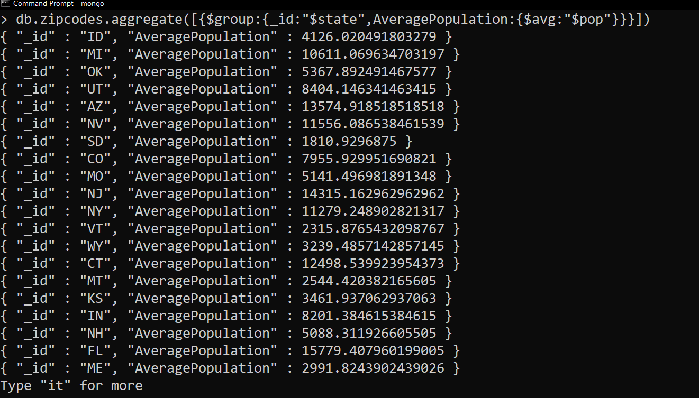

- What are the top 3 states in terms of average city population?
Ans: -