MongoDB Lab Assignments -Day 1
MongoDB Exercise in mongo shell Connect to a running mongo instance, use a database named mongo_practice. Document all your queries in a JavaScript file to use as a reference.
Insert Documents Insert the following documents into a movies collection
title : Fight Club
writer : Chuck Palahniuko
year : 1999
actors : [
Brad Pitt
Edward Norton
]

title : Pulp Fiction
writer : Quentin Tarantino
year : 1994
actors : [
John Travolta
Uma Thurman
]

title : Inglorious Basterds
writer : Quentin Tarantino
year : 2009
actors : [
Brad Pitt
Diane Kruger
Eli Roth
]

title : The Hobbit: An Unexpected Journey
writer : J.R.R. Tolkein
year : 2012
franchise : The Hobbit

title : The Hobbit: The Desolation of Smaug
writer : J.R.R. Tolkein
year : 2013
franchise : The Hobbit

title : The Hobbit: The Battle of the Five Armies
writer : J.R.R. Tolkein
year : 2012
franchise : The Hobbit
synopsis : Bilbo and Company are forced to engage in a war against an array of
combatants and keep the Lonely Mountain from falling into the hands of a rising
darkness.

title : Pee Wee Herman's Big Adventure

title : Avatar

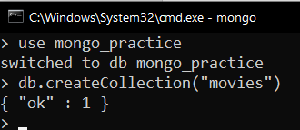

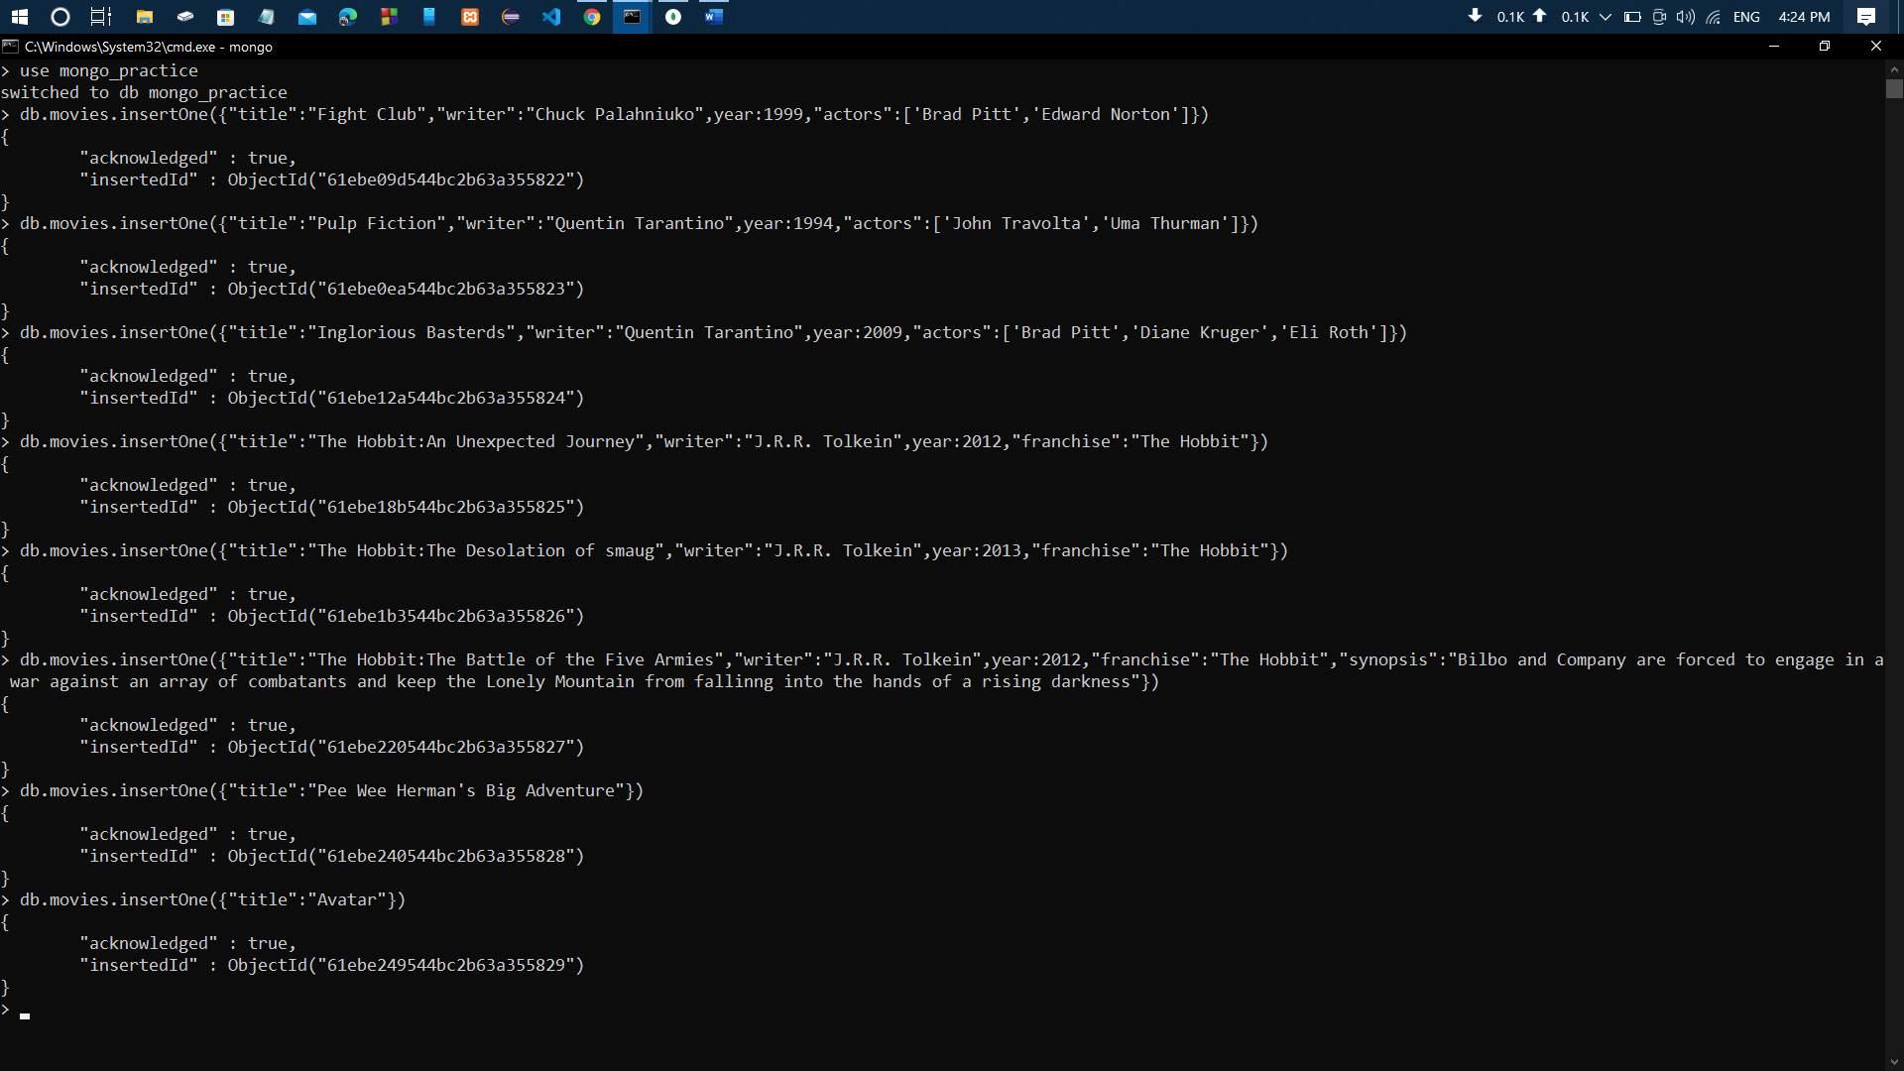
Query / Find Documents query the movies collection to
- Get all documents
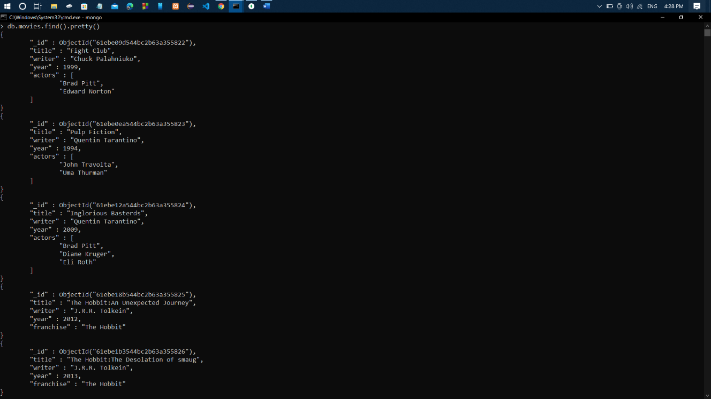
Ans:-

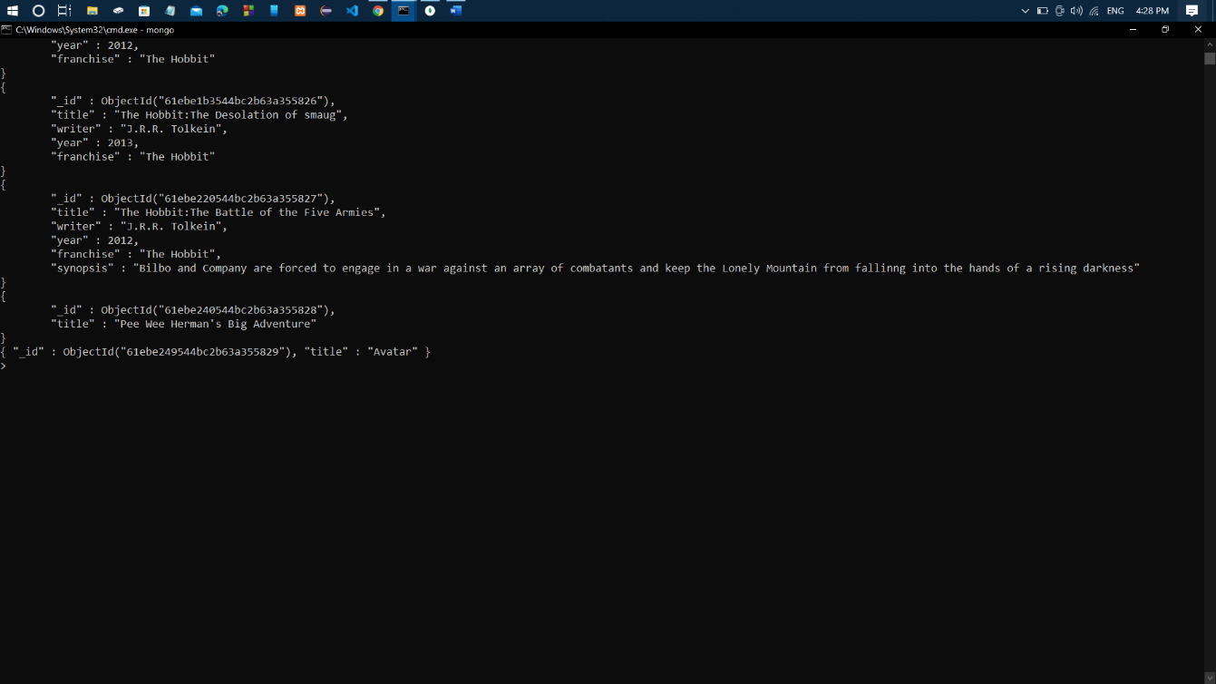

- Get all documents with writer set to "Quentin Tarantino"
Ans:-

- Get all documents where actors include "Brad Pitt"
Ans:-

- Get all documents with franchise set to "The Hobbit"
Ans:-
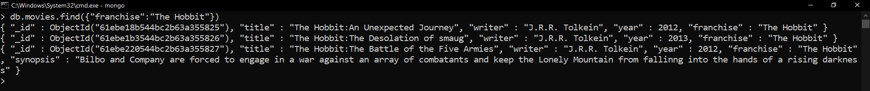

- Get all movies released in the 90s
Ans:-

- Get all movies released before the year 2000 or after 2010
Ans:-
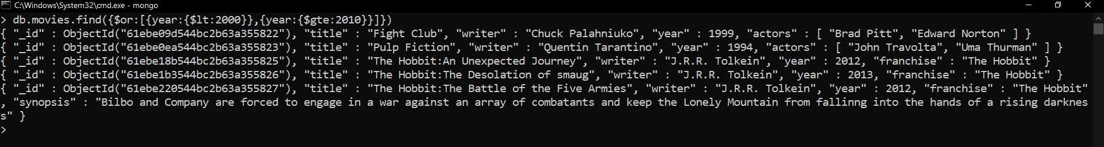

Update Documents
- add a synopsis to "The Hobbit: An Unexpected Journey" : "A reluctant hobbit, Bilbo Baggins, sets out to the Lonely Mountain with a spirited group of dwarves to reclaim their mountain home - and the gold within it - from the dragon Smaug."
Ans: -
Here synopsis is added
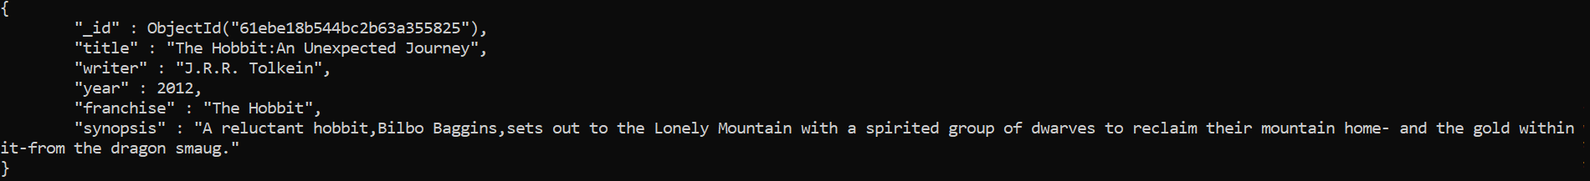

- add a synopsis to "The Hobbit: The Desolation of Smaug" : "The dwarves, along with Bilbo Baggins and Gandalf the Grey, continue their quest to reclaim Erebor, their homeland, from Smaug. Bilbo Baggins is in possession of a mysterious and magical ring."
Ans: -
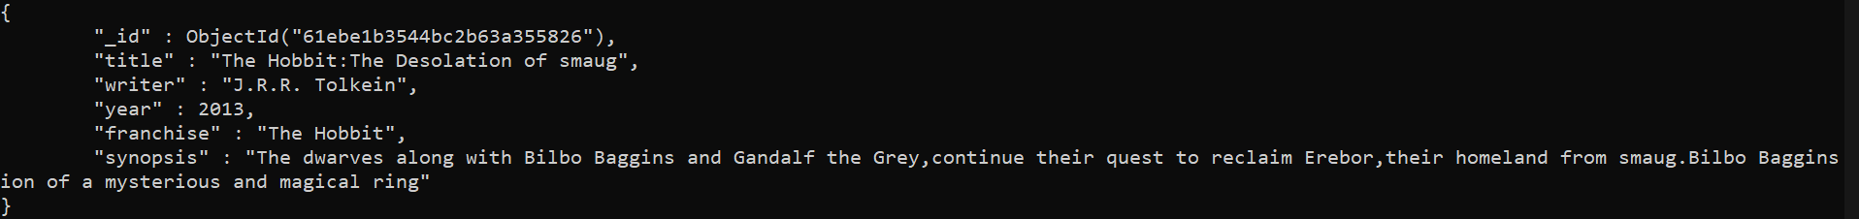

- add an actor named "Samuel L. Jackson" to the movie "Pulp Fiction"
Ans: - 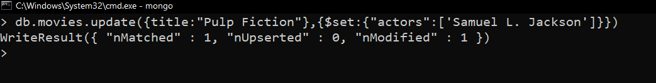
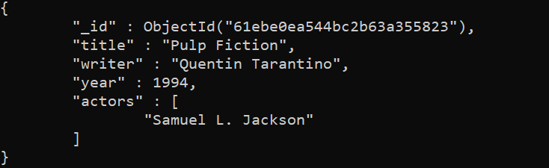

Text Search
- find all movies that have a synopsis that contains the word "Bilbo"
Ans: -
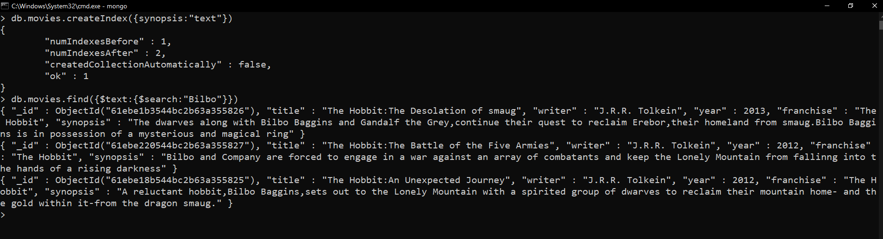
- find all movies that have a synopsis that contains the word "Gandalf"
Ans: -

- find all movies that have a synopsis that contains the word "Bilbo" and not the word "Gandalf"
Ans:-
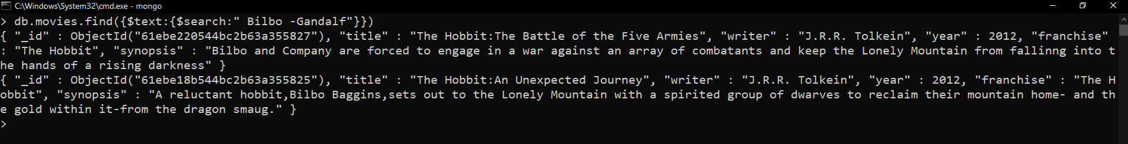

- Find all movies that have a synopsis that contains the word "dwarves" or "hobbit"
Ans: -
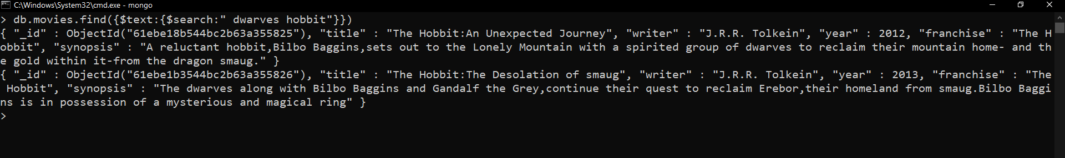

- find all movies that have a synopsis that contains the word "gold" and "dragon"
Ans: -
Delete Documents
- delete the movie "Pee Wee Herman's Big Adventure"
Ans: -

- delete the movie "Avatar"
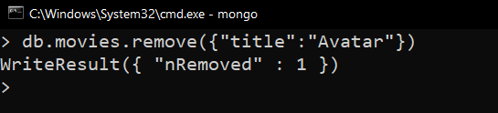
Ans: -

Relationships
Insert the following documents into a users collection
username : GoodGuyGreg
first_name : "Good Guy"
last_name : "Greg"

username : ScumbagSteve
full_name :
first : "Scumbag"
last : "Steve"

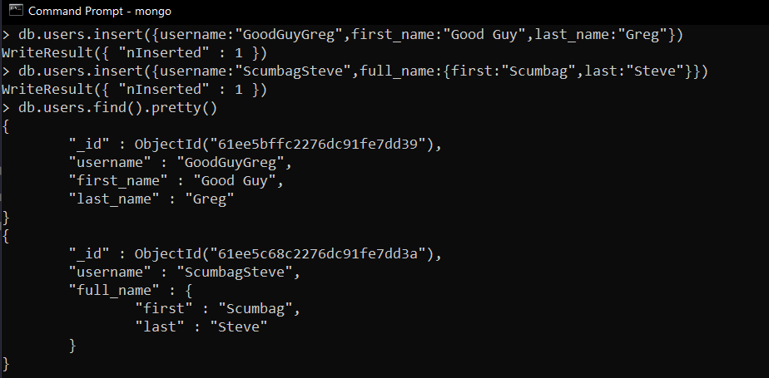

Insert the following documents into a posts collection
username : GoodGuyGreg
title : Passes out at party
body : Wakes up early and cleans house

username : GoodGuyGreg
title : Steals your identity
body : Raises your credit score

username : GoodGuyGreg
title : Reports a bug in your code
body : Sends you a Pull Request
username : ScumbagSteve
title : Borrows something
body : Sells it

username : ScumbagSteve
title : Borrows everything
body : The end

username : ScumbagSteve
title : Forks your repo on github
body : Sets to private

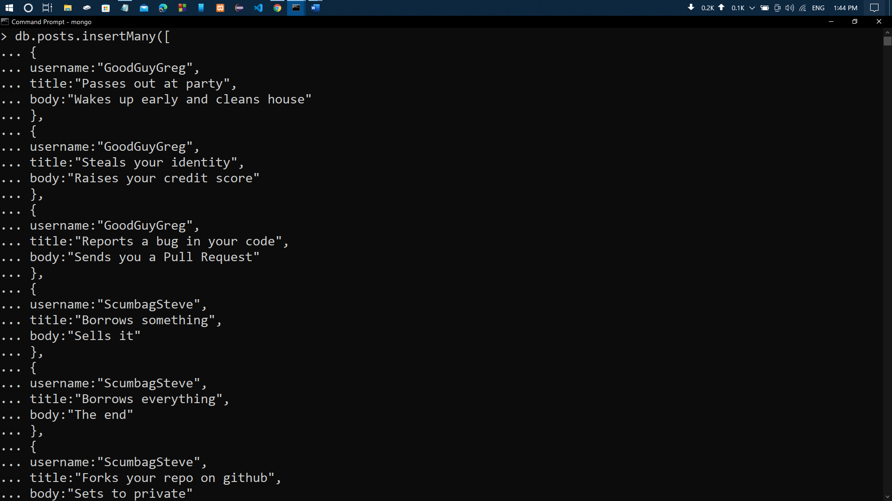
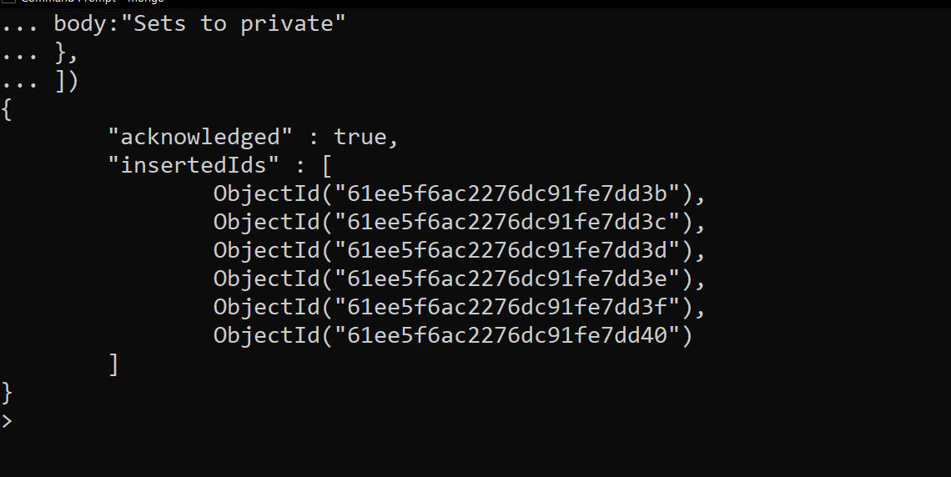
Insert the following documents into a comments collection

username : GoodGuyGreg
comment : Hope you got a good deal!
post : [post_obj_id]
where [post_obj_id] is the ObjectId of the posts document: "Borrows something"

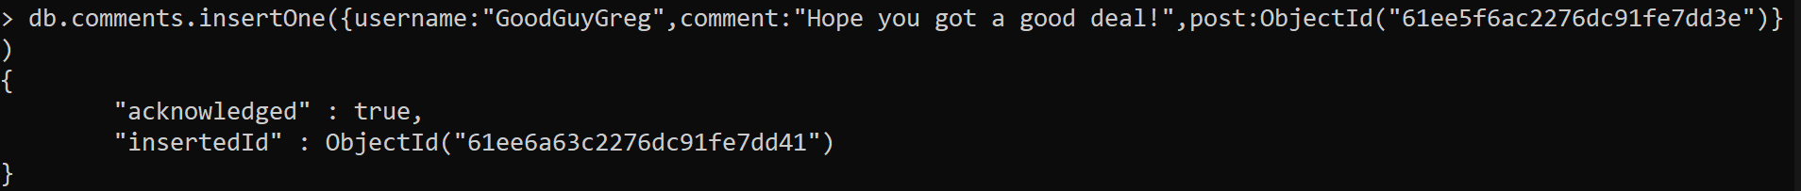

username : GoodGuyGreg
comment : What's mine is yours!
post : [post_obj_id]
where [post_obj_id] is the ObjectId of the posts document: "Borrows everything"

username : GoodGuyGreg
comment : Don't violate the licensing agreement!
post : [post_obj_id]
where [post_obj_id] is the ObjectId of the posts document: "Forks your repo on
github

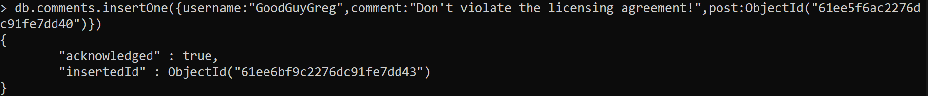

username : ScumbagSteve
comment : It still isn't clean
post : [post_obj_id]
where [post_obj_id] is the ObjectId of the posts document: "Passes out at party"

username : ScumbagSteve
comment : Denied your PR cause I found a hack
post : [post_obj_id]
where [post_obj_id] is the ObjectId of the posts document: "Reports a bug in your
code"

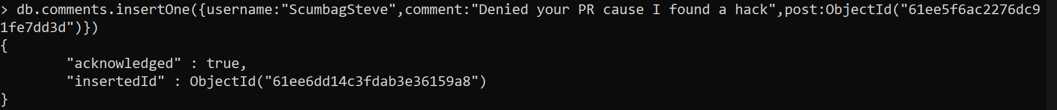

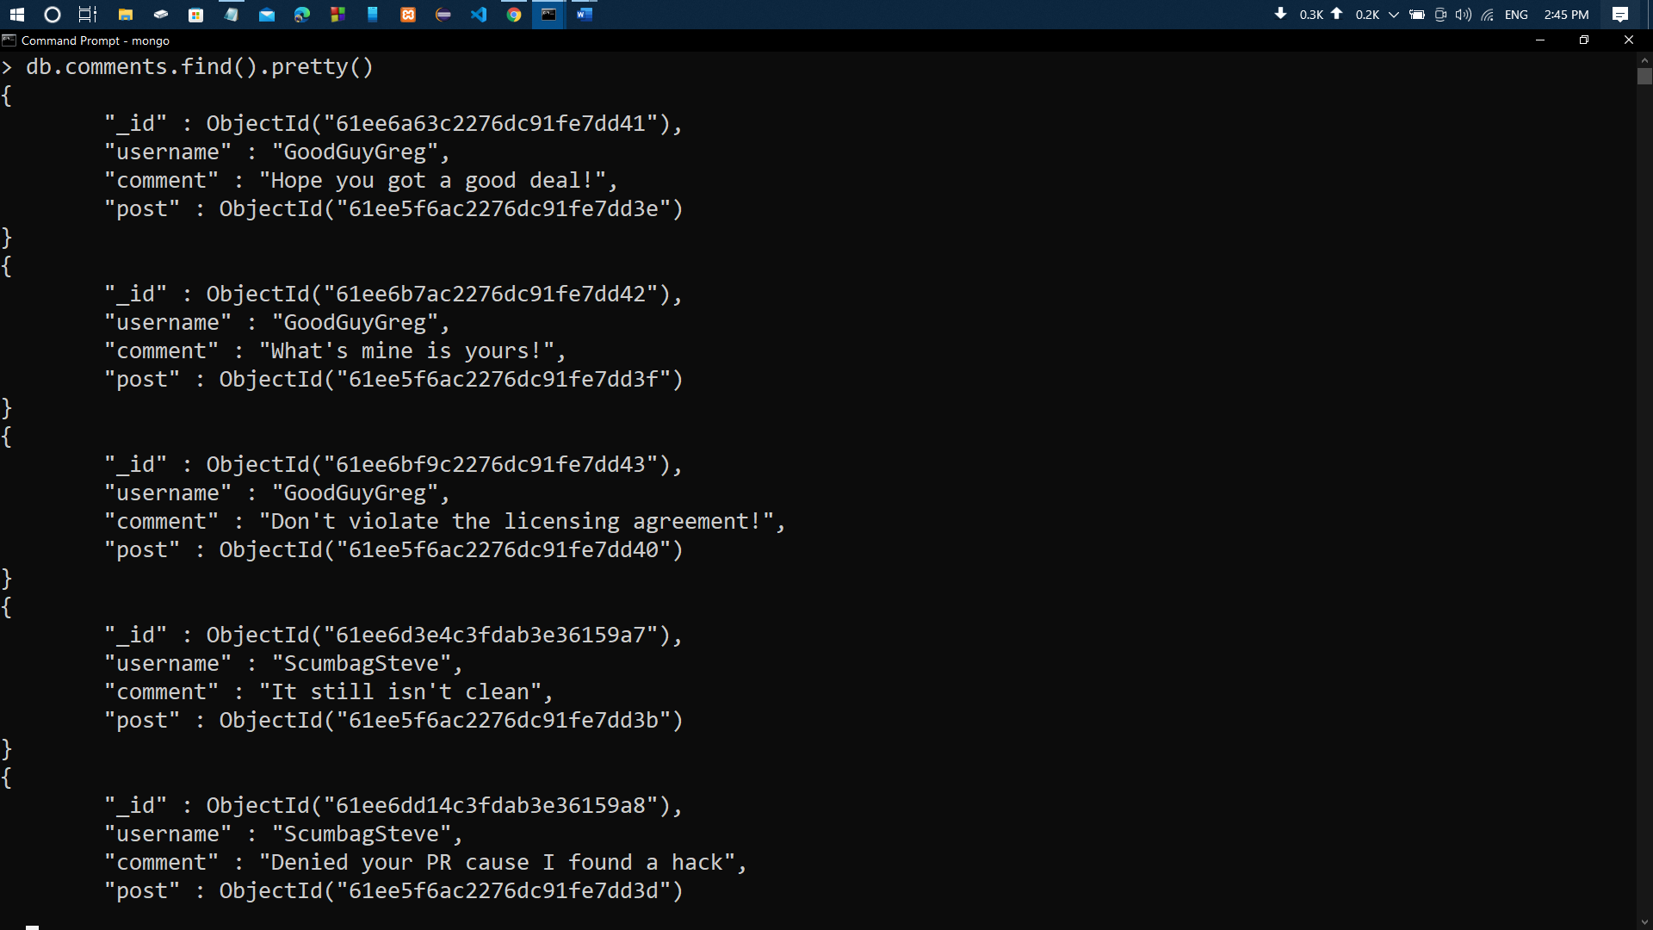

Querying related collections
- find all users
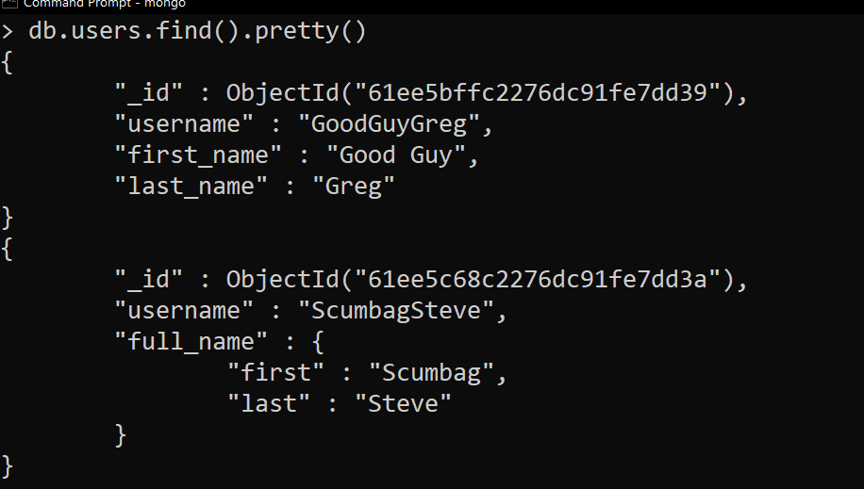
Ans: -

- find all posts
Ans: -
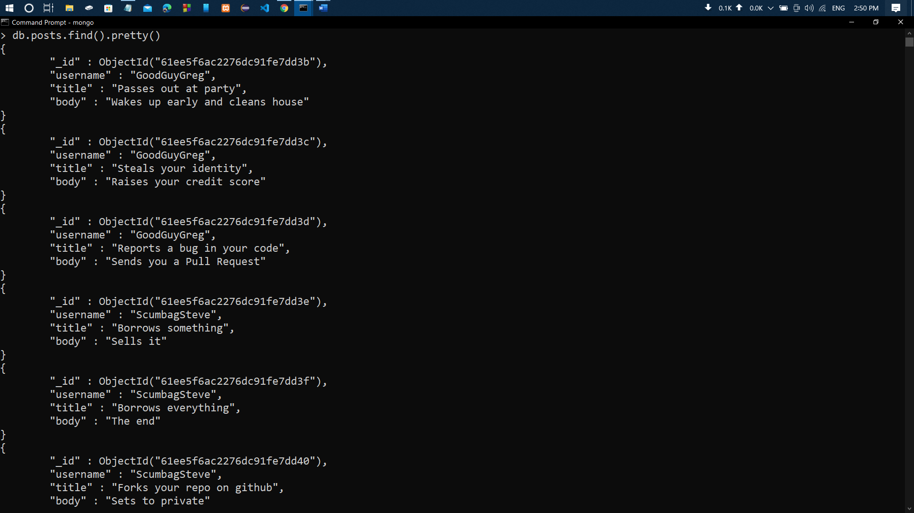

- find all posts that was authored by "GoodGuyGreg"
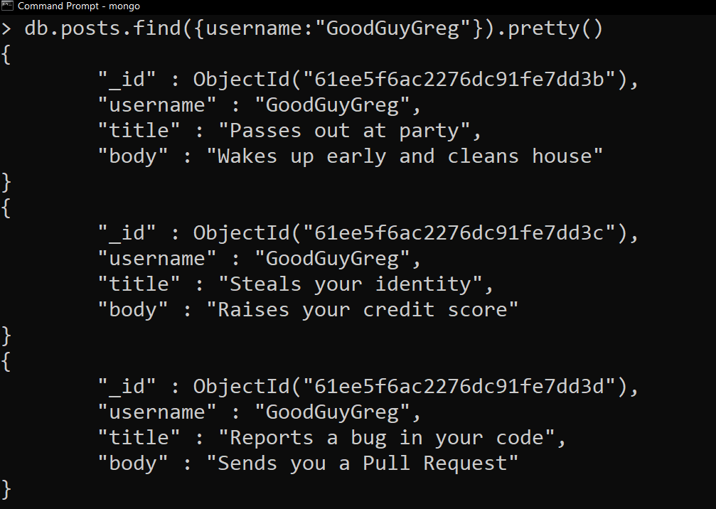
Ans: -
4. find all posts that was authored by "ScumbagSteve"
Ans: - 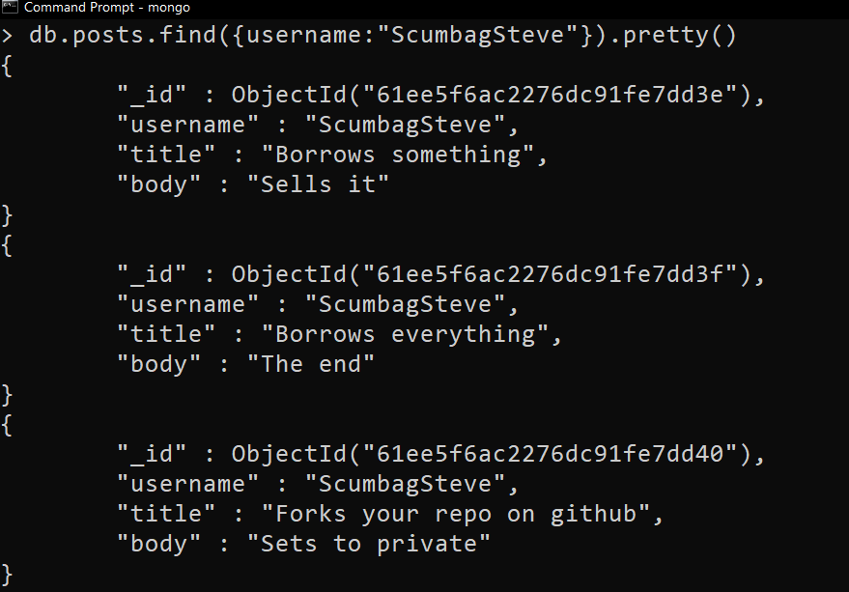

5 . find all comments
Ans: - 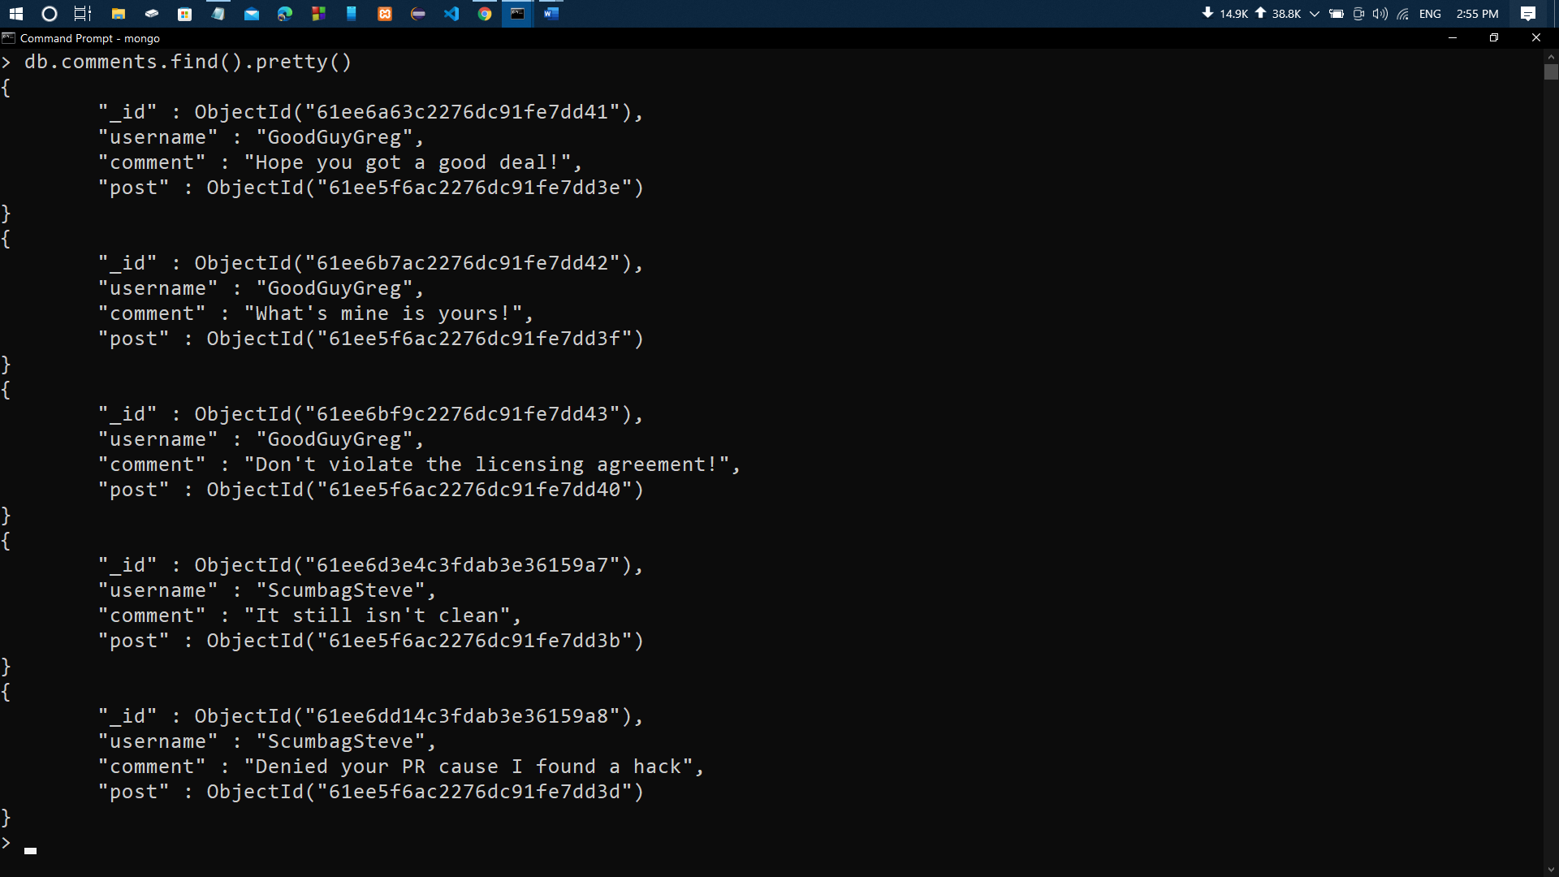

- find all comments that was authored by "GoodGuyGreg"
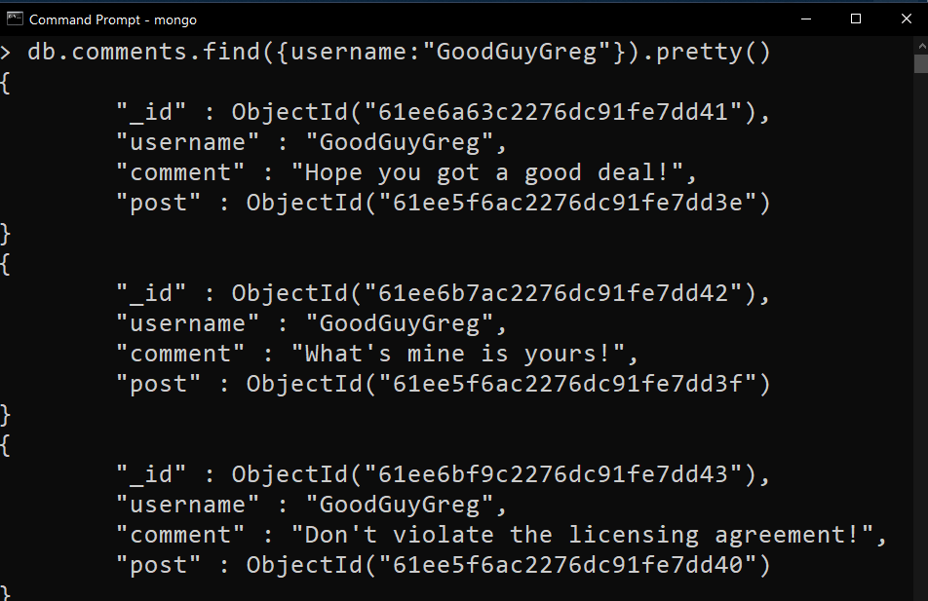
Ans: -
7. find all comments that was authored by "ScumbagSteve"
Ans: - 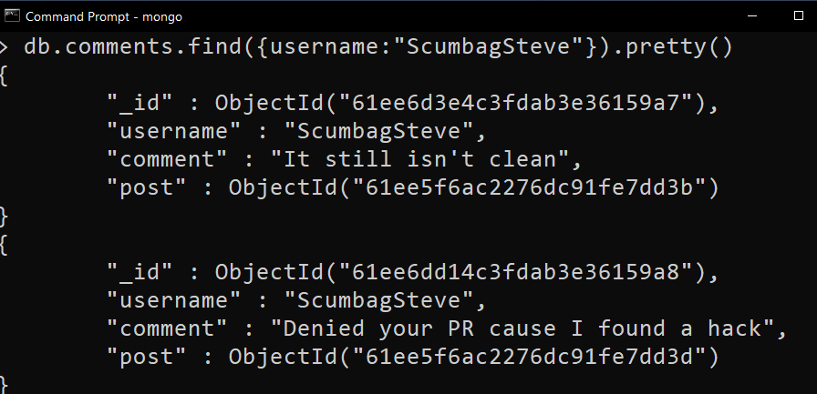

8 . find all comments belonging to the post "Reports a bug in your code"
Ans: - 