- Create a directory ‘project_dir’ & cd to ‘project_dir’.
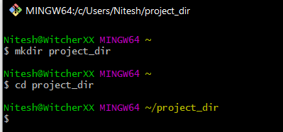
Ans: -

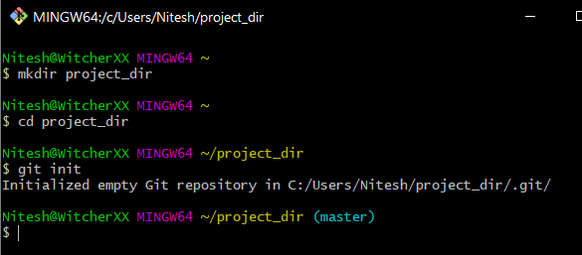
- Initialize git version database. (git init)
Ans: -

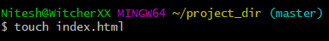
- Create a new file index.html
Ans: -

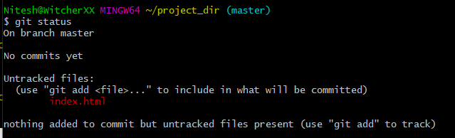
- Check the git status. You should find index.html as untracked file.
Ans: -

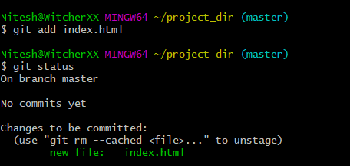
- Stage the index.html file.
Ans: -

- Commit index.html
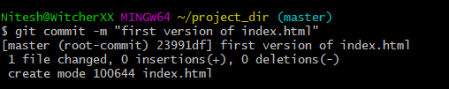
Ans: -

- Make few changes in index.html & create a new file info.txt file.
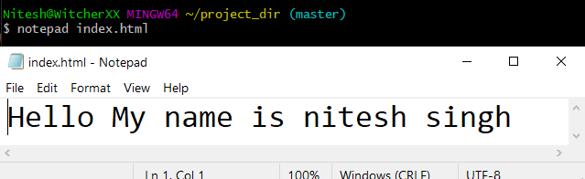
Ans: -

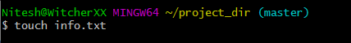

- Check git status. You should find index.html & info.txt as untracked files.
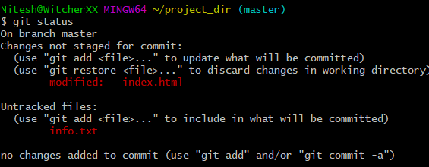
Ans: -

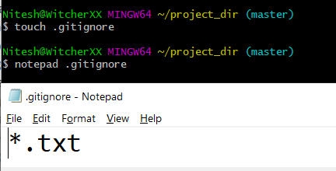
- Configure GIT to ignore all txt files.
Ans: -

- Again check the git status. You should find only index.html as untracked file.
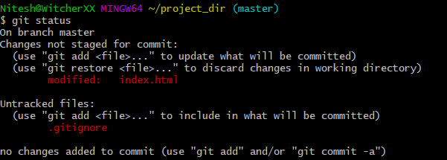
Ans: -

- Stage & commit index.html
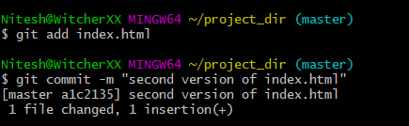
Ans: -

- Log all your comments so far
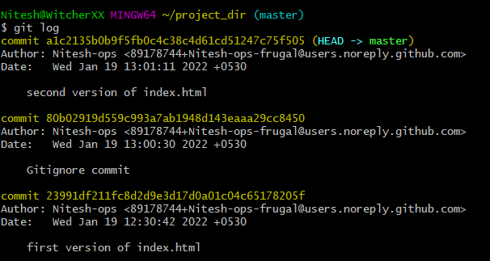
Ans: -

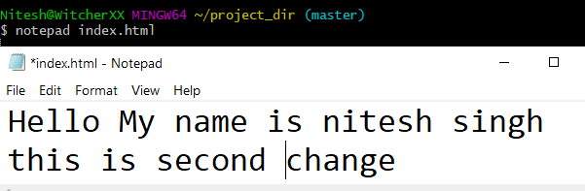
- Make some changes in index.html.
Ans: -

- Revert the change made in the previous step using git command.
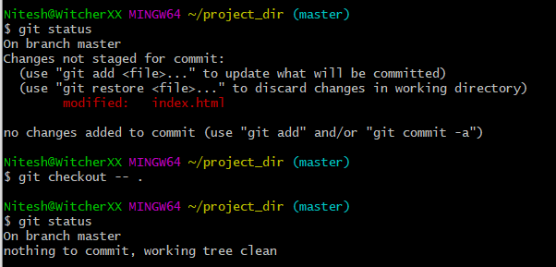
Ans: -

- Again change index.html.
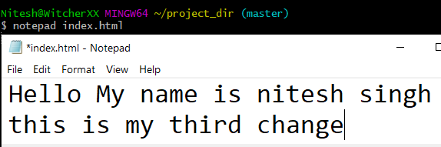
Ans: -

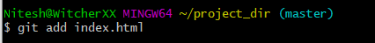
- Stage index.html
Ans: -

- Revert back the last stage.
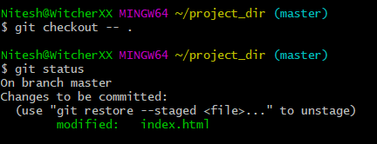
Ans: -

- Rename ‘add’ command to ‘my-add’.
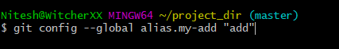
Ans: -

- Using my_add command Stage index.html again & commit the changes.
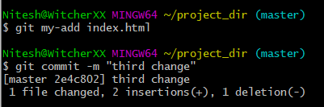
Ans:-
- Revert the last commit.
Ans: -

GIT Branching
SECTION-1 (HTML assignments) -
21. First take a backup of your assignments & projects. This is required because due to incorrect GIT operation you may lose your files.
Ans: -
22. Create an empty directory ‘Assignments’ & cd to ‘Assignments’.
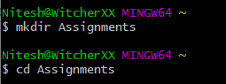
Ans: -

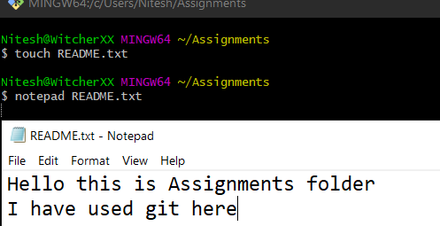
23. Create a file README.txt inside ‘Assignments’ & write few lines about the contents of ‘Assignments’ folder
Ans: -

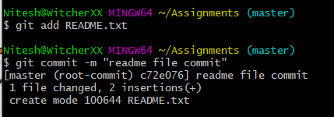
24. Commit README.txt file.
Ans: -

25. Now create a new branch ‘html-assignments’.
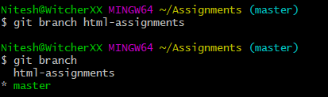
Ans: -

26. Switch to ‘html-assignments’ branch.
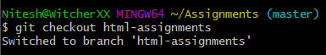
Ans: -

27. Copy all HTML assignments inside ‘Assignments’ folder
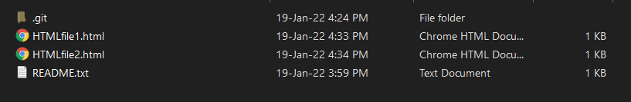
Ans: -

28. Commit HTML assignments into ‘html-assignments’ branch.
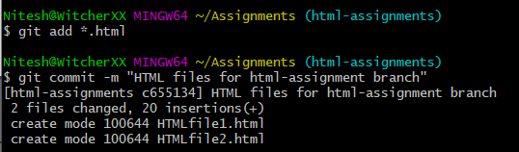
Ans: -

29. Make minor changes into few files belonging to ‘html-assignments’ branch
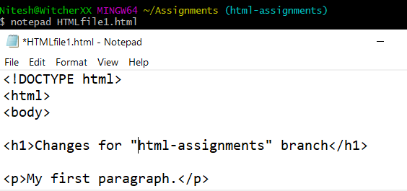
Ans: -

30. Commit those changed files.
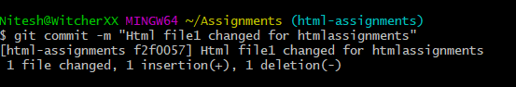
Ans: -

31. Switch to master branch.
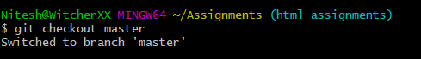
Ans: -

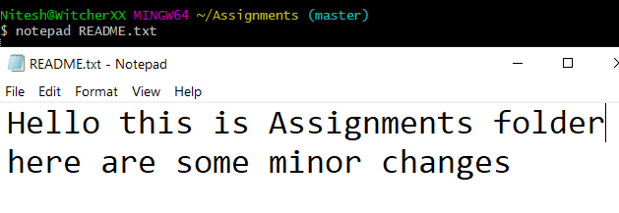
32. Make minor changes into README.txt file & commit those changes into master.
Ans: -

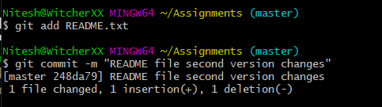

33. Again switch to ‘html-assignments’ branch.
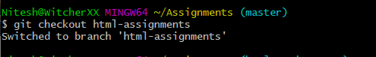
Ans: -

34. Make minor changes into few files belonging to ‘html-assignments’ branch.
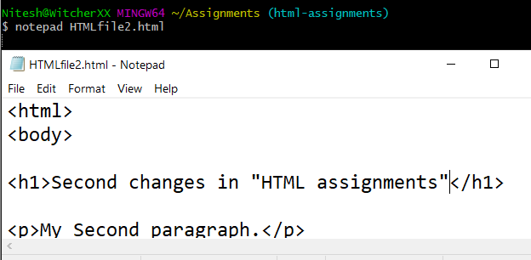
Ans: -

35. Commit those changes
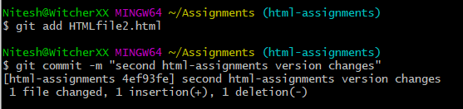
Ans: -

36. Switch to master.
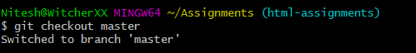
Ans: -

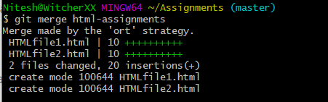
37. Merge ‘html-assignments’ branch into master. Confirm all html assignments are shown in master.
Ans: -

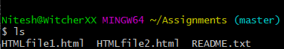

38. Finally delete the ‘html-assignments’ branch.
Ans: -
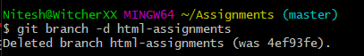

SECTION-2 - (CSS assignments)
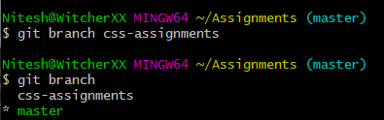
- Create a new branch ‘css-assignments’.
Ans: -

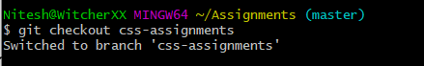
- Switch to ‘css-assignments’ branch.
Ans: -

- Copy all CSS assignments inside ‘Assignments’ folder.
Ans: - 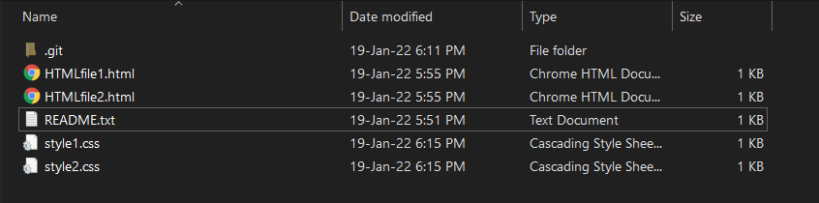
- Commit CSS assignments into ‘css-assignments’ branch
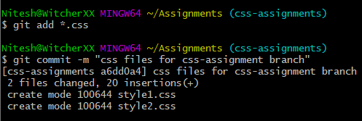
Ans: -

- Make minor changes into README.txt file on line 1 belonging to ‘css-assignments’ branch.
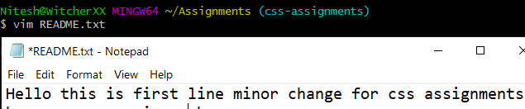
Ans: -

- Commit those changed files.
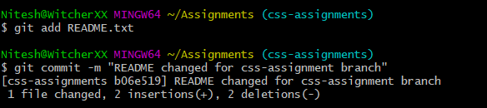
Ans: -

- Switch to master branch.
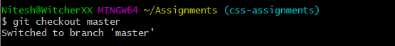
Ans: -

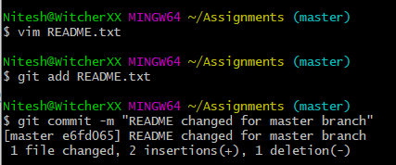
- Make minor changes into README.txt file on line 3 & commit those changes into master.
Ans: -

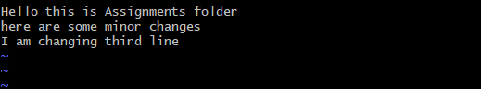

- Again switch to ‘css-assignments’ branch.
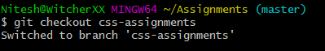
Ans: -

- Make minor changes into few files belonging to ‘css-assignments’ branch
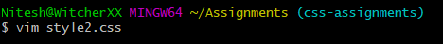
Ans: -

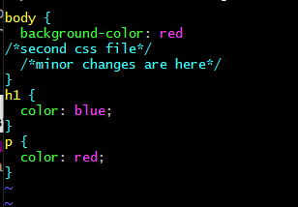

- Commit those changes.
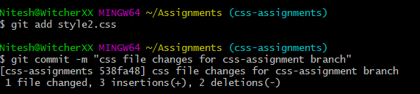
Ans:-

- Switch to master.
Ans: -

- Merge ‘css-assignments’ branch into master. Confirm all css assignments are shown in master.
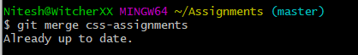
Ans: -

- Finally delete the ‘css-assignments’ branch.
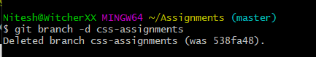
Ans: -

SECTION-3 - (JavaScript assignments)
- Create a new branch ‘js-assignments’.
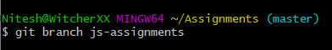
Ans: -

- Switch to ‘js-assignments’ branch.
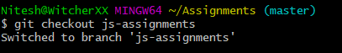
Ans: -

- Copy all JavaScript assignments inside ‘Assignments’ folder.
Ans: -

- Commit JavaScript assignments into ‘js-assignments’ branch.
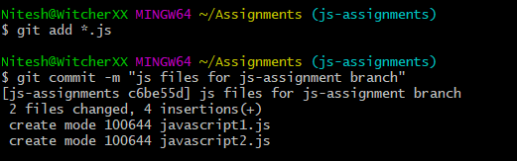
Ans: -

- Make minor changes into README.txt file on line 1 belonging to ‘js-assignments’ branch.
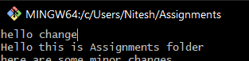
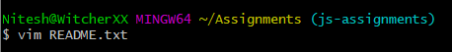
Ans: -

- Commit those changed files.
Ans: -
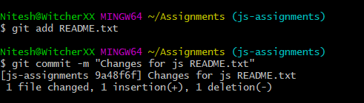

- Switch to master branch.
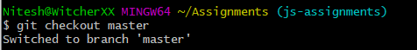
Ans: -

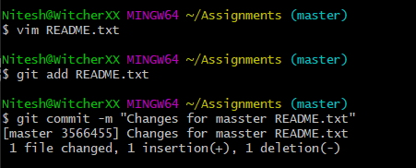
- Make minor changes into README.txt file on line 1 & commit those changes into master
Ans: -

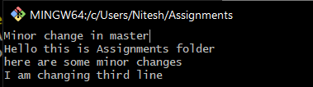

- Again switch to ‘js-assignments’ branch.
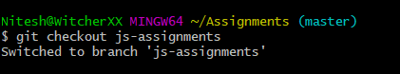
Ans: -

- Make minor changes into few files belonging to ‘js-assignments’ branch.
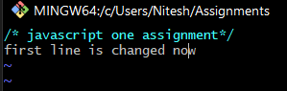
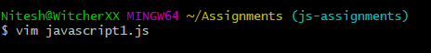
Ans: -

- Commit those changes.
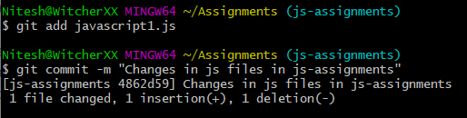
Ans: -

- Switch to master
Ans: -

- Merge ‘js-assignments’ branch into master. Confirm all JavaScript assignments are shown in master.
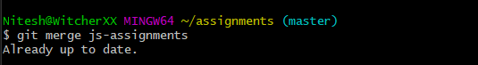
Ans: -

- Finally delete the ‘js-assignments’ branch.
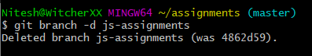
Ans: -

GIT Remoting
SECTION-1 (Pushing assignments to remote repository) –
39. Create a github account if you do not have already
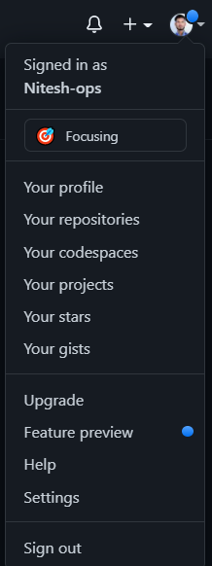
Ans: - I already have my github account here.

40. Login on into github account.
Ans: -

41. Create new public repository ‘freshersbatch-oct16’.
Ans: -
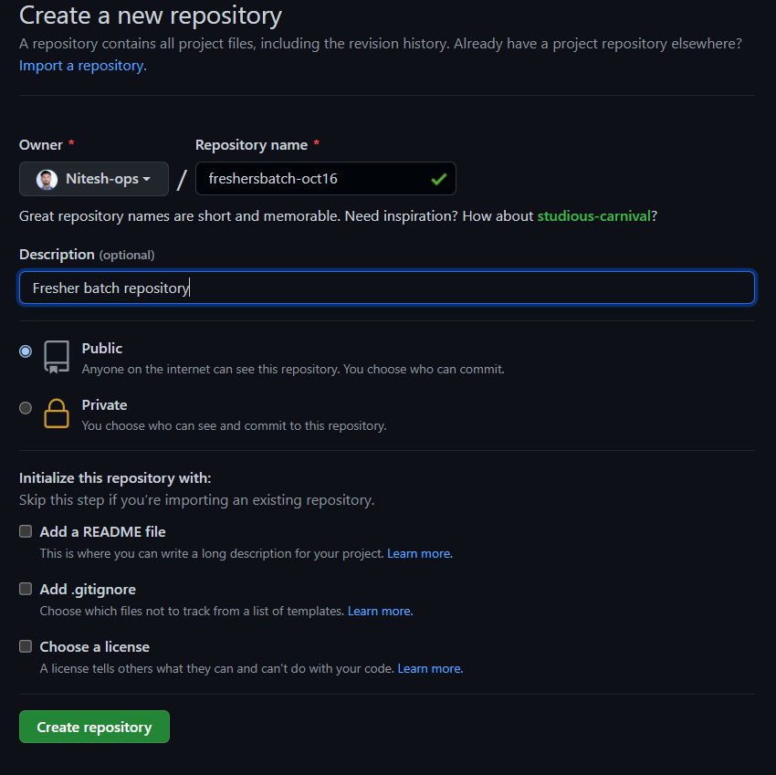

42. Commit & push any sample file to this repository under ‘Assignments’ directory.
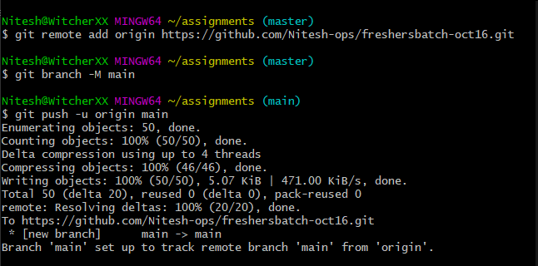
Ans: -

