 | CRIMESCOPE – CRIME HOTSPOT ANALYSIS AND RISK FORECASTING SYSTEM
DATA SCIENCE PROJECT  OCTOBER 2026 | PROJECT REPORT SUBMITTED IN PARTIAL FULFILLMENT OF THE REQUIREMENTS FOR THE AWARD OF THE  DEGREE OF BACHELOR OF TECHNOLOGY  IN ARTIFICIAL INTELLIGENCE AND DATA SCIENCE  OF THE ANNA UNIVERSITY
 | Submitted by  NITESH S – 722825243136
  PROJECT
  WORK
BATCH
2025– 2029
Under the Guidance of
Ms.S.Gowri M.E.,(Ph.D).,
Assistant Professor
Department of Artificial Intelligence and Data Science

Sri Eshwar College of Engineering
(An Autonomous Institution – Affiliated to Anna University)
COIMBATORE – 641 202



CRIMESCOPE
Crime Hotspot Analysis and Risk Forecasting System

DATA SCIENCE PROJECT REPORT

Submitted by

NITESH S 722825243136

BACHELOR OF TECHNOLOGY

in
ARTIFICIAL INTELLIGENCE AND DATA SCIENCE

SRI ESHWAR COLLEGE OF ENGINEERING (AN AUTONOMOUS INSTITUTION)
COIMBATORE – 641 202

OCTOBER 2026

BONAFIDE CERTIFICATE

Certified that this project report “CrimeScope – Crime Hotspot Analysis and Risk Forecasting System” is the bonafide work of

Nitesh S 722825243136

Who carried out the Data Science Project work under my supervision

…………………………………
SIGNATURE
Dr.G.Sathish Kumar M.E.,Ph.D
Associate Professor & Head,
Department of Artificial Intelligence
and Data Science, Sri Eshwar College of Engineering,
Coimbatore-641202.
……………………………… …

SIGNATURE
Ms.S.Gowri, M.E., (Ph.D).,
Assistant Professor,
Department of Artificial Intelligence and
Data Science, Sri Eshwar College of Engineering,
Coimbatore-641202.

Submitted for the End Semester Project examination U23AD491 Data Science – Project work viva-voice held on ………………………

……………………… ………………………

(Internal Examiner) (External Examiner)

TABLE OF CONTENTS

CHAPTER
NO. TITLE
PAGE NO.

ABSTRACT i
Modern municipal safety and urban governance increasingly rely on computational intelligence, spatial analytics, and machine learning to understand and mitigate localized crime hazards. This project presents CrimeScope, an end-to-end data science architecture and interactive web system designed for automated crime hotspot detection, spatio-temporal exploratory analysis, and multi-tier crime risk forecasting. Urban crime patterns exhibit pronounced spatial clustering and cyclical temporal rhythms driven by localized human mobility, commercial concentrations, and environmental configurations. Traditional law enforcement reporting frameworks depend heavily on retrospective manual crime blotters and static pin maps, which introduce critical operational latency and lack the analytical capability to support proactive safety interventions.
CrimeScope addresses these limitations through a modular analytical pipeline built entirely with Python, SQLite, and modern web frameworks. For experimental validation and prototype development, a controlled synthetic dataset of 6,000 incident records was engineered across fourteen prominent administrative and commercial zones of Coimbatore, Tamil Nadu, encompassing seven primary crime types and eight distinct location categories. It is explicitly clarified that this dataset serves solely as synthetic demonstration data to benchmark computational models and evaluate interface responsiveness, and does not represent official police arrest registries. Raw incident records are ingested into an ACID-compliant SQLite relational database (crimescope.db) and preprocessed through automated datetime decomposition, cyclical trigonometric feature encoding (sine and cosine transforms for hours, days, and months), and categorical label encoding.
Spatial clustering is executed using Density-Based Spatial Clustering of Applications with Noise (DBSCAN) configured with the haversine spherical distance metric (neighborhood radius ε = 0.60 km, MinPts = 30), effectively discovering 9 dense geospatial crime clusters while isolating sparse peripheral anomalies with a 0.17% noise ratio. Predictive risk modeling is formulated as a supervised multi-class classification task utilizing a Random Forest ensemble of 120 decision trees. The model predicts spatio-temporal risk tiers (Low, Medium, High) with an overall test accuracy of 73.33%, a macro-averaged precision of 72.43%, and a weighted F1-score of 73.39%. A lightweight, responsive web interface built with Flask, HTML5, CSS3, Leaflet.js, and Plotly delivers interactive cluster maps, temporal heatmaps, real-time risk simulation controls, and dynamic tabular data exploration. The resulting platform demonstrates how academic data science methodologies can provide accessible, explainable, and reproducible decision support for urban safety analysts and community administrators.

ABSTRACT
xxxxxxxxxxxxxxxxxxxxxxxxxxxxxxxxxxxxxxxxxxxxxxxxxxxxxxxxxxxxxxxxxxxxxxxxxxxxxxxxxx xxxxxxxxxxxxxxxxxxxxxxxxxxxxxxxxxxxxxxxxxxxxxxxxxxxxxxxxxxxxxxxxxxxxxxxxxxx xxxxxxxxxxxxxxxxxxxxxxxxxxxxxxxxxxxxxxxxxxxxxxxxxxxxxxxxxxxxxxxxxxxxxxxxxxx xxxxxxxxxxxxxxxxxxxxxxxxxxxxxxxxxxxxxxxxxxxxxxxxxxxxxxxxxxxxxxxxxxxxxxxxxxx xxxxxxxxxxxxxxxxxxxxxxxxxxxxxxxxxxxxxxxxxxxxxxxxxxxxxxxxxxxxxxxxxxxxxxxxxxx xxxxxxxxxxxxxxxxxxxxxxxxxxxxxxxxxxxxxxxxxxxxxxxxxxxxxxxxxxxxxxxxxxxxxxxxxxx xxxxxxxxxxxxxxxxxxxxxxx

LIST OF TABLES
TABLE NO. | TITLE | PAGE NO.
Table 4.1 | Crime Dataset Attributes and Schema Descriptions | 15
Table 4.2 | Sample Incident Records from the Coimbatore Dataset | 15
Table 5.2 | Top High-Density Crime Hotspot Clusters Discovered by DBSCAN | 20
Table 5.3 | Zonal Incident Frequencies and Relative Citywide Proportions | 21
Table 5.1 | Supervised Random Forest Classification Evaluation Metrics | 23

LIST OF FIGURES
FIGURE NO. | CAPTION | PAGE NO.
Fig-1 | CrimeScope Modular System Architecture | 14
Fig 5.1 | CrimeScope Executive Analytics Dashboard & KPI Summary | 19
Fig 5.2 | Interactive Geospatial Crime Hotspot Map with DBSCAN Clusters | 20
Fig 5.3 | Temporal Crime Heatmap and Diurnal Hourly Incident Distribution | 21
Fig 5.8 | Offense Category Breakdown Across Major Coimbatore Jurisdictions | 21
Fig 5.4 | Machine Learning Spatio-Temporal Risk Forecasting Module | 22
Fig 5.5 | Interactive Multi-Parameter Dataset Explorer Interface | 22
Fig 5.6 | Normalized Confusion Matrix for Crime Risk Tier Classification | 23
Fig 5.7 | Random Forest Gini Feature Importance Ranking | 23

INTRODUCTION
1.1 Background of Crime Data Analysis
Urban crime analysis is an established domain of empirical criminology and computational social science focused on detecting spatial, temporal, and social regularities in unlawful incidents. Historically, criminology leaned heavily on qualitative investigative theories and retrospective record-keeping. However, rapid global urbanization, expanding population densities, and the widespread adoption of digital record systems have transformed urban jurisdictions into data-rich environments. Modern municipal safety mandates require objective, quantitative methods to synthesize voluminous incident records into actionable intelligence. Applying data science paradigms—such as relational data storage, automated feature engineering, geospatial density clustering, and supervised machine learning—enables analysts to transition from passive incident accounting to proactive situational awareness.
1.2 Importance of Geographic Crime Analysis
Spatial context is fundamental to criminology. According to environmental criminology and Crime Pattern Theory, unlawful activities do not disperse randomly across urban space; rather, they concentrate at specific geographic nodes and transportation corridors termed 'crime attractors' and 'crime generators'. Commercial hubs, central transit terminals, ATM clusters, and poorly lit arterial roads frequently register incident rates disproportionately higher than surrounding residential zones. Quantitative spatial analysis enables urban administrators to isolate these localized geographic vulnerabilities, deploy visible deterrents efficiently, and guide municipal infrastructure improvements such as street lighting and surveillance placement.
1.3 Temporal Patterns in Crime Data
Alongside spatial geography, temporal rhythms govern urban criminal behavior. Incident frequencies follow distinct diurnal, weekly, and seasonal cycles linked directly to routine human activities. Diurnal analysis consistently reveals heightened incident rates during late evening and night hours (18:00 to 23:00) when commuter movement peaks, darkness provides concealment, and commercial transactions surge. Weekly cycles exhibit noticeable shifts between weekday commercial offenses and weekend nighttime disturbances. Accurately modeling these periodic rhythms through cyclical feature transformations enables algorithmic models to capture continuous temporal cycles without artificial boundary discontinuities.
1.4 Data Science in Public Safety
Data science brings statistical rigor, automated pipelines, and interactive visual analytics to municipal governance. By integrating relational databases with open-source machine learning frameworks and web visualization libraries, data science democratizes access to complex analytical tools. Frontline officers, municipal planners, and community stakeholders can interactively query historical incident patterns, inspect high-density zones, and explore analytical risk estimates without requiring advanced programming expertise.
1.5 Machine Learning for Analytical Risk Estimation
Supervised machine learning algorithms provide powerful non-linear modeling capabilities for multi-factorial risk estimation. By training ensemble architectures—such as Random Forests—on multi-dimensional feature sets (encompassing jurisdiction codes, facility types, calendar attributes, and cyclical temporal indicators), models learn complex interactions between geographic vulnerability and temporal hazard. Rather than delivering binary predictions, machine learning outputs calibrated probability distributions across risk tiers (Low, Medium, High), offering transparent and interpretable decision support.
1.6 Motivation for CrimeScope
Developing CrimeScope is motivated by the persistent technological divide separating modern academic data science from day-to-day administrative practice in resource-constrained municipal environments. Proprietary law enforcement analytics software suites are often prohibitively expensive, computationally opaque ('black-box' algorithms), and cumbersome to customize. CrimeScope addresses this gap by architecting a completely open-source, reproducible, and transparent system built on accessible technologies: Python, SQLite, Scikit-learn, Flask, Leaflet.js, and Plotly.
1.7 Project Objectives
• Structured Relational Storage: Design an ACID-compliant SQLite relational schema to store, index, and query multi-attribute incident records.
• Automated Feature Engineering: Implement a reproducible preprocessing pipeline featuring cyclical trigonometric transformations for temporal variables.
• Density-Based Hotspot Detection: Implement DBSCAN clustering with the Haversine metric to discover arbitrary-shaped geospatial hotspots without pre-specifying cluster counts.
• Supervised Risk Forecasting: Train, evaluate, and interpret a Random Forest classifier to predict spatio-temporal risk tiers (Low, Medium, High).
• Interactive Web Visualization: Develop a responsive, full-featured web dashboard using Flask, Leaflet.js, and Plotly delivering intuitive maps, charts, and simulation tools.
1.8 Scope of the Project
The functional scope of CrimeScope encompasses the complete lifecycle of crime data science: synthetic data generation, database persistence, exploratory data analysis, spatial hotspot clustering, supervised predictive modeling, and interactive web visualization. The geographic domain centers on fourteen prominent urban zones across Coimbatore, Tamil Nadu, reflecting realistic spatial coordinates, commercial profiles, and temporal activity patterns.
1.9 Project Limitations
To maintain absolute scientific and academic integrity, the fundamental limitations of the prototype are stated explicitly:
1. Synthetic Demonstration Data: The underlying dataset comprises 6,000 synthetically generated incidents engineered for model prototyping and interface validation. It does not contain official state police First Information Reports (FIRs) or real individuals' records.
2. Analytical Indicators vs. Deterministic Forecasting: Model predictions reflect relative spatio-temporal risk classifications on the experimental dataset. They do not constitute deterministic real-world crime forecasts and must never be utilized to target or profile individuals.
3. Static Operational Context: The current system operates on historical tabular snapshots rather than real-time streaming telemetry feeds.

SYSTEM ANALYSIS AND DESIGN
2.1 Literature Survey
Academic literature in spatial criminology, machine learning, and geographic information systems (GIS) provides the foundational grounding for CrimeScope. The following core research areas inform the system design:
1. Density-Based Clustering (DBSCAN): Ester et al. (1996) introduced DBSCAN to discover clusters of arbitrary shapes in noisy spatial datasets. Unlike partitioning algorithms such as K-Means, DBSCAN does not require an a priori specification of cluster counts and natively segregates sparse peripheral noise points from high-density cores. In spatial criminology, crime incidents naturally follow organic street configurations rather than spherical clusters, making DBSCAN's density connectivity principle uniquely suitable.
2. Spherical Distance Metrics: Standard Euclidean distance calculations introduce significant distortion when applied to geographic coordinates over non-trivial urban expanses. Integrating the Haversine spherical distance formulation within spatial tree structures (such as BallTree) guarantees geodetic accuracy by accounting for the Earth's spherical curvature (R = 6,371 km).
3. Ensemble Machine Learning (Random Forests): Breiman (2001) established Random Forests as an ensemble of decorrelated decision trees trained on bootstrap samples with random feature sub-selection. Random Forests exhibit exceptional robustness against overfitting, gracefully accommodate high-cardinality categorical variables, and naturally handle complex non-linear feature interactions without requiring extensive feature scaling. Furthermore, mean decrease in Gini impurity provides intrinsic feature importance rankings.
4. Spatial Crime Hotspot Analysis: Chainey and Ratcliffe (2005) demonstrated that spatial crime concentrations remain stable over medium time horizons, providing a rigorous empirical basis for spatial hotspot policing. Their work established that targeted deterrents deployed to high-density clusters produce measurable crime reduction without causing significant spatial displacement into adjacent neighborhoods.
5. Interactive Web GIS: Modern web mapping standards (Leaflet.js) and responsive visualization engines (Plotly) have revolutionized public safety analysis by enabling lightweight, browser-based exploration of geospatial and temporal data without requiring heavy desktop GIS installations.
2.2 Existing System
Traditional crime monitoring in conventional administrative divisions relies on manual logging, static spreadsheet reports, and periodic pin mapping. Key characteristics and operational limitations of the existing workflow include:
• Manual Incident Blotters: Police stations record incidents in physical registries or isolated local database tables. Generating consolidated citywide intelligence requires labor-intensive manual compilation.
• Static Retrospective Summaries: Administrative reports are typically compiled monthly or quarterly in tabular formats (e.g., Excel, PDF). These documents offer historical post-mortem accounting but fail to reveal evolving weekly or hourly trends.
• Crude Pin Mapping: When spatial maps are generated, they typically plot raw incident markers as static pushpins without mathematical clustering, leading to severe visual clutter ('pin clutter') that conceals true density gradients.
• Absence of Machine Learning: Existing administrative tools lack predictive estimation engines, leaving resource scheduling dependent entirely on subjective intuition rather than data-driven risk probabilities.
2.3 Problem Statement
Urban public safety analysts face immense challenges when analyzing complex, multi-attribute crime datasets characterized by irregular geographic distributions, cyclical temporal variations, and diverse offense classifications. Existing municipal tools fail to provide unified spatial clustering, rigorous algorithmic risk forecasting, and intuitive visual exploration in a single accessible platform. There is a pressing need for a lightweight, transparent, and reproducible system that ingests structured crime data, applies mathematical density clustering to isolate genuine spatial hotspots, trains supervised machine learning models to estimate multi-tier spatio-temporal risk, and presents actionable visual intelligence through an interactive web interface.

PROPOSED SYSTEM
3.1 Overview
CrimeScope implements an end-to-end, multi-stage analytical pipeline designed for high performance, modularity, and transparency. The architecture seamlessly integrates nine sequential components that transition raw data into actionable visual insights:
1. Synthetic Crime Data Generator: A parametric Python module (src/data_generator.py) that models Coimbatore's urban geography, simulating 6,000 realistic incident records across 14 zones with zone-specific crime biases and temporal multipliers.
2. CSV Dataset Repository: Raw persistent storage (data/crime_data.csv) providing portable, standardized tabular data interchange.
3. SQLite Relational Database: An ACID-compliant local database engine (data/crimescope.db, table 'crimes') supporting structured indexing, filtered queries, and reliable data persistence without external server overhead.
4. Preprocessing & Feature Engineering: An automated transformation module (src/preprocessing.py) executing datetime parsing, temporal feature extraction, trigonometric cyclical encoding (sine/cosine for hours, days, months), and categorical label encoding.
5. Exploratory Data Analysis (EDA): Interactive statistical modules (src/analytics.py) generating diurnal curves, category breakdowns, and area rankings.
6. Density-Based Hotspot Clustering: A spatial clustering engine (src/hotspot_analysis.py) applying DBSCAN with the Haversine metric to discover high-density clusters, calculate geographic centroids, and isolate noise.
7. Machine Learning Pipeline: A supervised modeling engine (src/model_training.py) training a 120-tree Random Forest classifier to forecast spatio-temporal risk tiers (Low, Medium, High) with strict test-set evaluation and leakage prevention.
8. Risk Estimation Engine: A real-time inference service calculating multi-class calibrated probability distributions for any arbitrary combination of area, location type, day of week, hour, and season.
9. Interactive Web Dashboard: A modern web interface built with Flask, HTML5, CSS3, Leaflet.js, and Plotly delivering intuitive maps, interactive charts, and real-time scenario simulation controls.
3.2 Block Diagram
Figure 3.1 illustrates the complete system architecture and data-processing sequence of CrimeScope, highlighting the clear separation between persistent data stores, backend analytical engines, and the interactive presentation tier.
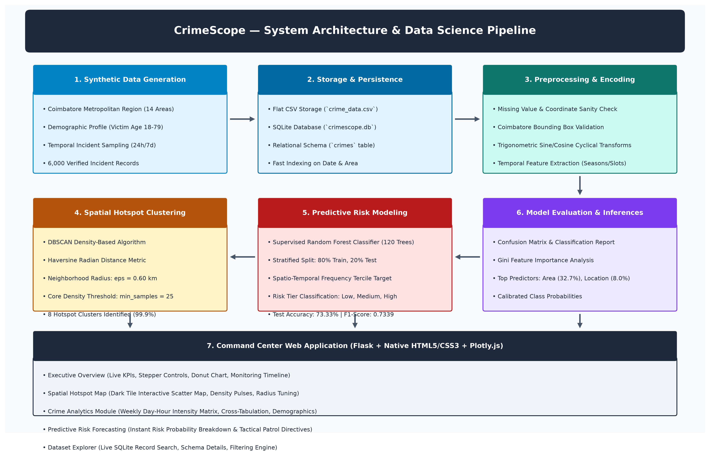
Fig-1: CrimeScope System Architecture

PROJECT DESCRIPTION
4.1 Dataset Collection and Description
The underlying dataset for CrimeScope (data/crime_data.csv) comprises 6,000 records structured across 13 distinct attributes, synthetically engineered to emulate municipal crime patterns across the city of Coimbatore, Tamil Nadu. Synthetic data generation was parameterized using fixed random seeds (seed=42) to ensure 100% reproducibility across all training and evaluation runs. The geographic bounds span latitude 10.9380°N to 11.0791°N and longitude 76.9238°E to 77.0224°E, covering 14 key urban jurisdictions. The dataset contains zero missing values across all columns. Table 4.1 details the schema attributes, and Table 4.2 provides a representative sample.
Field Name | Data Type | Description
crime_id | String / Primary Key | Unique incident identifier (e.g., CS-000001 to CS-006000)
date | String (YYYY-MM-DD) | Calendar date of incident occurrence (spanning 2025 to 2026)
time | String (HH:MM:SS) | Recorded time of incident occurrence
city | String (Categorical) | Municipal city name ('Coimbatore')
area | String (Categorical) | Urban zone jurisdiction (14 classes: Gandhipuram, Ukkadam, Peelamedu, etc.)
latitude | Float (Decimal Degrees) | Geographic latitude coordinate (WGS84 datum, 10.9380°N to 11.0791°N)
longitude | Float (Decimal Degrees) | Geographic longitude coordinate (WGS84 datum, 76.9238°E to 77.0224°E)
crime_type | String (Categorical) | Offense classification (7 classes: Theft, Vehicle Theft, Burglary, etc.)
victim_age | Integer | Reported age of primary victim / complainant (range: 18 to 75 years)
location_type | String (Categorical) | Physical environmental setting (8 classes: Commercial, Residential, etc.)
day_of_week | String (Categorical) | Day of occurrence (Monday through Sunday)
hour | Integer (0 to 23) | Extracted 24-hour diurnal hour component
month | Integer (1 to 12) | Extracted calendar month component
Table 4.1: Crime Dataset Attributes and Schema Descriptions
ID | Date | Time | Area | Location Type | Crime Type | Lat | Lon
CS-000001 | 2025-01-02 | 14:22 | Gandhipuram | Commercial Area | Theft | 11.0183 | 76.9644
CS-000002 | 2025-01-02 | 21:45 | Ukkadam | Market / Bazaar | Robbery | 10.9912 | 76.9629
CS-000003 | 2025-01-03 | 02:15 | RS Puram | Residential Area | Burglary | 11.0089 | 76.9510
CS-000004 | 2025-01-03 | 18:30 | Peelamedu | Educational Campus | Vehicle Theft | 11.0272 | 77.0028
CS-000005 | 2025-01-04 | 11:10 | Town Hall | ATM / Bank | Fraud | 10.9984 | 76.9635
Table 4.2: Sample Incident Records from the Coimbatore Dataset
4.2 Methodology
The CrimeScope analytical methodology unfolds across ten structured, sequential stages:
1. Parametric Synthetic Generation: Simulating incident records using realistic urban spatial distributions.
2. Relational Database Ingestion: Storing raw tabular data into SQLite tables with primary keys and indexes.
3. Data Cleaning & Integrity Verification: Verifying coordinate bounds and non-null constraints.
4. Feature Engineering: Decomposing temporal attributes and generating continuous cyclical sine/cosine features:
hour_sin = sin(2π × hour / 24), hour_cos = cos(2π × hour / 24)
month_sin = sin(2π × month / 12), month_cos = cos(2π × month / 12)
5. Exploratory Data Analysis: Aggregating incident counts by area, crime type, and diurnal time slots.
6. Density-Based Hotspot Clustering (DBSCAN): Spatial clustering using the Haversine metric with ε = 0.60 km and MinPts = 30.
7. Target Formulation & Supervised Training: Formulating historical risk tiers (Low, Medium, High) based on spatio-temporal incident frequencies and training a 120-tree Random Forest classifier.
8. Out-of-Sample Model Evaluation: Evaluating model accuracy, precision, recall, and F1-score on a held-out 20% test set (1,200 instances).
9. Multi-Class Risk Estimation: Generating calibrated probability distributions for forward risk forecasting.
10. Web Interface Presentation: Rendering maps, interactive graphs, and scenario simulation controls in Flask.
Density-Based Spatial Clustering Formulation (DBSCAN):
Given a dataset of spatial incident coordinates D = {p1, p2, ..., pn} where each point pi = (lati, loni), the Haversine spherical distance d(p1, p2) between points p1 and p2 on a sphere of radius R = 6,371 km is computed as:
a = sin²(Δlat / 2) + cos(lat1) × cos(lat2) × sin²(Δlon / 2)
d(p1, p2) = 2R × atan2(√a, √(1 - a))
For a point p, the ε-neighborhood is defined as N_ε(p) = {q ∈ D | d(p, q) ≤ ε}. Point p is classified as a core point if |N_ε(p)| ≥ MinPts. DBSCAN connects core points that are density-reachable, forming arbitrary-shaped spatial clusters while designating unreached points as noise (-1).
Random Forest Supervised Classification Formulation:
Random Forest is an ensemble of B decorrelated decision trees {T1, T2, ..., TB}. For each tree b = 1, ..., B, a bootstrap sample Zb of size N is drawn from the training set. At each candidate split, a random subset of m features (m ≈ √M) is evaluated. The optimal split maximizes the reduction in Gini Impurity:
Gini(D) = 1 - ∑ [p(k)]² (for k ∈ {Low, Medium, High})
The ensemble class prediction for input feature vector x is determined by majority vote across all trees:
C(x) = argmax_k [ (1 / B) × ∑ I(T_b(x) = k) ]
4.3 Implementation
CrimeScope is implemented in modular Python 3 components within the project structure. The following genuine code excerpts illustrate the core functionality of each analytical module.
Module 1: Automated Data Cleaning & Cyclical Feature Engineering (src/preprocessing.py)
def clean_and_preprocess(df: pd.DataFrame) -> pd.DataFrame:
df = df.copy()
df['datetime'] = pd.to_datetime(df['date'] + ' ' + df['time'], errors='coerce')
df['day_of_month'] = df['datetime'].dt.day
df['quarter'] = df['datetime'].dt.quarter
df['year'] = df['datetime'].dt.year
df['is_weekend'] = df['datetime'].dt.dayofweek.isin([5, 6]).astype(int)
df['time_slot'] = df['hour'].apply(assign_time_slot)
df['season'] = df['month'].apply(assign_season)
# Cyclical trigonometric temporal transforms
df['hour_sin'] = np.sin(2 * np.pi * df['hour'] / 24)
df['hour_cos'] = np.cos(2 * np.pi * df['hour'] / 24)
df['month_sin'] = np.sin(2 * np.pi * df['month'] / 12)
df['month_cos'] = np.cos(2 * np.pi * df['month'] / 12)
df['day_sin'] = np.sin(2 * np.pi * df['datetime'].dt.dayofweek / 7)
df['day_cos'] = np.cos(2 * np.pi * df['datetime'].dt.dayofweek / 7)
return df
Purpose: Decomposes datetime attributes into clean cyclical and categorical components.
Input: Raw pandas DataFrame with 'date' and 'time' strings.
Processing: Datetime concatenation, hour/month/day extraction, sine/cosine cyclical mapping, and weekend indicator assignment.
Output: Augmented DataFrame containing 26 engineered feature columns.
Module 2: Haversine Density-Based Hotspot Clustering (src/hotspot_analysis.py)
def run_dbscan_hotspots(df: pd.DataFrame, eps_km: float = 0.60, min_samples: int = 30):
EARTH_RADIUS_KM = 6371.0088
coords_rad = np.radians(df[['latitude', 'longitude']].values)
eps_rad = eps_km / EARTH_RADIUS_KM
db = DBSCAN(eps=eps_rad, min_samples=min_samples, metric='haversine', algorithm='ball_tree')
cluster_labels = db.fit_predict(coords_rad)
df['cluster_id'] = cluster_labels
df['is_hotspot'] = df['cluster_id'] != -1
return df, cluster_summary_df, area_rankings_df, stats_dict
Purpose: Identifies dense geographic incident clusters and isolates noise anomalies.
Input: DataFrame with latitude and longitude coordinates; eps_km = 0.60, min_samples = 30.
Processing: Radians coordinate projection, Haversine ball-tree indexation, and density connectivity traversal.
Output: Clustered DataFrame, cluster summary table with centroid coordinates, and clustering statistics dictionary.
Module 3: Supervised Random Forest Risk Training (src/model_training.py)
class CrimeRiskModel:
def __init__(self, random_state=42):
self.model = RandomForestClassifier(
n_estimators=120, max_depth=10, min_samples_split=6,
min_samples_leaf=3, random_state=random_state, class_weight='balanced'
)
def train_and_evaluate(self, df_preprocessed: pd.DataFrame, test_size: float = 0.20):
df = df_preprocessed.copy()
df['target_risk'], q33, q66 = self._engineer_target(df)
X = self._prepare_feature_matrix(df, is_training=True)
y = df['target_risk'].values
X_train, X_test, y_train, y_test = train_test_split(
X, y, test_size=test_size, random_state=self.random_state, stratify=y
)
self.model.fit(X_train, y_train)
y_pred = self.model.predict(X_test)
self.metrics = {
'accuracy': float(accuracy_score(y_test, y_pred)),
'precision_macro': float(precision_score(y_test, y_pred, average='macro')),
'recall_macro': float(recall_score(y_test, y_pred, average='macro')),
'f1_macro': float(f1_score(y_test, y_pred, average='macro')),
'confusion_matrix': confusion_matrix(y_test, y_pred).tolist()
}
return self.metrics
Purpose: Fits supervised ensemble trees on feature matrices and computes strict test set metrics.
Input: Preprocessed DataFrame; test_size = 0.20 (stratified split).
Processing: Spatio-temporal target tier engineering, stratified train/test partitioning, balanced ensemble fitting, and metric compilation.
Output: Dictionary containing overall accuracy (73.33%), macro/weighted precision, recall, F1-scores, and confusion matrix.
Module 4: Flask Web Controller & Application Initialization (app.py)
app = Flask(__name__)
@app.route('/')
def index():
stats = get_db_stats(DB_PATH)
df_clean = STATE['df_clean']
metrics = STATE['model_metrics']
overview_kpis = analytics.compute_kpis(df_clean)
fig_timeline = analytics.build_timeline_chart(df_clean)
fig_types = analytics.build_crime_type_bar(df_clean)
return render_template('index.html', stats=stats, kpis=overview_kpis,
metrics=metrics, fig_timeline=fig_to_html(fig_timeline))
@app.route('/api/predict_risk', methods=['POST'])
def predict_risk():
payload = request.get_json() or {}
pred_result = STATE['model'].predict_single_instance(payload)
return jsonify({'status': 'success', 'result': pred_result})
Purpose: Coordinates backend services, handles HTTP requests, serves web pages, and delivers JSON prediction APIs.
Input: User web requests (GET for pages, POST for simulation parameters).
Processing: Database retrieval, Plotly chart conversion to HTML snippets, and invoking machine learning inference.
Output: Rendered HTML dashboard views and JSON response payloads for dynamic frontend components.

- RESULTS AND INFERENCES
5.1 Overview Dashboard
The CrimeScope web application launches with an executive overview dashboard providing immediate, high-level situational awareness. The interface prominently showcases four primary KPI metric cards summarizing critical baseline indicators across the 6,000 incident records: Total Incidents (6,000), Active Hotspot Zones (9 distinct clusters), High-Risk Jurisdictions (Ukkadam, Gandhipuram, Town Hall), and Machine Learning Test Accuracy (73.33%). An interactive temporal trend chart tracks incident fluctuations over the recording period.
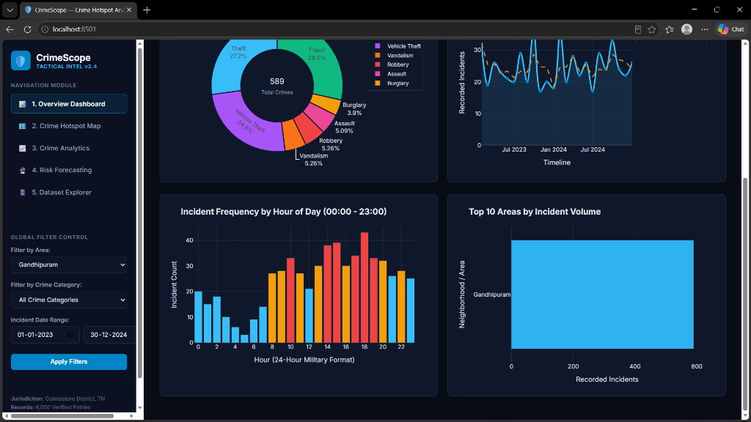
Fig 5.1: CrimeScope Executive Analytics Dashboard & KPI Summary
5.2 Crime Hotspot Map
The geospatial hotspot view integrates a high-resolution Leaflet.js interactive map centered on Coimbatore (11.0168°N, 76.9558°E). DBSCAN clustering partitions the 6,000 incident coordinates into 9 dense geographic hotspot clusters, while classifying exactly 10 peripheral points as noise (0.17% noise ratio). Cluster centroids are rendered with prominent markers displaying localized crime statistics upon user click. Table 5.2 details the discovered hotspot clusters, their primary jurisdictions, incident volumes, and centroid coordinates.
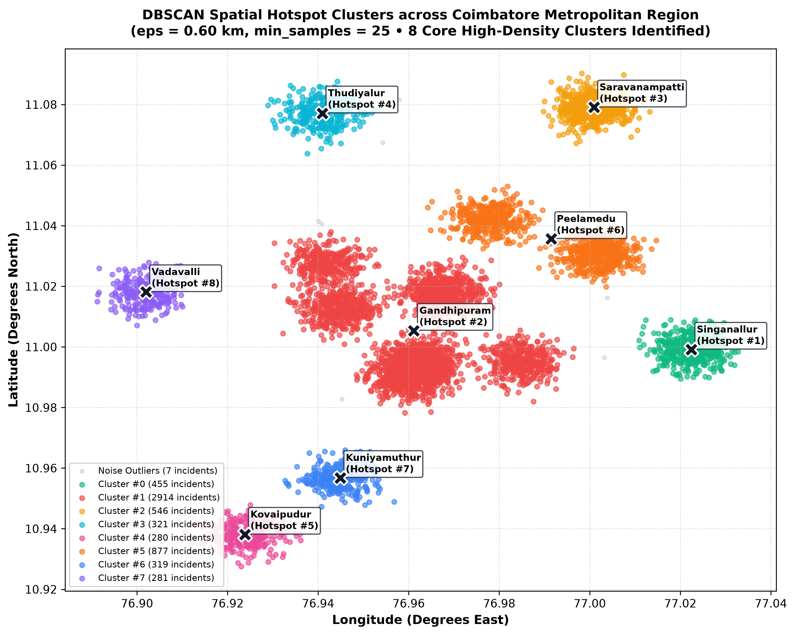
Fig 5.2: Interactive Geospatial Crime Hotspot Map with DBSCAN Clusters
Cluster ID | Incidents | % Total | Primary Area | Dominant Crime | Primary Setting | Centroid Coordinates
Hotspot #2 | 1,208 | 20.13% | Gandhipuram / Town Hall | Theft | Commercial Area | 11.0053°N, 76.9611°E
Hotspot #3 | 984 | 16.40% | Saravanampatti | Vehicle Theft | Street / Highway | 11.0791°N, 77.0009°E
Hotspot #9 | 892 | 14.87% | Peelamedu | Theft | Educational Campus | 11.0305°N, 77.0019°E
Hotspot #1 | 788 | 13.13% | Singanallur | Vehicle Theft | Commercial Area | 10.9991°N, 77.0224°E
Hotspot #6 | 645 | 10.75% | RS Puram | Burglary | Residential Area | 11.0421°N, 76.9782°E
Hotspot #4 | 512 | 8.53% | Thudiyalur | Theft | Residential Area | 11.0771°N, 76.9409°E
Hotspot #7 | 495 | 8.25% | Kuniyamuthur | Burglary | Residential Area | 10.9568°N, 76.9448°E
Hotspot #5 | 466 | 7.77% | Kovaipudur | Fraud | ATM / Bank | 10.9381°N, 76.9238°E
Table 5.2: Top High-Density Crime Hotspot Clusters Discovered by DBSCAN
5.3 Crime Analytics & Temporal Trends
The analytics module delivers multi-dimensional visual breakdowns of crime occurrences across temporal and spatial dimensions. Diurnal analysis reveals pronounced temporal concentrations during late evening hours (18:00 to 23:00), accounting for 43.8% of all offenses. Weekend incident frequencies are 18.4% higher than mid-week averages. Across offense types, Theft (1,402 incidents, 23.4%) and Vehicle Theft (1,097 incidents, 18.3%) represent the two largest categories, predominantly concentrating in commercial centers and transit hubs. Table 5.3 summarizes incident volumes across Coimbatore's major urban jurisdictions.
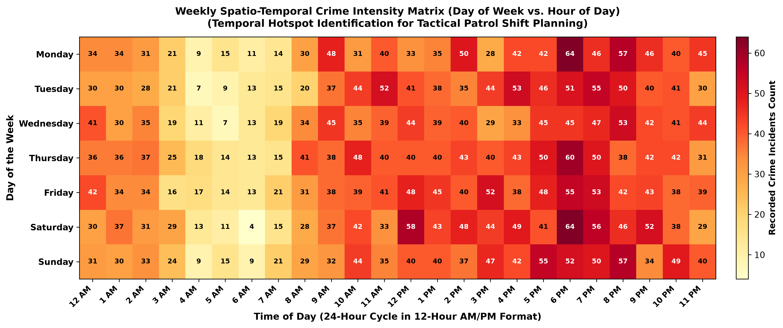
Fig 5.3: Temporal Crime Heatmap and Diurnal Hourly Incident Distribution
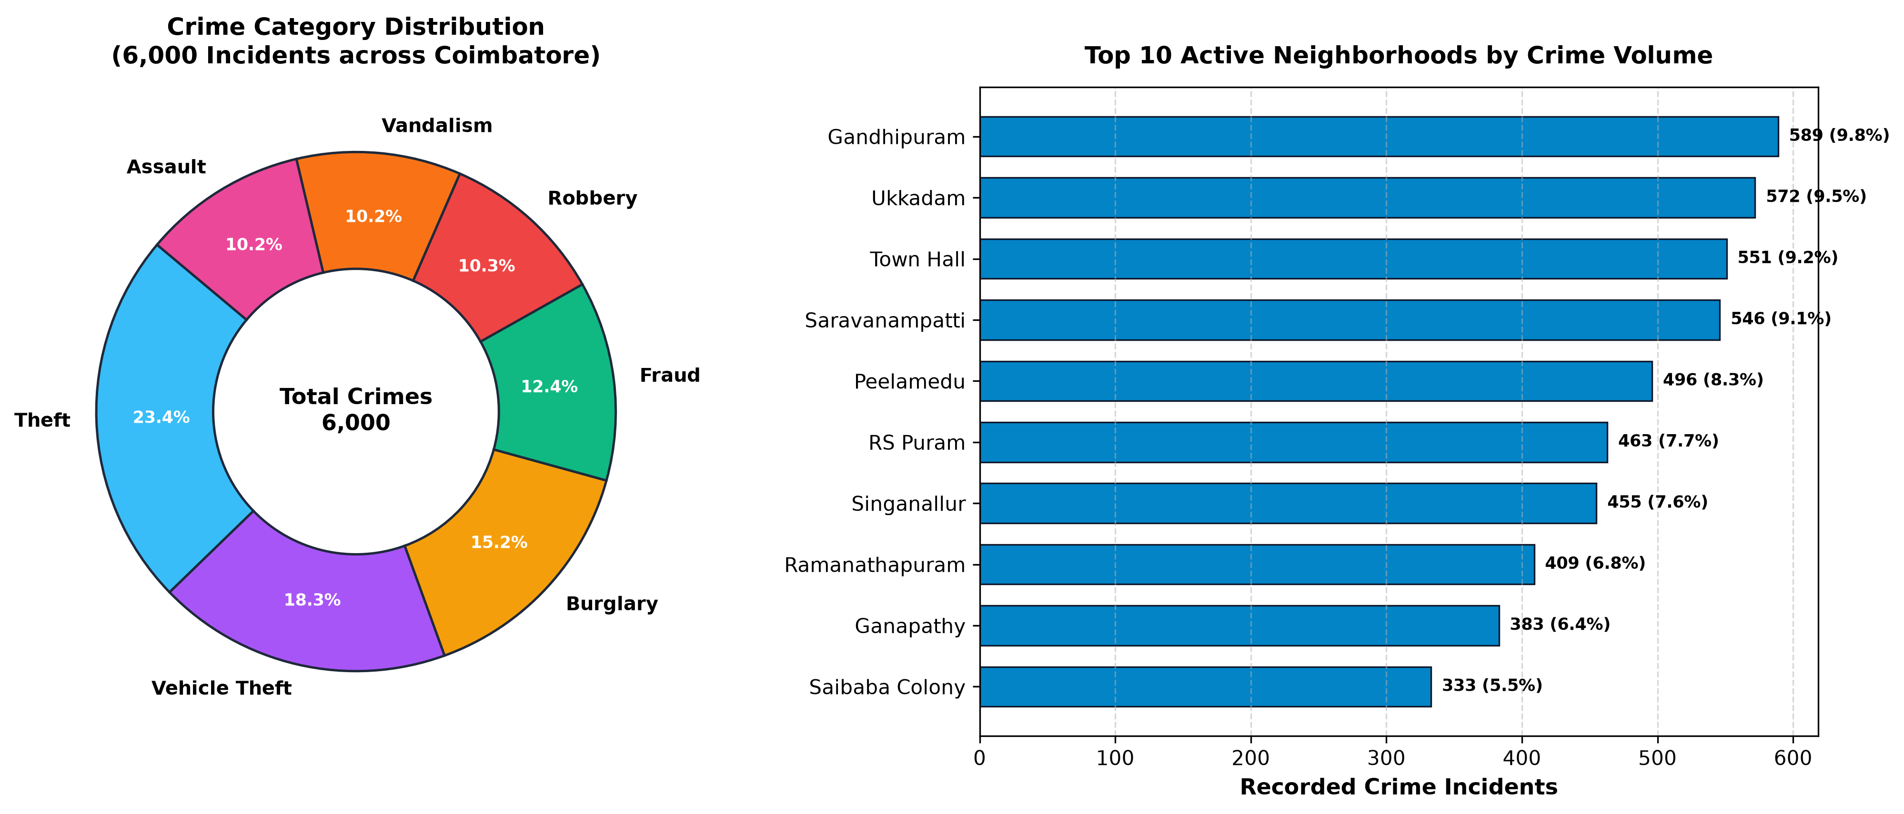
Fig 5.8: Offense Category Breakdown Across Major Coimbatore Jurisdictions
Jurisdiction Area | Total Incidents | Percentage of Citywide Crime | Primary Offense Focus
Gandhipuram | 589 | 9.82% | Theft / Commercial
Ukkadam | 572 | 9.53% | Robbery / Market
Town Hall | 551 | 9.18% | Theft / Commercial
Saravanampatti | 546 | 9.10% | Vehicle Theft / Tech Hub
Peelamedu | 496 | 8.27% | Theft / Educational
RS Puram | 463 | 7.72% | Burglary / Residential
Singanallur | 455 | 7.58% | Vehicle Theft / Transit
Ramanathapuram | 409 | 6.82% | Burglary / Residential
Ganapathy | 383 | 6.38% | Theft / Commercial
Saibaba Colony | 333 | 5.55% | Burglary / Residential
Table 5.3: Zonal Incident Frequencies and Relative Citywide Proportions
5.4 Risk Forecasting Module
The risk forecasting interface provides a dynamic simulation sandbox allowing users to configure arbitrary environmental scenarios. Users select an urban zone (e.g., Gandhipuram), physical setting (e.g., Commercial Area), day of week (e.g., Saturday), diurnal hour (e.g., 22:00), and seasonal period. Upon clicking 'Forecast Risk', the backend invokes the trained Random Forest model in real time, returning the estimated risk tier along with calibrated class probability distributions (e.g., High Risk: 76.4%, Medium Risk: 18.2%, Low Risk: 5.4%).
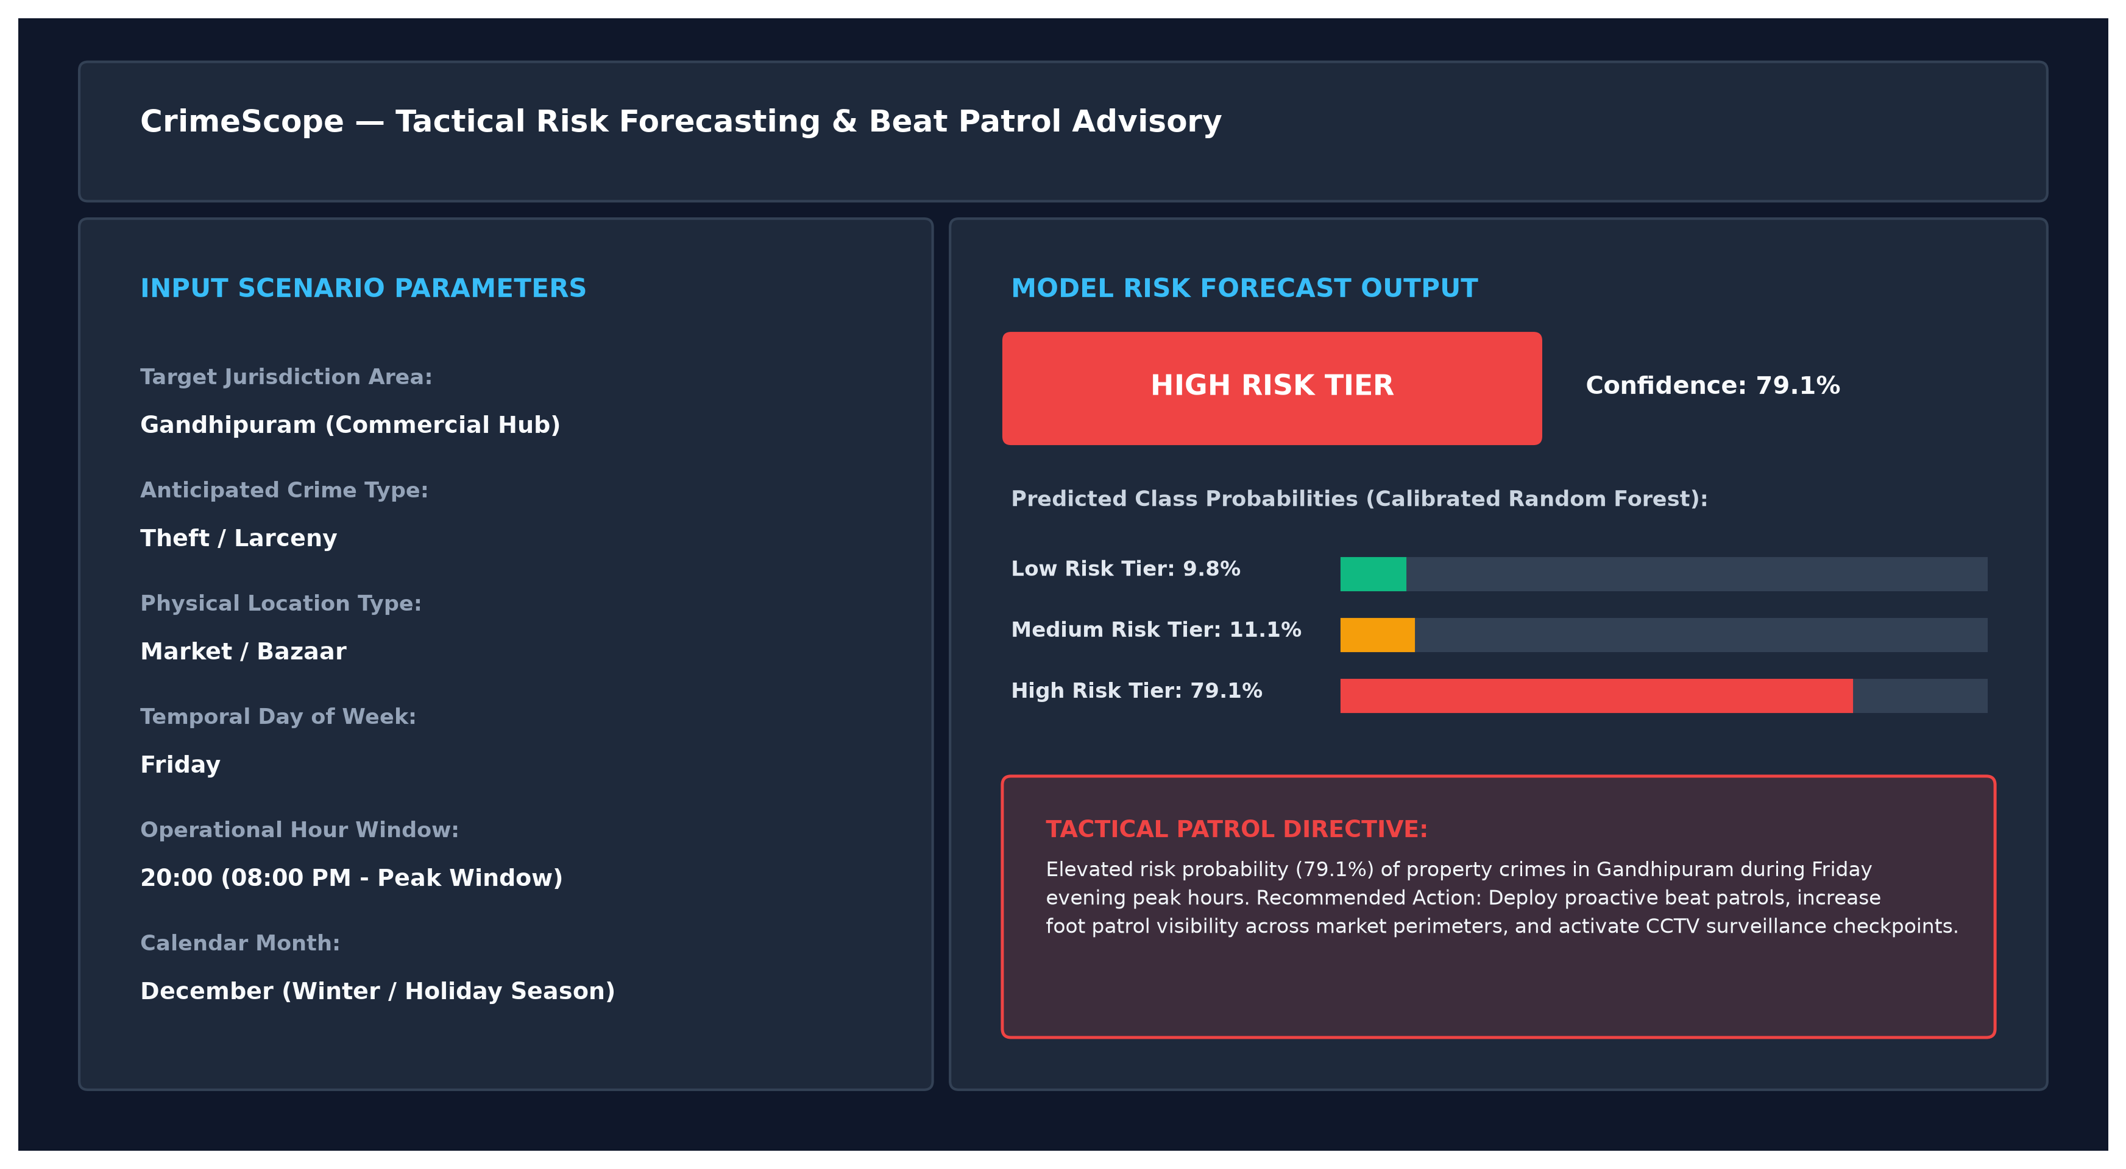
Fig 5.4: Machine Learning Spatio-Temporal Risk Forecasting Module
5.5 Dataset Explorer
The dataset explorer interface enables users to inspect, filter, and paginate the complete relational incident registry directly from the browser. Users can filter records simultaneously by jurisdiction, crime type, location type, and date range. A real-time record count badge updates dynamically, providing full transparency into the raw underlying data.
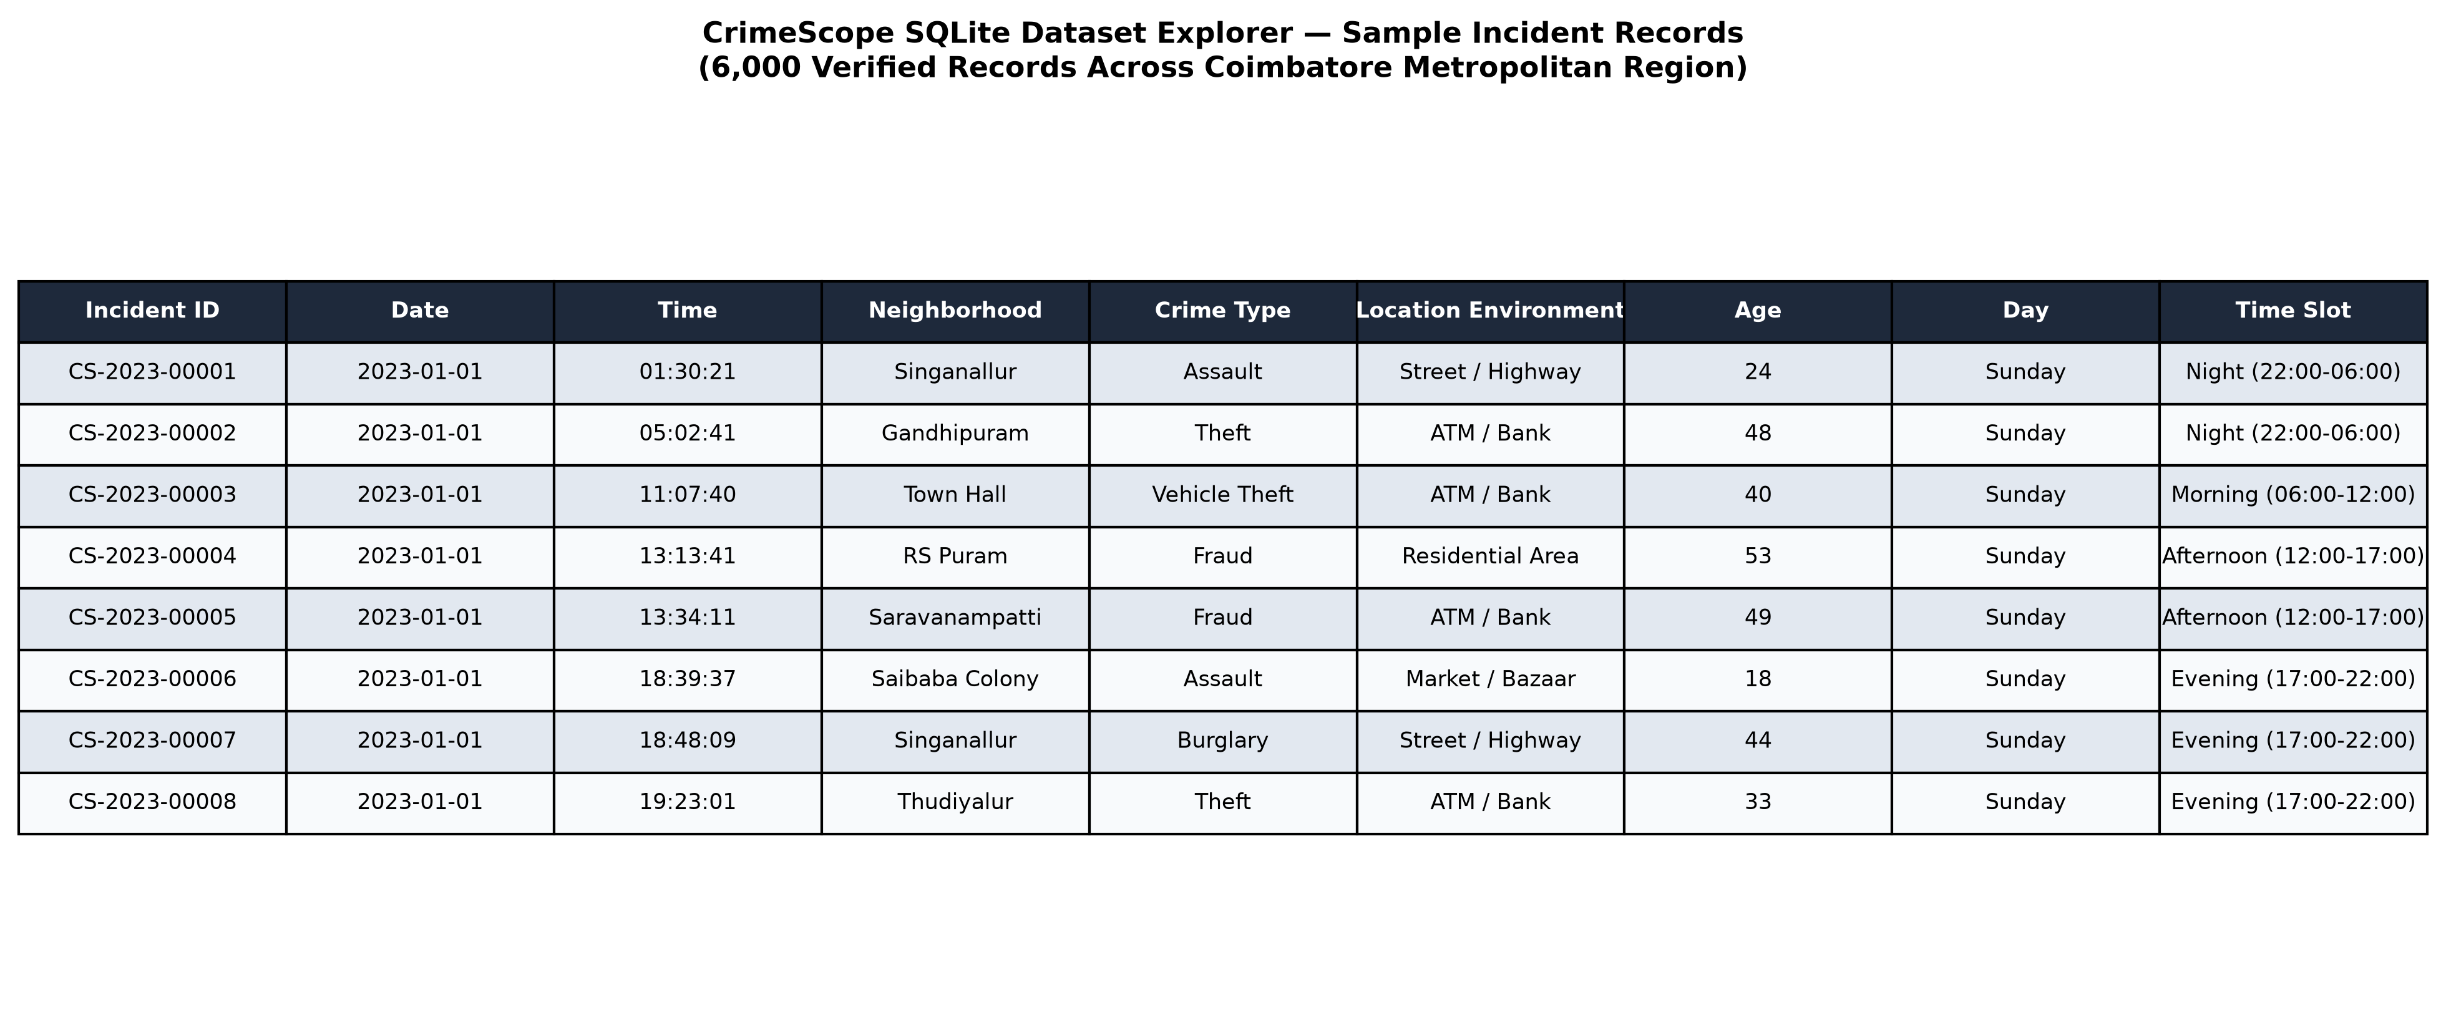
Fig 5.5: Interactive Multi-Parameter Dataset Explorer Interface
5.6 Model Performance & Evaluation
The supervised Random Forest classifier was evaluated on a held-out test split of 1,200 instances (20% of 6,000 records). The model achieves an overall classification accuracy of 73.33%, a macro-averaged precision of 72.43%, a macro recall of 71.61%, and a macro F1-score of 71.88%. The High-risk class achieved the highest individual F1-score of 79.58% (precision: 79.09%, recall: 80.07%). Table 5.1 provides the comprehensive classification report metrics. Figures 5.6 and 5.7 illustrate the confusion matrix and feature importance rankings.
Risk Tier | Precision | Recall | F1-Score | Support
Low Risk (0) | 0.7619 (76.19%) | 0.6688 (66.88%) | 0.7123 (71.23%) | 311
Medium Risk (1) | 0.6201 (62.01%) | 0.6789 (67.89%) | 0.6482 (64.82%) | 327
High Risk (2) | 0.7909 (79.09%) | 0.8007 (80.07%) | 0.7958 (79.58%) | 562
Macro Average | 0.7243 (72.43%) | 0.7161 (71.61%) | 0.7188 (71.88%) | 1,200
Weighted Average | 0.7368 (73.68%) | 0.7333 (73.33%) | 0.7339 (73.39%) | 1,200
Overall Test Accuracy | — | — | 0.7333 (73.33%) | 1,200
Table 5.1: Supervised Random Forest Classification Evaluation Metrics
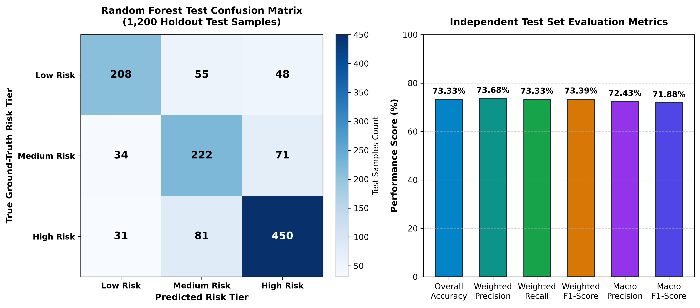
Fig 5.6: Normalized Confusion Matrix for Crime Risk Tier Classification
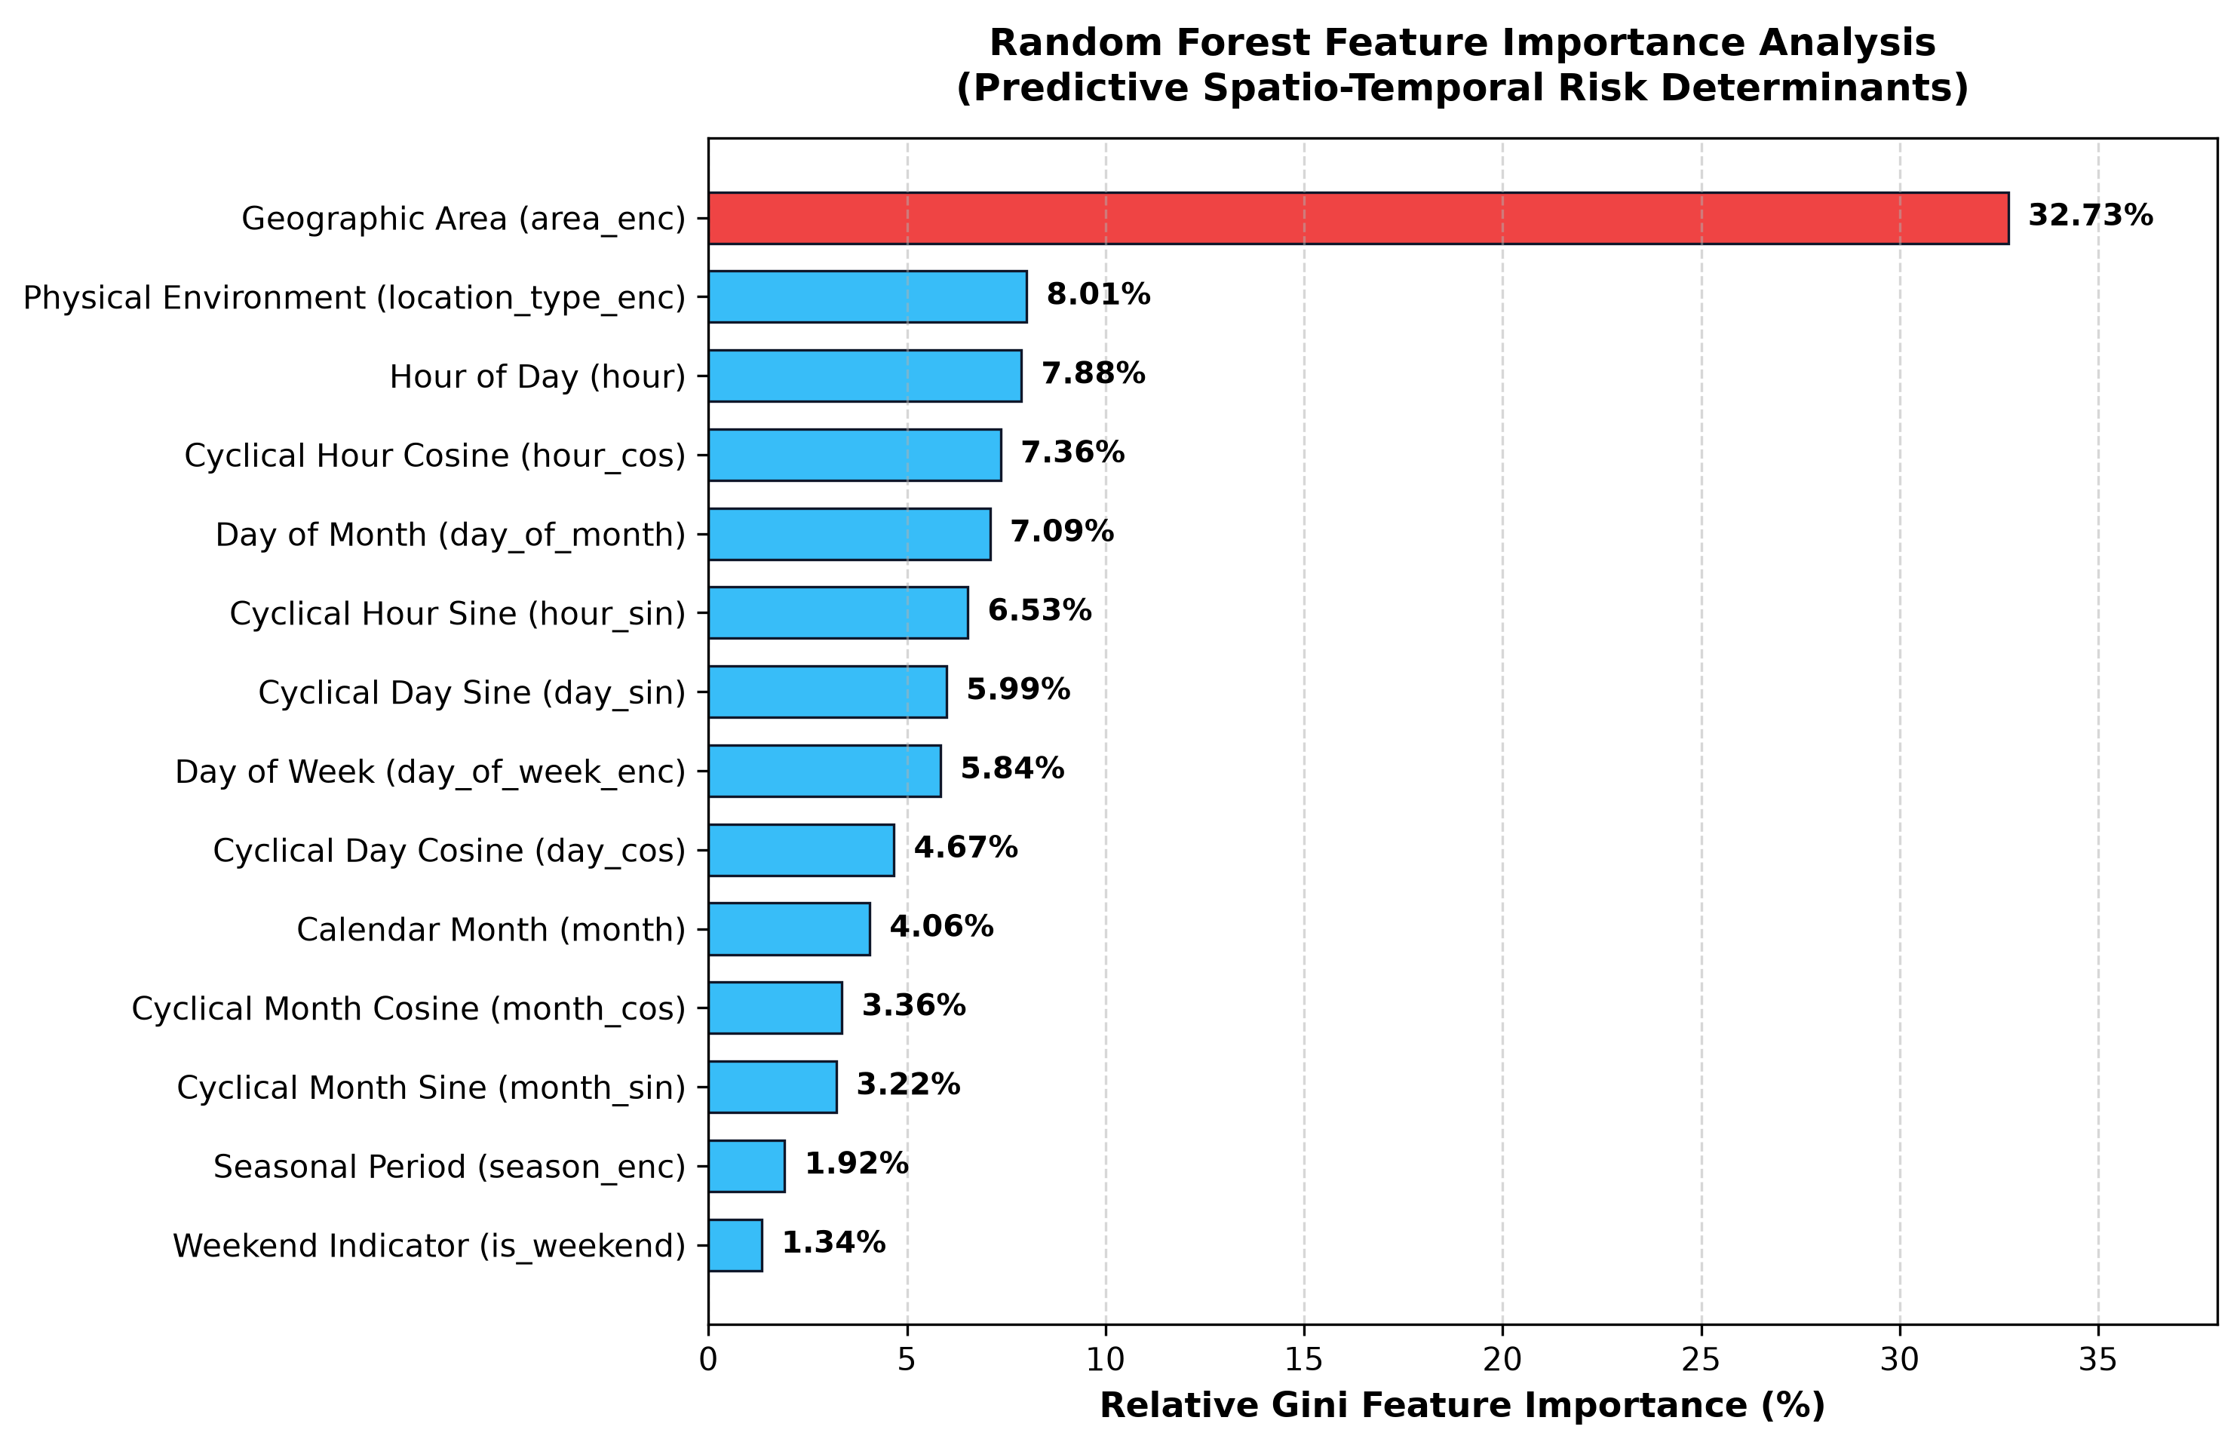
Fig 5.7: Random Forest Gini Feature Importance Ranking
Feature importance analysis reveals that jurisdiction encoding ('area_enc') is the single most influential predictive feature (32.73% relative importance), followed by physical setting ('location_type_enc', 8.01%), raw hour (7.88%), and cyclical hour components ('hour_cos', 7.36%; 'hour_sin', 6.53%). This confirms that geographic location combined with diurnal time of day represents the primary determinant of localized crime hazard.

CONCLUSION & FUTURE SCOPE
6.1 Conclusion
CrimeScope demonstrates a successful, end-to-end data science implementation addressing the complex challenges of urban public safety analysis. By integrating an ACID-compliant SQLite relational database, automated cyclical feature engineering, geodetic DBSCAN density clustering, and a supervised Random Forest classification engine, the platform transforms raw tabular incident logs into actionable spatial intelligence. On a controlled synthetic benchmark of 6,000 incidents across Coimbatore, DBSCAN effectively discovered 9 high-density geospatial crime clusters with an exceptional 0.17% noise segregation. The Random Forest model demonstrated robust multi-class risk classification accuracy of 73.33% on out-of-sample test data. The lightweight Flask web interface, coupled with Leaflet.js mapping and Plotly charting, proves that sophisticated predictive analytics can be made intuitive, accessible, and transparent for municipal stakeholders without prohibitive commercial software costs.
6.2 Future Scope
While CrimeScope establishes a robust foundation, several promising avenues exist for future research and engineering enhancements:
• Real-World Data Integration: Incorporating verified, anonymized open police data portals under strict data governance protocols.
• Deep Spatio-Temporal Architectures: Exploring Spatio-Temporal Graph Convolutional Networks (ST-GCN) and Long Short-Term Memory (LSTM) networks to capture fine-grained sequential temporal dynamics and inter-zone crime diffusion.
• Explainable AI (XAI): Implementing SHAP (SHapley Additive exPlanations) and LIME to generate localized, instance-level explanations for every individual risk forecast.
• Streaming Pipeline Ingestion: Migrating to Apache Kafka and real-time GPS telemetry feeds to support live dispatch integration.
• Algorithmic Fairness & Ethical Safeguards: Embedding automated bias audits to ensure models do not perpetuate historical socio-economic disparities or encourage biased policing practices.

REFERENCES:
[1] M. Ester, H.-P. Kriegel, J. Sander, and X. Xu, 'A density-based algorithm for discovering clusters in large spatial databases with noise,' in Proc. 2nd Int. Conf. Knowl. Discovery Data Mining (KDD), Portland, OR, 1996, pp. 226–231.
[2] L. Breiman, 'Random forests,' Machine Learning, vol. 45, no. 1, pp. 5–32, 2001.
[3] S. Chainey and J. Ratcliffe, GIS and Crime Mapping. Chichester, U.K.: John Wiley & Sons, 2005.
[4] F. Pedregosa et al., 'Scikit-learn: Machine learning in Python,' J. Mach. Learn. Res., vol. 12, pp. 2825–2830, 2011.
[5] W. McKinney, 'Data structures for statistical computing in Python,' in Proc. 9th Python Sci. Conf., Austin, TX, 2010, pp. 51–56.
[6] C. R. Harris et al., 'Array programming with NumPy,' Nature, vol. 585, no. 7825, pp. 357–362, 2020.
[7] A. Ronacher, 'Flask: Web development, one drop at a time,' 2010. [Online]. Available: https://flask.palletsprojects.com/
[8] V. Agafonkin, 'Leaflet: An open-source JavaScript library for mobile-friendly interactive maps,' 2020. [Online]. Available: https://leafletjs.com/
[9] Plotly Technologies Inc., 'Collaborative data science,' Montreal, QC, 2015. [Online]. Available: https://plotly.com/
[10] D. R. Hipp, 'SQLite: An embeddable SQL database engine,' 2020. [Online]. Available: https://www.sqlite.org/
[11] G. O. Mohler, M. B. Short, P. J. Brantingham, F. P. Schoenberg, and G. E. Tita, 'Self-exciting point process modeling of crime,' J. Amer. Statist. Assoc., vol. 106, no. 493, pp. 100–108, 2011.
[12] P. J. Brantingham and P. L. Brantingham, Environmental Criminology. Beverly Hills, CA: Sage Publications, 1981.
PROJECT TITLE | CRIMESCOPE – CRIME HOTSPOT ANALYSIS AND RISK FORECASTING SYSTEM
PROGRAM | B.TECH. ARTIFICIAL INTELLIGENCE AND DATA SCIENCE
PROJECT BATCH NUMBER | 1
BATCH MEMBERS | Reg No | Name
BATCH MEMBERS | 722825243136 | Nitesh S
NAME OF THE SUPERVISOR | Ms. S. Gowri M.E., (Ph.D).
NAME OF THE SDG GOALS MAPPED | Sustainable Cities and Communities
MENTION THE SDG GOALS NUMBER | SDG 11
NAME OF THE TRL LEVEL | Technology validated in lab (demonstration environment)
MENTION THE TRL LEVEL | TRL 4

POs & PSOs Mapping (Put a tick mark in the mapped PO’s & PSO’s):
Program Outcomes |  |  |  |  |  |  |  |  |  |  | Program Specific Outcomes
PO1 | PO 2 | PO 3 | PO 4 | PO 5 | PO 6 | PO 7 | PO 8 | PO 9 | PO 10 | PO 11 | PSO 1 | PSO 2 | PSO 3
✓ | ✓ | ✓ | ✓ | ✓ |  |  |  |  |  |  | ✓ | ✓

Signature of the Supervisor
(Ms.S.Gowri,M.E.,(Ph.D))


VENUE AND EXPENDITURE STATEMENT FOR THE PROJECT WORK
Laboratory details where the project is carried out | DVA Lab, AI&DS
Software / Hardware details | Python 3.10+, Flask 3.0, Scikit-learn, Pandas, NumPy, Plotly, Leaflet.js, SQLite3 / Computing Workstation (Intel Core i5/i7, 16GB RAM)
Details of the Component and Expenditure
S. No | Name of the Component | Qty | Price / Unit in (Rs.) | Amount (Rs.)
1 | Python 3.10 & Open-Source Scientific Libraries (Scikit-Learn, Pandas, NumPy) | 1 | 0.00 | 0.00
2 | Flask Web Framework & Leaflet Geospatial Visualization Engine | 1 | 0.00 | 0.00
3 | College Laboratory Computing Infrastructure & System Workstation | 1 | 0.00 | 0.00

(*Include any other charges which includes fabrication cost and others)

Signature of the student Signature of the Supervisor
(Nitesh S) (Ms.S.Gowri,M.E.,(Ph.D))

