AI ASSISTANT CODING ASSIGNMENT-14.2

Name: Nitesh Kumar
Enrollment no: 2303A52098 Batch: 33
Semester: VI
Branch: CSE(AIML)

Lab 14: Web Design Application – AI-Assisted HTML/CSS/JS Generation Lab Objectives
- Design functional, visually appealing web applications using HTML, CSS, and JavaScript with AI assistance.
- Apply responsive, accessible, and interactive design principles.
- Create practical UI components for real-world web applications.
- Use AI to optimize layout, UX, and performance.

Task Description 1 – (Landing Page Design)
- Create a simple landing page for a product or service. Include a header, hero section, and footer.
Requirements:
- Use HTML and CSS to structure the page.
- Use AI to suggest layout alignment and typography.
- Ensure the page is responsive across devices.

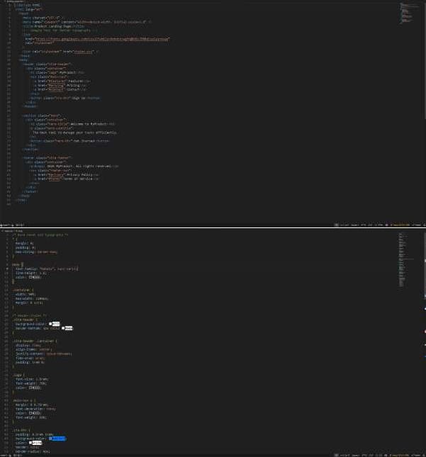

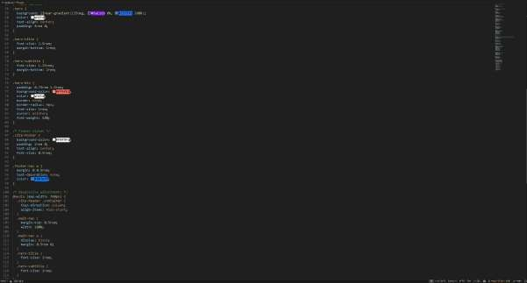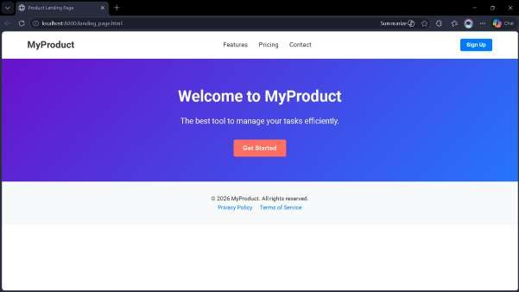

Task Description 2 – (Theme Toggle Feature)
- Provide a button to switch between light and dark themes.. Requirements:
- Use JavaScript to toggle CSS classes.
- Use AI assistance to manage color contrast and accessibility.
- Ensure theme preference applies instantly on click.

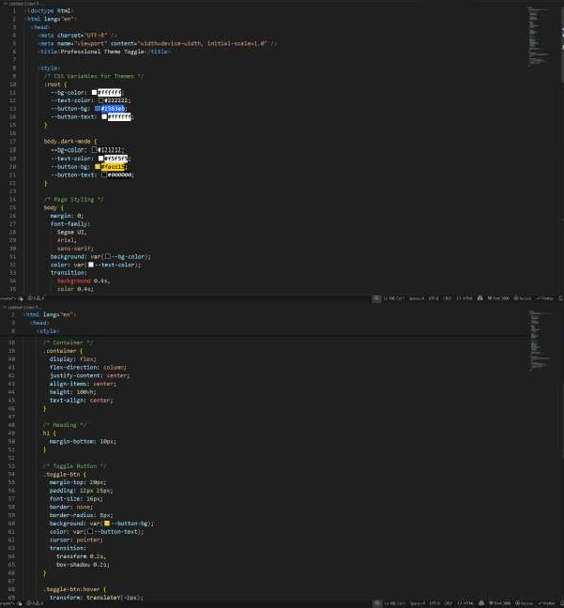

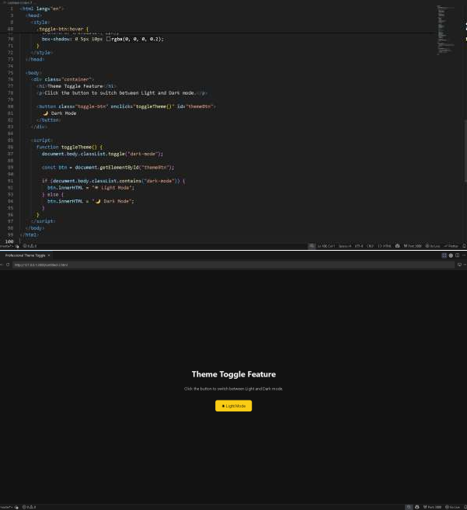

Task Description 3 – (User Feedback Form)
- Create a feedback form with fields: Username, Rating, Comments. Requirements:
- Use JavaScript to validate required fields.
- Display success or error messages dynamically.
- Use AI to improve form usability and layout.

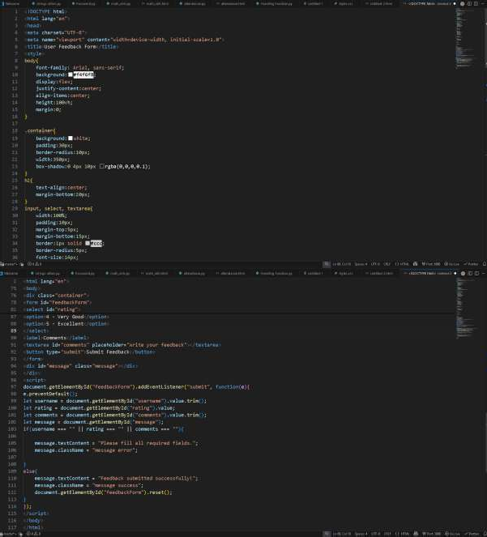

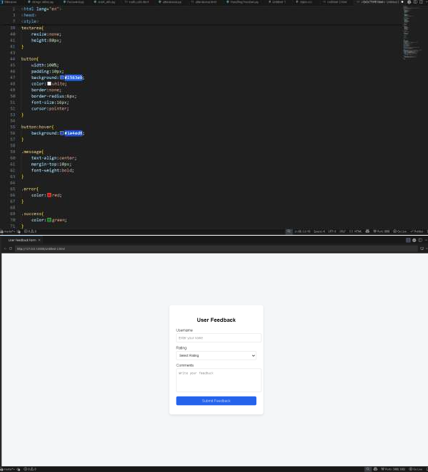

Task Description - 4 (Image Gallery with JavaScript)
- Task: Display a small image gallery on a web page. Requirements:
- Use JavaScript to dynamically load images.
- Add next/previous navigation buttons.
- Use AI to optimize layout responsiveness.

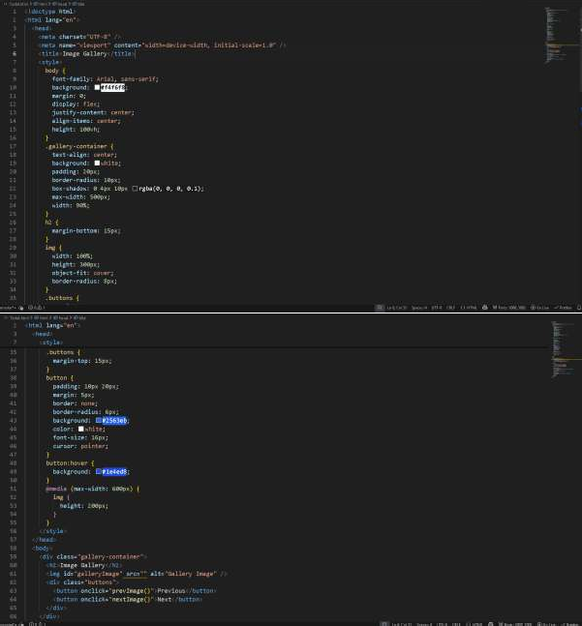

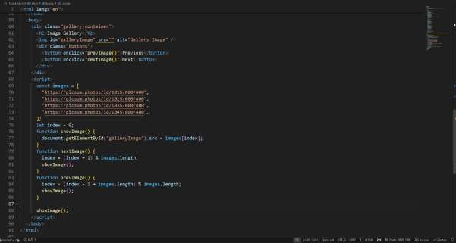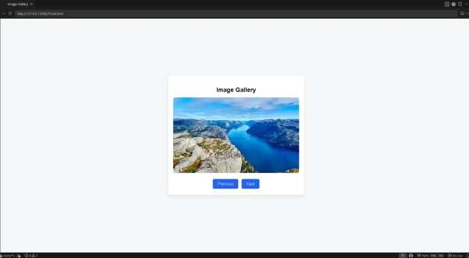

Task Description - 5: (Notification Banner)
- Display a notification banner at the top of the page. Requirements:
- Use JavaScript to show and hide the banner.
- Style the banner using CSS.
- Use AI to ensure smooth transitions and clean UI behavior.

