School of Computer Science and Artificial
Intelligence

Lab Assignment # 19.2

Program : B. Tech (CSE)
Specialization :AIML
Course Title : AI Assisted Coding
Course Code : 23CS002PC304
Semester : VI
Academic Session : 2025-2026
Name of Student : Nitesh Kumar
Enrollment No. : 2303A52098
Batch No. : 33
Date :07/04/26

Task 1 – Python to Java Conversion
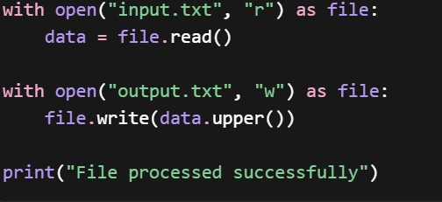
Prompt:
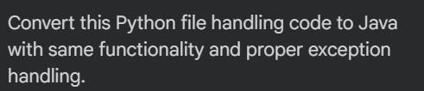
Code:

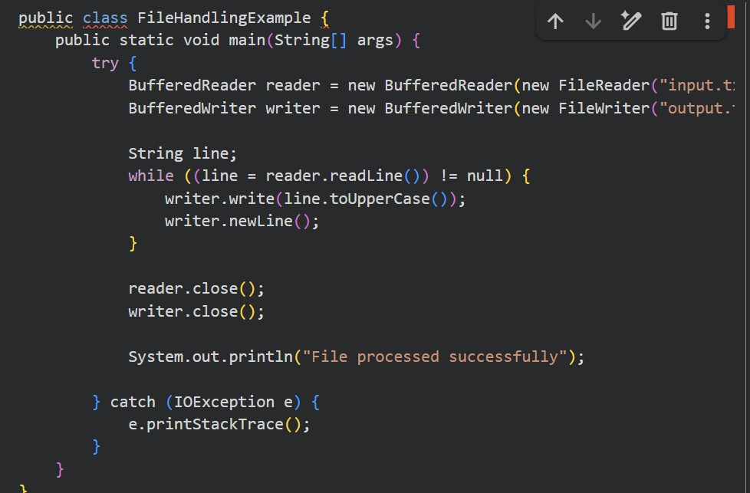
Task 2 – C++ to Python (Sorting Algorithm)
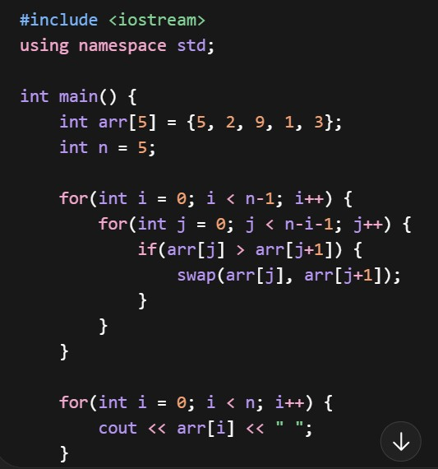
Prompt:

Code:
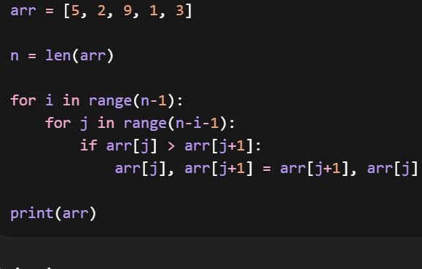
Task 3 – SQL to Pandas Query
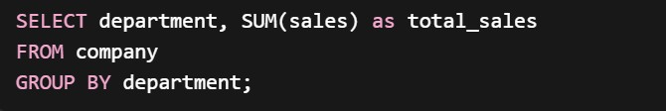
Prompt:
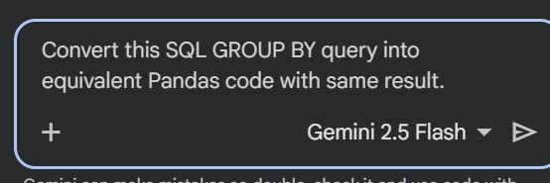

Code:
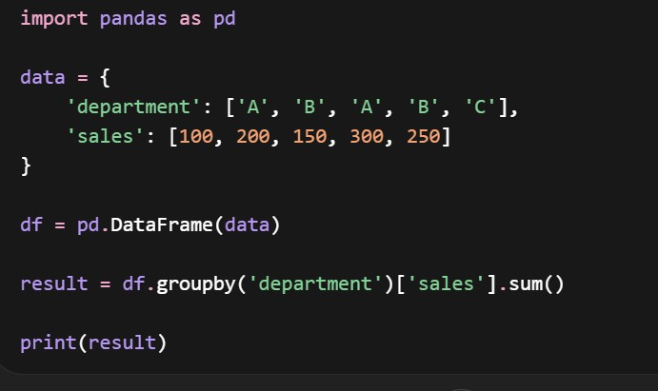
Task 4 – Real-Time Application (Python Flask → Java Spring Boot)
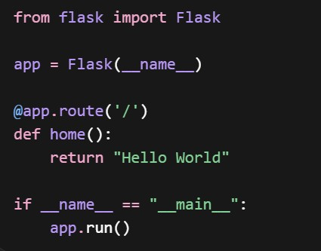
Prompt:
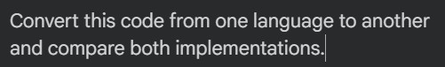
Code:
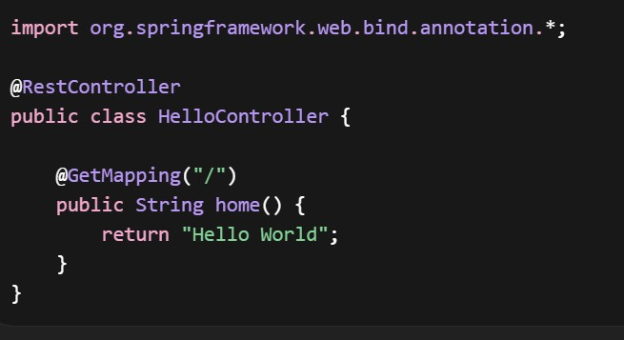
Task 5 – Python to C++ (Even/Odd Check)
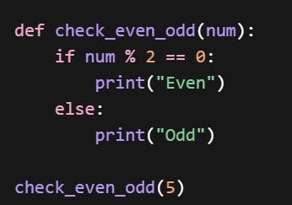
Prompt:
Code:
