School of Computer Science and Artificial Intelligence

Lab Assignment # 3.2

Program : B. Tech (CSE)
Specialization : AIML
Course Title : AI Assisted Coding Course Code: 23CS002PC304
Semester : VI
Academic Session : 2025-2026
Name of Student : Nitesh kumar Enrollment No. : 2303A52098
Batch No. : 33
Date : 13/01/26

Lab 3: Prompt Engineering – Improving Prompts and Context Management

Lab Objectives
- To understand how prompt structure and wording influence AI-generated code.
- To explore how context (comments, function names, and examples) helps AI generate more relevant output.
- To evaluate the quality, accuracy, and structure of AI-generated code based on prompt clarity.
- To develop effective prompting strategies for AI-assisted programming.

Lab Outcomes (LOs)
After completing this lab, students will be able to:
- Generate Python code using Google Gemini in Google Colab.
- Analyze the effectiveness of code explanations and suggestions provided by Gemini.
- Set up and use Cursor AI for AI-powered coding assistance.
- Evaluate and refactor Python code using Cursor AI features.
- Compare AI tool behavior and code quality across different platforms.

Tools Used
- Google Gemini (Google Colab)
- Cursor AI
- Python 3.x

Task Description – 1

Progressive Prompting for Calculator Design
Design a simple calculator program using progressive prompt enhancement:
- Start with only the function name
- Add comments describing functionality
- Add usage examples
Analyze how each step improves the AI-generated code.

Step 1: Minimal Prompt (Function Name Only):
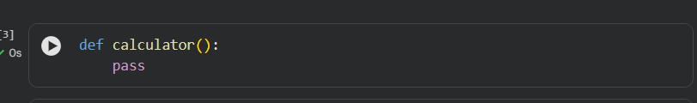
Observation
- AI lacks context
- No logic, parameters, or functionality
- Output is incomplete and unusable

Step 2: Prompt with Comments (Added Context):

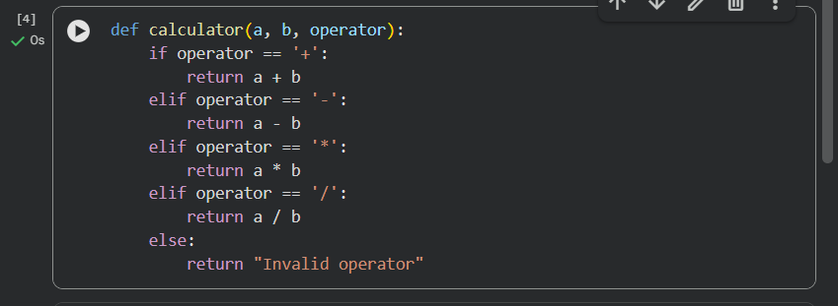
Observation
- Correct logic implemented
- Parameters inferred correctly
- No input validation (division by zero not handled)

Step 3: Prompt with Comments + Usage Examples:
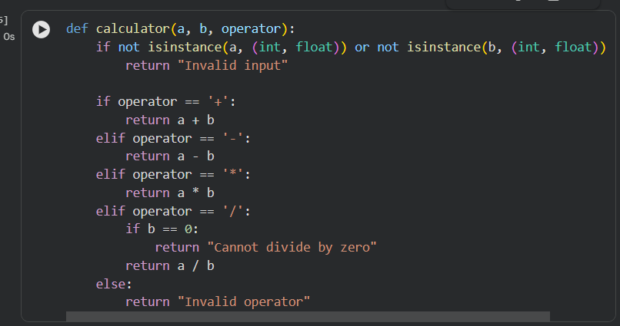

Observation
- Input validation added
- Division by zero handled
- Code is robust, readable, and user-safe
- Output format matches examples

Expected Output – Comparison Analysis
Comparison of AI-Generated Calculator Code
Prompt Level | Logic Quality | Validation | Robustness | Code Clarity
Function Name Only | Very Poor | None | None | Very Low
With Comments | Good | Partial | Limited | Good
Comments + Examples | Excellent | Full | High | Very High

Task Description – 2:

Refining Prompts for Sorting Logic
Objective:
To observe how refining a vague prompt into a clear, constrained prompt improves the correctness and efficiency of an AI-generated sorting function for student marks.

Step 1: Vague Prompt

Observation
- Sorting order not specified (ascending or descending)
- No validation of input type
- Assumes marks are always valid

Step 2: Refined Prompt with Constraints
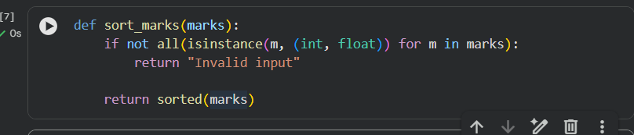
Observation
- Sorting order clearly defined
- Input validation added
- Logic is more reliable

Step 3: Fully Refined Prompt
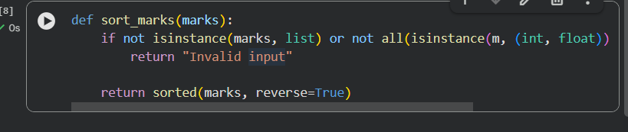

Expected Output – 2 (Analysis)
Prompt Clarity | Sorting Accuracy | Validation | Efficiency
Vague | Low | None | Medium
Refined | High | Partial | High
Fully Refined | Very High | Full | High

Task Description – 3

Few-Shot Prompting for Prime Number Validation
Objective:
To analyze how providing multiple input-output examples improves correctness and edge-case handling.

Few-Shot Prompt:
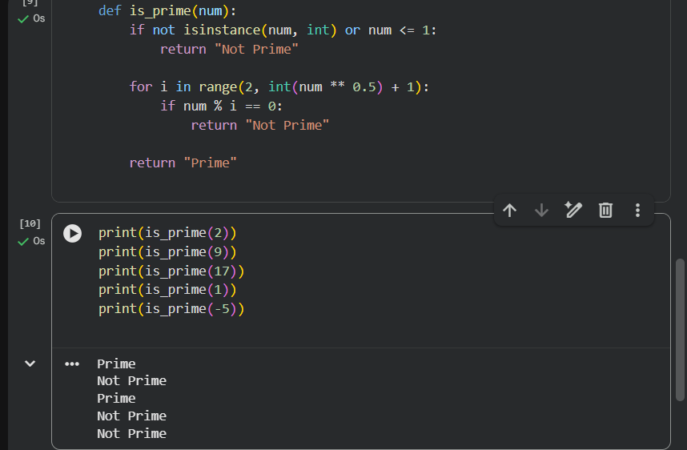

Expected Output – 3
- Correct handling of 0, 1, and negative numbers
- Efficient √n optimization
- Clear output format

Task Description – 4

Prompt-Guided UI Design for Student Grading System
Objective:
To generate a simple UI-based program that calculates total marks, percentage, and grade using prompt guidance.

Prompt
“Design a Python UI program for a student grading system.
The program should:
- Accept marks of 5 subjects
- Calculate total and percentage
- Display grade based on percentage
- Show clear output”
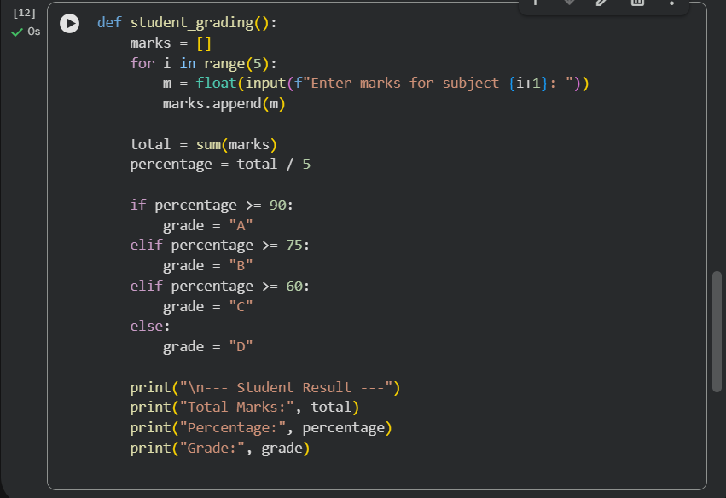

Expected Output – 4
- Clean UI flow
- Accurate calculations
- Easy-to-read result display
- Logic directly guided by prompt clarity

Task Description – 5

Analyzing Prompt Specificity in Unit Conversion Functions
Objective:
To analyze how clearer instructions improve accuracy in unit conversion functions.

Prompt 1: Vague Prompt
“Write a function to convert distance.”


Issue:
- Conversion direction unclear
- No flexibility

Prompt 2: Refined Prompt
“Write a function to convert kilometers to miles.”


Prompt 3: Fully Specific Prompt
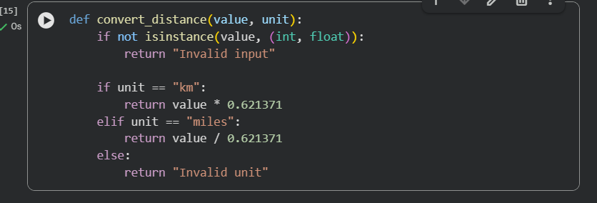

Expected Output – 5 (Analysis)
Prompt Type | Accuracy | Flexibility | Validation
Vague | Low | None | None
Refined | High | Partial | None
Specific | Very High | High | Yes

Final Result :
- Prompt refinement leads to:
  - Better logic
  - Improved validation
  - More efficient algorithms
- Few-shot prompting significantly improves edge-case handling
- UI-based programs benefit greatly from clear task decomposition

Conclusion
This lab demonstrates that prompt specificity and context management are critical in AI-assisted programming. As prompts evolve from vague to well-defined, the generated code becomes more accurate, efficient, and usable. Few-shot prompting and UI-guided prompts further enhance reliability and structure.

