School of Computer Science and Artificial Intelligence

Lab Assignment # 7.2

Program : B. Tech (CSE)
Specialization : AIML
Course Title : AI Assisted Coding Course Code:
23CS002PC304
Semester : VI
Academic Session : 2025-2026
Name of Student : Nitesh Kumar
Enrollment No. : 2303A52098 Batch No. : 33
Date : 03/02/26

Lab 7: Error Debugging with AI (Week 4 – Tuesday)
Topic: Systematic approaches to finding and fixing bugs using AI

Task 1 – Runtime Error Due to Invalid Input Type
Bug Analysis (AI Explanation)
- input() always returns a string
- Adding a string and an integer causes a TypeError

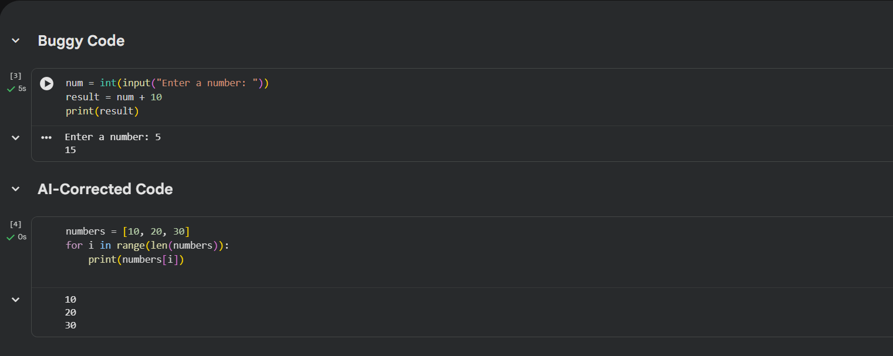

Expected Output – 1
- AI converts user input to an integer
- Runtime error is eliminated

Task 2 – Incorrect Function Return Value
Bug Analysis (AI Explanation)

- Function calculates the square but does not return it
- Without return, Python returns None

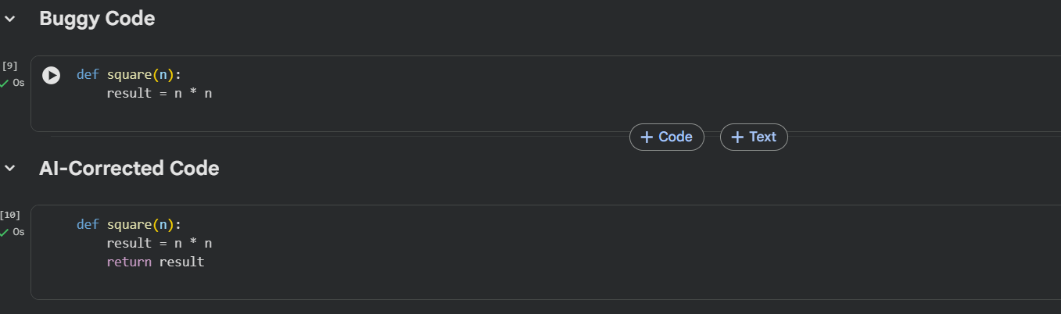

Expected Output – 2
- Function correctly returns the square of the number

Task 3 – IndexError in List Traversal
Bug Analysis (AI Explanation)

- range(0, len(numbers)+1) goes one step too far
- Causes IndexError: list index out of range

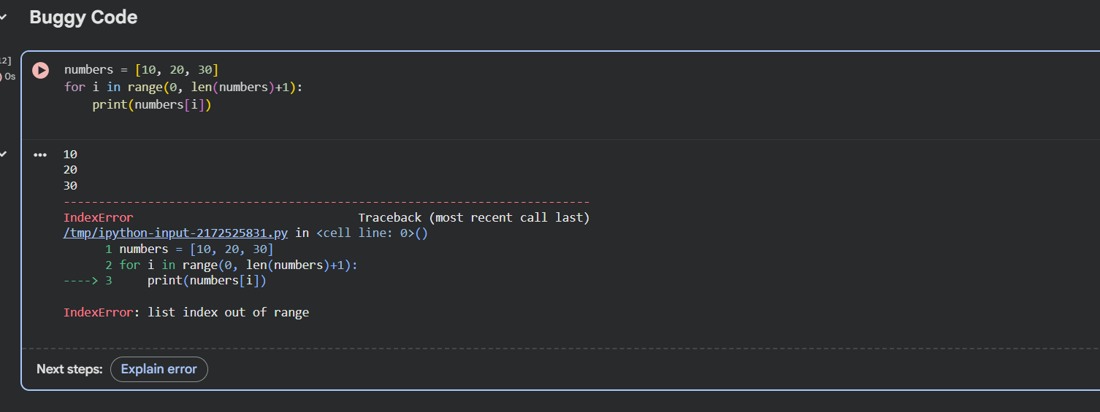

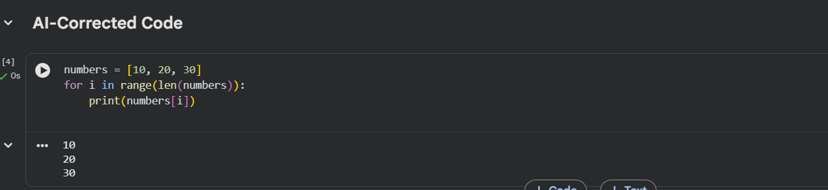

Expected Output – 3
- Loop boundary corrected
- Prevents out-of-range access

Task 4 – Uninitialized Variable Usage
Bug Analysis (AI Explanation)
- Variable total is used before assignment
- Causes NameError

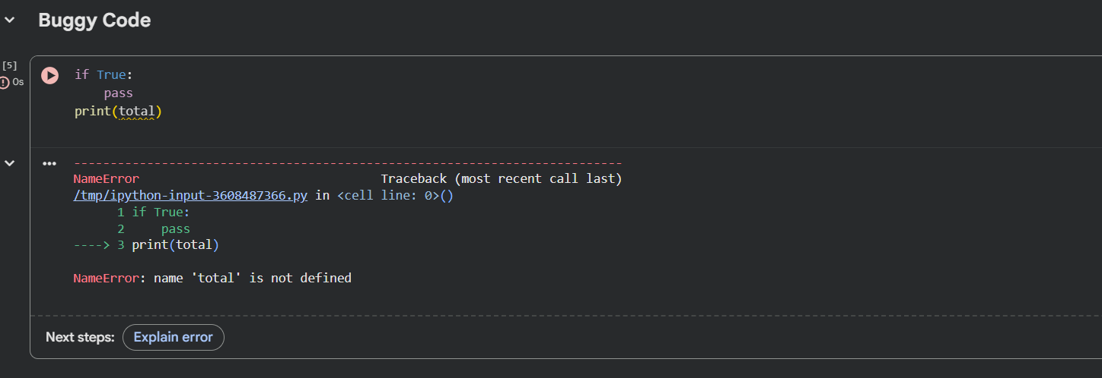

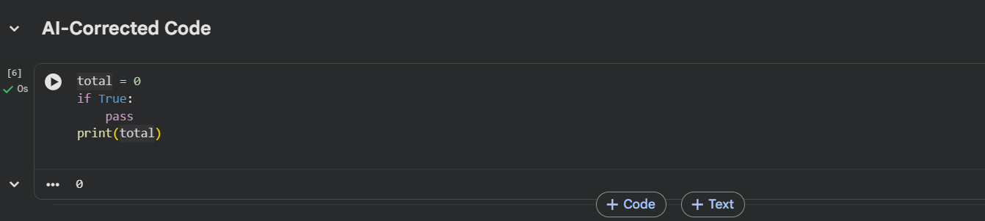

Expected Output – 4
- Variable initialized before use
- Program runs safely

Task 5 – Logical Error in Student Grading System
Bug Analysis (AI Explanation)

- Logical order of grading conditions is incorrect
- marks >= 80 wrongly assigns grade C
- else block assigns B incorrectly

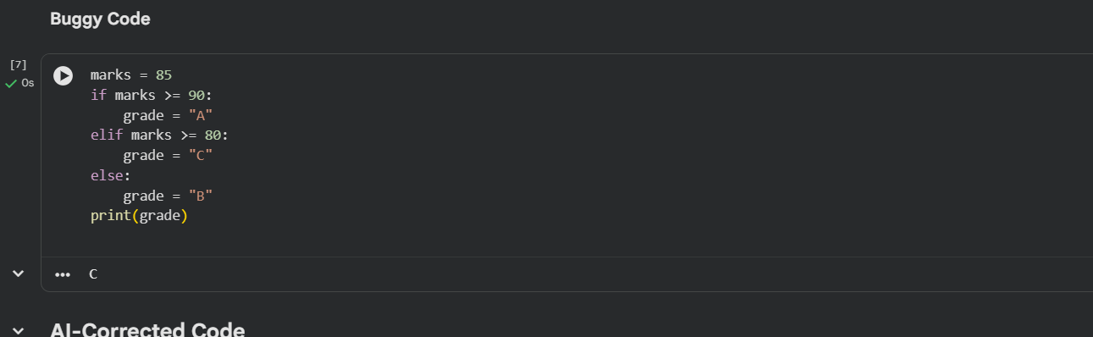

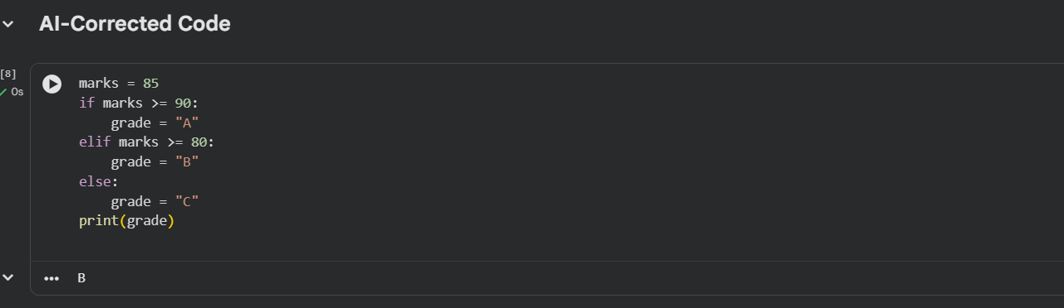

Expected Output – 5
- Correct grade is assigned based on marks
- Logical flow fixed

Summary: AI-Assisted Debugging Strategies Used
✔ Type conversion for runtime errors
✔ Return statement validation
✔ Loop boundary correction
✔ Variable initialization checks
✔ Logical condition reordering

