School of Computer Science and Artificial
Intelligence

Lab Assignment # 15.5

Program : B. Tech (CSE)
Specialization :AIML
Course Title : AI Assisted Coding
Course Code : 23CS002PC304
Semester : VI
Academic Session : 2025-2026
Name of Student : Nitesh Kumar
Enrollment No. : 2303A52098
Batch No. : 33
Date :13/03/26

Task 1 – Student Attendance API
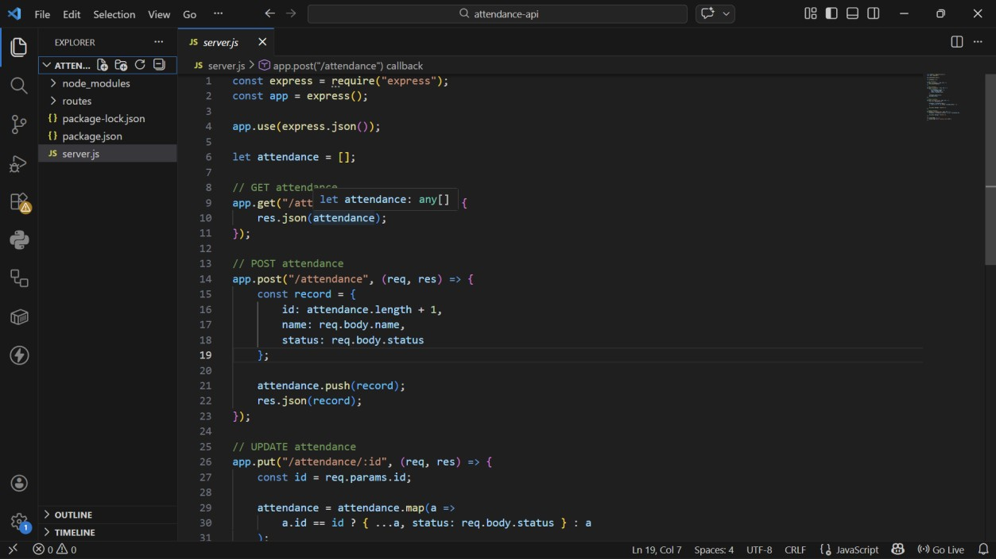
GET /attendance → View attendance records
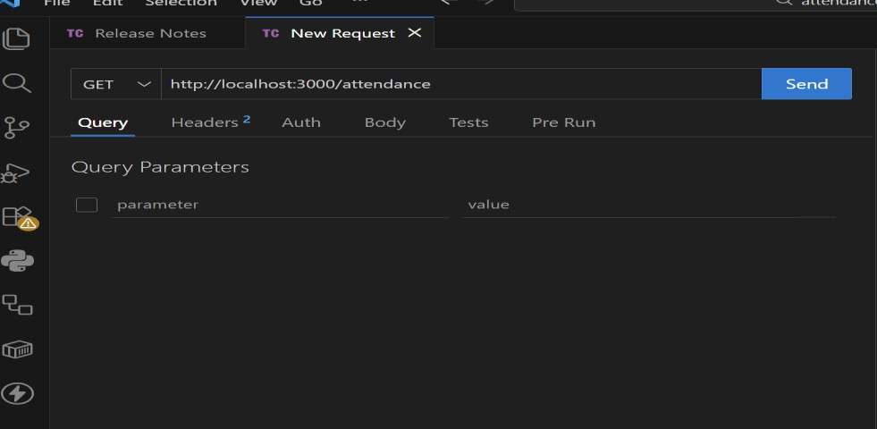

- POST /attendance → Mark attendance
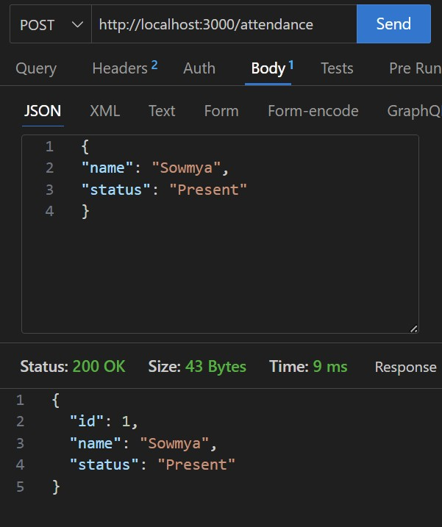
- PUT /attendance/{id} → Update attendance record
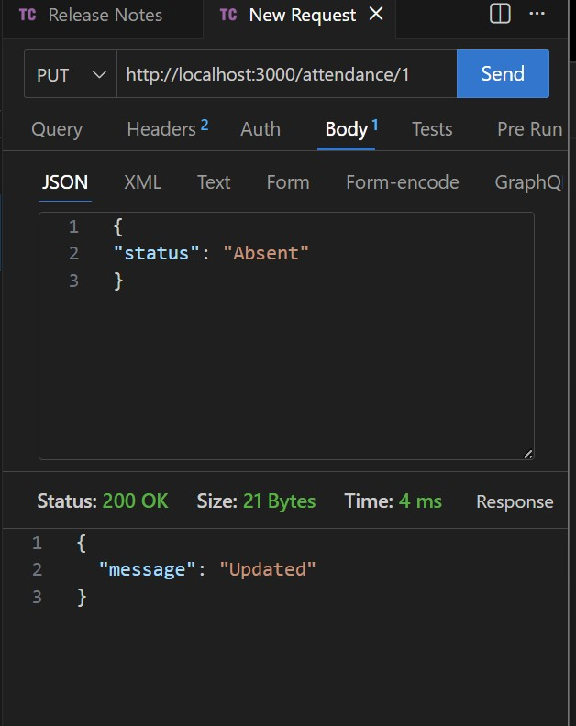
- DELETE /attendance/{id} → Remove attendance entry
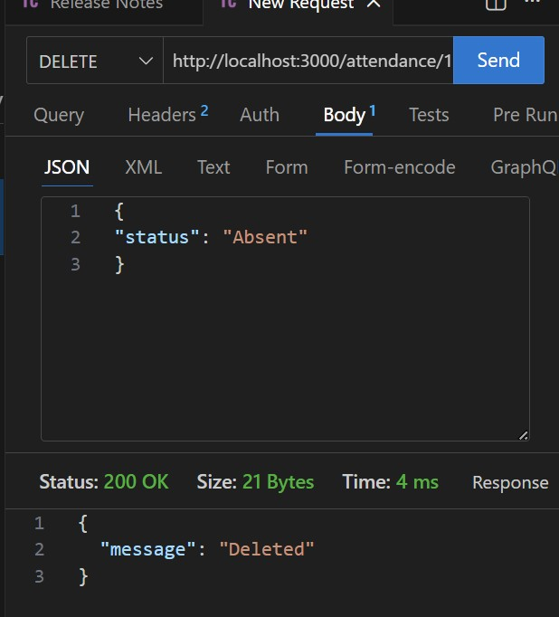

Task 2 – Inventory Management API
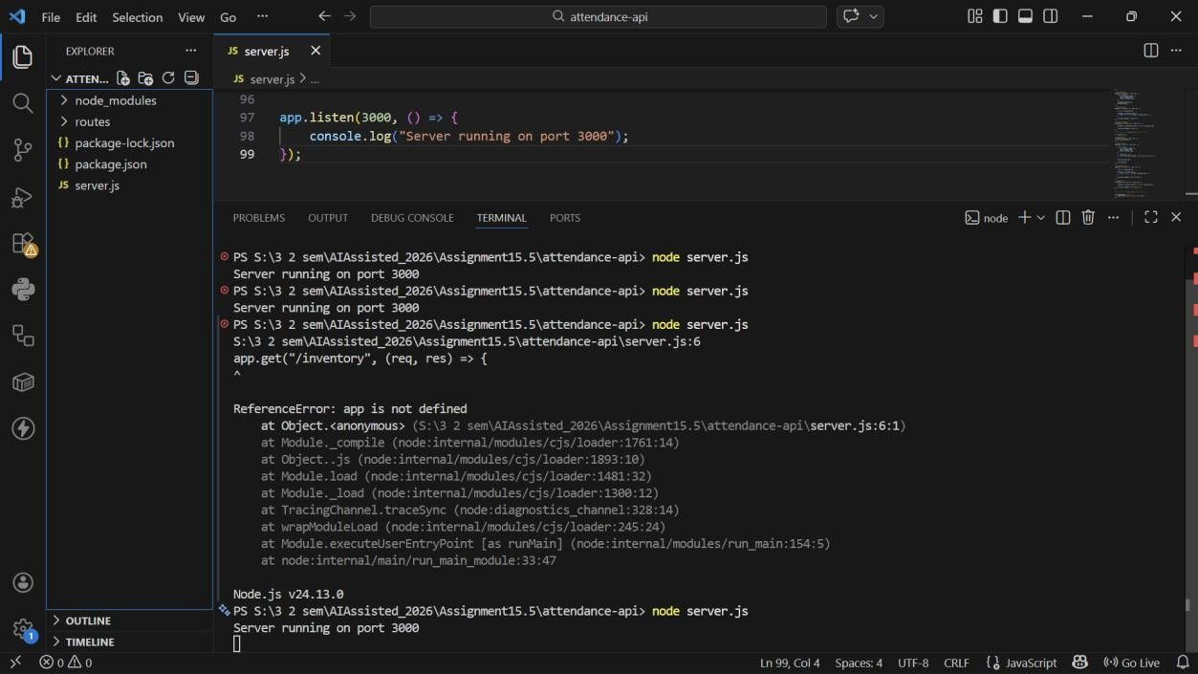
GET /inventory → List all items
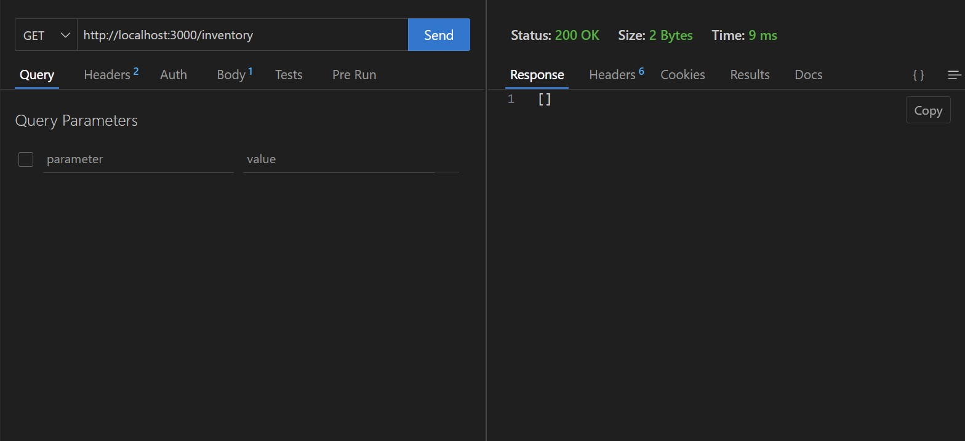
- POST /inventory → Add new item
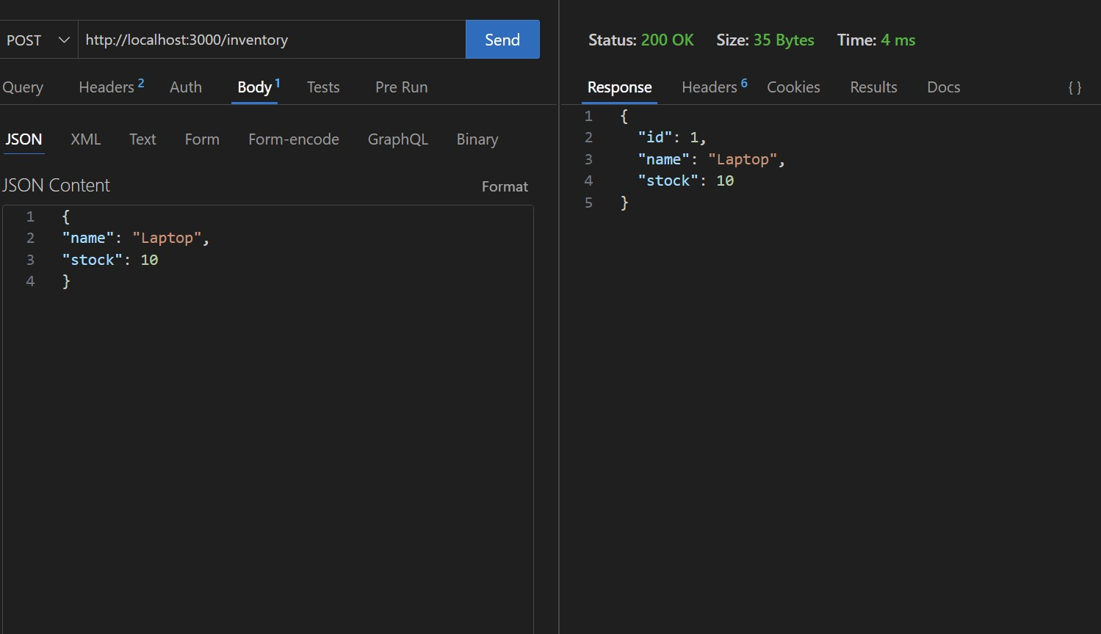
- PUT /inventory/{id} → Update stock quantity
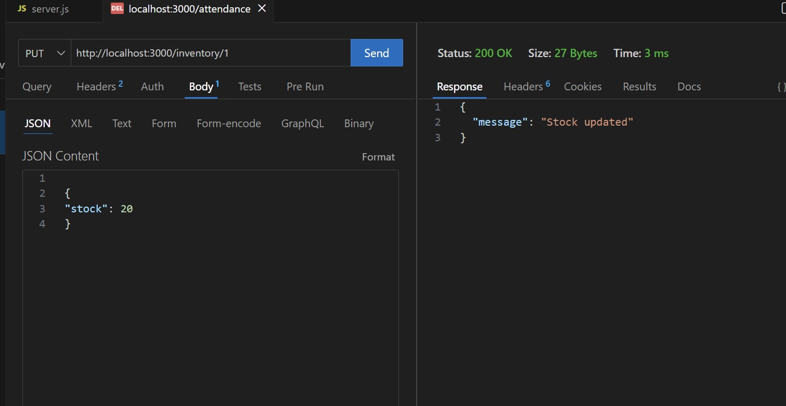
- DELETE /inventory/{id} → Remove an item
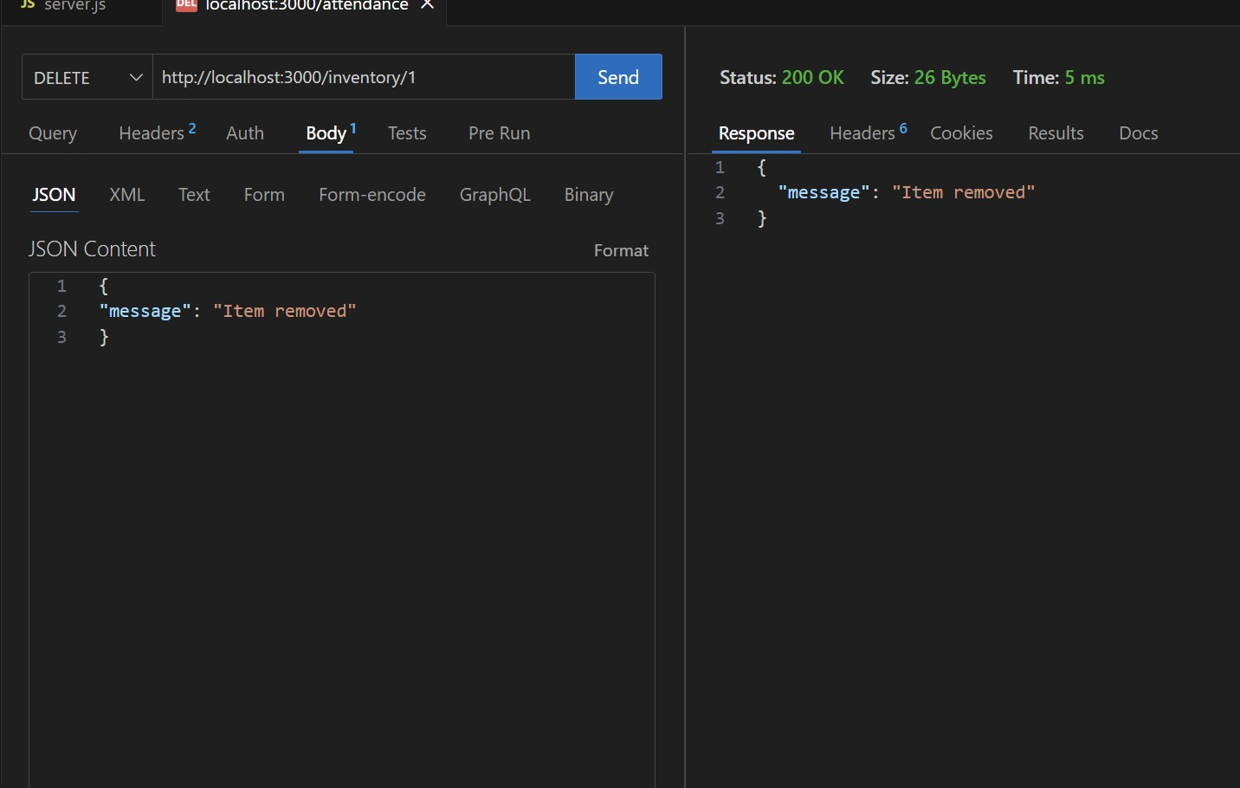

Task 3 – Hotel Room Booking API
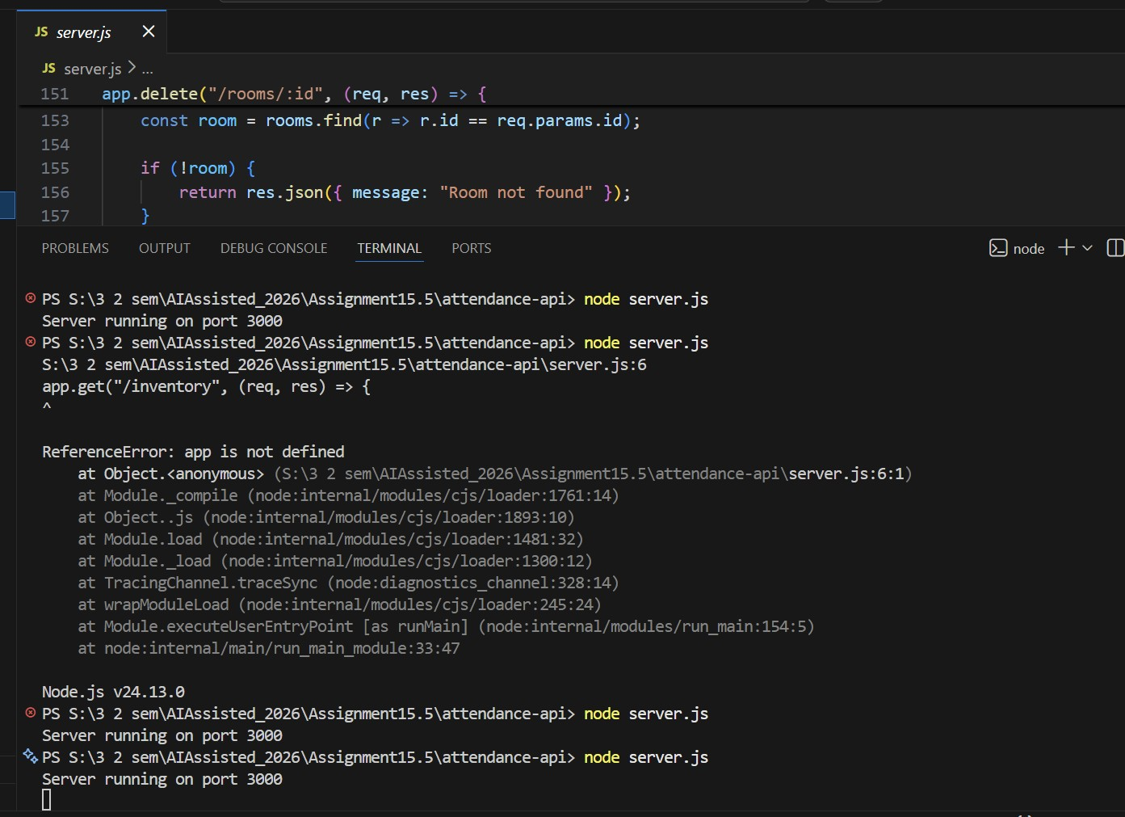

- GET /rooms → View available rooms
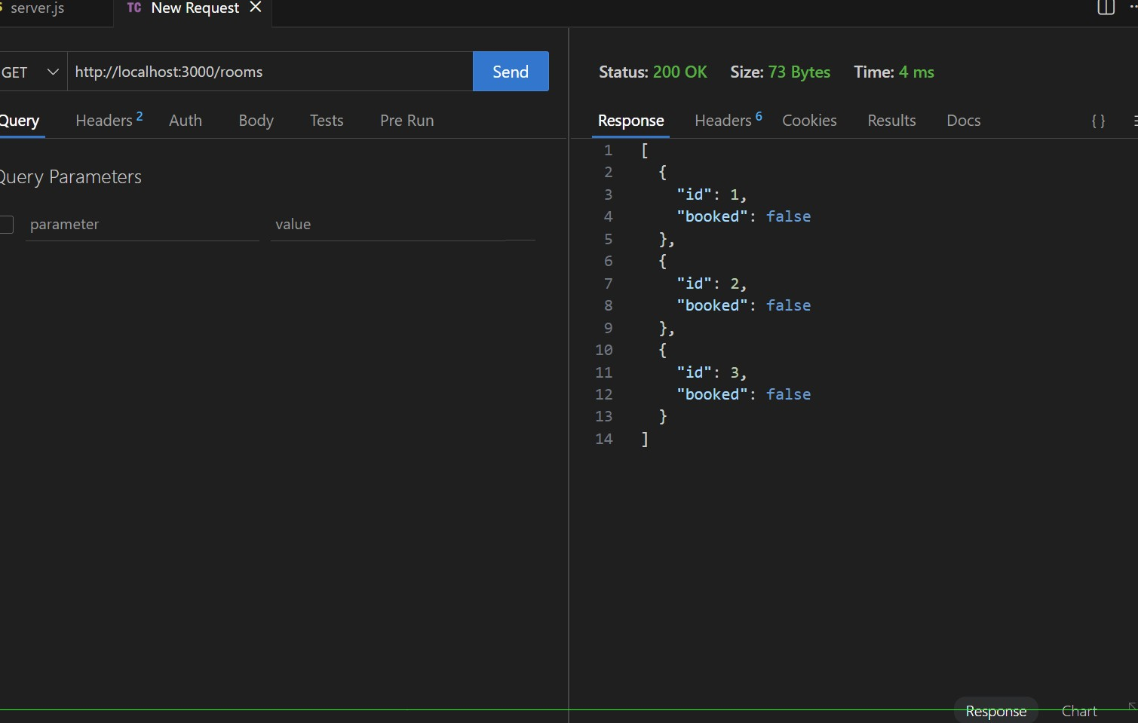
- POST /rooms/book → Book a room
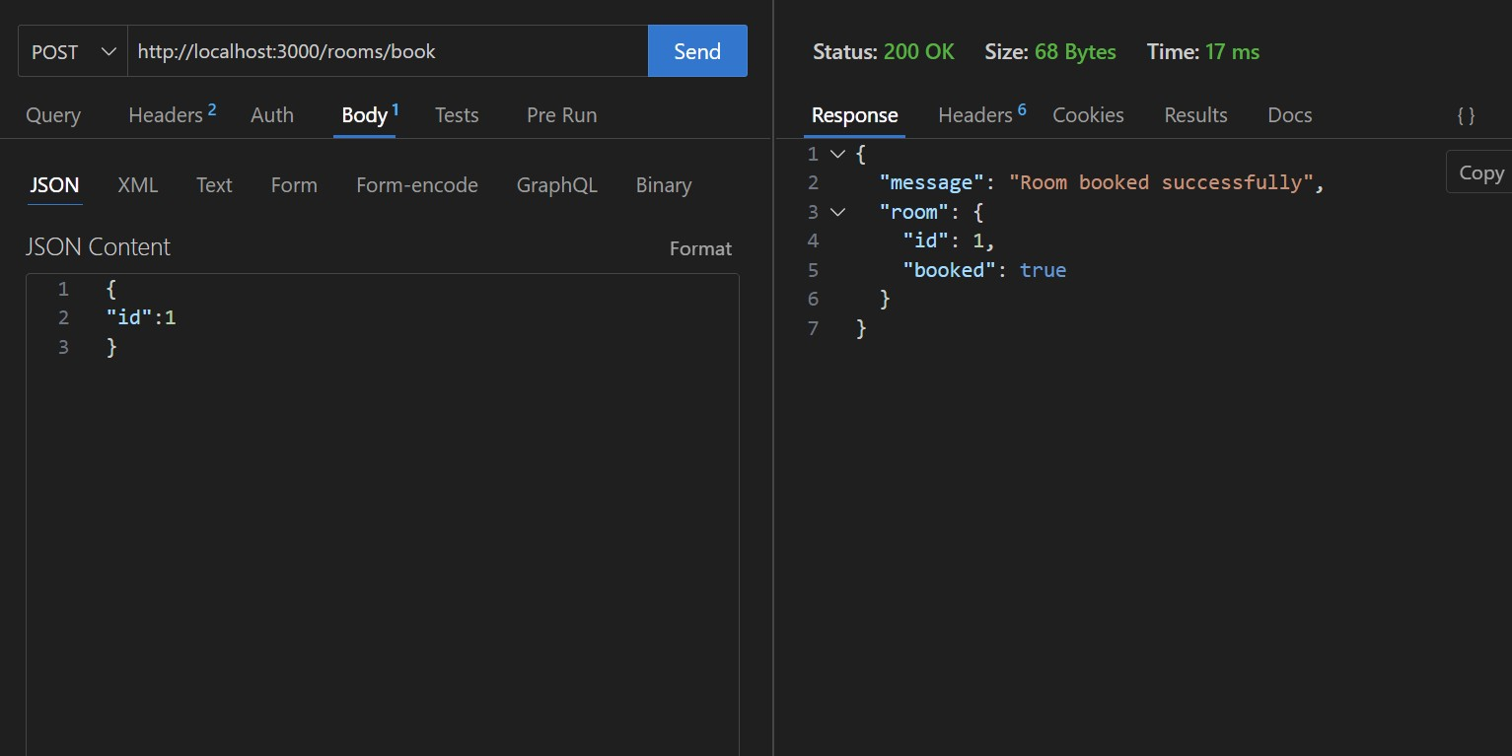

- GET /rooms/{id} → View booking details
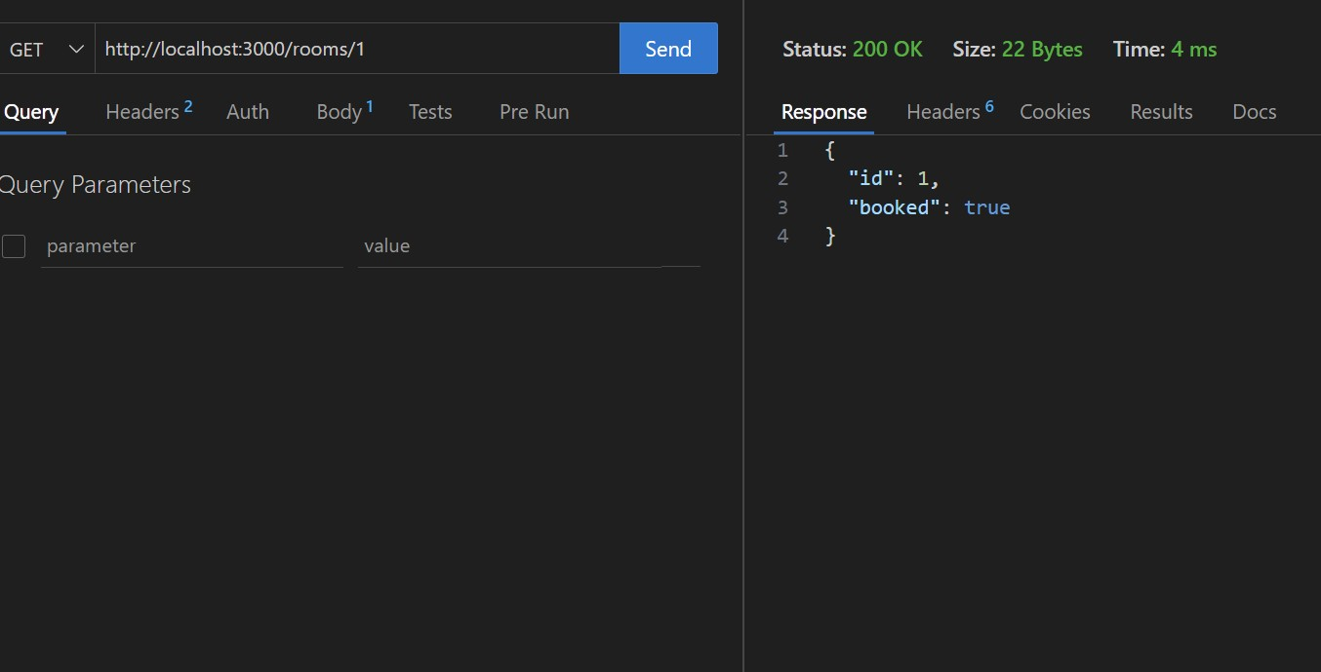
- DELETE /rooms/{id} → Cancel booking
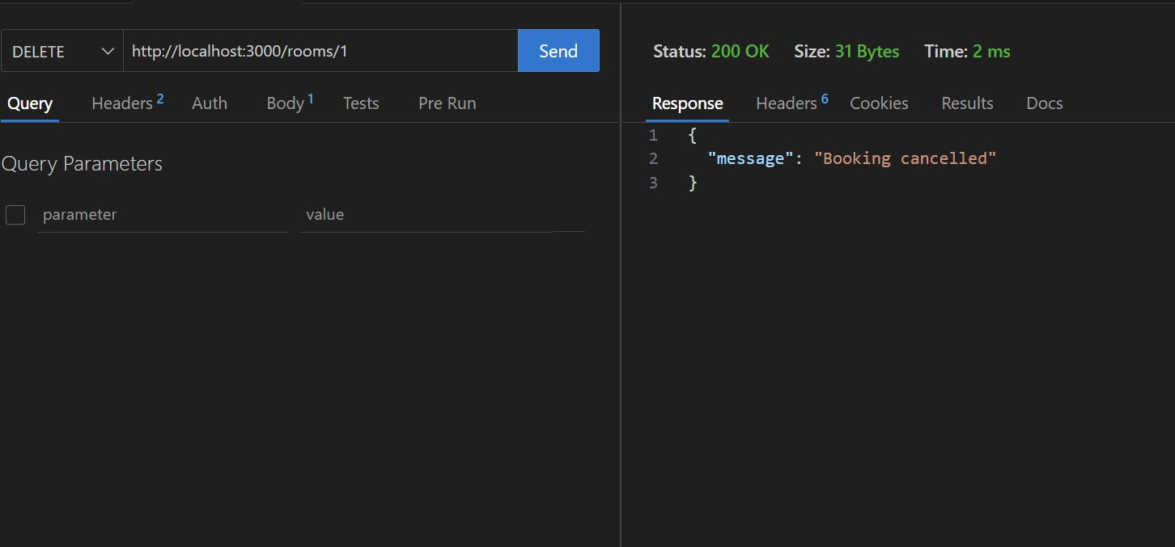
Task 4 – Online Voting API
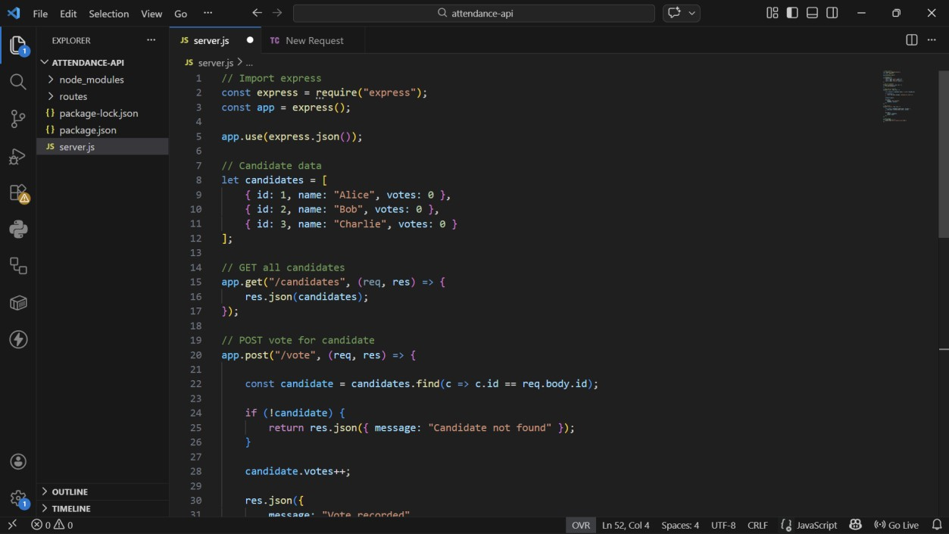
- GET /candidates → List candidates
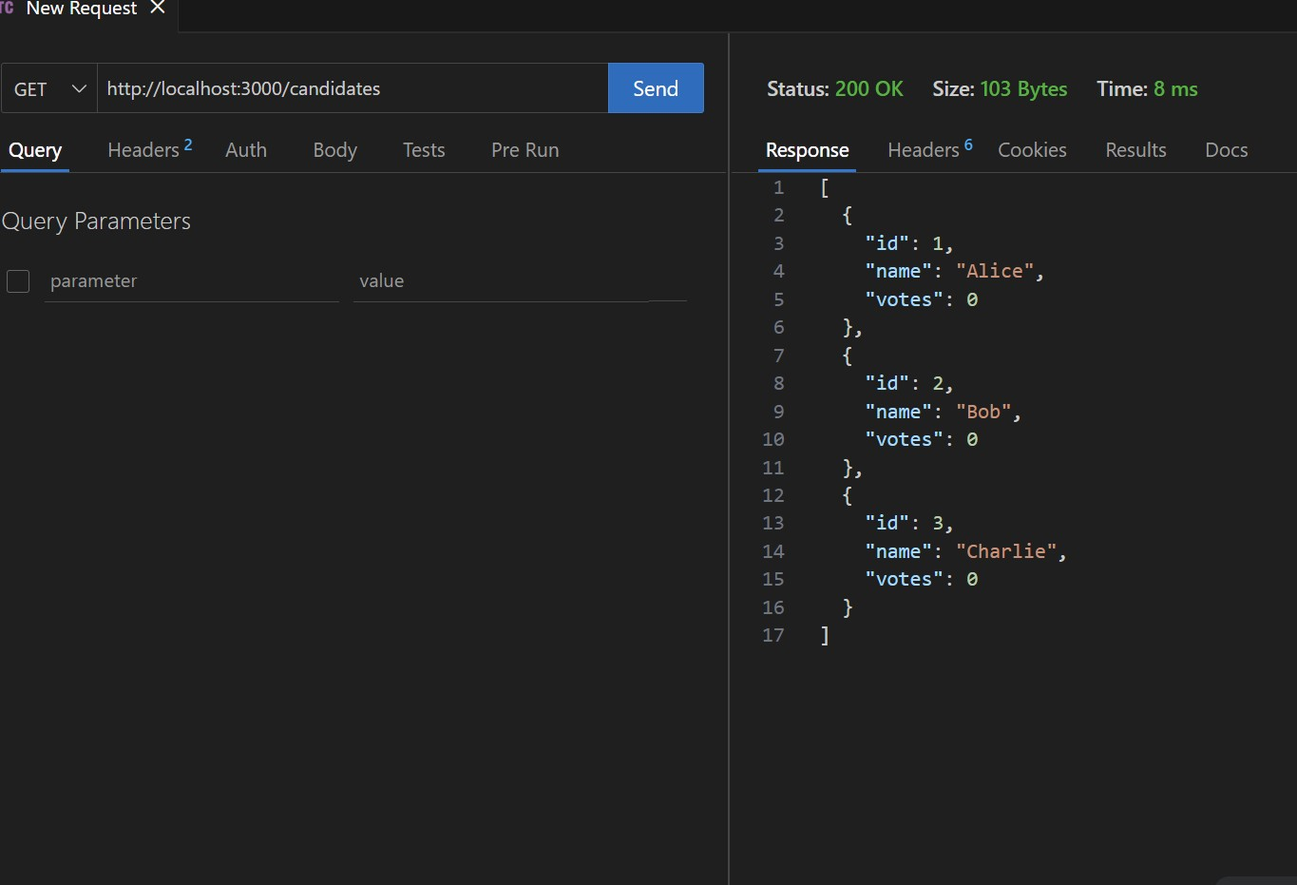
- POST /vote → Cast a vote
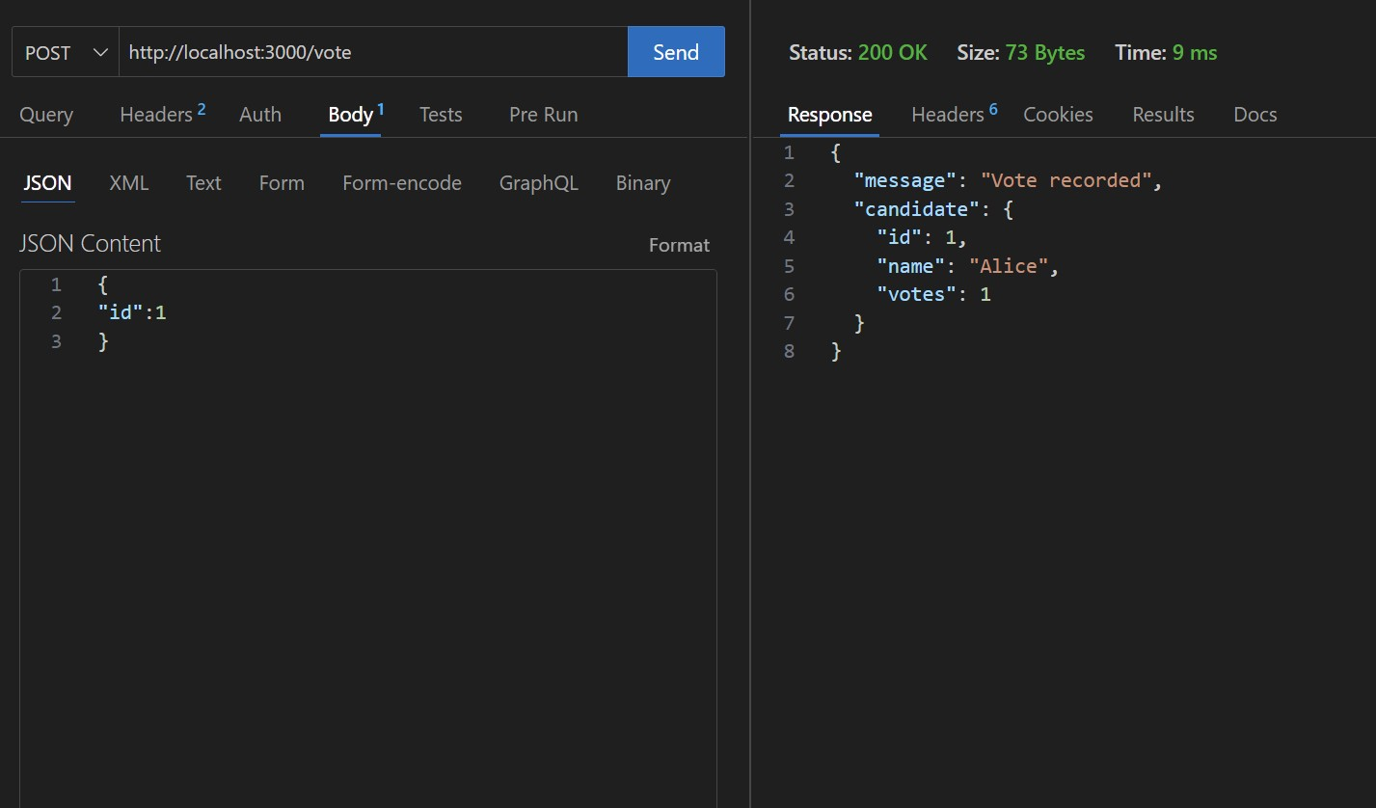
- GET /results → View voting results
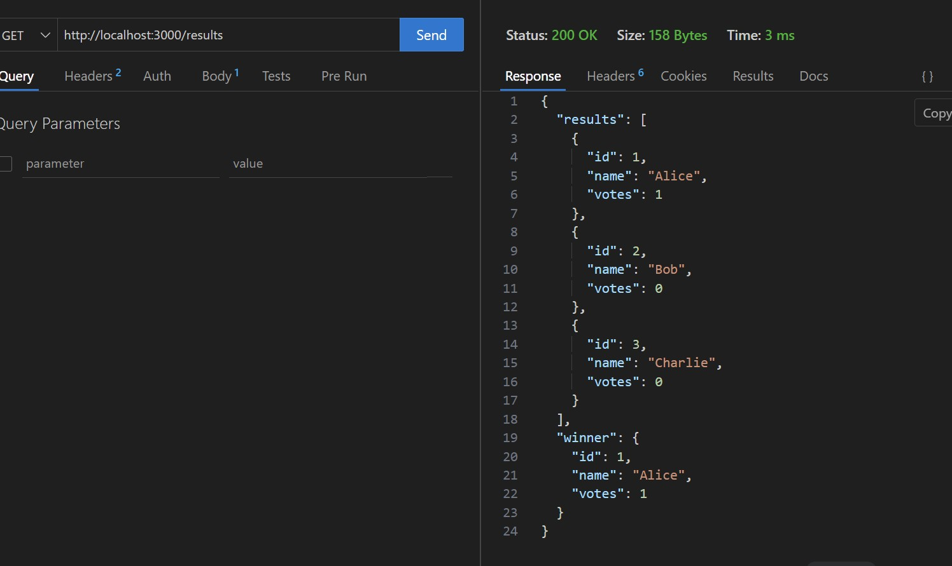

Task 5 – Teacher Management API
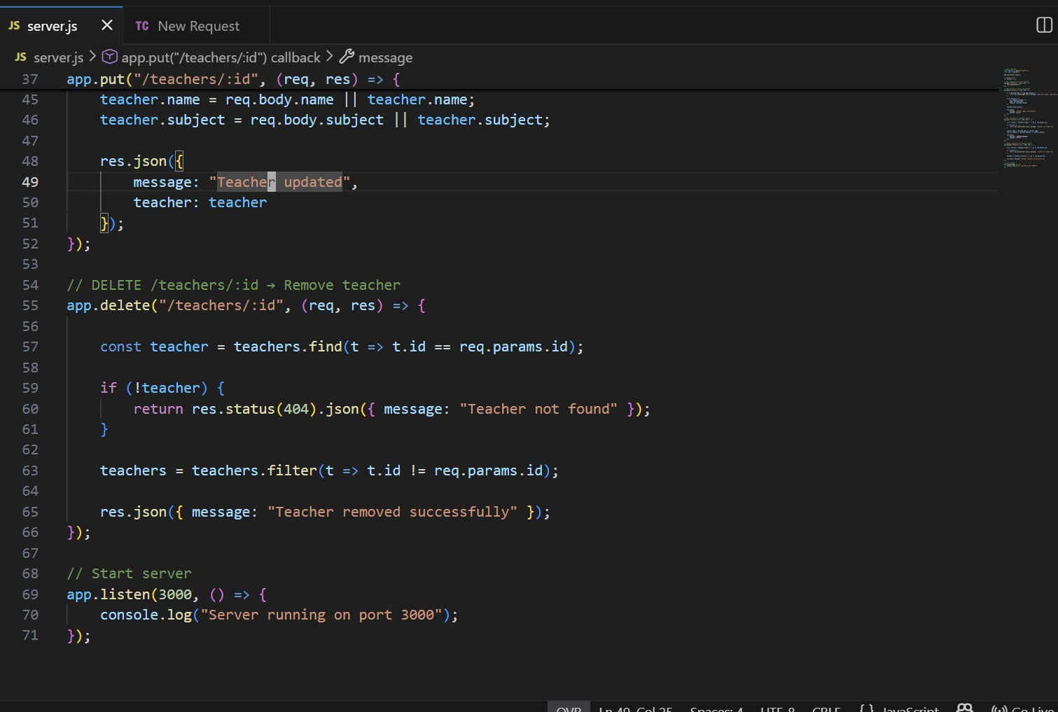
- GET /teachers → List all teachers
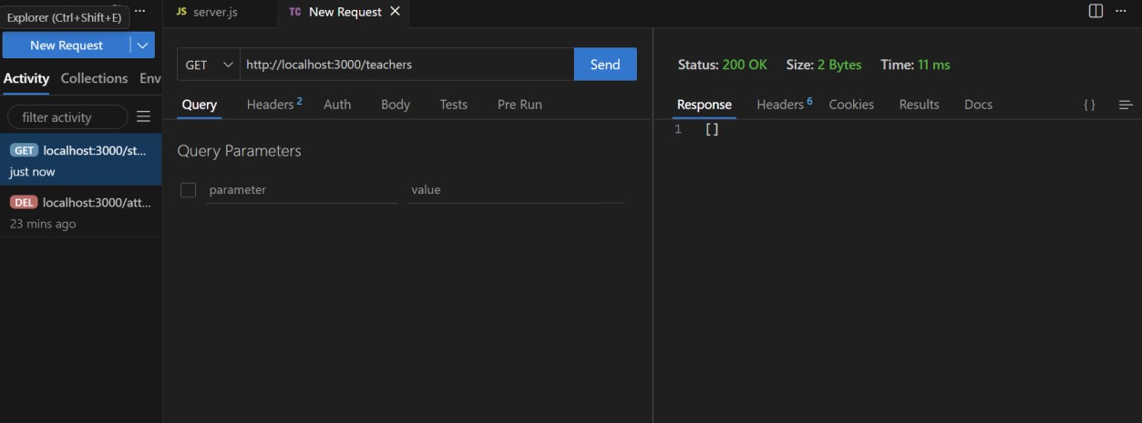
- POST /teachers → Add a new teacher
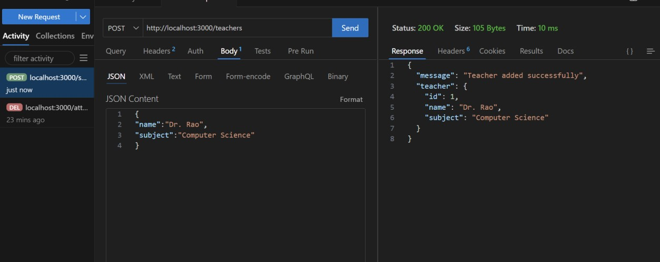
- PUT /teachers/{id} → Update teacher details
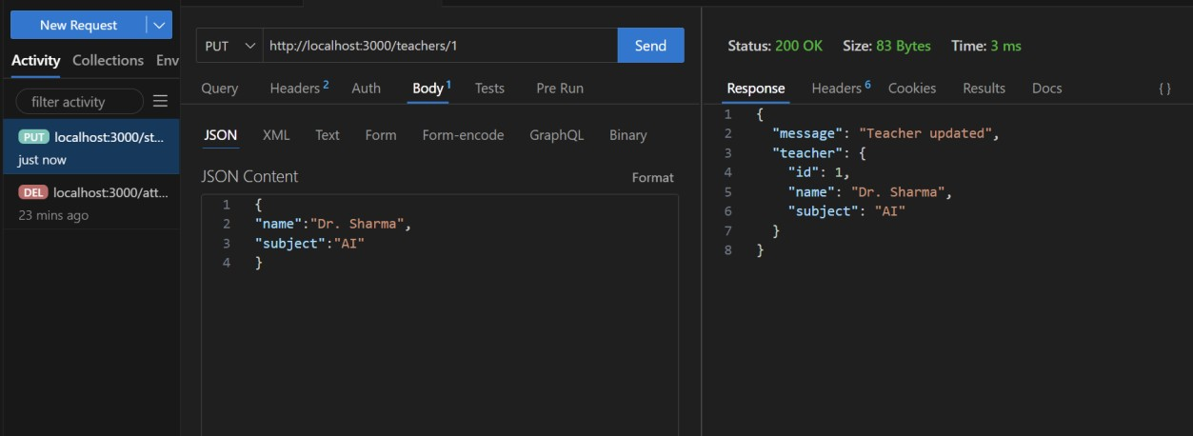
- DELETE /teachers/{id} → Remove a teacher
