Project Report: Real-Time Monitoring and Alerting System (Full Observability)

Executive Summary
This project successfully implemented a comprehensive, automated observability stack for an EC2-hosted application environment, utilizing CloudWatch, Prometheus, Grafana, and Slack. A key innovation was the use of EC2 User Data (user-data.sh) to fully automate the installation and configuration of Prometheus, Node Exporter, and Grafana, eliminating manual SSH steps. Furthermore, the Grafana dashboard was provisioned using a JSON model, adhering to Infrastructure as Code (IaC) principles for visualization. The alerting pipeline, integrating CloudWatch metrics via SNS and a custom AWS Lambda function, ensures real-time notification to a Slack channel. This fully automated setup drastically reduces deployment time and meets the goal of minimizing the time spent by engineers on routine monitoring and fixing, thereby achieving full observability.

1. Project Overview and Initial Setup
This phase establishes the foundational AWS resources (IAM User/Role, Security Group) and launches the core compute instance using the automation script.

1.1 IAM User Setup for Administration
1.1.1 AWS Console search bar used to find the IAM service.
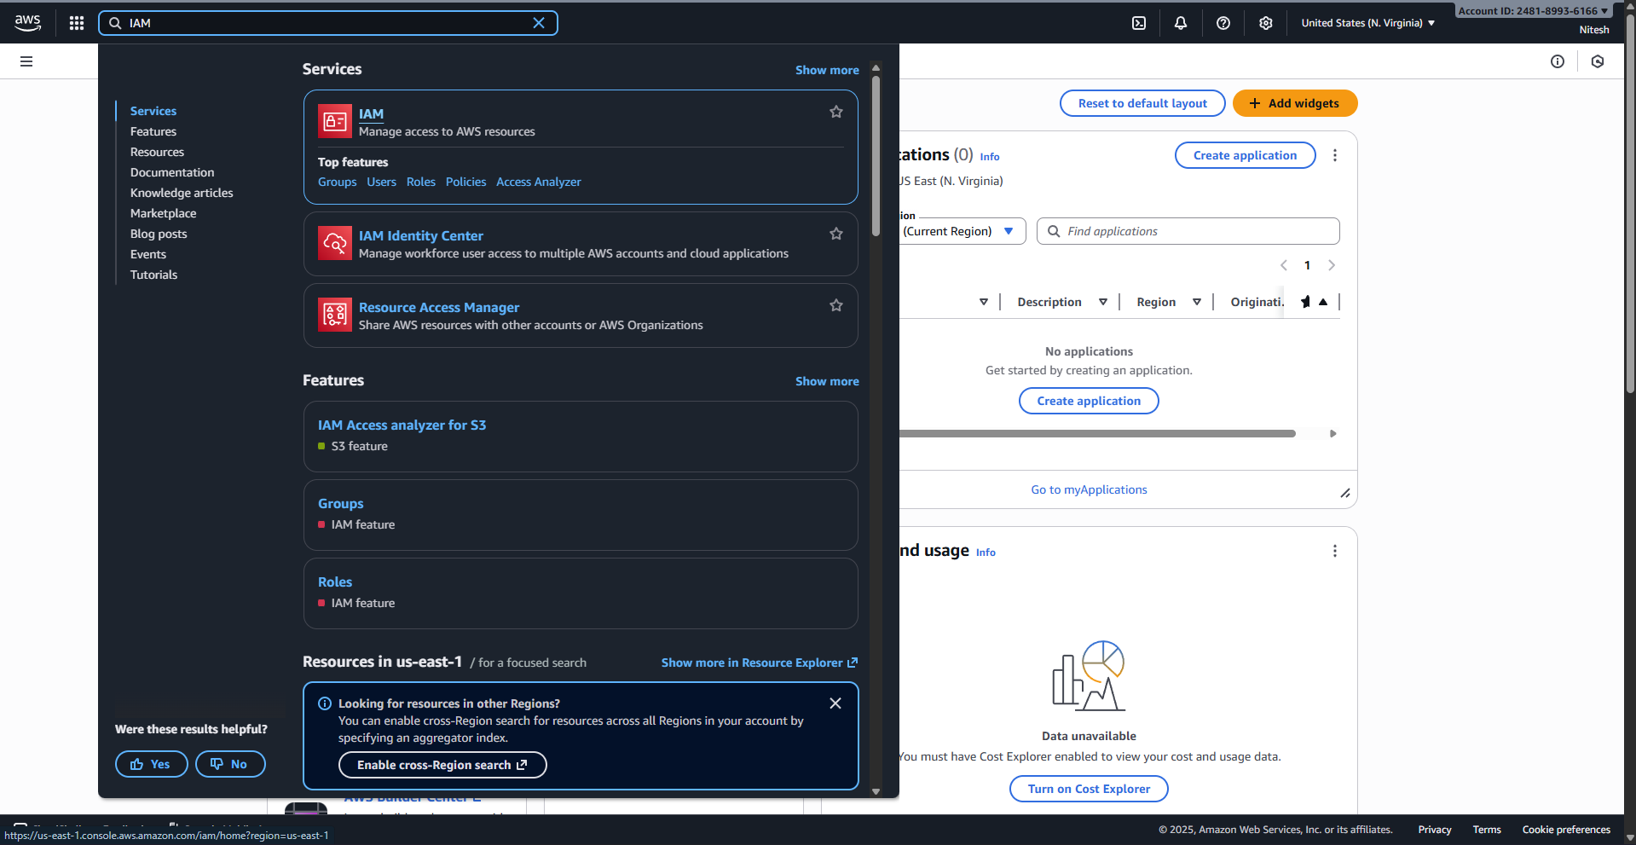
1.1.2 IAM Users page, ready to click "Create user".
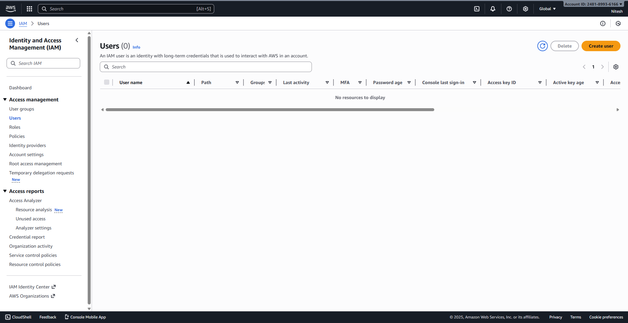
1.1.3 User details screen: observability-admin, Autogenerated password selected.
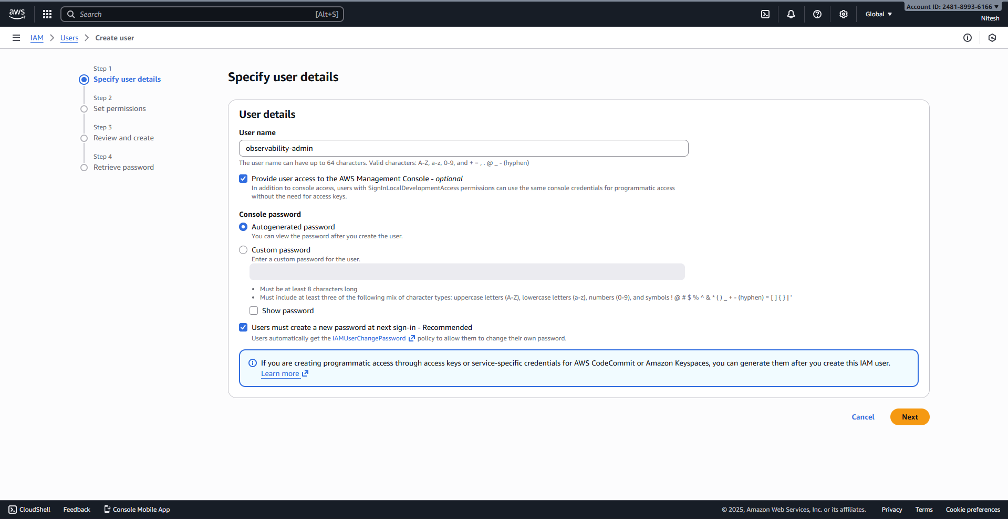
1.1.4 Permissions screen: Attach policies directly selected.
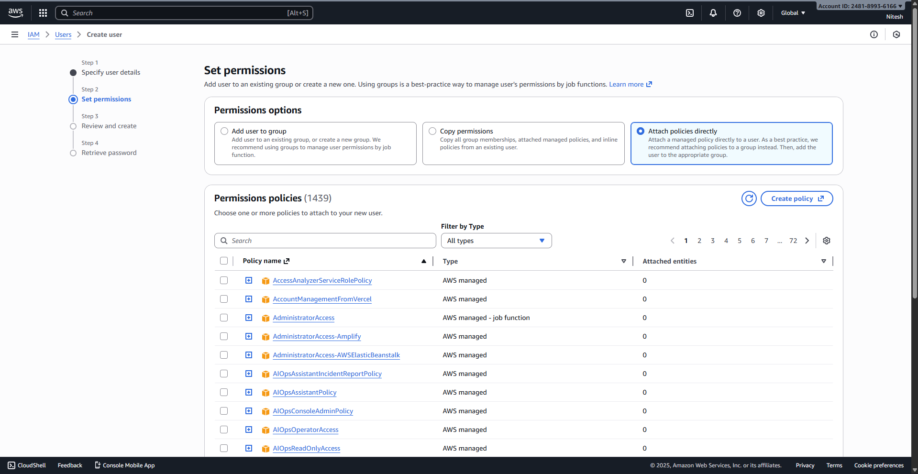
1.1.5 Review screen: Listing all necessary policies attached to the new user.
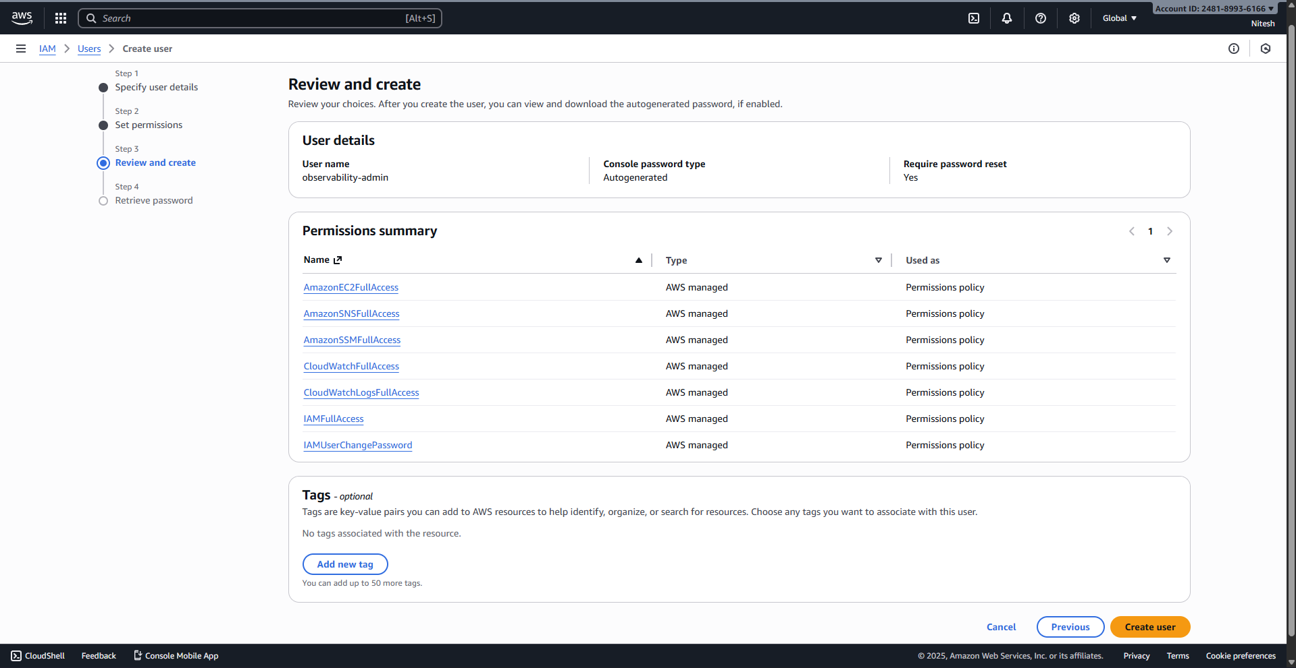
1.1.6 Final success screen showing the Console sign-in URL.
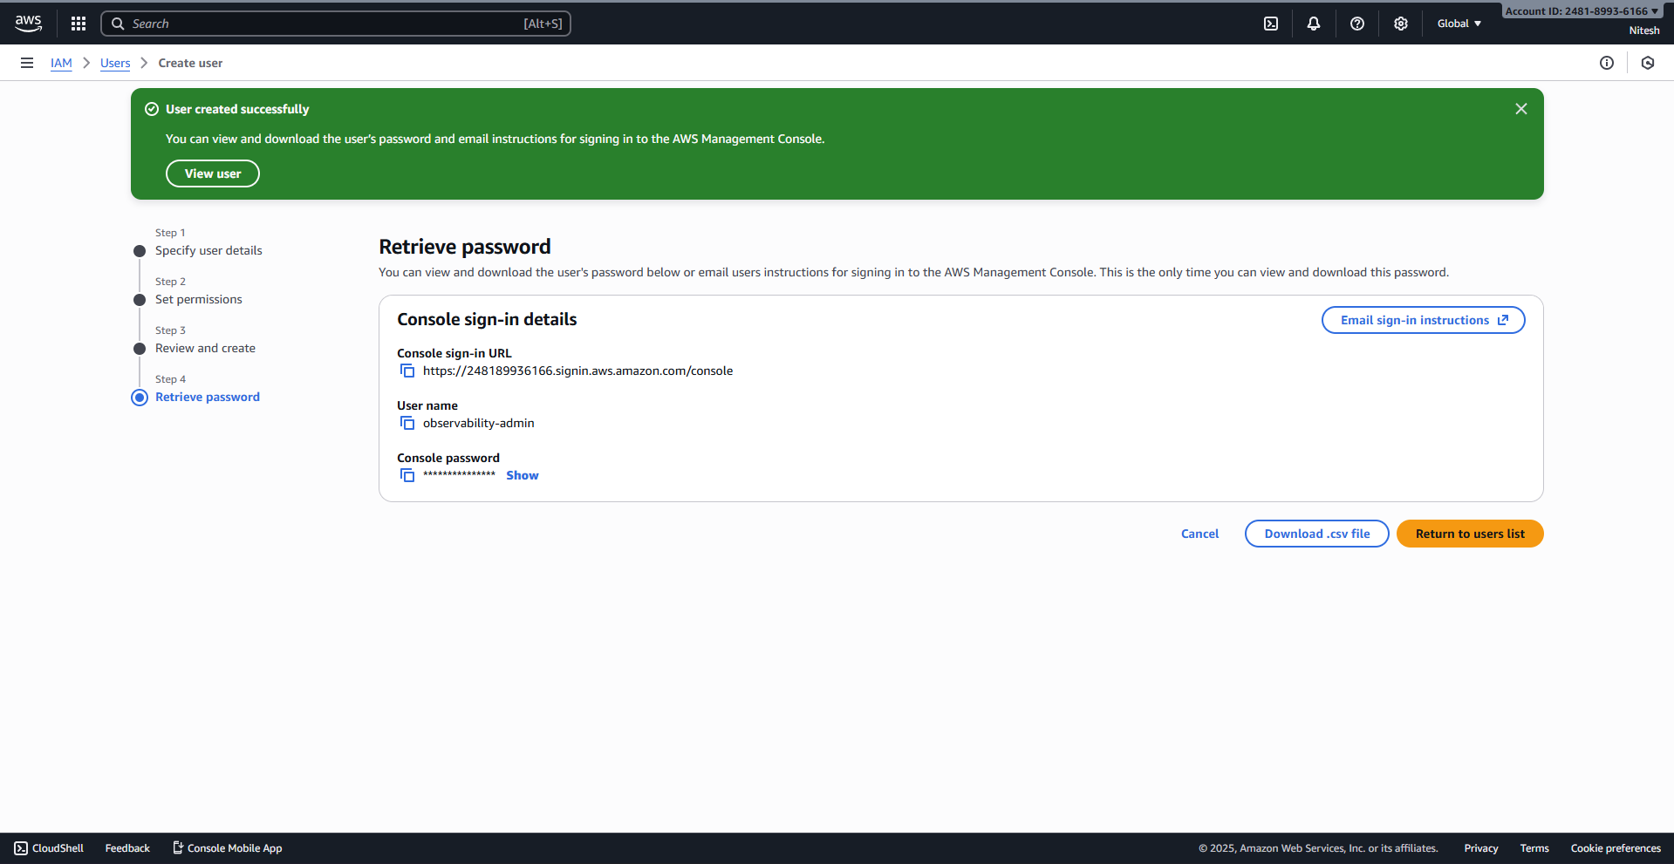
1.1.7 The AWS login screen with the observability-admin user name.
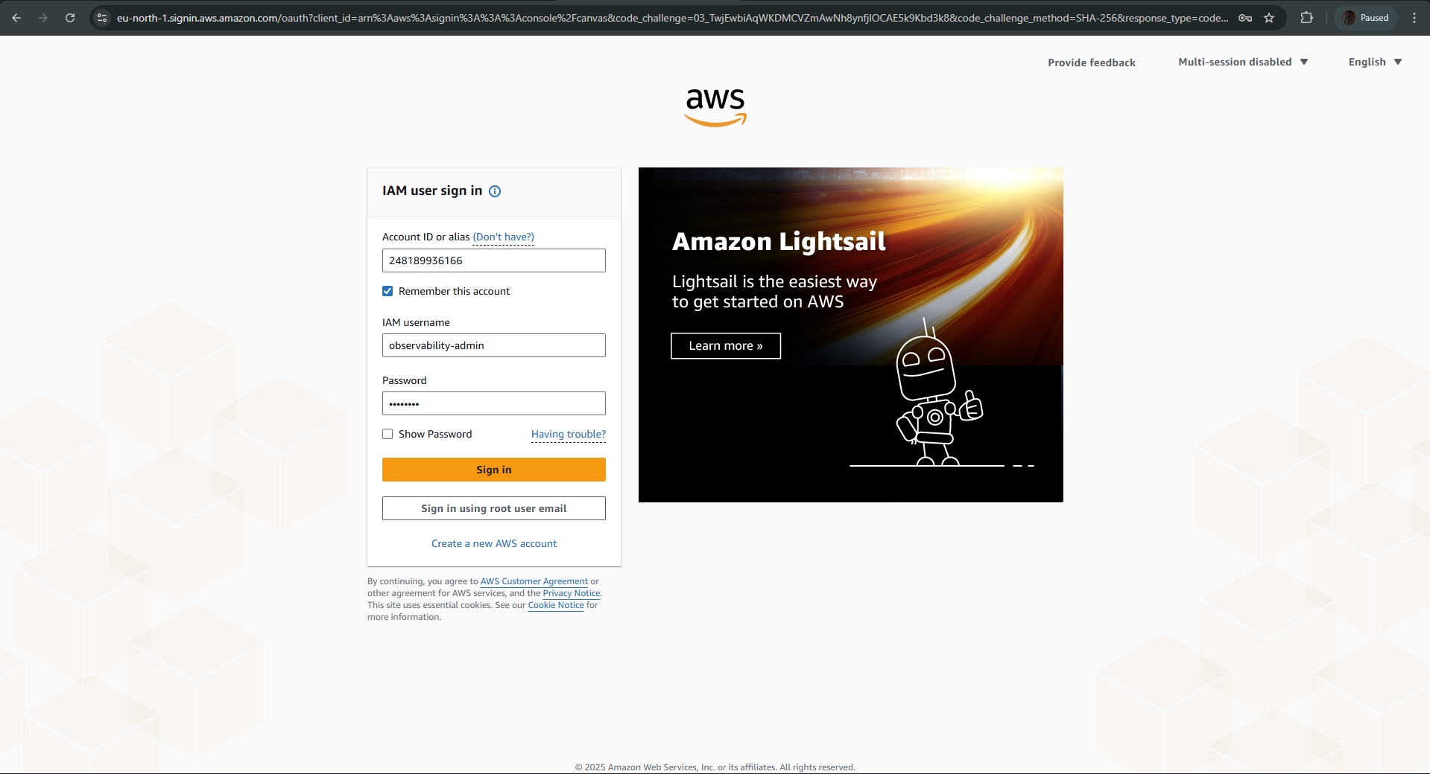
1.1.8 The mandatory password reset page after the first login.
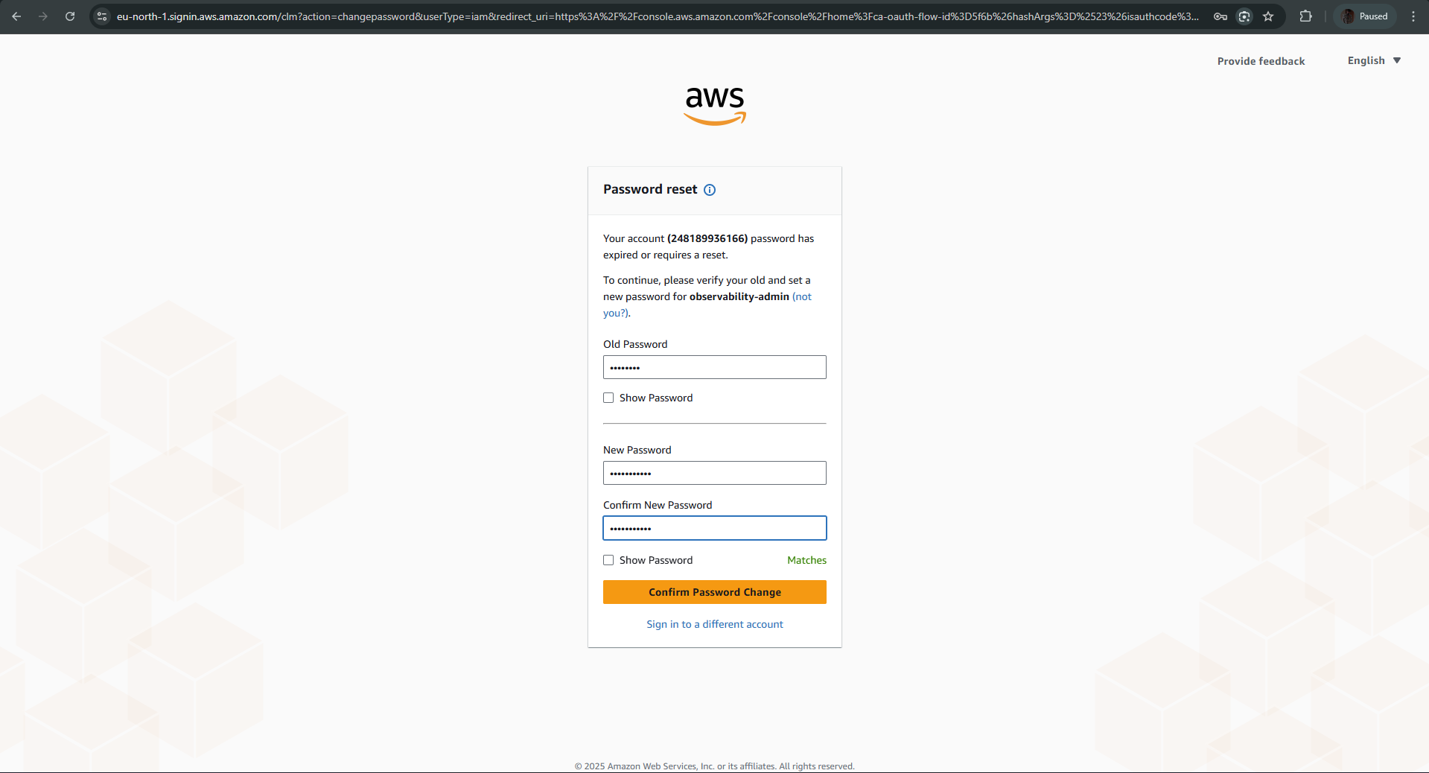
1.1.9 Confirmation that the password reset was successful.
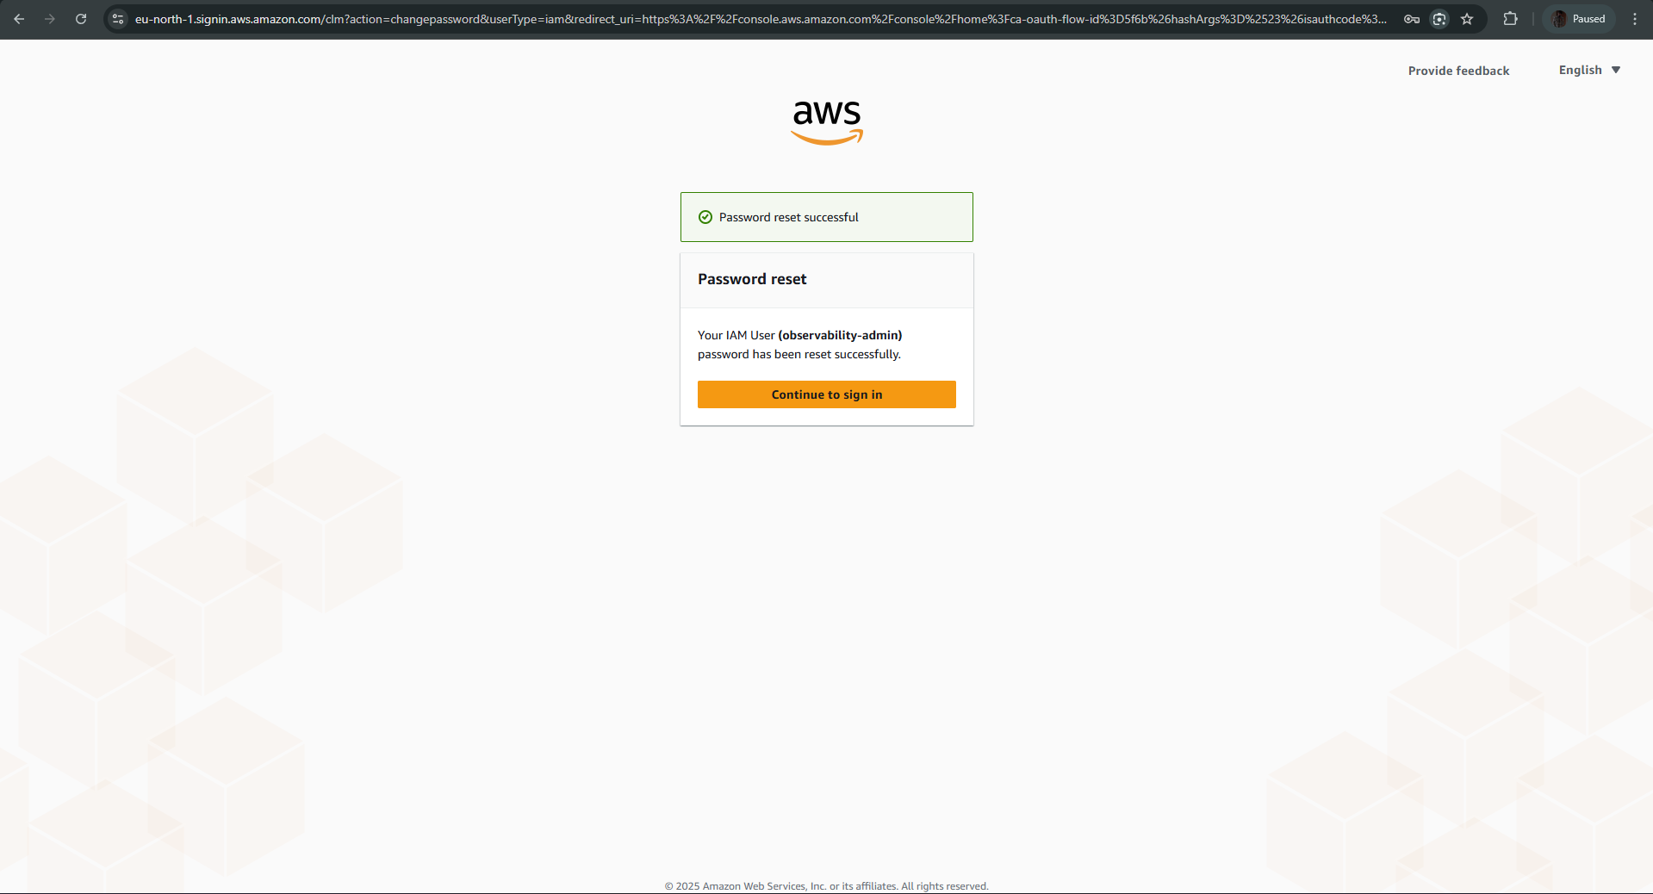
1.1.10 AWS Console homepage after successful login.
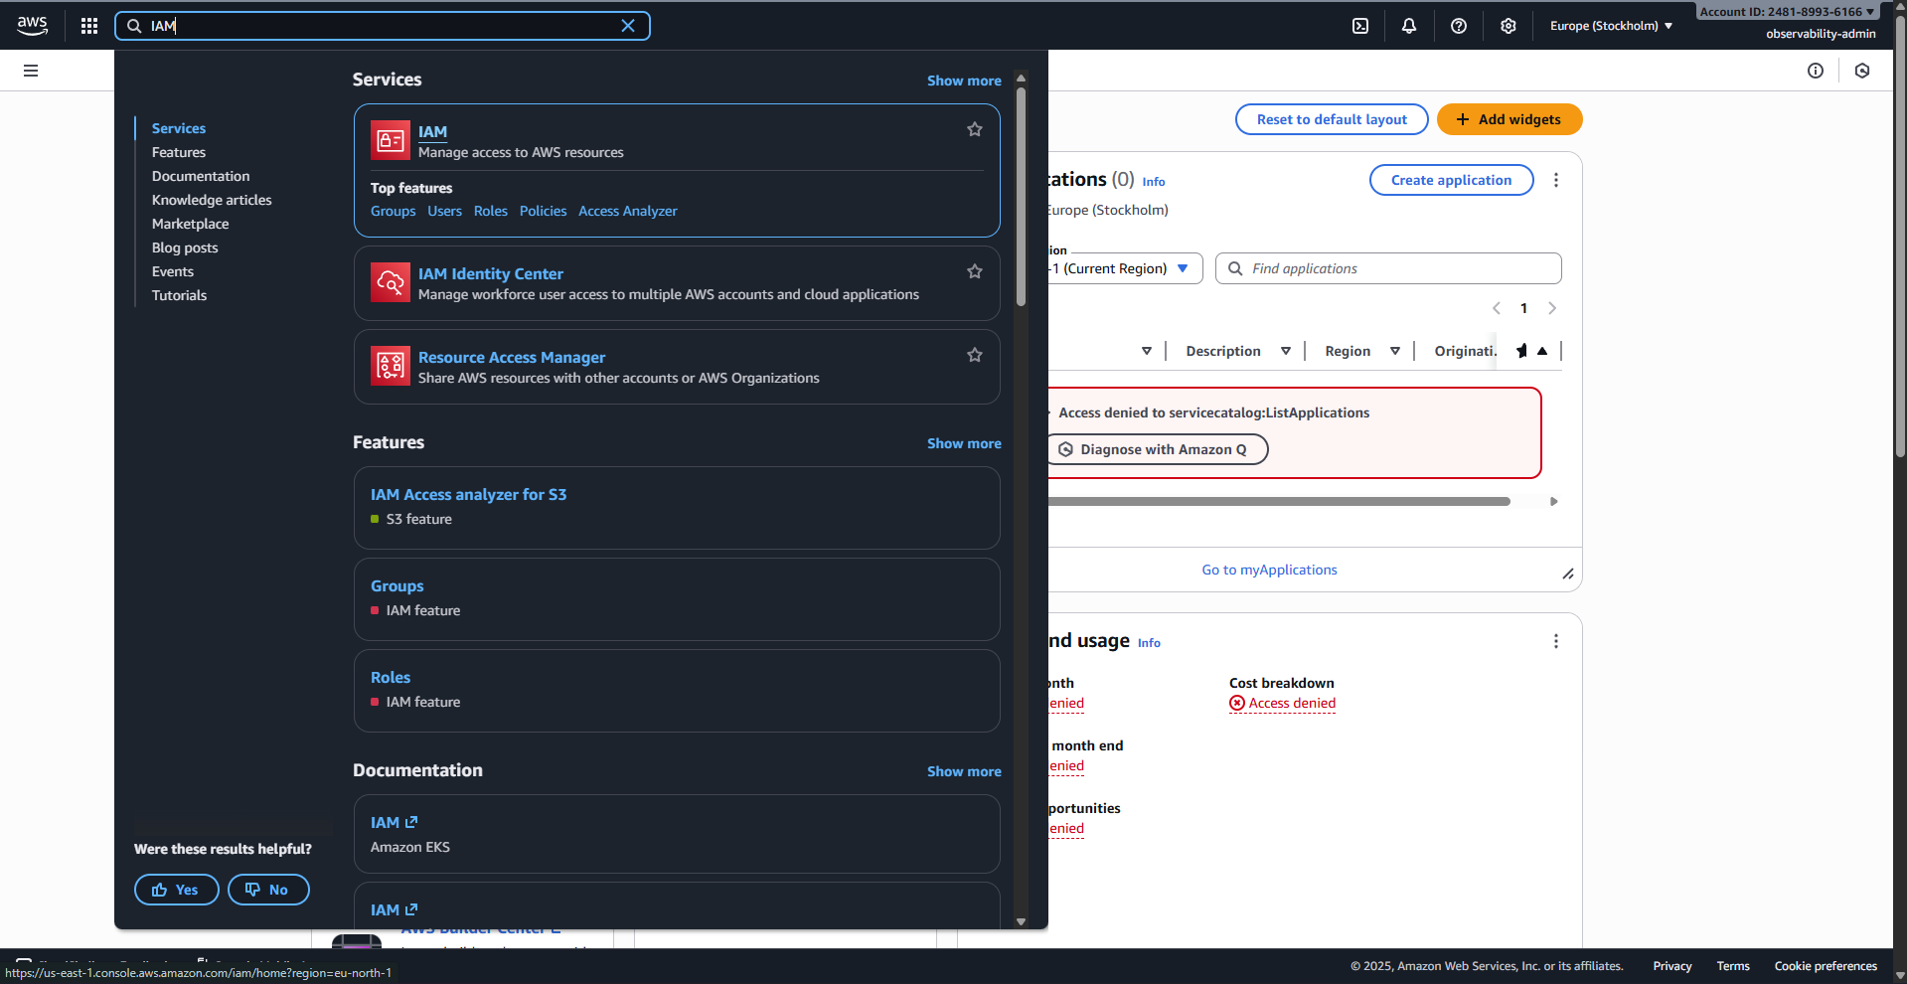

1.2 EC2 Prerequisites: IAM Role and Network Access (Security Group)
1.2.1 IAM Roles page, ready to click "Create role".
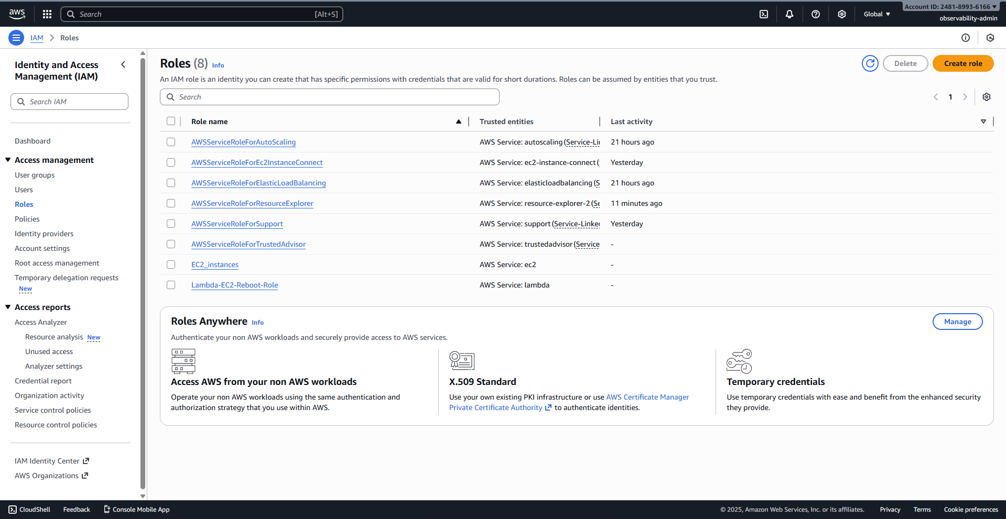
1.2.2 "Create role" Step 1: AWS service selected, EC2 selected as the use case.
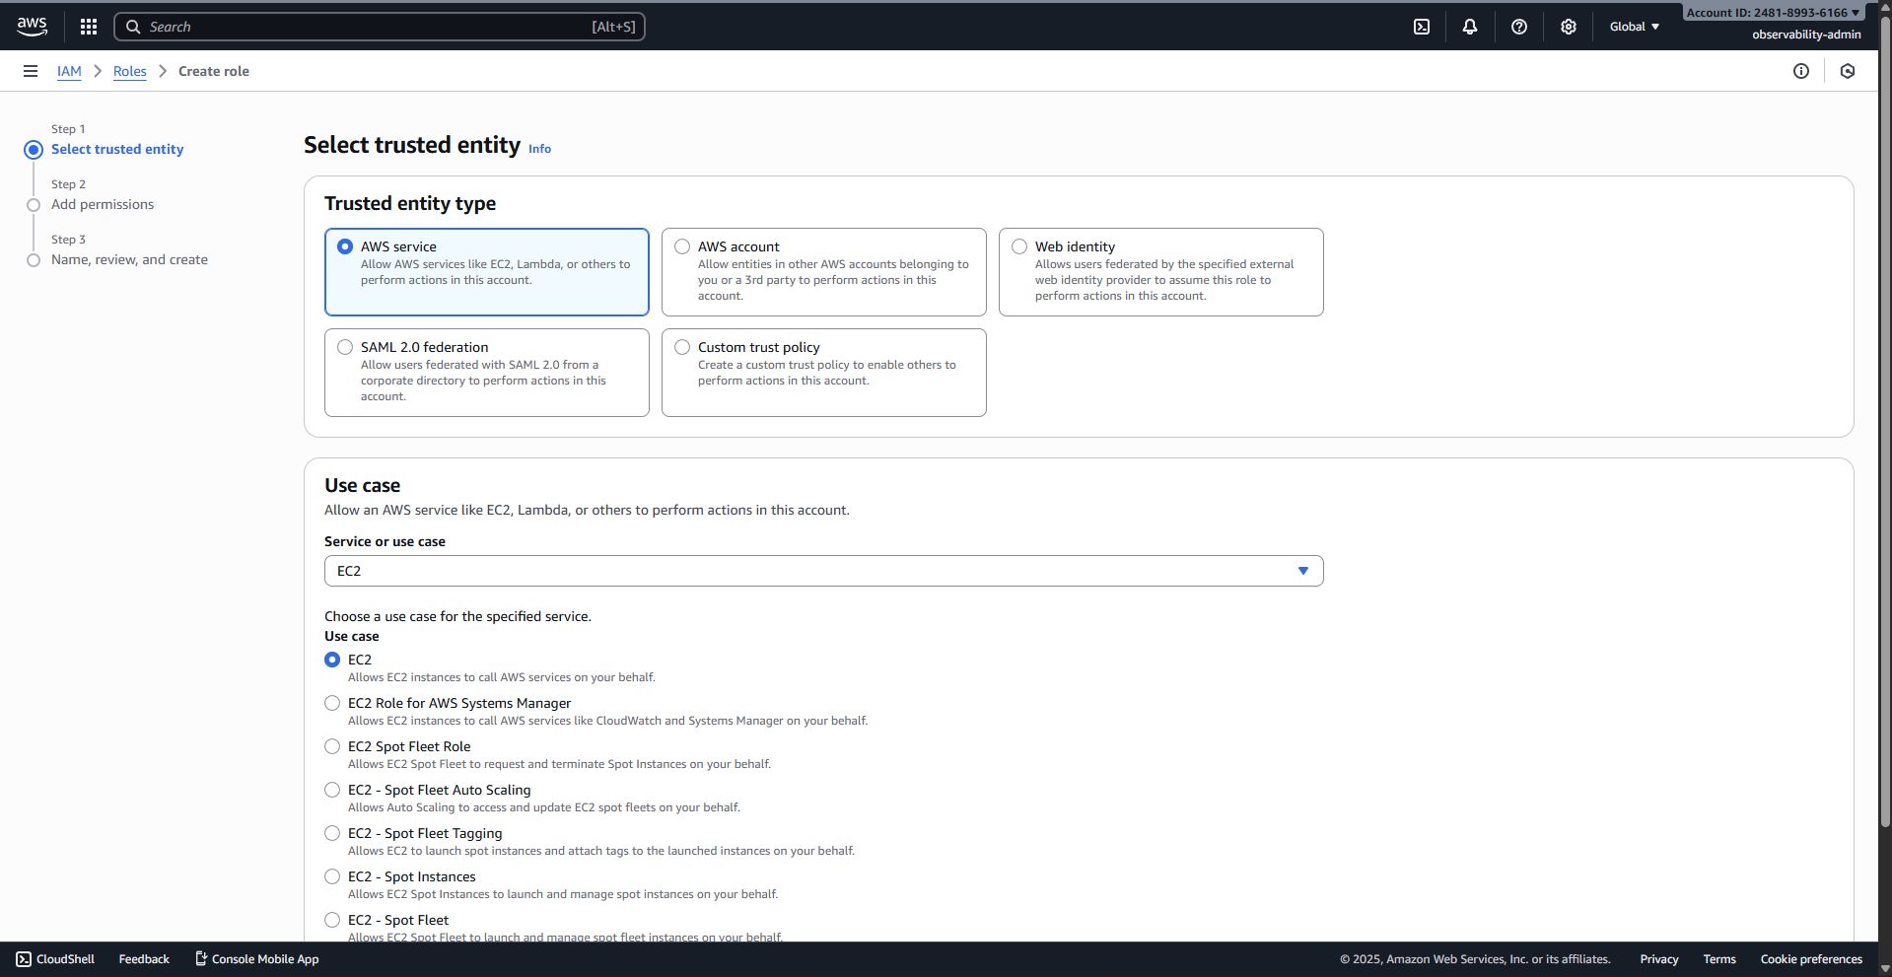
1.2.3 "Create role" Step 2: Selecting the CloudWatchAgentServerPolicy.
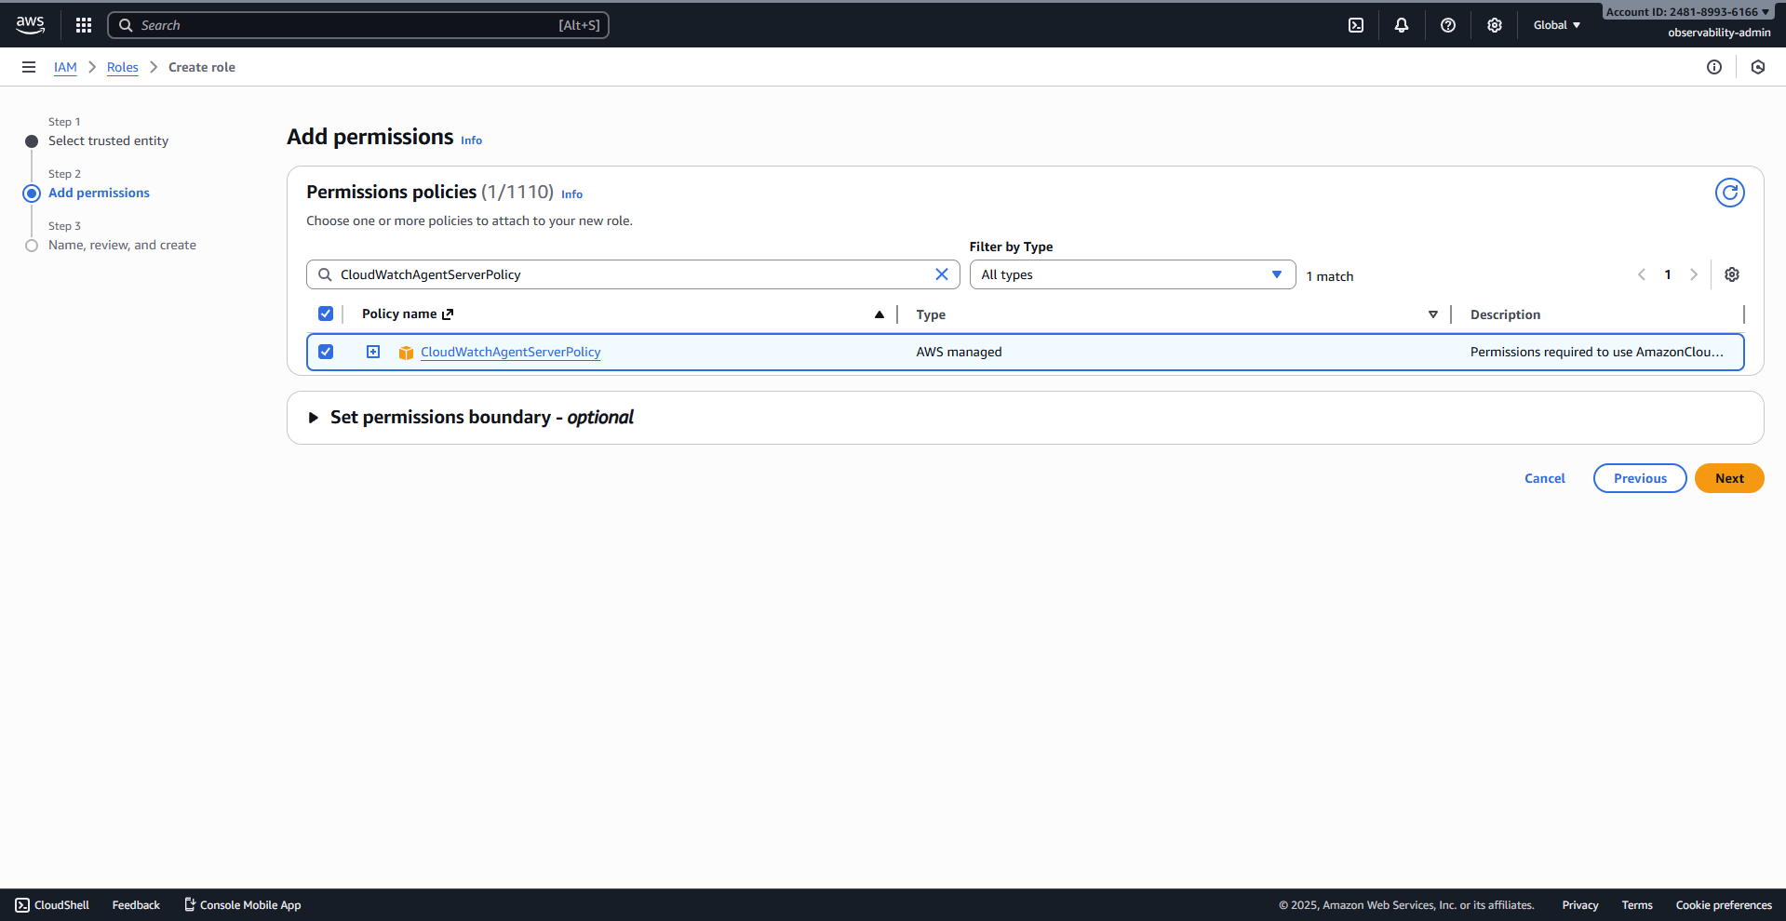
1.2.4 "Create role" Step 3: Naming the role as EC2-CloudWatch-Agent-Role.
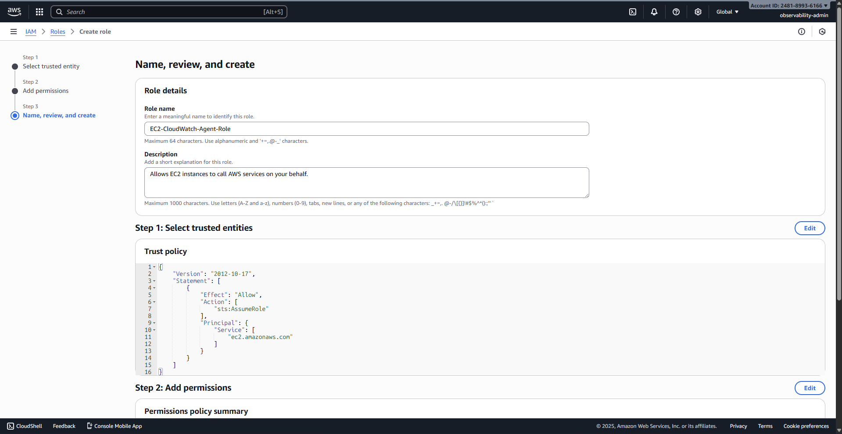
1.2.5 "Create role" Step 3: Final view showing the attached policy and the EC2 Trust Policy.
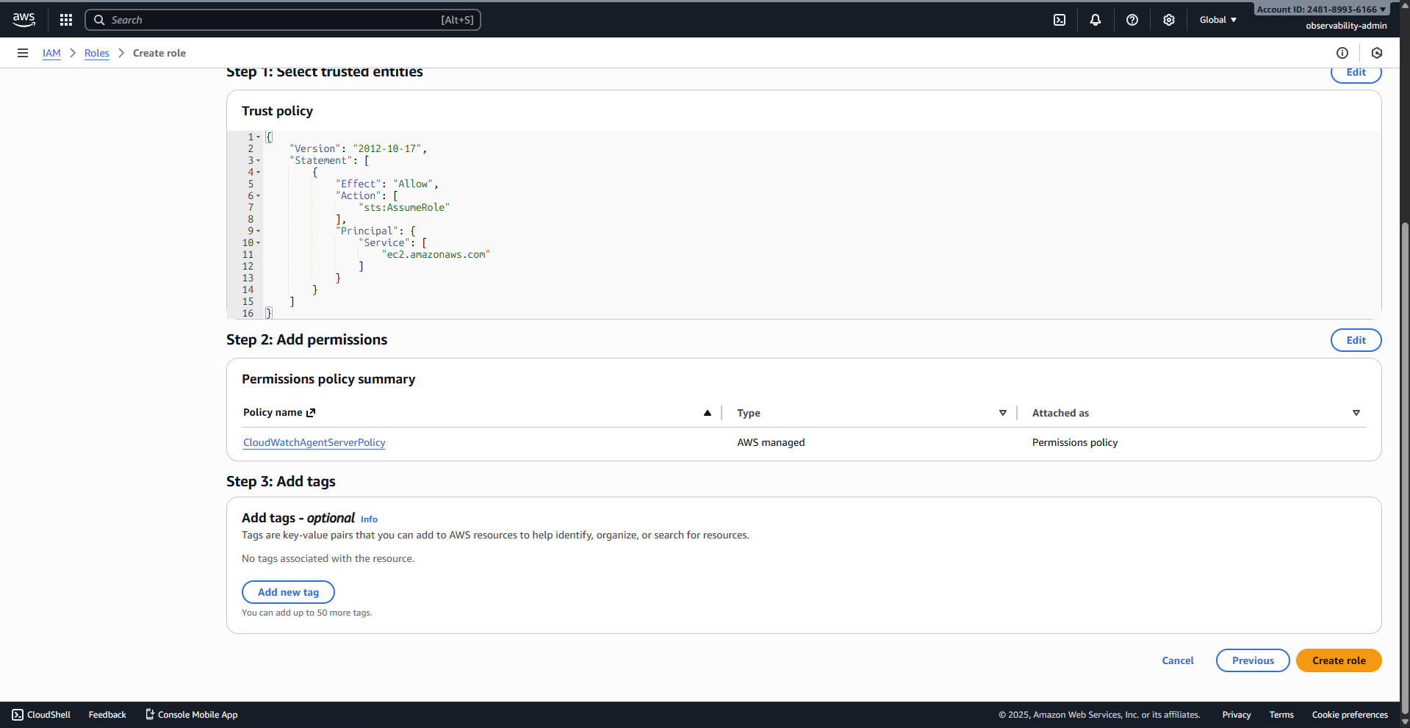
1.2.6 Final screen confirming the EC2-CloudWatch-Agent-Role was successfully created.
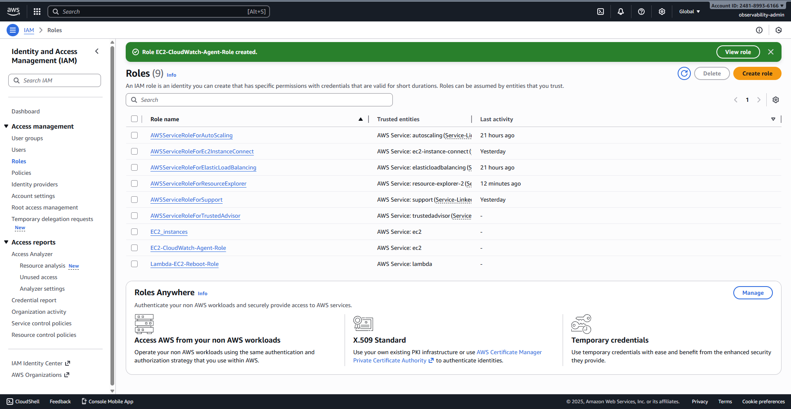
1.2.7 AWS Console search bar used to find the EC2 service.
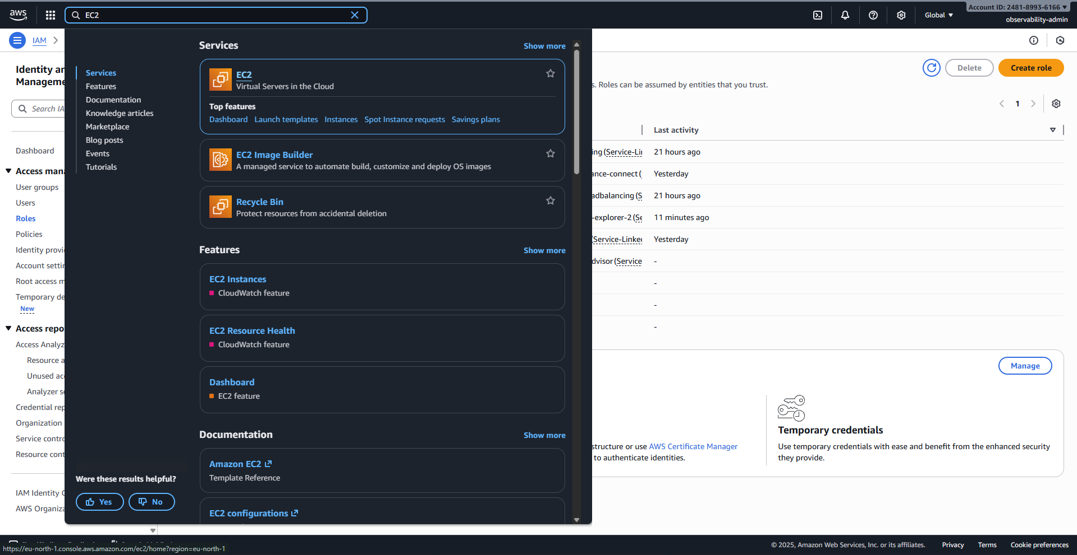
1.2.8 EC2 Security Groups page, ready to click "Create security group".
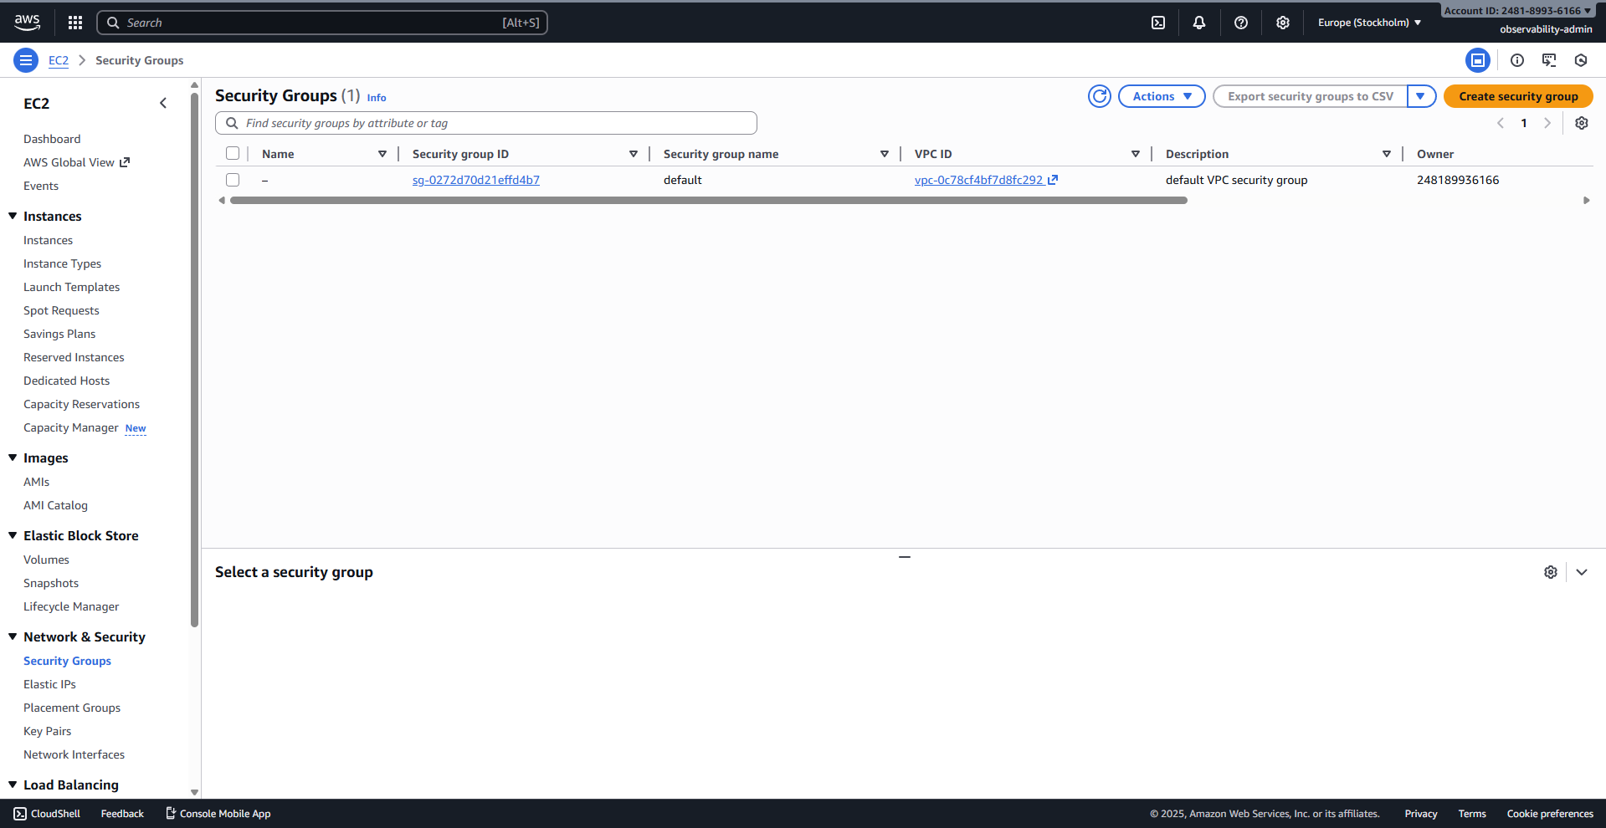
1.2.9 Security Group configuration: Name (real-time-monitoring-sg). Showing SSH (22), Grafana (3000), Prometheus (9090), and Node Exporter (9100) rules added
.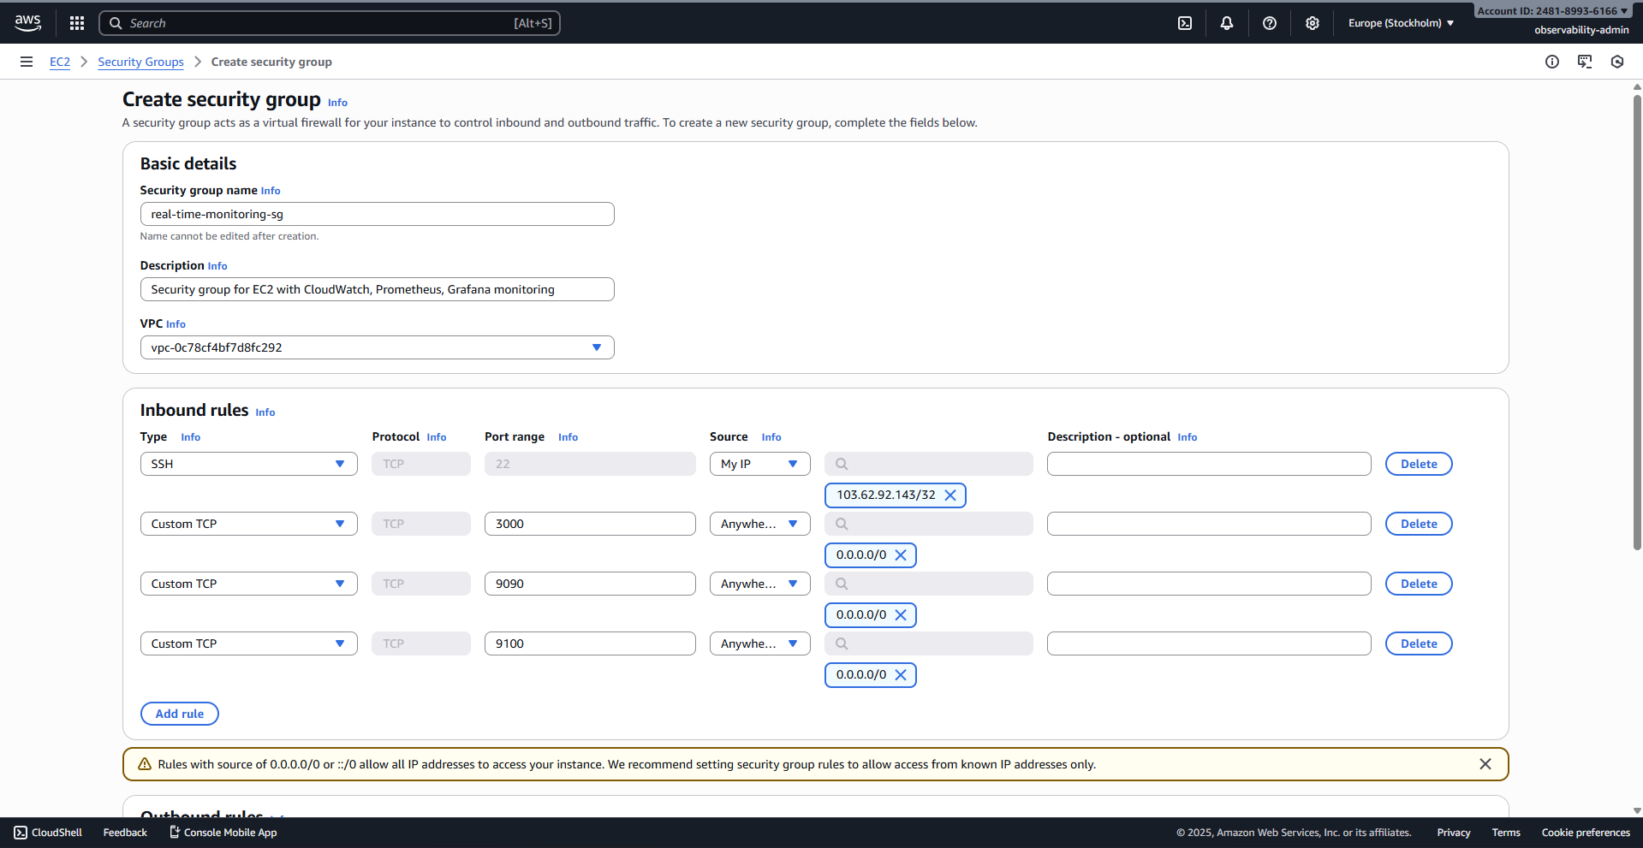
1.2.10 Security Group configuration: Final review of all inbound/outbound rules.
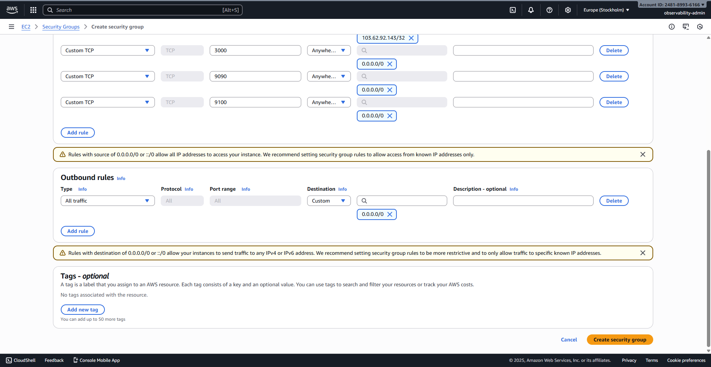
1.2.11 The Security Group details page, confirming the successful creation.
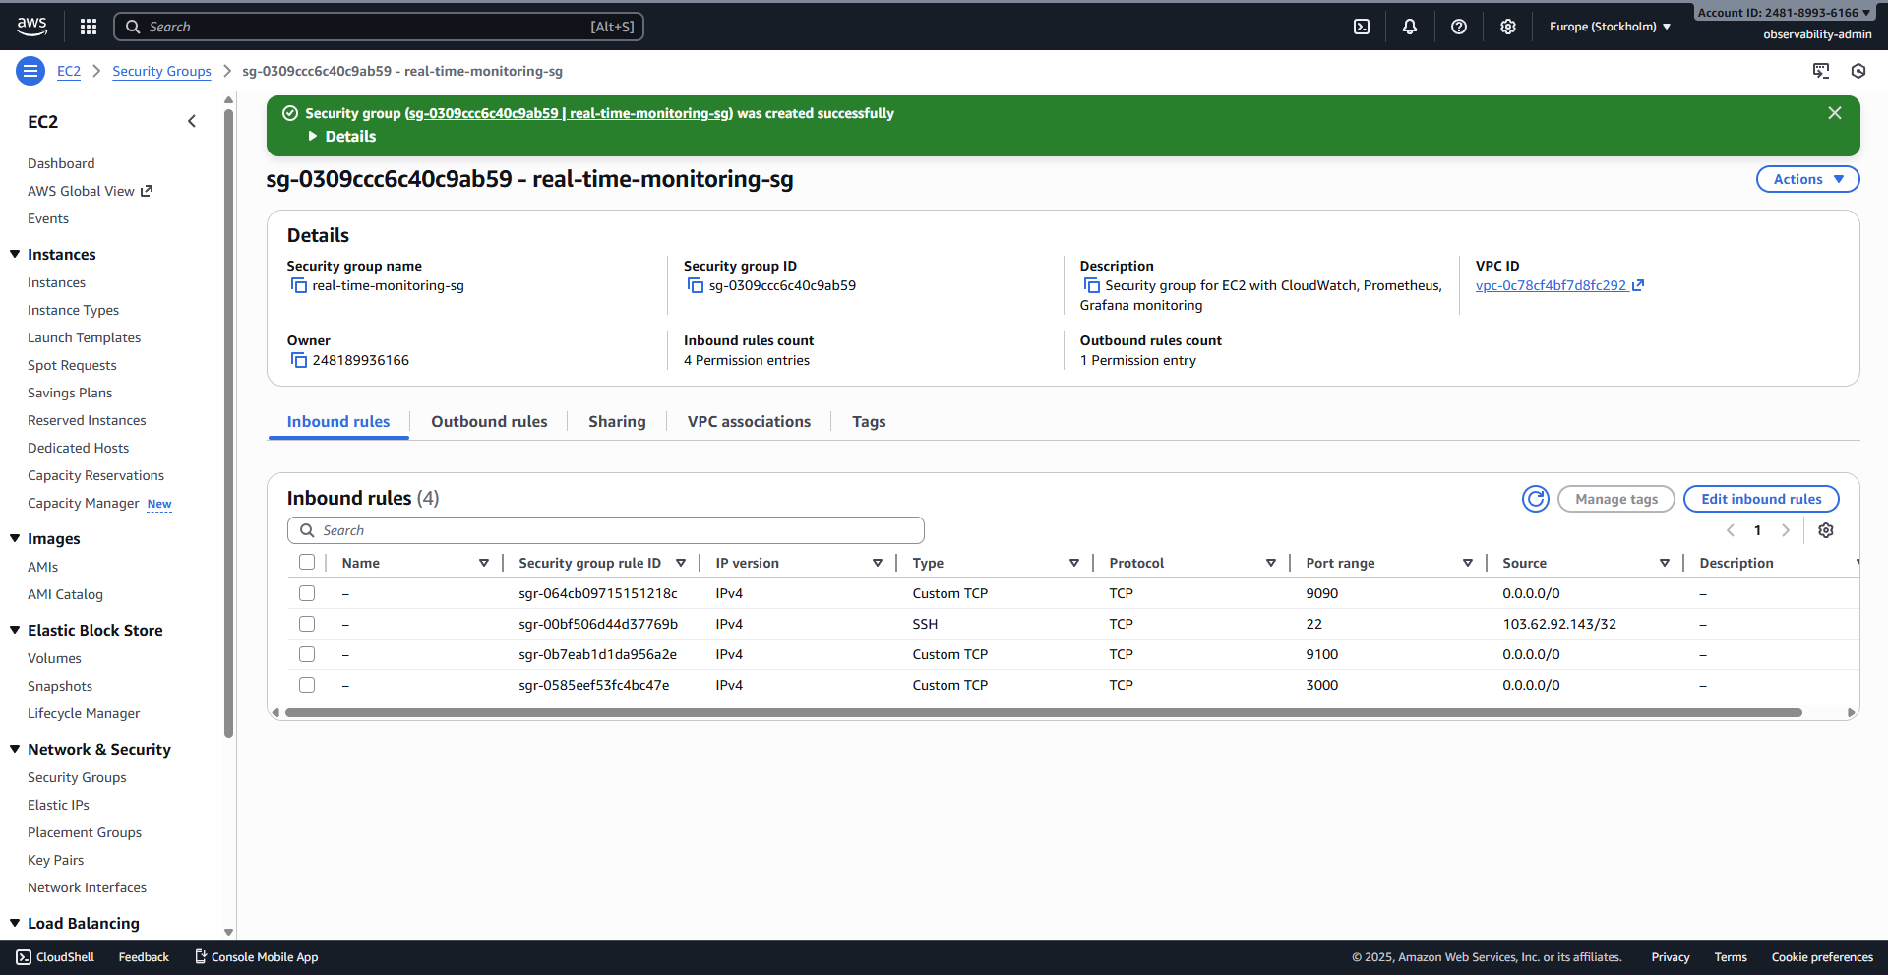

1.3 EC2 Instance Launch and Initial Validation
1.3.1 EC2 Instances page, ready to click "Launch instances".
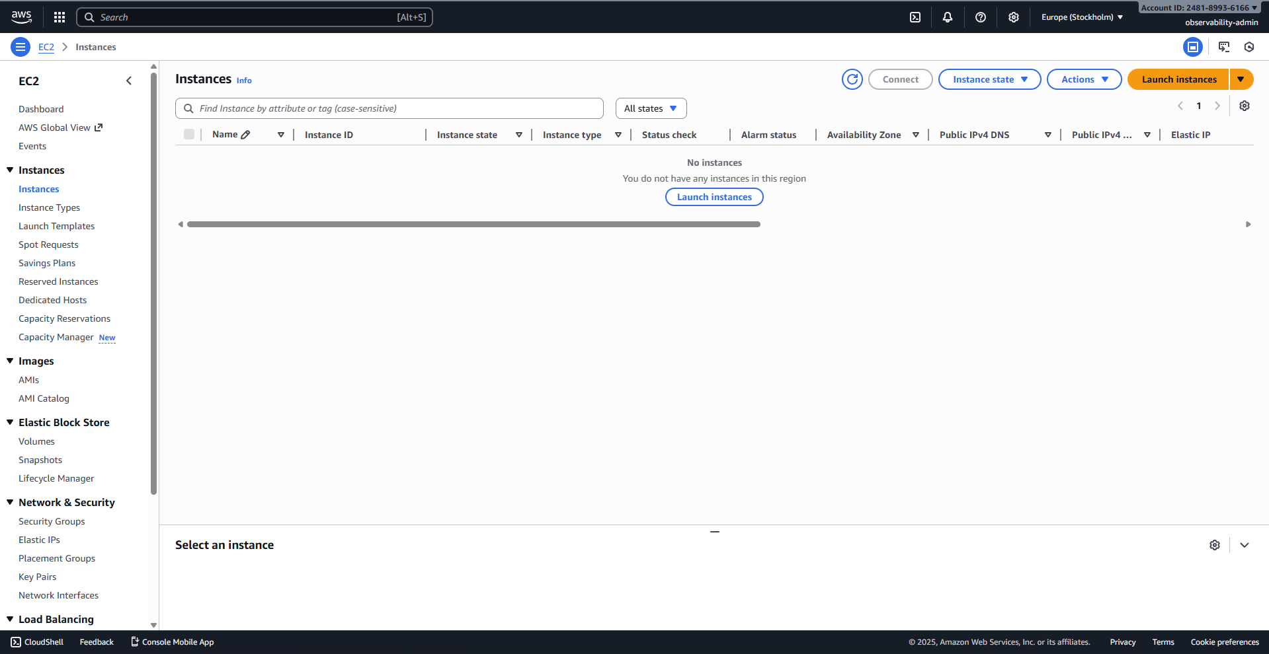
1.3.2 Launch Instance wizard: Name (Dev-Monitoring), Amazon Linux 2023 AMI selected.
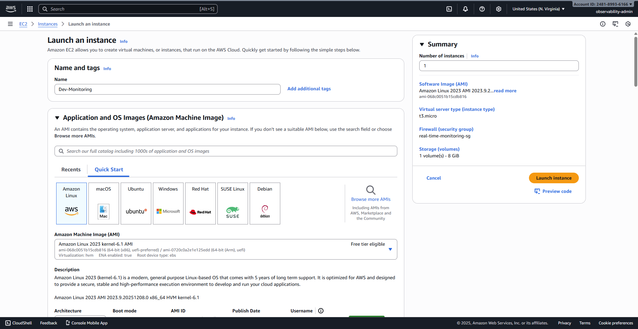
1.3.3 Launch Instance wizard: Advanced details expanded, showing the selection of the EC2-CloudWatch-Agent-Role.
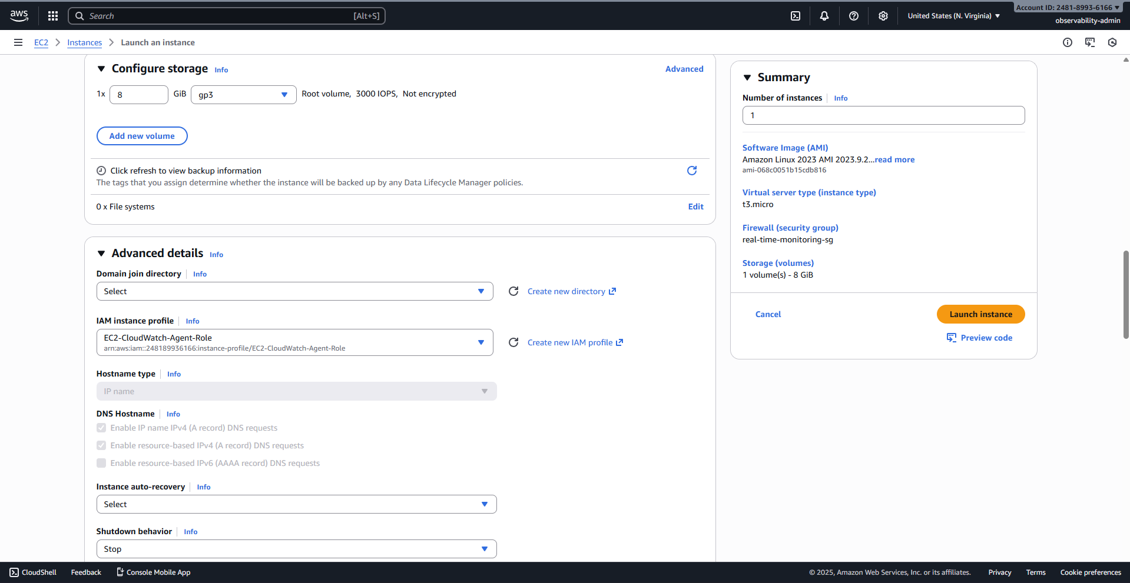
1.3.4 Launch Instance wizard: User Data section showing the beginning of the user-data.sh script pasted.
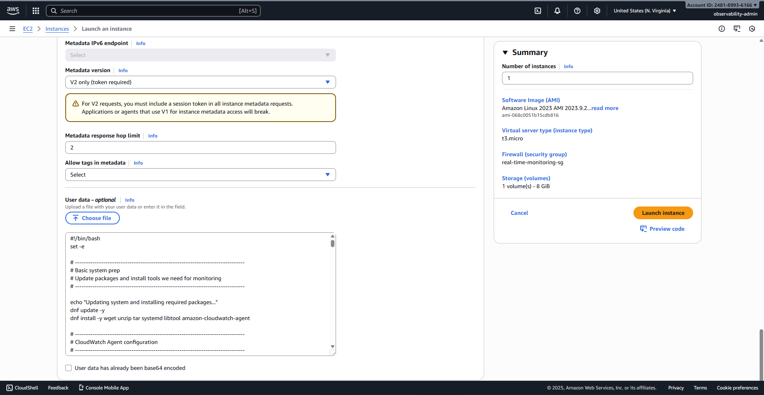
1.3.5 Final screen confirming the successful launch of the instance.
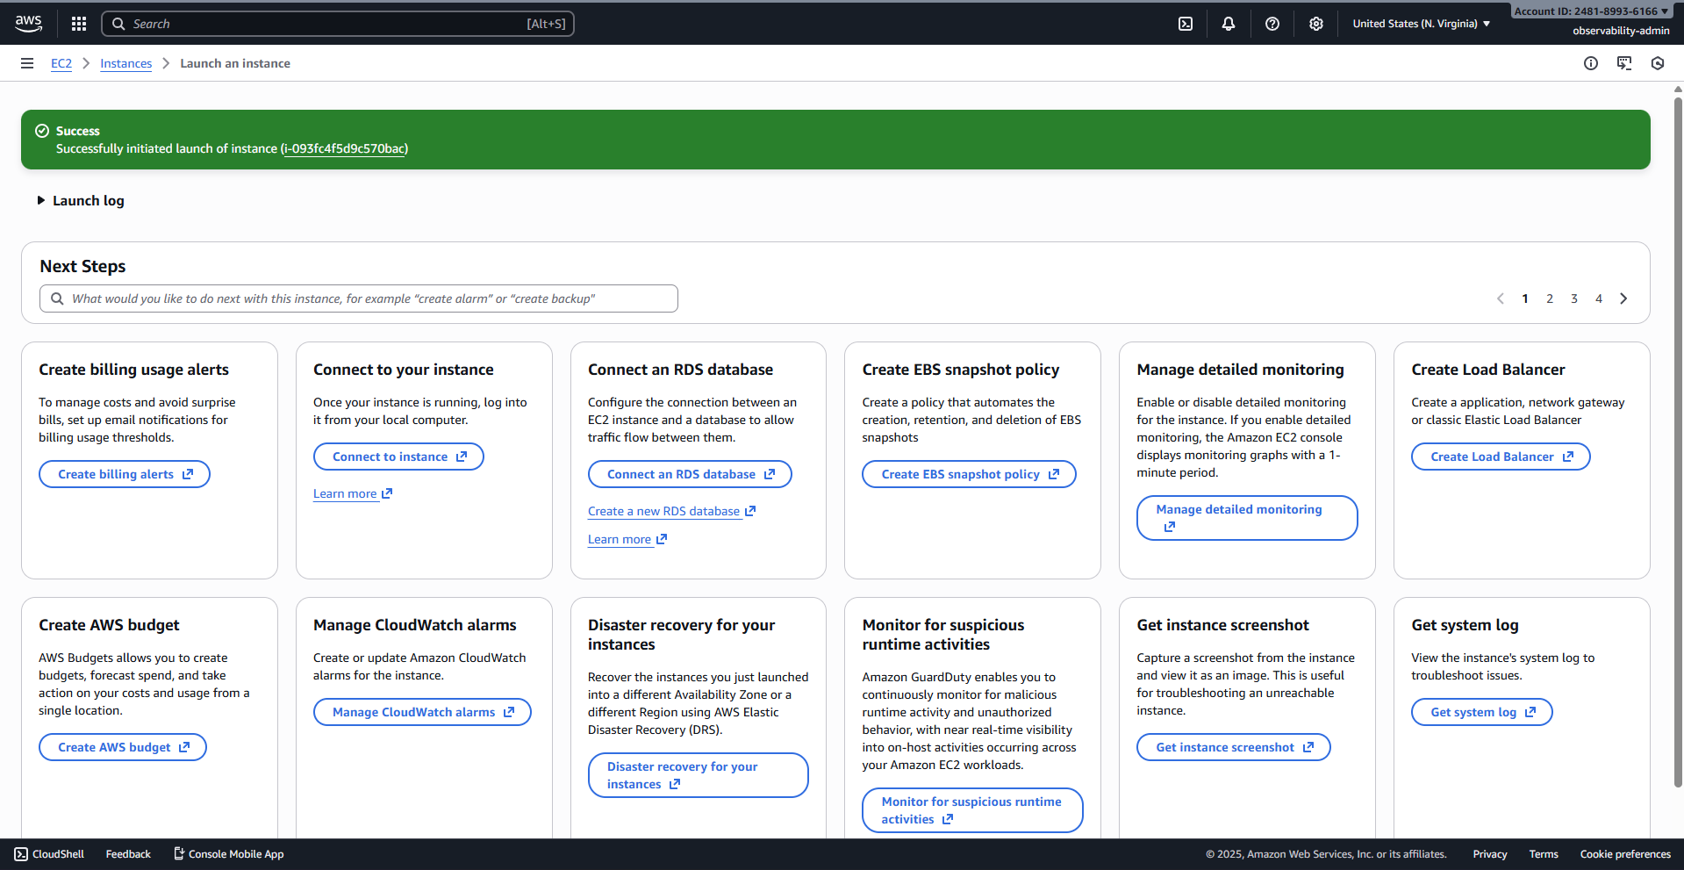
1.3.6 Launch Instance wizard: Selecting the Key pair and attaching the existing real-time-monitoring-sg security group.
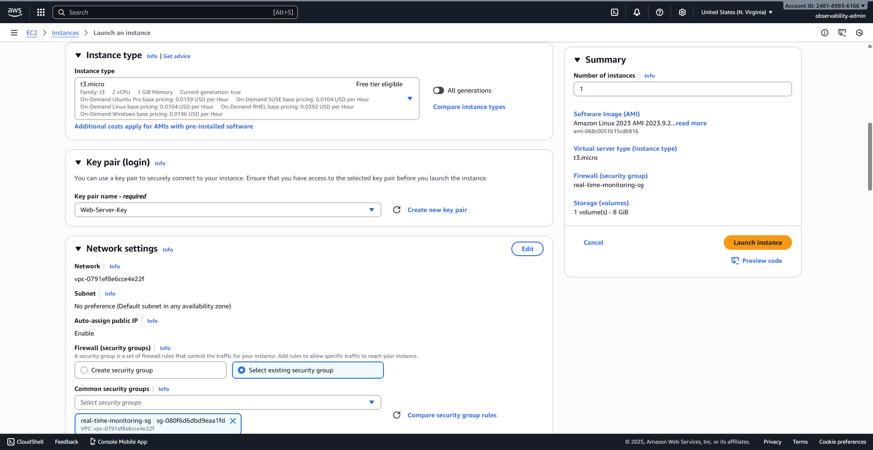
1.3.7 EC2 Instances list, showing the Dev-Monitoring instance is Running.
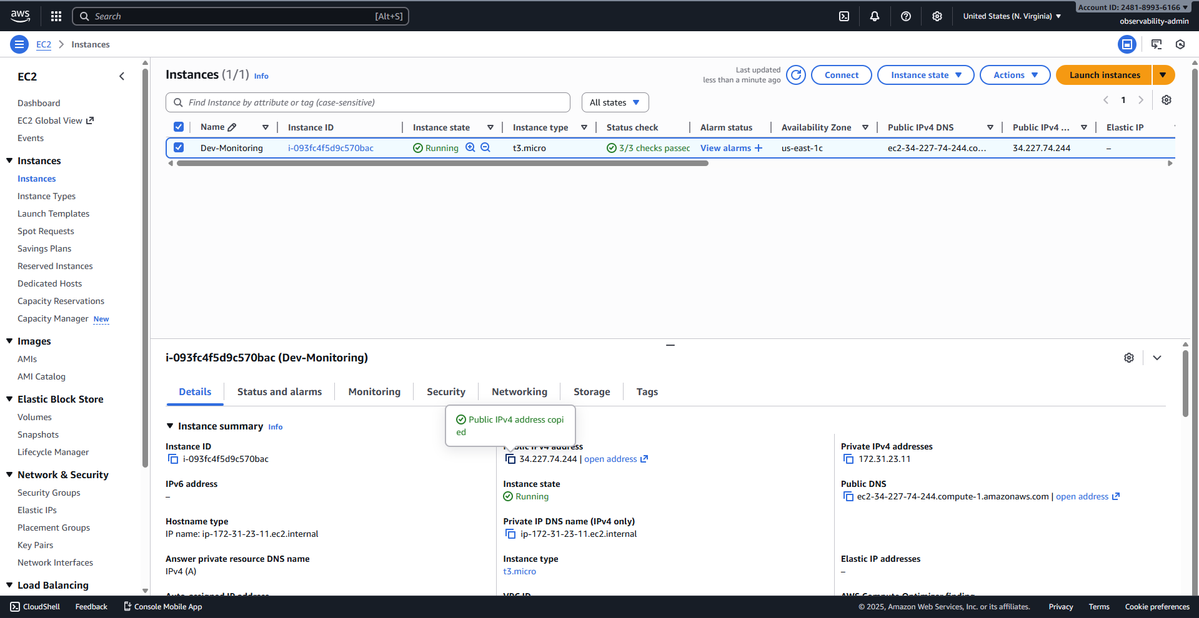

2. Visualization: Grafana Dashboard Configuration
This section validates the deployment of the Prometheus/Node Exporter stack and the automated provisioning of the Grafana dashboard.
2.1 Accessing http://<EC2-IP>:3000, showing the Grafana login screen.
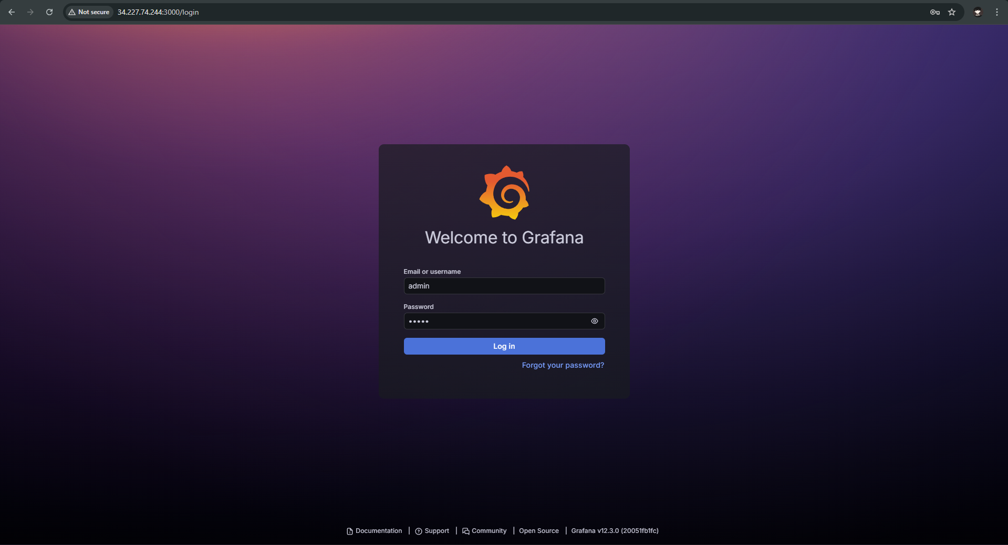
2.2 The screen prompting the user to Update your password.
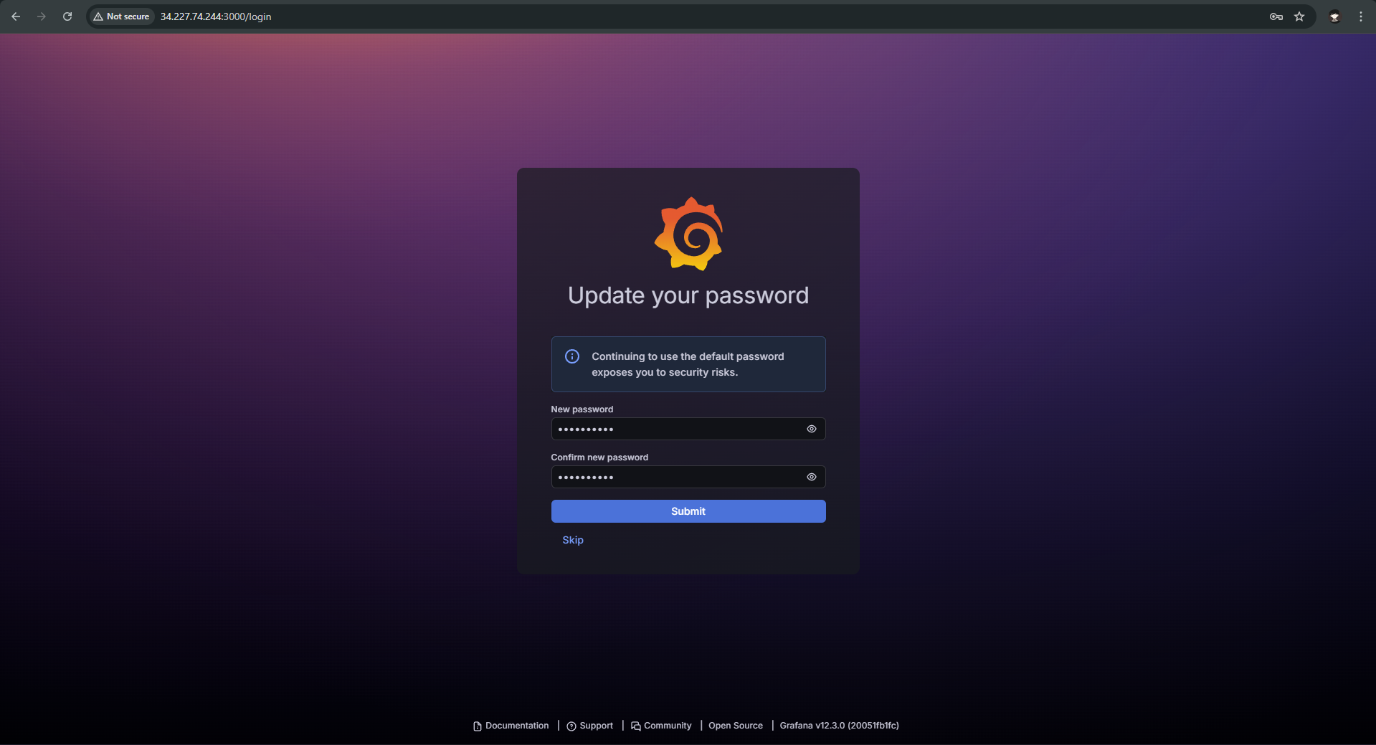
2.3 Grafana Home screen, showing "No data sources defined."
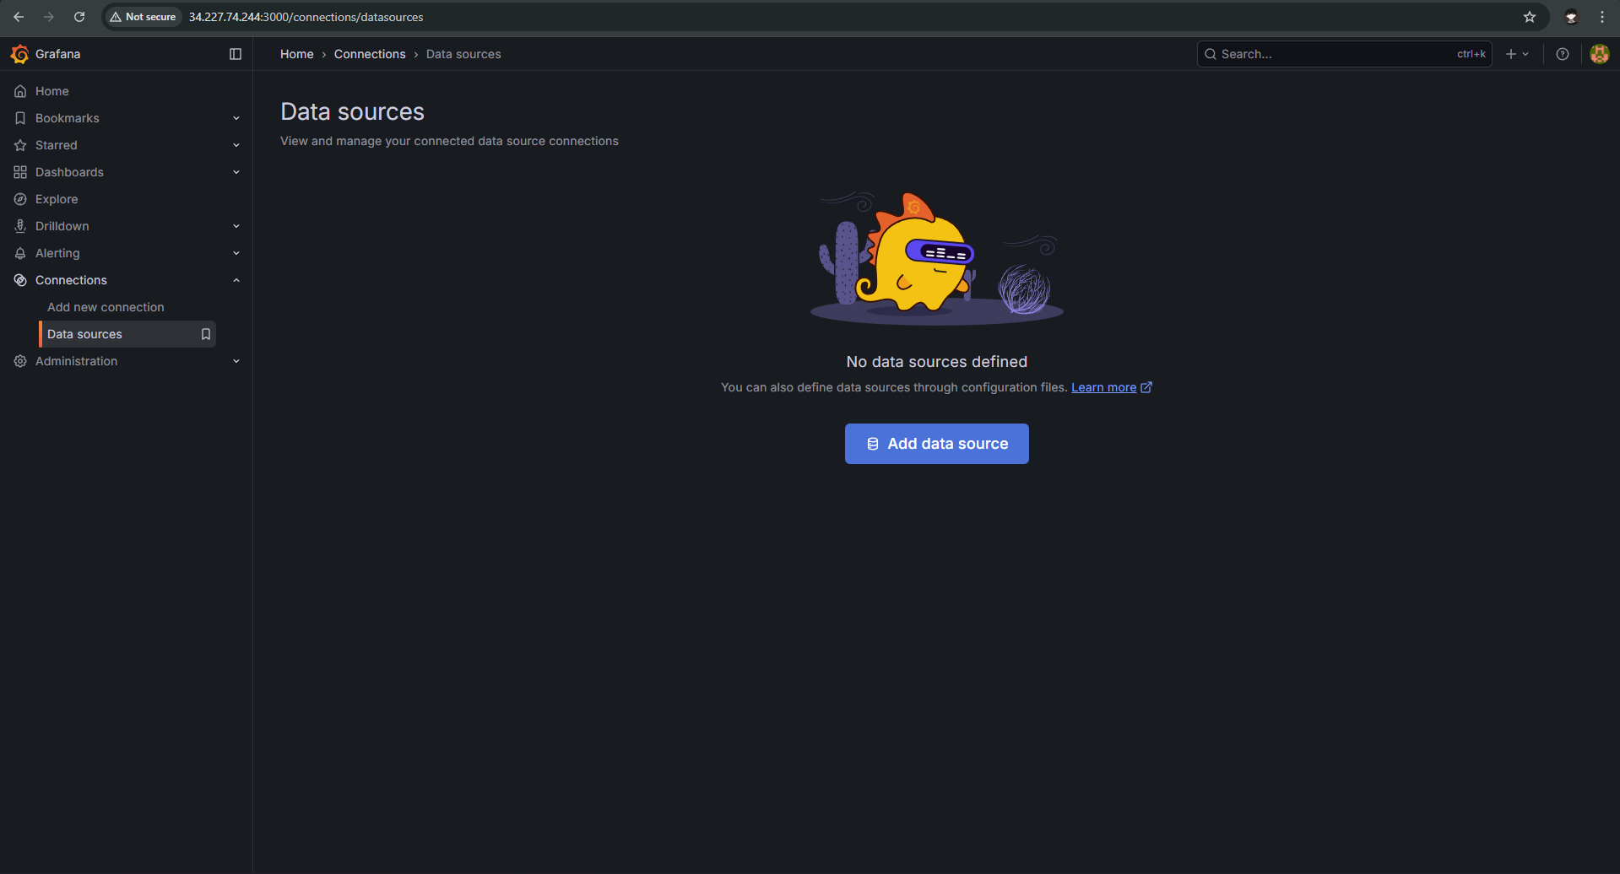
2.4 Selecting Prometheus from the list of data sources.
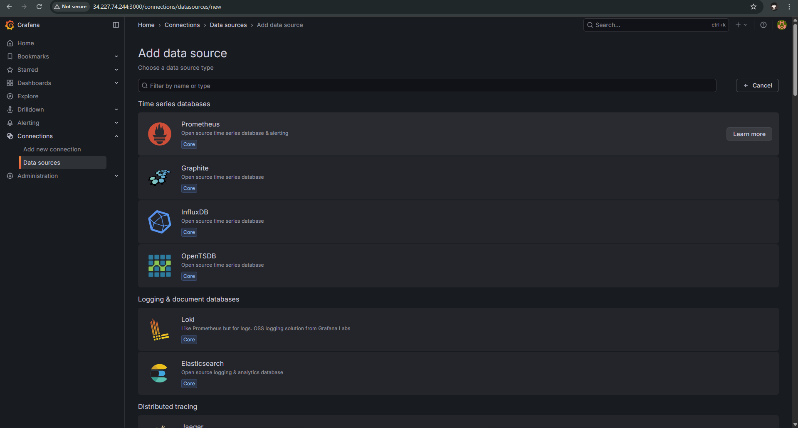
2.5 Prometheus configuration screen, showing the HTTP URL set to http://localhost:9090.
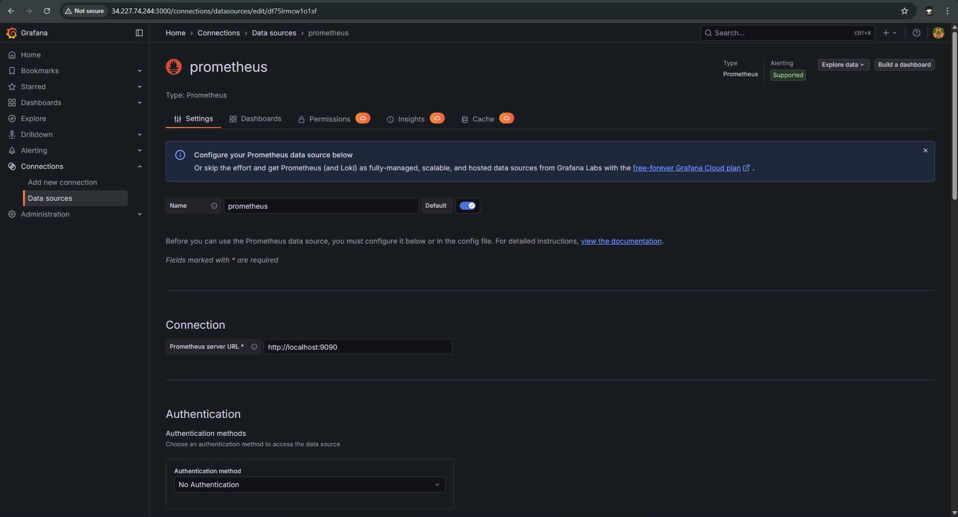
2.6 Prometheus configuration screen, showing the "Successfully queried the Prometheus API" message.
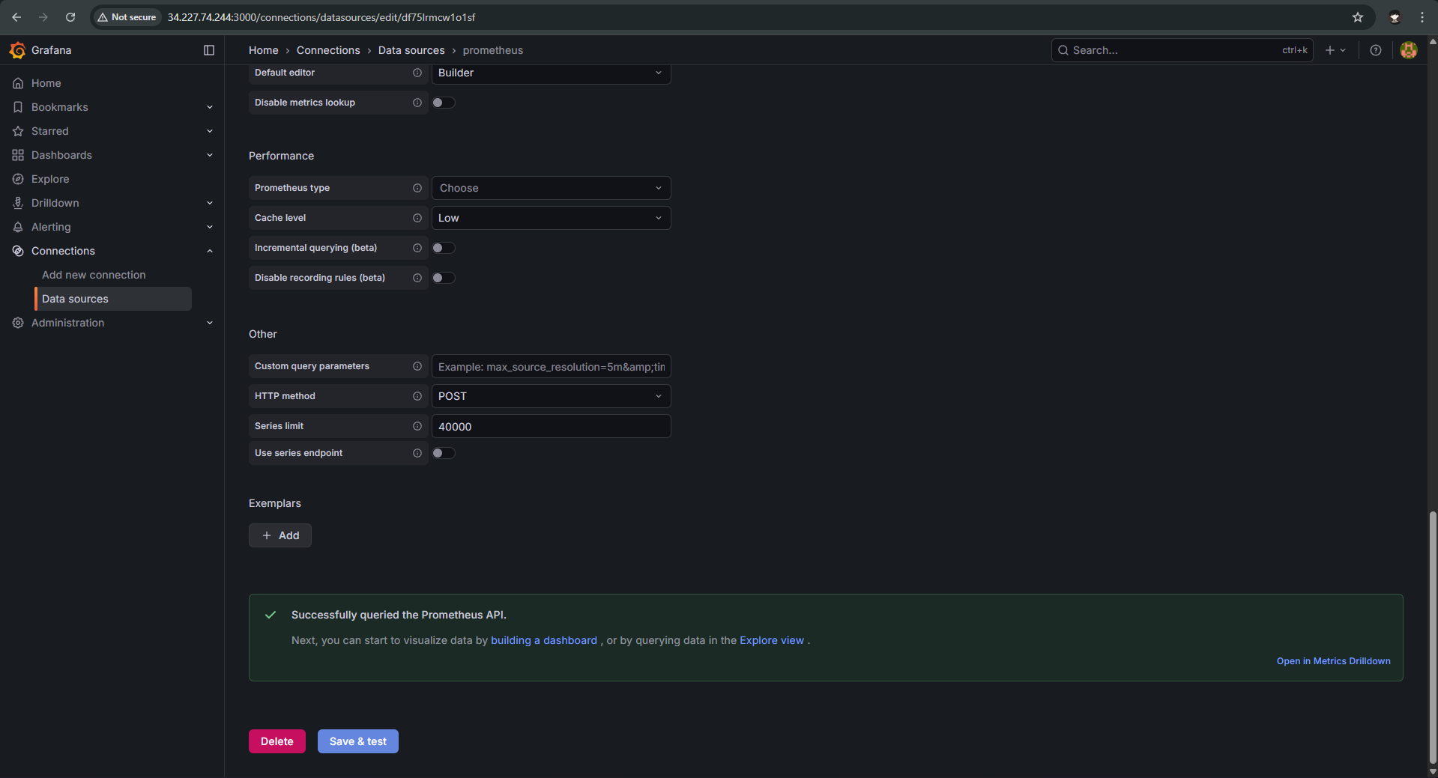
2. 7 Grafana Dashboards screen, selecting Import dashboard.
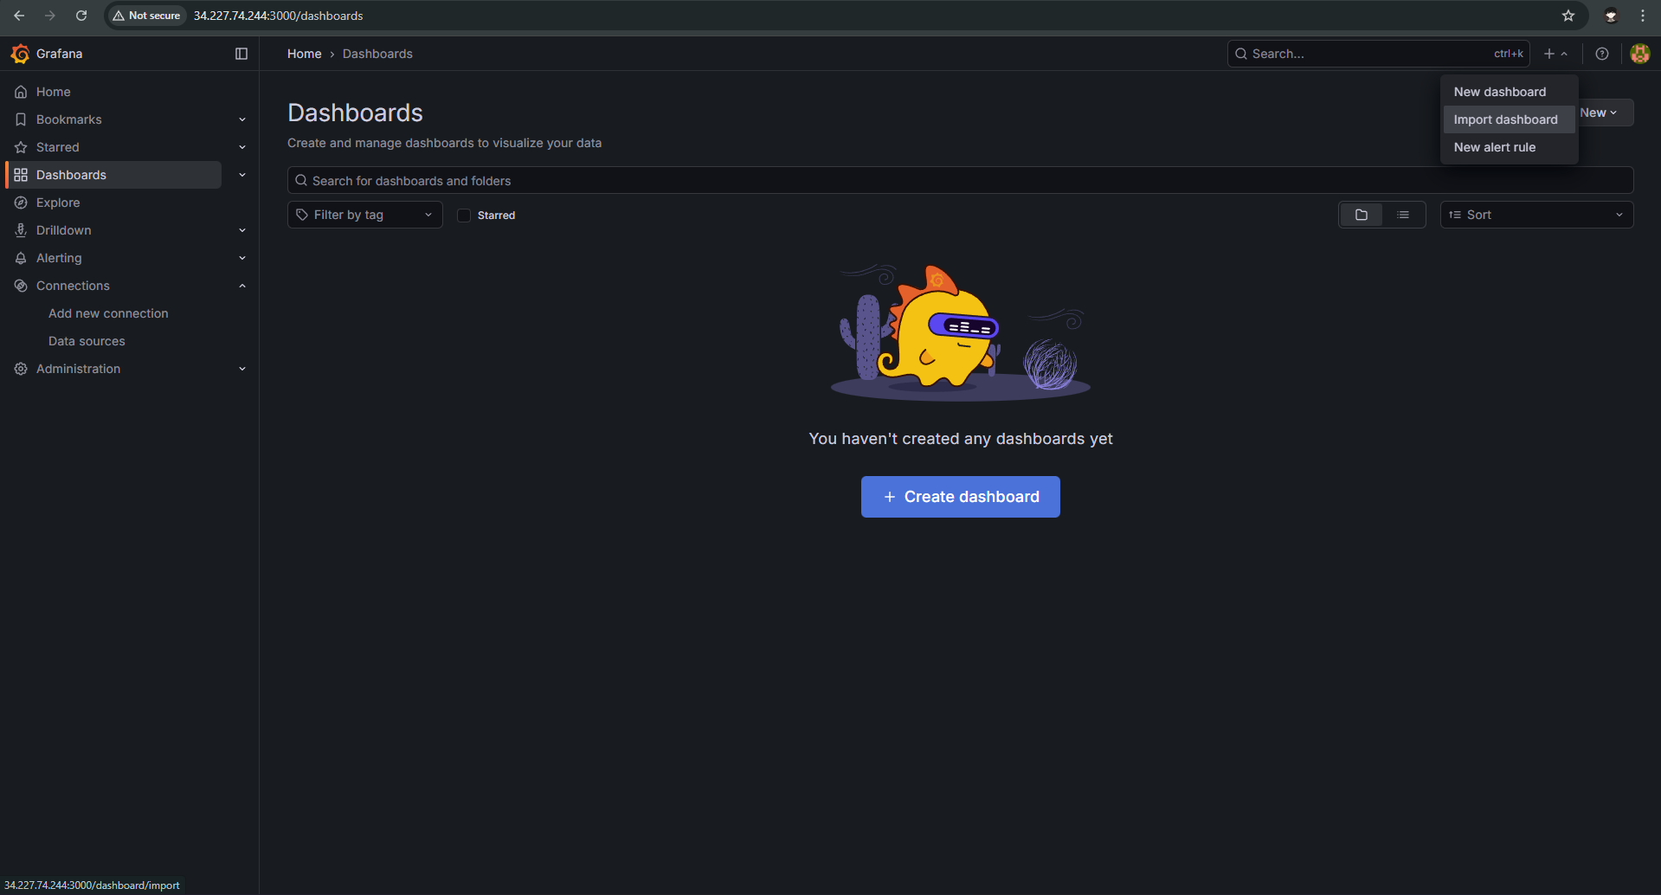
2.8 The Import Dashboard screen, showing the provided JSON code pasted into the text box.
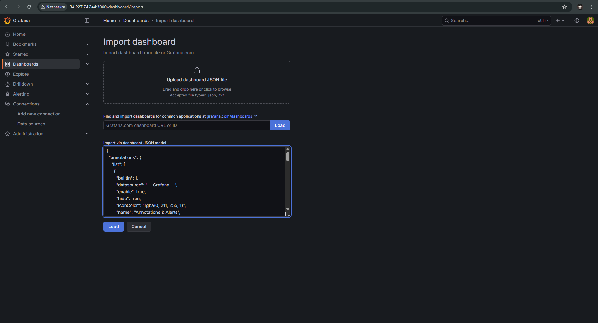
2.9 The final import options screen, confirming the dashboard name.
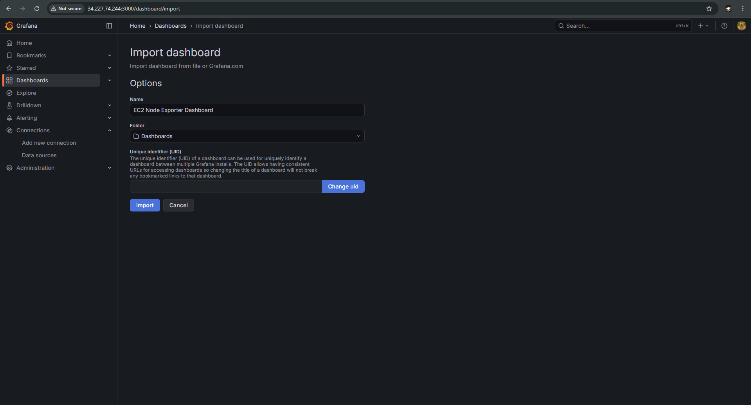
2.10 The fully populated Grafana dashboard, showing the CPU Usage, Memory Usage, and Disk Usage panels.
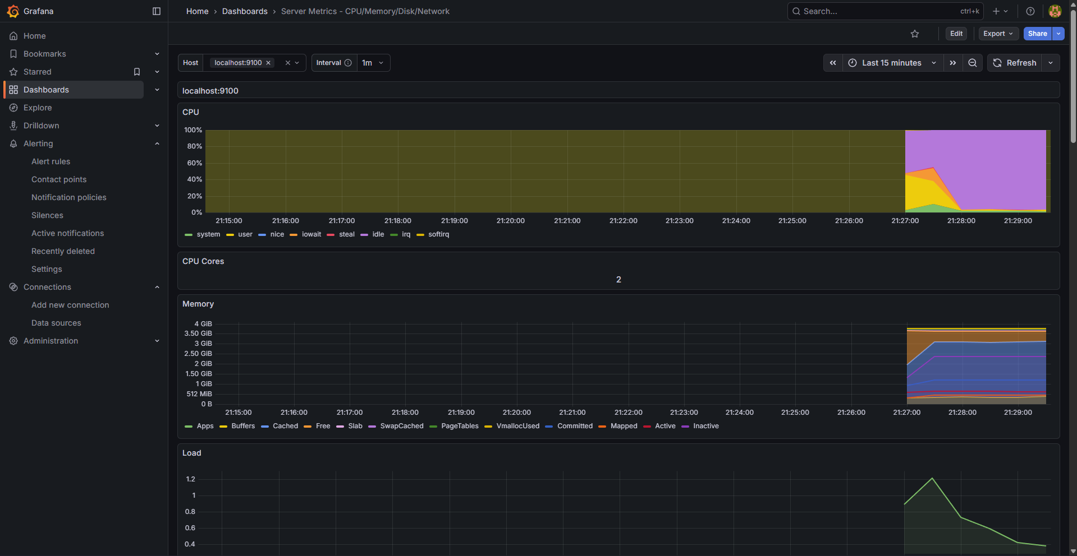

3. Log Aggregation and Alerting Setup
This phase documents the setup of the unified logging and the robust, multi-channel alerting pipeline leveraging AWS services.

3.1 SNS Topic and Alarms Setup
3.1.1 AWS SNS Topics page, ready to click "Create topic".
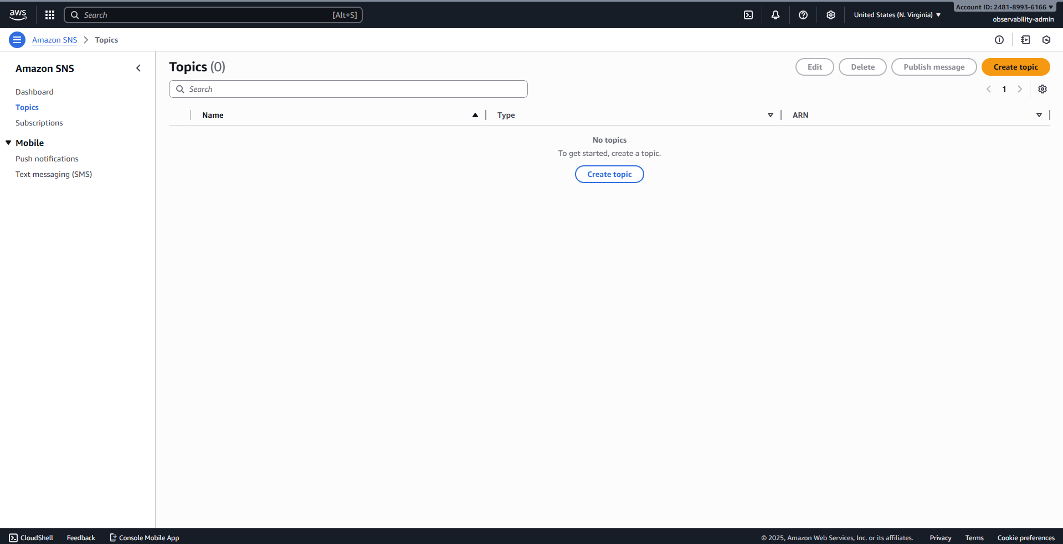
3.1.2 The "Create topic" screen, naming the topic CloudWatchAlerts.
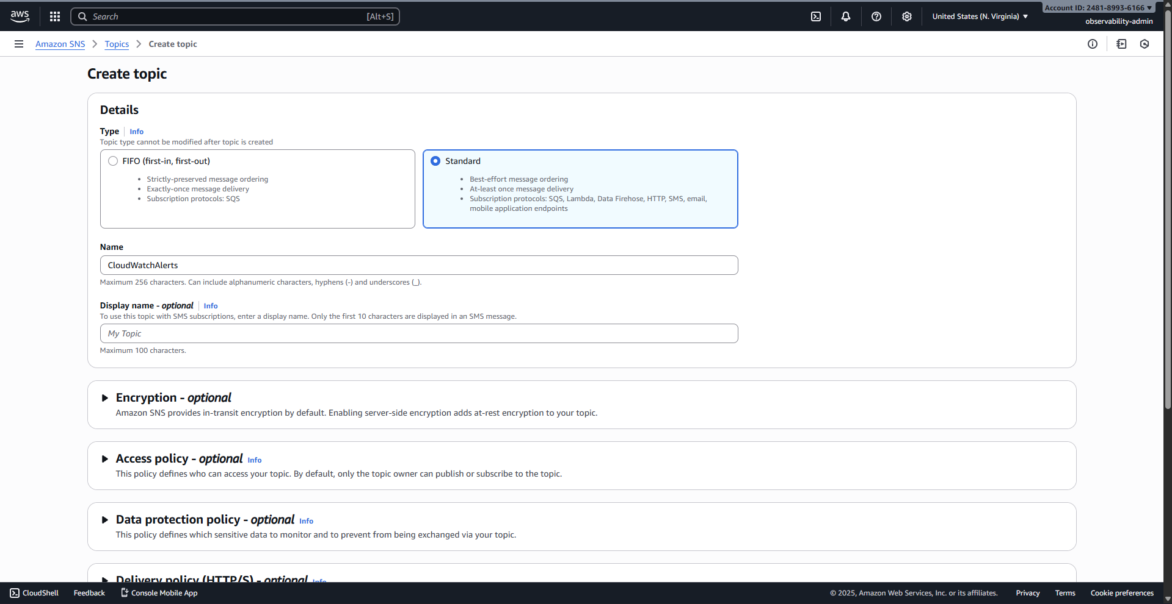
3.1.3 The CloudWatchAlerts topic details page, showing successful creation.
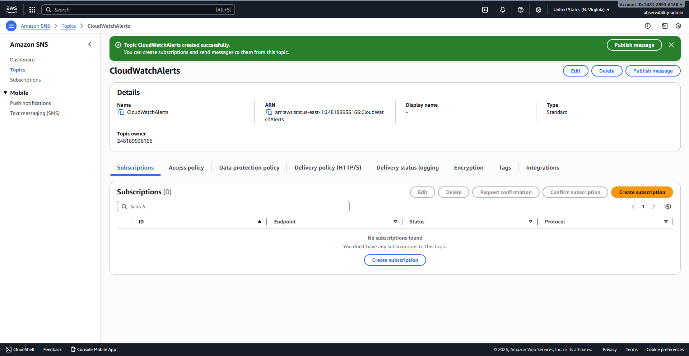
3.1.4 Create subscription screen: Protocol set to Email, and the recipient email address entered.
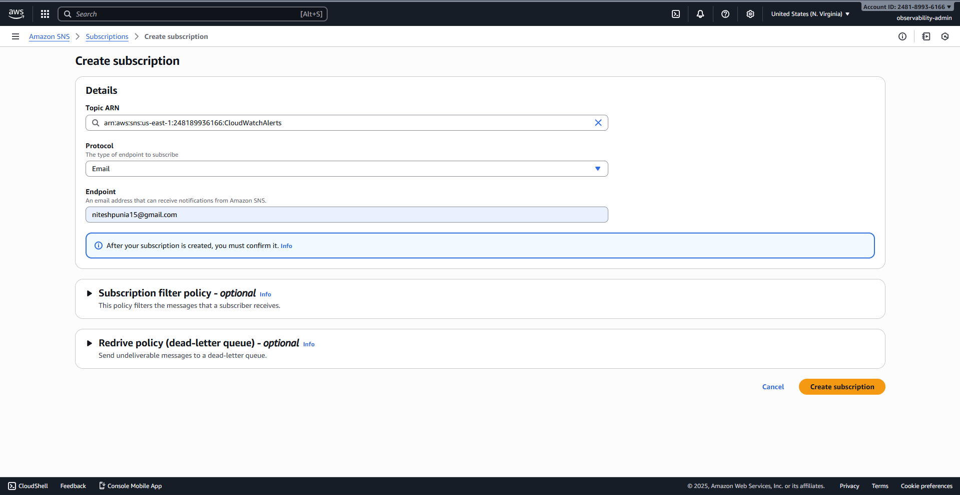
3.1.5 The Subscription details page, showing the Status as Pending confirmation.
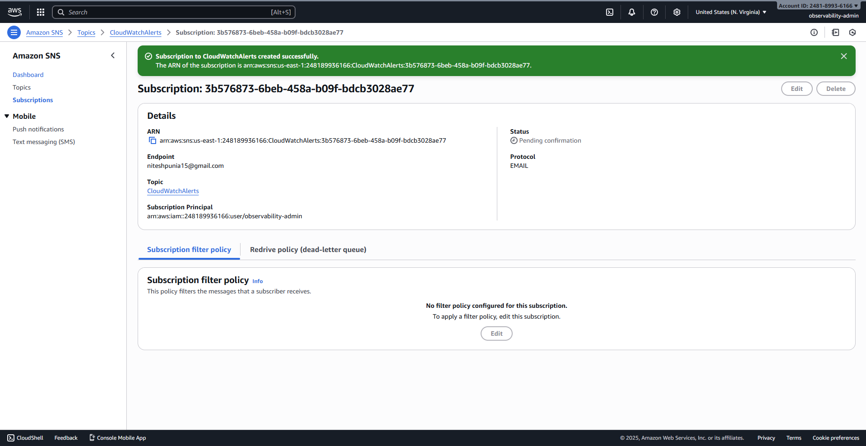
3.1.6 AWS Console search bar used to find the CloudWatch service.
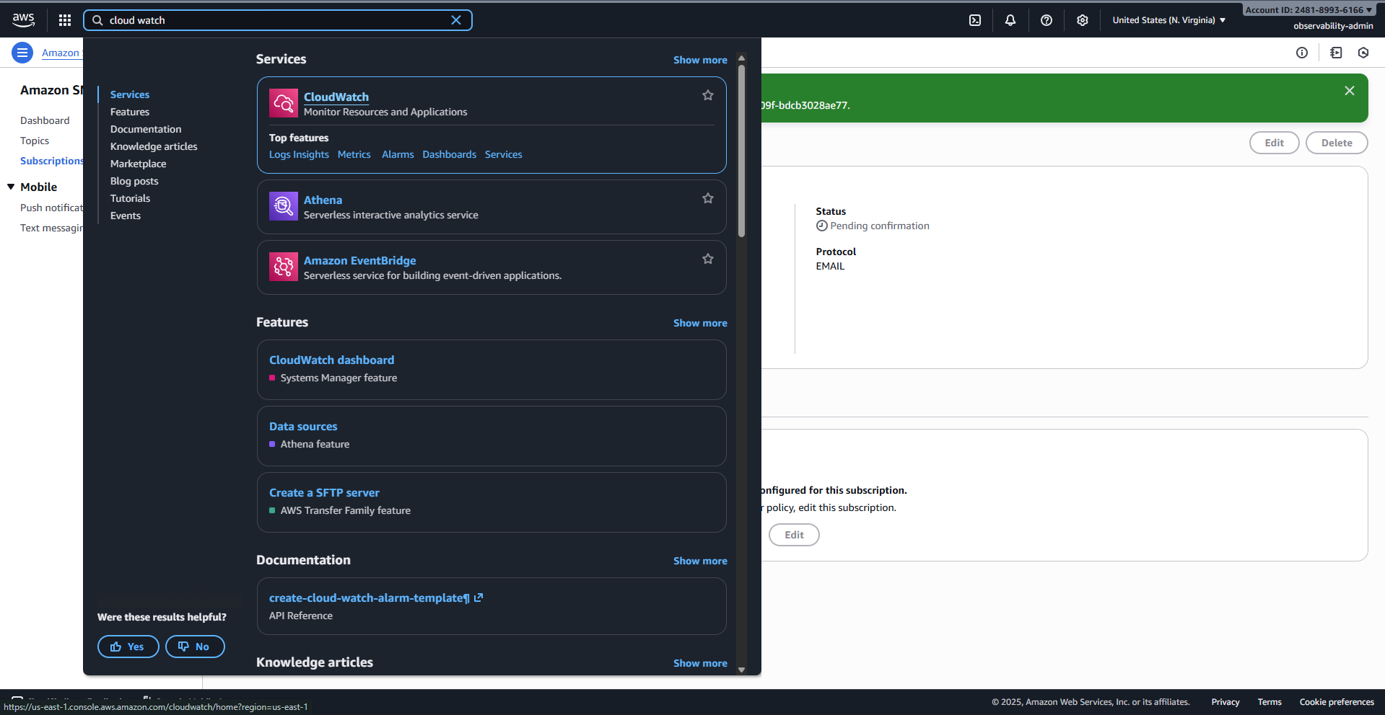
3.1.7 CloudWatch Alarms page, ready to click "Create alarm".
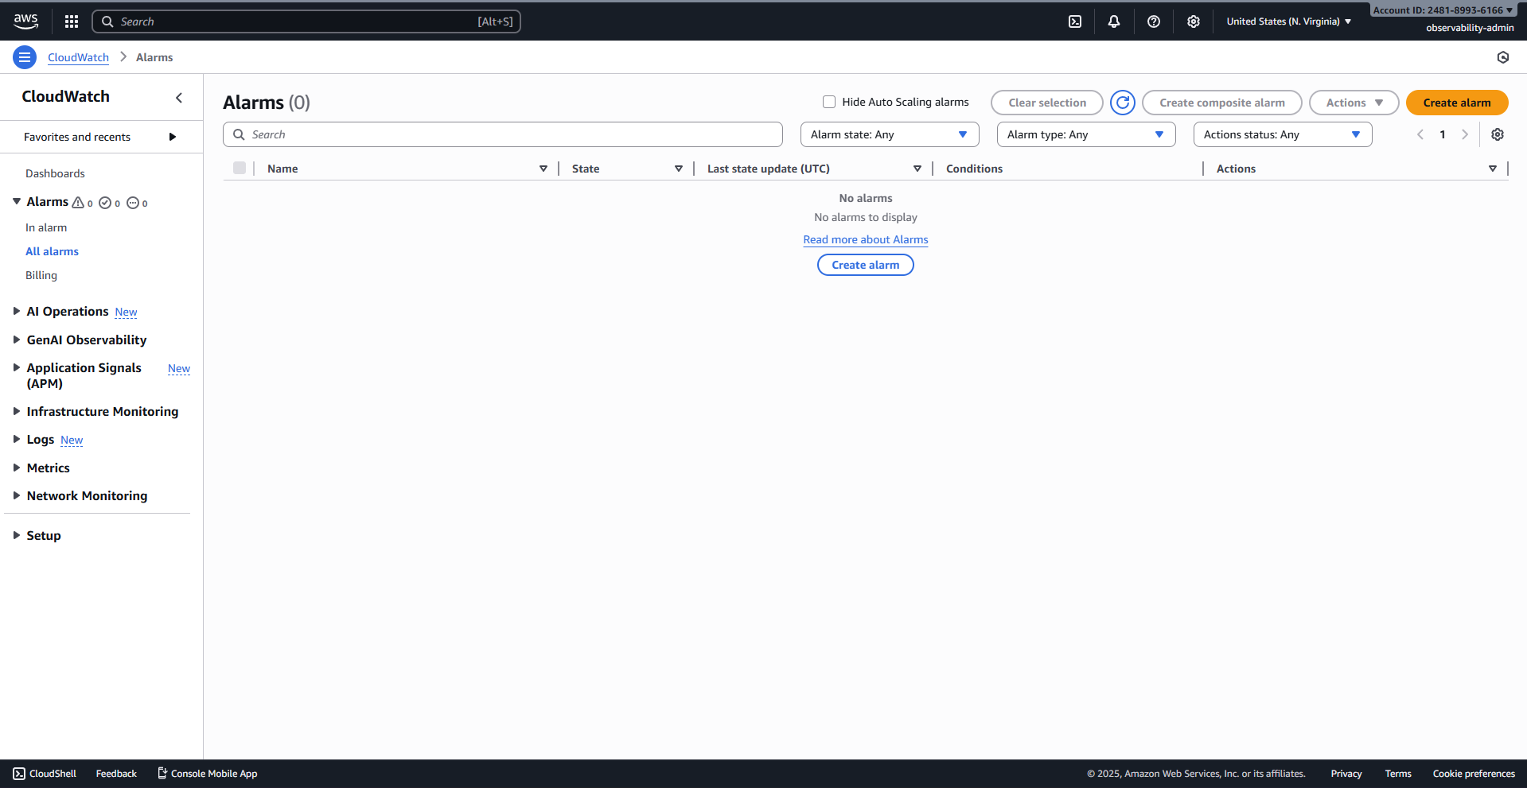
3.1.8 Select metric screen: Choosing the cpu_usage_user metric.
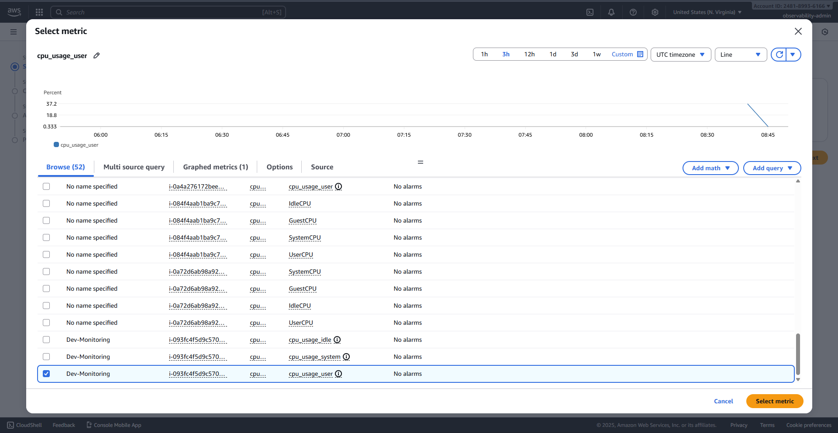
3.1.9 Specify metric and conditions screen: Threshold type Static, value of 80%.
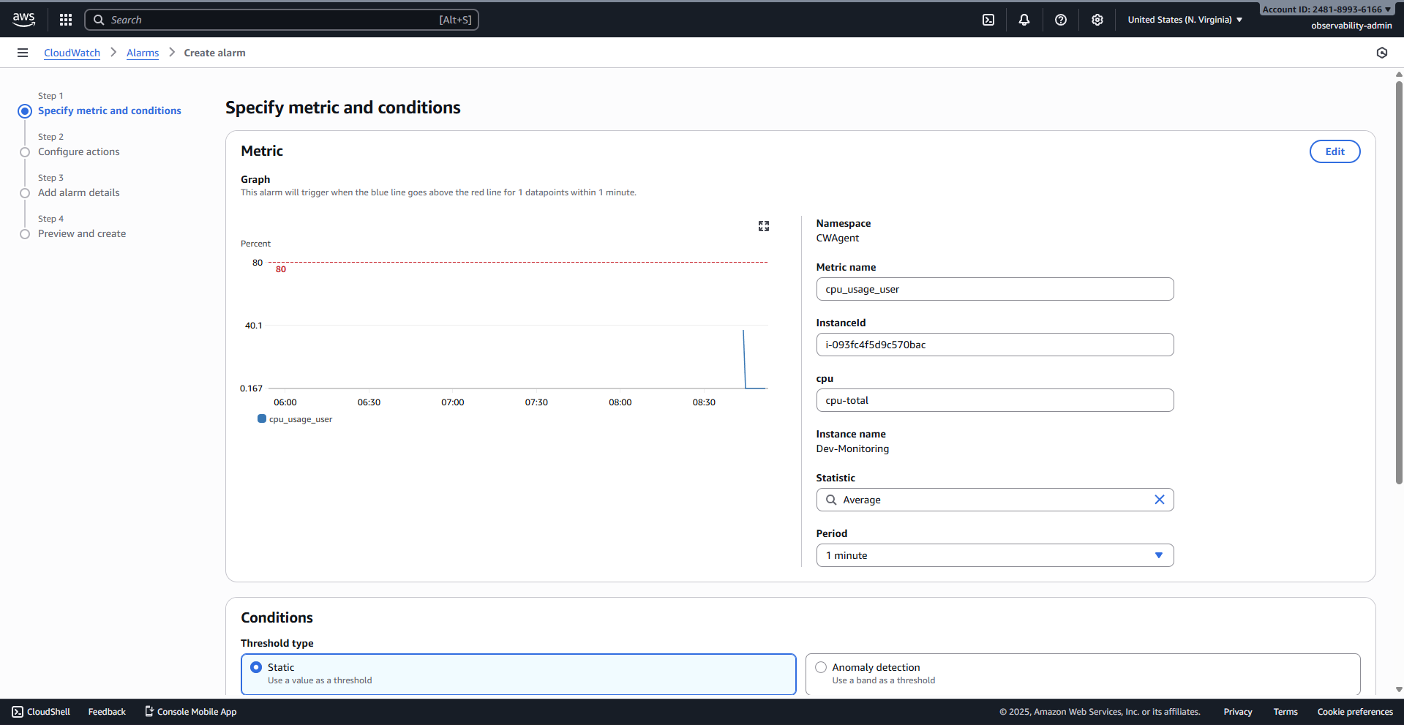
3.1.10 Specifying the condition: Greater/Equal and the threshold value of 80.
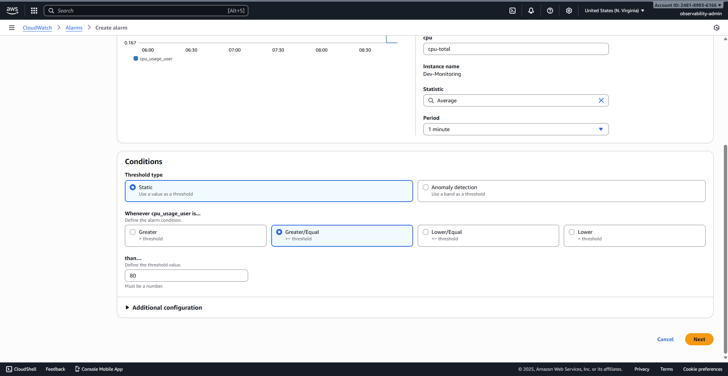
3.1.11 Configure actions screen: In alarm state trigger, selecting CloudWatchAlerts SNS topic.
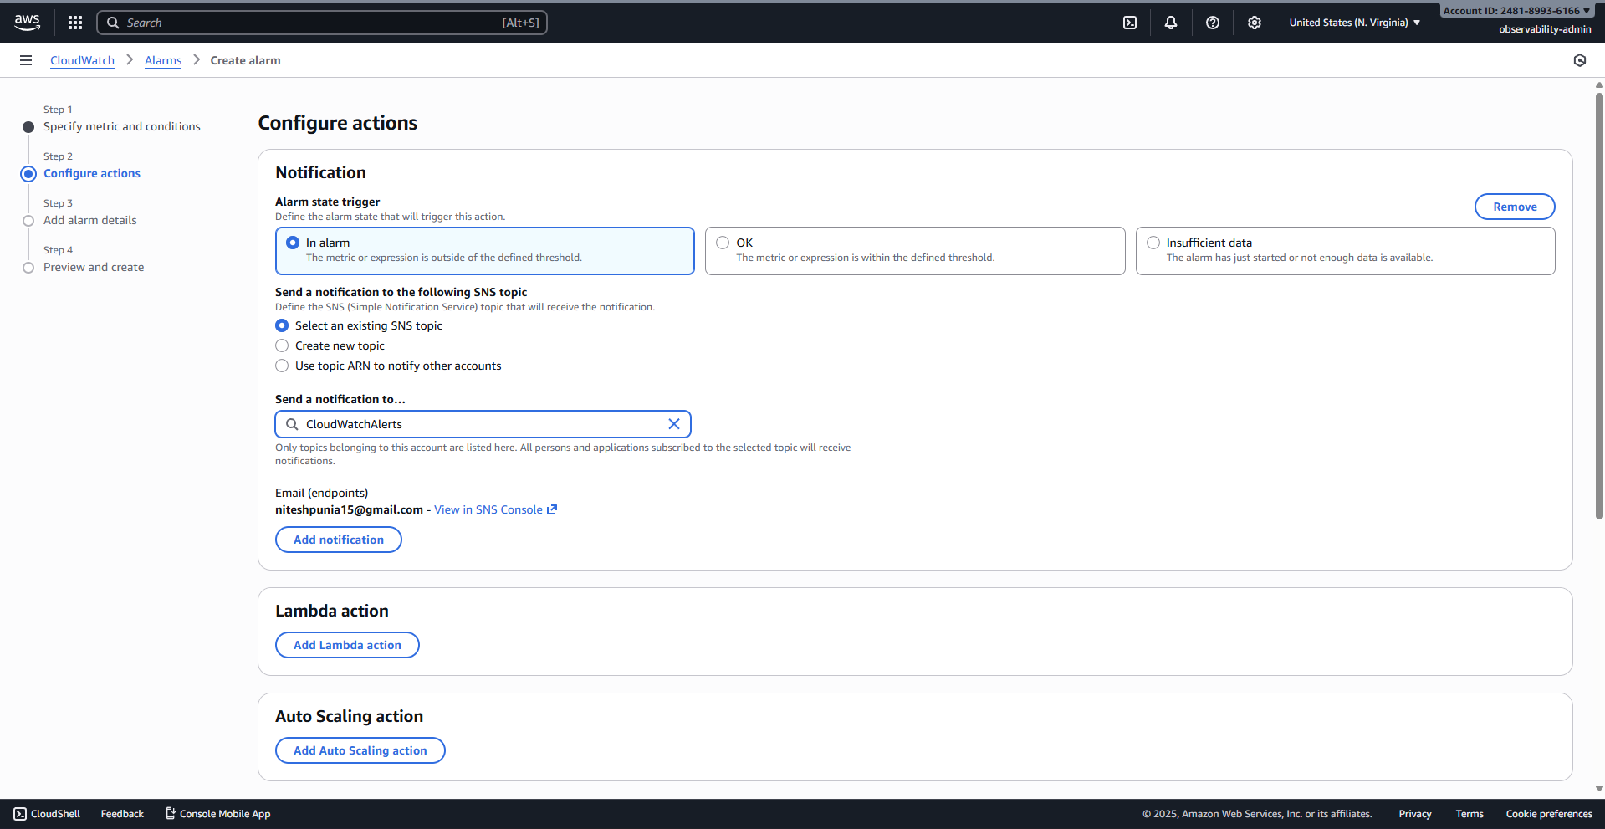
3.1.12 Add alarm details screen: Alarm named EC2-CPU-Usage-High.
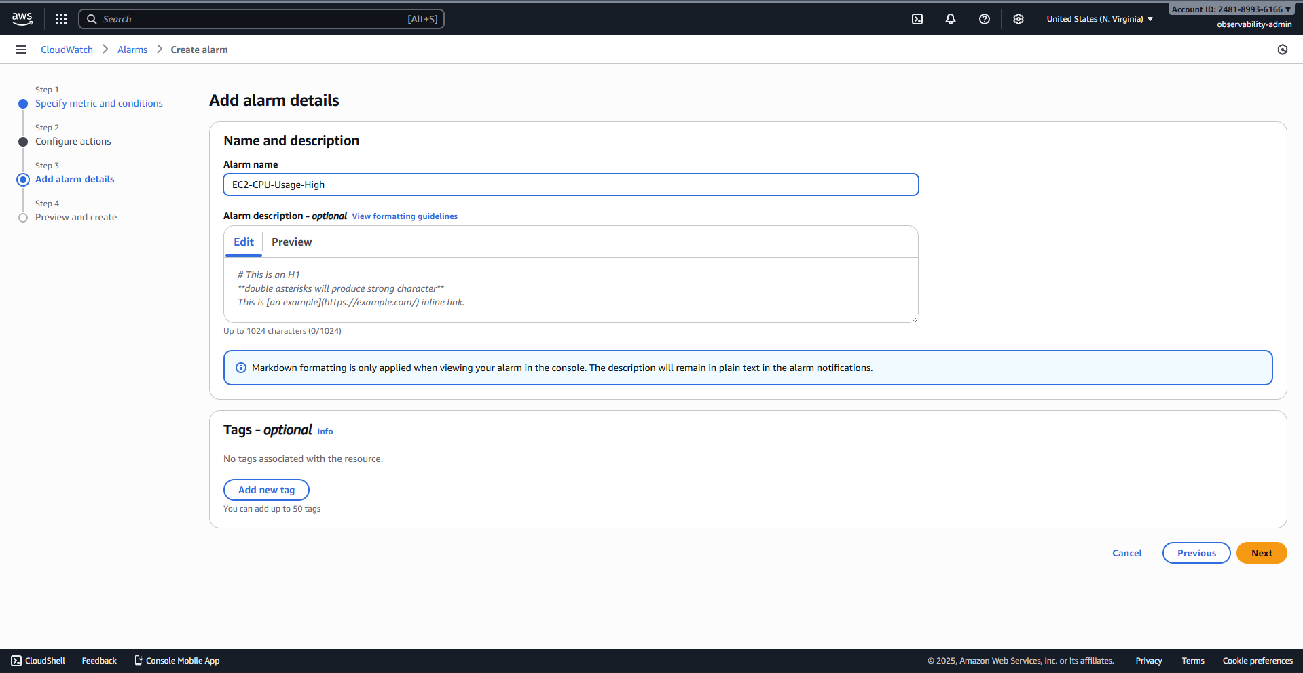
3.1.13 Select metric screen: Choosing the disk_used_percent metric for the root volume (/).
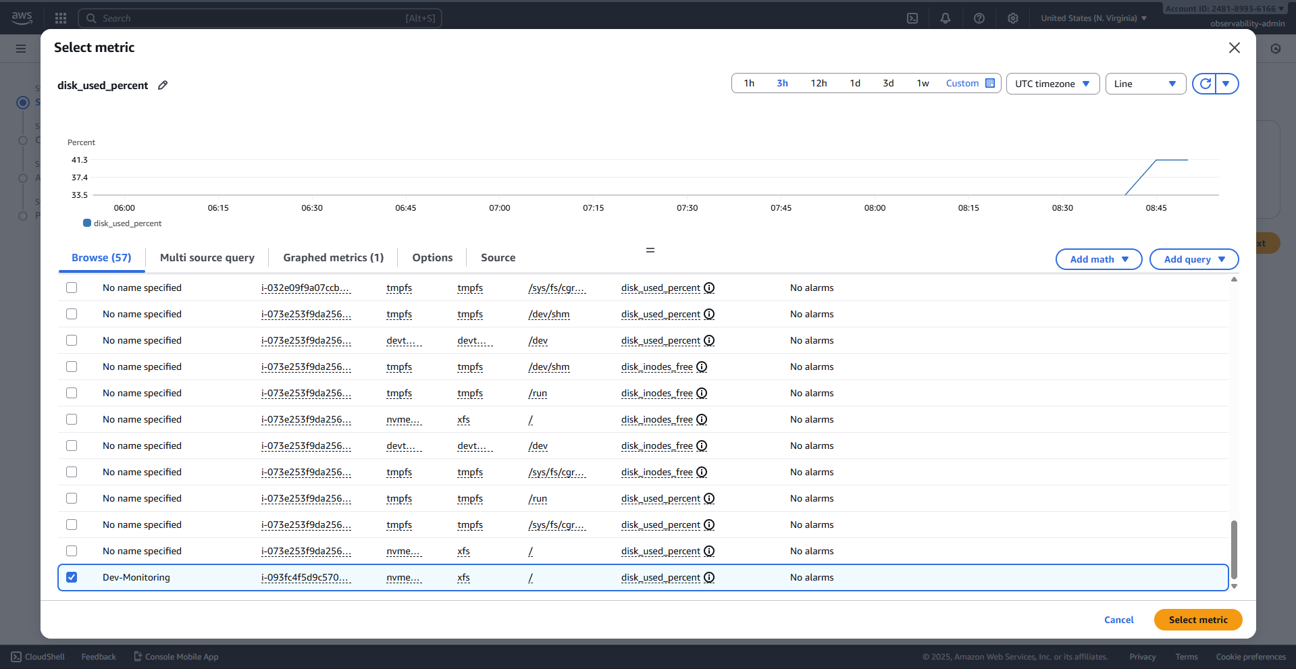
3.1.14 Specify metric and conditions screen: Threshold type Static, value of 80%.
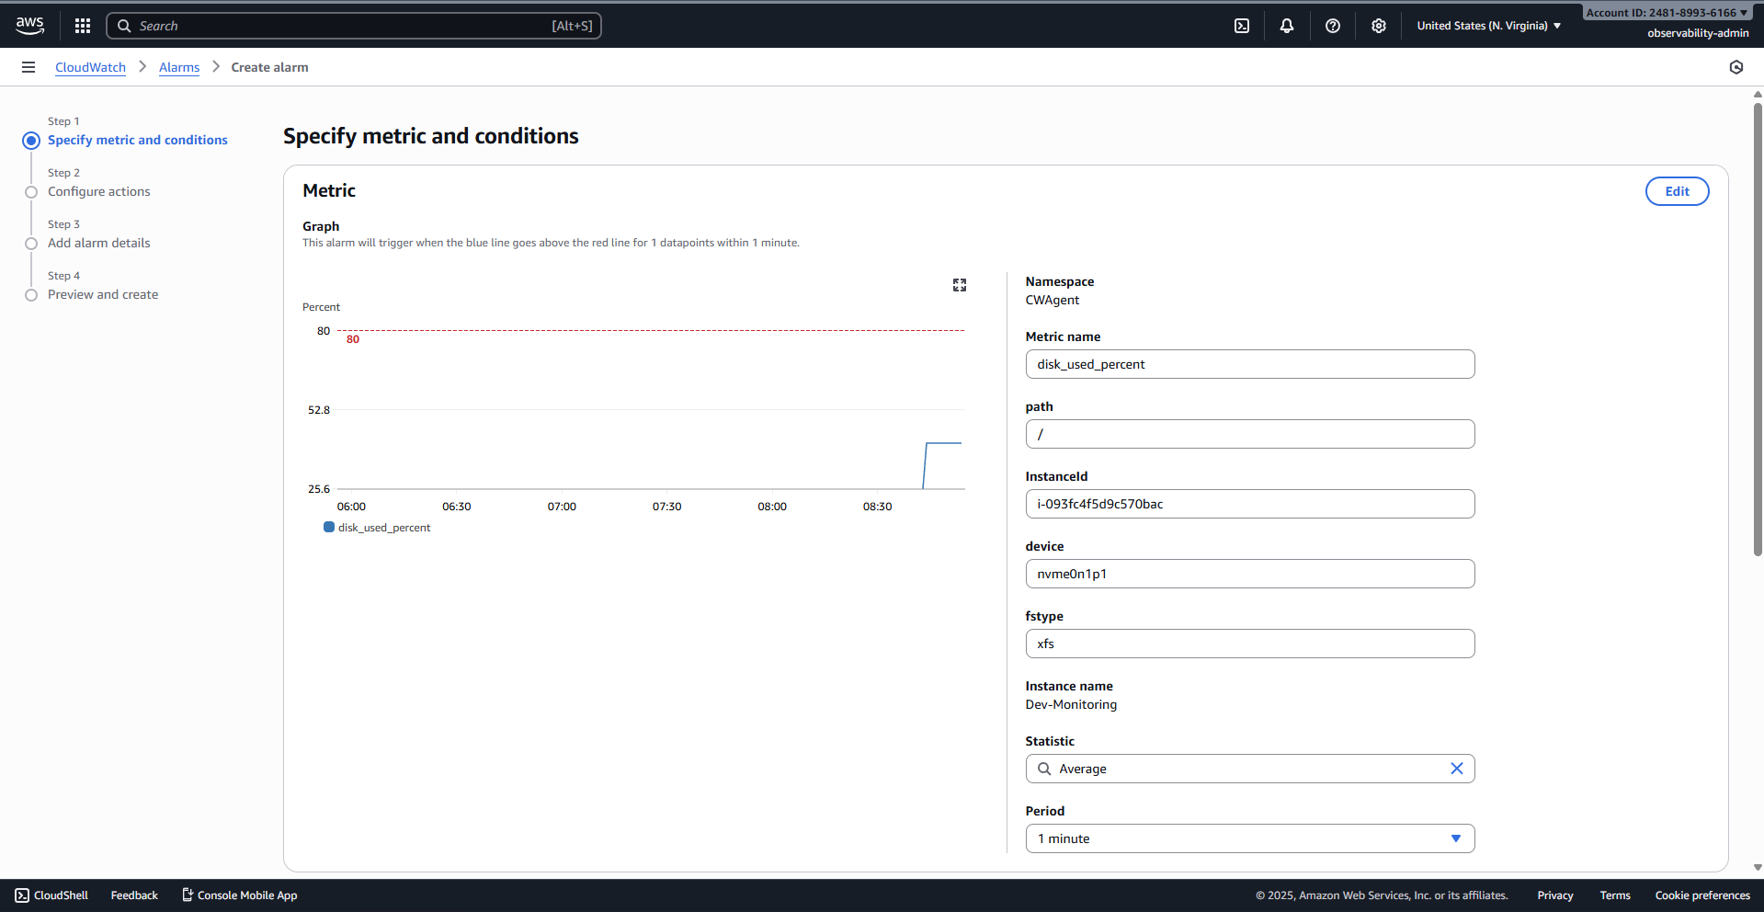
3.1.15 Specifying the condition: Greater/Equal and the threshold value of 80.
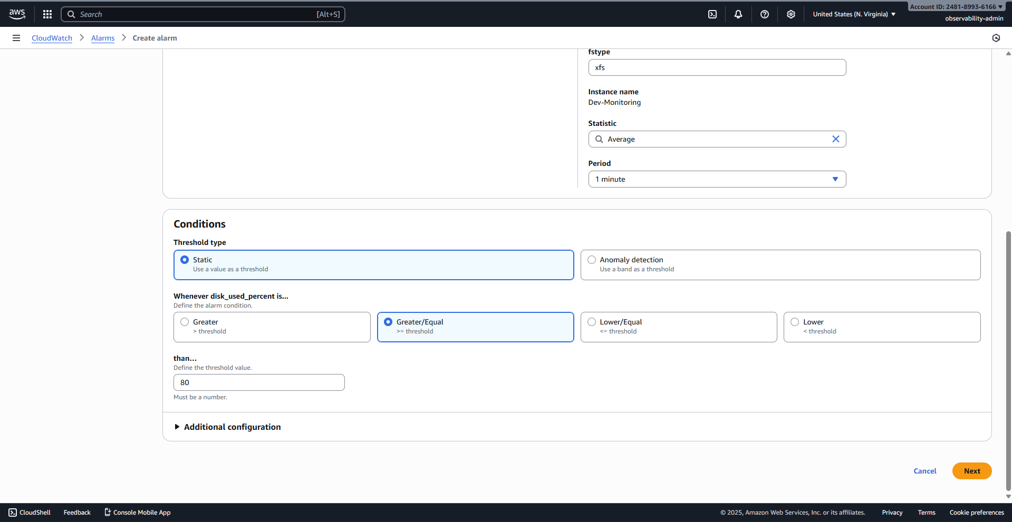
3.1.16 Configure actions screen: In alarm state trigger, selecting CloudWatchAlerts SNS topic.
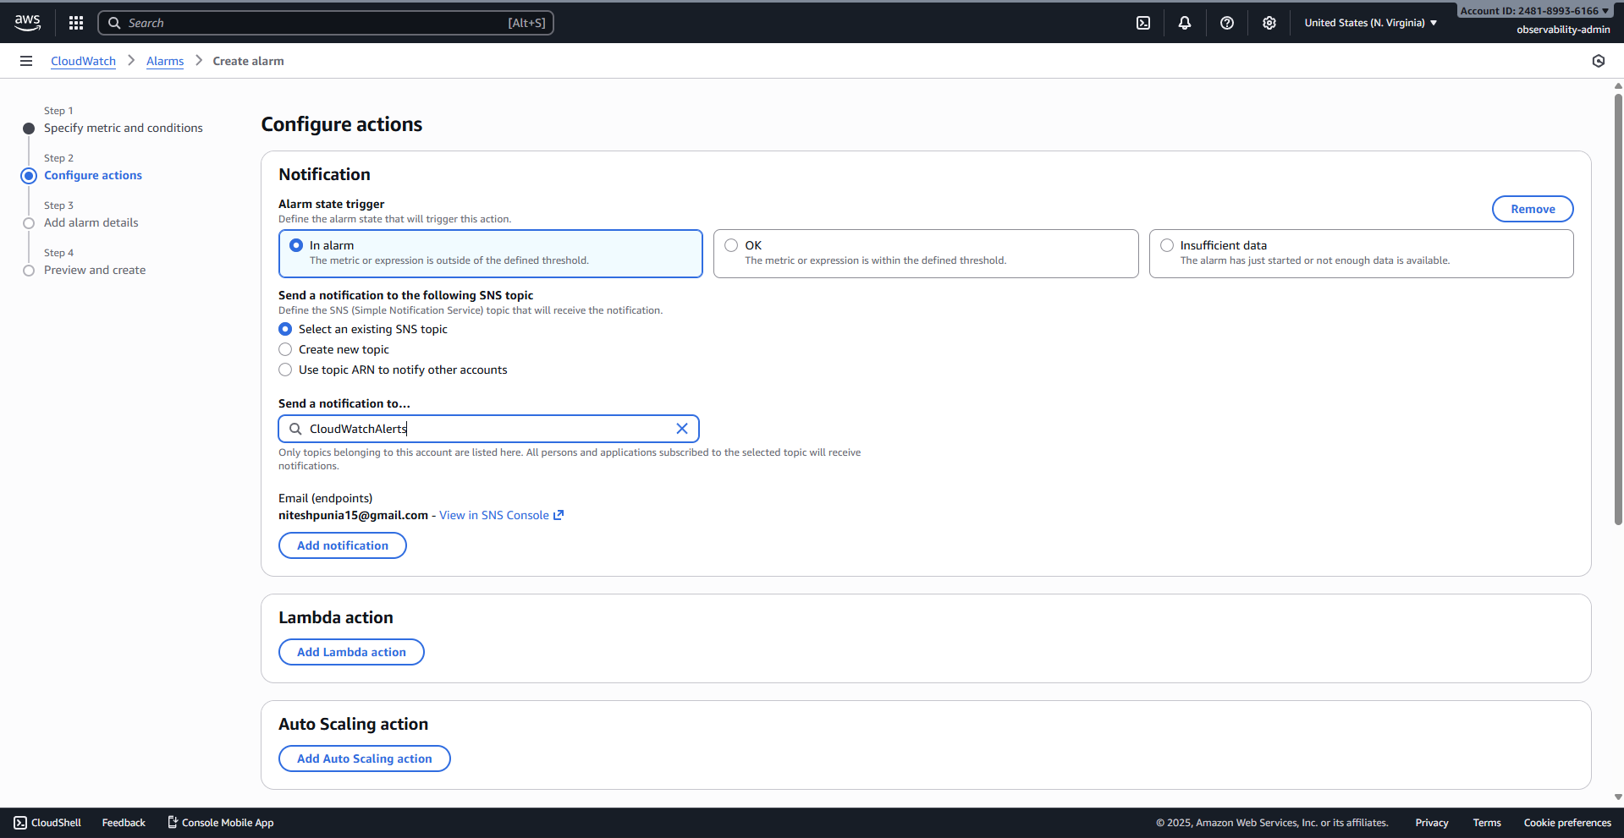
3.1.17 Add alarm details screen: Alarm named EC2-Disk-Usage-High.
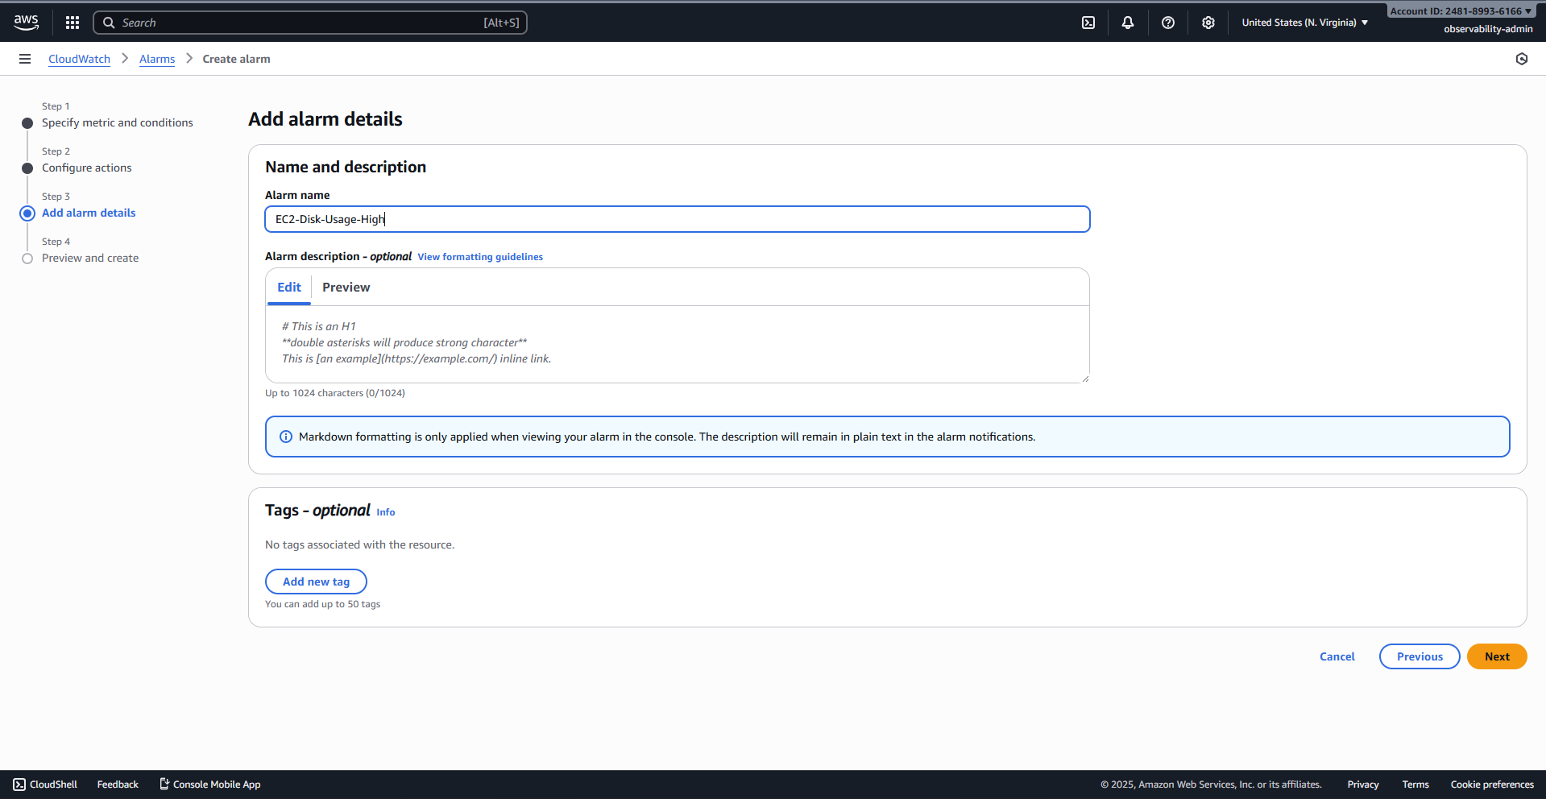
3.1.18 Select metric screen: Choosing the mem_used_percent metric.
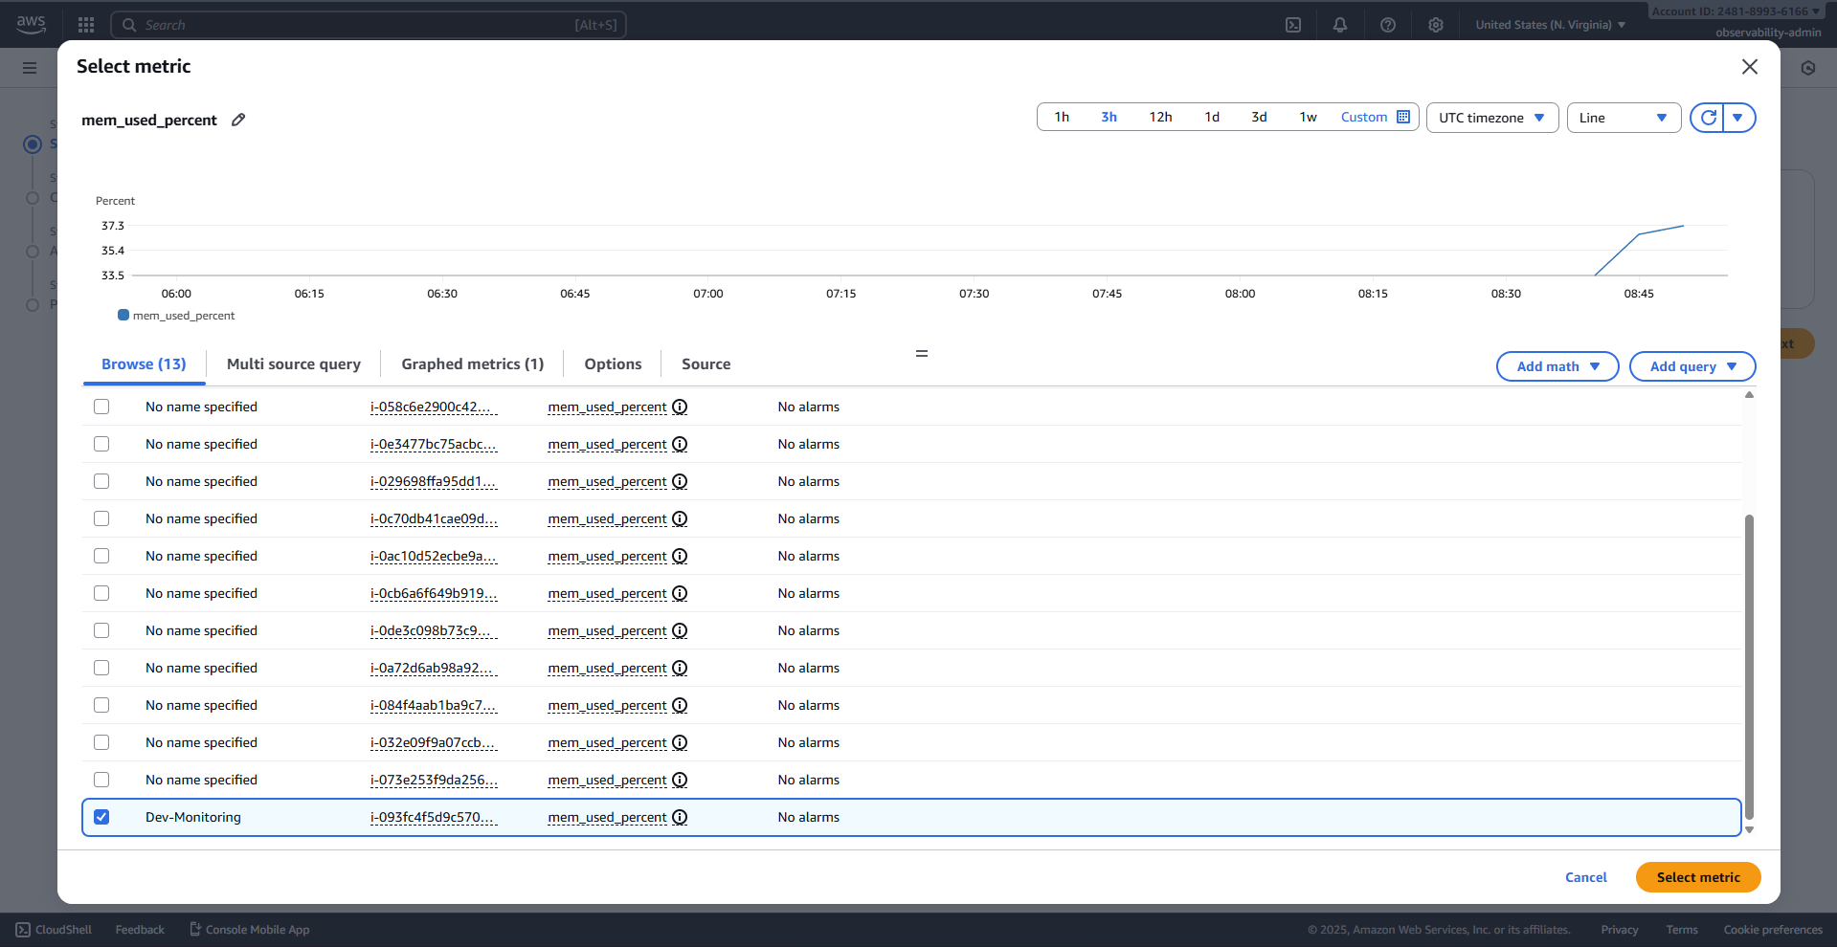
3.1.19 Specify metric and conditions screen: Threshold type Static, value of 80%.
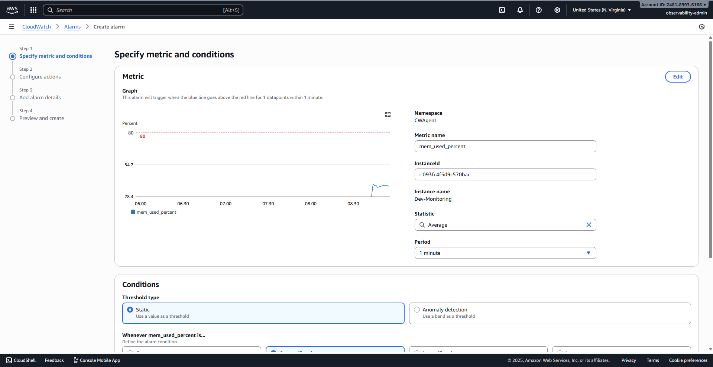
3.1.20 Specifying the condition: Greater/Equal and the threshold value of 80.
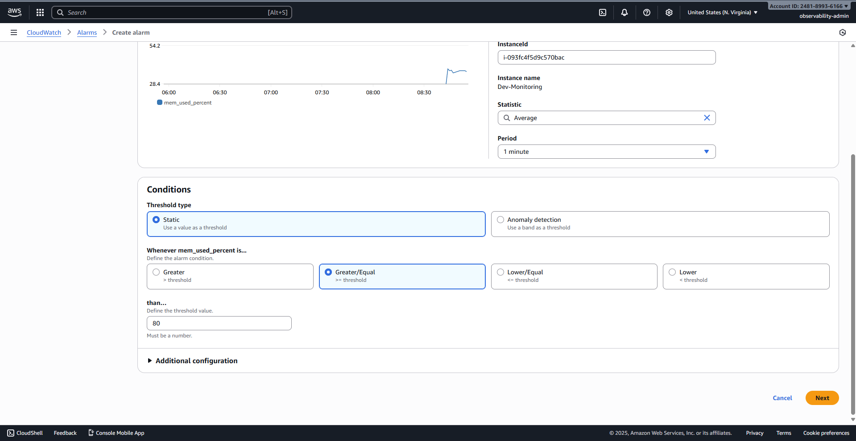
3.1.21 Final review screen before clicking "Create alarm".

3.1.22 Configure actions screen: In alarm state trigger, selecting CloudWatchAlerts SNS topic.
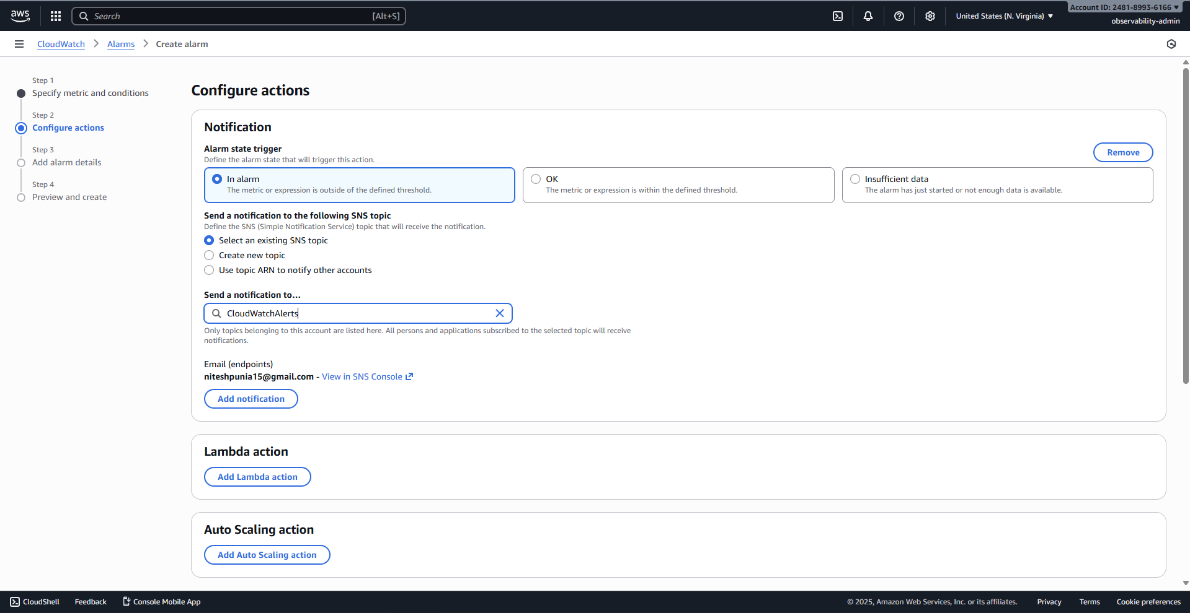
3.1.23 Add alarm details screen: Alarm named EC2-Memory-Usage-High.
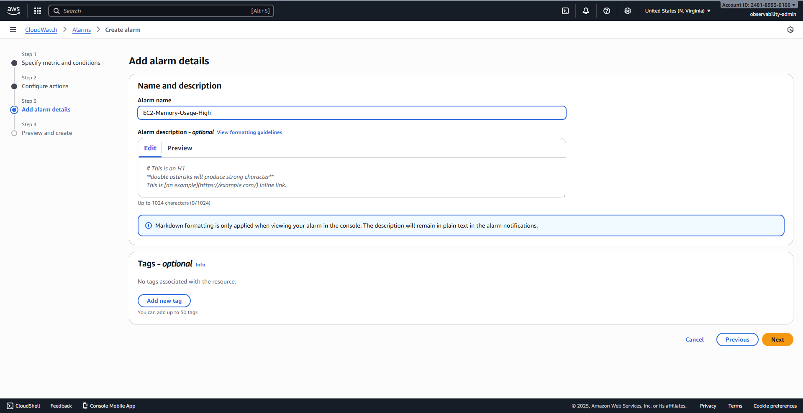
3.1.24 CloudWatch Alarms list, showing the successful creation of all three alarms.
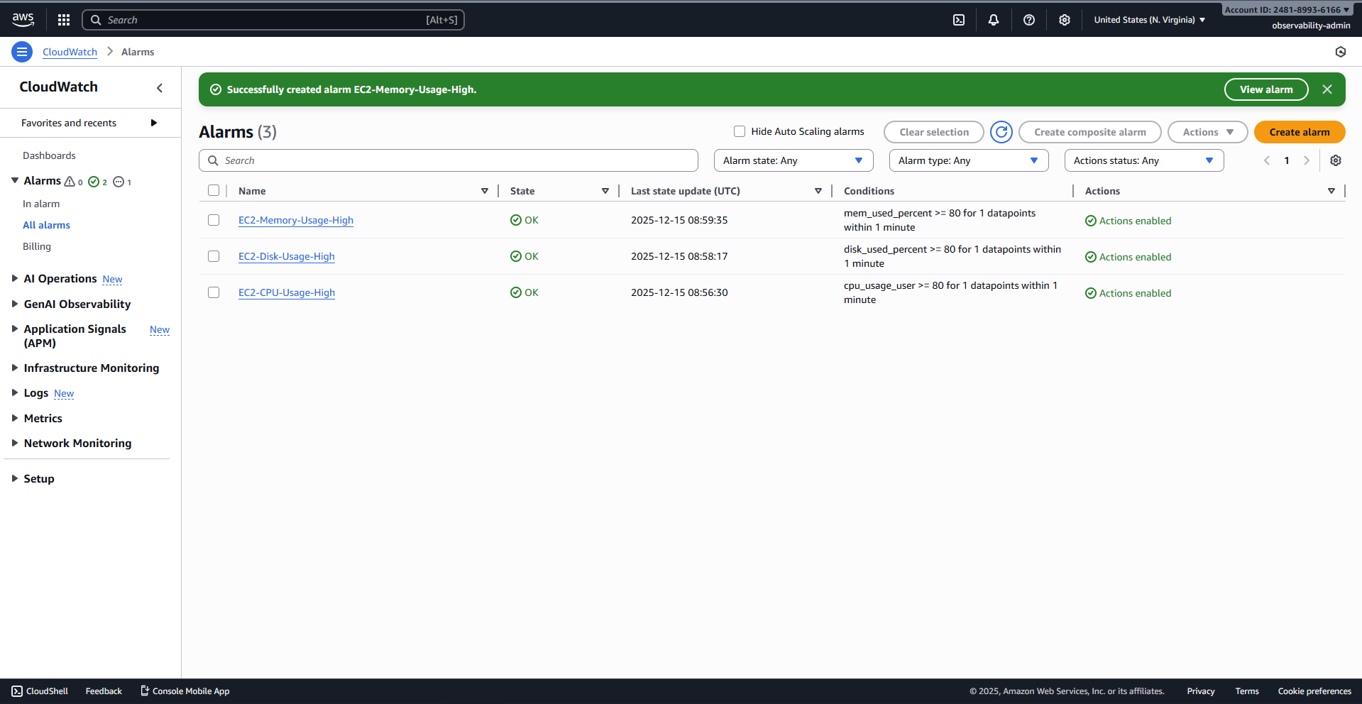

3.2 CloudWatch Logs and Lambda Function Setup
3.2.1 CloudWatch Log groups page, showing the presence of the /ec2/cloud-init log group.
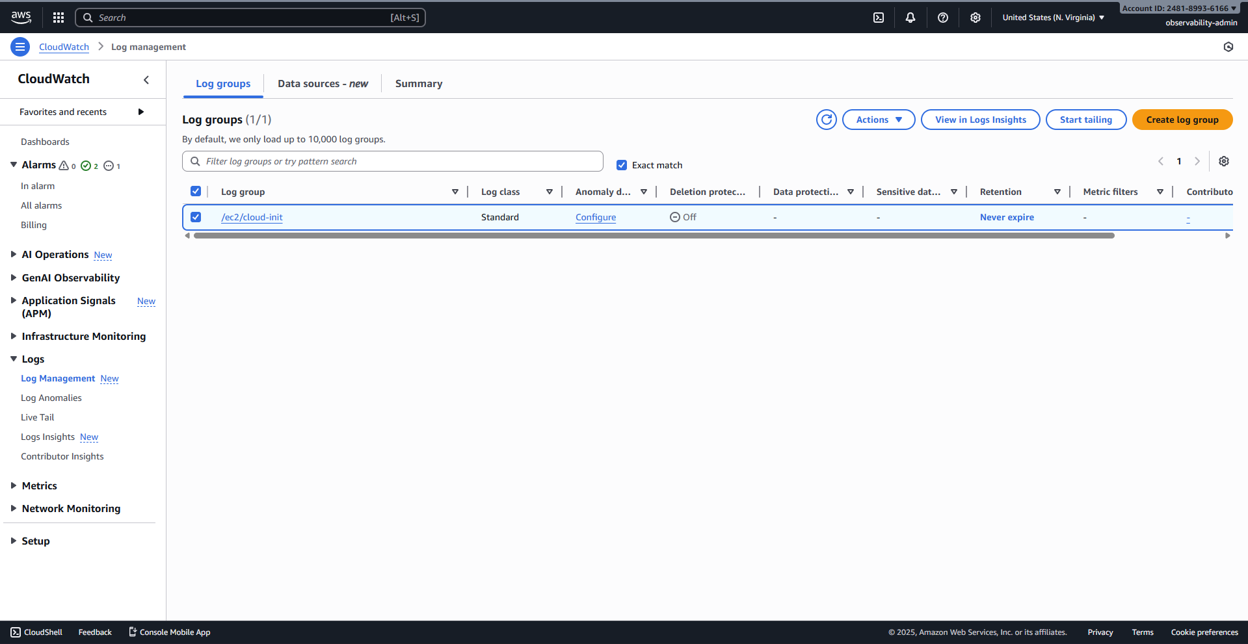
3.2.2 The Log group details page for /ec2/cloud-init, showing the active log stream.
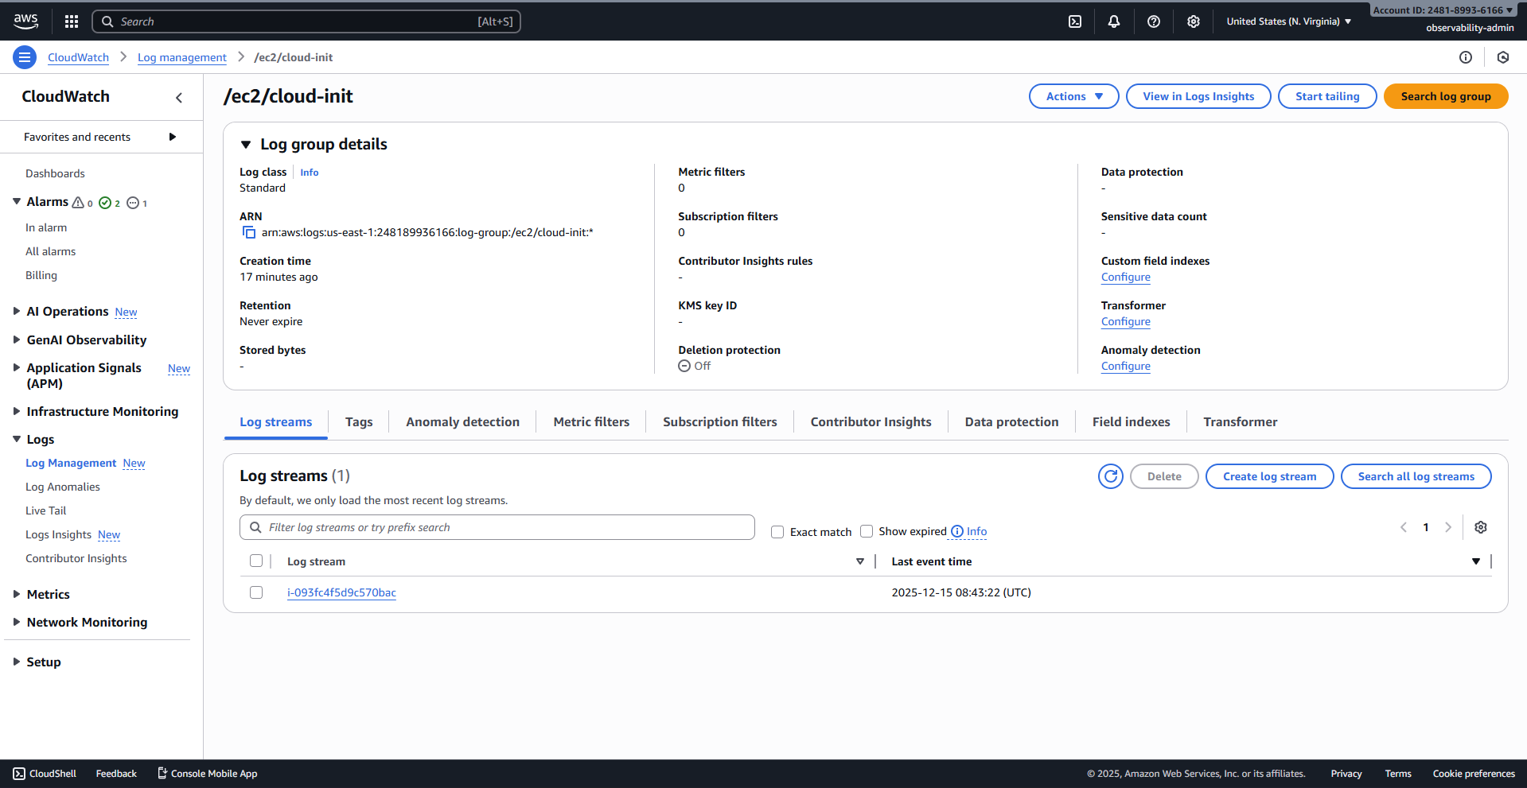
3.2.3 Log stream events, showing the script execution logs.
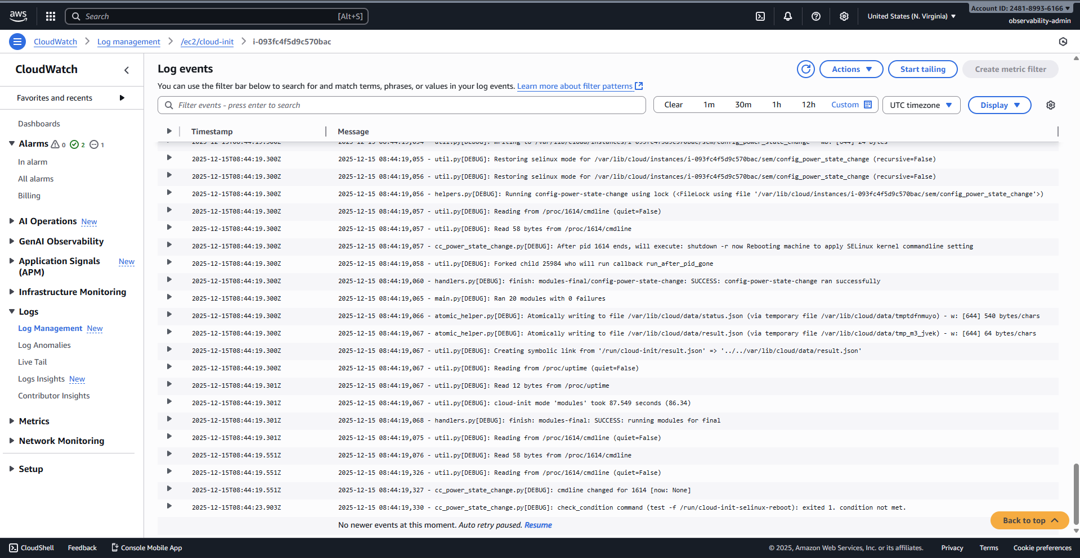
3.2.4 AWS Lambda console, showing the "Create a function" button.
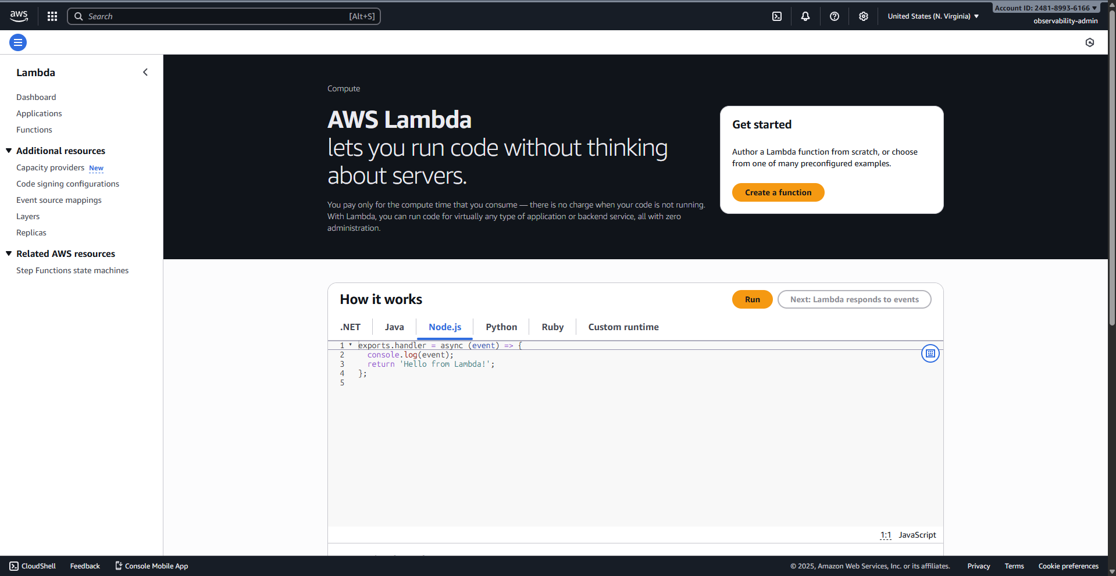
3.2.5 Create function screen: Author from scratch, Function name CloudWatchToSlack, and Python 3.11 runtime selected.
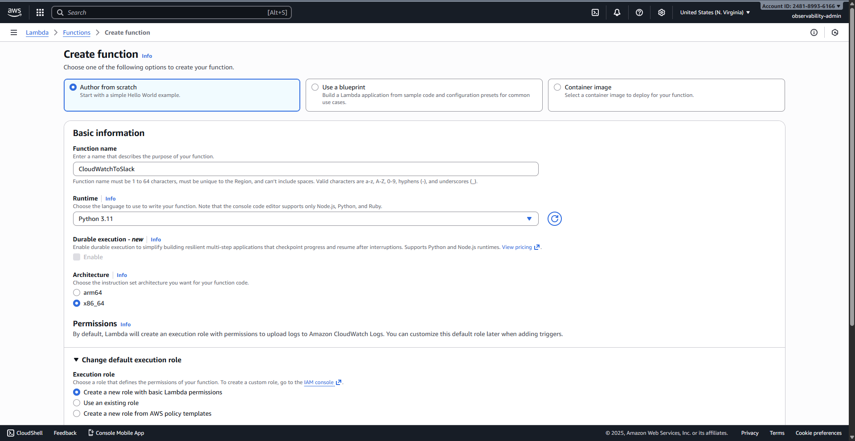
3.2.6 Create function screen: Create a new role with basic Lambda permissions selected.
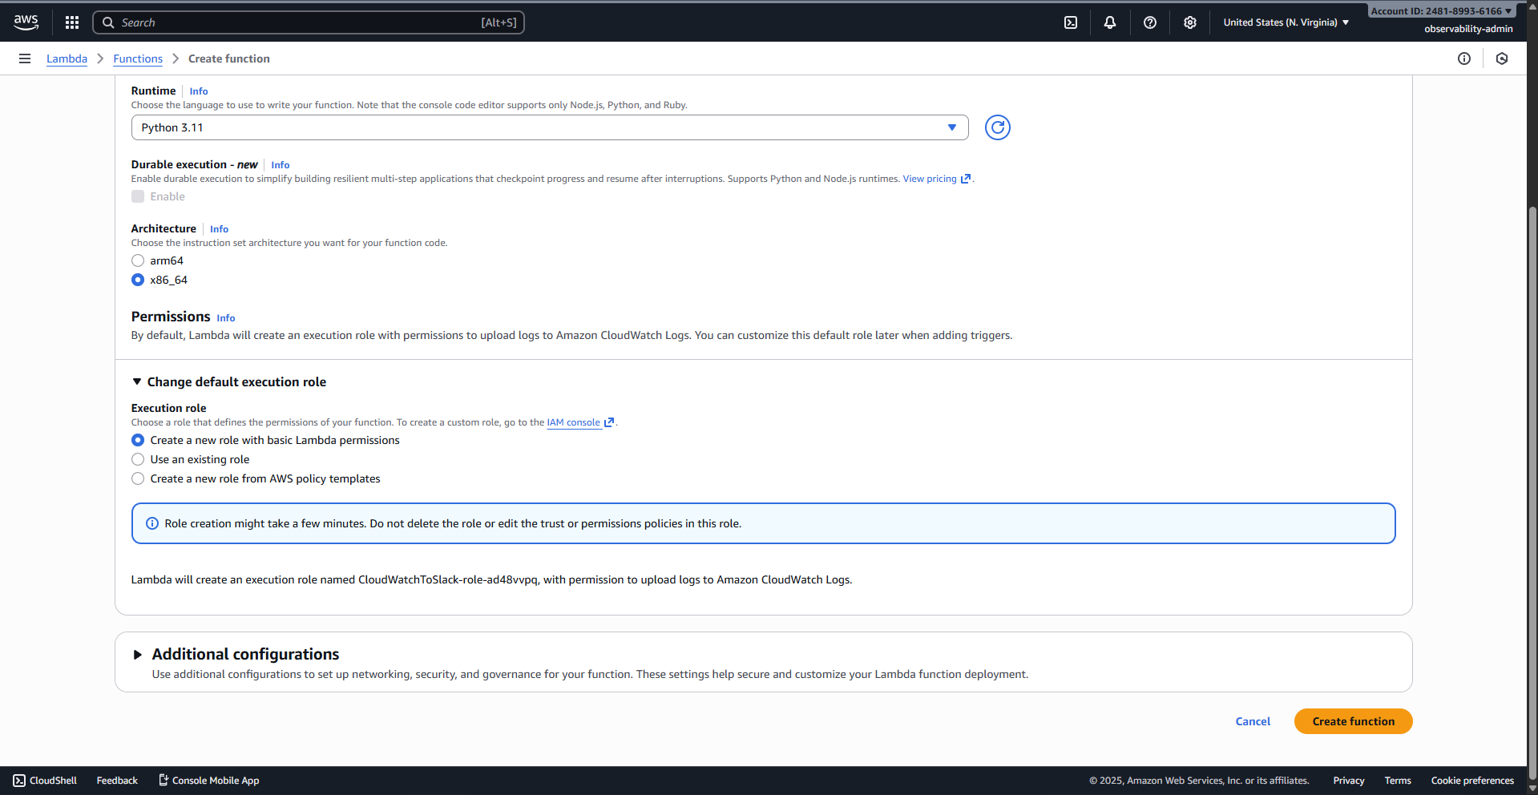
3.2.7 The Lambda function editor, showing the lambda_function.py code pasted into the code source area.
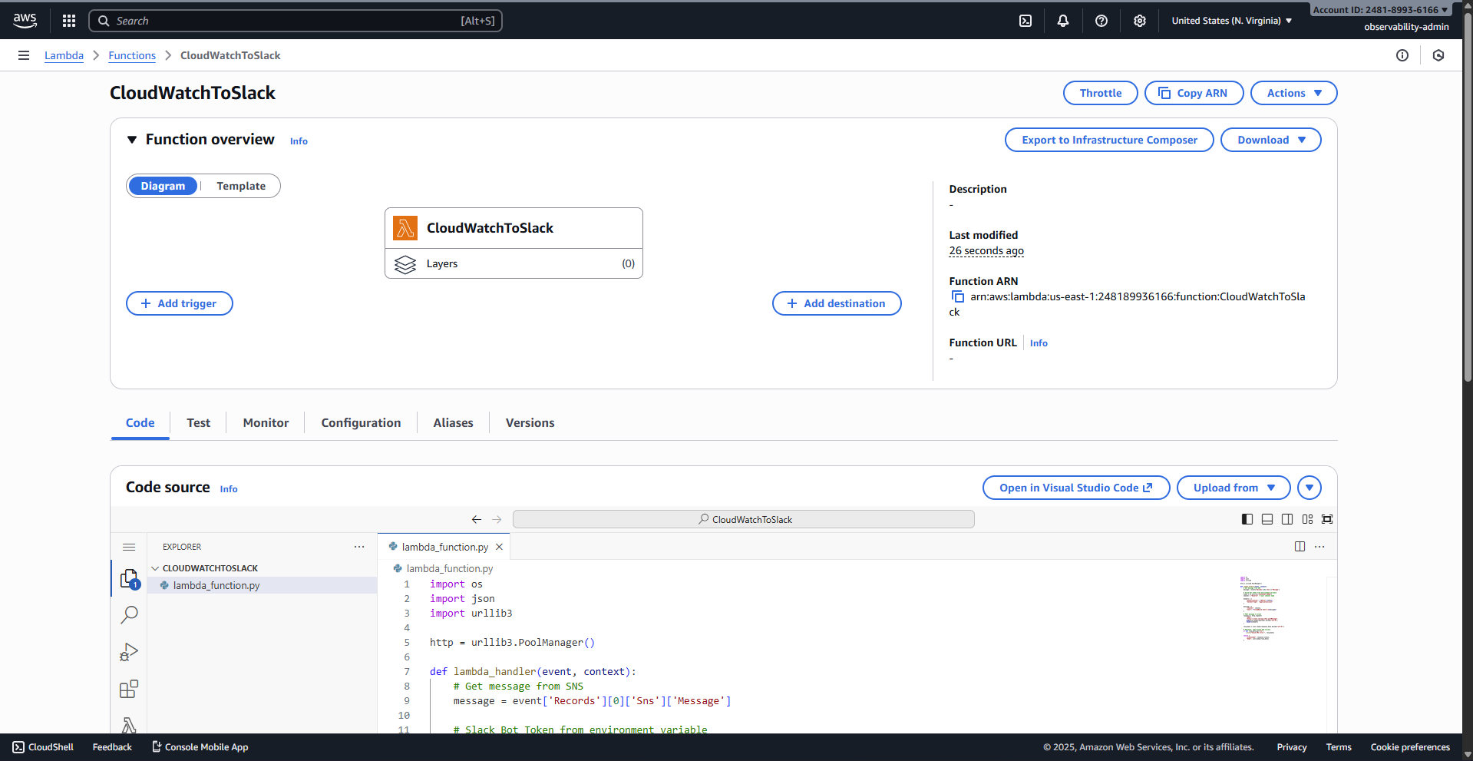
3.2.8 The Lambda function screen, showing the success banner after saving the code.
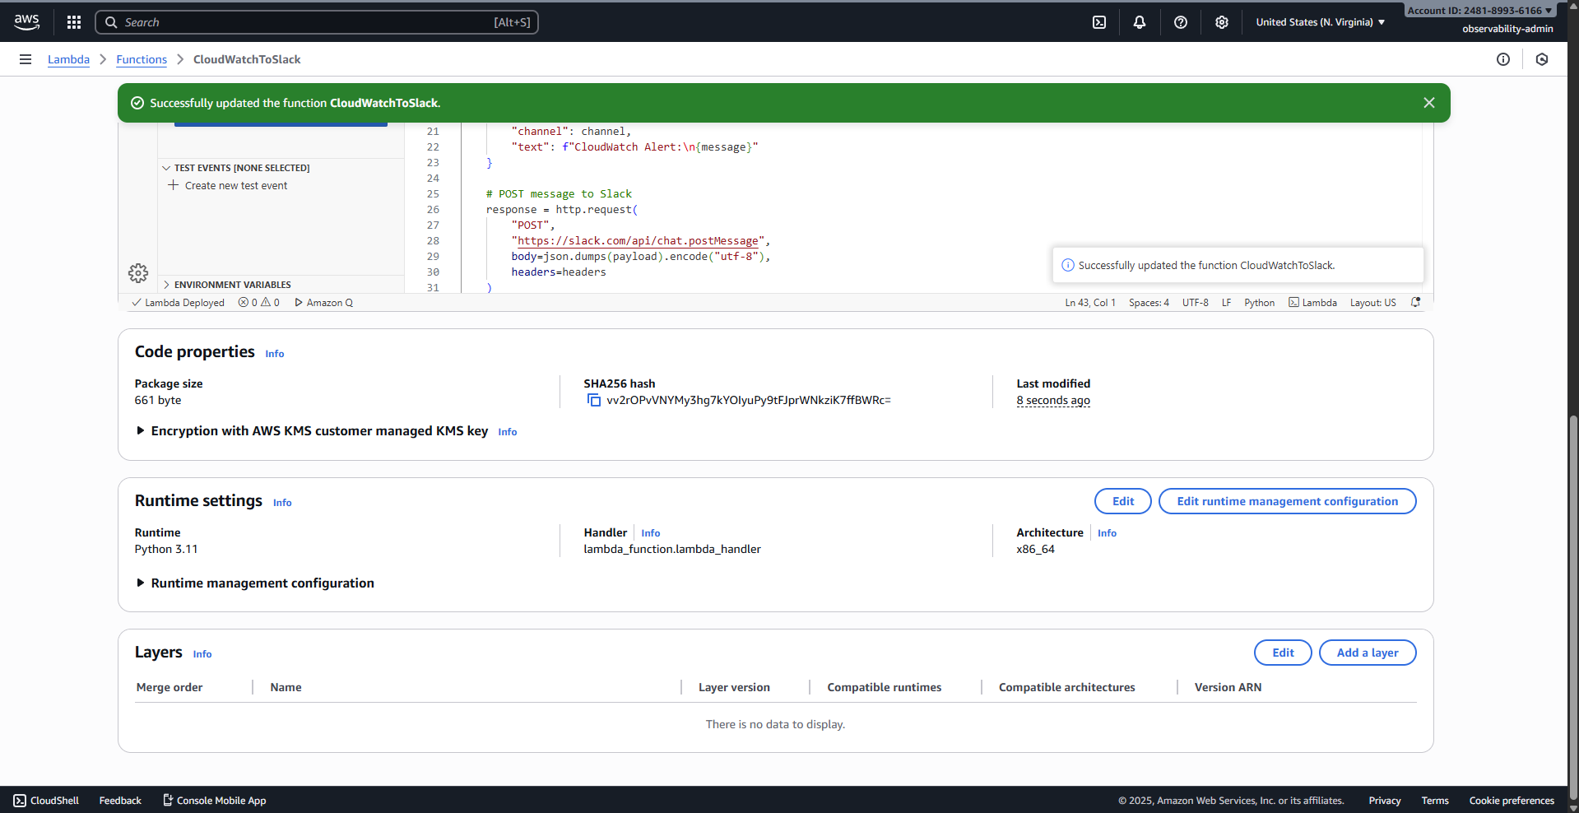
3.2.9 Lambda Configuration tab, showing the Environment variables section.
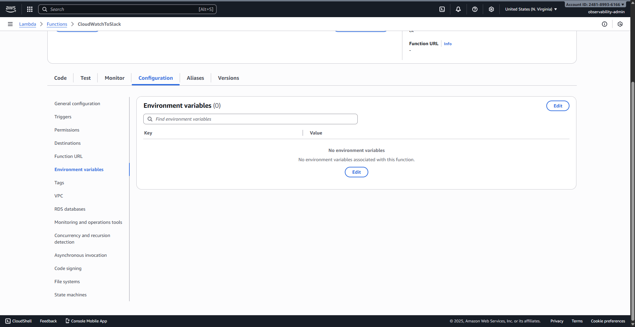
3.2.10 The Edit environment variables screen, ready to add the Slack webhook URL.
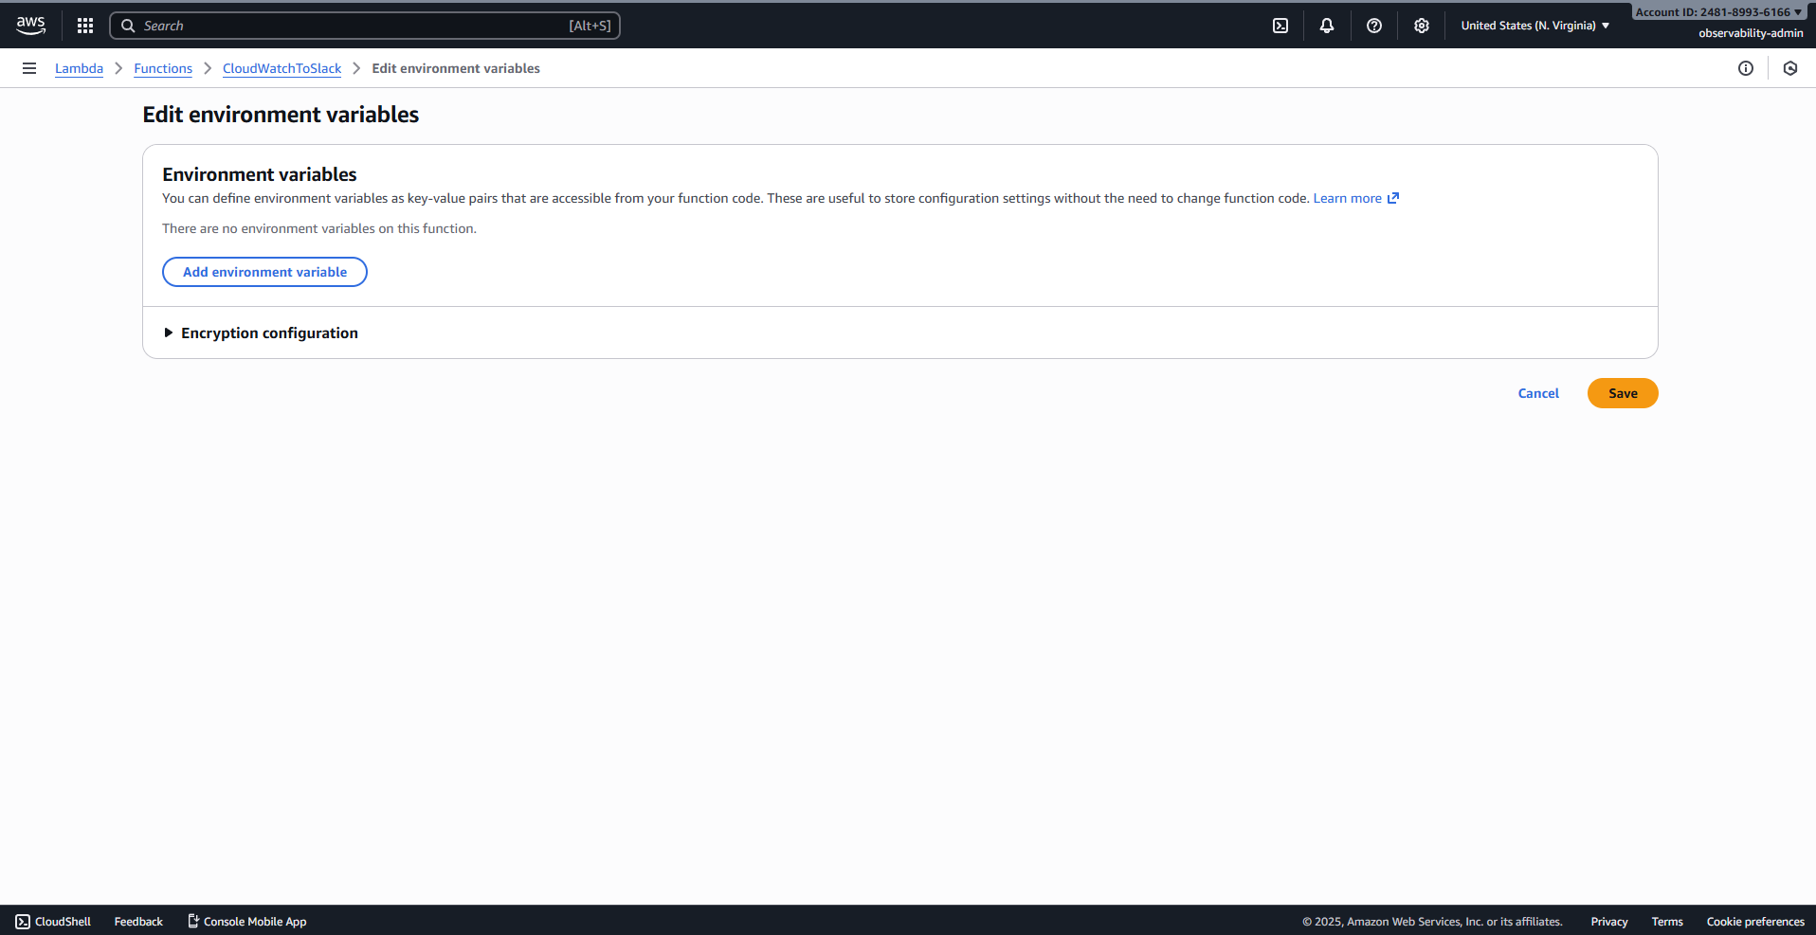
3.2.11 The Edit environment variables screen, showing the key SLACK_BOT_TOKEN and the value entered and saved.
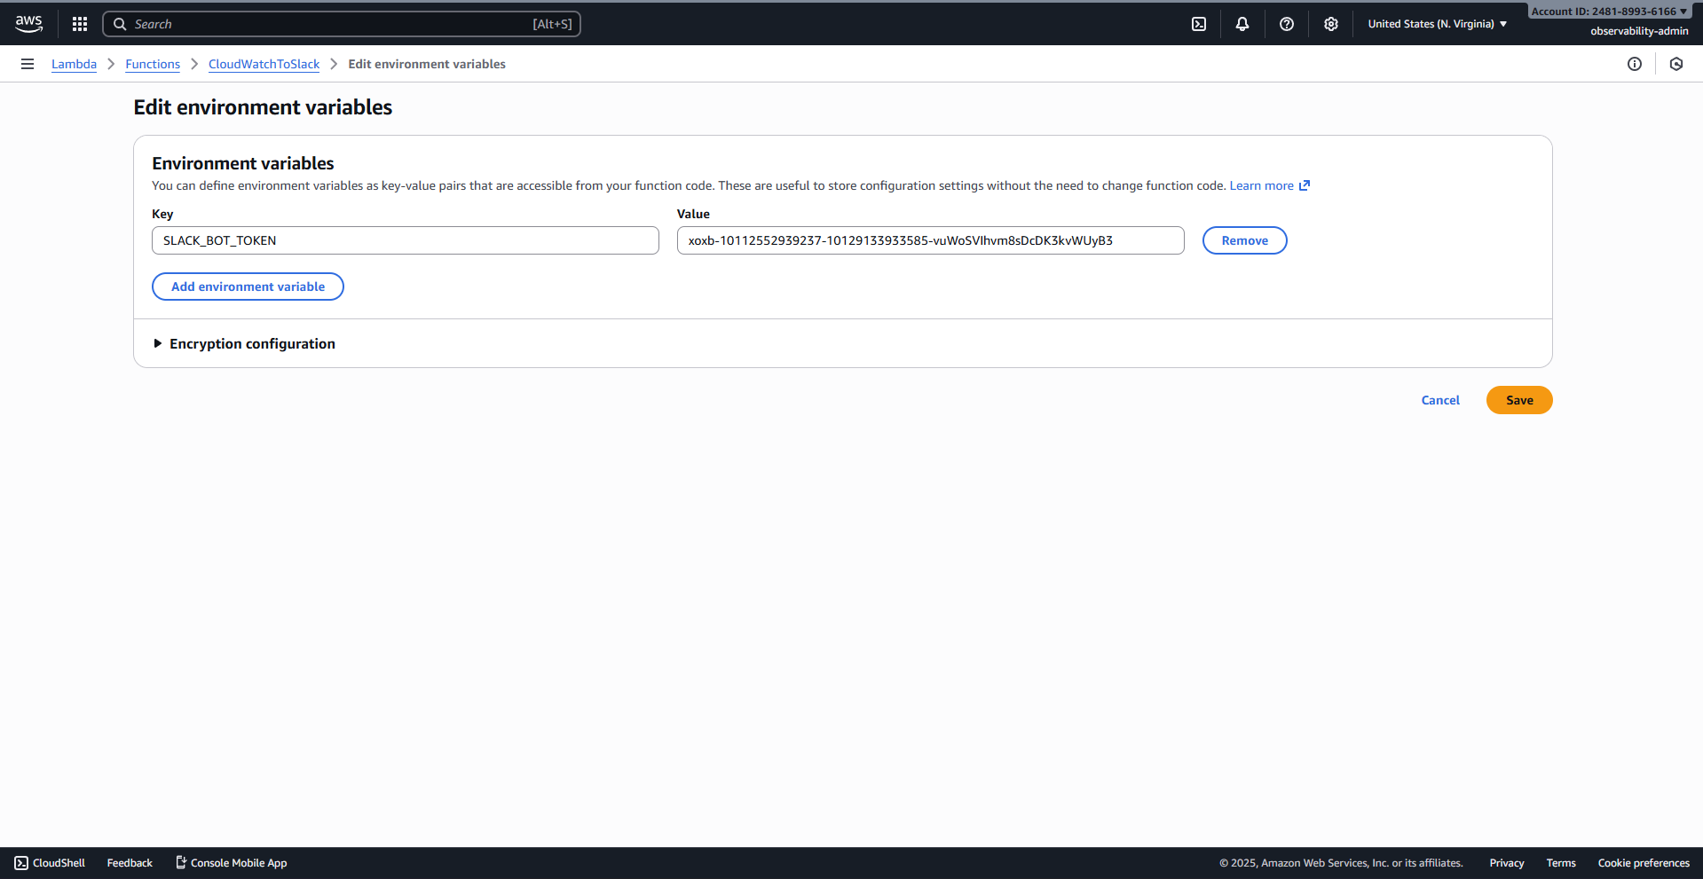
3.2.12 Lambda Configuration tab, showing the Triggers section.
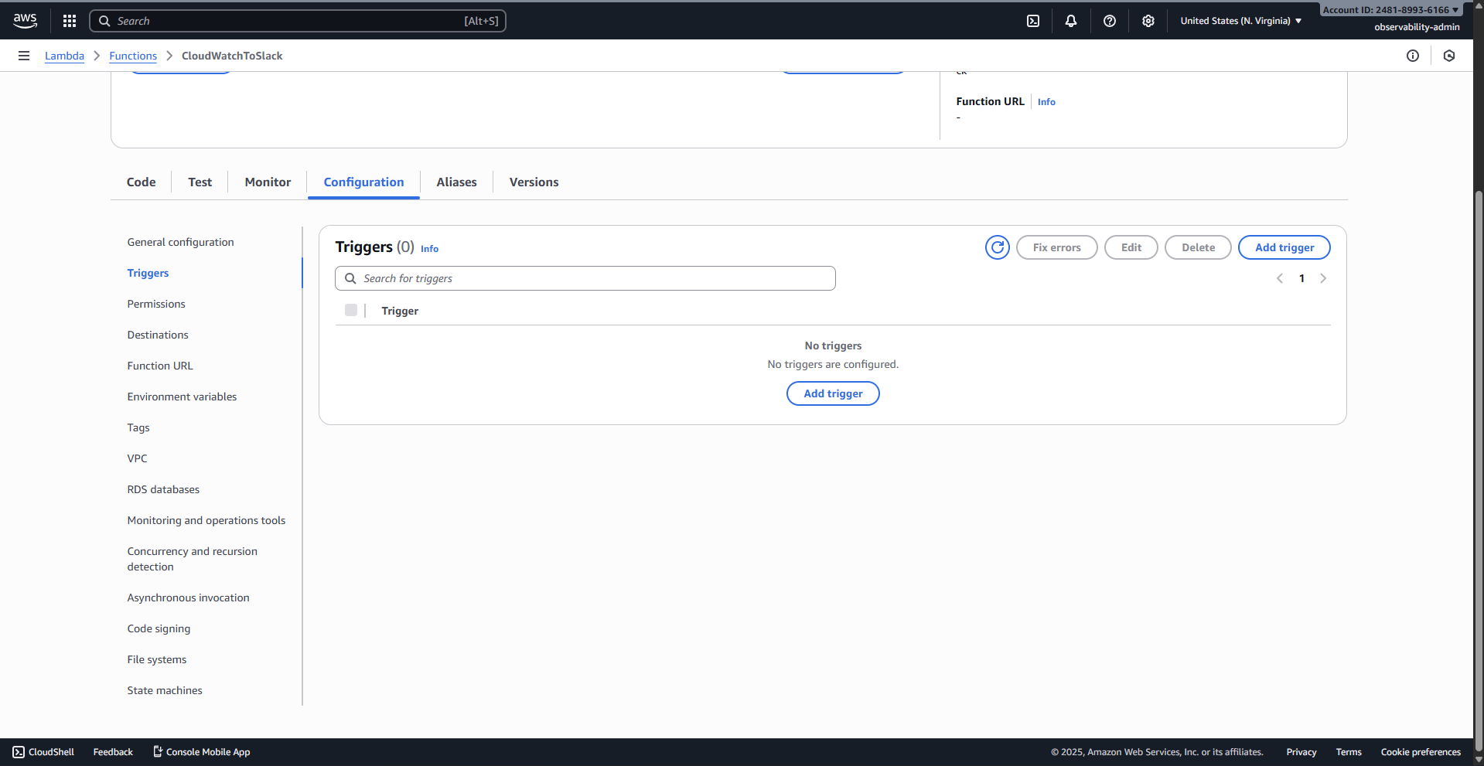
3.2.13 Add trigger configuration: SNS selected, and CloudWatchAlerts selected as the topic.
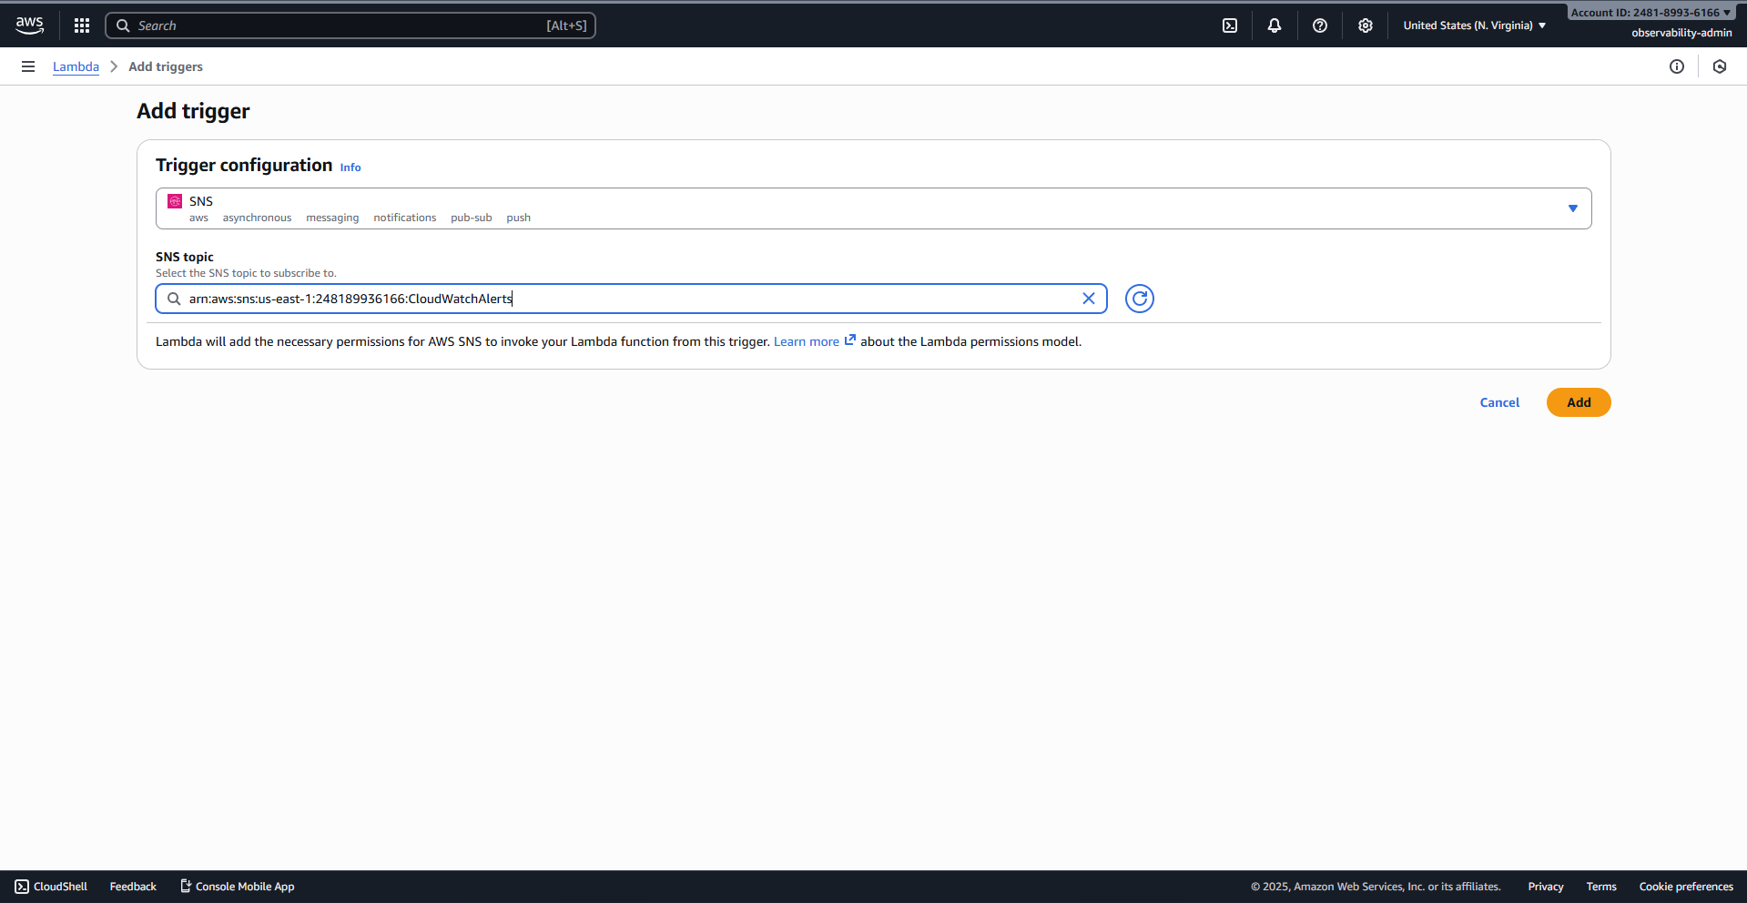

4. End-to-End Alert Testing and Project Conclusion
This final section validates the entire monitoring and alerting pipeline by simulating a high-load event and documenting the system's response and recovery.
4.1 Lambda Test tab, showing a mock SNS event JSON configured.
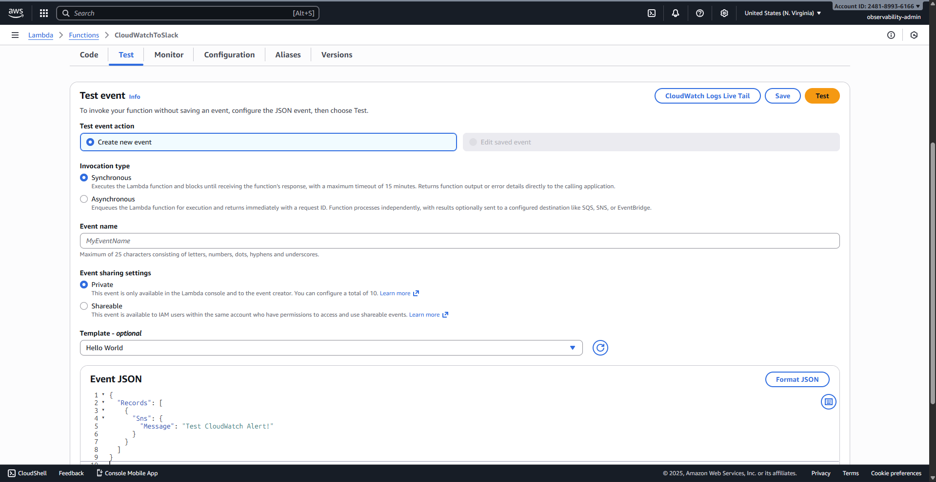
4.2 Lambda Test tab, showing "Execution result: succeeded".
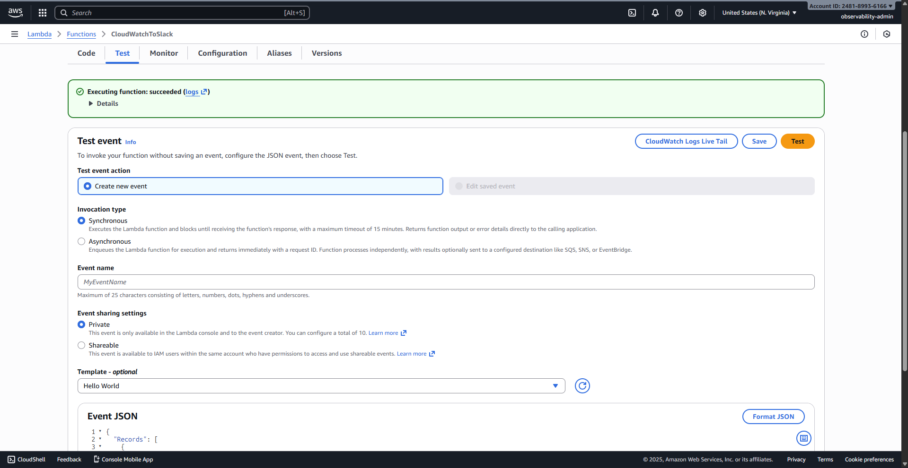
4.3 Terminal window, showing a successful SSH connection to the Dev-Monitoring instance.
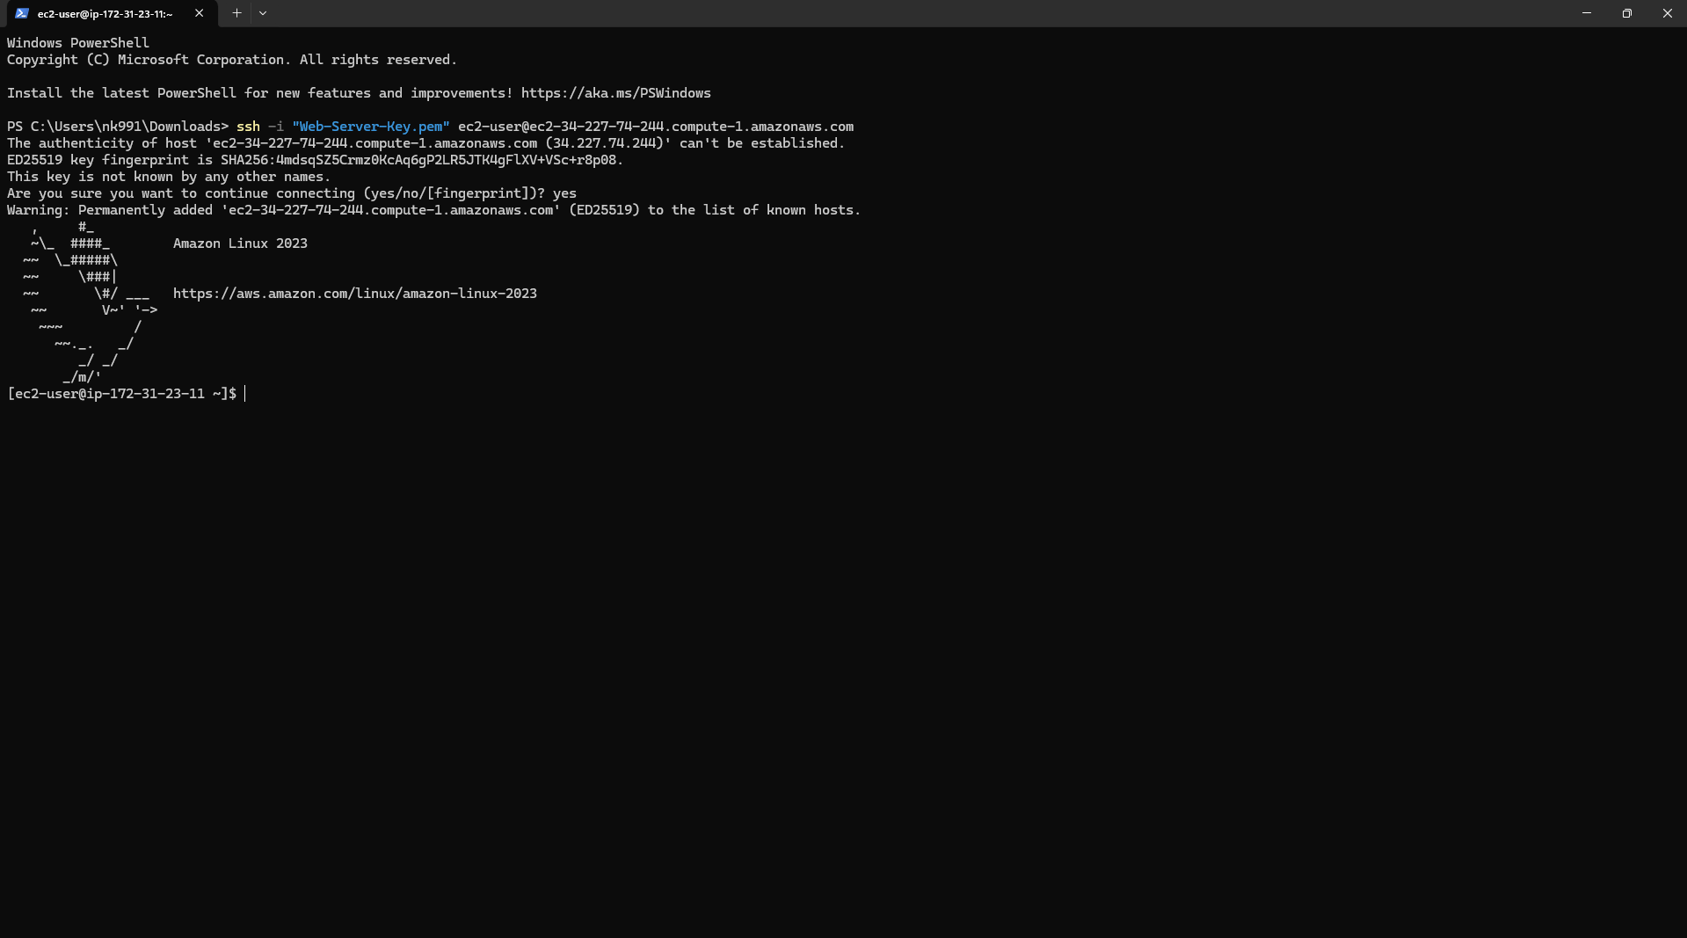
4.4 SSH session showing: sudo yum install -y stress followed by running stress -c 2 -t 60 to max out the CPU.
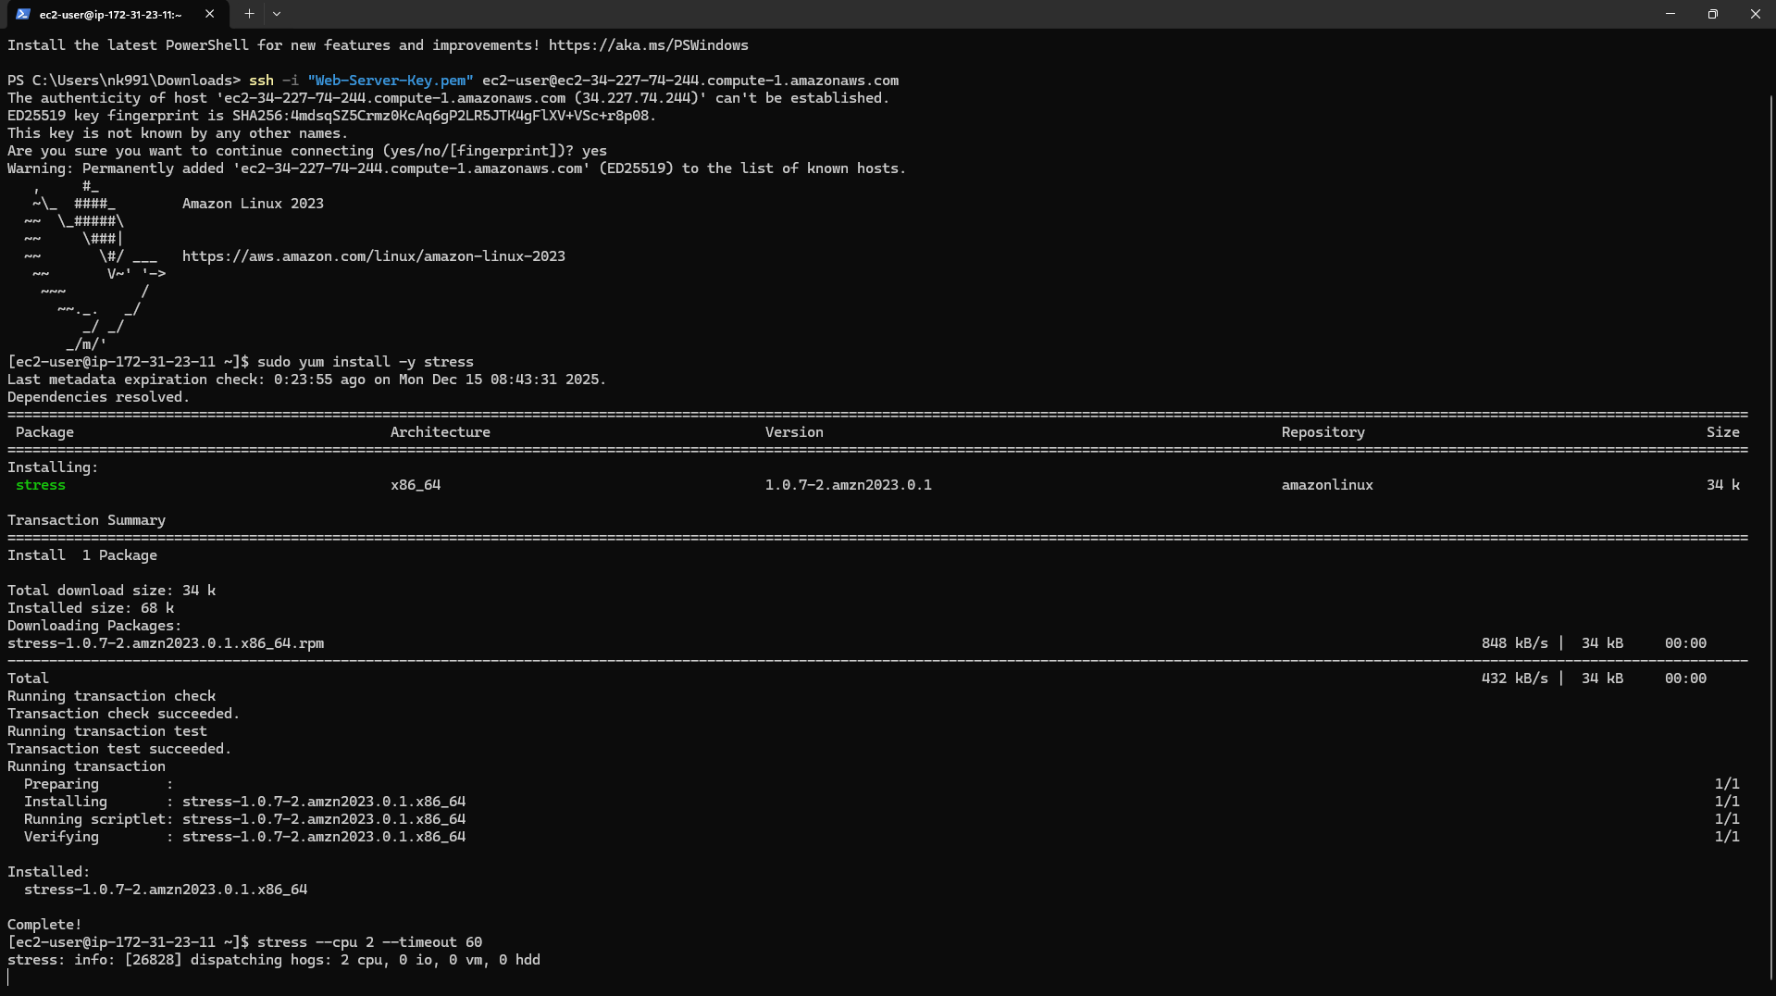
4.5 Grafana dashboard, showing the CPU Usage spiking to 100%.
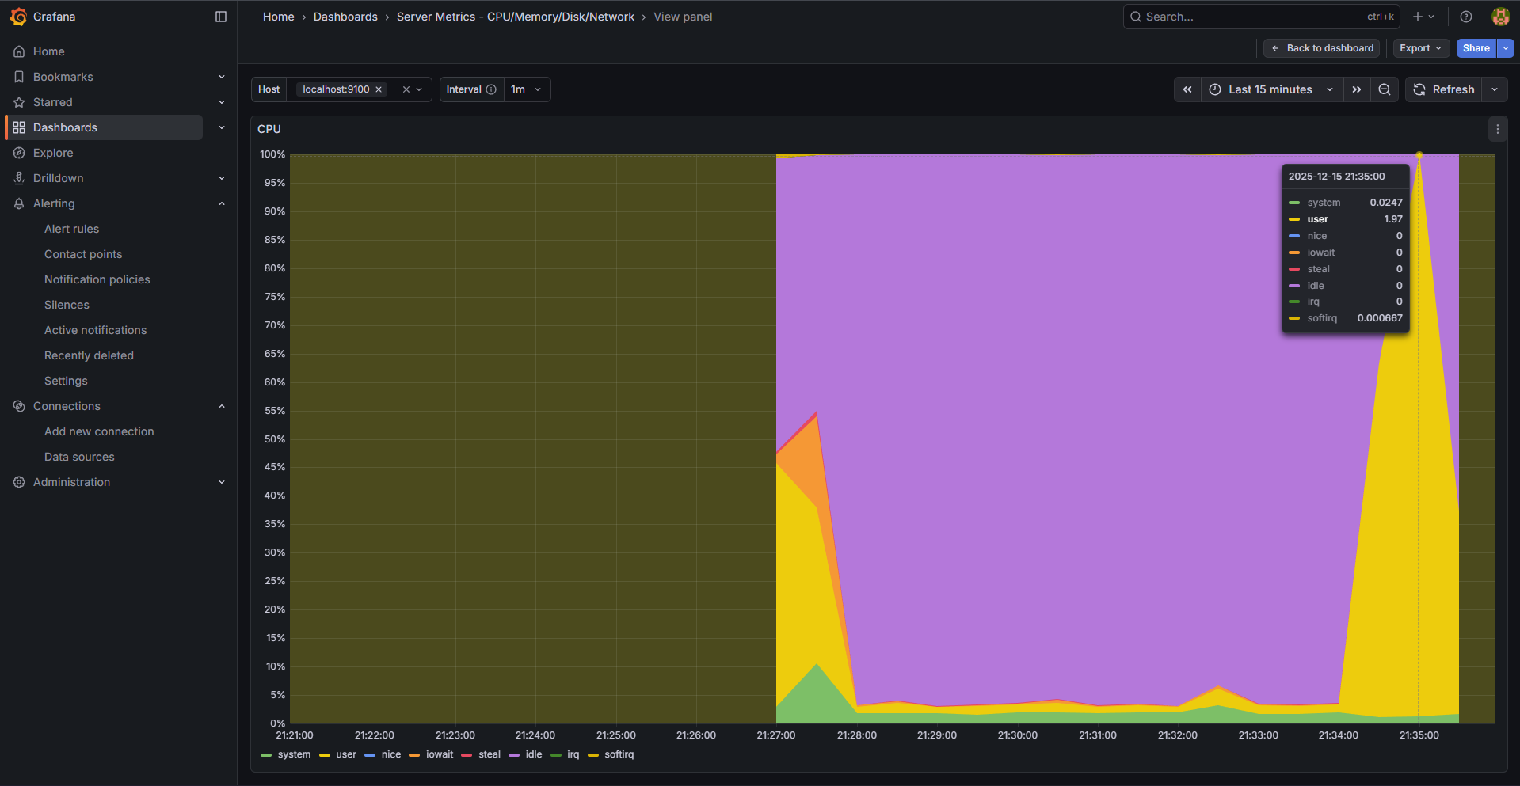
4.6 CloudWatch Alarms list showing the EC2-CPU-Usage-High alarm in the ALARM state (Red).
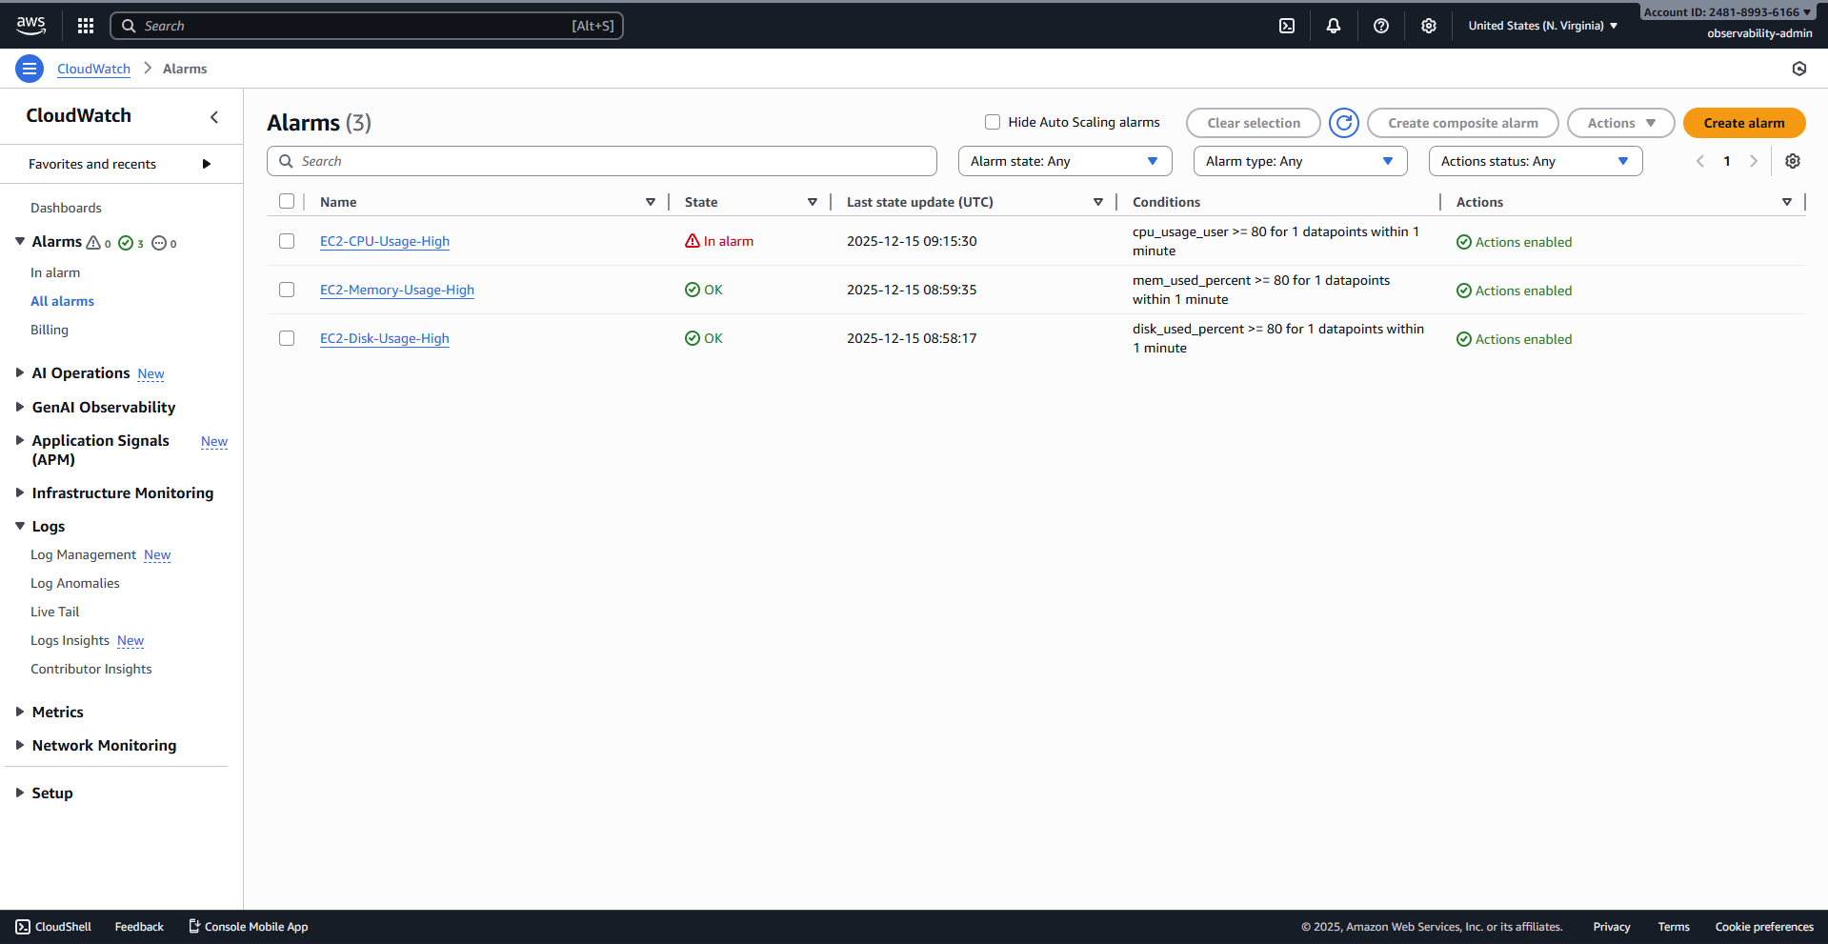
4.7 The final Slack channel interface showing the alert message received from CloudWatch/Lambda.
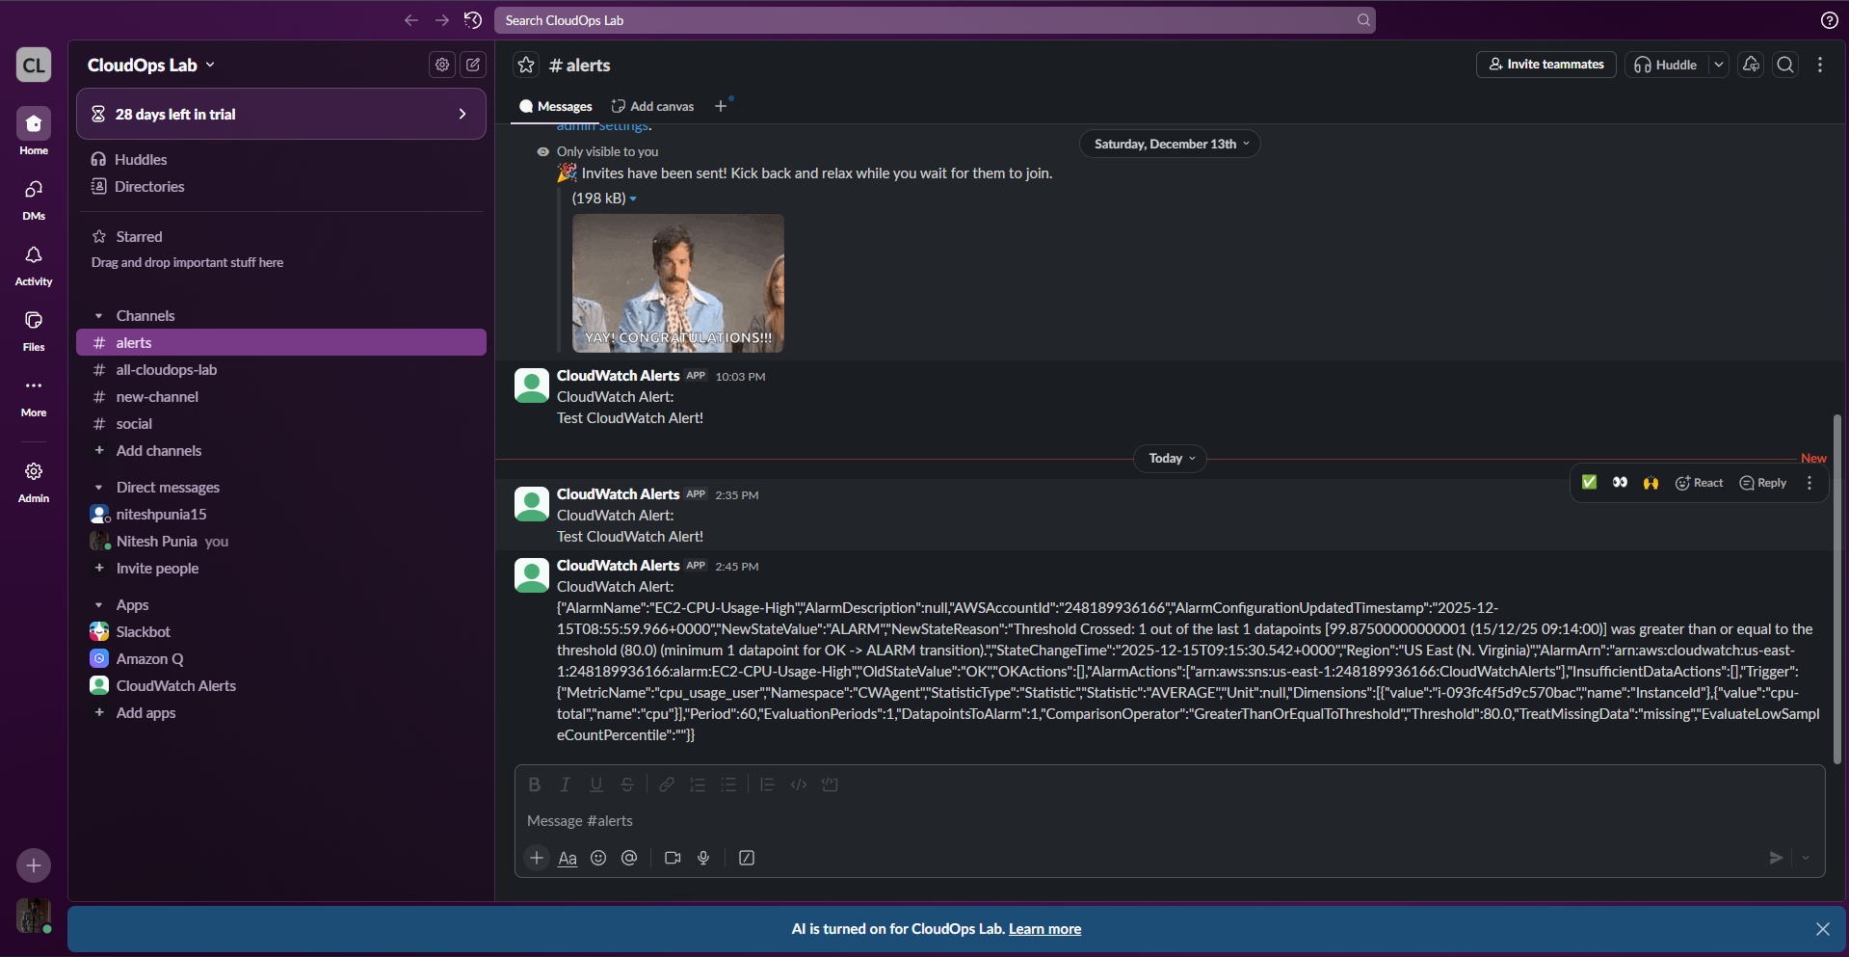
4.8 The recipient's Email Inbox showing the alert notification received from the SNS topic.
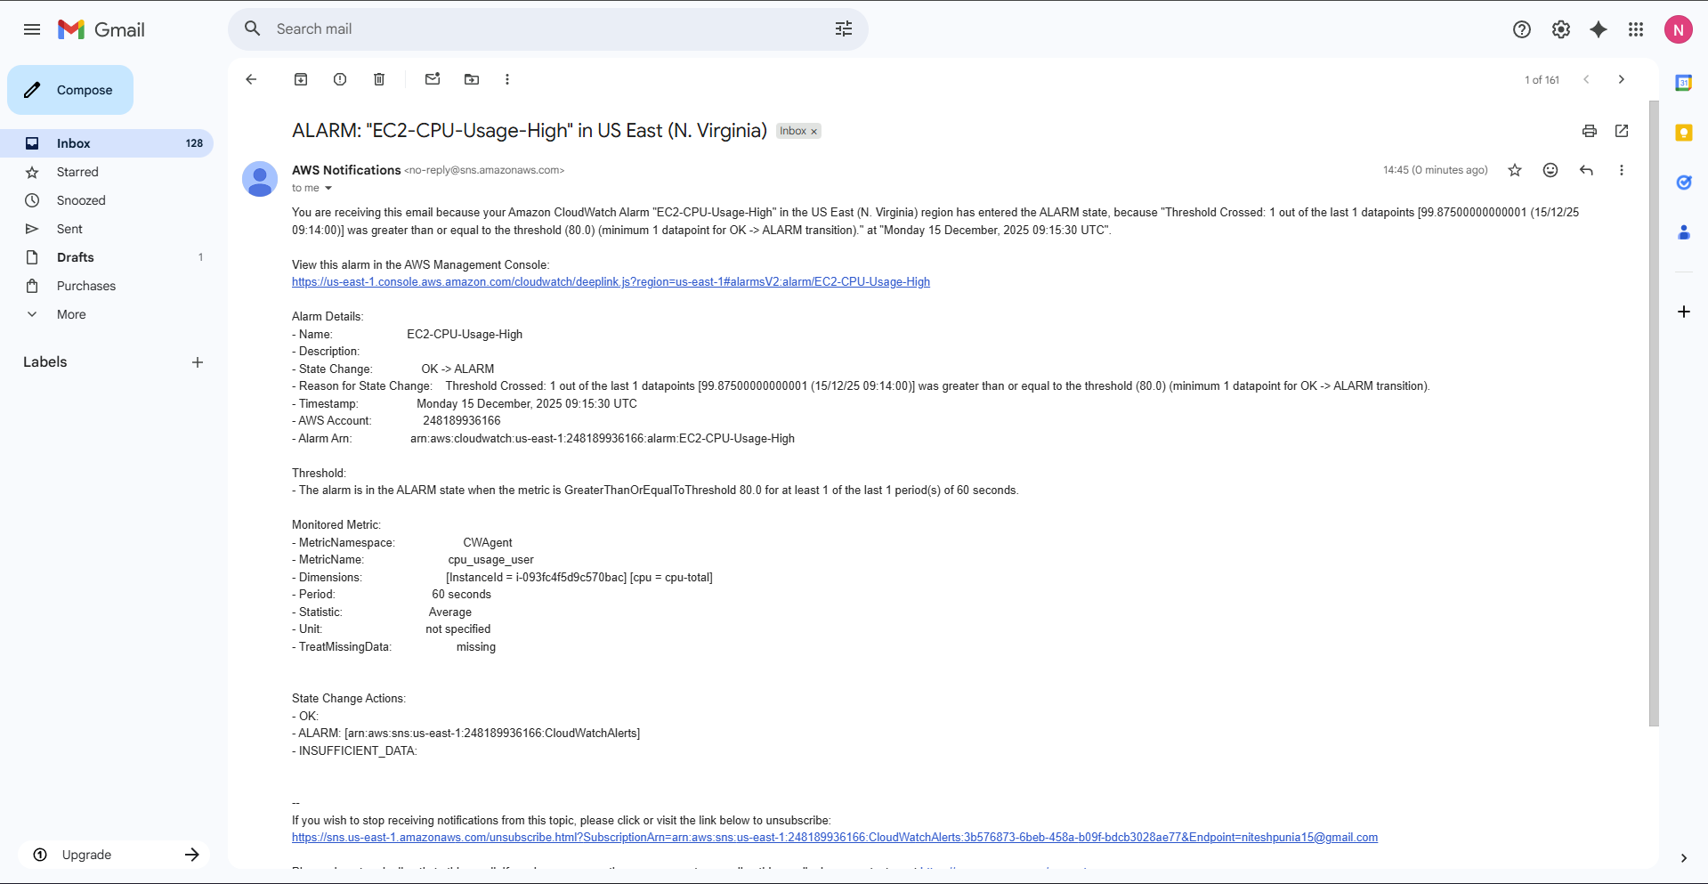
4.9 SSH session showing: running stress --vm 1 --vm-bytes 500M --timeout 60 to max out the CPU.
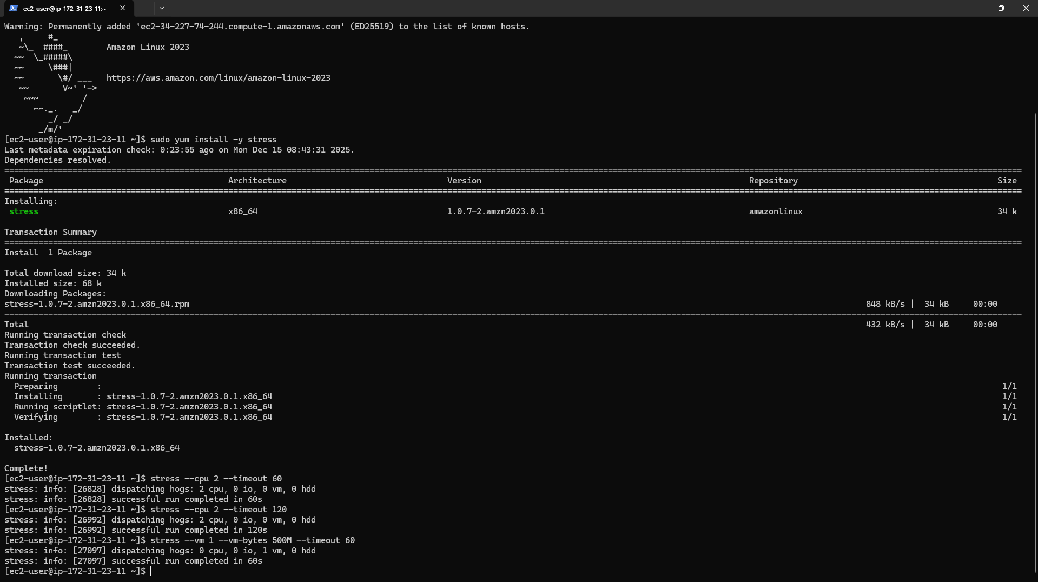
4.10 CloudWatch Alarms list showing the EC2-Memory-Usage-High alarm in the ALARM state (Red).
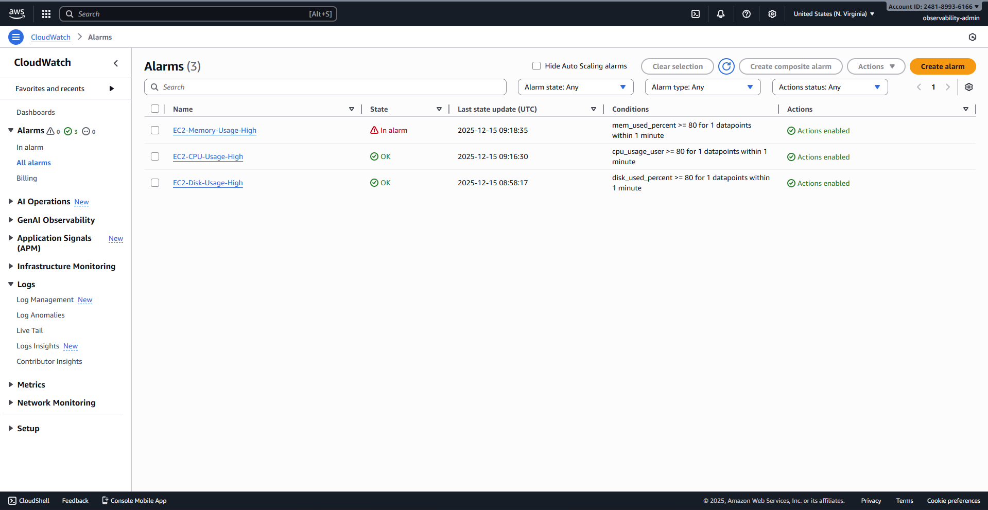
4.11 The final Slack channel interface showing the alert message received from CloudWatch/Lambda.
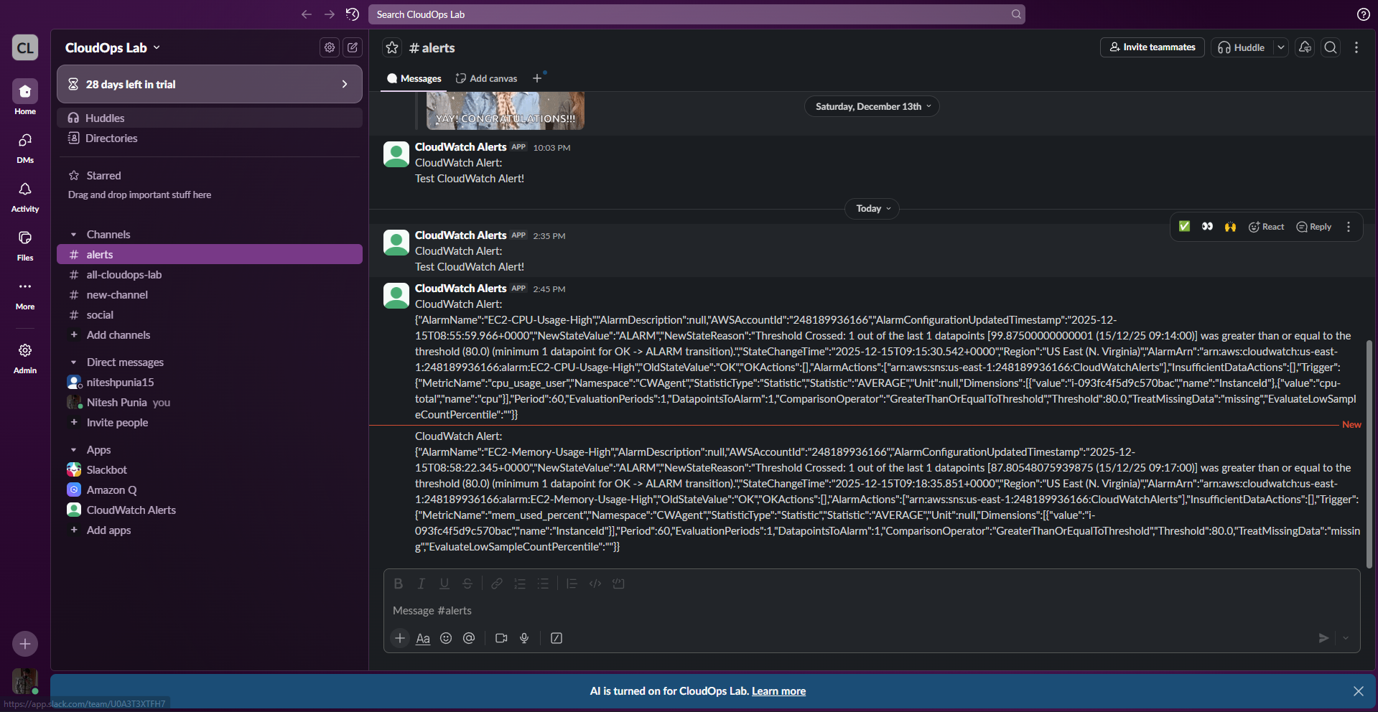
4.12 The recipient's Email Inbox showing the alert notification received from the SNS topic.
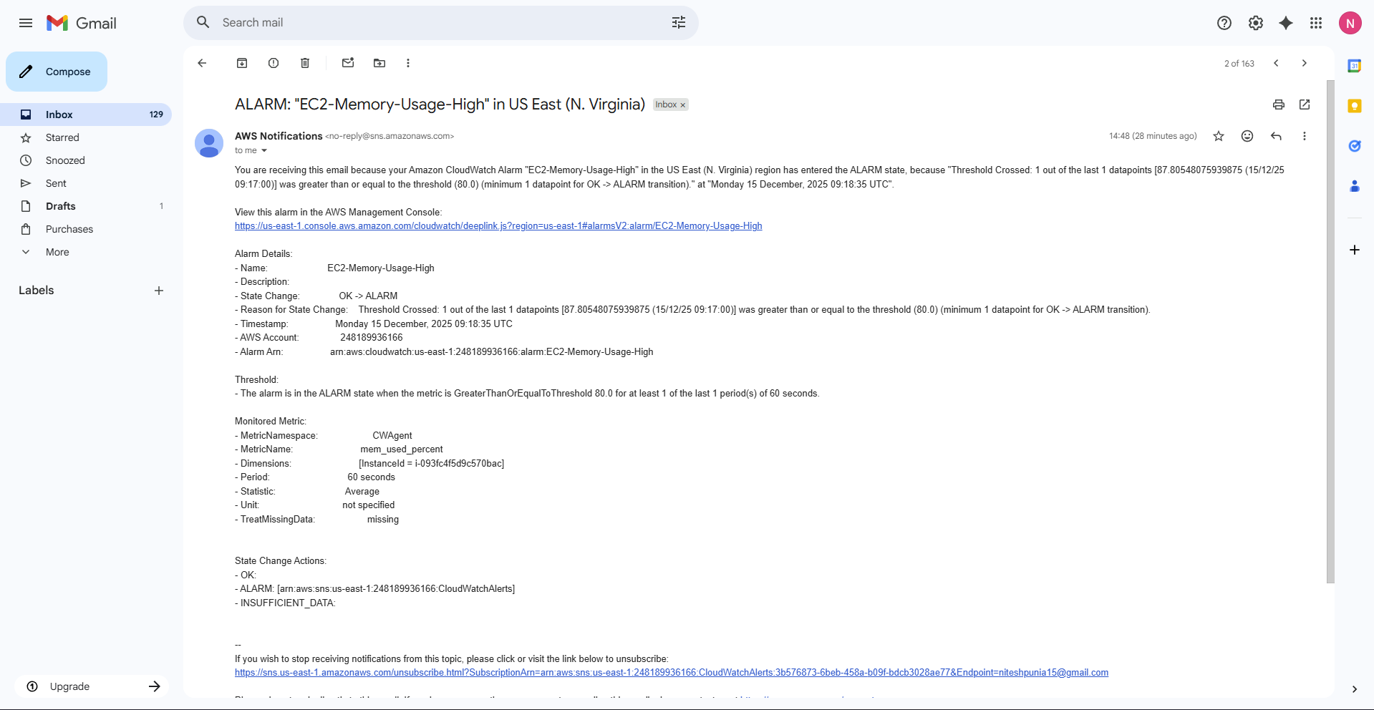
4.13 SSH session showing: running sudo fallocate -l 4b /root/testfile to max out the CPU.
4.14 CloudWatch Alarms list showing the EC2-Disk-Usage-High alarm in the ALARM state (Red).
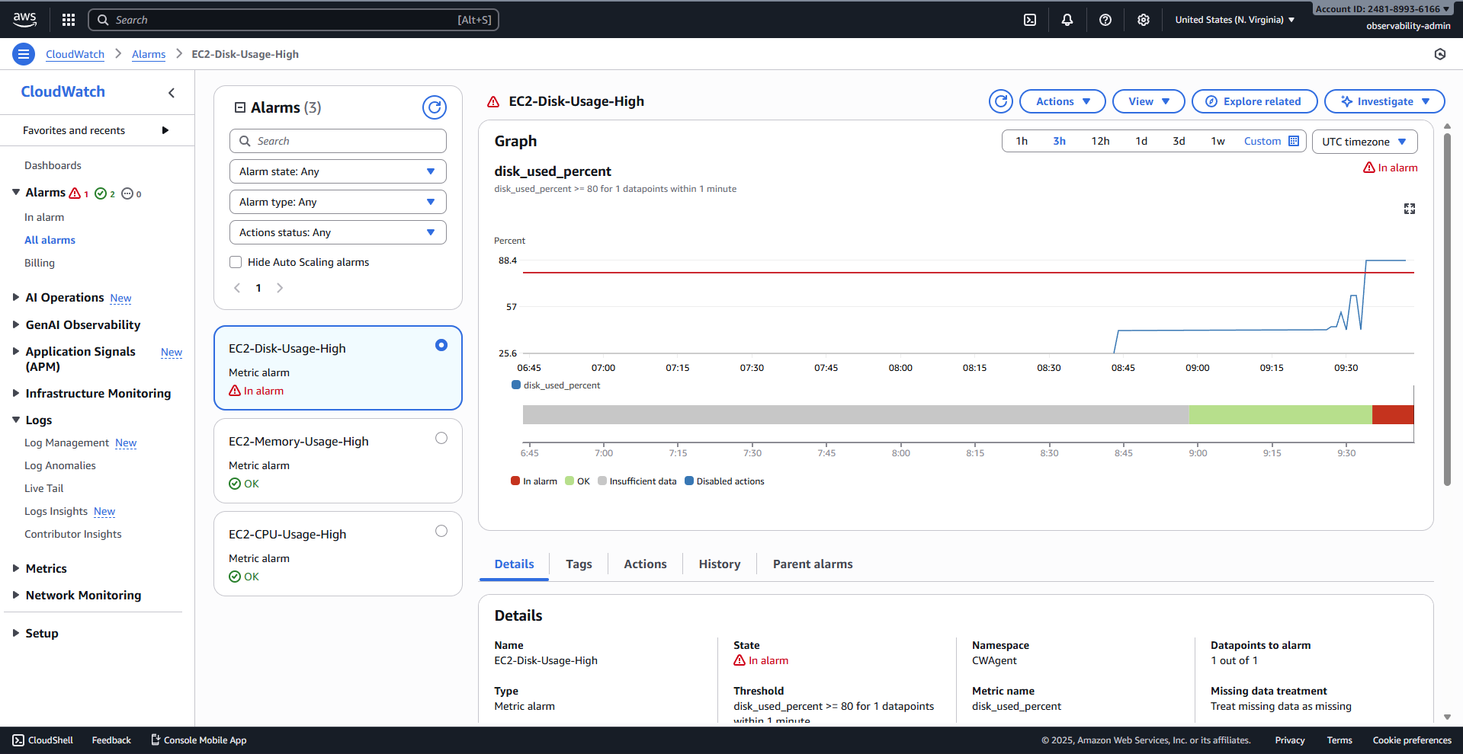
4.15 The final Slack channel interface showing the alert message received from CloudWatch/Lambda.
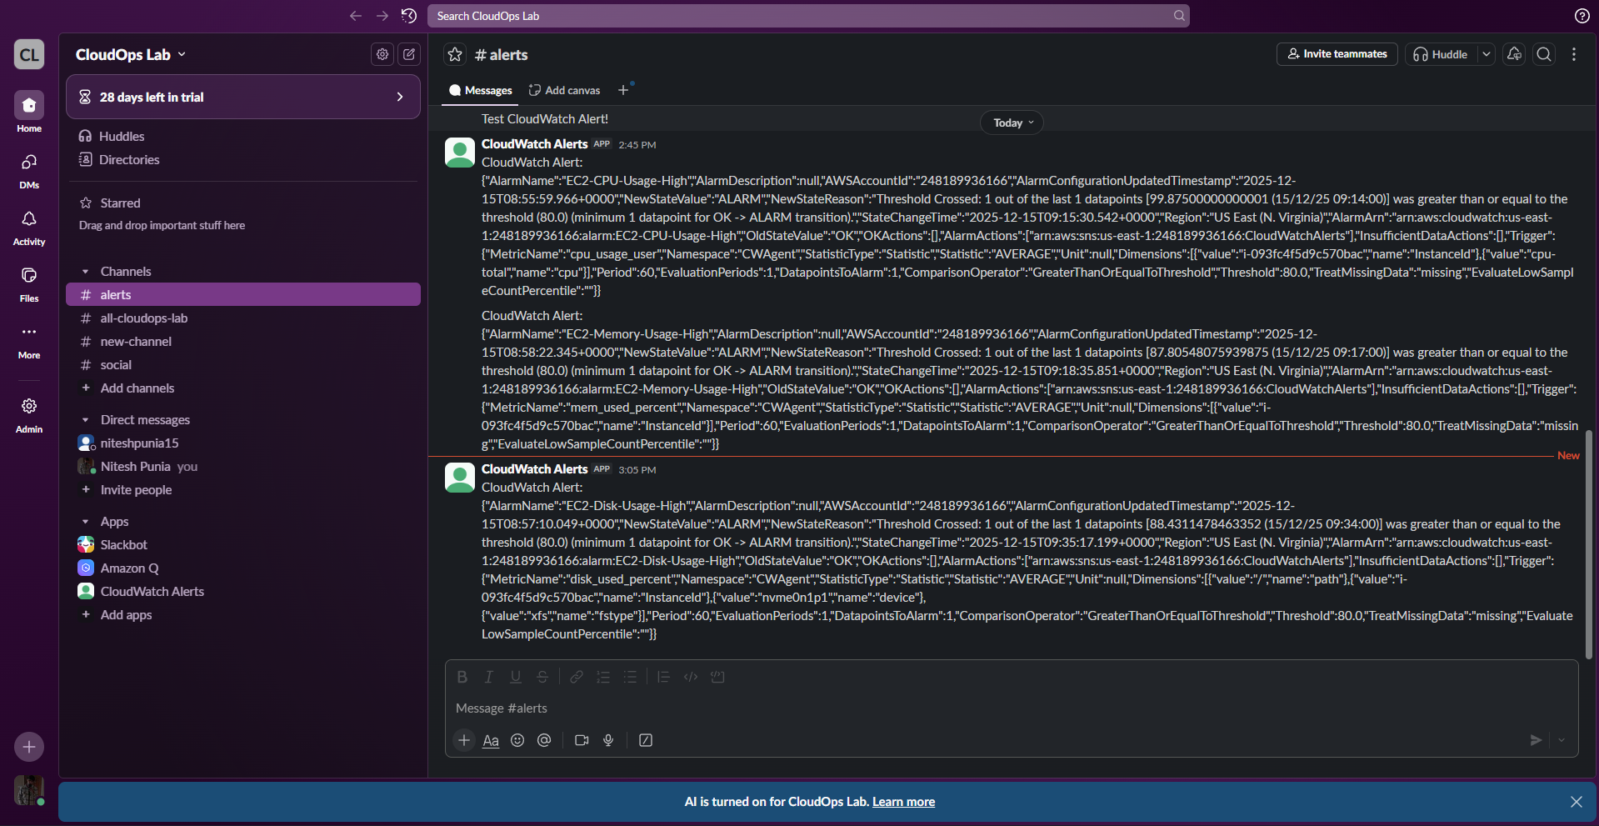
4.16 The recipient's Email Inbox showing the alert notification received from the SNS topic.
