Device management

1.Write about I/O devices?
Ans: I/O devices can be roughly divided into two categories: block devices and character devices. The block devices stores information in fixed sized blocks, each one with its own address. Read or write is possible independent of other blocks. A character device delivers or acknowledges a stream of characters, without respect to any block structure. It is not addressable and does not have any seek operation. Printers, network interfaces, mice (for pointing), rats (for psychology lab tests), and most different devices that are not disk-like can be seen as character devices.

2. Explain about Device Controllers?
Ans: I/O units typically consist of mechanical and electronic components. A controller is a collection of electronics that can operate a bus or a device. On PC, it often takes the form of printer circuit card that can be inserted into an expansion slot. A single controller can handle multiple devices; some devices have their own built-in controller. The controller has one or more registers for data and signals. The processor communicates with the controller by reading and writing bit patterns in these registers. When transferring a disk block of size 512 bytes, the block is first assembled bit by bit in a buffer inside the controller. After its checksum has been verified and the blocks are declared error free, it can be copied to the main memory.

3.Explain about DMA?
Ans: DMA is a feature of modern computers that allow certain hardware subsystems within the computer to access system memory for reading or writing independently of the CPU. Without DMA, the CPU is fully occupied for the entire duration of read or write operation and is unavailable to perform other tasks. With the help of DMA, the CPU would initiate the transfer, do other operations while the transfer is in progress and receive an interrupt from the DMA controller once the operation has been done (Operating System Concepts, 2008). Many computers avoid burdening the CPU by offloading some of its work to special purpose processor called DMA controller. It consists of memory address register, a byte count register, and one or more control registers. More commonly, a single DMA controller is available for regulating transfer to multiple devices but some systems may have integrated with disk controllers.

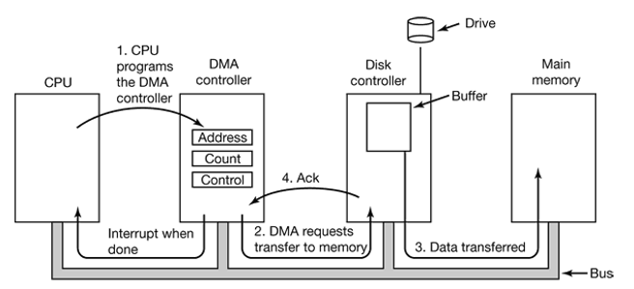
Working:
The CPU programs the DMA controller by its registers so it knows what to transfer where. It also issues a command to disk controller telling it to read data from disk to its internal buffer and verify the checksum. When valid data are in disk’s controller buffer, DMA can start.
- The DMA controller initiates the transfer by issuing a read request over the bus to the disk controller.
- Data is transferred from disk controller to memory.
- When the transfer is completed, the disk controller sends an acknowledgment signal to DMA controller. The DMA controller then increments the memory address to use and decrements the byte count. This continues till the byte count is greater than 0.
- When the transfer is complete, the DMA controller interrupts the CPU.

4.What is Device Driver?
Ans.: Every I/O device attached to a PC needs some device-specific code for controlling it. This code called the device driver, is for the most part written by the device's producer and delivered alongside the device. Since each OS needs its own drivers, device makers commonly supply drivers for a few well known OS. Each device driver normally handles one device type, or at most one class of closely related devices. In some systems, the OS is a single binary program that contains all the drivers that it will need to be compiled into it.
5.What do you mean by Buffering?
Ans.: A buffer is a memory area that stores data while they are transferred between two devices or between a device and an application.It is a technique, which is used in the operating system to bridge the gap between the slow I/O devices and the fast processor. Buffering attempts to keep both CPU and I/O devices busy all time

Network Management

1.

