Adding a DS3231 Real Time Clock to the Raspberry Pi 3

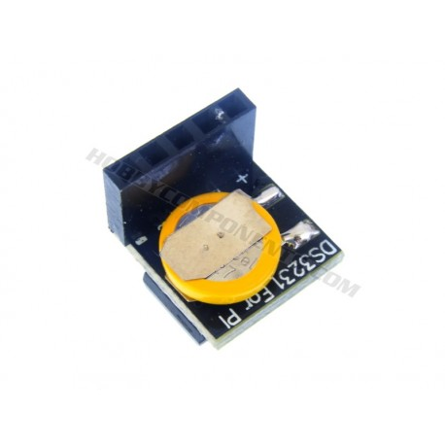
1. Get a DS3231 real time clock module and install it on the GPIO header of the Raspberry Pi 3 on pin 1

RTC DS3231
Connect rtc(real time clock) to rasberry pi 3 board as show

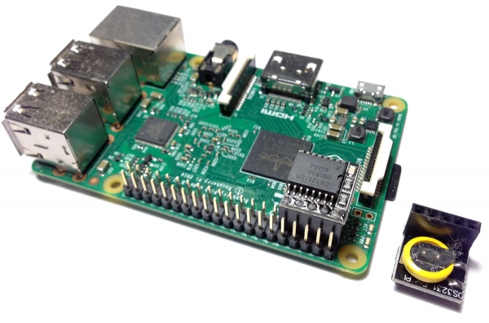

2. change the path boot

$ cd /boot
$boot: sudo vim config.txt

3. We don’t need fake-hwclock anymore:

$ sudo apt-get purge fake-hwclock

4.Check/set the current system time and write the system time to the RTC module using:

$ hwclock -w

5. Set the correct time zone using:

$ sudo dpkg-reconfigure tzdata

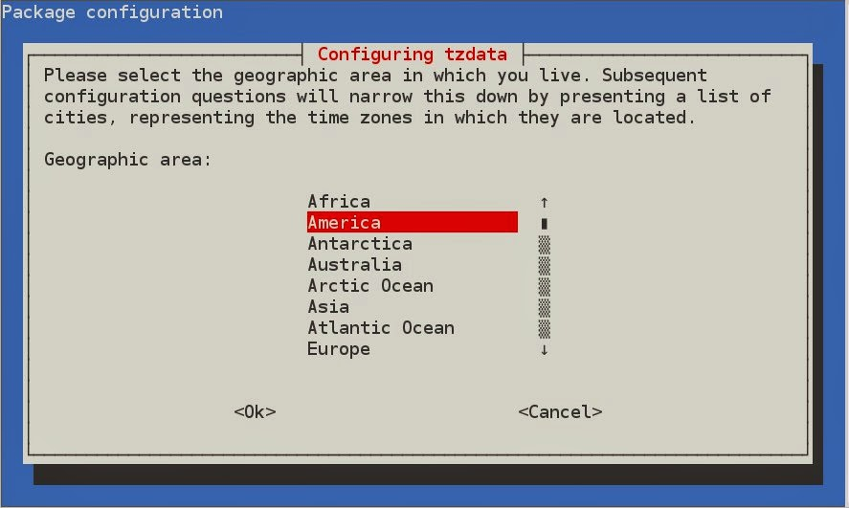

we have to choose geographical area and city

5. Edit /etc/rc.local and add the hwclock command above the line that says “exit 0”:

$ cd /etc/
sudo vim rc.local

$ /sbin/hwclock -s

6.The /etc/init.d/hwclock.sh shell scripts tends to corrupt this RTC clock module. In my case, the RTC clock was set to 2066/01/01 after every reboot. To prevent this from happening, edit /etc/default/hwclock and set HWCLOCKACCESS to no:

HWCLOCKACCESS=no

7.Reboot

