x = int(input("Enter a x value : "))
y = int(input("Enter a y value : "))
for i in range(1,x+1):
for j in range(1,y+1):
print i*j,
print "\n"

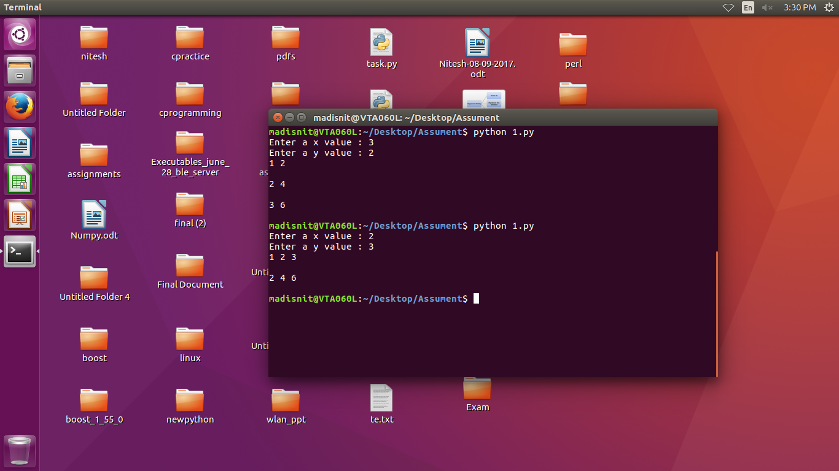
val = ([[1,3,5],[2,4,6]])
lis = []
lis2 = []
lis3 = []
for i in val:
lis.append(i[0],)
lis2.append(i[1],)
lis3.append(i[2],)
val = lis,lis2,lis3,
print list(val)
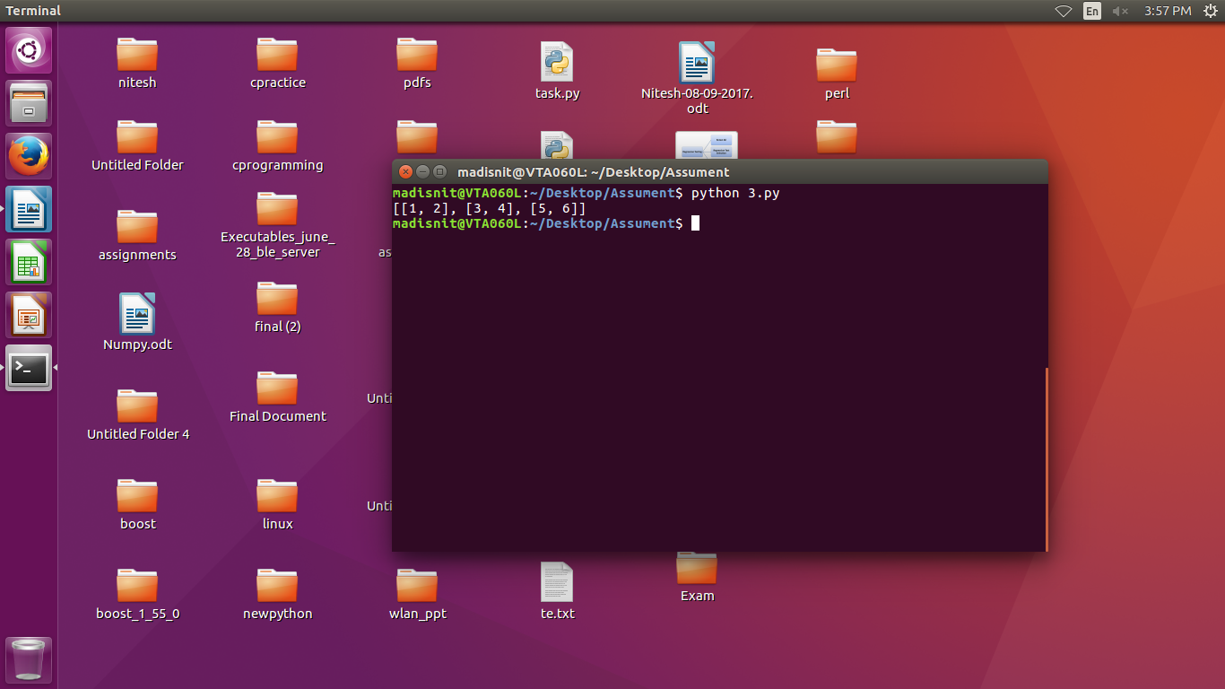

val = ([[1,4,9]])
lis = []
for i in val:
li = []
li2 = []
li3 = []
li.append(i[0])
li2.append(i[1])
li3.append(i[2])
val = li,li2,li3
print list(val)

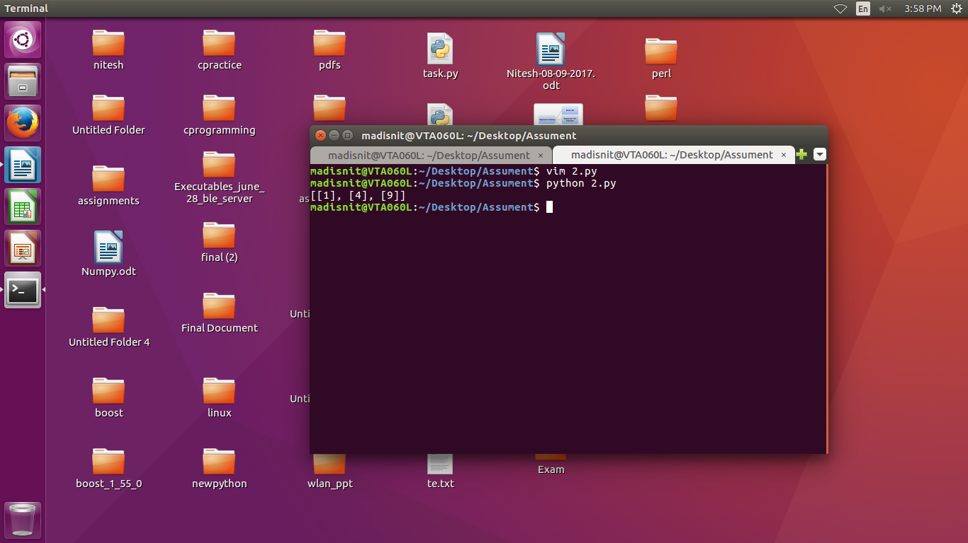

val = ([[1,1,1],[2,2,2],[3,3,3]])
lis = []
lis2 = []
lis3 = []
for i in val:
lis.append(i[0],)
lis2.append(i[1],)
lis3.append(i[2],)
val = lis,lis2,lis3,
print list(val)

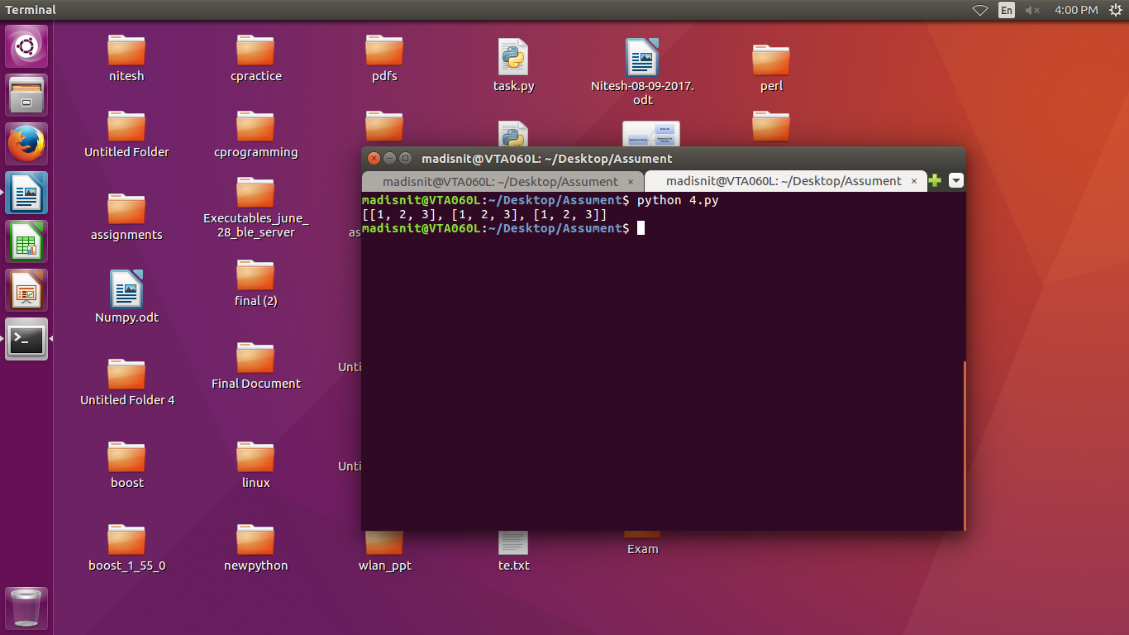

lis = [13,12,11,13,14,13,7,11,13,14,13]
lis2 =[]
lis3 = []
lis4 = []
val = max(lis,key=lis.count)
val2 = min(lis)
lis2.append(val)
lis3.append(val2)
lis4.append(lis2)
lis4.append(lis3)
print lis4,

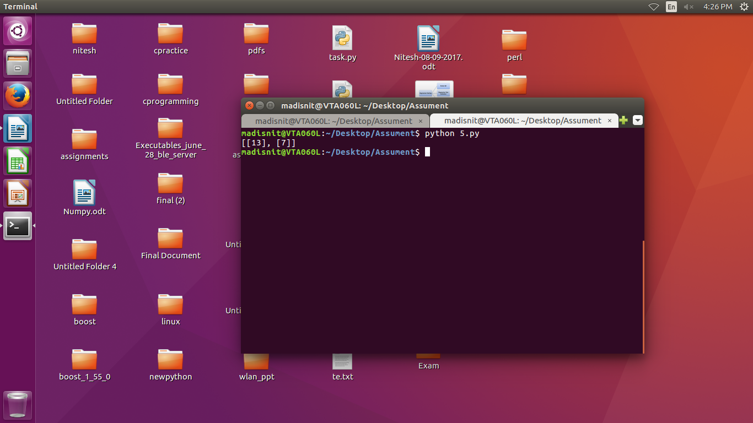

lis = [13,12,11,13,14,13,7,11,13,14,13]
lis2 =[]
lis3 = []
lis4 = []
val = max(lis,key=lis.count)
val2 = min(lis)
lis2.append(val)
lis3.append(val2)
lis4.append(lis2)
lis4.append(lis3)
print lis4,
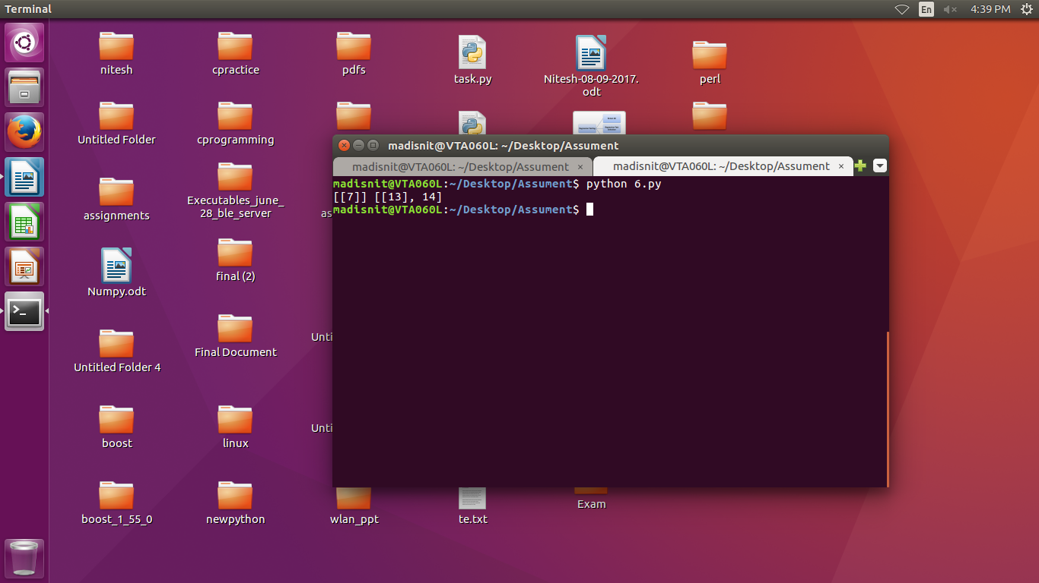

lis = input("Enter a input: ")
for i in lis:
if len(i) >= 3:
print "True"
break
elif len(i) <= 2:
print "False"

