2 . question

val = input("Enter a input: ")
l = len(val)
if l%2 == 0:
list1 =[]
for i in range(1,l,2):
v=val[i-1]+val[i]
list1.append(v)
print list1
t=[]
for i in range(2,len(list1),1):
sumn=int(list1[i-2])+int(list1[i-1])
if sumn is int(list1[i]):
t.append(sumn)
print t

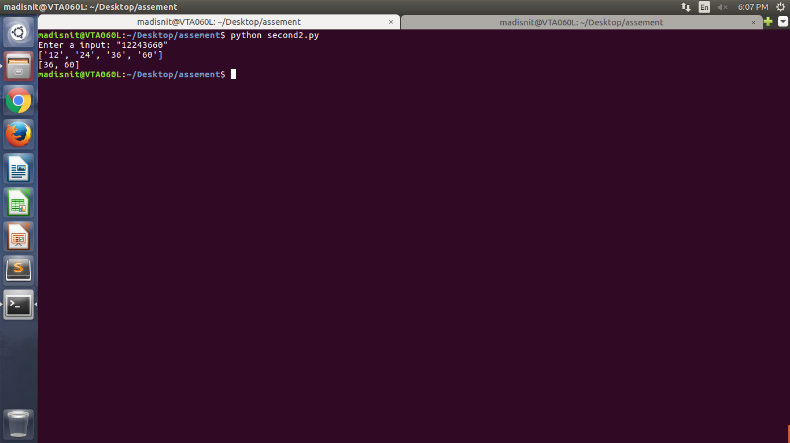

3.question
dict1 = {"i","like","sam","sung","samsung","mobilemice","cream","icecream","man","go","mango"}
dict2 = {"ilikesamsungmobile"}
d = {}
for k in range(len(dict1)):
if k in dict:
dict1[k].append(dict2[k])
else:
d[dict[k]] == {}
dict1[k].append(dict2[k])
print d

4.question

x = raw_input(“Enter a input: “)
l = input(“Enter a start bit: “)
r= input(“Enter a start bit: “)
x=type(x)
for i in range(n,l,2):
n=n|1<<i
print i

