1. writre a calculator program in BASH using switch case perform arthemetic operation.

1 #!/bin/bash

2 echo "Enter a numbers: "

3 read -p "number1=>" number1

4 echo "Enter a number: "

5 read -p "number2=>" number2

6 echo "Enter a choice: 1) ADD 2) MUL 3) DIVI 4) reminder"

7 read -p "choice=>" choice

8 case "$choice" in

9 1)echo "adding two numbers:`expr $number1 + $number2`"

10 ;;

11 2)echo "mulplying two numbers:`expr $number1 \\* $number2`"

12 ;;

13 3)echo "divistion of two numbers:`expr $number1 / $number2`"

14 ;;

15 4)echo "reminder two numbers:`expr $number1 % $number2`"

16 ;;

17 \*)echo "no output"

18 ;;

19 esac

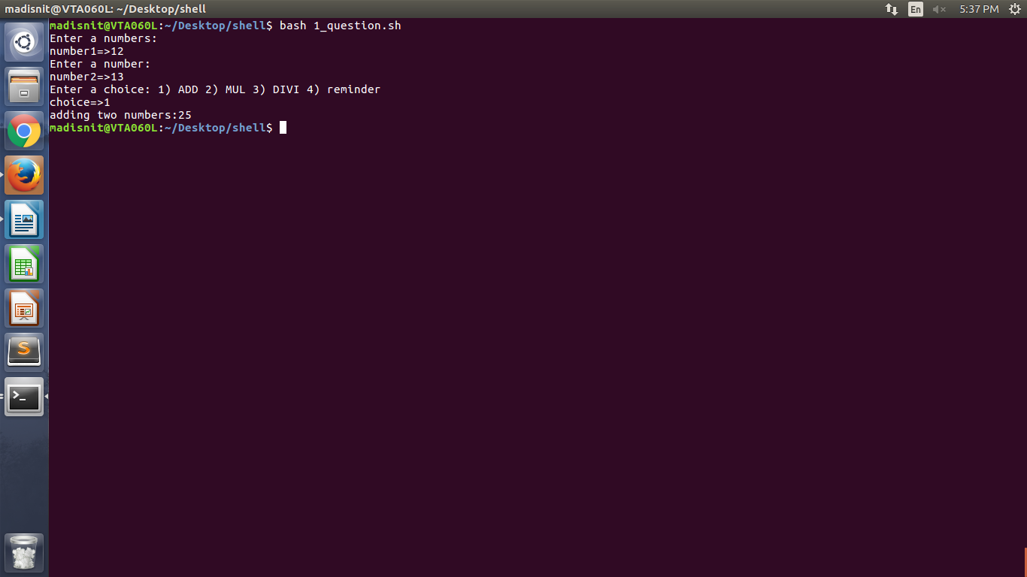

2) write a program to print numbers from 1 to 10 using while loop

1 #!/bin/bash

2 number=1

3 while [ $number -le 10 ]

4 do

5 echo $number

6 number=`expr $number + 1`

7 done

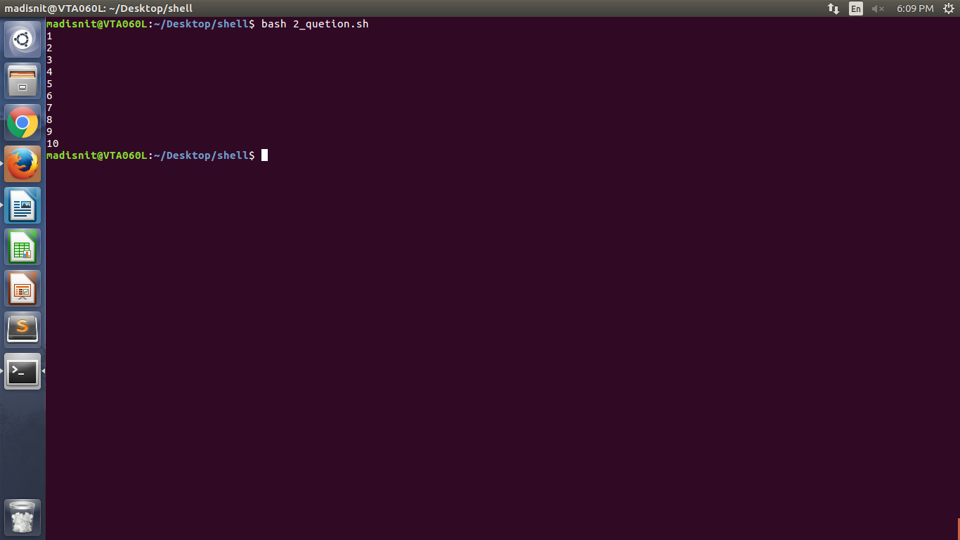

3) write a shell scripting program to print number of files and subdirectries in a directry

dirs=0

files=0

for val in `ls` ;do

if [ -d $val ]; then

dirs=`expr $dirs + 1`

fi

if [ -f $val ];

then

files=`expr $files + 1`

fi

done

echo "Total # of dirs= $dirs”

echo "Total # of regular files= $files”

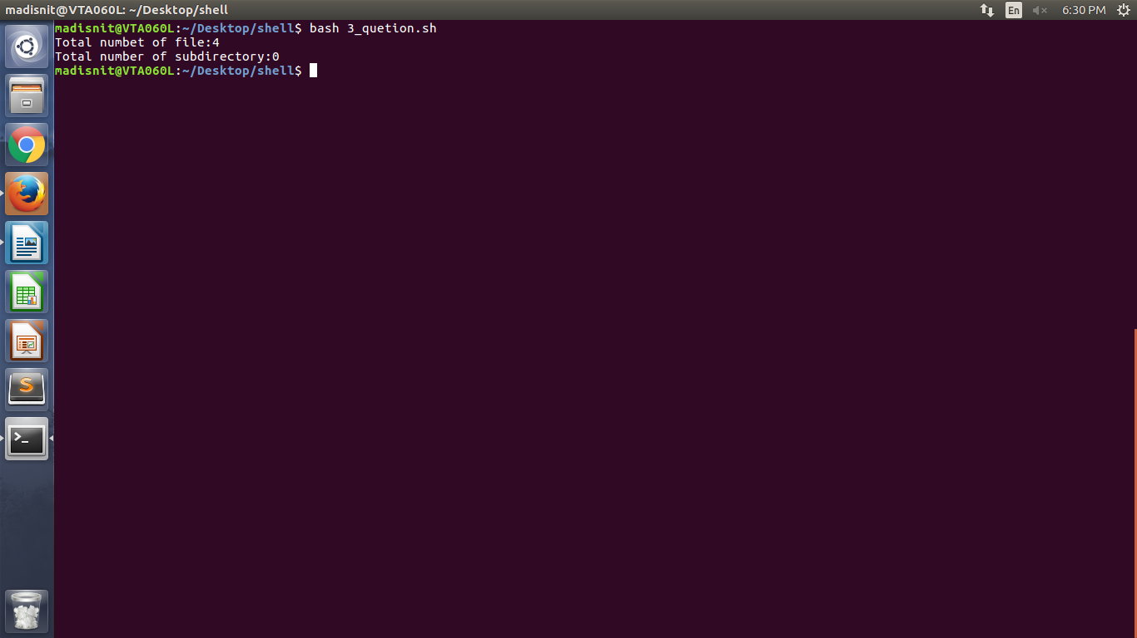

1 #!/bin/bash

2 if [ $# -eq 1 ]

3 then

4 num=$1

5 else

6 echo -n "Enter a Number :"

7 read num

8 fi

9

10 f1=1

11 f2=1

12

13 echo "The Fibonacci sequence for the number $Num "

14

15 for (( i=0;i<=Num;i++ ))

16 do

17 echo -n "$f1 "

18 fn=$((f1+f2))

19 f1=$f2

20 f2=$fn

21 done

