Ques 1 -Initialize a git repository -

nitesh@nitesh-Latitude-3450:~$ mkdir Assignment-Git
nitesh@nitesh-Latitude-3450:~$ cd Assignment-Git
nitesh@nitesh-Latitude-3450:~/Assignment-Git$ git init
hint: Using 'master' as the name for the initial branch. This default branch name
hint: is subject to change. To configure the initial branch name to use in all
hint: of your new repositories, which will suppress this warning, call:
hint:
hint: git config --global init.defaultBranch <name>
hint:
hint: Names commonly chosen instead of 'master' are 'main', 'trunk' and
hint: 'development'. The just-created branch can be renamed via this command:
hint:
hint: git branch -m <name>
Initialized empty Git repository in /home/nitesh/Assignment-Git/.git/
nitesh@nitesh-Latitude-3450:~/Assignment-Git$ echo "git assignment" > README.md
nitesh@nitesh-Latitude-3450:~/Assignment-Git$ git add .
nitesh@nitesh-Latitude-3450:~/Assignment-Git$ git commit -m "1 commit"
[master (root-commit) 43c232e] 1 commit
1 file changed, 1 insertion(+)
create mode 100644 README.md

----------------------------------------------------------------------------------------------------------------------------
Ques-2 Create at least 2 feature branches from the main branch (Add multiple files) -
Add commits on each feature branch.

>Git Branch--->

nitesh@nitesh-Latitude-3450:~/Assignment-Git$ git branch
* master
nitesh@nitesh-Latitude-3450:~/Assignment-Git$ git branch Branch1
nitesh@nitesh-Latitude-3450:~/Assignment-Git$ git branch
Branch1
* master
nitesh@nitesh-Latitude-3450:~/Assignment-Git$ git checkout Branch1
Switched to branch 'Branch1'
nitesh@nitesh-Latitude-3450:~/Assignment-Git$ vi file1
nitesh@nitesh-Latitude-3450:~/Assignment-Git$ git add file1
nitesh@nitesh-Latitude-3450:~/Assignment-Git$ git status
On branch Branch1
Changes to be committed:
(use "git restore --staged <file>..." to unstage)
new file: file1

nitesh@nitesh-Latitude-3450:~/Assignment-Git$ git commit -m "my hobbies"
[Branch1 4f650aa] my hobbies
1 file changed, 4 insertions(+)
create mode 100644 file1
nitesh@nitesh-Latitude-3450:~/Assignment-Git$ git branch
* Branch1
master

nitesh@nitesh-Latitude-3450:~/Assignment-Git$ git checkout -b Branch2
Switched to a new branch 'Branch2'
nitesh@nitesh-Latitude-3450:~/Assignment-Git$ git branch
Branch1
* Branch2
master
nitesh@nitesh-Latitude-3450:~/Assignment-Git$ vi file2.txt
nitesh@nitesh-Latitude-3450:~/Assignment-Git$ git status
On branch Branch2
Untracked files:
(use "git add <file>..." to include in what will be committed)
file2.txt

nothing added to commit but untracked files present (use "git add" to track)
nitesh@nitesh-Latitude-3450:~/Assignment-Git$ git add .
nitesh@nitesh-Latitude-3450:~/Assignment-Git$ git commit -m "my subjects"
[Branch2 88ea5b5] my subjects
1 file changed, 3 insertions(+)
create mode 100644 file2.txt

----------------------------------------------------------------------------------------------------------------------------

Ques 3-Try these commands, stash, reset soft, reset hard, diff, branch -d & -D - push each branch to the remote -
Diff -
nitesh@nitesh-Latitude-3450:~/Assignment-Git$ vi file2.txt
nitesh@nitesh-Latitude-3450:~/Assignment-Git$ git diff
diff --git a/file2.txt b/file2.txt
index 3ab45d3..2cd1fdd 100644
--- a/file2.txt
+++ b/file2.txt
@@ -1,3 +1,5 @@
Subject
java
react
+springboot
+spring

-------------------------------------------------------------------
Reset -
nitesh@nitesh-Latitude-3450:~/Assignment-Git$ git status
On branch Branch2
Changes not staged for commit:
(use "git add <file>..." to update what will be committed)
(use "git restore <file>..." to discard changes in working directory)
modified: file2.txt

no changes added to commit (use "git add" and/or "git commit -a")
nitesh@nitesh-Latitude-3450:~/Assignment-Git$ git add .
nitesh@nitesh-Latitude-3450:~/Assignment-Git$ git status
On branch Branch2
Changes to be committed:
(use "git restore --staged <file>..." to unstage)
modified: file2.txt

nitesh@nitesh-Latitude-3450:~/Assignment-Git$ git reset file2.txt
Unstaged changes after reset:
M file2.txt
nitesh@nitesh-Latitude-3450:~/Assignment-Git$ git status
On branch Branch2
Changes not staged for commit:
(use "git add <file>..." to update what will be committed)
(use "git restore <file>..." to discard changes in working directory)
modified: file2.txt

no changes added to commit (use "git add" and/or "git commit -a")

----------------------------------------------------------------------------------------------------------------------

Log-
nitesh@nitesh-Latitude-3450:~/Assignment-Git$ git log
commit 3b54ad1aa031d4a0b490c2bd9f019b4b7f7f05d8 (HEAD -> Branch2)
Author: nitesh292003 <nitesh.singh@joshsoftware.com>
Date: Wed Apr 2 17:25:26 2025 +0530

new subject added

commit 88ea5b5aac400cec758bb5f1171cf9b26dcf89fd
Author: nitesh292003 <nitesh.singh@joshsoftware.com>
Date: Wed Apr 2 17:09:13 2025 +0530

my subjects

commit 43c232e68001b48244d1a4b475c27f15f8b2e509 (master)
Author: nitesh292003 <nitesh.singh@joshsoftware.com>
Date: Wed Apr 2 16:52:50 2025 +0530

1 commit

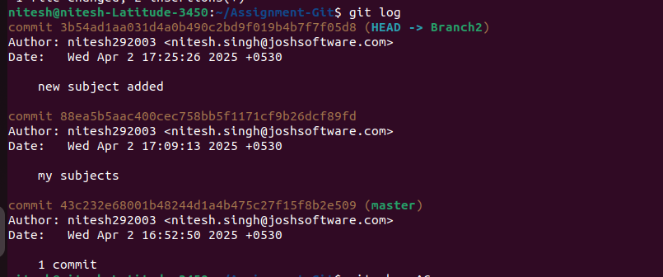
----------------------------------------------------------------------------------------------------------------
git stash-

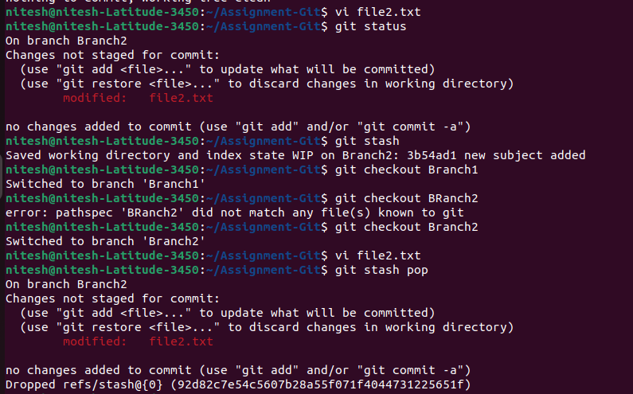
-------------------------------------------------------------------------------------------------------------------
rest soft -

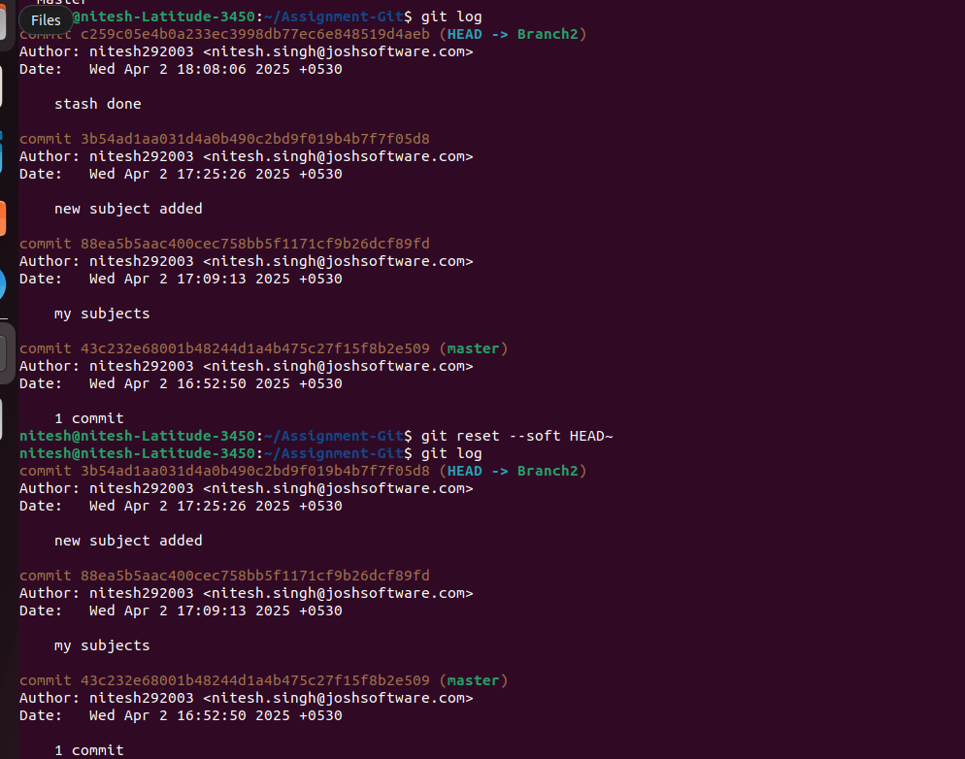
-------------------------------------------------------------------------------------------------------------------
reset hard-


--------------------------------------------------------------------------------------------------------------------
delete branch-


