Sprint Planning & Backlog

  - Trello Sprint Planning Screenshot
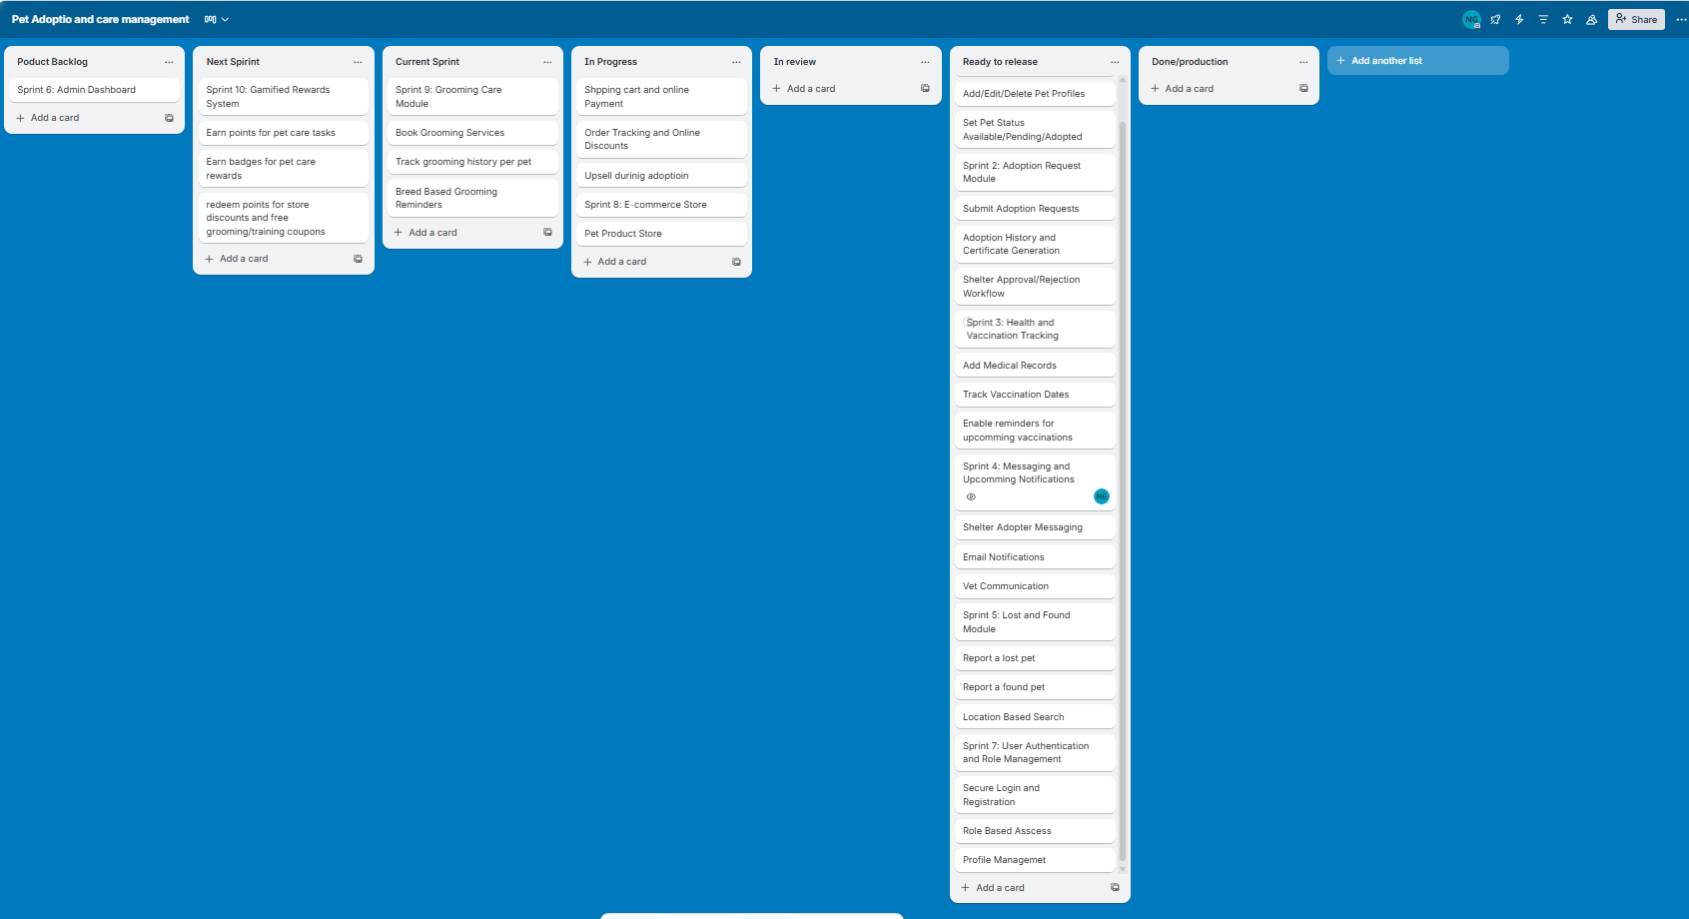

  - Incomplete or Carried Forward Tasks from Previous Sprint

I completed the lost and found section of which the logic wasn’t handled properly and made the chat system real time using the websocket

API Development & Testing

APIs Worked on
API Name | Method | Status | Tested
Send Message | Post | Completed | Sucessfull

API Testing Screenshots
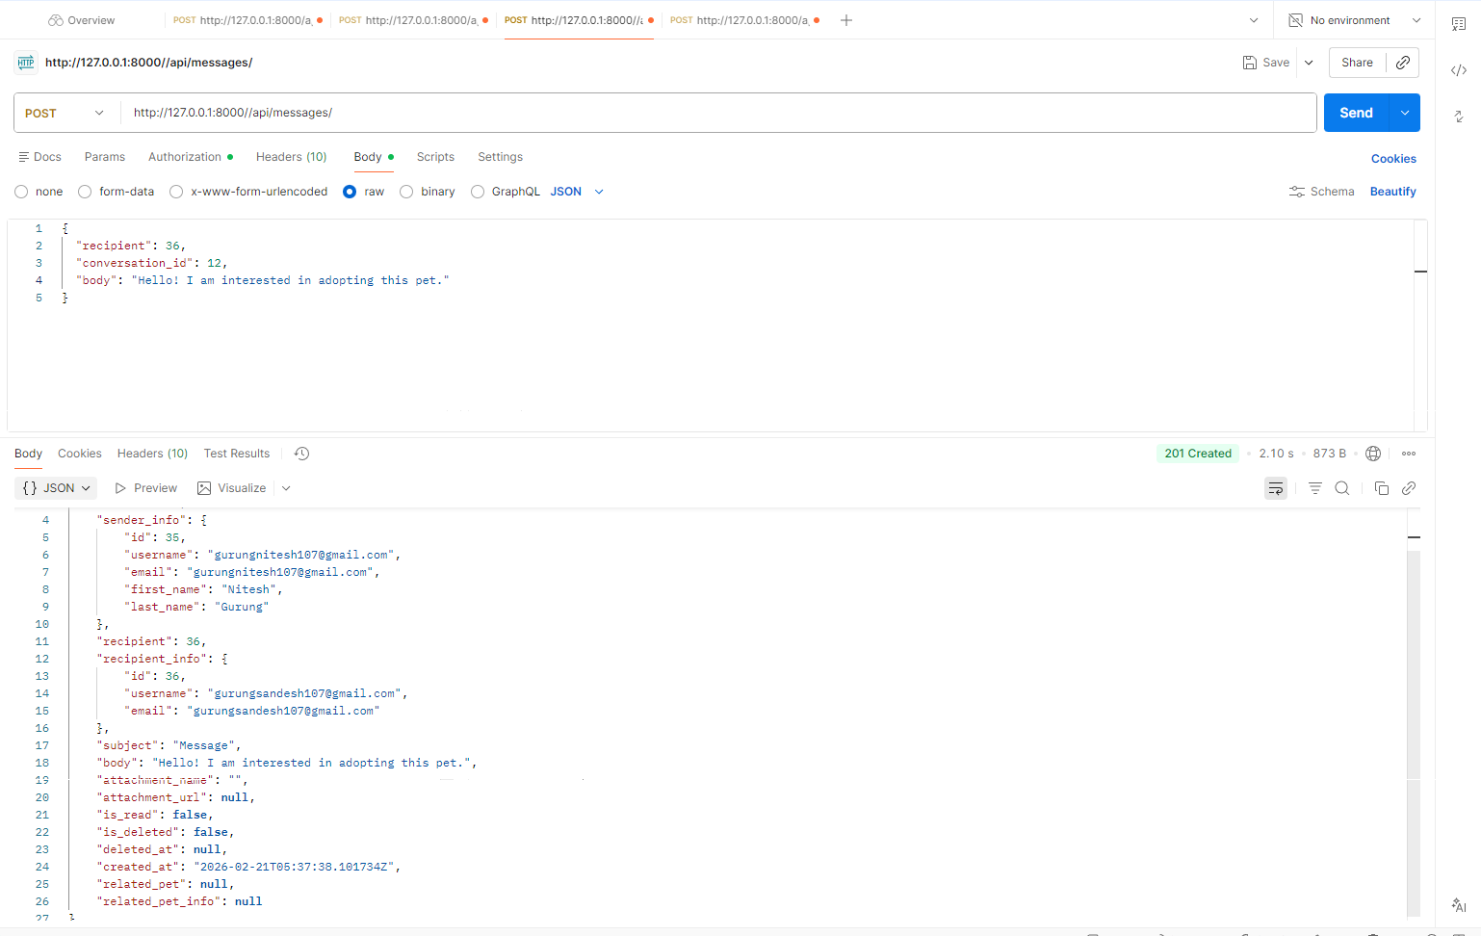

Chat Testing Successful between adopter and shelter
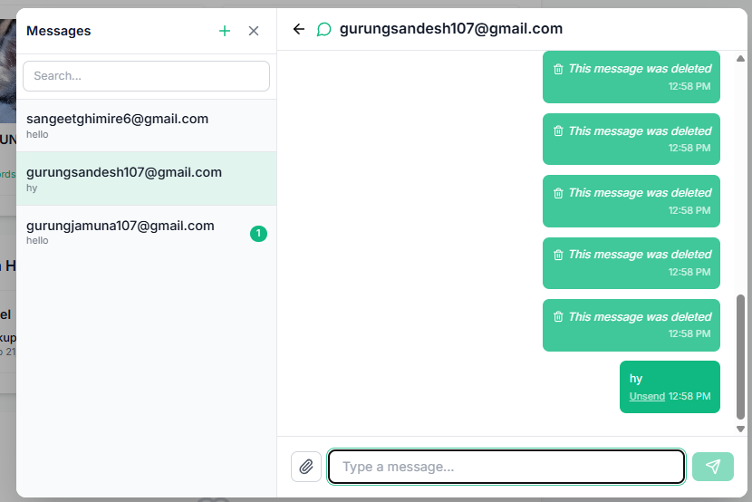

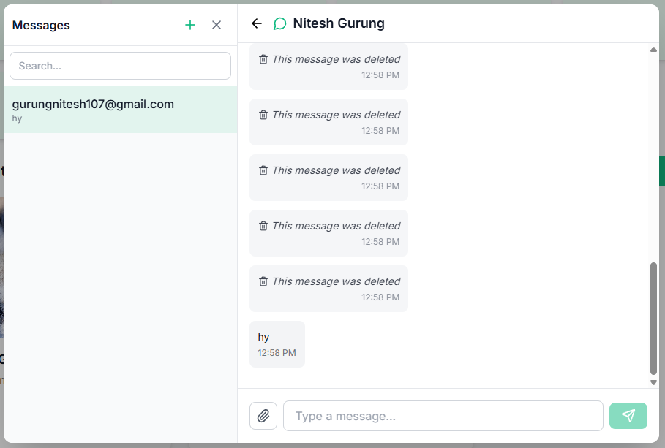

Successfull

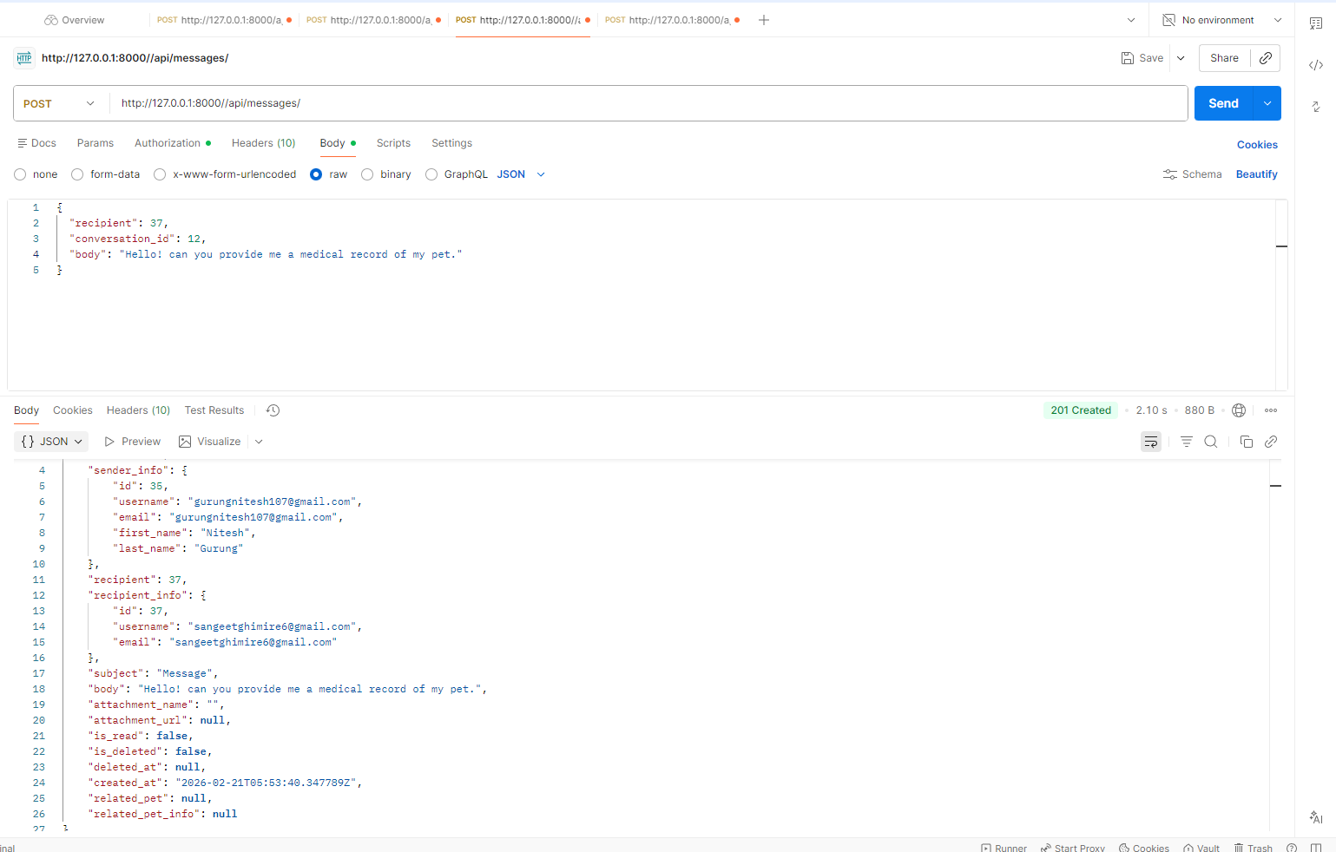
Chat testing successful between adopter and vetenerian
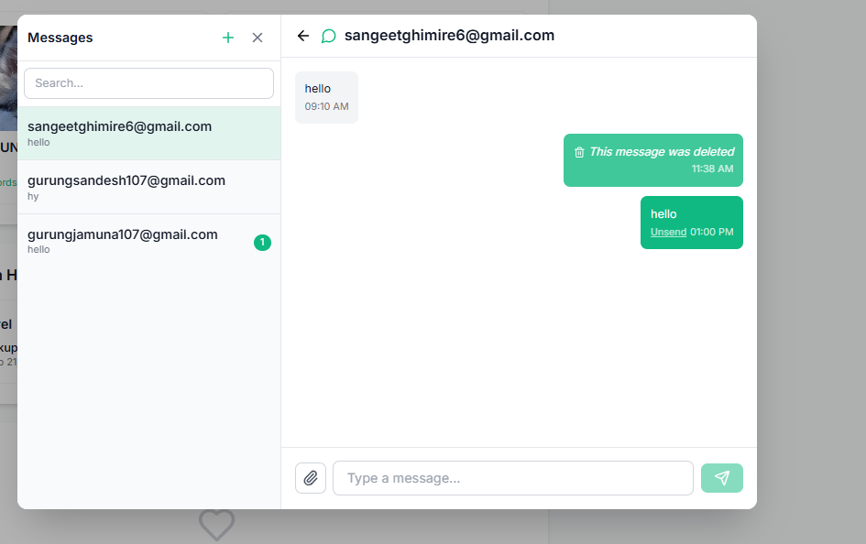

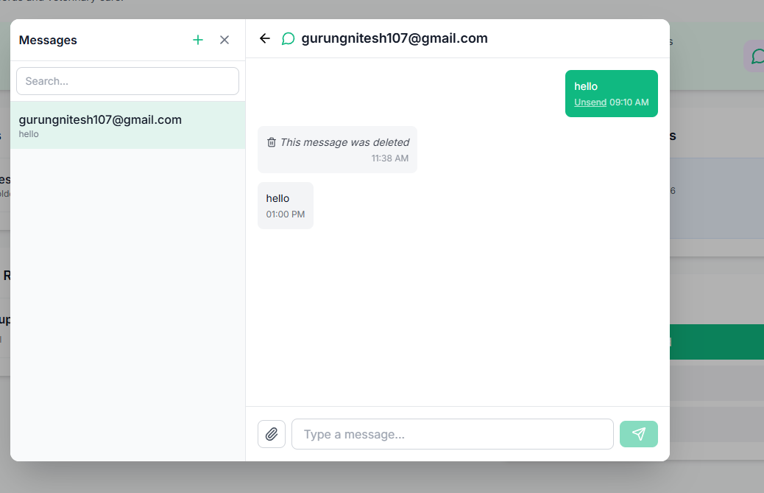
Successfull

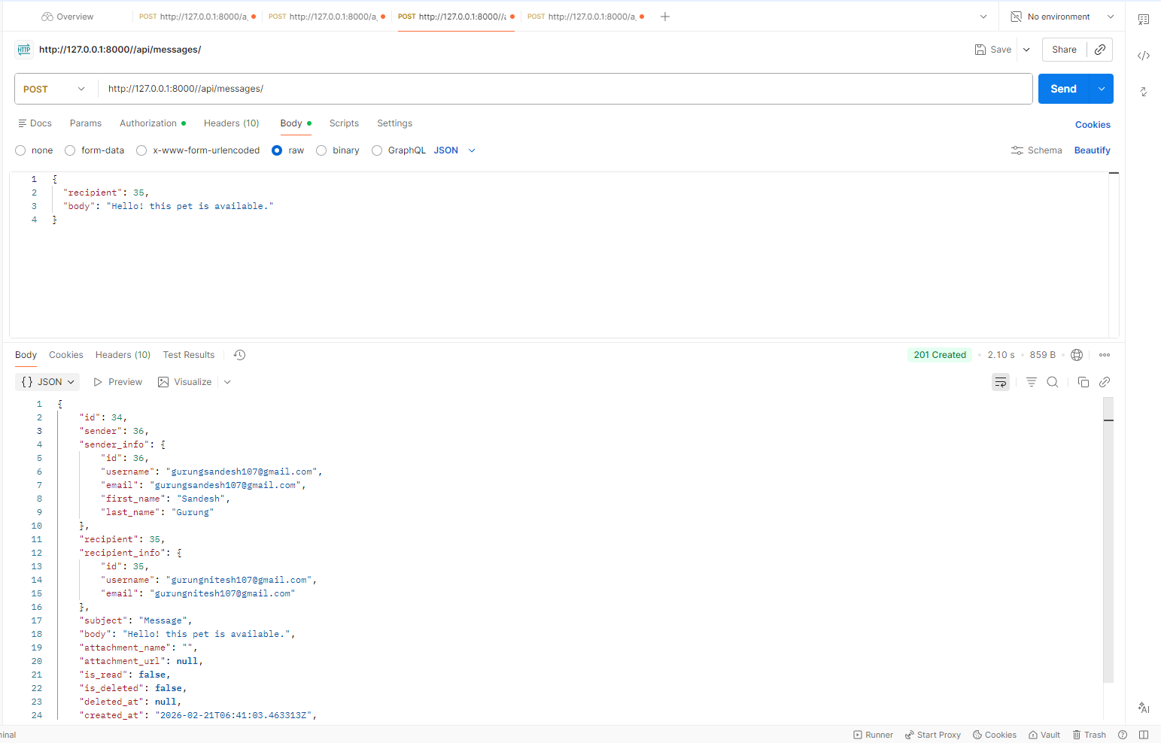
Chat testing successful between shelter and adopter
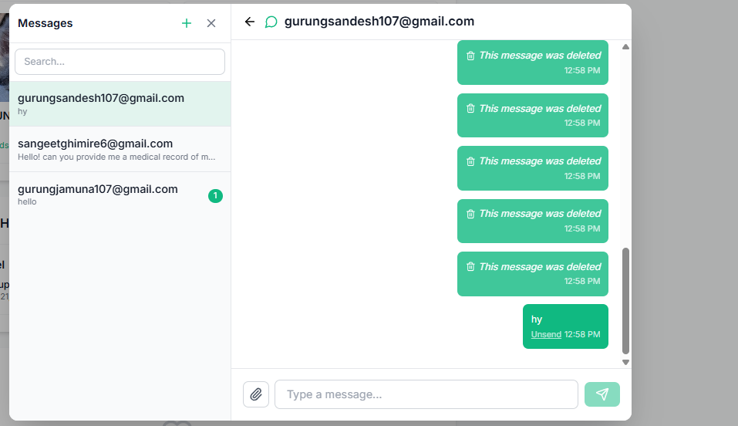

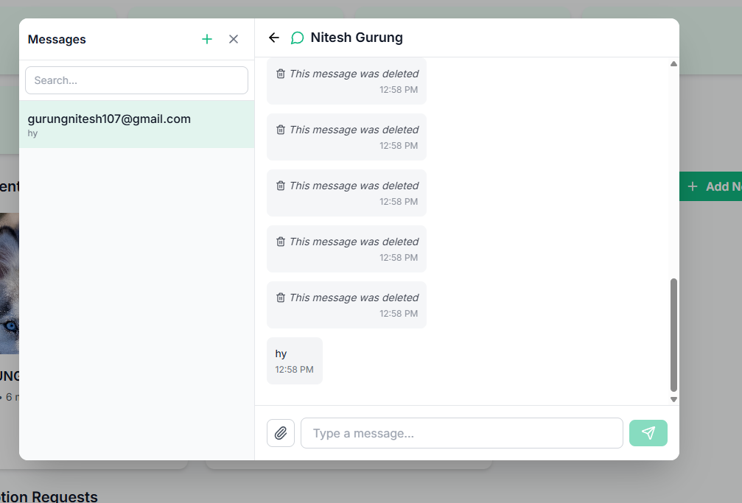
Successful

Frontend Integration Progress
Frontend Integration Screenshots
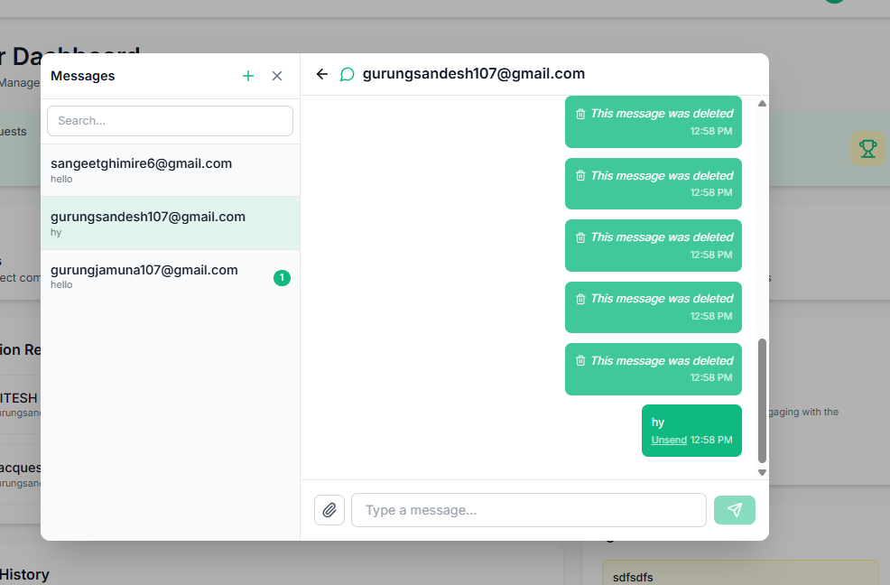
Chat Frontend Integration
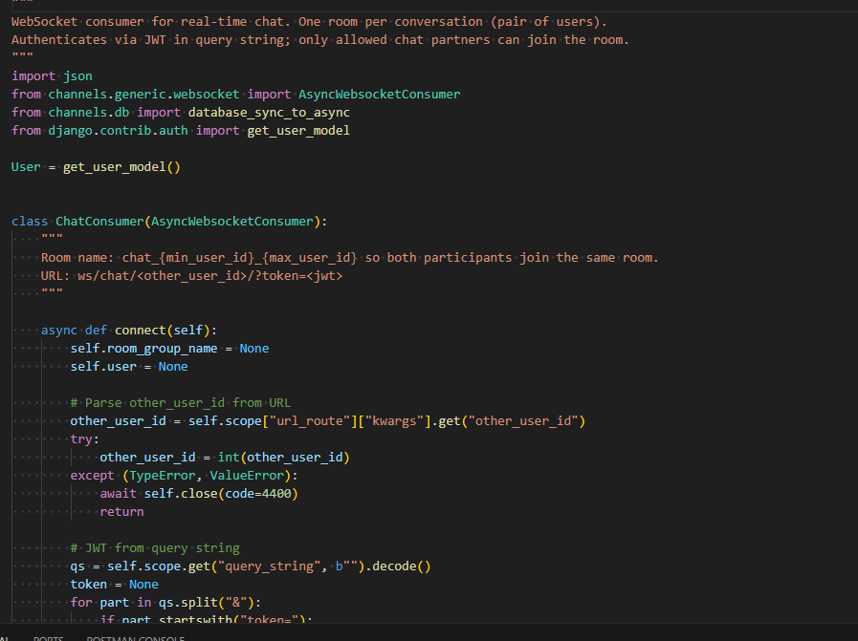

Backend code

Unfinished tasks, Issues & Blockers
- left to make the logic of shelter and veterinarian chat

Sprint Status & Next Steps

  - End of Sprint Trello Screenshot

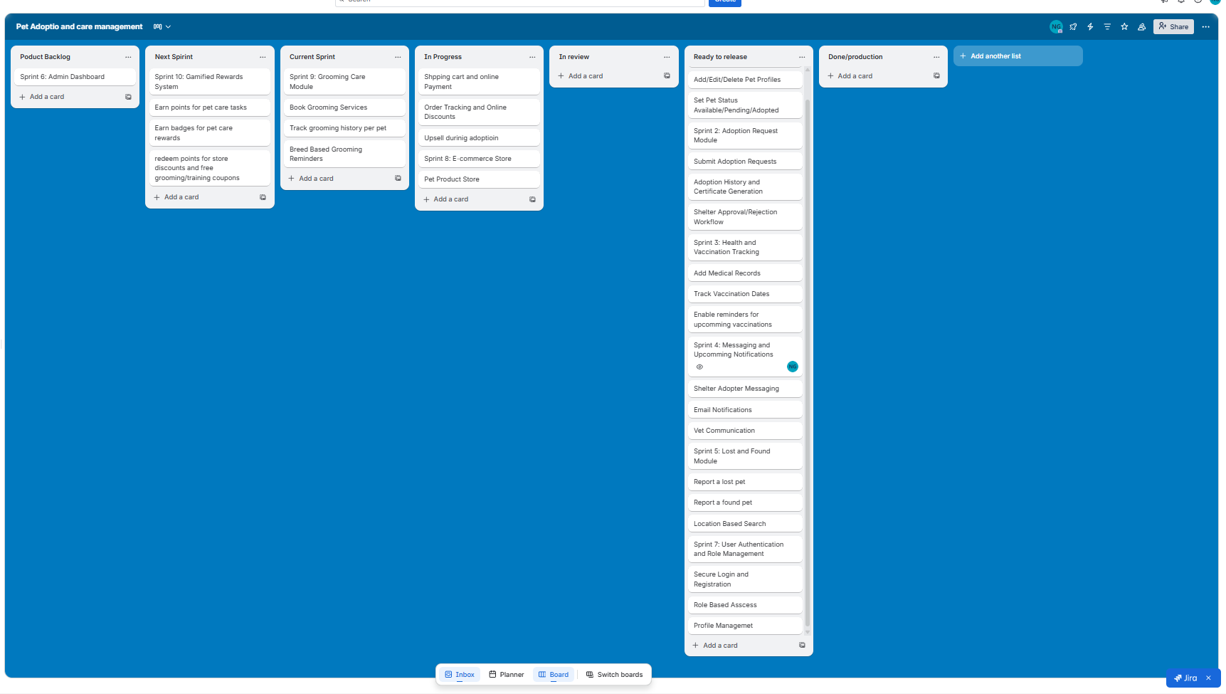

  - Next Sprint Focus:
Sprint 8 focuses on building the E-Commerce Store module of PetCare system. In this sprint, it will create a pet product store where users can browse items like food, toys, grooming supplies, and health products, add them to a shopping cart, and complete purchases using secure payment options such as Khalti, eSewa, or cash on delivery. The system will generate orders, allow users to track delivery status, and support discount coupons. Additionally, the store can recommend essential pet products (like starter kits or beds) during the adoption process. This sprint enhances the platform by providing a complete pet care ecosystem beyond adoption, making the system more practical and realistic.

Overall Sprint Status: On Track

