PARTITIONS

**Partitioning** enables you to decompose very large tables and indexes into smaller and more manageable pieces called **partitions**. Each partition is an independent object with its own name and optionally its own storage characteristics.

Advantages:

1. Manageability
2. Scalability
3. Availability

**Partitions are 3 types**

1. **Range partition**
2. **List partition**
3. **Hash partition**

**Range Partition**:

Created based on range of values from a column.

CREATE TABLE time_range_sales

(

prod_id NUMBER(6)

, cust_id NUMBER

, **time_id** DATE

, channel_id CHAR(1)

, promo_id NUMBER(6)

, quantity_sold NUMBER(3)

, amount_sold NUMBER(10,2)

)

PARTITION BY RANGE (**time_id**)

(PARTITION SALES_2014 VALUES LESS THAN

(TO_DATE('01-JAN-2015','DD-MON-YYYY')),

PARTITION SALES_2015 VALUES LESS THAN

(TO_DATE('01-JAN-2016','DD-MON-YYYY')),

PARTITION SALES_2016 VALUES LESS THAN

(TO_DATE('01-JAN-2017','DD-MON-YYYY')),

PARTITION SALES_2017 VALUES LESS THAN

(TO_DATE('01-JAN-2018','DD-MON-YYYY'),

PARTITION SALES_2018 VALUES LESS THAN

(TO_DATE('01-JAN-2019','DD-MON-YYYY')

);

***Figure 4-1 Range Partitions***

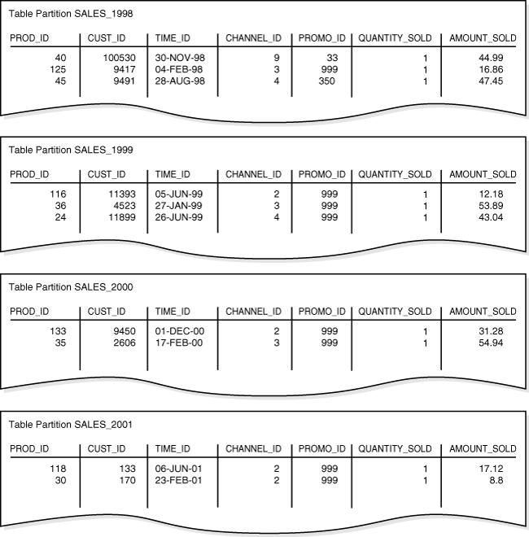

**List Partitioning:**

It is created based on list of values from a column.

CREATE TABLE list_sales

(

prod_id NUMBER(6)

, cust_id NUMBER

, time_id DATE

, **channel_id** CHAR(1)

, promo_id NUMBER(6)

, quantity_sold NUMBER(3)

, amount_sold NUMBER(10,2)

)

PARTITION BY LIST (**channel_id**)

(

PARTITION even_channels VALUES (2,4),

PARTITION odd_channels VALUES (3,9)

);

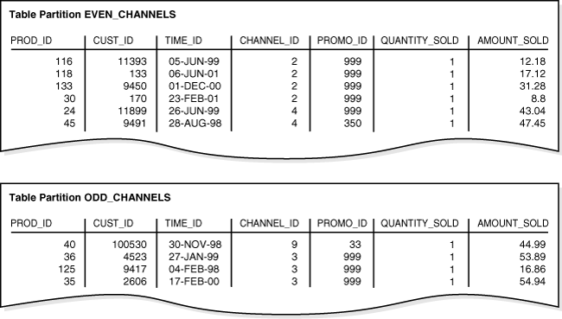

**HASH Partitioning:**

It is created based on equal size, means each partition contains same number of records.

CREATE TABLE hash_sales

(

**prod_id** NUMBER(6)

, cust_id NUMBER

, time_id DATE

, channel_id CHAR(1)

, promo_id NUMBER(6)

, quantity_sold NUMBER(3)

, amount_sold NUMBER(10,2)

)

PARTITION BY HASH (**prod_id**)

PARTITIONS 2;

***Figure 4-3 Hash Partitions***

