Creating Clusters
To create a cluster in your schema, you must have the CREATE CLUSTER system privilege and a quota for the
tablespace intended to contain the cluster or the UNLIMITED TABLESPACE system privilege.
To create a cluster in another user's schema you must have the CREATE ANY CLUSTER system privilege, and
the owner must have a quota for the tablespace intended to contain the cluster or the UNLIMITED TABLESPACE
system privilege.
You create a cluster using the CREATE CLUSTER statement. The following statement creates a cluster named emp_dept, which stores the emp and dept tables, clustered by thedeptno column:
CREATE CLUSTER emp_dept (deptnoNUMBER(3))

If no INDEX keyword is specified, as is true in this example, an index cluster is created by default. You can also create a HASH cluster, when hash parameters (HASHKEYS, HASH IS, orSINGLE TABLE HASHKEYS) are specified

Creating Clustered Tables
To create a table in a cluster, you must have either the CREATE TABLE or CREATE ANY TABLE system privilege. You do not need a tablespace quota or the UNLIMITED TABLESPACEsystem privilege to create a table in a cluster.
You create a table in a cluster using the CREATE TABLE statement with the CLUSTER clause. The emp and dept tables can be created in the emp_dept cluster using the following statements:

CREATE TABLE emp (
empnoNUMBER(5) PRIMARY KEY,
ename VARCHAR2(15) NOT NULL,
. . .
deptnoNUMBER(3) REFERENCES dept)
CLUSTER emp_dept (deptno);

CREATE TABLE dept (
deptnoNUMBER(3) PRIMARY KEY, . . . )
CLUSTER emp_dept (deptno);

CLUSTERED TABLES NON-CLUSTERED TABLES

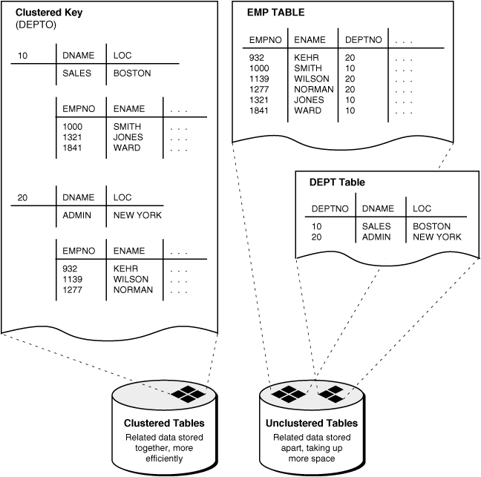

Cust_dtls( custid,cname,city)
Act_types( act_type,act_name,desc)
Cust_act_dtls(actno,act_type,act_open_dt,act_bal,custid)

Example:
Creating a cluster based on common column?

create clusteremp_dept (deptno number(2));

Example:
Creating parent table deptcp?

create table deptcp
(
deptno number(2) primary key,
dname varchar2(20),
loc varchar2(20)
)
cluster emp_dept(deptno);

Example:
Creating child table empcp?

create table empcp
(
eid number(4) primary key,
ename varchar2(20),
sal number(5),
deptnonumber(2) references deptcp(deptno)
)
cluster emp_dept(deptno);

