1. when adding a new project not getting displayed message of new project created.

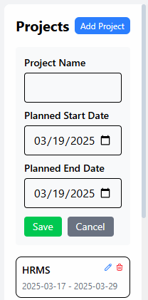

1. Auto refreshing not working.
2. when adding a new developer not getting displayed message of new developer created.
3. Alignment not correct.

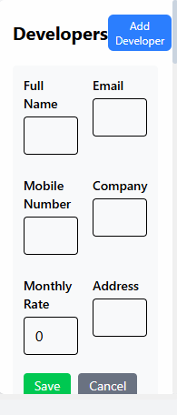

1. Mandatory field is not required.

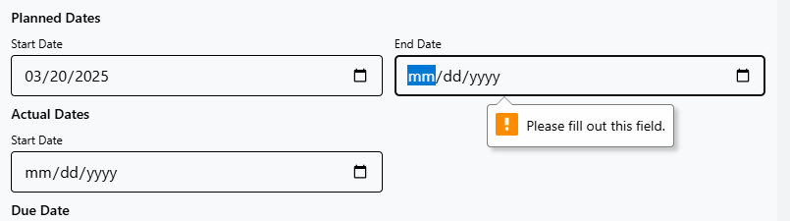

1. Add Kpro logo and change text to Kpro Task Management