## Currency Converter - ASP.Net MVC Application

### Problem Statement

Create a MVC based Web Application which can be used to manage currency rates. SQL Server Express will be used as the database, and use Entity framework with Edmx files for data manipulation.

The user will be able to:

1. View the list of currency conversion rates.
   1. 07/03/2014 - INR - 0.05 - Edit
   2. 07/03/2014 - AUD - 2 - Edit
   3. 07/03/2014 - JPY - 3 - Edit
2. Create a new entry for a currency conversion.
   1. E.g. Let’s say they enter a new currency GBP. The add entry fields will have three fields.
      1. Date : 07/03/2014
      2. Currency : GBP
      3. Value : 2
3. Edit a existing entry.
4. Delete a entry.

### The following diagrams may be helpful.

### Usecase Diagram

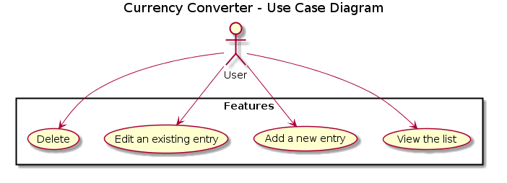

### Component Diagram

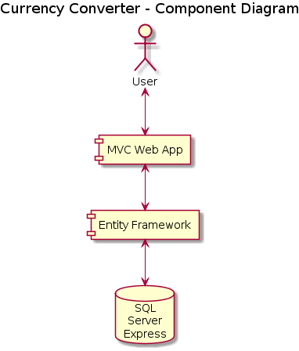

### Software:

1. Front-end technology
   1. ASP.Net MVC
2. Middle Tier
   1. Entity Framework
3. Database
   1. SQL Server Express
4. IDE
   1. Visual Studio Trial can be downloaded for free from <http://www.asp.net/get-started/websites>

### Deliverables

1. ASP.Net MVC Application
2. SQL Database
3. Edmx Models