Nitesh Kedia

(1206342939)

DSOD Assignment 4 Part 2 Testing

**Service Operation 5.1 and 5.2 implemented**

**XML Validation:**

1. **Positive Test-Case:**

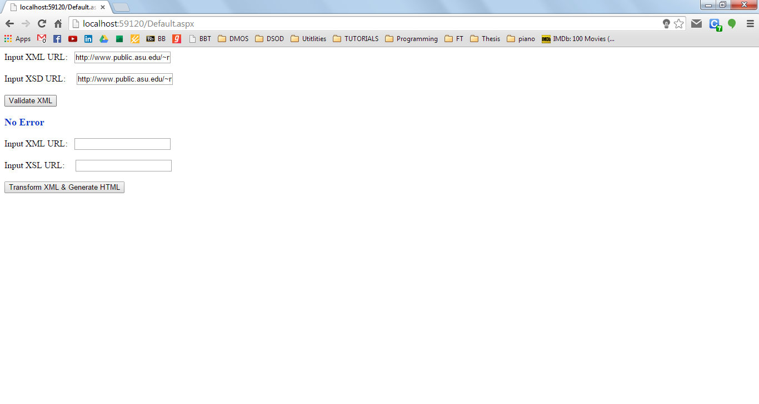

**Negative Test-Cases:**

1. **Missing Required Attribute**

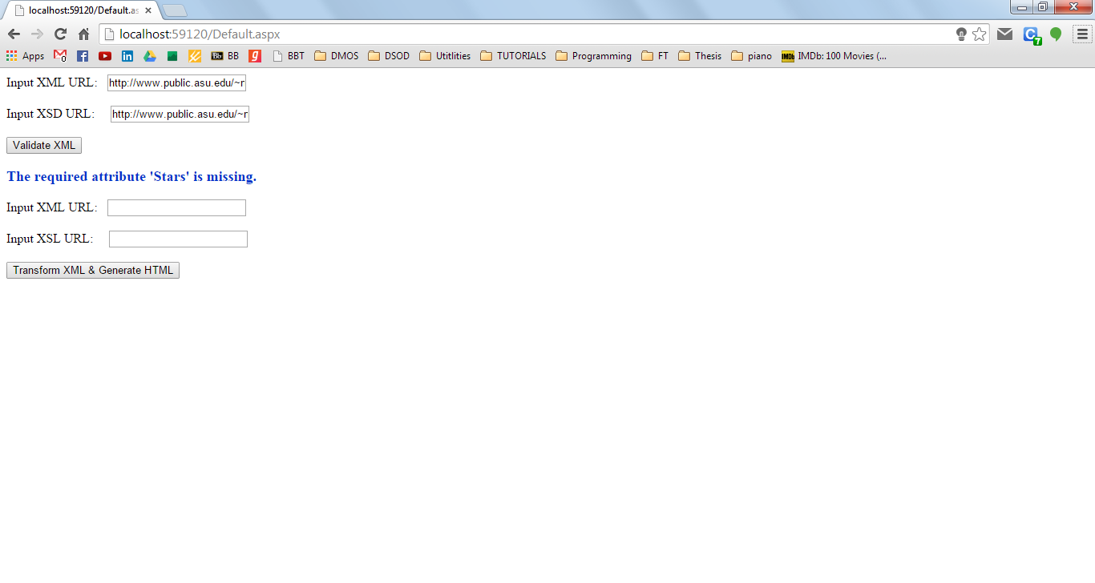

1. **Undefined Element Tag**

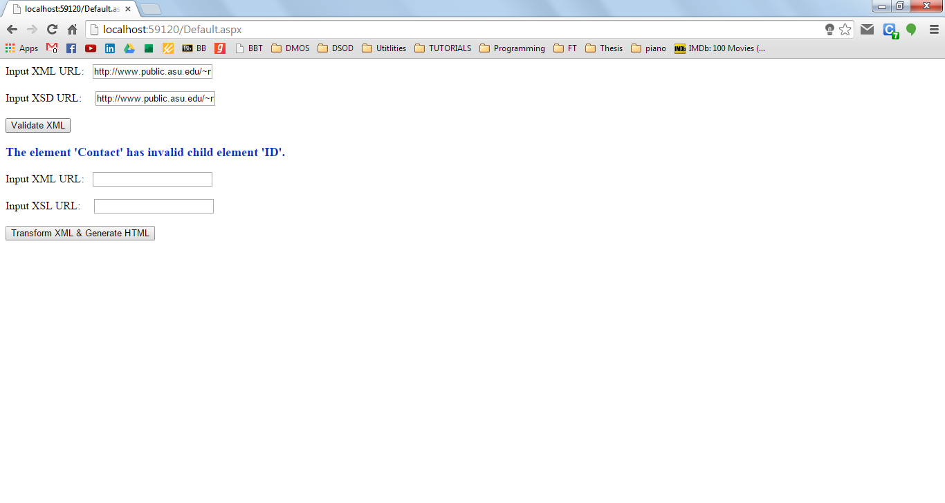

**XML to HTML File Transformation**

