Configuration 1
Raspberry Pi IP camera – Router – Intel NUC / Raspberry Pi

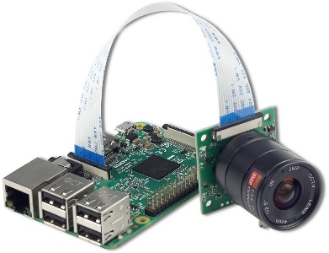
Raspberry Pi IP Camera
192.168.13.102:8081 – Local IP
166.249.52.131:9002 – Global IP

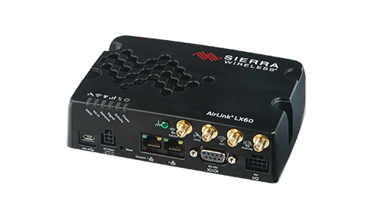
Router
192.168.13.31:9001

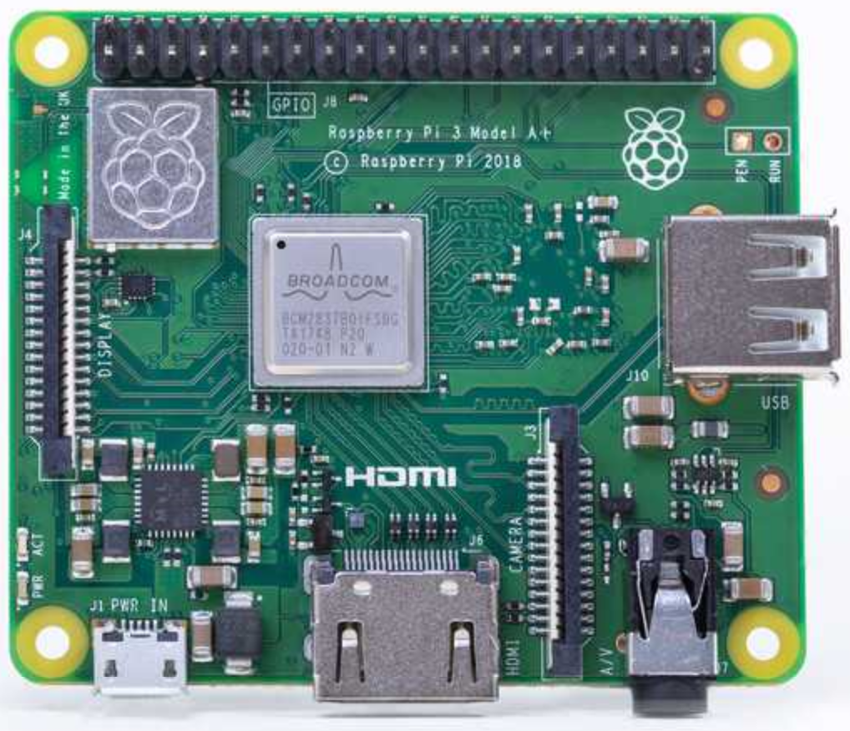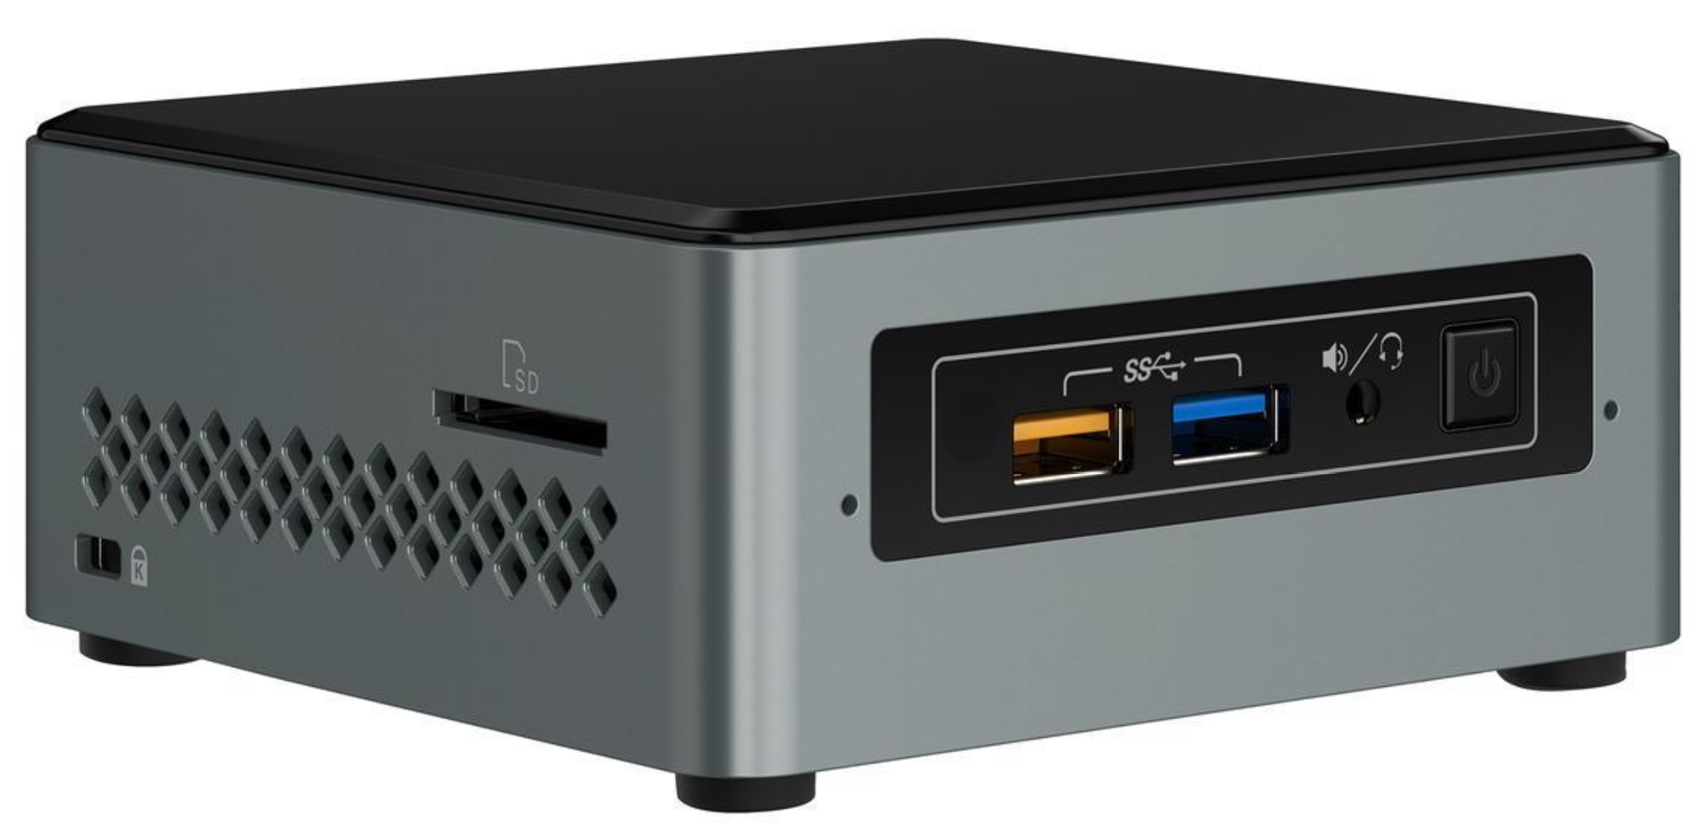
Raspberry Pi Intel NUC
192.168.13.103 192.168.13.101

Configuration 2
Raspberry Pi IP camera – Wifi – Intel NUC / Raspberry Pi

Raspberry Pi IP Camera
192.168.13.102:8081 – Local IP

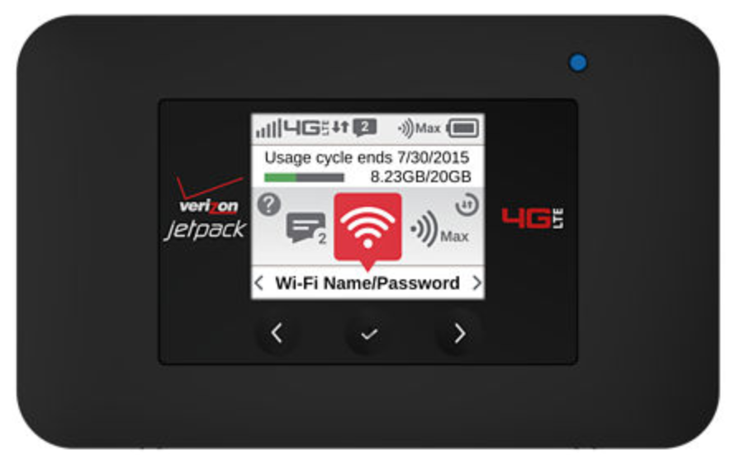
Wifi Hotspot

Raspberry Pi Intel NUC
192.168.13.103 192.168.13.101

Configuration 3
IP camera – Router – Intel NUC / Raspberry Pi

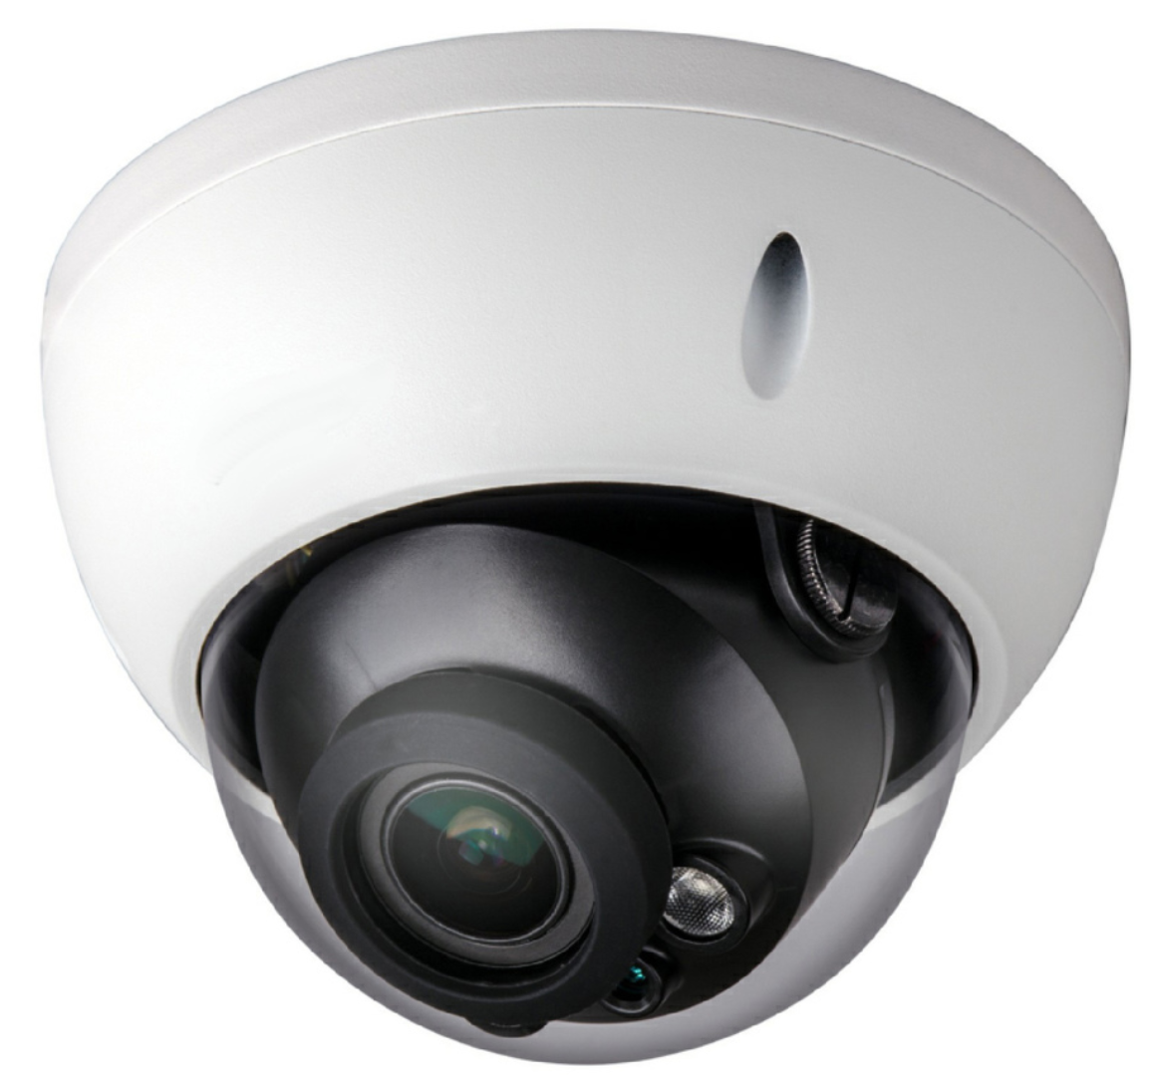
IP Camera
192.168.13.100:8081 – Local IP
166.249.52.131:9003 – Global IP

Router
192.168.13.31:9001

Raspberry Pi Intel NUC
192.168.13.103 192.168.13.101

Configuration 4
IP camera – Wifi – Intel NUC / Raspberry Pi

IP Camera
192.168.13.10:8081 – Local IP

Wifi Hotspot

Raspberry Pi Intel NUC
192.168.13.103 192.168.13.103

