**Difference Between Document Object and Window Object**

|  |  |
| --- | --- |
| **Document Object** | **Window Object** |
| 1. It represents any HTML document or web page that is loaded into browser. 2. Document object always load inside Window object. 3. Document is the object of Window. 4. We can access Document object using just “**document**” or “**window.document**” 5. Syntax : **document.property_name;** 6. It consists of all the tag, elements with attributes in HTML. 7. Document object is a part of both **Document Object Model (DOM)** and **Browser Object Model (BOM)**. 8. Document object cannot access properties of Window object. 9. Example : document.links (it returns all <area> and <a> tag consists of href) | 1. It represents a browser window or frame that displays the contents of the webpage. 2. It is topmost object which is loaded in the browser. 3. Window is the object of Browser. 4. We can access window object using “**window**” keyword only. 5. Syntax : ***widow.property_name;*** 6. It consists of Global objects, functions, and variables of JavaScript 7. Window is a part of only **Browser Object Model (BOM)**. 8. Window object can access all the properties of document object. 9. Example : window.close(); (It will close the current window) |

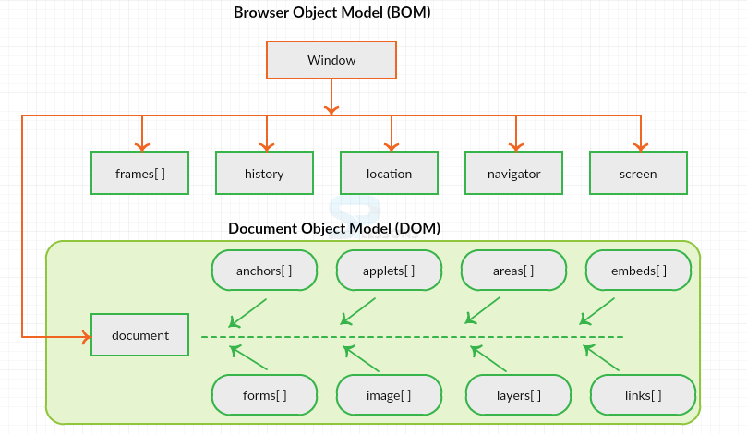

**Figure 1 : Hierarchy of Window and Document object using BOM and DOM**