AI STRATEGY ARENA
An Interactive Tic-Tac-Toe Environment for Minimax and Alpha-Beta Pruning

A project report submitted for
Fundamentals of Artificial Intelligence

Submitted by
Nitesh Kumar Sah
Register Number: CH.SC.U4CSE23166

Submitted to
Dr. J. Umamageswaran
AMRITA VISHWA VIDYAPEETHAM
AMRITA SCHOOL OF COMPUTING
CHENNAI, INDIA
October 2026



Abstract
AI Strategy Arena is an interactive educational application built to demonstrate adversarial search in a familiar game environment. The project uses Tic-Tac-Toe to explain how an AI agent selects moves by exploring possible future game states. It implements Minimax and Alpha-Beta Pruning and provides multiple views for playing against the AI, inspecting search activity, comparing algorithm work, and running AI-versus-AI games.
The Play Arena provides direct interaction with a 3×3 board and displays live search telemetry, including nodes entered, terminal leaves, pruning cutoffs, maximum search depth, root value, and the selected cell. The AI Thinking Lab presents search traces and candidate move evaluations. Algorithm Showdown compares Minimax and Alpha-Beta Pruning on the same position, while AI vs AI allows the algorithms to compete. A Learn AI section explains core concepts and supports academic discussion.
The application is designed as a visual learning tool rather than only a game. It connects game-tree search theory with visible algorithm behavior. The attached screenshots document the Play Arena, a sample search run, a search trace, and the algorithm comparison interface. Performance figures discussed in this report are limited to values visible in those screenshots; results may vary by position and execution environment.
Keywords: Artificial Intelligence, Tic-Tac-Toe, Adversarial Search, Minimax, Alpha-Beta Pruning, Game Tree, Heuristic Evaluation, Interactive Visualization.

Table of Contents
1. Introduction
2. Problem Definition and Objectives
3. Theoretical Background
4. System Design and Architecture
5. Minimax and Alpha-Beta Algorithms
6. Implementation Details
7. Experimental Setup and Evaluation Metrics
8. Results, Testing, and Application Screenshots
9. Complexity Analysis
10. Limitations and Future Enhancements
11. Conclusion
12. References
Appendix A: Algorithm Pseudocode
Appendix B: Application Screenshots

1. Introduction

Artificial Intelligence (AI) includes methods that allow a computer to select actions, reason about alternatives, and solve problems. In competitive environments, an action can affect not only the current state but also the choices available to an opponent. This makes game playing a useful setting for studying decision-making and search.
Tic-Tac-Toe is a two-player, turn-based game played on a 3×3 board. One player uses X and the other uses O. Players alternate placing their symbol in an empty square. A player wins by forming a horizontal, vertical, or diagonal line of three symbols; if the board fills without a winner, the game is a draw.
AI Strategy Arena uses this game to make adversarial search observable. Instead of presenting the AI as a black box, the interface exposes candidate moves, search events, tree depth, terminal states, and pruning behavior. Users can play against the AI or compare two search strategies on the same board.

1.1 Motivation
Minimax and Alpha-Beta Pruning are foundational techniques in classical AI. Minimax evaluates possible future outcomes under the assumption that both players choose rationally. Alpha-Beta Pruning improves the search process by avoiding branches that cannot affect the final decision. A visual arena makes these ideas easier to inspect and explain during a laboratory demonstration.

1.2 Project Scope
- Interactive Tic-Tac-Toe with human-versus-AI play.
- Minimax and Alpha-Beta Pruning as selectable AI algorithms.
- Live search telemetry and candidate-move evaluation.
- Search-trace visualization for inspecting explored states and cutoff events.
- Algorithm comparison on a shared position.
- AI-versus-AI mode and a learning section for algorithm concepts.

2. Problem Definition and Objectives

2.1 Problem Statement
Given a legal Tic-Tac-Toe board and the player whose turn it is, select a legal move that maximizes the AI player's outcome while assuming the opponent responds optimally. The system must update the board, detect terminal states, and present enough information for users to understand the decision process.

2.2 Objectives
- Model Tic-Tac-Toe as a finite game tree of states and legal actions.
- Implement Minimax to evaluate moves under optimal play.
- Implement Alpha-Beta Pruning to reduce unnecessary recursive exploration without changing the optimal result.
- Allow direct interaction with the board and prevent moves in occupied squares.
- Show search statistics and candidate move values.
- Provide a trace-based view of search events and cutoff behavior.
- Compare the two algorithms on the same starting position.
- Support AI-versus-AI demonstrations and learning-oriented explanations.

2.3 Functional Requirements
Requirement | Description
Board interaction | The user selects an empty square directly on the 3×3 board.
Move validation | Occupied squares are not available for a new move.
AI move selection | The selected algorithm chooses a legal move after the human move.
Game state detection | The application identifies wins, losses, and draws.
Telemetry | The interface reports recursive nodes, terminal leaves, pruning cutoffs, maximum depth, root value, selected cell, and elapsed time.
Search trace | A trace view shows events such as ENTER, EXPLORE, TERMINAL, BOUND, and CUTOFF.
Comparison | Minimax and Alpha-Beta Pruning are evaluated from the same board position.
Learning support | A dedicated section explains algorithm concepts and complexity.

3. Theoretical Background

3.1 Game-State Representation
A state is a 3×3 board configuration together with the player to move. Each square is either empty, contains X, or contains O. A legal action places the current player's symbol in one empty square. The successor state is the board after that action, with the turn passed to the other player.

3.2 Terminal States and Utility
A state is terminal when X has three symbols in a row, O has three symbols in a row, or no empty squares remain. A utility function assigns a score to a terminal state from the AI's perspective. In the implementation, the interface reports root values using a signed display such as +0 for a draw. Win/loss scores may also incorporate depth so that the AI prefers a faster win and, where possible, delays a forced loss.

3.3 Minimax
Minimax searches the game tree recursively. At a MAX node, the AI chooses the child with the largest utility. At a MIN node, the opponent is assumed to choose the child with the smallest utility. This alternating choice models rational competition.
MINIMAX(state, maximizing):
if state is terminal:
return utility(state)
if maximizing:
best = -infinity
for child in legal_successors(state):
best = max(best, MINIMAX(child, false))
return best
else:
best = +infinity
for child in legal_successors(state):
best = min(best, MINIMAX(child, true))
return best

3.4 Alpha-Beta Pruning
Alpha-Beta Pruning produces the same optimal decision as Minimax while avoiding the evaluation of some branches. Alpha (α) is the best value MAX can guarantee along the current path. Beta (β) is the best value MIN can guarantee. Once α is greater than or equal to β, the remaining siblings at that node cannot improve the relevant decision and can be skipped.
ALPHA_BETA(state, alpha, beta, maximizing):
if state is terminal:
return utility(state)
if maximizing:
value = -infinity
for child in legal_successors(state):
value = max(value,
ALPHA_BETA(child, alpha, beta, false))
alpha = max(alpha, value)
if alpha >= beta:
record_cutoff()
break
return value
else:
value = +infinity
for child in legal_successors(state):
value = min(value,
ALPHA_BETA(child, alpha, beta, true))
beta = min(beta, value)
if beta <= alpha:
record_cutoff()
break
return value

3.5 Why Compare Both Algorithms?
Minimax is a useful baseline because it explores the relevant game tree without alpha-beta bounds. Alpha-Beta Pruning uses the same utility objective but may visit fewer nodes. A fair comparison must use the same starting position, move ordering, terminal utility, and search depth. The optimal move/value should agree even when the amount of search work differs.

4. System Design and Architecture
The application is organized around a game state, a search engine, an interaction layer, and visualization panels. The user interface collects a move or experiment configuration, the game logic validates and applies it, and the selected search algorithm evaluates legal future states. Search statistics and trace events are then returned to the UI.
Module | Responsibility | Main output
Board and game state | Stores X/O/empty cells, turn, move history, and terminal status. | Updated board and legal moves
Game rules | Generates legal moves and detects wins, draws, and ongoing games. | Successor states and terminal result
Minimax engine | Evaluates future states using MAX/MIN recursion. | Move values and selected move
Alpha-Beta engine | Performs Minimax search with α/β bounds and early cutoffs. | Move values, cutoff count, selected move
Telemetry collector | Counts recursive calls, terminal leaves, cutoffs, maximum depth, and timing. | Metrics displayed in cards
Trace visualizer | Displays ordered search events and depth/bound details. | Latest search trace
Comparison module | Runs both algorithms from a shared benchmark position. | Side-by-side search-work comparison
Learning interface | Explains concepts and provides viva-oriented notes. | Educational content

4.1 High-Level Workflow
User selects mode / algorithm
|
v
Initialize or load a legal board
|
v
Human move or experiment request
|
v
Validate move and check terminal state
|
v
Search engine: Minimax or Alpha-Beta
|
+--> Utility evaluation and best move
+--> Node / leaf / cutoff / depth metrics
+--> Search trace events
|
v
Update board, charts, telemetry, and status
|
v
Continue until win, loss, or draw

4.2 User Interface Modes
Mode | Purpose
Play Arena | Play Tic-Tac-Toe against the selected AI algorithm and view live telemetry.
AI Thinking Lab | Inspect an example or custom position, move evaluations, and search trace.
Algorithm Showdown | Compare Minimax and Alpha-Beta Pruning on the same position.
AI vs AI | Let two AI strategies play against each other and review move-level information.
Learn AI | Review the algorithm principles, complexity, and concepts useful for explanation.

5. Minimax and Alpha-Beta Algorithms

5.1 Minimax Procedure
- Check whether the current state is terminal; if so, return its utility.
- Determine whether the current level is a MAX or MIN level.
- Generate all legal successor states.
- At MAX levels, retain the largest child value; at MIN levels, retain the smallest child value.
- At the root, choose the legal move associated with the best value.

5.2 Alpha-Beta Procedure
- Initialize α to negative infinity and β to positive infinity at the root.
- Explore a child and receive its evaluated value.
- At MAX nodes, update the best value and α; at MIN nodes, update the best value and β.
- If α ≥ β, record a cutoff and skip the remaining sibling branches at that node.
- Return the resulting root value and the best legal move.

5.3 Search Trace Events
Event | Meaning
ENTER | A recursive search function begins evaluating a state.
EXPLORE | A candidate child/move is considered.
TERMINAL | A win, loss, or draw has been reached and utility is returned.
BOUND | An alpha or beta bound is updated.
CUTOFF | The condition α ≥ β is met and remaining sibling exploration is skipped.

The trace is intended as a teaching aid: it presents the order and context of selected search events. It should not be interpreted as a complete persistent record of every possible game-tree node if the interface limits the number of retained events for responsiveness.

6. Implementation Details
The project is implemented as an interactive Python application intended to run in a notebook environment using Gradio for the interface and Plotly for charts. The provided notebook installs the required UI libraries and launches the app with a shareable interface. The implementation uses classical recursive search rather than calling an external game-playing service.

6.1 Core Data and Rules
- The board has nine cells, indexed from 1 through 9 in the visible UI.
- A cell is selectable only while it is empty; occupied cells are disabled to prevent overwriting a move.
- The current board is evaluated after each move to determine whether the game is still active or has reached a terminal state.
- The AI evaluates legal successor states and returns a selected move.

6.2 Telemetry and Charts
The Play Arena displays Nodes Entered, Terminal Leaves, Pruning Cutoffs, Max Depth, Root Value, and Selected Cell. The candidate move chart summarizes the values calculated for available moves. The Algorithm Showdown visualizes the relative search work of Minimax and Alpha-Beta Pruning. These displays are intended to make search effort visible rather than to claim that one timing result generalizes to every board.

6.3 Interactive Board Design
The board is presented as a 3×3 arrangement of rounded square cells. Empty cells show their positions and respond to user clicks. Once a move is made, the square displays X or O and becomes unavailable for further selection. New Game and Undo controls support repeated experimentation.

7. Experimental Setup and Evaluation Metrics

7.1 Demonstration Setup
The screenshots supplied with the project show the application interface during an initial state, a sample played position, a search-trace inspection, and an algorithm comparison. The results below are therefore described as observations from the attached demonstration screenshots, not as a comprehensive benchmark over many boards or machines.

7.2 Evaluation Metrics
Metric | Interpretation
Nodes entered | Number of recursive search calls recorded by the selected algorithm.
Terminal leaves | Number of terminal states reached and evaluated during the search.
Pruning cutoffs | Number of times Alpha-Beta Pruning stopped exploring remaining siblings.
Maximum depth | Deepest search level reached in the observed run.
Root value | Utility value returned for the position from the AI's perspective.
Selected cell | Board location selected by the AI in the observed decision.
Elapsed time | Time reported for the observed search; depends on hardware, position, and runtime.

7.3 Correctness Checks
- Every AI-selected move should target a legal empty cell.
- The game should stop accepting moves after a win or draw.
- Minimax and Alpha-Beta Pruning should agree on the optimal value under the same rules and utility function.
- Alpha-Beta Pruning may explore fewer nodes, depending on move ordering and the current position.
- Undo and New Game should restore a consistent board and search state.

8. Results, Testing, and Application Screenshots

8.1 Observations from the Attached Run
The first Play Arena screenshot shows the initial game state: telemetry values are zero, no cell has yet been selected by the AI, and the candidate-move chart is waiting for a search result. This confirms the intended initial layout of the board, controls, and telemetry cards.
In the next Play Arena screenshot, the visible telemetry reports 6,304 nodes entered, 2,418 terminal leaves, 2,198 pruning cutoffs, maximum depth 8, root value +0, and selected cell 5 with a displayed duration of 42.512 ms. These figures are recorded as the values visible in that screenshot only; they are not universal performance guarantees.
The search trace screenshot shows events such as ENTER, EXPLORE, TERMINAL, BOUND, and CUTOFF. One visible terminal event is marked as a draw with utility 0, and a cutoff event illustrates how the alpha-beta condition can stop the remaining sibling exploration. The Algorithm Showdown screenshot provides a visual comparison of search work and separate candidate-value views. It supports the qualitative point that pruning can substantially reduce work on the demonstrated position, but the screenshot is not used here to claim a precise percentage reduction.
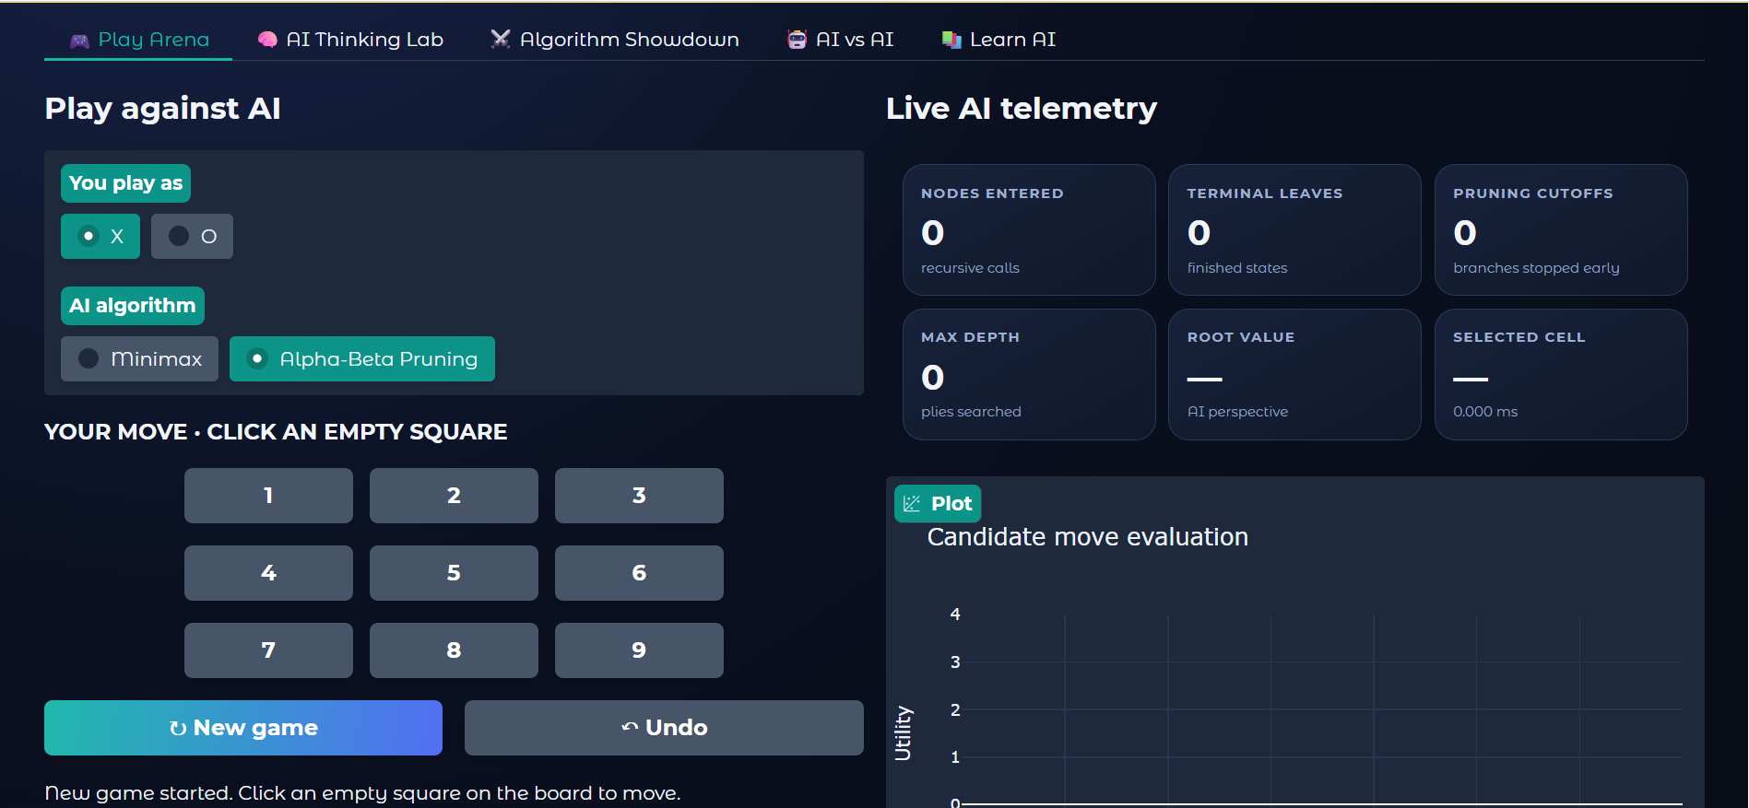
Figure 8.1. Play Arena in its initial state, with board controls and zeroed AI telemetry.
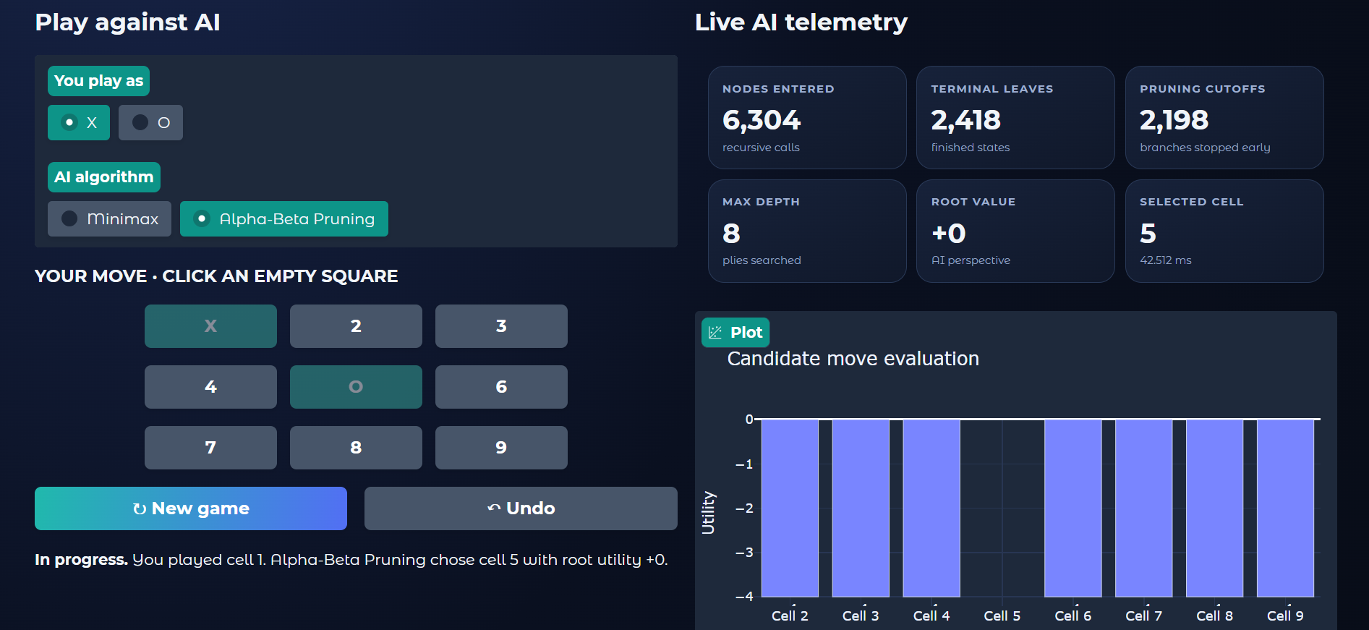
Figure 8.2. Play Arena after a move, showing sample search metrics and candidate move evaluation.
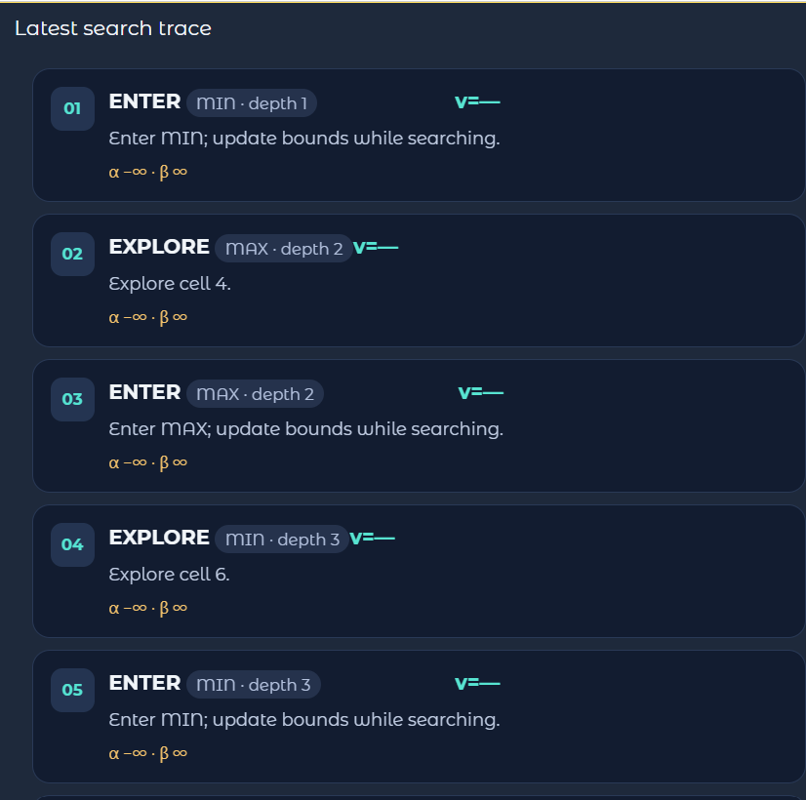
Figure 8.3. Search trace with recursive entry, exploration, terminal evaluation, bound update, and cutoff events.
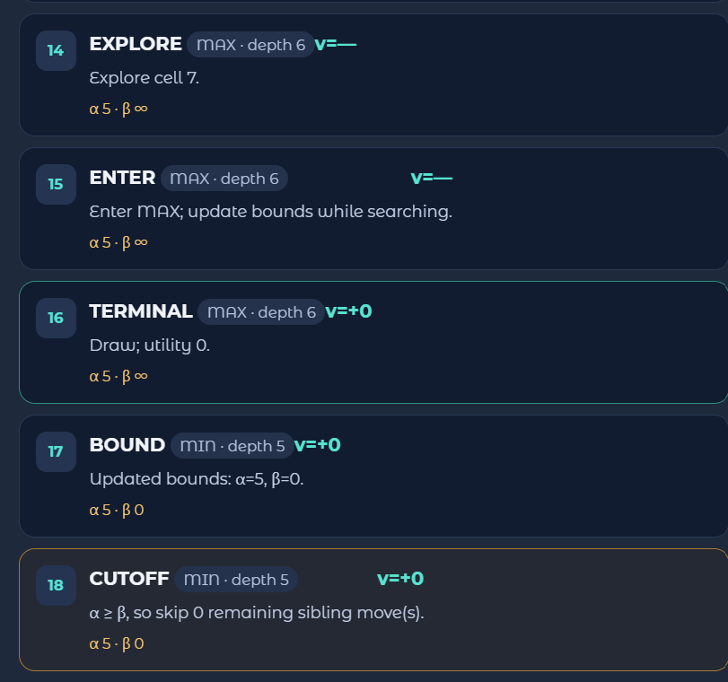
Figure 8.4. Algorithm Showdown comparing search work for Minimax and Alpha-Beta Pruning.
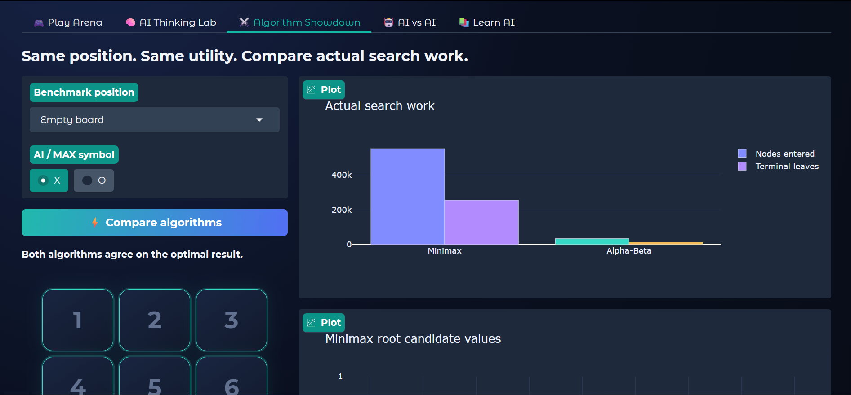
Figure 8.5. Additional application view supplied with the project demonstration.

8.2 Test Case Plan
Test ID | Action | Expected behavior | Evidence status
T1 | Launch application | Main interface and tabs render. | Interface visible in screenshot
T2 | Select an empty square | Move is registered and AI responds when appropriate. | A played position is visible
T3 | Select an occupied square | The move is rejected/disabled. | Feature described by UI design; verify during live run
T4 | Run Alpha-Beta search | Metrics and trace are populated. | Visible in screenshots
T5 | Open Algorithm Showdown | Search work for both algorithms is compared. | Visible in screenshot
T6 | Undo or start a new game | Board state resets or returns to the previous state. | Verify during live run
T7 | Run AI vs AI | Two AI agents alternate legal moves until terminal state. | Verify during live run
T8 | Compare optimal results | Minimax and Alpha-Beta return equivalent optimal values. | Designed invariant; verify with repeatable tests

Note: The screenshots demonstrate the visible UI and selected search run, but they do not independently prove every interaction path. The remaining cases should be tested in the live application before the report is submitted as a fully validated test report.

9. Complexity Analysis
Let b be the branching factor (the number of legal moves available from a state) and d be the maximum search depth. Tic-Tac-Toe has at most nine legal moves at the initial state, with fewer empty cells as the game progresses. Because the game tree is finite and small, exhaustive search is practical for this game.
Algorithm / operation | Time complexity | Space complexity | Comment
Minimax | O(b^d) | O(d) recursive stack, excluding stored traces | Worst-case search explores the game tree.
Alpha-Beta Pruning | O(b^d) worst case; O(b^(d/2)) with ideal ordering | O(d) recursive stack, excluding stored traces | The practical savings depend on move ordering and available cutoffs.
Terminal test | O(1) for a fixed 3×3 board | O(1) | Checks rows, columns, and diagonals.
Move generation | O(1) for fixed board size | O(b) successors | At most nine candidate cells at the start.

The complexity expressions describe general game-tree search behavior. Tic-Tac-Toe has a fixed small board, so actual runtime is usually short; the telemetry is valuable mainly for comparing how much work the algorithms perform on a particular position.

10. Limitations and Future Enhancements

10.1 Limitations
- The application currently focuses on Tic-Tac-Toe; the search design does not directly establish performance on larger games.
- The amount of pruning depends on the order in which legal moves are explored.
- Execution time varies with runtime environment and should not be generalized from a single screenshot.
- The trace visualization is a user-facing explanation of selected search events, not necessarily a full export of every recursive event.
- Some interaction and comparison test cases should be verified in a live run before making stronger correctness claims.

10.2 Future Enhancements
- Add repeatable benchmark suites with multiple board positions and exportable CSV results.
- Display a synchronized game-tree diagram with explicit parent-child links.
- Allow users to step forward and backward through individual search events.
- Add configurable move ordering to demonstrate its effect on alpha-beta pruning.
- Add a board-state editor with validation and clear explanation of illegal states.
- Extend the architecture to other small adversarial games and compare their search behavior.
- Add automated unit tests for win detection, draw detection, move legality, undo, and equivalence of Minimax and Alpha-Beta values.

11. Conclusion
AI Strategy Arena demonstrates adversarial search through an interactive Tic-Tac-Toe application. It brings together Minimax, Alpha-Beta Pruning, game-state evaluation, search telemetry, trace inspection, and side-by-side algorithm comparison in a single educational interface. The board and live metrics make it possible to connect a visible AI move with the recursive search that supports it.
The supplied screenshots show an initial interface, a sample search result, a trace containing terminal and cutoff events, and a comparison view. In the illustrated run, the telemetry reports 6,304 nodes entered, 2,418 terminal leaves, 2,198 pruning cutoffs, maximum depth 8, root value +0, and selected cell 5. These values are examples from one displayed position and should not be treated as fixed properties of the algorithm.
The main educational contribution is transparency: the application does not only choose a move but also exposes information about how the decision was reached. Further work should focus on reproducible benchmark tests, clearer full-tree visualization, and systematic verification of every interactive mode.

12. References
[1] S. J. Russell and P. Norvig, Artificial Intelligence: A Modern Approach, 4th ed. Pearson, 2021.
[2] D. E. Knuth and R. W. Moore, “An Analysis of Alpha-Beta Pruning,” Artificial Intelligence, vol. 6, no. 4, pp. 293–326, 1975.
[3] C. E. Shannon, “Programming a Computer for Playing Chess,” Philosophical Magazine, vol. 41, no. 314, pp. 256–275, 1950.
[4] Python Software Foundation, “Python 3 Documentation.” Available: https://docs.python.org/3/
[5] Gradio, “Gradio Documentation.” Available: https://www.gradio.app/docs
[6] Plotly, “Plotly Python Graphing Library.” Available: https://plotly.com/python/

Appendix A: Core Search Pseudocode

A.1 Minimax Root Selection
best_move = None
best_value = -infinity
for move in legal_moves(board):
child = apply_move(board, move, ai_symbol)
value = minimax(child, maximizing=False)
if value > best_value:
best_value = value
best_move = move
return best_move, best_value

A.2 Alpha-Beta Root Selection
best_move = None
alpha = -infinity
beta = +infinity
best_value = -infinity
for move in legal_moves(board):
child = apply_move(board, move, ai_symbol)
value = alpha_beta(child, alpha, beta, maximizing=False)
if value > best_value:
best_value = value
best_move = move
alpha = max(alpha, best_value)
return best_move, best_value
These pseudocode listings summarize the search logic at a high level. They are explanatory and should be aligned with the final submitted source code if function names, utility values, or move-ordering rules differ.

Appendix B: Application Screenshots
The following figures are included as evidence of the application interface and observed run. They correspond to the screenshots supplied with the request.
Figure | Description
Figure 8.1 | Initial Play Arena interface and empty telemetry.
Figure 8.2 | Play Arena with a sample AI decision and displayed metrics.
Figure 8.3 | Latest search trace with terminal and cutoff events.
Figure 8.4 | Algorithm Showdown comparison view.
Figure 8.5 | Additional supplied application view.

