Codebook for combineData()

Autogenerated data summary from dataMaid

2020-06-14 13:17:27

# Data report overview

The dataset examined has the following dimensions:

|  |  |
| --- | --- |
| Feature | Result |
| Number of observations | 30 |
| Number of variables | 7 |

# Codebook summary table

|  |  |  |  |  |  |
| --- | --- | --- | --- | --- | --- |
| Label | Variable | Class | # unique values | Missing | Description |
|  | **Subject** | integer | 30 | 0.00 % |  |
|  | **LAYING** | numeric | 30 | 0.00 % |  |
|  | **SITTING** | numeric | 30 | 0.00 % |  |
|  | **STANDING** | numeric | 30 | 0.00 % |  |
|  | **WALKING** | numeric | 30 | 0.00 % |  |
|  | **WALKING_DOWNSTAIRS** | numeric | 30 | 0.00 % |  |
|  | **WALKING_UPSTAIRS** | numeric | 30 | 0.00 % |  |

# Variable list

## Subject

|  |  |
| --- | --- |
| Feature | Result |
| Variable type | integer |
| Number of missing obs. | 0 (0 %) |
| Number of unique values | 30 |
| Median | 15.5 |
| 1st and 3rd quartiles | 8.25; 22.75 |
| Min. and max. | 1; 30 |

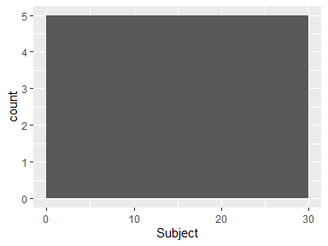

## LAYING

|  |  |
| --- | --- |
| Feature | Result |
| Variable type | numeric |
| Number of missing obs. | 0 (0 %) |
| Number of unique values | 30 |
| Median | -0.44 |
| 1st and 3rd quartiles | -0.55; -0.37 |
| Min. and max. | -0.65; -0.27 |

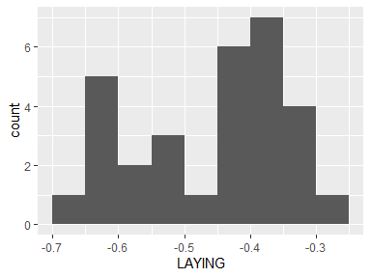

## SITTING

|  |  |
| --- | --- |
| Feature | Result |
| Variable type | numeric |
| Number of missing obs. | 0 (0 %) |
| Number of unique values | 30 |
| Median | -0.47 |
| 1st and 3rd quartiles | -0.54; -0.38 |
| Min. and max. | -0.64; -0.31 |

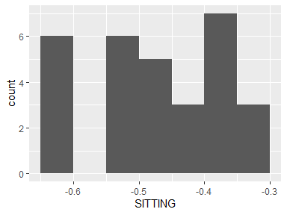

## STANDING

|  |  |
| --- | --- |
| Feature | Result |
| Variable type | numeric |
| Number of missing obs. | 0 (0 %) |
| Number of unique values | 30 |
| Median | -0.61 |
| 1st and 3rd quartiles | -0.63; -0.52 |
| Min. and max. | -0.65; -0.3 |

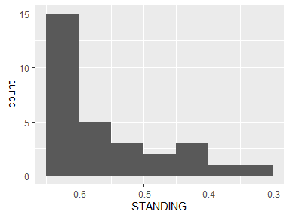

## WALKING

|  |  |
| --- | --- |
| Feature | Result |
| Variable type | numeric |
| Number of missing obs. | 0 (0 %) |
| Number of unique values | 30 |
| Median | -0.57 |
| 1st and 3rd quartiles | -0.63; -0.39 |
| Min. and max. | -0.65; -0.3 |

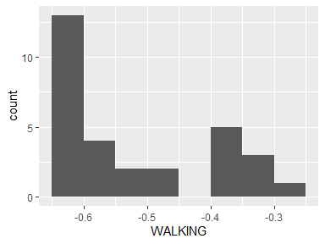

## WALKING_DOWNSTAIRS

|  |  |
| --- | --- |
| Feature | Result |
| Variable type | numeric |
| Number of missing obs. | 0 (0 %) |
| Number of unique values | 30 |
| Median | -0.48 |
| 1st and 3rd quartiles | -0.6; -0.38 |
| Min. and max. | -0.65; -0.27 |

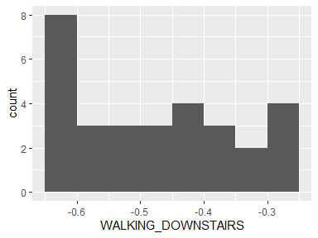

## WALKING_UPSTAIRS

|  |  |
| --- | --- |
| Feature | Result |
| Variable type | numeric |
| Number of missing obs. | 0 (0 %) |
| Number of unique values | 30 |
| Median | -0.62 |
| 1st and 3rd quartiles | -0.64; -0.52 |
| Min. and max. | -0.65; -0.35 |

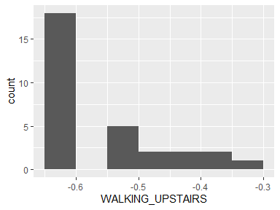

Report generation information:

* Created by: NithaDuff (username: chali).
* Report creation time: Sun Jun 14 2020 13:17:27
* Report was run from directory: C:/Users/chali/Documents/test1/TidyData
* dataMaid v1.4.0 [Pkg: 2019-12-10 from CRAN (R 4.0.0)]
* R version 4.0.1 (2020-06-06).
* Platform: x86_64-w64-mingw32/x64 (64-bit)(Windows 10 x64 (build 18362)).
* Function call: dataMaid::makeDataReport(data = combineData(), mode = c("summarize", "visualize", "check"), smartNum = FALSE, file = "codebook_combineData__.Rmd", checks = list(character = "showAllFactorLevels", factor = "showAllFactorLevels", labelled = "showAllFactorLevels", haven_labelled = "showAllFactorLevels", numeric = NULL, integer = NULL, logical = NULL, Date = NULL), listChecks = FALSE, maxProbVals = Inf, codebook = TRUE, reportTitle = "Codebook for combineData()")